Covid-19, also known as Coronavirus, is an infectious disease caused by a newly discovered coronavirus. To date (16th November 2020) there has been 54.5 million cases of Covid-19 worldwide and there have unfortunately been 1.32 million deaths worldwide due to Covid-19. As well as serious implications for people's health and the healthcare services, coronavirus (COVID-19) is having a significant impact on businesses and the economy.

The impact of the Coronavirus Disease on businesses overall has been huge and there are many reasons for this. Firstly, large amounts of staff layoffs and business closures occurred within the first few weeks of the pandemic. Secondly, the risk of closure was also a worry for businesses due to the unexpected and unknown length of the pandemic. Thirdly, many businesses, big and small, have become financially fragile during this time. This is mainly because certain business industries have had to close for at least a short while due to lockdowns, this means that while the businesses were closed, they were losing out on money.

This pandemic was a shock to every person, business, government and organization. No one knew how to deal with this virus and what to do, however it is evident that certain industries have been affected more than others. One of those business sectors that has been severely impacted by the virus and the lockdowns is the hospitality sector, which has felt the full impact of COVID-19.

The industry is an essential component of the UK economy and is the third largest sector for employment with an estimated 3.2 million people working in restaurants, pubs and other outlets. The hospitality industry itself is larger than the automotive, pharmaceutical, and aerospace industries combined. Other supporting evidence that shows the importance of the sector to the economy are statistics published by Eventbrite which stated that “the UK event industry alone was worth £42.3 billion to the UK economy in 2018, employing over 500,000 people and delivering 35% of the UK’s total visitor economy”. This clearly demonstrates why the pandemic has had such a negative effect on the UK’s economy.

Rumors were already being heard in early March about a potential UK National lockdown but with the seriousness of COVID-19, a lockdown was eventually announced by the UK’s Prime Minister, Boris Johnson, on the 23rd of March 2020. This sudden withdrawal from society would have an impact on all business, irrelevant of size. However, the impact initially started on the 16th of March, just a week before the UK went into lockdown, when Boris Johnson advised the public to take a break from going out to restaurants, pubs, theatres and cinemas. This was announced because the government’s main focus was to keep the mortality rate from COVID-19 as low as possible, meaning it was safer for people to stay home and keep themselves and others safe than to go out to all these places. Many of these businesses already operate on low margins and fragile cash flow therefore the likelihood of them surviving with little to no income for an indefinite amount of time was unpromising. It was also a worry that the Prime Minister did not put a complete ban on visiting hospitality businesses straight away, this meant that the owners of these businesses could not claim on their insurance for disrupted business, making the lives of all who work in hospitality extremely difficult and concerning. The question that was then being asked by those businesses in the hospitality sector was, how would the government support these businesses and staff? And how would they make sure they still had a business to run by the end of this pandemic?
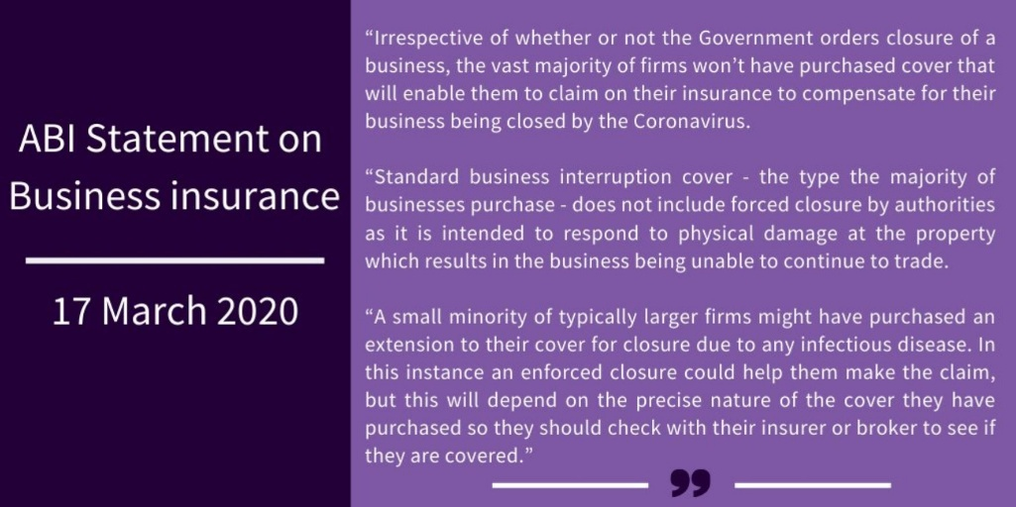
This was when, on the 17th of March, the UK government said they would provide an unprecedented package of £330 billion to help businesses though the pandemic and they introduced other support measures such as tax cuts and other grants and loans that businesses could apply for. However, the chancellor himself, Rishi Sunak, stated that there was no way the government would be able to save every single business and unfortunately this would see several businesses in the hospitality industry face near bankruptcy. There are other things that the government did to try and help these businesses and employees survive, such as:
- A package of £330 billion of loan guarantees to businesses, with more to be made available if needed
- Interest-free business interruption loans will be increased to £5 million, up from £1.2 million. No interest will be due for the first six months
- A 12-month business rates holiday for all shops, pubs, theatres, music venues, restaurants and any other hospitality or leisure business
- A cash grant of up to £25,000 for those businesses with a ratable value of less than £51,000
- A three-month mortgage holiday for those in difficulty because of coronavirus
- Cash grants of £10,000 to £700,000 for the smallest businesses

Inevitably, on the 23rd of March 2020, Boris Johnson announced that a lockdown would need to happen in order to slow down the rates of infections, allowing the NHS (National Health Service) to be able to cope with the startling number of patients admitted to hospital with severe symptoms of the virus. Coincidently, with the Prime Minister contracting the virus himself, being admitted to hospital and spending a few days in intensive care, the extend of the pandemic further hit home in terms of the seriousness of its impact on the economy. It was then revealed by the Office for Budget Responsibility – that Britain’s overall economy could shrink by 35% in the second quarter and we could see unemployment in the UK leap by two million because of COVID-19, even with the governments furlough scheme in place.

During the many months of the UK lockdown Boris Johnson told people to work from home if possible and limit the amount of people you come into contact with. Where this may have been possible for quite a few jobs, for some it was not. If you work in a restaurant, bar, café or pub then you cannot work from home. On the other hand, many takeaway businesses flourished during this time due to the fact that people could not go out to eat but did not want to cook their own meals everyday therefore they would order from a takeaway which brought money into them businesses.

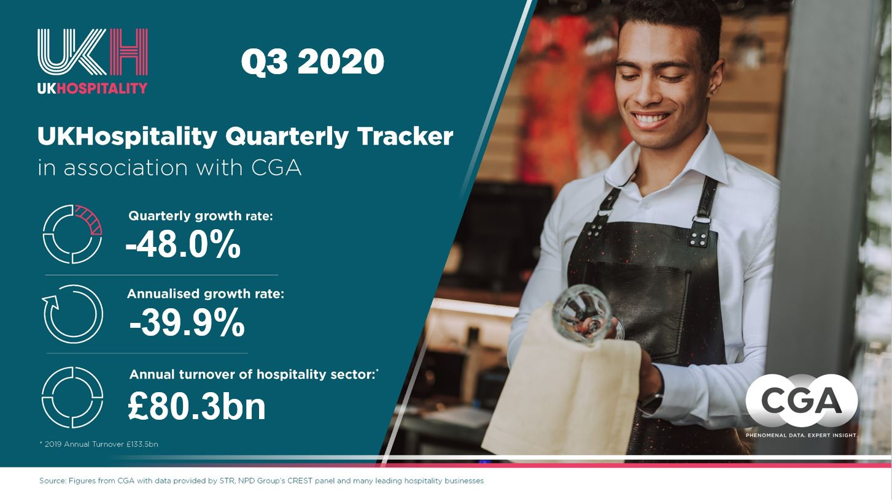
The UK Hospitality’s own Quarterly tracker reported that the hospitality sector saw a 48% decrease in the third quarter of 2020. This equates to a shortfall of £17 billion compared to the same quarter in 2019. The huge drop in sales comes despite a boost of trade from the governments ‘Eat Out to Help Out’ promotion in August. Since the scheme has ended, there have been tougher lockdowns and customer confidence continues to fall. During the peak of the pandemic, the UK hospitality industry has essentially come to a standstill with an estimated 75% of companies in the sector closing and 85% of the workforce being furloughed during months of March to April.
The ‘Eat Out to Help Out’ discount scheme was introduced by Rishi Sunak and provided customers, who were having a sit-down meal in cafes, restaurants, and pubs across the UK, with a 50 percent reduction. This was capped at £10 a head and the discount was only available Monday to Wednesday throughout the month of August. The businesses that registered in the scheme actually made profit during this time because they were able to give their customers 50 percent off their sit-in meals and then claim a reimbursement from the government for the discount they have given. This scheme actually ended up costing the Treasury, the government’s economic and finance ministry, around £522 million. After this scheme ended, many businesses. The scheme worked out well because it enabled businesses in the hospitality industry to stay open therefore being able to bring back staff who had been placed on furlough and save many jobs.

There was hope for businesses when Boris Johnson announced that the UK hospitality industry, this includes pubs, restaurants, bars and cafes, could reopen on the 4th of July 2020 which was when all hospitality in England reopened their doors. However, not all of the leaders of the countries in the UK agreed with this. Hospitality in Northern Ireland did not reopen until the 3rd of July 2020, in Scotland it was the 15th of July 2020 and finally Wales reopened hospitality on the 3rd of August 2020. All UK countries hospitality was open in time for the ‘Eat Out to Help Out’ scheme that was mentioned above. This worked because many people had been cooped up inside their own homes for way too long and just wanted to get out and with most cafes, restaurants and pubs offering 50 percent off sit-in meals (up to £10 a head) there was even more reason for people to go and spend their time and money in these places. Obviously, there were rules and new restrictions that needed to be followed in order for these businesses to be as safe as possible and limit the spread of coronavirus as much as they can. People must keep a social distance of at least 2 meters (1 meter if you live in England) away from any person they do not live with, people must wear a face covering in indoor public spaces, on public transport and where social distancing cannot be maintained.

It is not just restaurants, bar, cafes and pubs that have been impacted by covid-19. The travel and tourism industry has also taken a large hit. In the past decades, tourism has grown continuously and become one of the fastest growing economic sectors globally. However, the strong continuous growth has come to a standstill this year because of the Covid-19 pandemic. With airplanes not being used, hotels being shut and travel restrictions being introduced, travel and tourism quickly became one of the most affected sectors since the start of the pandemic. This has meant a cut in international tourist arrivals in the first quarter of 2020 to a fraction of what they were a year ago.

Countries all over the world started to apply travel restrictions and bans to limit the spread of coronavirus. Airport closures, suspending incoming and outgoing flights and nationwide lockdowns are just some of the measures that countries put in place in an effort to help contain the coronavirus. In the first two quarters of 2020, at least 93 percent of the global population lived in countries with coronavirus-related travel restrictions. Approximately 3 billion people were living in countries that were enforcing complete border closures to anyone who didn’t live in that country. The number of international tourist arrivals has been growing exceptionally in the last decade and sustained growth the last years. According to The United Nations World Tourism Organization (UNWTO) in 2017, tourist arrivals reached a total of 1.3 billion globally, 2018 reaching 1.4 billion and 1.5 billion in 2019.

In 2020, with the impact of Covid-19 being so severe, international tourism went down by 65 percent in the first half of 2020 when compared with figures from 2019. In March 2020, The United Nations World Tourism Organization (UNWTO) proposed 3 scenarios for possible declines in arrivals of 58 percent to 78 percent for 2020 depending on when countries started reopening their borders and lifting travel restrictions.

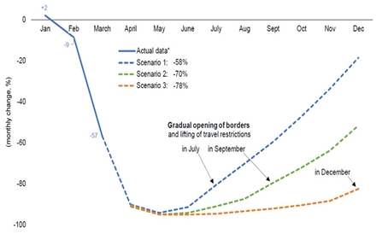
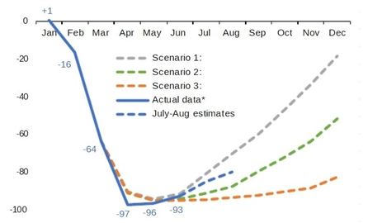
As you can see from the images above, the March forecast and the update in September, the recovery for this industry might happen in 2021 and domestic demand is expected to recover faster than international. In May 2020 the majority of tourism experts at UNWTO said they expect to see signs of recovery by the final quarter of 2020 but mostly in 2021.

So what’s next? Currently England are in a second lockdown lasting (supposedly) until the 2nd of December 2020. In Scotland, Nicola Sturgeon (the first minister of Scotland) has announced that more than two million residents of Scotland will return to a near-full state of lockdown on the 20th of November 2020 under new restrictions. Whereas Wales have just come out of a two-week fire break lockdown that lasted from the 23rd of October 2020 until the 9th of November 2020. And there are no current plans for a lockdown in Northern Ireland. It is obvious that no person or business knows how the future will turn out and how long Covid-19 will affect lives and businesses so severely. However, there are ways in which the hospitality sector and many other industries can overcome these difficulties. There are rules and restrictions that have been put in place so that people can still go out and live their lives, but everyone must follow the rules set in place.

Covid-19 has definitely made businesses stronger and a lot more resilient and able to adapt to new situations than they were before the pandemic. Kelly Grier, Chair and Managing Partner, EY US LLP and EY America’s Managing Partner said “In this period of unprecedented uncertainty, optionality, agility and decisiveness and vital”. The pandemic has made businesses more aware of how quickly things can change but also made them more prepared for any unforeseen events that happen in the future. Businesses will know how to handle things better, how to make better decisions and what needs to be done for the wellbeing of them, their employees and their business. Still with this being said there are no guarantees for anything. Many businesses who have plans for events such as Christmas and New year still do not know if these are going to go ahead or whether any business will be fully recovered by that point. However, the whole sector has to believe that there is a light at the end of the tunnel and those who adapt and innovate are most likely to benefit from the unavoidable change in consumer habits.

Reference list
https://www.mckinsey.com/featured-insights/business-resilience (May 21st, 2019)
Leadership in a crisis: Responding to the coronavirus outbreak and future challenges https://www.mckinsey.com/business-functions/organization/our-insights/leadership-in-a-crisis-responding-to-the-coronavirus-outbreak-and-future-challenges (March 16th 2020)
‘Agile resilience in the UK: Lessons from COVID-19 for the ‘next normal’’ https://www.mckinsey.com/business-functions/organization/our-insights/agile-resilience-in-the-uk-lessons-from-covid-19-for-the-next-normal (13th October 2020)
Covid-19 response https://www.unwto.org/tourism-covid-19 (no date)
International tourism and covid-19 https://www.unwto.org/international-tourism-and-covid-19 (no date)

