

Student name: Habiba Mahmud Happy

Student ID:2409257

Module name: Introduction to Physiology
Module code: BMHP5023

Assessment: Component 1: Written Assignment (Case Study Report)

Table of Contents
Introduction 1
Blood Sugar Regulation 2
Cellular Metabolism 3
For Type 2 Diabetes Recording and Tracking Blood Sugar Levels 4
Recommendations 5
Conclusion 6
References 7

Introduction
A chronic metabolic problem described by long-term high glucose levels, an outcome from the body’s incapability to make and successfully leverage of insulin, is known as Diabetes (World Health Organisation, 2024). A hormone created by the organ that manages the shift of glucose from the flow of blood into cells, from where it is used to create energy, is known as insulin. Diabetes has mainly two important types. An autoimmune disorder in which insulin-producing beta cells are damaged and the creation of insulin is meaningfully decreased is known as Type 1 diabetes. Furthermore, the most common type, in which the body is unresponsive to insulin and cannot create sufficient glucose, is known as Type 2 diabetes. Type 2 diabetes is critically connected to factors of daily life, like diet, insufficient physical activity, smoking, and obesity and more than 90% of the diabetes cases globally are Type 2 diabetes (The Lancet, 2023). This report will particularly emphasise Type 2 diabetes. This type is growing and becoming widespread in the primary care environment, integrating health centres. To help personnel know their condition, as a practice nurse, learning before a patient has an important function. Like understanding the significance of observing glucose levels in blood, and adjusting healthier attributes to help secure and successful self-management (AlDwaikat et al., 2021). Serious issues can happen if diabetes is not managed, like cardiac conditions, marginal neuropathy, kidney problems, and slow healing of wounds. Hence, preparing people with insight about the fundamental mental process, the significance of glucose in blood, and proof-oriented lifestyle involvement is important for improving long-term health results. Furthermore, this report will analyse the biological foundation of diabetes and describe how sugar in the blood balance is managed. The report will also find how glucose and oxygen are used in metabolism to create energy and understand how regular observation level of the blood sugar helps individuals to handle their situation successfully. Lastly, proof-oriented lifestyle suggestions will be given, underlining the effect of smoking, change in diet, physical tasks, and self-observation in stop challenges and help positive blood sugar control.
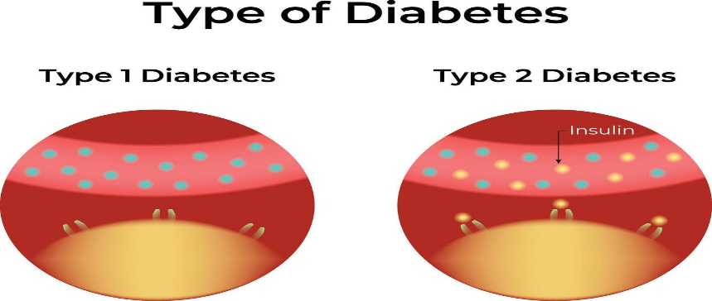
Figure 1: Types of Diabetes.
Source: (Vecteezy, 2025).

Blood Sugar Regulation
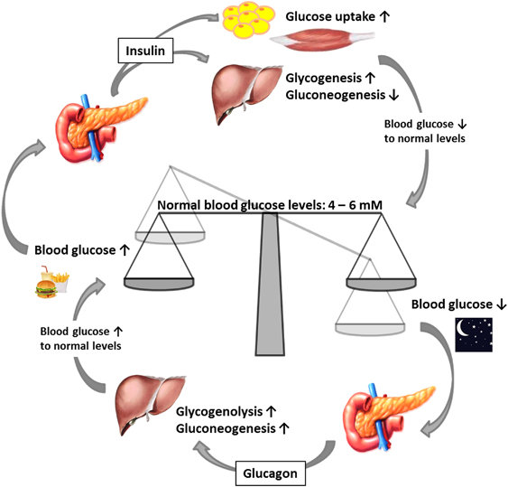
Figure 2: Maintenance of Blood Glucose Levels.
Source: (ResearchGate, 2025).
For normal body operation, holding stable blood glucose levels is important. Specifically, for brain functioning, muscle movements, and the metabolism process (Bodenheimer and WillardGrace, 2022). Glucose homeostasis is a complicated mental process that the human body uses to manage blood sugar. Mainly managed by the hormone system and includes hormones released by the organ, particularly the pancreatic islets. Insulin and glucagon, the two important hormones, have different functions in handling the level of blood glucose and help to maintain the optimal range before food of 4-6 mmol/L (Duke, 2021). Through pancreatic insulin-producing cells and lower blood glucose levels, insulin is created. By making sure the approval of glucose into cells, specifically in bone, muscle and adipose tissue. It boosts the shift of glucose into glycogen inside the muscles and liver; this process is known as glycogenesis. Also, stop the damage to fats and proteins needed for energy. Insulin is out routinely in answer to growing levels of blood glucose after a meal for a healthy person. This guarantees glucose is inside the cells successfully and blood glucose is back in a safe position. In the same manner, in the time of fasting and physical exercise, the blood glucose decreases (İlhan et al., 2021). To increase glucose levels, glucagon, secreted by alpha cells, takes action. The interruption of reserve glycogen into glucose in the liver and gluconeogenesis, also the creation of glucose from non-carbohydrate bases, boost glycogenolysis. The body has stable energy supply is made sure by this hormonal balance. The legislative system becomes ineffective because of insulin fight back in Type 2 diabetes (Jafaripour et al., 2021). In which insulin creation decreases slowly over time because the body cells do not answer successfully to insulin. Hence, instead of entering cells, the glucose remains in the blood flow. This causes a purposeful hyperglycaemia. The energy supply cells will be damaged and influence to long-term complications if it is not treated. This integrates damage in the heart, nerve, kidney, and eye issues (Kar et al., 2020). To refine insulin awareness and holding on secure level of glucose, understanding why medication obedience, food management, and regular exercise are important for Type 2 diabetes. Knowing blood sugar management helps patients with this. Knowing better involvement with diabetes control strategies and endorsing secure long-term health results is accompanied by learning about this physiological process.

Cellular Metabolism
It is essential to find out how the body shifts glucose and oxygen into important energy using cellular metabolism (Skinner et al., 2023). To know why blood glucose management is important for Type 2 diabetes person. Specifically, the cellular breathing process. For the normal operations of all organs, glucose is the main energy source in the body, and adjusting its distribution is important. Particularly for the brain and muscles. In the metabolic track, oxygen has an important function. Through the process known as aerobic respiration, this allows cells to divide glucose successfully. In various phases, cellular metabolism happens (Wildman and Wildman, 2021). Start with the support of insulin, glucose enters cells. This attaches to receptors on the surface of the cell and allows glucose to move all over the cell membrane. In the cytoplasm, inside the cell, glucose experiences glycolysis. From this, it divides into oxaloacetate, in the form of ATP, creating a small scale of energy. Oxaloacetate goes inside mitochondria when there is oxygen. In which the Krebs Cycle and electron moves chain create meaningfully higher ATP (Skinner et al., 2023). As waste items, this process creates water and carbon dioxide, which are generally released using circulation and breathing. Although cells are unsuccessful in creating sufficient ATP, when glucose cannot go inside cells, like in Type 2 diabetes, insulin resistance factor. These actions can lead the body to divide fats and energy proteins. This can direct to the creation of ketones and a mismatch of metabolism (Rosenfeld et al., 2025). Determined insufficiency of glucose inside cells, even with high levels of blood glucose, can create headache, weakness in bones, healing wounds slowly, and a growing possibility of other diseases for people with higher diabetes. Cellular metabolism is also affected by lifestyle habits. Insulin awareness is increased with constant physical activity. This action helps cells to leverage glucose more successfully and increase the creation of ATP (Kar et al., 2020). Oxidative damage and irritation can increase because of smoking and bad food habits. This decreases the operations of mitochondria and decreases the optimisation of metabolism. For better management of metabolism, sufficient sleep, and stress management also have an impactful support. As long-term stress enhances the level of cortisol, it can increase the level of glucose in the blood and decrease insulin sensitivity (Jafaripour et al., 2021). In energy creation, knowing the function of oxygen and glucose is important. As it assists patients to know why handling a sustainable level of blood sugar and having healthy habits are important to stop issues and making sure cells are effectively working.

For Type 2 Diabetes Recording and Tracking Blood Sugar Levels
One of the important factors of successful Type 2 diabetes management is observing and recording levels of blood glucose (İlhan et al., 2021). To know how individuals' diet, exercise levels, anxiety of medication, and sickness impact blood sugar to accomplish constant tracking is important. This solidifies patients to be more successful with their care strategies, increasing secure and stable management of glucose levels. The sugar level of blood can be observed using finger-prick testing in kids, and a constant sugar observation system. Keeping the sugar level at a secure position is suggested for the majority of patients with Type 2 diabetes. The ranges of secure level are before food is 4-7 mmol/Land 8.5 mmol/L, is after two hours of eating food (Harrington and Henson, 2024). Recognising movement is allowed by recording these values. For example, growth in particular foods and a decrease during physical tasks. These help to adjust a suitable lifestyle and medication. In important defensive function tracking of the level of blood sugar is an important function. Complications are there with chronic hyperglycaemia. Such as heart problems, neuro issues, and eye problems with diabetics. Stopping long-term harm to blood vessels and nerves, observing helps recognise an increasing level at an early stage. Also, hypoglycaemia is recognised through observation (Garvey et al., 2022). A possible harmful decrease in sugar level in blood, specifically for personal taking oral medication and taking insulin. Identifying at the starting phase, patients can take proper steps, like eating instant carbohydrates to regain a secure level of sugar. Also, cooperative care is possible through constant glucose recording. For hospitals to analyse treatment success and make proof-oriented medication decisions, recorded information gives important data. To insert and evaluate their information instantly, digital health equipment like mobile apps and wearable devices will offer information. These will refine obedience and self-management results (Garvey et al., 2022). Patients possibly be unaware of the changes in blood sugar, without observing regularly. This enhances the possibility of complexity and an emergency rush to the hospital. To make sure safety for Type 2 diabetes individuals, motivating them to observe, record, and analyse their blood sugar levels regularly is important. Also, improving long-term health results and independent self-management.

Recommendations
To acquire a steady lifestyle adjustment that helps sustainable level of blood sugar, successful management of Type 2 diabetes is needed by patients. These will improve insulin awareness and decrease the long-term difficulties risks. In refining glycaemic management and stopping the disease from spreading, according to Rosenfeld et al. (2025), systematic lifestyle addition can be as helpful as medicine.
For diabetes management, dietary refinement is important. To eat healthy foods must be motivated to patients (AlDwaikat et al., 2021). Like eating vegetables, lean protein, sugar-free foods, and healthy fats. Also, ignore processed foods and carbohydrate drinks. Assisting in a steady level of blood sugar, slow-release carbs help slow sugar intake. According to Garcia-Molina et al. (2020), food habits like Mediterranean foods help to refine sugar management and decrease risks of heart disease. To help a person in accomplishing a stable transformation, referring to a professional, nutritious and learning about diabetes is important. Furthermore, another important lifestyle fix is constant physical activity (Bodenheimer and WillardGrace, 2022). Insulin awareness and weight management are possible through moderate exercise like walking, running and swimming for more than 150 minutes per week (Harrington and Henson, 2024). Muscle mass can be improved through tough training twice each week. These will help to approve sugar increase. Also, type 2 diabetes patients are motivated to decrease sitting habits by adding a movement routine in daily life. Another important function is weight management (Duke, 2021). Specifically for the person who is fat and obese and has type 2 diabetes. As per Garvey et al. (2022), reducing more than 10% body mass can meaningfully refine sugar management and decrease dependency on insulin. Motivation and obedience can be improved through systematic weight-management efforts combined with attribute assistance. Stopping smoking must be robustly motivated. According to the World Health Organisation (2023), smoking enhances the struggle for insulin and increases the risk of heart diseases in a person who has diabetes. Being involved in programmes for stopping smoking must be suggested and attributed to helping efforts. Lastly, learning and self-observation are important (İlhan et al., 2021). As per Duke (2021), motivating individuals who have Type 2 diabetes to daily input their blood sugar levels and repeating similar habits. These will help to make well-judged decisions, considering exercise, diet, and taking medication. Self-optimisation and long-term health results are improved through involvement in diabetes self-control learning efforts.

Conclusion
Hence, contributed by lifestyle and described by decreased insulin activity and an increase in blood sugar levels, Type 2 diabetes is a long-term metabolic disease. For successful self-management and stopping long-term complications, knowing sugar management, energy creation in cells, and the significance of constantly observing is important. Various studies showed that adjusting healthy attributes, integrating a balanced diet, constant physical exercise, weight management, and stopping smoking can refine the management of glycaemia and general health results. Using constant learning, regular self-observation, and involvement with professional assistance, people can handle their diseases securely and improve their long-term standard of living.

References
AlDwaikat, T.N., Rababah, J.A., AlHammouri, M.M. and Chlebowy, D.O. (2021). Social support, self efficacy, and psychological wellbeing of adults with type 2 diabetes. Western Journal of Nursing Research, 43(4), pp.288–297.
Bodenheimer, T.S. and WillardGrace, R. (2022). Care Management For Patients With Type 2 Diabetes: The Roles Of Nurses, Pharmacists, And Social Workers: Study examines the roles of nurse, pharmacists, and social workers in managing care for patients with Type 2 Diabetes. Health Affairs, 41(7), pp.947–954.
Duke, N. (2021). Type 2 diabetes self management: spirituality, coping and responsibility. Journal of Research in Nursing, 26(8), pp.743–760.
GarciaMolina, L., LewisMikhael, A., RiquelmeGallego, B., Can Ibanez, N., Oliveras Lopez, M. and BuenoCavanillas, A. (2020). Improving Type 2 Diabetes Mellitus Glycaemic Control through Lifestyle Modification Implementing Diet intervention: a Systematic Review and Metaanalysis. European Journal of Nutrition, 59(4), pp.1313–1328.
Garvey, W.T., Umpierrez, G.E., Dunn, J.P., Kwan, A.Y.M., Varnado, O.J., Konig, M. and Levine, J.A. (2022). Weighing the Evidence for Weight Management in Individuals with Type 2 Diabetes. Diabetes, Obesity and Metabolism, 24(8).
Harrington, D. and Henson, J. (2024). Physical Activity and Exercise in the Management of Type 2 diabetes: Where to start? Practical Diabetes, [online] 38(5), p.35. Available at: https://wchh.onlinelibrary.wiley.com/doi/full/10.1002/pdi.2361.
İlhan, N., Telli, S., Temel, B. and Aştı, T. (2021). Health literacy and diabetes selfcare in individuals with type 2 diabetes in Turkey. Primary care diabetes, 15(1), pp.74–79.
Jafaripour, F., Taqvaeinasab, H., Mirsamiyazdi, N., Masoudiyekta, L. and Amiri, R. (2021). The relationship between health literacy and health promoting behaviors in patients with type2 diabetes. Journal of Health Literacy.
Kar, P., Goward, C., Whitman, M., Davies, M., Willner, T. and Shaw, K. (2020). Engagement and effectiveness of digitally enabled behavioural change support for people living with type 2 diabetes. Practical Diabetes, 37(5), pp.167–172a.
ResearchGate (2025). Figure 2: Maintenance of blood glucose levels by glucagon and insulin.... [online] ResearchGate. Available at: https://www.researchgate.net/figure/Maintenance-of-blood-glucose-levels-by-glucagon-and-insulin-When-blood-glucose-levels_fig3_297896821.
Rosenfeld, R.M., Grega, M.L., Karlsen, M.C., Abu, Nisha, A.R., Bonnet, J.P., Donnell, L., Fitzpatrick, S.L., Frates, B. and Joy, E.A. (2025). Lifestyle Interventions for Treatment and Remission of Type 2 Diabetes and Prediabetes in adults: a Clinical Practice Guideline from the American College of Lifestyle Medicine. American Journal of Lifestyle Medicine, 19(2), pp.10S131S.
Skinner, A., Hartfiel, N., Lynch, M., Jones, A.W. and Edwards, R.T. (2023). Social return on investment of social prescribing via a diabetes technician for preventing type 2 diabetes progression. International Journal of Environmental Research and Public Health, 20(12), p.6074.
The Lancet (2023). Global, regional, and National Burden of Diabetes from 1990 to 2021, with Projections of Prevalence to 2050: a Systematic Analysis for the Global Burden of Disease Study 2021. The Lancet, [online] 402(10397). Available at: https://www.thelancet.com/journals/lancet/article/PIIS0140-6736(23)01301-6/fulltext.
Vecteezy (2025). Type of Diabetes Science Design Illustration Diagram. [online] Vecteezy. Available at: https://www.vecteezy.com/vector-art/57182426-type-of-diabetes-science-design-illustration-diagram [Accessed 5 Nov. 2025].
Wildman, J. and Wildman, J.M. (2021). Evaluation of a community health worker social prescribing program among UK patients with type 2 diabetes. JAMA network open, 4(9), pp.e2126236–e2126236.
World Health Organisation (2023). Quitting smoking cuts your risk of developing type 2 diabetes by 30–40%. [online] www.who.int. Available at: https://www.who.int/news/item/14-11-2023-quitting-smoking-cuts-your-risk-of-developing-type-2-diabetes-by-30-40.
World Health Organization (2024). Diabetes. [online] World Health Organization. Available at: https://www.who.int/news-room/fact-sheets/detail/diabetes.

