Working with point references and Spreadsheet data

Looking at methods for data collection to monitor waste around the Gower area. Using the data to building a GIS model that could be used to analyse and possible predict waste detrimental to the environment.

How do we start to build up the GIS:
First you will need a base map. Use the data provided by MapInfo and in the training data folder, select the UK-regions. Your map should look something like this:

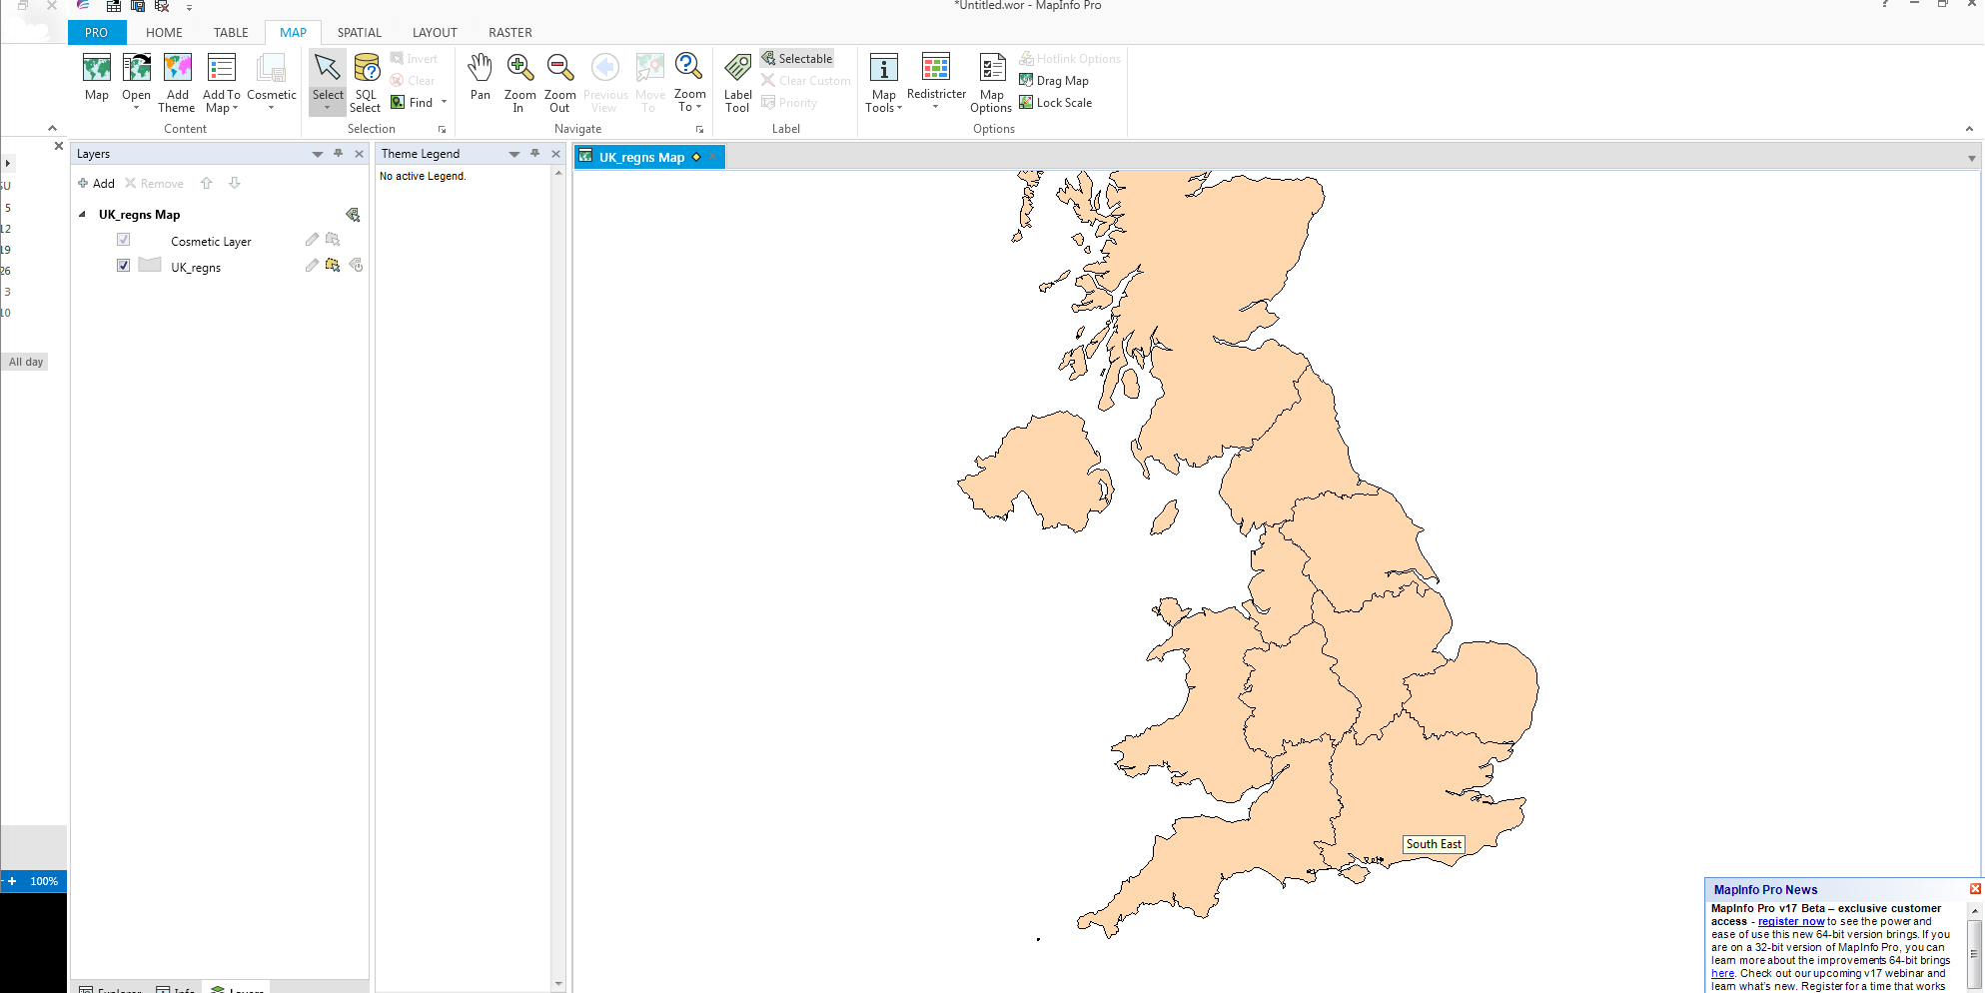

Next, because our study area is in Wales we could select the Wales region polygon and create a new table just for this area.
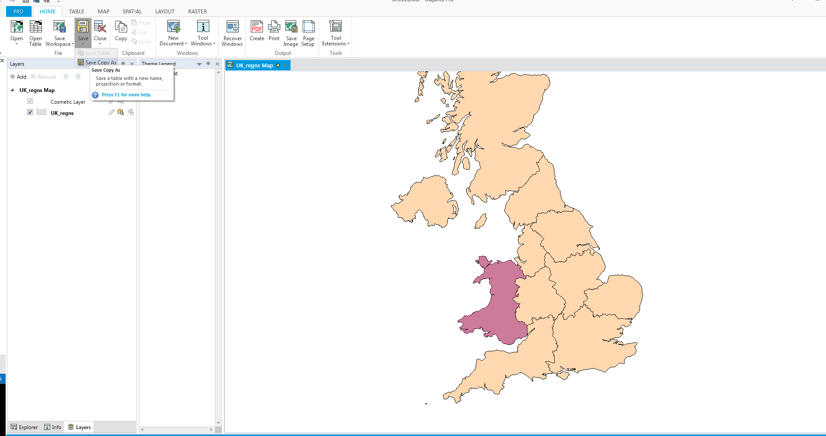
Once you have selected your polygon use the File: Save copy as and give your selection a meaningful name. Save this to the directory that contains all your study area data.

You will need to open this new table as another layer in you GIS. You can also close down the original UK map.
Nest using the coastal points .xls (Microsoft excel on moodle) file open this into MapInfo. Remember we need to check the box that stated use the first row as headings (this gives us our attribute reference)
There is additional information in two columns time date and survey findings with appropriate x and y coordinates. We will be using this data to explore the SQL functions in MapInfo.
You will then need to use a Table: Create Points using x coastlon y coastlat your screen should look something like this:
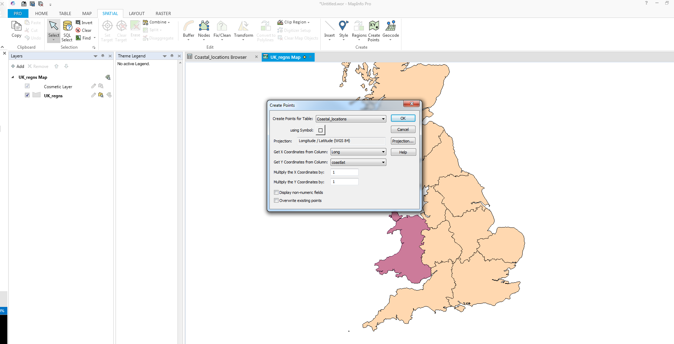

Now we can build queries using our coastal location data.

The query options are on the pull down menu. Select Query:
Within the selection window choose coastal _location as the table you want to question and us the assist button this will take you to another dialog box where you can select a column an operator and type in your criteria for example Time = “summer”.
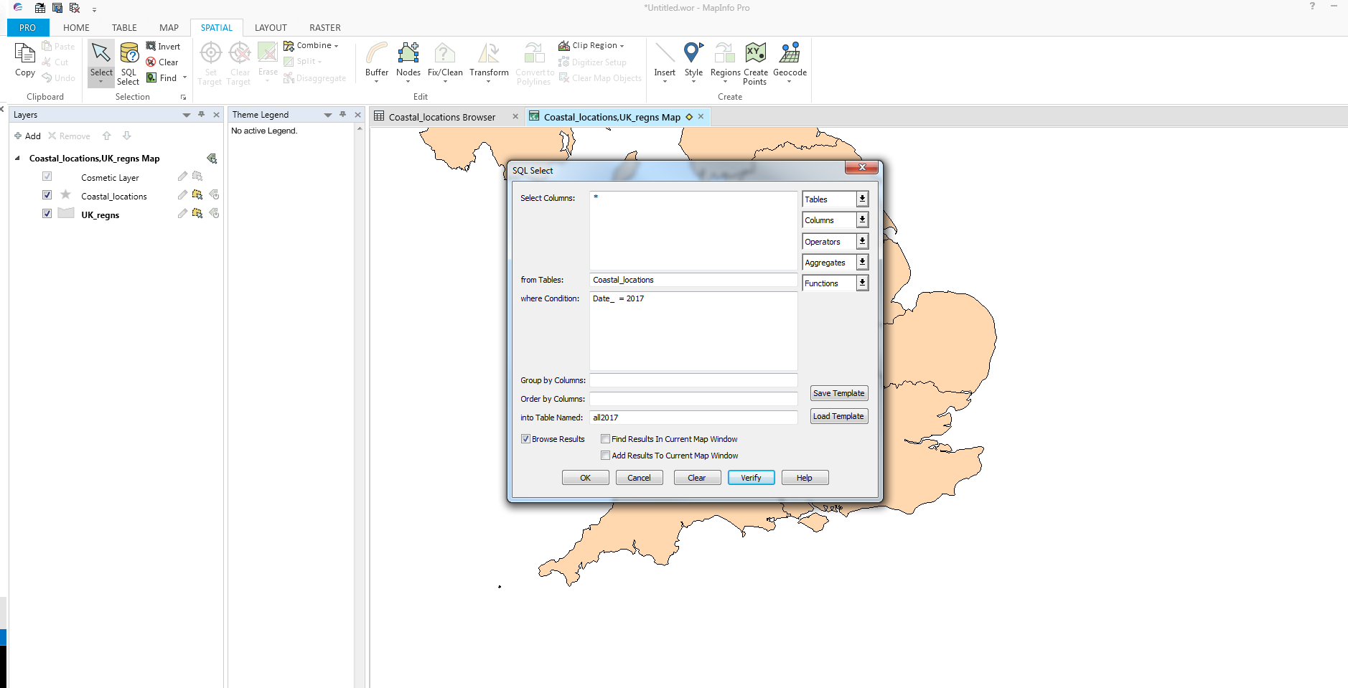

Once you have completed your query MapInfo will highlight the objects that match your choice. You will also have created a new browser window. Once you a happy with the contents of your query you could save it to another table and use it within the GIS or you can printout detail via the layout window and save this to a windows document or pdf file to use later with a report. The following screen shot shows the result of the query summer only data.

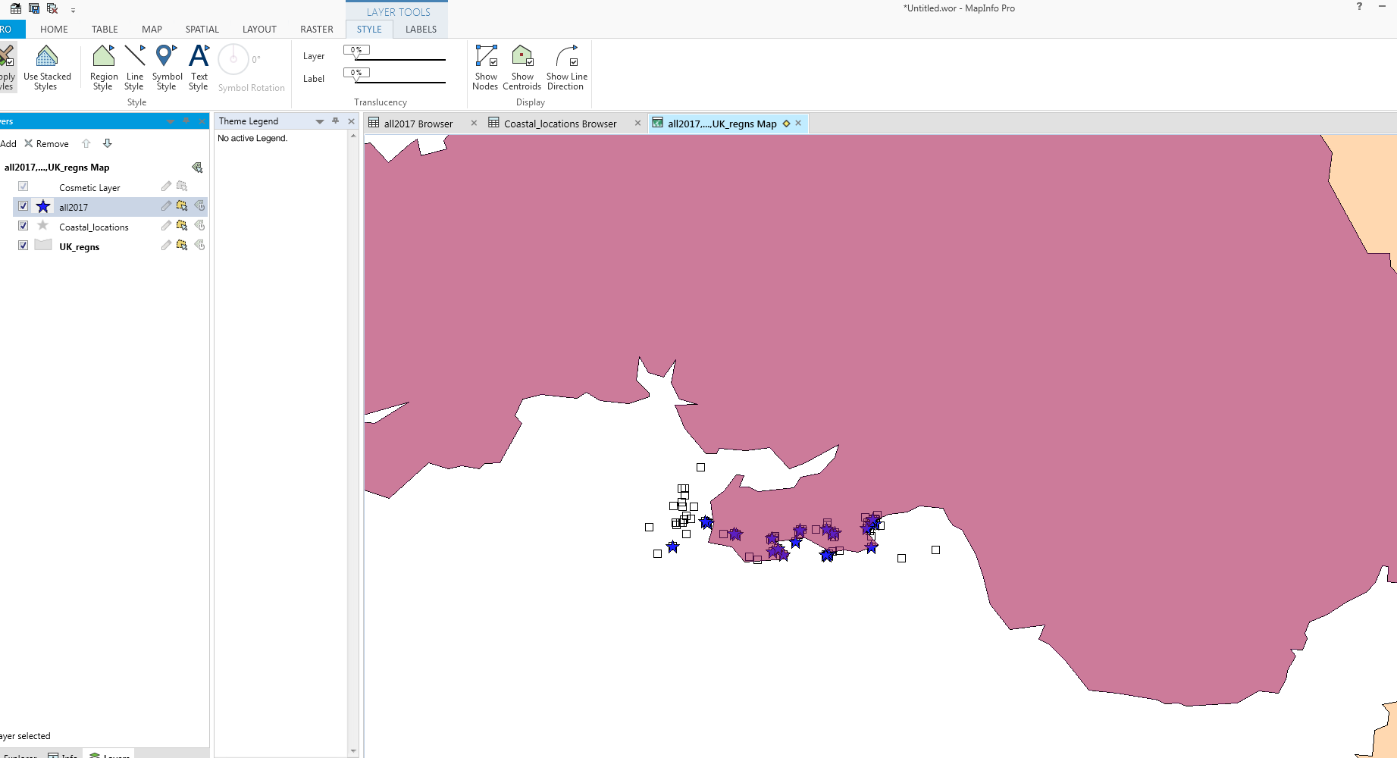

If you want to save your layout window in a documents for later use - build your layout window and then choose the file:print and select Microsoft office document image writer.
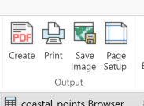
As you can see we can create a PDF of our layers save as an image or print to a file.

You can continue to build you GIS by looking at data from other sources and you could look for patterns in data. For example will the summer generate more waste?
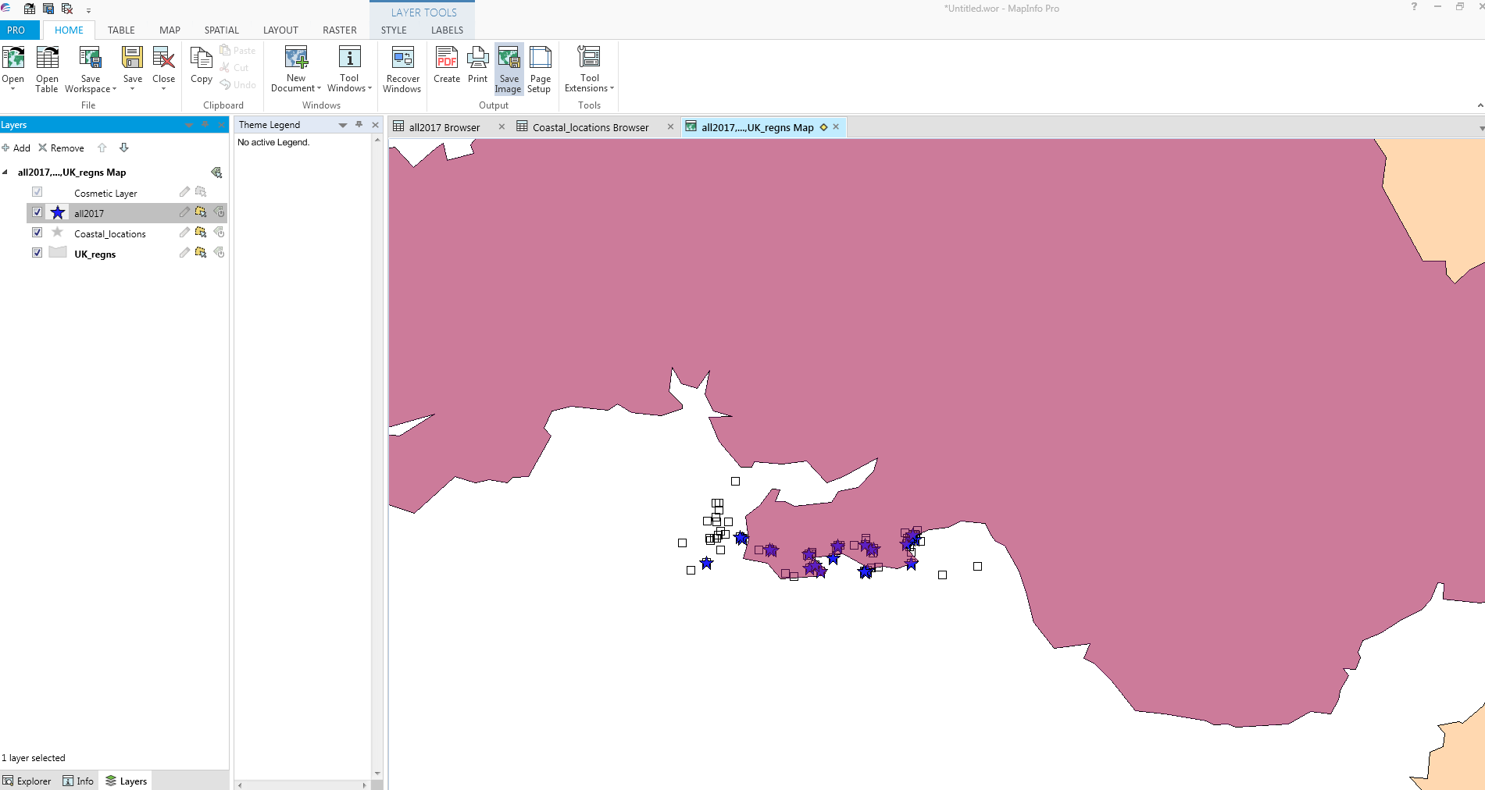
Later, we could add another layer of demographic data formed form UK data services census data sets or UK boundary maps. We could look at the data available from the OS map set in DIGIMAPS) do we find more litter near parks etc. Lots of questions to build up a study.

