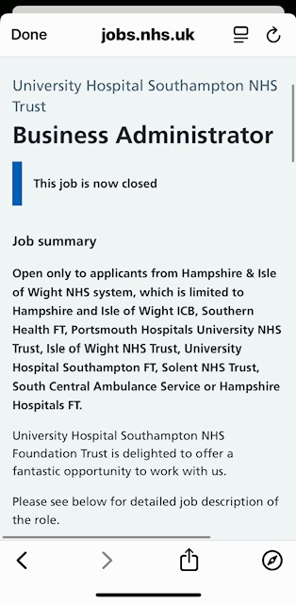

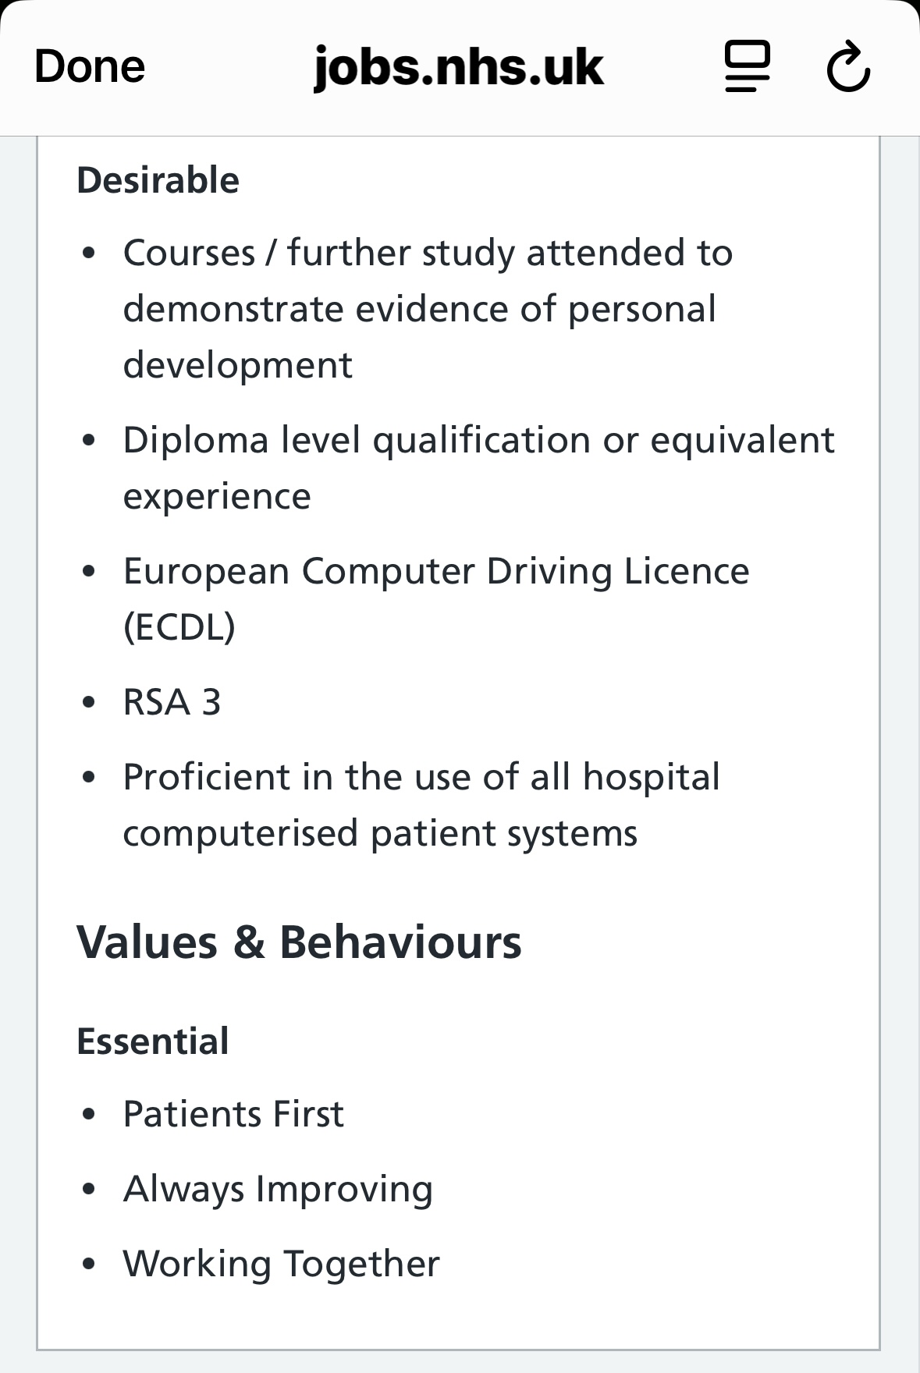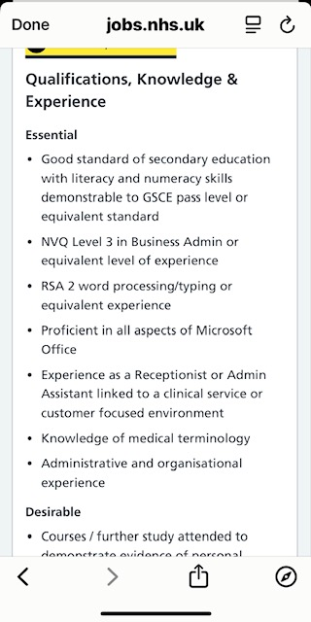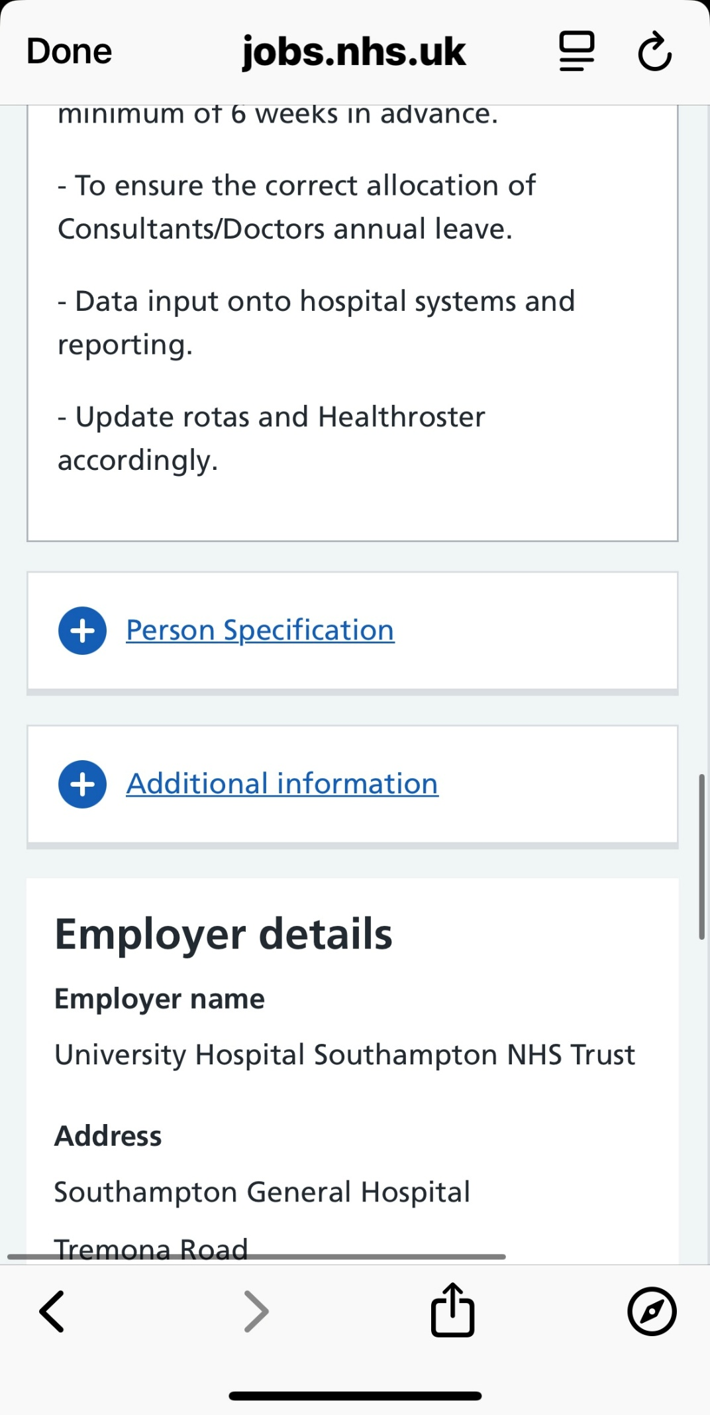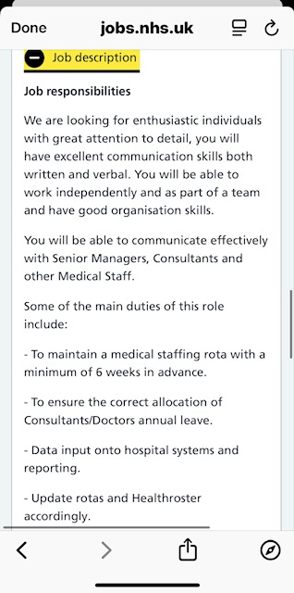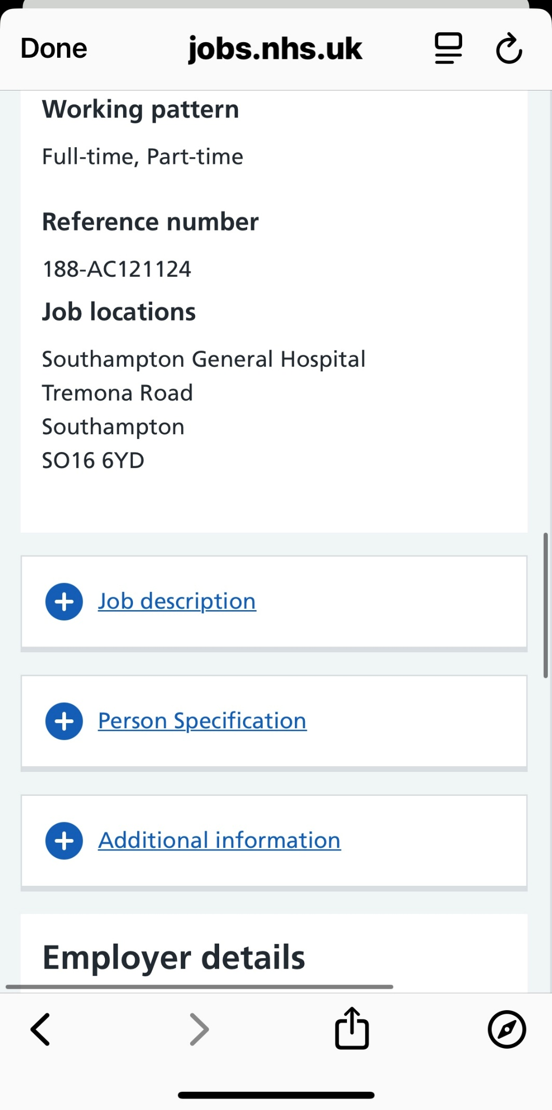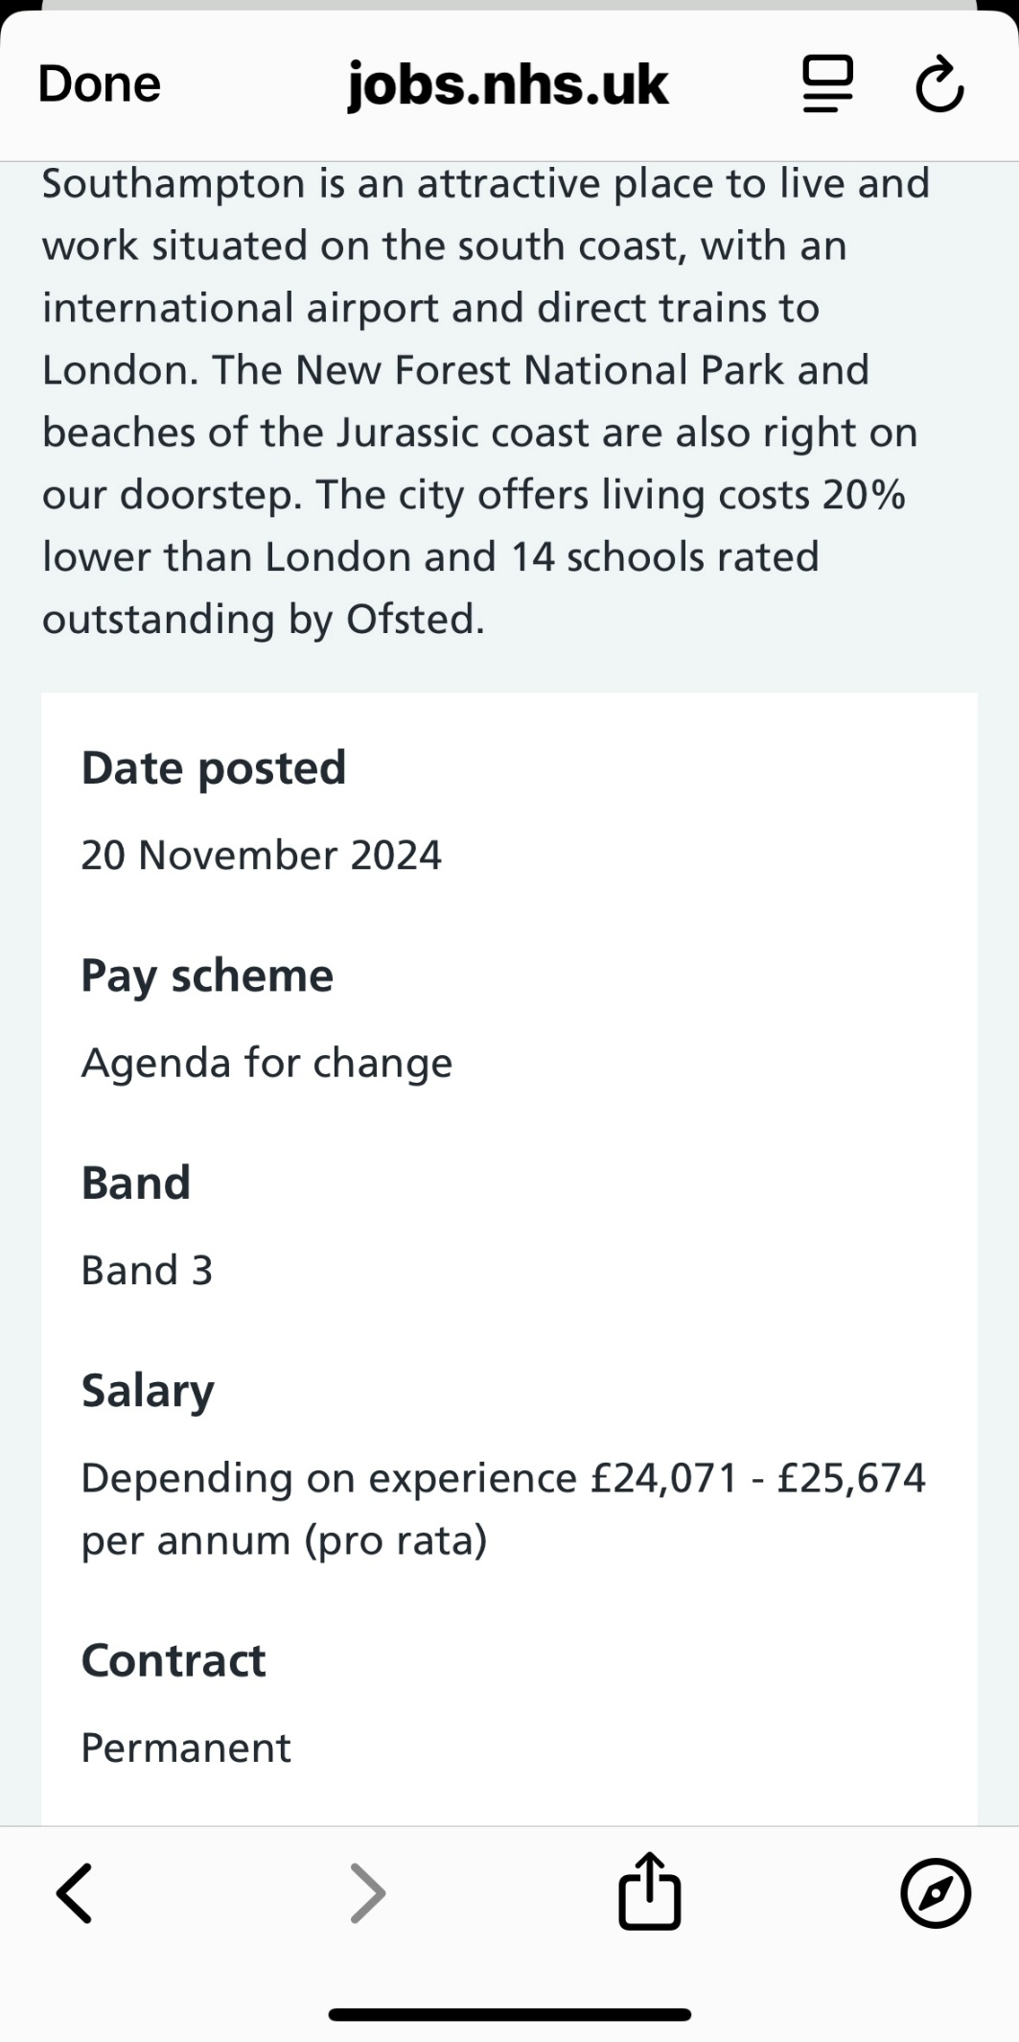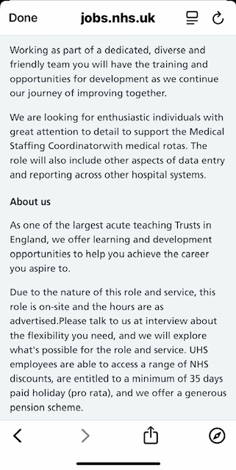

Cover Letter
Southampton General Hospital
Tremona Road
Southampton
SO16 6YD

Dear Sir/Madam,
I am writing to apply for the Business Administrator position. I have experience in
administration, customer service, and recruitment, which has helped me develop strong
organisational and communication skills. I work well under pressure, enjoy supporting
others, and take pride in keeping tasks running smoothly.
In my current role as a Learning Support Assistant, I help with classroom organisation,
record-keeping, and preparing documents for lessons. This has strengthened my attention
to detail and my ability to manage different tasks throughout the day. My previous
experience in recruitment and retail has also taught me how to handle paperwork, schedule
tasks, and support colleagues in a professional and friendly manner.
I hold a Level 2 Certificate in Principles of Business Administration, and I am currently
studying for a Level 4 Diploma in Business Skills for the Workplace. These qualifications
have improved my understanding of how businesses operate and how to support daily
office duties effectively.
I am a positive, organised, and hardworking person who enjoys learning new skills. I believe
I would make a valuable contribution to your team and would welcome the opportunity to
discuss my application further.

Yours faithfully,
Candidate ID: 2422378
Curriculum Vitae
Personal Profile
A motivated and detail-oriented professional with strong administrative, organisational,
and communication skills developed through experience in education, recruitment, and
customer service. Currently completing a Level 4 Diploma in Business Skills for the
Workplace and qualified in Principles of Business Administration (RQF). Confident
managing documentation, supporting daily operations, and maintaining professional
standards in busy office environments.
Key Skills
- Office administration and document management
- Very good at communicating with others and building positive relationships
- Able to stay organised and manage my time well
- Record keeping and database management
- Scheduling, diary and meeting coordination
- Team collaboration and leadership support
- Digital literacy: Microsoft Office, Canva, and online systems
- Problem-solving and conflict resolution
Employment and Administrative Experience
2024 – Present Learning Support Assistant – Educational Setting
Support pupils with additional learning needs and maintain accurate records. Assist
teachers with lesson preparation, documentation, and daily classroom administration.
Promote inclusion and ensure a positive and organised learning environment.
2023 – 2024 Maternity Leave
2022 – 2023 Resourcing Associate – Recruitment Agency
Managed candidate records in the Applicant Tracking System and maintained recruitment
databases. Prepared and sent correspondence to candidates and hiring managers.
Scheduled interviews, organised files, and assisted with performance reporting.
• 2021 – 2022 Senior Sales Assistant – Retail
Handled customer enquiries, processed transactions, and maintained stock records.
Supported store management with administrative and daily operational tasks.
2016 – 2020 Team Leader / Customer Service Assistant – Retail Food Outlet

Supervised staff rotas, managed inventory records, and processed financial reports.
Ensured compliance with company standards and handled documentation related to
operations.
2015 – 2016 Support Worker – Care Organisation
Completed daily reports, maintained confidential client records, and followed policies and
procedures. Assisted with staff handovers and ensured compliance with health and safety
requirements.
2015 Health Care Assistant – Residential Care Home
Supported residents with daily tasks while maintaining detailed documentation of care
activities.
2011 – 2014 Healthcare Assistant – Dementia Care Home
Recorded updates in care plans, communicated with colleagues, and ensured accurate
information sharing.
2007 – 2009 Retail Assistant – Supermarket
Handled cash, assisted with inventory tracking, and ensured accurate transaction records.
2009 – 2011 Parental Responsibilities
Education &amp; Training
Level 4 Diploma in Business Skills for the Workplace – In progress (2025 completion)
TQUK Level 2 Certificate in Principles of Business Administration (RQF) – 2023
Level 2 Certificate in Introduction to Cabin Crew – 2021
Level 2 Diploma in Travel and Tourism – 2017
GCSEs in core subjects including English and Mathematics
Hobbies & Interests
Cooking | Baking | Contemporary Dance | Creative Design | Small Business Development |
Professional Growth
References
Available upon request

