

STUDENT NAME: Jolanta Wiecaszek
STUDENT NUMBER: 1909652
MODULE TITLE: Managing People
MODULE CODE: LCBB5004
ASSIGNMENT TITLE: Assessment 2
MODULE LECTURER NAME: DR. Mushfiqur
Rahman

AGENDA

- INTRODUCTION

- METHODOLOGY

- FINDINGS/ RESULTS

- DISCUSSION

- CONCLUSSION

- REFERENCES

- INTRODUCTION

This report will talk about and surveys the idea and drivers of worker commitment. Assesses demonstrative instruments to gauge commitment . Builds a worker incentive from the thoughts and examination recently covered, including procedures to raise levels of commitment. This day, the corporation positioning is replacing comparable to the global epidemic. Person benefit supervisors are firmly grow imaginative, creative, and compelling speak to draw in the workers in additional advantageous path in this difficult time. Employee dedication is a working habitat nature that is following all follower of an alliance to give of their distinction regularly, committed to their unions intention and standards. Connections frequently recollect that officers who are all around engage with an corporation will cause planning in the work conditions, and this creates a bigger client trust and, completely, changes in trade in and interest in the organisation. (https://www.ncbi.nlm.nih.gov/pmc/articles/PMC7536939/)

- METHODOLOGY

In the present company situation in the course of pandemic, representative commitment realized one the peak of outstanding primacy for human asset administrators and professionals in union because of pandemic. The report is to decide the commitment of representatives by different organisations during pandemic. Associations these days are regularly generate talented and compelling intends to connect with the workers through this hard stretch. This report is an applied report that depends on different examination reports, articles, websites, online papers, and reports of World Health Organisation. During this pandemic circumstance, associations are advancing numerous commitment exercises like online family commitment rehearses, virtual learning and improvement, online group building exercises, online classes with industry specialists, online direct week after week arrangement meetings, group meet‐ups , online courses, thankfulness meetings, correspondence works out, live meetings for new‐skill preparing, internet advising meetings, acknowledgment and affirmation meeting, online courses managing uneasiness and stress, giving on the web direction to exercise and contemplation, social connections in a virtual office, study halls preparing modules carefully, e‐learning modules, and a lot more inventive learning meetings. (https://www.ncbi.nlm.nih.gov/pmc/articles/PMC7536939/)

- FINDINGS / RESULTS

Workers need remarks, learn and create and boost. Outfitting them with the points and course they need to show up by stock progressive analysis, will be significantly esteemed. Gratefulness and thankfulness mean quite a lot to representatives and genuinely compensating your gathering properly is what builds up a culture of appreciation among specialist and chief, finally animating your agents to continue locking in for you and the association. Imparting that agent's fulfilment is basic to you, on a specialist and individual level, is a significant verbalisation that will rouse their respect and keep them secured. placing assets into their continues with all over and not actually bustling operating would be profitable for everybody. In any connection, correlation is the answer. Agents go through the majority of their periods at duties so it's huge that they detect extraordinary with their chief and fulfilled in their tasks. Making and strengthening relations among people at work is fundamental for data imparting to the objective that associations can quickly respond to the current exceptional business condition. In such a situation of COVID-19 pandemic, both the representative and business are liable for keeping up congruity in connection. (https://www.johnfoundation.com/journals/sparkling/sijmrsv3i2-2020/s-31/)
There are a few obligations a business needs to focus on keep up worker connections in great state:

Regulating and guiding all corporation-related activities to ensure the prosperity and help of workers;

Propelling phone meetings for social affairs over the up close and personal get-togethers and making a feeling of belongingness among the representative.

Giving a protected working environment and legitimate resources for far off working that are orchestrated.

Arrange plans in the event of emergency and crises.
(https://www.johnfoundation.com/journals/sparkling/sijmrsv3i2-2020/s-31/)

Commitment information should be estimated extra cautiously—and likely in an unexpected way—given the fragile idea of the current pandemic and its financial wake. That may mean checking how individuals are feeling all the more habitually, or with more focused on inquiries.

Though you may typically gauge commitment every year, you'll presently need to change that rhythm to three-month spans or significantly more frequently. This will assist you with deciding if your ability will emerge from the decline stimulated, withdrew, or some place in the middle.

Nobody realises how long the social separating (and far off work) orders identified with COVID-19 will last, nor the genuine monetary effects. What we can be sure of is that drawn in workers are genuinely dedicated to your association's prosperity—and that will support your capacity to push ahead.

A few characters and work styles may change more promptly than others. The change can show from numerous points of view, including an inner mind strain to be "consistently on" that can prompt a totally different arrangement of concerns ( absence of equilibrium, and inevitable burnout).

So it turns into a matter of taking continuous temperature checks and ensuring efficiency—activities all the more handily handled if a sound culture is now set up.
(https://www.predictiveindex.com/blog/how-to-measure-engagement-during-a-crisis/)

Worker Value Proposition (EVP) is typically characterized as a bunch of financial and non-money related advantages gave by an association to its representatives, as a trade-off for the aptitudes, capacities, and experience they bring and the commitments they make to the association.
Representative Value Proposition is a biological system of help, acknowledgment, and qualities that a business gives to workers to accomplish their most noteworthy potential at work.

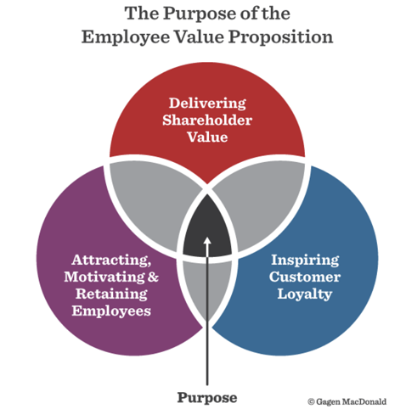
Source: Employee Value Proposition, Gagen MacDonald

(https://blog.smarp.com/6-steps-to-build-your-employees-value-proposition)

Boss marking is basic for an association to pull in top ability. Done in the proper way, an EVP provide a convincing response to the inquiry - Why an exceptionally skilled individual decide to work with us?
Planning an EVP that is novel to your association will impressively boost your ability obtaining and maintenance, giving you a business trade name that has an border over your rivals.
It provides ability the executives simple, regardless of whether you are attempting to pull in uninvolved applicants.

- DISCUSSION

Today, the business course of action is changing relating to the overall pandemic of COVID‐19. Human resource chiefs are continually progressing creative, inventive, and fruitful ways to deal with interface with the agents in a more valuable way during this inconvenient time. Delegate responsibility is a workplace attitude that is following all supporters of a relationship to give of their significance reliably, devoted toward their affiliation's targets and characteristics. Affiliations reliably review that delegates who are a lot of busy with an affiliation will incite productivity in the workplace, and this creates a higher customer devotion and, absolutely, enhancements in arrangements and advantage in the association . Mental states of weightiness, security, and accessibility are the three builds that assist commitment with creating in an association. Further examination recommends that in commitment, people utilise and communicate actually, psychologically, and genuinely in their job exhibitions. The intellectual aspect is related with convictions of pioneers, representatives, and workplaces. The enthusiastic feature implies representatives positive or negative mentality toward the association and the pioneers. Actual feature implies the actual power gave to achieve a hierarchical job.
(https://onlinelibrary.wiley.com/doi/full/10.1002/pa.25080).

Hierarchical culture can be impervious to change and building a culture of adaptability for the long haul is an excursion instead of a run. Shockingly, there can be negative generalisations related with adaptable laborers with research h recommending that adaptable specialists are frequently viewed as less dedicated, cause expanded work for other people and are more hard to oversee. Some association societies, preceding the COVID-19 episode, didn't loan themselves to adaptable working. For instance, numerous associations (and individuals administrators) judge individuals on their quality in the working environment. Different associations have an inclination for vis-à-vis gatherings, or had not embraced the innovation that would empower adaptability. A portion of the hindrances to adaptable working, both social and reasonable, have been tested by the new long stretches of home working. In any case, some will remain. Associations, and their HR offices should consider how they can make societies in which adaptable working can flourish.
The accompanying components of culture and exercises are regularly present in associations where adaptable working will be functioning admirably:

High trust.

Execution decided on results instead of essence and accessibility.

Accessibility of a scope of adaptable working alternatives.

Successful correspondence of adaptable working chances and progressing mindfulness raising exercises.

Adaptable turning out accessible for all representative gatherings on a fundamental level paying little mind to work job. Each solicitation is considered on its own benefits.

Strong senior pioneers including noticeable good examples.

Occupations publicised as reasonable for adaptable working.

Predictable utilisation of strategy – for instance guaranteeing all regions of the association adopts a comparative strategy to dynamic.

A significant level of comprehension across the association of the advantages of adaptable working.

Changing society implies evolving mentalities, convictions and practices. This isn't really a snappy cycle and will require steady exertion.
(https://www.cipd.co.uk/knowledge/fundamentals/relations/flexible-working/during-COVID-19-and-beyond)

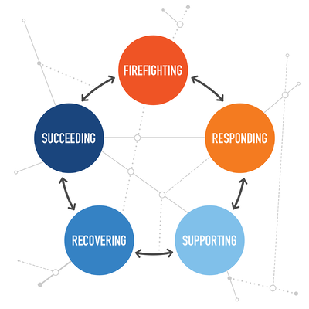

(https://www.quantumworkplace.com/en/engaging-employees-coronavirus-pandemic)

- CONCLUSSION

The COVID-19 pandemic has brought speedy moving and alarming elements, some of which existing crisis plans and gatherings weren't set up to manage. Various associations adequately made event the board plans unequivocal to this crisis, and are as of now looking forward.

What you can do now:

Hold your breaking point authoritative social event to start your reaction attempt in the short wake of the emergency - it can help as you progress into what's next. As you balance out and move around how to restore individuals to function, evaluate your association's reaction attempt to date and see areas for steady course changes. Look to what conclusive experiences the emergency cycle has given to help you key and experience the open door for occasion driven change. (https://www.pwc.com/gx/en/issues/crisis-solutions/covid-19.html)

Work from home isn't as basic all things considered apparently. That requires full responsibility towards work activities to perform well. The thought similarly demands to focus in on work schedule .There is a need as far as possible between the areas of home and work while following the idea of telecommuting. No questions, there are plentiful advantages to snatch by telecommuting. In any case, on similar side that places an individual in to a safe place which prompts lethargy and heaps of interruptions. Time the executives is another test to settle on. Work from home may make it less complex for representatives to counterbalance their work commitments with their own life and family occupations. A couple of affiliations grasp telecommute for natural reasons, as work from home can diminish blockage and air defilement, with less vehicles on the streets. Managers just as HR need to assume a urgent part in making a bond with the individuals under "Individuals interface 'idea and need to associate individuals from grass root level whom they have consistently disregarded The term has come to reconsider HR as a partner the board during COVID-19 period .they truly need to understand this reality truly that cash isn't everything except for to make a positive bond with them .So HR needs to perform various job with regards to individuals related. Skilling/Reskilling/Up-skilling – COVID period has made HR to reconsider on specific issues with respect to

persuading, moving and preparing and building up individuals and appropriation of an arrangement of conferring skilling (learning new abilities for being able in impending days, misfortune or difficulty or any emergency); up-skilling (learning current errands all the more profoundly); as this is the need of great importance to learn and see new innovation too as oversee connections to find a way into the changing situation and monetary scene. Individuals should be refreshed on innovation, plan thinking, investigation, narrating, and man-made consciousness and so on individuals at grass root level and working at lower profile are needed to be prepared on achieving their assignments and revealing about their improvements to their chiefs either by portable or some other stage. Along these lines, thusly, making individuals able also, multi-talented in an assortment of ways and improve their ranges of abilities. https://www.researchgate.net/profile/Meenakshi_Pandey8/publication/342011150_The_Impact_of_Pandemic_COVID_-19_in_Workplace/links/5ede65e892851cf13869888b/The-Impact-of-Pandemic-COVID-19-in-Workplace.pdf

- REFERENCES

https://www.ncbi.nlm.nih.gov/pmc/articles/PMC7536939/

https://www.johnfoundation.com/journals/sparkling/sijmrsv3i2-2020/s-31/

https://www.predictiveindex.com/blog/how-to-measure-engagement-during-a-crisis/

https://blog.smarp.com/6-steps-to-build-your-employees-value-proposition

(https://onlinelibrary.wiley.com/doi/full/10.1002/pa.25080

https://www.cipd.co.uk/knowledge/fundamentals/relations/flexible-working/during-COVID-19-and-beyond

https://www.pwc.com/gx/en/issues/crisis-solutions/covid-19.html

https://www.researchgate.net/profile/Meenakshi_Pandey8/publication/342011150_The_Impact_of_Pandemic_COVID_-19_in_Workplace/links/5ede65e892851cf13869888b/The-Impact-of-Pandemic-COVID-19-in-Workplace.pdf

https://www.gagenmacdonald.com/blog/are-you-ready-to-activate-an-employee-value-proposition/

https://www.quantumworkplace.com/en/engaging-employees-coronavirus-pandemic

