Ciprian Grosu Blog
Student Name: Ciprian Grosu Student Number: 2209375

Blog 1: Introduction to Project Management
Across industries, project management is critical to delivering successful outcomes. And, to discuss project management, it is important to understand the concept of a project. In the words of Schwalbe (2009), a project is a temporary endeavour with a clear beginning and end, undertaken to create a unique product, service, or result. This means that project management involves the structured use of processes, knowledge, skills, and tools to achieve specific outcomes within set time and budget limits (Kerzner, 2025). Unlike general management, which focuses on ongoing operations, Heagney (2016) states that project management is tailored to finite, often complex tasks that require clear direction and adaptability. To succeed, project managers rely on tools and methods to track progress, assign responsibilities, manage budgets, and identify potential risks (Richardson and Carstens, 2019). Depending on the project’s complexity and level of uncertainty, managers may apply predictive (traditional), adaptive (agile), or hybrid approaches. To support these methods, they use tools such as the Quad Chart, Gantt Chart, Work Breakdown Structure (WBS), the Iron Triangle, and a Stakeholder List (Celestin and Vanitha, 2017). These tools help ensure team alignment, enhance collaboration, and keep the project on course. In my next four blogs, I’ll share my direct involvement in various projects and how I’ve used these tools and approaches to strengthen my project management capabilities.

(Pexel, 2025)

-Reference List:
Celestin, M., & Vanitha, N. (2017). Beyond Gantt charts: Innovative tools every project manager should know. International Journal of Interdisciplinary Research in Arts and Humanities (IJIRAH), 2(2), 298-304.
Heagney, J. (2016). Fundamentals of project management. Amacom.
Kerzner, H. (2025). Project management: a systems approach to planning, scheduling, and controlling. John Wiley & Sons.
Richardson, G. L., & Carstens, D. S. (2019). Project management tools and techniques: A practical guide. CRC Press.
Schwalbe, K. (2009). Introduction to project management. Boston: Course Technology Cengage Learning.

Blog 2: Bucovina Project & Using Gantt-Chart
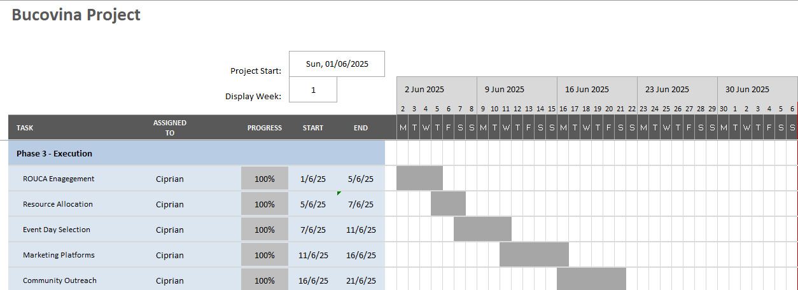
(Self-developed, 2025)
I was currently involved in the Bucovina Project, a group project dedicated to promoting my store, Bucovina, located in Newport, by donating traditional food products to the Romanian school ROUCA Cardiff to support their cultural initiatives. My team consisted of five members, and we chose WhatsApp as our main communication tool for its accessibility and ease of use. For project management, we relied on the Gantt chart. The Gantt chart is a tool developed by Henry Gantt (1861–1919), recognised as the father of planning and control techniques (Morris, 2011). Gantt charts are bar graphs used in project management to represent tasks over time. The length of each bar indicates how much time is allocated to each task (Bianconi, 2024). I was responsible for the Execution phase of the Bucovina Project. Using the Gantt chart allowed us to visualise our project timeline, track task completion, and stay aligned with our deadlines. One major benefit was the clarity it brought to our planning process. However, I also noticed a limitation. Gantt charts do not show task priority, which sometimes causes confusion about which activities need the most immediate attention. In my opinion, gantt charts are highly valuable tools for project managers because they support planning, track progress, and maintain communication with stakeholders (Maylor, 2001; Vasankari, 2024). While challenges may arise during the project, as Wadhwa (2024) stated, an experienced and well-prepared project manager can navigate these difficulties and continue to use the Gantt chart effectively.

Reference List:
Bianconi, F. (2024). Gantt Charts. In Data and Process Visualisation for Graphic Communication: A Hands-on Approach with Python (pp. 175-181). Cham: Springer Nature Switzerland.
Morris, P. W. (2011). A brief history of project management.
Maylor, H. (2001). Beyond the Gantt chart:: Project management moving on. European management journal, 19(1), 92-100.
Vasankari, P. (2024). The Effect of Project Communication and Project Performance: The Role of Detailed Gantt Chart in Substation Construction Project.
Wadhwa, K. (2024). The Role of Gantt Chart in the Project Management.

Blog 3: ActivityDo Project
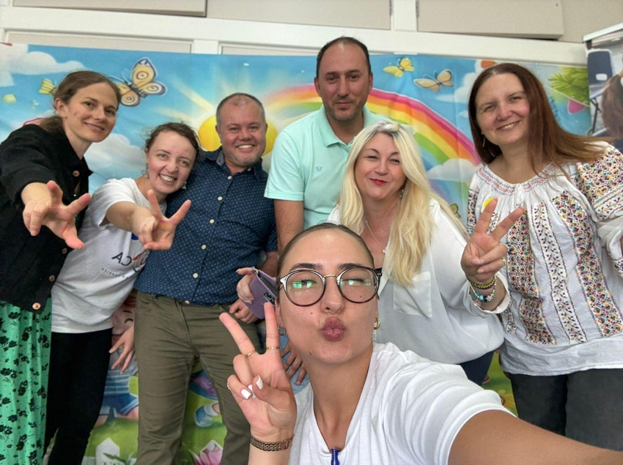
ActivityDo is a project launched by Emanuel, one of my business partners, and aims to positively impact underprivileged school children in Romania by raising funds to enhance their educational opportunities and well-being. Additionally, the project also extends support to teenagers facing serious financial and health challenges. I joined the project as a volunteer, eager to learn from Emanuel and gain hands-on experience in project management. One of the key things I observed was his use of an adaptive (Agile) method. Agile project management is a flexible, iterative approach that allows for rapid response to change, ongoing learning, and continuous collaboration (Hass, 2007; Highsmith, 2009). Rather than following a rigid plan, ActivityDo broke down its goals into smaller, achievable tasks (Cracknell, 1995). For example, one sprint involved raising £1000 to support a young adult undergoing cancer treatment, a goal that was met through community effort and transparent updates. In my opinion, this agile method proved essential because it allowed us to respond quickly to changing needs, deliver real impact in stages, and maintain motivation through visible progress. The transparency and flexibility of this approach helped build trust with donors and ensured that each small win contributed to a greater mission.

Reference List:
Cracknell, E. (1995). A small, achievable task. British Journal of Occupational Therapy, 58(8), 343-344.
Hass, K. B. (2007). The blending of traditional and agile project management. PM world today, 9(5), 1-8.
Highsmith, J. (2009). Agile project management: creating innovative products. Pearson education.

Blog 4: Adaptability as a Project Manager
Adaptability is the pillar of successful project management, especially in a world where uncertainty is the only constant (Levin, 2015; Heagney, 2016). As Schwalbe (2009) defines it, a project is a temporary endeavour designed to create a unique outcome, meaning that flexibility and adaptability are essential from start to finish. In my journey, I’ve come to appreciate how crucial adaptability is through real-life projects like the Bucovina Project and ActivityDo. While delivering the Bucovina project, we used a Gantt chart to track timelines and responsibilities. This tool brought great clarity, but I also discovered its limitation that it doesn’t show task priority. That’s where being adaptable made the difference because we adjusted plans on the go to help us stay focused on our goal (Bateson, 2017). In contrast, volunteering with ActivityDo exposed me to Agile methods. Watching Emanuel break down goals into sprints and respond to emerging challenges in real time showed me how adaptable project management can drive meaningful impact, especially in community-led initiatives. In my opinion, whether I am using a predictive or adaptive method, or blending both, success depends on how we respond to change, meaning that tools like the Gantt chart or Agile sprints are only as effective as the mindset behind them, and being adaptable is what keeps the project moving, growing, and delivering real value.

Reference List:
Bateson, P. (2017). Adaptability and evolution. Interface Focus, 7(5), 20160126.
Levin, H. M. (2015). The importance of adaptability for the 21st century. Society, 52(2),
36-141.
Heagney, J. (2016). Fundamentals of project management. Amacom.
Schwalbe, K. (2009). Introduction to project management. Boston: Course Technology Cengage Learning.

Blog 5: Evaluation of Project Management Skills

Through my involvement in the Bucovina Project and ActivityDo, I developed core project management skills, particularly adaptability, communication, and task coordination. In the Bucovina Project (read blog 2), I led the Execution phase using a Gantt chart to plan and monitor progress. This improved my planning and time management skills. However, I also encountered the chart’s limitations in conveying task priorities. Navigating this taught me to think critically, evaluate workloads, and communicate priorities more effectively with my team. With ActivityDo (read blog 3), I was introduced to Agile methods. Observing my business partner’s leadership taught me the value of flexibility, rapid iteration, and community engagement. I learned to break down objectives into manageable tasks and adapt based on real-time feedback. Skills essential in today’s fast-changing environments. While I’ve become more confident leading in both structured and agile contexts, I recognise the need to further develop my strategic thinking and stakeholder engagement, especially under pressure. Therefore, to improve on this, I set the following goals:
- My first goal is to lead a small-scale hybrid project by March 2026, blending predictive and adaptive approaches.
- My second goal is to join a mentorship programme by 30th November 2025 to improve my leadership and stakeholder management.
- My third goal is to establish a monthly reflection habit to track lessons learned and drive ongoing personal and professional development.

