

Student Name:Arbraj Mustufa Shaikh
Student ID:2534455
Module Name: Marketing Management

Module Code: LCMB7024

Lecturer’s Name: Haoran Liu

Work Count: 2577

Term 1

Table of Contents
Introduction 3
1. Task 1: Marketing Environment Analysis 3
1.1 Company Selection and Context 3
1.2 External Marketing Environment Actor 1: The Natural Environment 4
1.2.1 Carbon Regulation and Pricing 4
1.2.2 Resource Demand and Supply-Chain Pressure 5
1.2.3 Biodiversity and Land-Use Impacts 5
1.3 External Marketing Environment Actor 2: The Technological Environment 5
2. Task 2: Strategic Growth and Competitive Positioning 7
2.1 Strategic Growth Recommendation Using the Ansoff Matrix 7
2.1.1 Justification: Diversification via Jansen 8
2.1.2 Linking Diversification to Environmental Pressures 9
2.2 Competitive Advantage Through a Lower-Carbon Business Model 9
2.2.1 Differentiation as the Primary Strategy 11
2.2.2 Retaining Cost Leadership Where Appropriate 11
3. Task 3: Critical Reflection on AI Usage 12
3.1 Tool Disclosure 12
3.2 Critical Evaluation of AI Output 12
3.3 Contribution Analysis 13
3.4 Ethical and Professional Reflection 13
Reference List 14

Introduction
This report analyzes the external marketing environment and strategic growth opportunities of the BHP, one of the largest marketing companies in the world which is in an industry that is becoming more complex and sustainability driven in the global marketplace. It analyzes the environmental and technological forces in relation to influential impacts on the strategic choices, the competitive positioning and the long-term performance of BHP. In the report, the authors use the concept of the existing strategic frameworks (Ansoff Matrix) and Porters Generic Strategies and recommend the approaches to growth and competition which are relevant to the current market conditions and conditions. Lastly, it gives critical reflection on the accountable use of artificial intelligence in the preparation of the report based on its contribution, limitations, verifications and the ethical implications of the professional marketing practice.

1. Task 1: Marketing Environment Analysis

1.1 Company Selection and Context
BHP Billiton Ltd. is a major Australian multinational mining corporation, recognized for its extensive production of a variety of natural resources, including iron ore, coal, oil, natural gas, and uranium. Formed in 2001 through the merger of the Australian company Broken Hill Proprietary Company (BHP) and the Anglo-Dutch Billiton mining company, BHP Billiton quickly ascended to become one of the largest producers in the global natural resources sector. It ranks among the largest mining companies in the world by market capitalisation, supplying the commodities that underpin conventional steelmaking and the infrastructure required for global electrification (BHP, 2026a). The company has established a sustainable course of work, and its company has a Climate Transition Action Plan that mandates the creation of medium-term abatement ambitions and long-term net zero target of its operation and value-chain emissions (BHP, 2026b). This makes BHP not only a mere supplier of extractive commodities, but an active stakeholder in the global energy transition, which is constantly externally remade under the pressure of its external marketing environment,.

1.2 External Marketing Environment Actor 1: The Natural Environment
The natural environment which functions with three mutually reinforcing pressures works as the most significant outside influence that shaped the strategic path of BHP: regulation of carbon, resources and supply chain scarcity and effect of biodiversity.

1.2.1 Carbon Regulation and Pricing
New carbon-pricing regimes are reshaping cost structures across the mining sector. Ulrich, Trench and Hagemann (2022) illustrate that a hypothetical price of US$100 on a ton of CO2-equivalent would disproportionately increase the average production costs across jurisdictions, this means operations running on carbon-intensive electricity face a direct erosion of margin as carbon-pricing regimes tighten, which strengthens the commercial case for BHP to prioritise renewable power procurement. Meanwhile, the Broken Hill Proprietary Company (BHP) was founded in 1885 in Melbourne, Australia. The mining company discovered, harvested, developed, produced, and globally distributed various metals and other natural resources such as natural gas. This risk is significant enough that BHP's own disclosures classify the low-carbon transition as a major enterprise risk requiring board-level oversight (BHP, 2026c).
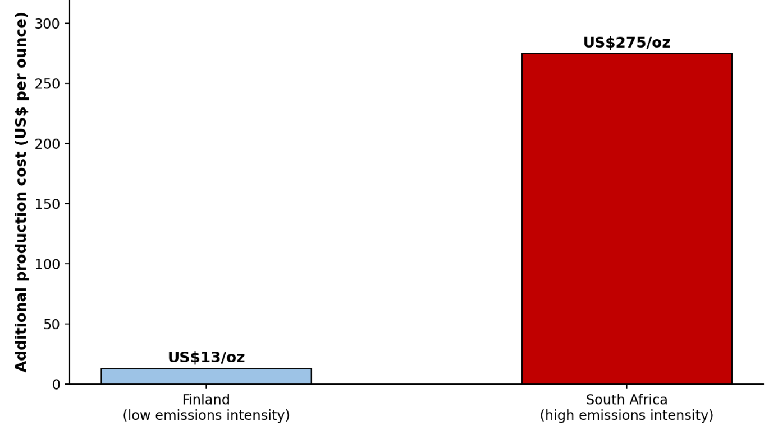
Figure 1: Impact of a Hypothetical US$100/t CO2-e Carbon Price on Gold Production Costs
(Source: Ulrich, Trench and Hagemann, 2022)

1.2.2 Resource Demand and Supply-Chain Pressure
The hottest commodity is the transition metals as increasingly more is electrified. Islamic et al. (2025) state that the lithium, nickel and cobalt producers are being pressured to disclose and reduce the value-chain emissions, and most prominent in nickel production rather than lithium production is carbon capture. The later 2010s showed BHP Billiton experiencing financial slumps as the corporation endeavored to increase production while reducing costs. Despite these difficulties, however, BHP Billiton continued to accrue billions of dollars a year in revenues, figures that solidified its position as one of the world’s largest and most successful producers of natural resources.

1.2.3 Biodiversity and Land-Use Impacts
The consequence of mining on the use of land is adverse in biodiversity and is a growing regulatory and reputational risk. In 2015, the Fundão Dam in Brazil collapsed, leading to a lawsuit. Over 620,000 individuals sought damages of $47 billion from BHP and its co-partner Vale for allegedly causing the collapse by dumping toxic waste into the Doce River. In 2024, Samarco, BHP, Vale, and Brazilian public authorities reached a settlement providing nearly $32 billion for reparations related to the Fundão dam failure, though this Brazilian settlement did not end the parallel litigation in London. In 2025 the UK Court ruled that BHP was liable for the collapse, though the battle on the final amount of compensation continues in 2026. This is a risk, through stricter environmental impact assessment provisions, and a possibility, as authentic biodiversity stewardship can help distinguish BHP to an increasingly ESG-aware stockholder and clientele (SRK Consulting, 2023).

1.3 External Marketing Environment Actor 2: The Technological Environment
1.3.1 Overview of the Technological Environment
A key external marketing environment actor that will impact the long-run competitiveness of BHP is the technological environment. The increased automation, artificial intelligence, digital analytics, robotics and data-driven mining operations are transforming how mining companies can optimize their operations and simultaneously meet expectations placed on them by the environment and stakeholders. This player is especially applicable since involvement of technological innovation would assist BHP in responding to the growing sustainability demands with less hazardous, more effective, and less emitting operations. And later, in mining sector globally, the technology capability has come out as a considerable variable that can lead organisational performance.
1.3.2 Opportunities Created by Technological Innovation
The opportunities that technological innovations offer are noteworthy in the light of being able to be more productive and enhance sustainability performance at BHP. According to Onifade et al. (2023), how digital technologies have improved exploration, fleet management, and environmental monitoring during mining operations is that it minimised the contribution of human error, improving the precision of operation and a step towards an efficient use of resources. The innovations will allow BHP to decentralize implementations of autonomous haulage systems, predictive maintenance and real-time emissions control, and increase operational efficiency and reduce environmental impact. Such technological investments also play a key role in solidifying environmental, social and governance (ESG) performance.
1.3.3 Technological Risks and Strategic Implications
Simultaneously with these opportunities, there are several strategic risks that technological change poses, which must be handled with utmost care. According to Codoceo-Contreras, Rybak and Hassall (2024), the automation of mining may result in interoperability issues, workers being displaced, and cyber threats across digitally linked operations. In the case of BHP, the deployment of sophisticated technology involves a significant capital outlay, as well as thorough reskilling of the workforce and an effective stakeholder marketing campaign to reduce opposition in mining circles. The impact of such technological risks experienced, lack of which leadership, could reduce the efficiency of its implementation; undermine organisational resilience.
Taken together, these opportunities and risks show that BHP's technological transition is not simply a matter of adopting new tools, but of managing the trade-off between the operational efficiency gains from automation and the workforce and community relationships on which its social licence to operate depends. How BHP balances this trade-off has a direct bearing on its competitive position, which is examined next in Task 2.

2. Task 2: Strategic Growth and Competitive Positioning

2.1 Strategic Growth Recommendation Using the Ansoff Matrix
According to the environment pressures, which were established in Task 1, the best growth direction of BHP is assessed with the help of the Ansoff Matrix. Table 1 specifies the four quadrants and uses them to explain the current strategic choice of BHP.
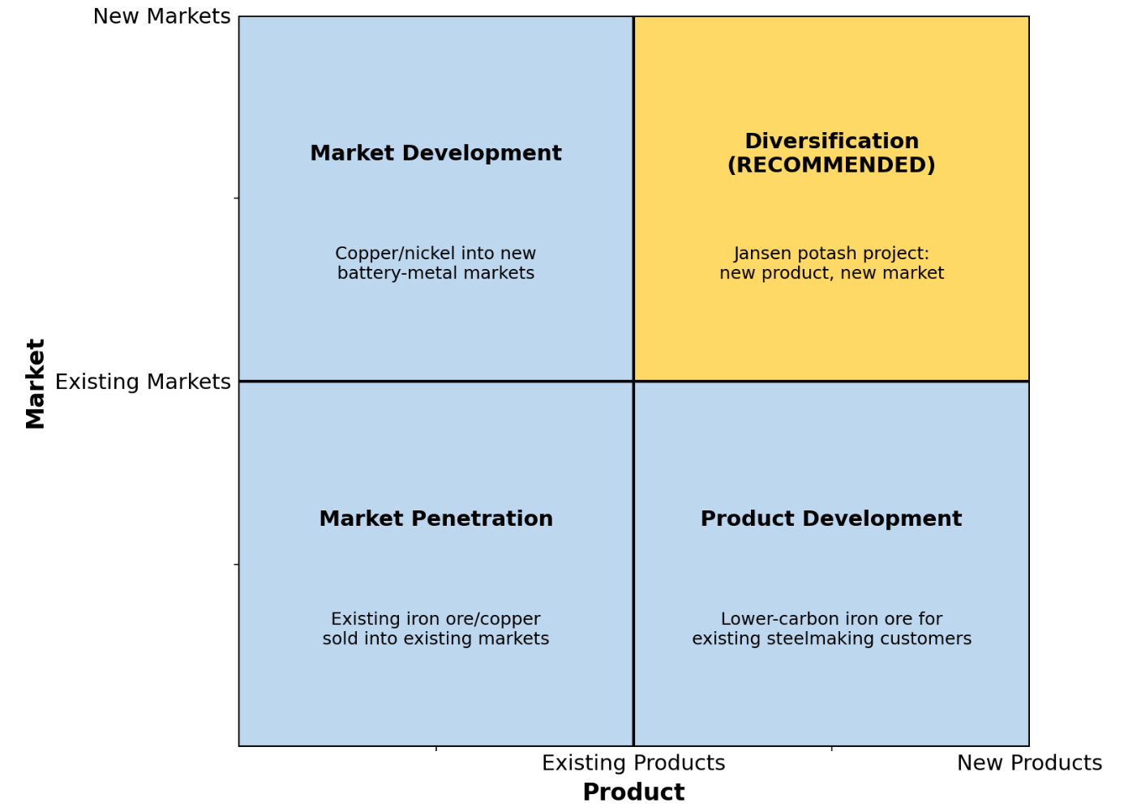
Figure 1: Ansoff Matrix Applied to BHP
(Source: Created by Author)
Quadrant | Description | Relevance to BHP
Market Penetration | Existing products sold more intensively in existing markets | Limited relevance; iron ore and copper markets are mature and largely committed under long-term contracts
Market Development | Existing products introduced to new markets | Partially relevant to growing Asian battery-metals demand for copper and nickel
Product Development | New products developed for existing markets | Reflected in lower-carbon iron ore initiatives for existing steelmaking customers
Diversification | New products developed for new markets | Recommended quadrant: the Jansen potash project moves BHP into fertilizer and agricultural end-markets entirely outside its traditional steelmaking and battery-metals customer base
Table 1: Ansoff Matrix Applied to BHP
(Source: Created by Author)

2.1.1 Justification: Diversification via Jansen
Diversification is the best strategic course of action that BHP can take under the Ansoff Matrix since the company is setting into a new type of product and different customer base. The Jansen Potash Project in Saskatchewan is a massive long-term project with approximately US10.6 billion, which will enable BHP enter the global fertilizer market producing potash, rather than continuing to produce the conventional product of iron ore, copper and metallurgical coal (Discovery Alert, 2026). This expansion targets the agricultural producers and fertilizer making companies and this constitutes an entirely new customer base than the current mining markets of BHP. The strategy is a true diversification in the Ansoff Matrix since the product and market both are novel to the organisation; this will help it grow in the long term, whilst minimizing the fluctuations of cyclically driven demand in the established commodity markets.

2.1.2 Linking Diversification to Environmental Pressures
BHP became a potash company that directly addresses the environmental stress found in the Task 1 setting - mitigating their exposure to some of the commodities becoming more susceptible to carbon risks and growing in regulations. Having spread its investment portfolio beyond iron ore and metallurgical coal helps to cover its risk of the carbon market, the impact on biodiversity, as well as various policy shifts and climate impacts, which have occurred and impacted traditional mining activities. The reconfiguration of investment, and long-term competitiveness, decisions brought about by environmental regulation more generally is noted by other authors, notably by Ulrich, Trench and Hagemann (2022) andCabernard and Pfister (2022).
But for other academics, diversification is no simple risk-reduction exercise: Jansen will keep having cost pressures due to carbon over some years after the lead-in time for multi-year construction; BHP's key products remain the real carbon “exposures“ for several years in the future. On the contrary, potash has been an ingredient in boosting agricultural productivity and food security in the world with the demand largely being attributed to the increase in population than the carbon consuming industrial production. In this regard, the Jansen project brings sustainability to BHP in the long-term, thanks to its better balance of commodities that are more likely to remain viable in the future, in the face of possible risks to the environment and the market (Discovery Alert: 2026).

2.2 Competitive Advantage Through a Lower-Carbon Business Model
The concept of sustainable competitive advantage as the process of transforming BHP into a lower-carbon model would be addressed in the context of the Porters Generic Strategies, discussed in Islami, Mustafa and Topuzovska Latkovikj, (2020). Table 2 defines the three generic strategies and how they apply to BHP.
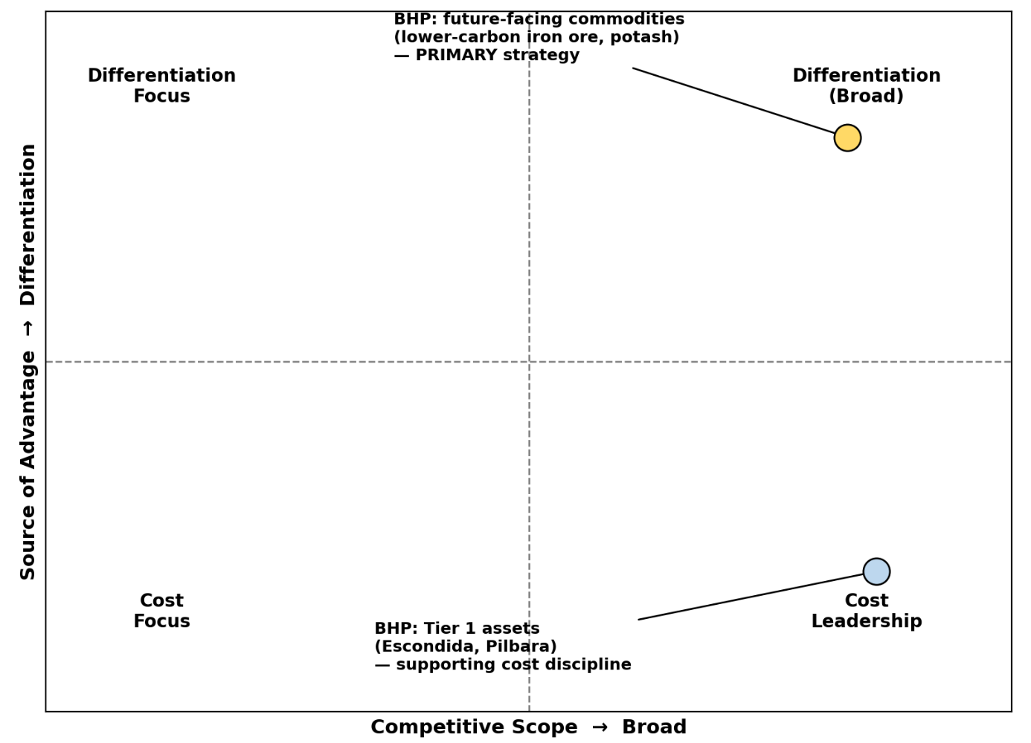
Figure 2: Porter's Generic Strategies Applied to BHP
(Source: Created by Author)
Generic strategy | Core logic | Application to BHP
Cost leadership | Competing to be the lowest-cost producer in the industry | Retained at Tier 1 assets such as Escondida and the Pilbara, supporting resilience through commodity price cycles
Differentiation | Compete by offering a product perceived as unique or superior | Recommended primary strategy: lower-carbon iron ore and copper positioned to steelmakers and OEMs pursuing their own emissions targets
Focus | Compete within a narrow segment via cost or differentiation | Limited fit given BHP's scale and diversified commodity portfolio
Table 2: Porter's Generic Strategies Applied to BHP
(Source: Created by Author)

2.2.1 Differentiation as the Primary Strategy
One of the diversification strategies that BHP holds as a priority is to introduce itself as a market leader provider of the low-carbon and responsibility produced minerals. On that note, McKinsey (2020) reports that the market is becoming more in demand with carbon-neutral metals, which is indicative that only customers in the industrial sector are currently more than willing to pay high prices on verifiable low-emission raw materials. Such a strategic course will allow BHP to compete based on values and not on price, improving their environmental, social and governance (ESG) reputation. Also, Islamic, Mustafa and Topuzovska Latkovikj (2020) found that differentiation strategies generate high-quality organisational performance as opposed to cost leadership or focus strategy on most industries. Realising this advantage in practice will, however, require BHP to invest in independent third-party verification of its emissions data, since differentiation claims that cannot be substantiated risk being dismissed as greenwashing by increasingly sceptical industrial buyers.

2.2.2 Retaining Cost Leadership Where Appropriate
Although the most relevant competitive advantage of BHP is differentiation, cost leadership is also undertaking a strategic part in the company in established operations. This recommendation is based on the natural-environment analysis in Task 1: because the same extent of regulatory and reputational pressure has been applied to Tier-1 assets, such as Escondida and the Pilbara, the cost leadership maintenance in the US will still be required and thus provide BHP with the ability to fund capital-intensive transition to other differentiation forms without compromising on near term profitability.
The Escondida and Pilbara iron ore field mining activities qualifies as mining resources at Tier-1 scale which is highly productive in mining continuing to generate the economy of scale, efficient operation and comparatively low unit operating cost in the mines that render BHP competitive even in a scenario where prices of the commodities are volatile (BHP, 2026a). The high cost discipline improves profitability and financial capacity by reducing the cost of activities and providing the financial capability to invest in both innovation and sustainability activities. Similarly, Islamic, Mustafa and Topuzovska Latkovikj (2020) caution that by aiming to differentiate and simultaneously attain cost leadership, organisations are doomed to be slowed down and become less strategic.

3. Task 3: Critical Reflection on AI Usage

3.1 Tool Disclosure
To develop this report, an AI-based language model (Claude) was used in three stages, i.e., the structure of the marketing environment and strategic expansion sections rather than in the assessment brief, the finding and synthesis of viable sources of information regarding the sustainability position of BHP and academic frameworks that would support the details of the circumstances under which the Ansoff Matrix and Porters Generic Strategies tables were to be used. The tool was not used to derive the final analytical judgements in Sections 1 and 2 with independent verification.

3.2 Critical Evaluation of AI Output
The AI-generated content was checked in three manners. Firstly, the onus was not put on the face of what factual claims about BHP had to say, but cross- verifying such claims through company and third-party industry reports disclosures. Second, the tool verified any scholarly sources that were suggested or summarized against their original information of publication including the names of the authors, the name of the journal and the year of publication to make sure that they were genuine and credited. Third, the overall argumentation structure was considered against the criteria of evaluation to conclude that the decisions were made not on the AI output, but on the arguments per se. This way of verification is justified by Kofinas, Tsay and Pike (2025) who state that the implementation of criteria-based evaluation activities contributes to the increase in the difficulty of relevancy of AI-created content instead of real knowledge.

3.3 Contribution Analysis
The AI assistant aided in the organization of the report, locating the sources of candidates, and creating the initial versions of the explanatory texts. The technological environment decision as the second external force, the rationality of diversification via the Jansen project as opposed to diversification in another Ansoff quadrant, and the idea that the first differentiation followed by an emphasis on cost leadership are all the original critical analysis. According to Bittle and El-Gayar, meaningful contribution analysis will also demand that students differentiate between AI-assisted drafting and independent judgement as opposed to the latter presenting AI output in a non-reflective manner i.e. the strategy here.

3.4 Ethical and Professional Reflection
Applications of AI in this manner pose real ethical concerns. Some of the risks of over-reliance are the degradation of important analytical abilities, and that AI-only created summaries may have undetectable concealed biases or errors that cannot be easily identified without bearing specifically to the field. Even though in most situations the application of AI is difficult to point out at the time of marking, there is still a professional obligation to disclose the type of disclosure provided in Section 3.1. The lesson to a future marketer in this experience is that AI tools must be used to assist rather than to interfere with professional judgment, particularly where the result of the analysis is a commercially/ reputationally sensitive decision. The key implication to practising marketers is that such assertions of plausible difference in the extractive sectors hinge more on the verifiable evidence particularly independently guaranteed and assured information on emissions than those asserted through promotional messages.

Reference List
Bittle, K. and El-Gayar, O. (2025) 'Generative AI and academic integrity in higher education: A systematic review and research agenda', Information, 16(4), Article 296. Available at: https://www.mdpi.com/2078-2489/16/4/296 (Accessed: 7 July 2026).
BHP (2026a) Sustainability approach. Available at: https://www.bhp.com/sustainability/approach (Accessed: 7 July 2026).
BHP (2026b) Climate Transition Action Plan. Available at: https://www.bhp.com/sustainability/climate-change/climate-transition-action-plan (Accessed: 7 July 2026).
BHP (2026c) Form 6-K, filed with the U.S. Securities and Exchange Commission. Available at: https://www.sec.gov/Archives/edgar/data/0000811809/000119312526052851/d104139d6k.htm (Accessed: 7 July 2026).
Cabernard, L. and Pfister, S. (2022) 'Hotspots of mining-related biodiversity loss in global supply chains and the potential for reduction through renewable electricity', Environmental Science & Technology, 56(22), pp.16357–16368. Available at: https://pubs.acs.org/doi/10.1021/acs.est.2c04003 (Accessed: 7 July 2026).
Codoceo-Contreras, L., Rybak, N. and Hassall, M. (2024) 'Exploring the impacts of automation in the mining industry: A systematic review using natural language processing', Mining Technology, 133(3), pp.191–213. Available at: https://journals.sagepub.com/doi/10.1177/25726668241270486 (Accessed: 7 July 2026).
Discovery Alert (2026) BHP's Jansen Potash Project: Saskatchewan's $10.6 billion mining investment. Available at: https://discoveryalert.com.au/news/bhp-jansen-potash-project-saskatchewan-2025/ (Accessed: 7 July 2026).
Islami, M.S., Urmee, T., Lund, C., Bahri, P.A. and Anisuzzaman, M. (2025) 'Decarbonisation strategies for critical mineral supply chain: State-of-art in mining and refining industries', Renewable and Sustainable Energy Reviews, 218. Available at: https://www.sciencedirect.com/science/article/pii/S1364032125004848 (Accessed: 7 July 2026).
Islami, X., Mustafa, N. and Topuzovska Latkovikj, M. (2020) 'Linking Porter's generic strategies to firm performance', Future Business Journal, 6(1), pp.1–15. Available at: https://link.springer.com/article/10.1186/s43093-020-0009-1 (Accessed: 7 July 2026).
Kofinas, A.K., Tsay, C.H-H. and Pike, D. (2025) 'The impact of generative AI on academic integrity of authentic assessments within a higher education context', British Journal of Educational Technology, 56(6), pp.2522–2549. Available at: https://bera-journals.onlinelibrary.wiley.com/doi/10.1111/bjet.13585 (Accessed: 7 July 2026).
McKinsey & Company (2020) Climate risk and decarbonization: What every mining CEO needs to know. Available at: https://www.mckinsey.com/capabilities/sustainability/our-insights/climate-risk-and-decarbonization-what-every-mining-ceo-needs-to-know (Accessed: 7 July 2026).
Onifade, M., Adebisi, J.A., Shivute, A.P. and Genc, B. (2023) 'Challenges and applications of digital technology in the mineral industry', Resources Policy, 85(Part B), Article 103978. Available at: https://www.sciencedirect.com/science/article/abs/pii/S030142072300689X (Accessed: 7 July 2026).
SRK Consulting (2023) Counting the cost of carbon. Available at: https://www.srk.com/en/publications/counting-the-cost-of-carbon (Accessed: 7 July 2026).
Ulrich, S., Trench, A. and Hagemann, S. (2022) 'Gold mining greenhouse gas emissions, abatement measures, and the impact of a carbon price', Journal of Cleaner Production, 340, Article 130851. Available at: https://www.sciencedirect.com/science/article/pii/S0959652622004899 (Accessed: 7 July 2026).

