How has crime photography and evidence changed?
Eden Jones
Beginning
Answering the question of “how has crime photography and evidence has changed?” This proposal states what aspects I plan to research in detail for my dissertation. Looking in to the history of technology, the justice system and of course my practice of photography but in the crime realm. I will have to intensively research in to history was that’s the main bulk on my question. I plan to break it up in to three sections, crime photography, photographers and system and evidence. Investigate each one, including research to see how much crime photography has change and that effect on our system.

Crime photography
Crime photography is a documentation of a crime that could be the crime, possible evidence, irregularities within the scene, every little detail down to the body, its marks and so on. Unfortunately, murder has been round since the beginning of time, and therefore crime scenes. There are many reasons as to why people murdered from religious reasons to other beliefs and even some gaining a sexual profit. There have been many famous murders who have committed some horrid crimes such as Ed Gein who killed only two people but dig up the deceased and used their skin to make a human suit. His crimes were made in to a movie that has had a huge response. When dealing with a crime scene psychologically there are three major theories. One is the “psychodynamic theory meaning the suspect was influenced by early childhood experiences”. The “second is behavioural theory which is behaviour modelling and social learning”. “The third is cognitive theory, the major premise of which suggests that an individual’s perception and how it is manifested affect his or her potential to commit crime.” (Unknown) These theories are something to look in to, to fully understand all aspects of a crime scene.
Crime scene photography is also the subject of many artists work making this an area worthy of research. As Gail Buckland writes: “We are all wildly ambivalent about crime scene photographs. We want to look, and we want to look away. Our response to many images of violence is the same as it is to a terrifying scene in a movie: we cover our eyes but leave our fingers just a little apart.” Crime scene photography is grim and horrible yet people still look because they find it somewhat interesting, even picturesque. (Bond, 2009)
Artists have documented crimes in many ways some being argued as crime scene photography because it is still a documentation of the crime or the scene of the crime. Many artists and photographers have responded differently to the scene of a crime, some have staged the scene whilst others have used a crime as starting point for a body of work. Where is the line between documentation and art? This is defiantly something that needs to be investigated further.
Crime scene photography is based on the scene itself, documenting the area as part of forensic evidence. Photos are taken from many angles to be used as the best evidence. It is ultimately a documentation of an event that has happened. There are many other forms of evidence other than the scene, there’s mugshot images from both crimes and insanity asylum patients which going back years and years patients were seen as non-human and so humanity laws didn’t apply to them.
The history of crime photography has changed in many ways. Naturally, technology has changed since the 1900s and so has the development of taking such photographs, for example photomicrography is now used to capture small detail that maybe useful later on in the case. Not only technology but people mind sets have changed, people are less superstitious now compared to years ago, which has a huge effect on the changes.

Photographers
People have a strange obsession with the macabre, artists from all medias have realised this and have used it within their work to draw in the viewers mind. Since the beginning of time there has always been conflict, at the beginning humans would kill others for survival but as time went on crimes of all nature were committed due to different reasons mainly greed, jealousy, or power. You can see this in lots of different artists work, ranging from well known photographers such as Weegee and Sally Mann to smaller photographers like Paul Seawright. I want to look at the relationship between artists work and the crime scene as each artist portrays a crime differently through their work. The line between art and evidence is blurred. It’s an aspect that I will have to explore and investigate to conclude if its art or evidence. A great example is Weegee a great photojournalist who captured black and white street photography during the 1930s and 1940s.
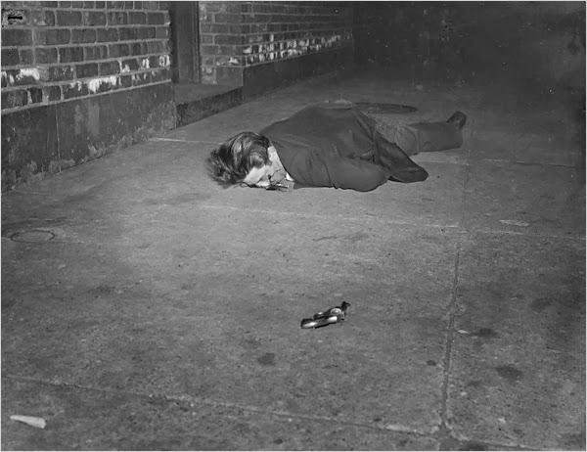
(Barth, 1997)

This image is an excellent example of the line being blurred between art and evidence. When we say ‘art’ most people would assume that would be fictional and therefore wouldn’t be acceptable to use said art as evidence. The image above is an image capturing a dead off duty police man. The angle of the image is quite artistic capturing the weapon, a handgun, and the man laying, facedown. However, the image could well be classed as evidence, it documents the crime scene, how the man fell, the gun fall and so on. It all depends if the scene was tempered with before the image was taken or not.
Photojournalists take photos in the form of documentation while photographers from a artistic background look at other factors such as the scene of the crime, the history, the victims. Loads of people are interested in these factors and so am I otherwise artistes wouldn’t have the success that they do when crating such work. My own work has explored murder and crime, going to crime scenes, and creating beautiful images that are hiding something sinister, it really interests me how people react after finding out that this beautiful landscape is where a crime happened, it become instantly sinister and dark rather what a beautiful landscape.
I find this ‘line’ shall we say very interesting why couldn’t my work be classes as evidence it is after all a documentation of a scene where a crime happened, not at the time of course but could still be used to see what the crime scene looked like. I plan to explore weather or not art can or should be considered sufficient evidence. ”The forensic photographer must seek evidence, not a creative work of art.” (Bond 2009) It is very difficult to agree or disagree as it’s all depending on the circumstances however I plan to explore the whole area to come up with conclusion. There are array of artist to consider along with arguments for and against when investigating the ‘line’.

System and evidence
Systems have naturally changed throughout history. The main reason why is because technology has changed and the forensic equipment has improved. There are loads of ways that forensics use technology to find new or concealed evidence. Take the 1910s crime scene photos from New York that were fished out of a river as an example.
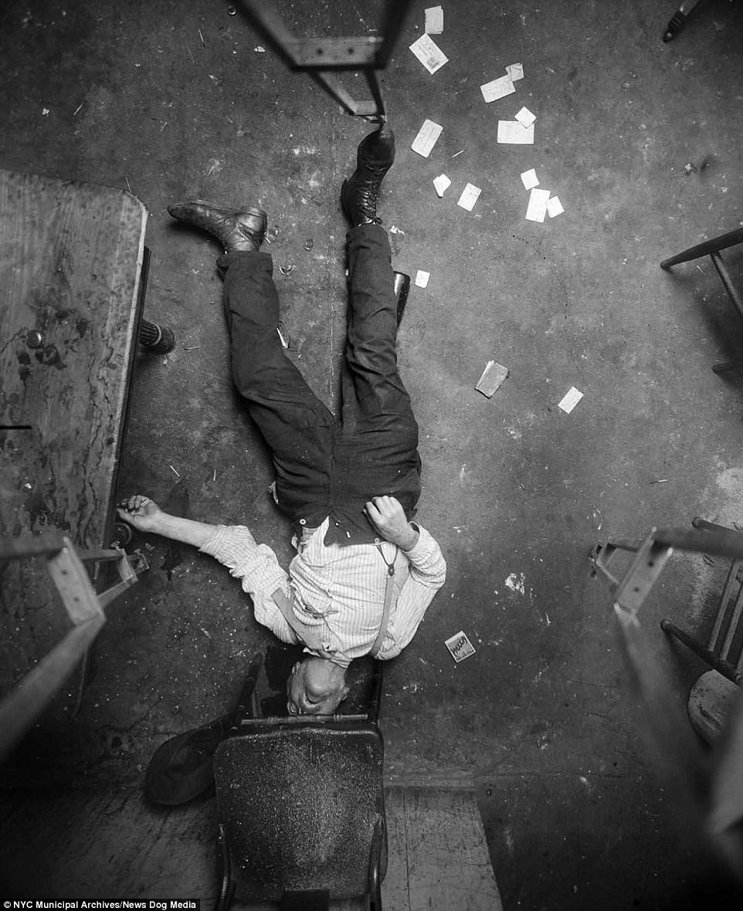
(mail online, 2017)
Within the image you can see the wooden tripods legs, suggesting that the camera is facing down, in todays crime scenes a tripod wouldn’t be used in order to keep as much evidence in tact as possible from floor marks to fibres and so on. The most major technological change from the 1910s compered to now to that digital cameras were introduced in the 1990s meaning that in the 1910s film cameras were used and from my own experience with film cameras is that things go wrong. If a crime scene photographer took photos of a crime scene the aperture wasn’t quite right or so on the images wouldn’t be as accurate meaning it would be harder for police to investigate them. Granted this was the time film was used and people were used to it, but all the film needed was a little exposure to light in order to be ruined.
Another factor that has changed is our justice system, years ago the system was corrupted because lords ruled the courts whilst the king would rule them, this created a biased ruling that’s mainly favoured the rich. “bribes and payments were common, but even so, in the middle of the 13th century the judiciary was openly accused of corruption.” (Rivlin, 1956) as the court gained more and more independence by growing and laws and gains jury and so on the king and lords had less and less of an influence.
The mind sets of people have ultimately changed throughout time, in the 13th century the public were superstitious of witches. There were many, many cases and trials of people who were believed to have been witches or practicing a dark worship. During this time the king would be at the top of the power triangle, were people would obey and look up to him. Times have changed since then the public now doesn’t look up to the monarch as much, with some even rebelling against. The public is also less superstitious now compared to the 13th century, with most superstations being about broken mirrors, ladders, and umbrella, that only a hand full follow.
I plan to research further in to how technology has changed through time and how that has affected how evidence is taken and stored. Looking in to how mugshots were used and how accurate they were photographically. The justice system has changed so much over the years and is an aspect to look in to in more detail, the justice system is the backbone to all crimes without a fair stable one there would be no need to take evidence. This is why it is important to critically analyse its changes and affects.

End
This subject is so broad that going in to detail on every angle would take a lot as many, many elements have changed throughout history as I have talked about previously from technology to people’s mind sets. For the dissertation I plan to answer all of the questions that have come up since looking in to and researching in to the changes of crime scene photography and evidence. I will need to break down every time frame analysing each one to see what has changed, why and weather the change benefited the system and the case.

Conclusion
To draw a conclusion is soon is irrational, after all is it only a proposal and therefore more in-depth research needs to be done. However, I think that although we cannot class photographers and artists work as evidence in court or in a case, their work could be classed as evidence in a form for the public to understand a scene and distance themselves from such gruesome scenes like in films, such as Leather Face which is about Ed Gein although really horrid people think of it was fake because it’s a film. Although I have an idea on my conclusions, I need to investigate further into every corner.
References

Unknown. Psychological theories of crime (viewed: 8th May 2018)
Available: http://criminal-justice.iresearchnet.com/criminology/theories/psychological-theories-of-crime/
Bond, H. (2009) Lacan at the Scene. MIT Press; Spain
Barth, M. (1997) Weegee’s World. Editions du seuil; Paris
Bond, H. (2009) Lacan at the scene. MIT Press; Spain

Mail Online. (2017) Gunned down at dinner, a couple slain in their bed and a body dumped in a barrel: Grisly crime scene photos chronicle the murder mysteries of violent 1910s New York (viewed: 8th May 2018)
Available: http://www.dailymail.co.uk/news/article-4752660/Grisly-crime-scene-photos-murder-mysteries-1910s-New-York.html

Rivlin, G (1979) History of the judiciary (viewed: 3rd may 2018)
Available: https://www.judiciary.gov.uk/about-the-judiciary/history-of-the-judiciary/

