Module: Learning in Digital Era
Module code: ACCA4025
Assignment 1: E-Portfolio
Student Name: Dina Ursuleac
Student Number: 2214932
Date: 15.11.2022
E-Portfolio
https://sites.google.com/view/dinaursuleac-e-portfolio/home

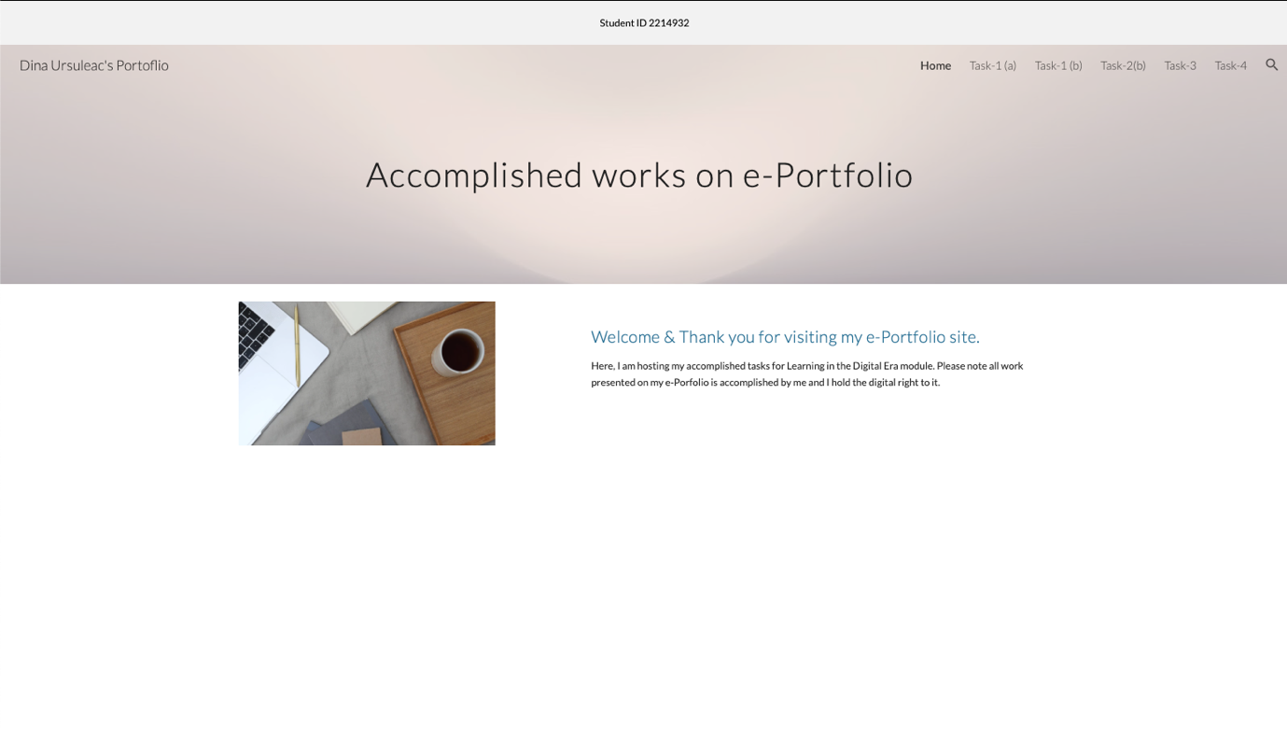
Figure 1. E-Portfolio.

E-Portfolio presentation hosted on YouTube channel:
https://youtu.be/8KNlr20mtKg


Figure 2. Team Poster.

