E-Commerce Business Model (Report)

Course: Business Information Technology

Module: E-Commerce

Lecturer: Susan Maw

Riaz Khan – p150731

Contents
1. Introduction to ASOS 3
1.1. SWOT Analysis 3
3
1.2. B2C Consumers 4
2. Analysis of the existing website 5
3. ASOS Business Model 5
3.1. Timmer’s 8 key elements 5
3.2. The Micro Environment 7
3.3. Chaffey’s Macro Environment 8
4. ASOS’ E-procurement process 8
5. Internationalisation 10
5.1. Hofstede’s Dimensions of Culture 12
6. Implementation issues 13
6.1. Amazon echo and ASOS 13
7. Conclusion 14
8. References 15

Introduction to ASOS
ASOS[1] is a worldwide fashion website that sells over 80,000 branded and own-branded products. These products include clothes, shoes, jewellery, hair and make-up products and many more. Their business is based online so all orders made are delivered straight to their customers, orders are made either from their website or their app. ASOS’ target audience are consumers who are in their “20-somethings”, as stated in their about us page[2] – this shows that they strive to achieve recognition from the younger generation more so than consumers who are older.
In 1999 founders Quentin Griffiths and Nick Robertson had the idea of selling clothes online so that fans could buy and wear clothes and products that their favourite celebrities wore. They registered a website called asseenonscreen.com in 1999 which went live in March 2000 and had a full launch of the business in June later that year under the name “AsSeenOnScreen”. What many customers including the writer himself know as ASOS, was originally called AsSeenOnScreen. The brand peaked at a very early time and had even won the Best Trendsetter Award by the Sunday Times later in 2000.
Quickly after winning that award many consumers were referring to AsSeenOnScreen as ASOS and eventually the business recognised that they needed to make the name shorter so that it would be easier to say and recognise.

SWOT Analysis
The figure below from mbaskool.com[3] shows a detailed outline of the SWOT Analysis of ASOS. It covers the strengths, weaknesses, opportunities, and threats that can be linked to ASOS.

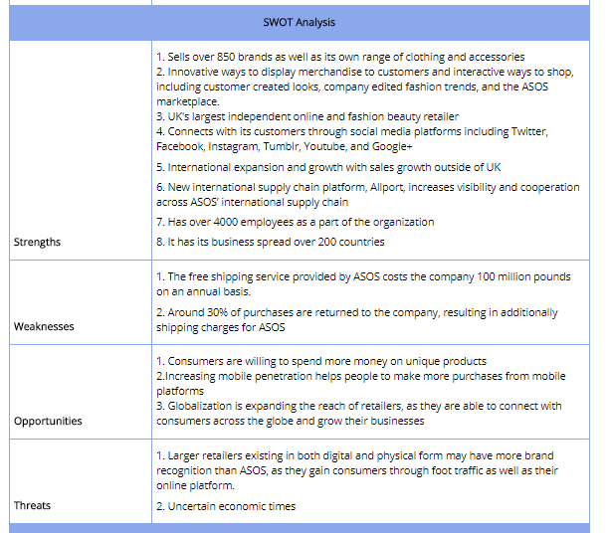

One opportunity that has not been mentioned in the above figure is that they can open a physical store. ASOS are a very big brand and is known all over the world. While running online is very popular nowadays there still isn’t that personal touch you get from meeting sales assistants in real life. By opening online they may gain a bit more trust from their customers as they will actually be able to check and try out the product(s) before actually buying. Something that the user is not able to do when browsing online.

B2C Consumers
ASOS can easily be seen as a B2C company as they sell mainly to their customers. The writer himself is a regular buyer of the brand and thinks that they strive on creating the best customer experience, here are some factors that may contribute to ASOS attracting their customers.
. Have a variety of options ranging from top branded clothes including Nike, Adidas, Ralph Lauren and they also sell their own branded clothes at a cheaper price, a good choice for students who are into fashion.
. They deliver straight to the recipient’s home which is convenient as they do not need to travel to purchase.
. Free returns are available to customers (depending on where they have ordered from) which makes it a very simple process for those who haven’t been given what they wanted or if a certain item was the incorrect size.
. A blog by linkhumans[4] suggests that ASOS is heavily reliant on social media to attract many of their followers. As mentioned earlier by the writer, the ASOS brand is mainly pushed towards the younger generation (late teens or early 20s). Many of those among this group will use social media for most of the time. The writer will now analyse how ASOS makes use of the top social media applications:
Facebook – ASOS is the biggest online fashion retail in the world with an outstanding 5.3 million likes. Their page is constantly used to promote new ranges, styles, and sales. Updates are normally given everyday using a visual image which usually gets at least one thousand likes and hundreds of comments, a very good way to interact with their followers.
Twitter – ASOS make fantastic use of Twitter to engage with their followers. Their main page has an amazing 1 million followers. Not only do they have a main page, but they also have pages dedicated to their different markets e.g. a page for France, Australia, Italy etc. They also have a twitter account for customer care, so any queries can be made on that page. The linkhman blog states that “The key use for their multiple fashion accounts is to circulate links to their current stories on their blog and magazine”.
Instagram – As well as keeping up with millions of followers on Facebook and Twitter, they also keep in touch with their 6.9 million followers on Instagram. This page mainly offers an inside look of the company by showing selfies of staff, images of what they eat and sometimes outfits that their stylists wear. By doing this they can keep up with recent trends and it also offers that personal touch with followers. The page often makes use of hashtags to make sure their posts get seen, however it is the followers who use this hashtag that makes the brand get recognised.

Analysis of the existing website
As the leading online fashion brand ASOS always needs to update their website so that it meets their users’ needs. Not only do they need to make it look good, but they also make the functionality of the website easy enough for everyone to use. If users are not able to use it or if they do not like the overall look of the website, then they are most likely not going to acknowledge it or visit it in the future.
The writer mentioned earlier in the report that he is a follower of ASOS and is a regular buyer. In his opinion he thinks that the website looks very good for the intended audience and thinks that the website is very easy to use and has the information that is required from him. To further test this statement the writer has been asked a potential customer about this. He will ask this potential customer what they expect from this website.
After researching with a potential customer one requirement that they mentioned was that the website needed to be fast, a quick response time is a very important factor for this future client as they would like to browse and buy quickly.
Another requirement that was mentioned was consistency throughout the website. The customer expects to see a similar layout and style throughout ever page on the website. They feel like if this standard is not met then it will look very unprofessional and not worth visiting.
Many young users rely on their mobile phones nowadays to mobile usability is a big requirement for the customer. Again, it is imperative that the response time on a mobile phone or tablet is the same as when you are using the website on the computer.
As someone who has never used the website before the customer feels that the most important requirement of the website is easy navigation. The menu page must be clear as to what each web page consists of and is it clear where you want to go for the intended purpose.

ASOS Business Model
A journal article called Business Models[5] by Veit et al. states various meanings of what a business model is including Timmers(1998) definition which is that a business model is “an architecture for the product, service and information flows, including a description of the various business actors and their roles……”. It is a plan which ensures the successful running of the business, the plan defines the sources of revenue, the target market, the products and services on offer and details of financing.
Within Timmers’ business model theory there were 8 key elements, these elements can be linked to ASOS and how they structure their business model.

Timmer’s 8 key elements
A blog post written in 2013 by IMT[6] outlines the 8 key elements in Timmers business model.
The first element is value proposition. This describes how a company is able to satisfy the needs of their customers. So, the question is, how do ASOS fulfil the needs of their customers with the products that they sell? One way in which they do this is by offering discounted prices. Buyers are always looking to by top brands at a lower price than usual and ASOS live up to this by regularly offering discounts on their websites and via email (to users who have created an account with them), they also offer a 10% discount to student every day. ASOS also has a wide range clothing to offer which means that the customer has a very good choice to choose from.
The second element is revenue models. This outlines how a business will generate revenue, create profits, and output an excellent return on capital. There are various types of revenue model, such as:
Advertising revenue models – A website that attracts many users can sell space on their page to other companies to advertise, a fee will be given for the available space.
Subscription revenue model – the user will be charged a fee to subscribe for the content of the website. The content must be of high quality for the user to feel that it’s worth paying for.
Transaction fee revenue model – A business will take a small amount of money from each financial transaction that is completed through their website e.g. eBay[7] takes a small cut from the transaction once the seller has sold an item.
Sales revenue model – This is the revenue model that ASOS uses which means that they sell their products directly to the customer. The transaction only takes place between the buyer and the company.
Affiliate revenue model – Businesses can pair up with other businesses to sell products on their website. This model is based on commission, you resell items from other retailers on your site. An example to help explain this model would be Dave Chaffey[8] and Amazon. Chaffey allows Amazon to display their books on his website. In return Amazon offers 5% of the cover price.
The next element is market opportunity. This relates to a certain need or want by the market that a company can take advantage of as competitors are not doing so. ASOS only run online which means that buyers do not need to travel to buy clothing. They also sell top brands of clothing which means that if a student saw an Adidas jacket in store and found the price to be a bit over their budget, they could get that same jacket at ASOS (depending on if it is available there) for a cheaper price using a discount code and have it delivered straight to their home.
The fourth element is the competitive environment. This refers to other businesses who are selling similar products to your business. In this case the biggest competitor of ASOS would be boohoo[9] who are also an online retail store.
The next element is competitive advantage. This advantage occurs when a business can offer a superior product to the market or sell products at a lower price than competitors. ASOS not only sells their own branded clothes but also top bands such as Diesel and Converse. Competitors such as boohoo sell their products at a lower price but can be seen to some as lower quality than ASOS, ASOS can sell all their products at a higher price as buyers see it as something worth paying for.
Market strategy is also part of Timmers business model. This refers to how a business plans to enter a market and promote themselves to their target audience. ASOS are partnered with a company called UNiDAYS[10] where students can receive discounts from all sorts of brands such as Spotify, New Look, Pizza Hut and many more. ASOS is advertised to many of the users that are signed up on the website.
Another element of the business model is organizational development. This entails how work will be organised for it to be completed. ASOS is a very large organisation which means that there are likely to be many departments within. Below is a screenshot of the asoscareers website. As we can see there are a variety of departments to choose from such as finance, production, merchandising and many more.
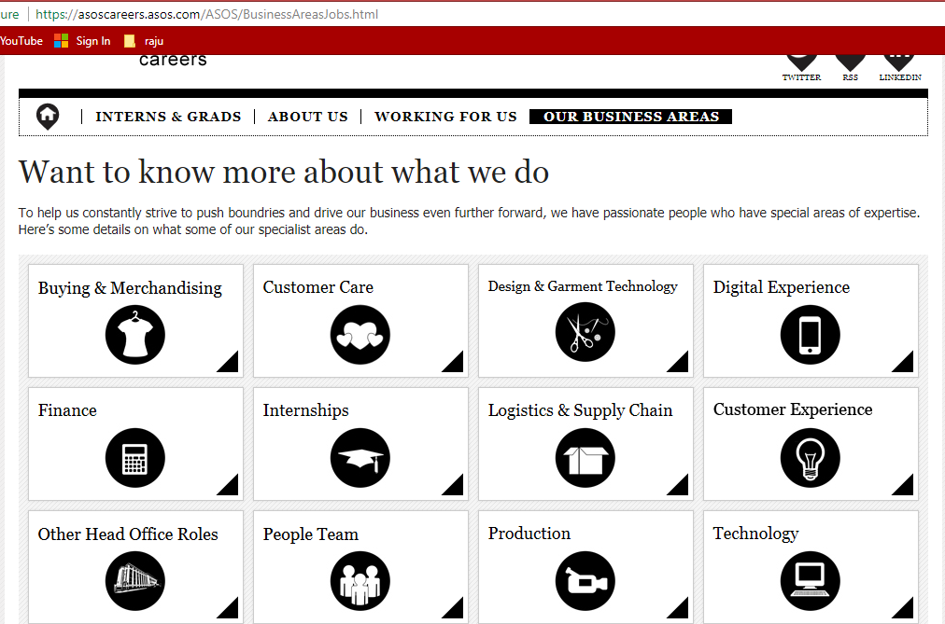

The final element of the business model is management team. This refers to employees of the company for making the business strategy work. A solid management team gives reliability to investors who are interested in the business.

The Micro Environment
The businessdictionary.com[11] defines the micro environment as factors within the business that affect its performance and decision making. These factors include:
Suppliers – The supplier holds power when they are the only or largest supplier of that good e.g. ASOS have 229 factories in China alone as well as hundreds of others across the world. If for some reason a disagreement was to occur between the director of the business and the manager of the factory then this may lead to a pause or decrease in production output.
Customers – Companies will need to find out what type of consumer base they have (B2B, B2C, C2C, for ASOS we have clearly identified that they are a B2C business) and why they are buying your products and services. This information is important to help market your business.
The public – When taking any sort of action, the company must take into consideration how the public will react. If in the future ASOS found that revenue goals weren’t being met they may offer less deals less regularly to try and sell at full price, this could have a negative impact on the public as they may not consider buying from the business again.

Chaffey’s Macro Environment
The macro environment refers to factors outside of the business that cannot be controlled. What ever the factor may be, it can sometimes help the business with performance but can also sometimes have a negative impact. Some of these factors, given by the Oxford college of marketing[12] are:
Natural events – Natural disasters such as earthquakes or floods could occur in countries such as Bangladesh where some of their own brand products are made, this is lead to a major pause and decrease in the number of items available that are made from there.
Political Forces – Political developments such as Brexit which is taking place in the UK could cause outside suppliers from Europe to stop shipping in products that are made there. According to the official ASOSplc page[13] there are hundreds of factories across Europe including countries like Albania, Spain, Ukraine, Macedonia and many more.
Technological factors – The skills are knowledge of production and materials that is required for the successful production of a businesses products and services can affect how smooth the running of the business can be

ASOS’ E-procurement process
Electronic procurement is the use of the internet to buy in goods and services that are used for the business. The whole system defines all steps within the purchasing process while applying control over spending. Deltabid[14] describes the E-procurement system as “a tool designed to improve the purchasing process transparency and efficiency and help companies capture savings”. One can only assume that a large organisation such as ASOS makes good use of E-procurement to try and gain better control of their budget and to utilise as much of their purchasing opportunity as they can.
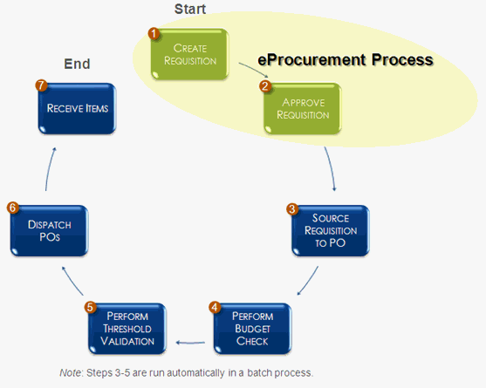
Key steps in the procurement process by finsource[15]
These 7 steps can be adapted to how ASOS’ procurement system works:
Step 1 – A buyer has found something from ASOS that they need or want so makes a request for that item.
Step 2 – At this step each request that is made by a buyer is sent to an approval agent. The approver verifies that the item is needed and then checks to see if the purchase figure is acceptable.
Step 3 – Once the requisition has been approved, a purchase order is made and is automatically sent to the supplier.
Step 4 – A budget check is performed to ensure that a budget is available to pay for an expense.
Step 6 – When the purchase orders have been internally verified by the ASOS warehouse and sent to the appropriate delivery company, they will be loaded onto the delivery trucked ready to be sent to the buyer.
Step 7 – The buyer has been sent the item that they requested in step 1.
The following advantages are described by P. Toktas-Palut, E. Baylav, S. Teoman et al. in The impact of barriers and benefits of e-procurement on its adoption decision: An empirical analysis[16]
The E-procurement system has many advantages to a business, one being that it leads to better management and control of suppliers. This gives buyers the opportunity to find suppliers with the best price and quality. Communication is also very clear when using the E-procurement system.
Another advantage is that savings are made through overall purchases. The whole procurement system is sped up which means that there is less of a need of operational personnel.
The decision-making process is also enhanced through procurement. The writer assumes that ASOS make use of the E-procurement system as it is such a large business. The information that the business has must be neatly organised which means that access to it is very easy (for staff within the business).
Businesses can respond quickly to problems that may occur. The increased speed in transactions and reporting of information, it helps to solve problems quicker and make decisions quickly when needed.
Improved communication and collaboration in supply chain. “E-procurement allows sections of electronic documentation to flow through the supply chain. ASOS have thousands of orders to keep up with everyday and the procurement system helps them to send items to their customers at a quick pace. Below is a figure that shows the standard shipping time if you were to order from china. This means that your order would take around 2 weeks to arrive (unless you paid for premium). The improved communication with supply chains allow for products to be made very well in advance so that the business can meet order deadlines.
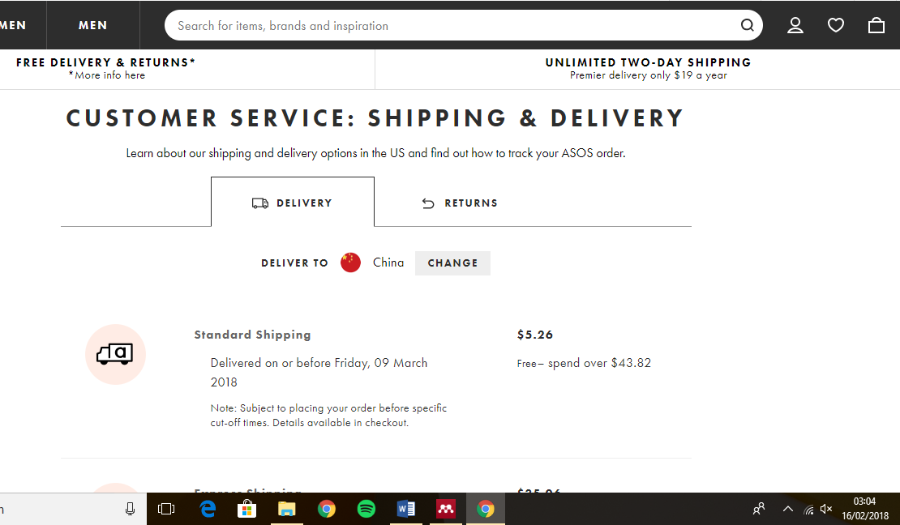

Internationalisation
A definition given by Investopedia[17] states that internationalisation is the “designing of a product in such a way that it will meet the needs of users in many countries”. ASOS is a worldwide brand that is known to many around the world. The business must ensure that the website design in the UK is the same or at least similar in a different country and that everything still works the same way.
Most importantly the website much ensure that its focus is to create a good customer experience and that it meets all user requirements of a good website.
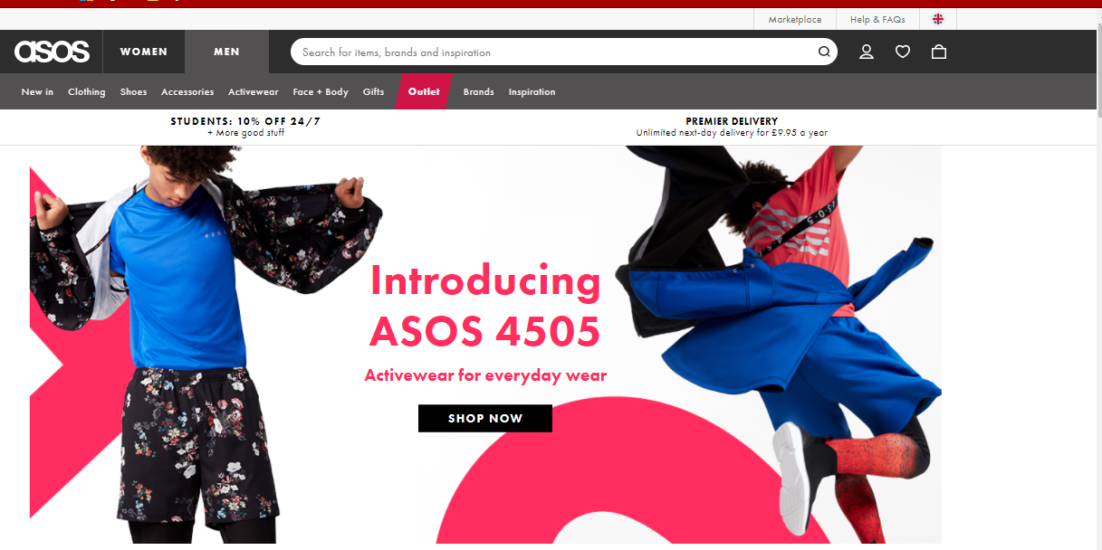
English version of the website
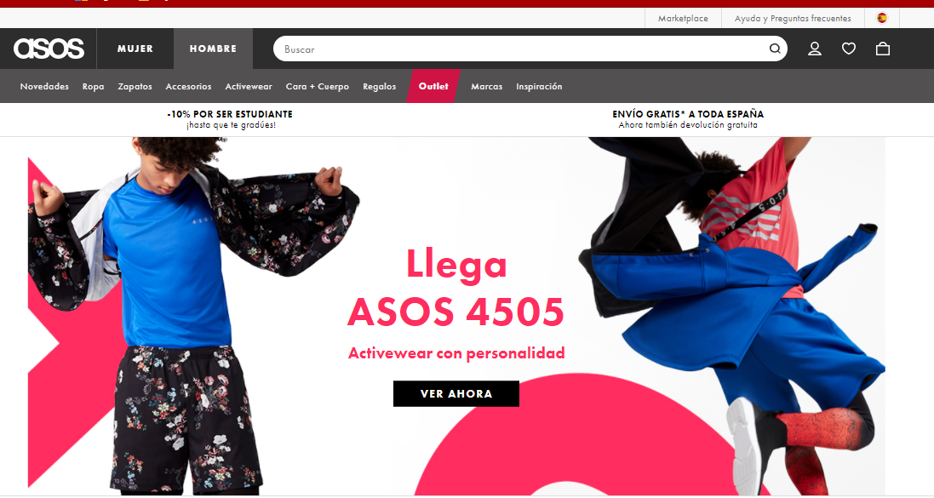
Spanish version of website.

As we can see the homepage for both the UK and the Spanish website is the same and that the language is adapted for both countries. One suggestion that could be made is to add more colour to both websites to represent the country that you are browsing from. When the writer thinks of Spain he thinks of vibrant colours like red and yellow. The writer understands that consistency is a key part of a business, especially if their website is their main base but using these colours to differentiate Spain from the UK can help to give it a more positive and up beat look. ASOS may consider this to attract customers worldwide.

Hofstede’s Dimensions of Culture
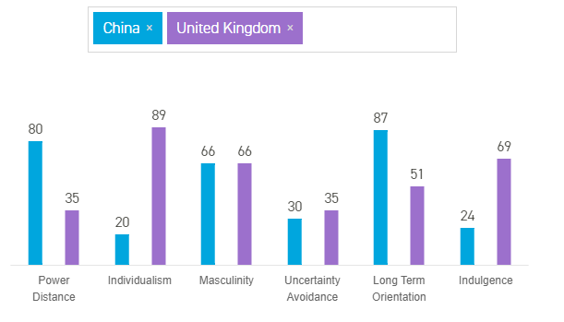
Geert Hofstede conducted a study that showed how values in the workplace are influenced by culture. To Hofstede culture is “the collective programming of the mind distinguishing the members of one group or category of people from others”.
Hofstede insights[18] shows that there is a total of six dimensions of national culture. Each culture represents preferences of one state over another that differentiate countries from each other. The scores of each dimension is relative, in that we all different but at the same time different from one another, the image above is a comparison of dimensions between the UK and China. The six dimensions are:
Power Distance Index (PDI) – This dimension enforces the fact that there are less powerful people within a society that accept the fact that power is spread out unequally. Members within a society who have a large amount of power follow a hierarchy where everyone has a place that does not need amending. In areas of low power distances work to even out the distribution of power. As we can see China has a high power distance which means that they accept that there are inequalities whereas the UK will work to solve those inequalities.
Individualism Versus Collectivism (IDV) – Individualism is a process in which individuals are expected to take care of themselves and their close families. On the low end of this dimension, collectivism is a tight society where individually can expect their relatives or close friends to look after them without 100% loyalty. In this dimension China has a low score of 20 which means they perform actions while considering a group rather than themselves. The UK has one of the highest scores in the world, only being beaten by Australia and the US. The high score represents that people are taught to take care of themselves first before others.
Masculinity Versus Femininity (MAS) – The masculinity stands for achievement, heroism, assertiveness, and material rewards for success. The femininity represents cooperation, modesty, caring for the weak and quality of life. China and the UK both scored 66 which means they lean towards the masculine side of the dimension. Most members are success oriented and goal driven.
Uncertainty Avoidance Index (UAI) – This dimension entails which members of a society feel uncomfortable with uncertainty, not being 100% content. The issue shown through this is that is how members deal with the fact that the future cannot be known. Both countries scored similar scores with China on 30 and the UK at 35. This shows that members of both societies are happy with the fact that they will not know what is going to happen in the future.
Long Term Orientation Versus Short Term Normative Orientation (LTO) – While handling challenges of the present and future, the past will always be taken into consideration. Low scorers like to maintain time-honoured traditions while being suspicious whereas high scorers appreciate efforts to prepare for the future. China scores an 87 on this dimension which means that they believe in long term orientation, “In societies with a pragmatic orientation, people believe that truth depends very much on situation, context and time”- this means that solid facts are relied on for something to be true. The UK also makes it into this category with a score of 51.
Indulgence Versus Restraint (IND) – This is the final dimension. The indulgence represents a society that appreciates human drives of living a free life and having fun. The restraint stands for a society that “supresses gratification of needs and regulates it by mean of strict social norms”[19]. The UK beats China in this comparison with a score of 69-24. High scorers will be classed as indulgent which means that they like to spend money on enjoying themselves and take a more relaxed approach when making choices. Restrained societies will restrict themselves and do not tend to spend a lot of money or leisure time or consider leisure time as an important part of life.

Implementation issues
When a plan is implemented success is not guaranteed. For some larger companies this may not be the case as they have a financial and competitive advantage however for smaller business, plans may not go the way they’d hoped. A blog post written by Jurgens Pieterse[20] outlines a few implementation issues:
. Understand business objectives – sometimes newly appointed employees may be misleading as to what the overall aim of the business is.
. Clarify context of the problem – Managers or owners of a business may not make it clear what the problem is that they are trying to solve.
Define criteria of the solution – In ASOS the head of the production department may not describe clearly what is needed to resolve a problem.
Determine expectations of the final state after completion – After completing a task or goal a manager and employee may fail to predict what is most likely going to happen after completion

Amazon echo and ASOS
Explained by Marie Black at techadvisor[21], The Amazon Echo is a voice-activated audio speaker that is able to connect with Bluetooth and WI-FI. Alexa is the name used to activate the echo and is primarily used to complete voice given commands such as ‘Alexa, play my music’ or ‘Alexa, add cheese to my shopping list’. The echo is a very smart device as it adapts to your speaking patterns and personal preferences. While it is not majorly needed the writer feels that the echo can easily be used by an amazon user to complete certain commands. A buyer can connect their account to the device and request it to carry out tasks such as adding an item to your shopping list, cancelling an order, read out what is on the screen (convenient for those who have problem with eyesight) and to pick out different styles to look at in general. All these tasks can be given to Alexa while the physical user is performing other tasks such as cleaning the dishes or taking a shower.

Conclusion
After doing extensive research about ASOS the writer has found that they are the largest online fashion retailer in the world and they have been a very successful business since starting almost 20 years ago. They have advantages over their competitors such as the range of items they have on offer and their business is also spread over 200 countries which means that they are bringing revenue from all around the world. The writer has defined ASOS as a B2C business as they sell to customers and strive to make sure that every customer experience is the best. The reporter also found that ASOS makes good use of Timmer’s 8 key elements to try and beat their competitors. Two major elements they make use of is value proposition where they consider what the real need of the user is and competitive advantage which refers to how they perform better than companies who are running a similar business. Chaffey’s micro and macro environment was analysed to consider internal and external factors that could affect how ASOS runs as a business. The writer also analysed the E-procurement process and how ASOS use it to save costs during the overall purchasing process and increase communication with supply chains. The reporter made suggestions to consider implementation issues and for every member to think about them when completing a task as things may not go as planned. The writer also made suggestions on how customers could use the Amazon echo when browsing the ASOS website or app.

References
[1] “ASOS | Online Shopping for the Latest Clothes &amp; Fashion.” [Online]. Available: http://www.asos.com/. [Accessed: 14-Feb-2018].
[2] “About Us | ASOS.” [Online]. Available: http://www.asos.com/about/. [Accessed: 22-Jan-2018].
[3] “ASOS SWOT Analysis | USP &amp; Competitors | BrandGuide | MBA Skool-Study.Learn.Share.” [Online]. Available: https://www.mbaskool.com/brandguide/lifestyle-and-retail/12876-asos.html. [Accessed: 14-Feb-2018].
[4] “How ASOS Uses Social Media - Link Humans.” [Online]. Available: https://linkhumans.com/blog/asos. [Accessed: 14-Feb-2018].
[5] D. Veit et al., “Business Models,” Bus. Inf. Syst. Eng., vol. 6, no. 1, pp. 45–53, Feb. 2014.
[6] “E-Business 2013 in IMT: 8 Key Elements of a business model | Ravi_12DM-119_Sec-B.” [Online]. Available: http://imtebiz2013.blogspot.co.uk/2013/10/8-key-elements-of-business-model.html. [Accessed: 15-Feb-2018].
[7] “Electronics, Cars, Fashion, Collectibles, Coupons and More | eBay.” [Online]. Available: https://www.ebay.co.uk/. [Accessed: 15-Feb-2018].
[8] “Digital Business Today | Dave Chaffey’s personal site.” [Online]. Available: https://blog.davechaffey.com/. [Accessed: 15-Feb-2018].
[9] “Clothes | Women’s &amp; Men’s Clothing &amp; Fashion | Online Shopping – boohoo.” [Online]. Available: http://www.boohoo.com/. [Accessed: 15-Feb-2018].
[10] “UNiDAYS.” [Online]. Available: https://www.myunidays.com/GB/en-GB?p=AQI. [Accessed: 15-Feb-2018].
[11] “What is microenvironment? definition and meaning - BusinessDictionary.com.” [Online]. Available: http://www.businessdictionary.com/definition/microenvironment.html. [Accessed: 15-Feb-2018].
[12] “Micro and Macro Environment Factors | Oxford College of Marketing Blog.” [Online]. Available: https://blog.oxfordcollegeofmarketing.com/2014/11/04/the-impact-of-micro-and-macro-environment-factors-on-marketing/. [Accessed: 15-Feb-2018].
[13] “Sourcing Map – ASOS plc.” [Online]. Available: https://www.asosplc.com/corporate-responsibility/our-products/sourcing-map#/europe. [Accessed: 15-Feb-2018].
[14] “E-Procurement - definition and functions : DeltaBid.” [Online]. Available: https://www.deltabid.com/e-procurement/. [Accessed: 14-Feb-2018].
[15] “(ePro) eProcurement Overview.” [Online]. Available: http://finsource.ohio.gov/mergedProjects/finman_eprocurement/eprocurement_overview.htm. [Accessed: 14-Feb-2018].
[16] P. Toktaş-Palut, E. Baylav, S. Teoman, and M. Altunbey, “The impact of barriers and benefits of e-procurement on its adoption decision: An empirical analysis,” Int. J. Prod. Econ., vol. 158, pp. 77–90, Dec. 2014.
[17] “Internationalization.” [Online]. Available: https://www.investopedia.com/terms/i/internationalization.asp. [Accessed: 16-Feb-2018].
[18] “National Culture - Hofstede Insights.” [Online]. Available: https://www.hofstede-insights.com/models/national-culture/. [Accessed: 15-Feb-2018].
[19] “Indulgence vs. Restraint - Intercultural Communication: a joint project between Effat University, Jeddah, Saudi Arabia and Hope College, Holland, MI, USA.” [Online]. Available: http://hopeinterculturalcomm.weebly.com/indulgence-vs-restraint.html. [Accessed: 15-Feb-2018].
[20] “Seven implementation issues.” [Online]. Available: https://it.toolbox.com/blogs/jurgenspieterse/seven-implementation-issues-101304. [Accessed: 15-Feb-2018].
[21] “What is Amazon Echo? Which Echo Should I Buy? - Tech Advisor.” [Online]. Available: https://www.techadvisor.co.uk/new-product/audio/what-is-amazon-echo-3584881/. [Accessed: 15-Feb-2018].

Appendix

Appendix 1: Presentation Slides
Slide 1
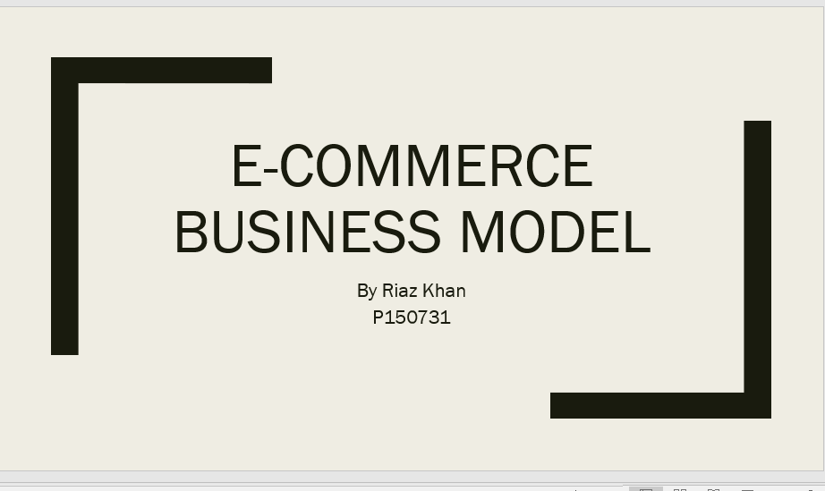
Slide 2
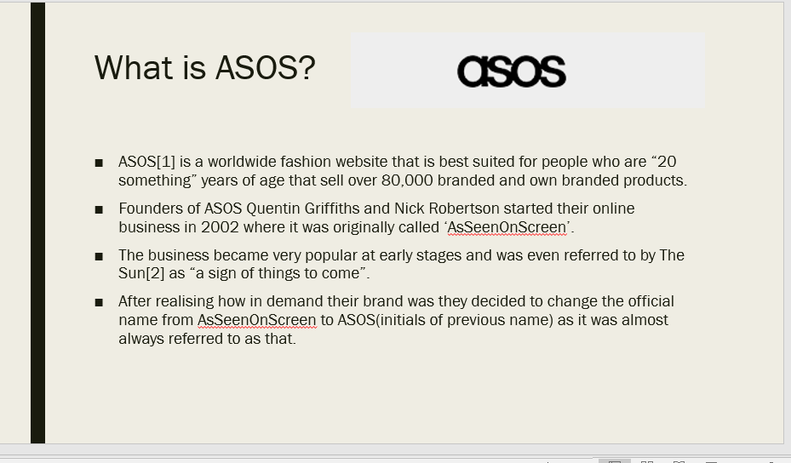

Slide 3
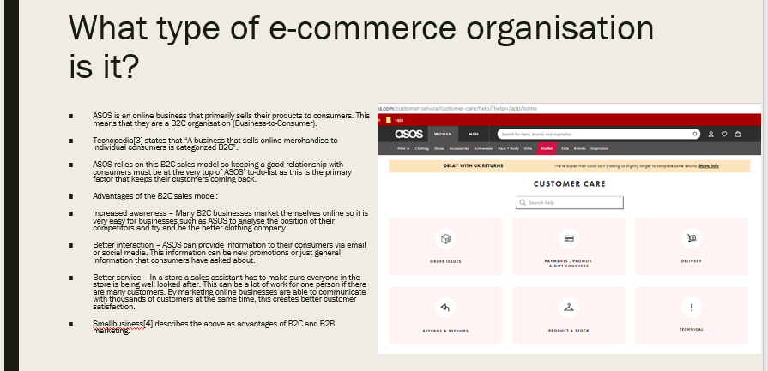
Slide 4
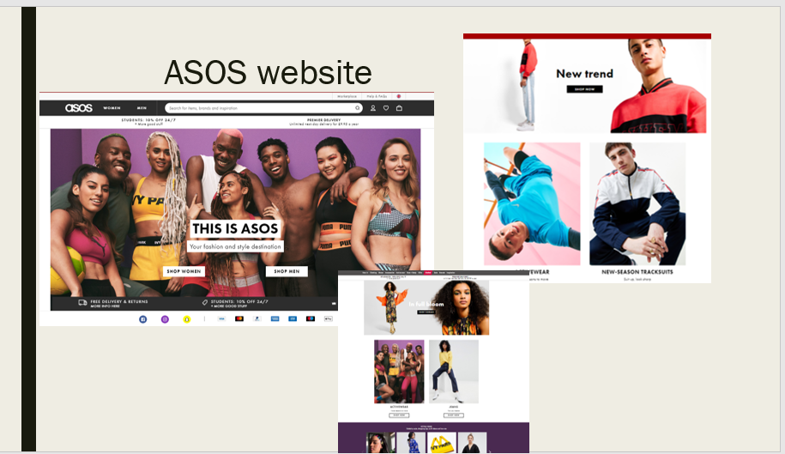

Slide 5
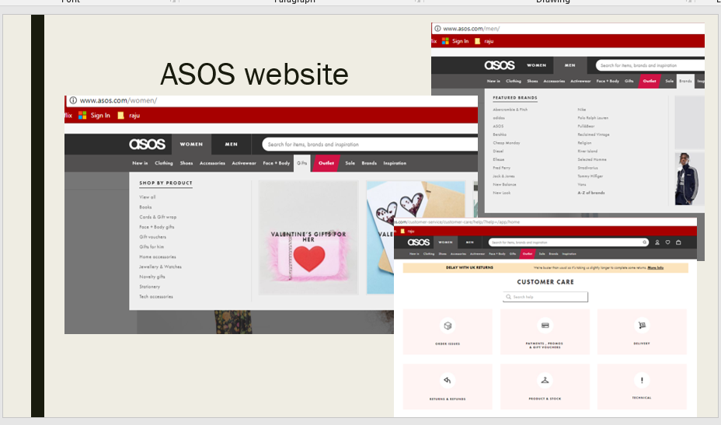
Slide 6
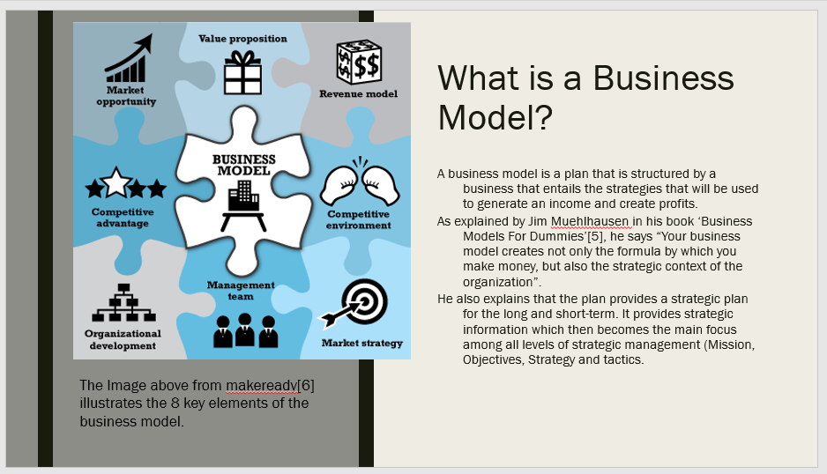
Slide 7
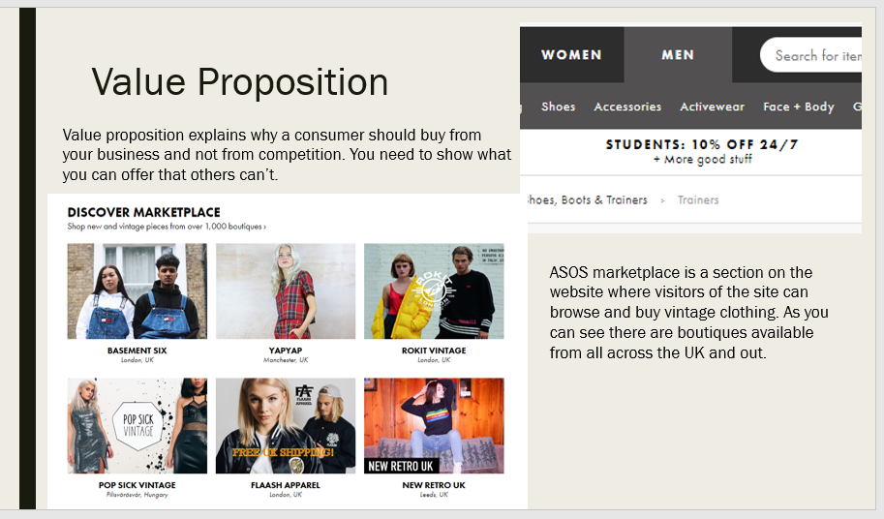
Slide 8
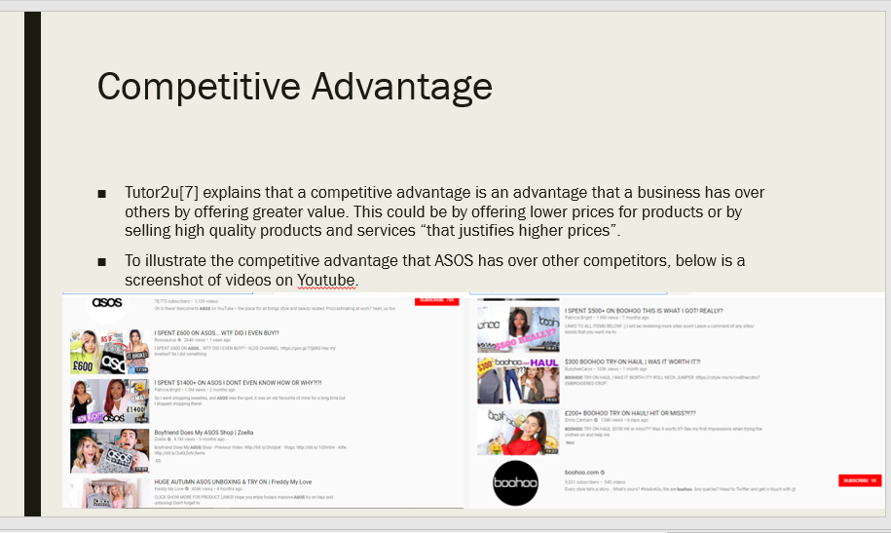

Slide 9
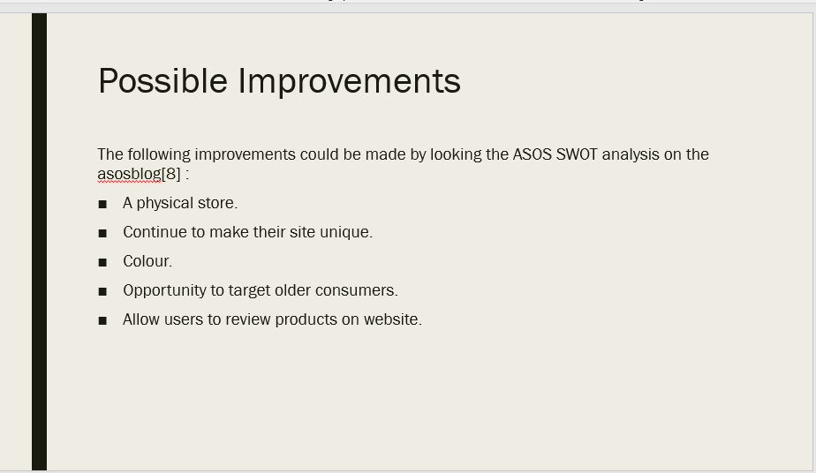
Slide 10


