
Programme: Master of Business Administration
Module: Human Capital Management
Module code: LCMB7023
Lecturer: Alireza Nazarian

Topic: Designing a Human Capital Architecture for Strategic Renewal: The Case of Helios Urban Mobility

Student Name: Divyang kaklotar
Student ID Number: 2536588
Word Count: 2588
Date of Submission: 15 July 2026

Executive Summary
This report critically discusses the organisation issues and suggests strategic HR interventions to enhance Helios Urban Mobility’s human resource management practices. It further will formulate an effective organisational socialisation design and an innovative job design approach based on both HR processes and HR situations theories. In addition, this report considers the ethical considerations of applying artificial intelligence as a human resource decision support system whilst retaining fair human decision making. It also provides a personal development plan to cultivate core capabilities to support future employability in strategic human resource management.
Table of Contents
1. Introduction 7
2. Task A: Socialisation, Identity & Business Activism 7
2.1 Strategic Importance of Organisational Socialisation at Helios 7
2.1.1 Traditional Onboarding versus Strategic Organisational Socialisation 7
2.1.2 Psychological Contract and Identity Construction 9
2.2 Proposed Organisational Socialisation Framework for Helios 11
2.3 Mechanisms to Cultivate Committed Organisational Citizens 12
2.3.1 Developing Organisational Identification 12
2.3.2 Ethical Professionalism 12
2.3.3 Developing a Business Activist Mindset 12
3. Task B: Job Design 13
3.1 Diagnosing Job Design Challenges at Helios 13
3.2 Proposed Innovative Job Design Strategy 14
3.2.1 Applying the Job Characteristics Model (Hackman & Oldham) 14
3.2.2 Applying Job Crafting Theory 15
3.2.3 Skills-Based Architecture and Internal Talent Marketplace 15
3.3 How the Proposed Job Design Supports Motivation and Innovation 15
3.3.1 Enhancing Intrinsic Motivation 15
3.3.2 Supporting Innovation through Job Design 16
4. Task C: Reflective report 16
4.1 Using AI as a Decision-Support Tool While Maintaining Critical Human Judgment 16
4.1.1 Role of AI in Strategic HR decision-making 16
4.1.2 Balancing AI Insights with Critical Human Judgment 17
4.1.3 My Personal Approach to Responsible AI Use 17
4.2 Personal Capability Development Plan 18
5. Conclusion 18
References 20

List of Figures
Figure 1: About Helios Urban Mobility (HUM) 7
Figure 2: Van Maanen and Schein's six socialisation tactics 9
Figure 3: Psychological Contract Theory 10
Figure 4: Proposed HUM Strategic Socialisation Framework 11
Figure 5: Ulrich’s HR Business Partner evolution 13
Figure 6: Hackman and Oldham’s Job Characteristics Model 15

List of Tables
Table 1: Personal Capability Development Plan 18

1. Introduction
Helios Urban Mobility (HUM), is an emerging European smart-transport start-up, with 450 employees in London, Berlin and Singapore (Helios, 2020). The company develops into electric mobility platform providing AI enabled system and offering analytics of smart infrastructure into cities (Helios, 2020). This report is to construct a new strategic human capital architecture through deploying organizational socialisation, designing innovative jobs and fostering personal HR capability building against sustainable organizational renewal.


Figure 1: About Helios Urban Mobility (HUM)
(Source: Helios, 2020)

2. Task A: Socialisation, Identity & Business Activism

2.1 Strategic Importance of Organisational Socialisation at Helios
Organisational implication of Helios Urban Mobility’s extended ramp-up period, low employee engagement and the high rate of graduate attrition are indicative of problems of larger organisational nature. These problems indicate that the new employees do not manage to assimilate, cooperate, contribute to the commitment and the innovation of the enterprise. It affects the organisation’s performance and its growth (Mebratie et al., 2025). Although traditional onboarding helps employees to settle into the current role, it does not necessarily encourage the long-term behavioural and cultural integration that knowledge intensive organizations thrive on. Thus, it is worth to evaluate the onboarding and organisational socialisation methods to find out which would be more suitable to Helios.

2.1.1 Traditional Onboarding versus Strategic Organisational Socialisation
Traditional Onboarding
Traditional onboarding new employees are provided with organisational policies, procedures and their specific job requirements, enabling them to settle in quickly within the organisation (Bauer et al., 2025). Its main advantages are to reduce uncertainty, ensure compliance to regulations, and offer an early definition of roles, thus enhancing employees’ confidence in entering an organization (Bauer et al., 2025). However, this short-term focus can constrain the development of key elements of cultural integration, relationship development and professional identity development which are essential for long-term organisational success. It was found that in the UK, CIPD (2024) states that 27% of the new starters did not turn up on their first day and 41% of new starters left within first 12 weeks. Thus, traditional Onboarding adapts operations but does not foster engaged staff that is so crucial to Helios’ continue innovation and sustainably success.
Strategic Organisational Socialisation
Continuous approach of strategic organisational socialisation considers that employee socialisation occurs continually, instead of a single event of employee orientation (Türk and Udum, 2025). It is intended to integrate the new employee with the values, culture and the strategic aims of the organisation. Didion et al. (2024) argue that structured socialisation tactics enhance Role clarity, Role commitment and Role adjustment. However, organisation context determines the effectiveness of the tactics and should not be generalized. Dumitriu et al. (2025) show that well-designed socialisation programmes enhance participation, the sharing of information, retention, relationships, and the understanding of performance expectations. Nevertheless, formal guarantees may also threaten employee discretion and creative problem solving which are two crucial elements for innovations (Pinco et al., 2024). As a result, Helios should offer both structured guidance, instructing and cooperative learning, and a high degree of employee autonomy. This combination will enhance employee adjustment, drive innovation, increase organisational commitment and foster the long-term development and renewal of the organisation.
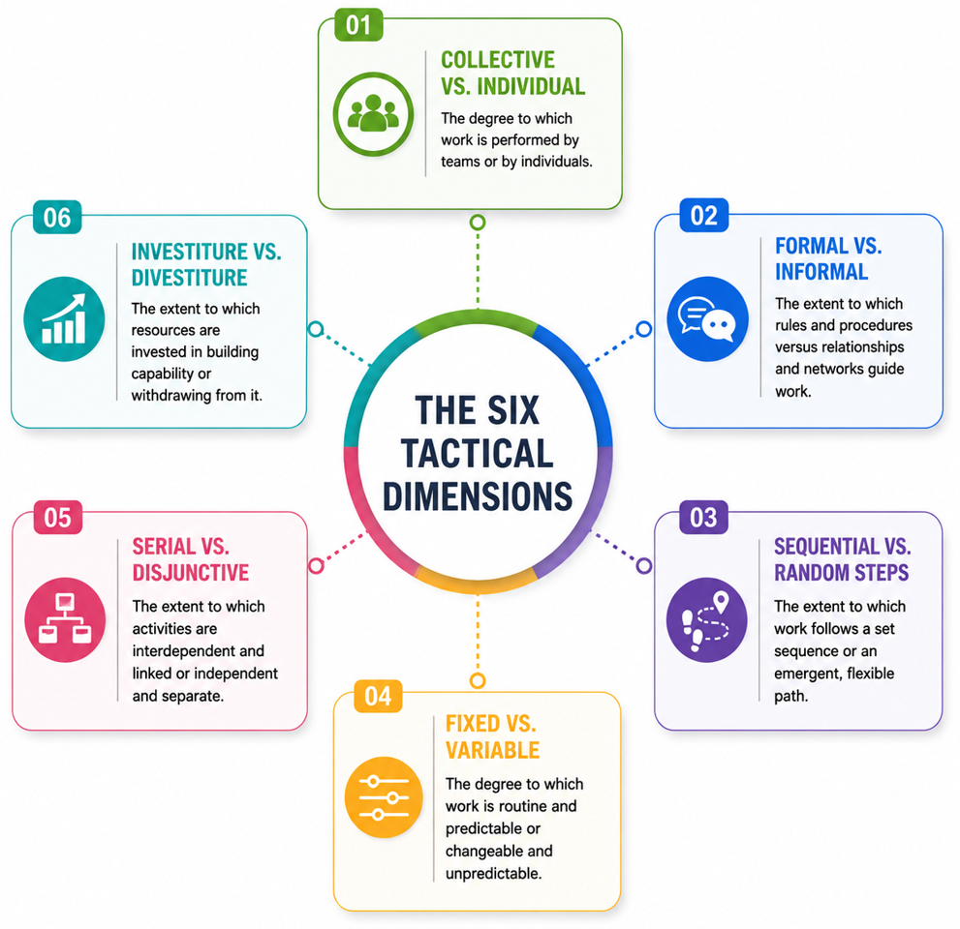

Figure 2: Van Maanen and Schein's six socialisation tactics
(Source: Author)

2.1.2 Psychological Contract and Identity Construction
Psychological Contract Theory
The Psychological Contract Theory describes the unspoken expectations that exist between employer and employee that shape the level of commitment, attitude, trust and behaviours in the workplace (Galema et al, 2022). Graduates who join HUM have expectations around: structured career opportunities, being enabled to acquire new skills and having ownership of diverse tasks and the chance to develop themselves. Meanwhile, the organisation requires the employees to display innovativeness, dedication, ethical conduct and engagement. A high graduate turnover might mean the mismatched expectations, which may make the employees feel that there are only limited career advancement opportunities and not enough organisational supports for development (Galema et al., 2022). HUM should communicate more, discover employees’ desires and provide them with development opportunities.
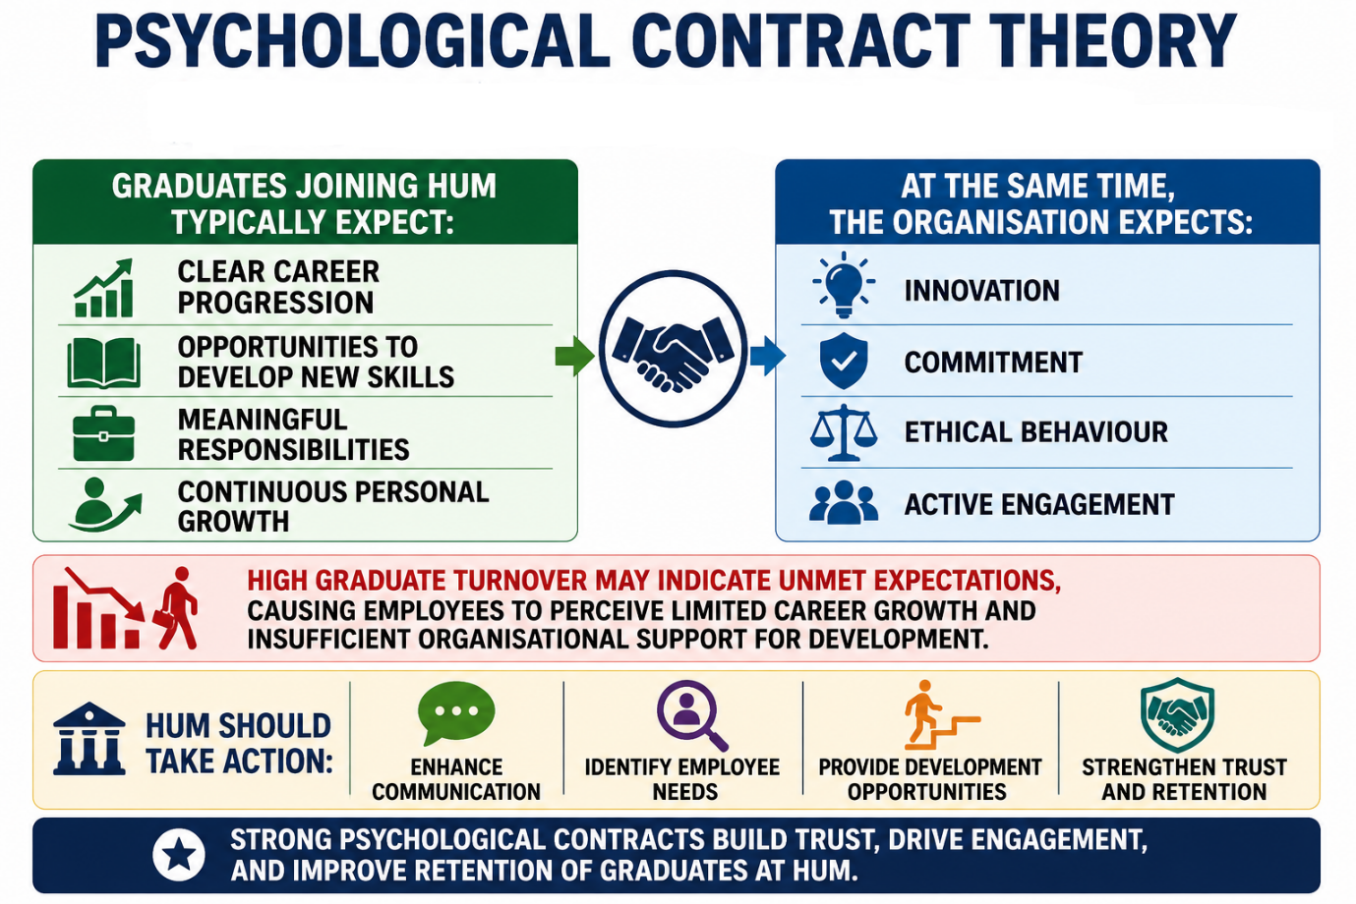

Figure 3: Psychological Contract Theory
(Source: Author)
Identity Construction
Identity construction refers to the process by which employees establish feeling of inclusion by aligning their personal values with organisational goals, consciousness and bonds created within the working environment (Kulshrestha et al., 2024). Likewise, organisational identification adopts a similar tendency which helps employees to develop their sense of self-identity as a part of organisation rather than individualistic (Afshari, 2021). Helios' extended ramp-up period may be associated with job design, leadership, and socialisation challenges, but also it may postpone the formation of the organisational identity among newcomers. But there's no automatic strong identification. Thus, building organisational identity helps build shared purpose, collaboration, sharing, innovation, integration and higher commitment among employees in the long term.

2.2 Proposed Organisational Socialisation Framework for Helios
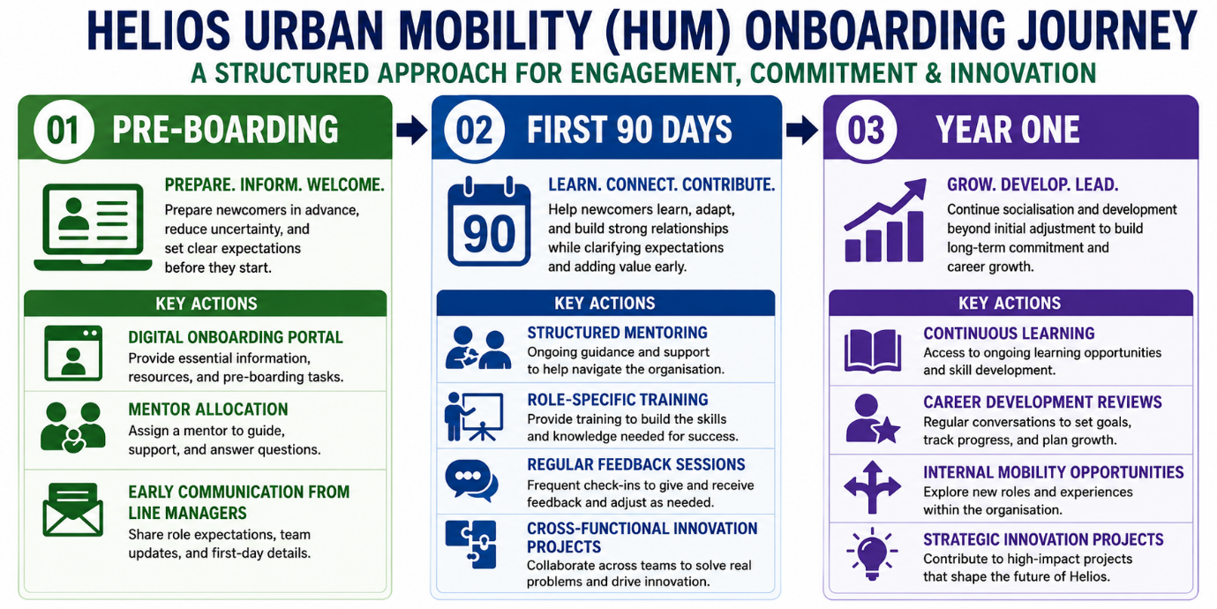

Figure 4: Proposed HUM Strategic Socialisation Framework
(Source: Author)
Pre-boarding
Helios may be able to put together a formal pre-boarding programme such as online pre-boarding system and Mentor allocation, and prompt contact from line managers. This is relevant as it will help to defuse uncertainty and set expectations prior to entering the workplace (Gibson et al., 2023). High levels of pre-boarding activity may help to reduce Helios’s long ramp-up, and the attrition during this period. As a result, employees are more likely to become quickly integrated in the organisation and be committed and innovative from the start.
First 90 Days
During the first 90 days, Helios should adopt formal mentoring, job-specific training, ongoing feedback and cross-functional innovation teams. These practices are suitable due to their ability to facilitate learning, build relationships and specify performance expectations (Riforgiate et al., 2025). This incremental approach targets Helios’ slow employee integrations, low involvement and early graduation dropouts, thus enabling newcomers to acquire organisational confidence, enhance collaboration, foster innovation and strengthen long-term dedication to the organisation.
Year One
In the first year, Helios should continue to follow practices of ongoing learning, career development discussion, internal mobility and involvement in strategic innovation projects. These are adapted to be employed because organisational socialisation is an ongoing process that extends beyond initial socialisation to build long-term commitment (Hosen et al., 2023). This is a practical way to address Helios’ low engagement and excess graduates by providing employees with a way to continue developing and progressing a career. The outcome will be that these employees will stay engaged, develop organisational commitment, get critical skills and contribute to strategic renewal through ongoing innovation.

2.3 Mechanisms to Cultivate Committed Organisational Citizens

2.3.1 Developing Organisational Identification
Helios should build on organizational identification via purpose-led leadership, employee storytelling, mentoring, communities of practice. These can be used since they assist employees to establish personal mission with Helios’ goal of sustainable urban mobility (Ribeiro, Gomes and Ramos, 2024). Hence, by fostering stronger emotional and social bonds among members they are tackling low engagement and slow integration of newcomers. As a result, employees will be more inclined to feel loyal, committed and more like organisational citizens leading to cooperation and creativity.

2.3.2 Ethical Professionalism
Helios may work in the direction of ethical professionalism by implementing responsible AI training, providing workshops on ethics & decision making, and instituting a transparent accountability system. This is suitable because professionals with exposure to AI-enabled mobility systems shape significant social impacts and stakeholder interest (Papagiannidis, Mikalef and Conboy, 2025). Through ensuring an ethical culture daily, Helios can manage the threats of potential technological advancement and responsible management. This hence enables employees to be part of a reliable innovation and may improve reputation with governments, customers and local community.

2.3.3 Developing a Business Activist Mindset
Helios needs to promote a business activist mindset through all forms of employee voice mechanisms, cross-business innovation projects and stakeholder focus activities. This reflects the Ulrich’s strategic HR business partner view and stakeholder capitalism by encouraging employees to bring value not only to their department but also to society (Cuofano, 2021). This is needed to pro-actively solve any issues related to the continuously changing mobility industry. As a result, employees will be part of the organisational strategy, innovation and long-term competitive advantage.
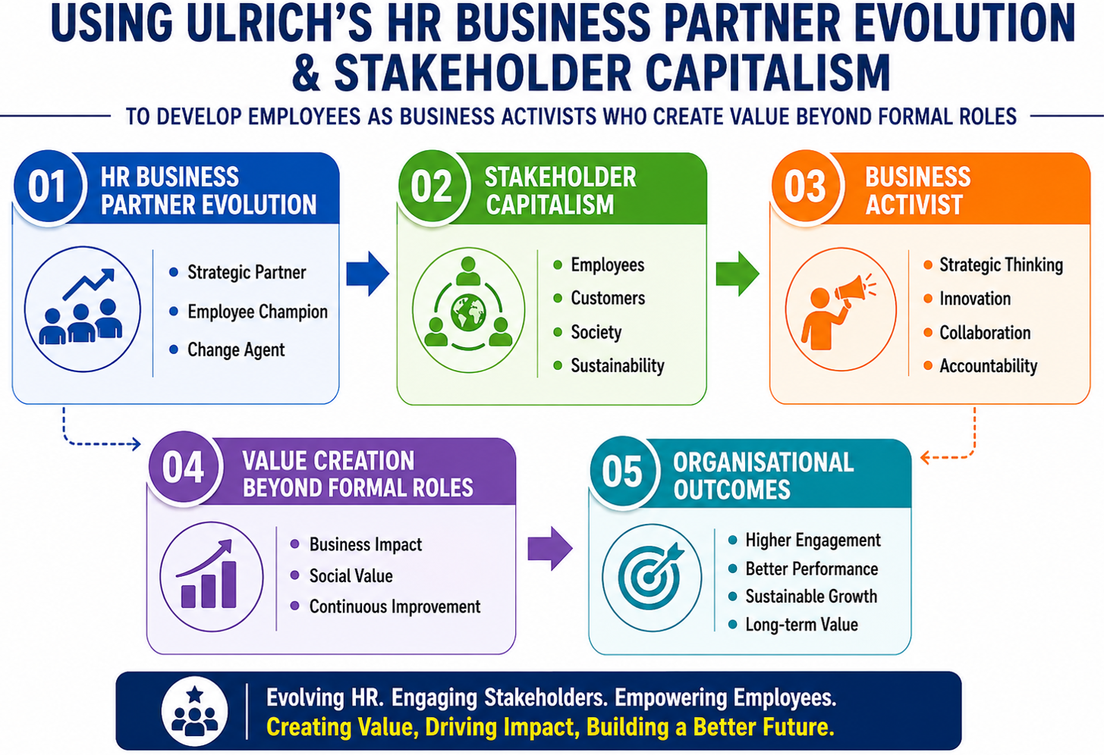

Figure 5: Ulrich’s HR Business Partner evolution
(Source: Author)

3. Task B: Job Design

3.1 Diagnosing Job Design Challenges at Helios
The reduction in Helios Urban Mobility’s engagement, its prolonged employees’ ramp-up time and the high rate of graduates’ attrition could be the indicators of disadvantages of work design practices. Conversely, other significant factors such as leadership, career development possibilities and corporate culture could be the not less important reasons of presented problems (Hosen et al., 2023). The Job Characteristics Model emphasizes the role of autonomy, task identity, task significance and meaningfulness of work in providing intrinsic motivation (Meynhardt, Hermann and Bardeli, 2024). Additionally, job crafting and skills-based approaches may empower staff to self-design their work, tap into internal opportunities and develop future skills. The surrounding conditions of autonomy, variety, support and challenge can promote knowledge sharing, experimentation and collaboration leading to Helios lowering career uncertainty, improving engagement and creating an innovative human capital architecture.

3.2 Proposed Innovative Job Design Strategy

3.2.1 Applying the Job Characteristics Model (Hackman & Oldham)
Helios should participate a Job Characteristics Model by increasing skill variety, task identity, task significance, autonomy and feedback of current jobs. Hackman and Oldham’s Job Characteristics Model define five key elements of a job as follows, they influence the meaningfulness, responsibility and knowledge of results (Cuofano, 2022). These aspects increase experienced meaningfulness, responsibility for outcomes and knowledge of results, strengthening intrinsic motivation (Meynhardt, Hermann and Bardeli, 2024). In Helios innovation focus, increasing autonomy could motivate employees to develop new ideas and greater task significance could strengthen their commitment to avoid relying solely on fossil fuels. In addition, a well-designed feedback system can facilitate continuous learning and quick performance improvements in addition to knowledge sharing, by providing a problem-solving approach and feedback to refine ideas (Crans et al., 2022). As a result, the implementation of Job Characteristics Model can enable Helios to design motivating jobs that increases engagement, initiate innovation process, and develop sustainable human capital capabilities.
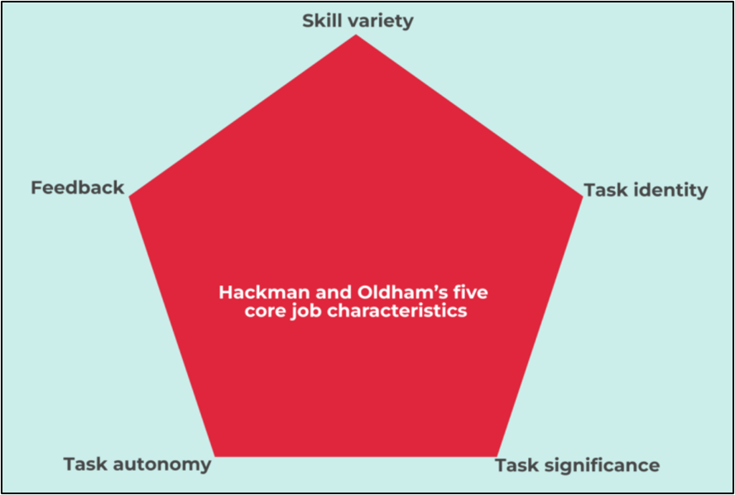

Figure 6: Hackman and Oldham’s Job Characteristics Model
(Source: Cuofano, 2022)

3.2.2 Applying Job Crafting Theory
Helios requires its employees to be empowered to craft jobs through changes in tasks, relations and work methods according to individual talents and career needs. Job crafting theory highlights that fitting job demands and resources to individual’s abilities can enhance meaningfulness (Liu, Peng and Wen, 2023). This strategy will be especially useful to Helios because it could enhance graduate’s involvement, job transparency and the evolution of the ownership of innovation projects. Through job crafting, employees share and learn about the difficulties around their work, communicate their interests in developing a work performance, elaborating new, innovative ideas and solutions (Pinco et al., 2024). Meanwhile, individual job crafting too often may lead to lack of fit among the teams in London, Berlin and Singapore by decreasing the coalesced coordination. Thus, Helios must supply a rule, such as coaching, shared goals, and guiding of leader, to ensure that the job enhancement is equipped with flexible edges.

3.2.3 Skills-Based Architecture and Internal Talent Marketplace
Helios should implement a skills-based architecture via an internal talent marketplace and AI enabled workforce planning to enable a more flexible and adaptive workforce. This is a move beyond roles by resource planning within the organisation based on capabilities, perceiving the right skills, placing people on suitable projects while providing customised career pathways (Yanamala, 2024). This is especially relevant for Helios as it is an AI enabled mobility environment ensuring continual reskilling. It is also a tool to facilitate better skills mapping and forecasting however this must be implemented with trust, transparency and leadership visibility while providing equitable participation in development opportunities (Zervas and Stiakakis, 2025). Human analysis must be employed to ensure no bias in the algorithms. Thus, this approach will enable Helios to reducing attrition of graduates and foster a more committed workforce.

3.3 How the Proposed Job Design Supports Motivation and Innovation

3.3.1 Enhancing Intrinsic Motivation
The job design proposed also positively impacts on intrinsic motivation by raising the levels of employee job autonomy, job importance, job skills and feelings of ownership. The enriched jobs, opportunities for job crafting, and skills utilization careers created can promote feelings of competence and purpose among employees (Popaitoon et al., 2025). These benefits are contingent upon strong leader support, employee preferences, and equal access to development opportunities. Thus, Helios should guarantee proper implementation to support motivation and engagement and promote retention and ongoing employee contribution.

3.3.2 Supporting Innovation through Job Design
The suggested job design fosters innovation through facilitating experimentations, knowledge sharing and collaboration from different functions. Job autonomy allows employees taking initiatives while job crafting offers a field in identifying problems and coming up with creative solutions (Nie et al., 2023). Skills-based talent systems enable Helios to deploy talent where it is most needed. Yet, too much flexibility may cause coordination problems across three teams in London, Berlin and Singapore. Hence, Helios needs to balance autonomy and strategic renewal with shared direction and mechanisms for collaboration.

4. Task C: Reflective report

4.1 Using AI as a Decision-Support Tool While Maintaining Critical Human Judgment
AI is increasingly an important decision-support tool in strategic HR by providing better data analysis, workforce planning and evidence-based decision-making (Bositkhanova and Dadaboyev, 2025). Nevertheless, they should not substitute professional judgement since other elements of HR decision-making such as moral judgment, the organisational framework and interpersonal skills are humans’ contributions. As a result, I am going to employ AI as a supportive tool rather than a replacement of skill in my HR decision-making.

4.1.1 Role of AI in Strategic HR decision-making
In my perspective, AI is beneficial in enhancing my strategic HR decisions by providing analysis of workforce data, showcasing trends, and facilitating improved evidences for some of its HR decisions. For instance, use of predictive analytics would facilitate faster detection of learning requirements, skills shortages and impending turnovers than manual review (Cvescu and Popescu, 2025). However, all AI application ideas need to be directly overseen by HR managers due to legal, ethical and organizational issues.

4.1.2 Balancing AI Insights with Critical Human Judgment
I will examine directions offered by AI along with organisational context, employee and personal factors, professional experience, and judgment. AI has the benefit of speed, cannot account for all factors and can eventually perpetuate bias or poor advice (Bositkhanova and Dadaboyev, 2025). I understand suggestions may be derived from skewed or inadequate data. I will challenge AI advice using alternative reliable evidence, considering stakeholders’ views, and questioning AI prescription prior to HR decision. This should give me the possibility to reach fair, transparent and responsible decision.

4.1.3 My Personal Approach to Responsible AI Use
My plan is to integrate AI in to my role as a strategic HR practitioner to support research and analyse workforce data, and explore alternative HR approaches, while remaining ultimately responsible for decisions taken. Critical evaluation of the recommendations provided by AI, cross reference with reliable academic and business sources, examine ethical considerations is part of my approach before implement the suggested solutions. In addition, colleagues audit and learning to continue developing my AI-awareness, therefore technology rather than innovative thinking would enhance my professional practice.

4.2 Personal Capability Development Plan
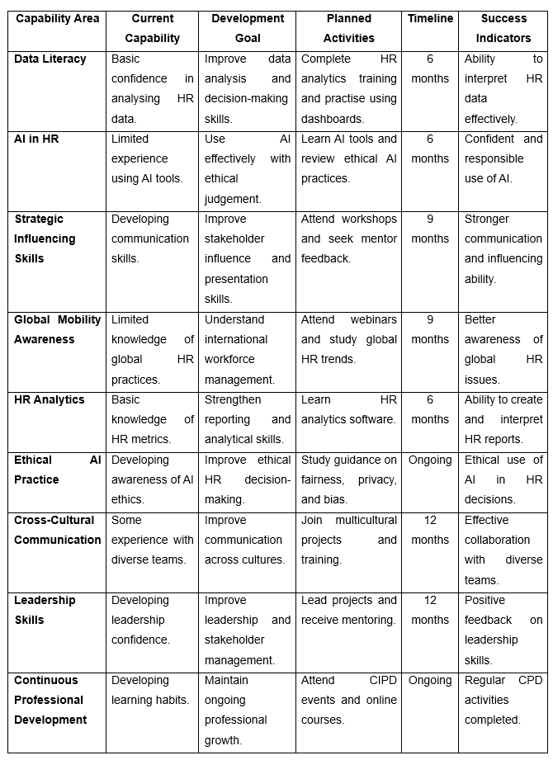

Table 1: Personal Capability Development Plan
(Source: Author)

5. Conclusion
Overall, the report concludes that two methods to improve levels of employee engagement and innovation in HUM are immediate organisational socialisation and innovative job design. In the long run, effective human capital management was encouraged through the development of skill sets in AI, data literacy, strategic effecting and global mobility.

References
Afshari, L. (2021) ‘Identification through meaning-making: Identity enactment towards organizational commitment’, Human Resource Development International, pp.1–22. Available at:https://doi.org10.1080/13678868.2021.1996171
Bauer, T.N., Erdogan, B., Ellis, A.M., Truxillo, D.M., Brady, G.M. and McCarthy, J.M. (2025) ‘The Evolving Future of Work: Implications for Newcomer Adaptability and Connectivity During Organizational Socialization’, Human Resource Management. Available at: https://doi.org/10.1002/hrm.70008
Bositkhanova, N. and Dadaboyev, S.M.U. (2025) ‘Revolutionizing workforce planning: The strategic role of AI in HR strategy’, Discover Global Society, 3(1). Available at: https://doi.org/10.1007/s44282-025-00252-y
Căvescu, A.M. and Popescu, N. (2025) ‘Predictive Analytics in Human Resources Management: Evaluating AIHR’s Role in Talent Retention’, AppliedMath, 5(3), p.99. Available at: https://doi.org/10.3390/appliedmath5030099
CIPD (2024) CIPD | New starter no-shows: Over a quarter of UK employers have been ghosted by new recruits on day one. Available at: https://www.cipd.org/en/about/press-releases/over-quarter-of-uk-employers-been-ghosted-by-new-recruits-day-one/ [Accessed 14 July 2026].
Crans, S., Aksentieva, P., Beausaert, S. and Segers, M. (2022) ‘Learning leadership and feedback seeking behavior: Leadership that spurs feedback seeking’, Frontiers in Psychology, 13(1). Available at: https://doi.org/10.3389/fpsyg.2022.890861
Cuofano, G. (2021) Ulrich Model In A Nutshell. Available at: https://fourweekmba.com/ulrich-model/ (Accessed: 14 July 2026).
Cuofano, G. (2022) Hackman and Oldham’s Job Characteristics Model. Available at: https://fourweekmba.com/job-characteristics-model/ (Accessed: 14 July 2026).
Didion, E., Perello-Marin, M.R., Catala-Perez, D. and Ambrosius, U. (2024) ‘Mapping the organizational socialization and onboarding literature: A bibliometric analysis of the field’, Cogent business & management, 11(1). Available at: https://doi.org/10.1080/23311975.2024.2337957
Dumitriu, S., George, B.C., Vărzaru, Anca Antoaneta, Al-Floarei, Andreea Teodora, Maria, S.N., Popescu, F.L. and Băloi, I.-C. (2025) ‘The Role of the Workplace Environment in Shaping Employees’ Well-Being’, Sustainability, 17(6), p.2613. Available at: https://www.mdpi.com/2071-1050/17/6/2613
Galema, G., Duvivier, R., Pols, J., Jaarsma, D. and Wietasch, G. (2022) ‘Learning the ropes: Strategies program directors use to facilitate organizational socialization of newcomer residents, a qualitative study’, BMC Medical Education, 22(1). Available at: https://doi.org10.1186/s12909-022-03315-9
Gibson, C.B., Gilson, L.L., Griffith, T.L. and O’Neill, T.A. (2023) ‘Should employees be required to return to the office’, Organizational Dynamics, 52(2), p.100981. Available at: https://doi.org10.1016/j.orgdyn.2023.100981
Helios (2020) Towards a new generation of electric battery packs | Helios.. Available at: https://www.helios-h2020project.eu/ (Accessed: 14 July 2026).
Hosen, S., Hamzah, S.R., Arif Ismail, I., NoormiAlias, S., Faiq Abd Aziz, M. and Rahman, M.M. (2023) ‘Training & development, career development, and organizational commitment as the predictor of work performance’, Heliyon, 10(1), p.e23903. Available at: https://doi.org/10.1016/j.heliyon.2023.e23903
Kulshrestha, R., Sengupta, S., Sahay, A. and Chandra, Y. (2024) ‘Process Typologies of Identity Construction in Entrepreneurship’, The Journal of Entrepreneurship, 33(2), pp.293–329. Available at: https://doi.org/10.1177/09713557241255404
Liu, G., Peng, H. and Wen, H. (2023) ‘How self-leadership promotes job crafting: Based on the perspective of self-determination theory’, Frontiers in Psychology, 14. Available at: https://doi.org/10.3389/fpsyg.2023.1079196
Mebratie, E., Shanbel, B., Awoke, A. and Dessalegne, B. (2025) ‘Knowledge-based human resource management practices and organizational performance in selected universities of Amhara regional state, Ethiopia: The moderating effect of intellectual capital’, Cogent Business & Management, 12(1). Available at: https://doi.org/10.1080/23311975.2025.2491688
Meynhardt, T., Hermann, C. and Bardeli, J. (2024) ‘Connecting value creation for society with work engagement: The relevance of an organization’s public value as an extension of the job characteristics model’, Current Psychology. Available at: https://doi.org/10.1007/s12144-024-05922-9
Nie, T., Tian, M., Cai, M. and Qiao, Y. (2023). Job Autonomy and Work Meaning: Drivers of Employee Job-Crafting Behaviors in the VUCA Times. Behavioural Sciences, 13(6), pp.493–493. Available at: https://doi.org/10.3390/bs13060493
Papagiannidis, E., Mikalef, P. and Conboy, K. (2025) ‘Responsible artificial intelligence governance: A review and research framework’, The Journal of Strategic Information Systems, 34(2). Available at: https://doi.org/10.1016/j.jsis.2024.101885
Pinco, O., Salanta, I.I., Beleiu, I.N. and Crisan, E.L. (2024) ‘The onboarding process: A review’, Vilakshan - XIMB Journal of Management, 22(1). Available at: https://doi.org/10.1108/xjm-01-2024-0008
Popaitoon, S., Mumi, A., Popaitoon, P. and Li, X. (2025) ‘The roles of job crafting, person-job fit and work engagement: New generation employees towards entrepreneurial intention’, Asia-Pacific Journal of Business Administration, pp.1–20. Available at: https://doi.org/10.1108/apjba-03-2025-0154
Ribeiro, M.F., Gomes, C. and Ramos, F.R. (2024) ‘Exploring Purpose-Driven Leadership: Theoretical Foundations, Mechanisms, and Impacts in Organizational Context’, Administrative sciences, 14(7), pp.148–148. Available at: https://doi.org/10.3390/admsci14070148
Riforgiate, S.E., Ruh, C., Ibiwoye, C., Zinia, J.F. and Nartey, G.M. (2025) ‘Mentoring in and Across Work Organizations’, Encyclopedia, 5(4), p.169. Available at: https://doi.org/10.3390/encyclopedia5040169
Türk, A. and Udum, O.E. (2025) ‘Understanding how organizational socialization shapes organizational commitment: A qualitative study in the aviation industry’, Acta Psychologica, 262, pp.106115–106115. Available at: https://doi.org/10.1016/j.actpsy.2025.106115.
Yanamala, K.K.R. (2024) ‘Strategic Implications of AI Integration in Workforce Planning and Talent Forecasting’, Journal of Advanced Computing Systems, 4(1), pp.1–9. Available at: https://doi.org/10.69987/jacs.2024.40101
Zervas, I. and Stiakakis, E. (2025) ‘HRM Strategies for Bridging the Digital Divide: Enhancing Digital Skills, Employee Performance, and Inclusion in Evolving Workplaces’, Administrative Sciences, 15(7), p.267. Available at: https://doi.org/10.3390/admsci15070267

