

BA BUSINESS MANAGEMENT
ALIGNMENT 1

LCBB6002
International Financial Management
Studen name:Mihael Velikov
Student ID:2123841
Lecturer name: Andrew Rakatovololona

Managing Foreign Exchange Risks: Strategies for Multinational Corporations

Table of Contents

1. Introduction 2
2. Theoretical Framework of International Financial Management 2
3. Strategies for Managing Foreign Exchange Risks 3
3.1 Natural Hedging 4
3.3. Operations Strategies 4
3.4. Variety 5
3.5: Exposure Netting 5
4. Empirical Evidence and Case Studies 6
5. Critical Evaluation of Strategies 6
6. Case Study on Rolls-Royce Holdings 7
7. Conclusion 7
References 8

Introduction
Global Multinational companies must handle foreign exchange risk. These firms are susceptible to exchange rate movements because they trade, invest, and borrow worldwide. Volatility may hurt profits, financial flows, and economic security. MNCs may stay competitive and financially stable by controlling foreign exchange risk.
Multinational companies have many tools to manage foreign exchange risk. We'll start with foreign currency risk and its causes. Second, foreign exchange risk management includes operational procedures, financial swaps, and hedging (Collings, Mellahi and Cascio, 2019). The benefits and cons of these tactics will be discussed at the end. Proactive risk management makes international firms more stable, profitable, and long-lasting. MNCs must manage foreign exchange risk in today's global economy, which is difficult.
- Theoretical Framework of International Financial Management
Exchange rates, risk management, and exposure are explained by theoretical frameworks and models in international financial management.

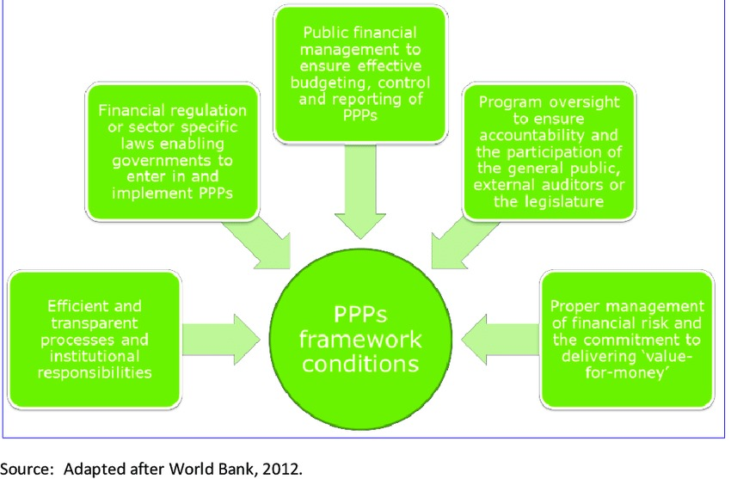
Figure 1: Purchasing power parity (PPP)
(Source: Cooke et al., 2019)
PPP is well-known. It says exchange rates should adjust to match pricing for the same goods and services across countries—changes in a country's long-term exchange rate affect inflation.
An important model is Interest Rate Parity (IRP). It says that spot exchange rate changes should cancel out country interest rate changes so foreign currency dealers can't take advantage of trading opportunities. To understand interest and exchange rates, study IRP.
Businesses that trade internationally face transaction, translation, and economic foreign exchange (Cooke et al., 2019). Transaction exposure originates from foreign currency contracts, while translation exposure comes from exchange rate movements that affect financial account consolidation. Currency fluctuations harm cash flow and competitiveness. The economy is like this.
Forward contracts, options, and swaps assist MNCs manage risk. Exchange rate fluctuations affect cash flows, profitability, and financial soundness. These methods reduce its effects. Understanding these academic theories and models helps you create strong foreign financial management plans for multinational companies.

Strategies for Managing Foreign Exchange Risks

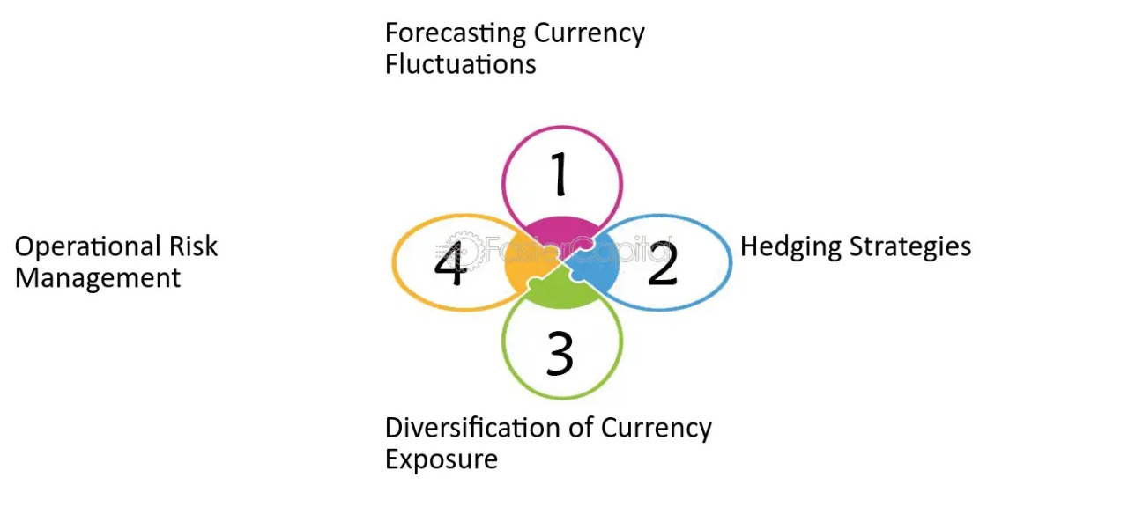
Figure 2: Operations Strategies foreign exchange risks
(Source: Kobrin, 2022)

Natural Hedging
Natural hedging reduces foreign currency risks by matching spending and income across currencies. Doing things like multinational companies reduces currency risk automatically.
Imagine a US company operating in Europe and Asia. Consider a US-based corporation with European and Asian operations. The corporation benefits from natural hedging if its European unit earns euros and its Asian subsidiary spends yen. Euro strength versus the US dollar brings in more European money (Eduardsen and Marinova, 2020). The yen may weaken, lowering Asian company costs. This reduces currency fluctuations and boosts the company's finances.
3.2. Money Hedging
Financial hedging uses options, swaps, forward contracts, and futures contracts to manage foreign exchange risks.
- Forward contracts: MNCs can lock in an exchange rate for future currency transactions. An adverse exchange rate change is less likely. They're not flexible because the exchange rate is established at the start.
- Futures contracts: Futures contracts lock in currency rates like forward contracts protect multinational firms. Market-sold standard contracts. More liquid, but counterparty risk.
- Options: A "call option" allows a buyer to purchase or sell a currency at a predetermined price within a specific time frame, but they are not compelled to. Options provide you with alternatives, but fees increase trading costs.
- Swaps: A currency swap involves trading one currency for another at the current exchange rate and then trading them again. This simplifies financial and translation risks for MNCs.
Each sort of financial protection has merits and downsides (Kobrin, 2022). They protect you from adverse currency value movements, but they are pricey and may not eliminate currency risk.
3.3. Operations Strategies
Operational strategies manage foreign exchange risks by changing corporate operations.
- Invoice currency: MNCs can negotiate contracts and invoices in their functional or safe currency to reduce transaction risk.
- Leading and lagging: MNCs may utilise currency projections to speed up or slow down agreements, decreasing exchange rate risks, by carefully managing money transfers.
- Strategic sourcing: Having sources in many countries or regions may disperse currency risk and reduce the impact of dollar fluctuations on input prices.
Operational techniques can enhance risk control in financial trading.
3.4. Variety
Businesses may reduce their currency and market dependence by diversifying across several markets or product categories.
- Geographic diversification: Doing business in numerous countries with diverse currencies and economic circumstances helps reduce the impact of dollar fluctuations on company success.
- Product diversification: If you sell different products and services in different regions, you may be able to prevent losing money when the dollar fluctuates, which could damage certain product lines or groups.
Multinational companies mitigate foreign exchange risk by diversifying across currencies and markets (McMaster et al., 2020).
Part 3.5: Exposure Netting
Financial risks are masked via exposure netting.
Paying and borrowing in several currencies might help a corporation balance its currency risks. Exchange risk can decrease. Exposure netting lets you see your net exposure across all currencies instead of just one account, making currency management and swap selection easier.
Diversification, operational strategies, exposure netting, natural hedging, and financial hedging help multinational organisations manage foreign exchange risks. Every method has merits and cons, and the ideal balance depends on the business plan, risk tolerance, and market conditions (Shapiro and Hanouna, 2019). A good risk management plan could make MNCs more competitive globally and reduce the impact of currency fluctuations on their profits.

Empirical Evidence and Case Studies
Real-world statistics and case studies indicate that UK international enterprises have handled foreign exchange risks in various ways.
British medicine company GlaxoSmithKline (GSK) combines nature and economy. Global corporation GSK uses and produces money in several currencies. GSK automatically protects itself from pound fluctuations by aligning its cost structures and income streams. Forward contracts and options reduce firm currency rate risks (Van Tulder et al., 2021). These approaches helped GSK profit during currency market volatility, according to its financials.
Unilever, a UK consumer goods company has foreign exchange risk management. Unilever deliberately buys many raw materials and parts. Diversifying its supplier network decreases currency risk. For transaction security, the firm negotiates contracts and delivers bills in secure currencies. Financial statistics illustrate how Unilever's business strategies help it weather currency swings and stay profitable.
These case studies show the need for a comprehensive risk management strategy tailored to multinational firms' business and financial needs. Operational, financial, and natural hedging help UK multinationals manage foreign exchange risks and compete globally.

Critical Evaluation of Strategies
Each foreign exchange risk management strategy has merits and cons.
Natural hedging uses multinational organisations' business practices to decrease currency risk cheaply. However, it may not fully safeguard against exchange rate changes, especially for enterprises with few international operations.
Forward contracts, options, and swaps can minimise risk, but premiums, fees, and the risk of losing money if exchange rates fluctuate negatively make them pricey (Cooke et al., 2019). They must be implemented by experts to work.
Billing currency and strategic purchases offer possibilities for financial balancing. They may not eliminate risk and make management harder.
Diversification reduces a company's dependence on one market or currency. Diversification is effective, but smaller MNCs may not have the money or time.
Exposure netting can simplify currency management and improve trading decisions, but it requires extensive risk assessment and monitoring tools.
Risk-taking, financial resources, regional reach, business models, and laws are key to the company's strategy (Eduardsen and Marinova, 2020). To manage foreign exchange risks while balancing costs and advantages in various business conditions, MNCs must carefully consider these elements.

Case Study on Rolls-Royce Holdings
UK aerospace and military corporation Rolls-Royce Holdings is an example. Rolls-Royce organically and financially hedges forex risks. The company operates globally and tracks income and expenses in multiple currencies. Coordinating production and buying to match multi-currency sales is a natural hedge. For large, long-term contracts, Rolls-Royce uses forward contracts and options to hedge foreign rates. For years, Rolls-Royce has hedged against global uncertainty and demand swings to maintain cash flow and sales (Van Tulder et al., 2021). According to some, the corporation overheated, missing out on currency rate gains. The Rolls-Royce case study indicates that natural and financial hedging should be balanced for foreign exchange risk, considering the pros and cons.

Conclusion
Multinational organisations must control foreign exchange risks in their international financial management. Currency volatility can be reduced via operating methods, diversification, exposure netting, natural hedging, and financial hedging. Case studies of UK corporations like Rolls-Royce demonstrate the importance of balanced risk management using natural and financial hedging. Good risk management keeps profits and cash flows consistent and makes a company more competitive globally. Future research should focus on risk management innovations, how global events affect currency markets, and how well hedging techniques function in different economic scenarios. Investigating how blockchain and AI may be utilised in foreign currency risk management could help multinational businesses (MNCs) adapt to the fast-changing finance sector.

References
Collings, D.G., Mellahi, K. and Cascio, W.F. (2019). Global Talent Management and Performance in Multinational Enterprises: A Multilevel Perspective. Journal of Management, 45(2), pp.540–566. doi:https://doi.org/10.1177/0149206318757018.
Cooke, F.L., Wood, G., Wang, M. and Veen, A. (2019). How far has international HRM travelled? A systematic review of literature on multinational corporations (2000–2014). Human Resource Management Review, 29(1), pp.59–75. doi:https://doi.org/10.1016/j.hrmr.2018.05.001.
Daniels, J.D., Radebaugh, L.H. and Sullivan, D.P. (2019). International Business: Environments and Operations. [online] thuvienso.hoasen.edu.vn. Pearson. Available at: https://thuvienso.hoasen.edu.vn/handle/123456789/10494.
Eduardsen, J. and Marinova, S. (2020). Internationalisation and risk: Literature review, integrative framework and research agenda. International Business Review, [online] 29(3), p.101688. doi:https://doi.org/10.1016/j.ibusrev.2020.101688.
Kobrin, S.J. (2022). Managing Political Risk Assessment: Strategic Response to Environmental Change. [online] Google Books. Univ of California Press. Available at: https://books.google.com/books?hl=en&lr=&id=kKxhEAAAQBAJ&oi=fnd&pg=PR11&dq=Title:+Managing+Foreign+Exchange+Risks:+Strategies+for+Multinational+Corporations+&ots=gvoUWZ_h68&sig=qrPVpoy1TdrVQCsXFtHQ3R27WZ8 [Accessed 26 Mar. 2024].
McMaster, M., Nettleton, C., Tom, C., Xu, B., Cao, C. and Qiao, P. (2020). Risk Management: Rethinking Fashion Supply Chain Management for Multinational Corporations in Light of the COVID-19 Outbreak. Journal of Risk and Financial Management, [online] 13(8), p.173. Available at: https://www.mdpi.com/1911-8074/13/8/173/htm.
Shapiro, A.C. and Hanouna, P. (2019). Multinational Financial Management. [online] Google Books. John Wiley & Sons. Available at: https://books.google.com/books?hl=en&lr=&id=gDLDDwAAQBAJ&oi=fnd&pg=PR19&dq=Title:+Managing+Foreign+Exchange+Risks:+Strategies+for+Multinational+Corporations+&ots=hgC_wsMxCs&sig=QszCeFOrU8oJiKXRRaJAL5bQ3-Q [Accessed 26 Mar. 2024].
Van Tulder, R., Rodrigues, S.B., Mirza, H. and Sexsmith, K. (2021). The UN’s Sustainable Development Goals: Can multinational enterprises lead the Decade of Action? Journal of International Business Policy, 4(1). doi:https://doi.org/10.1057/s42214-020-00095-1.

