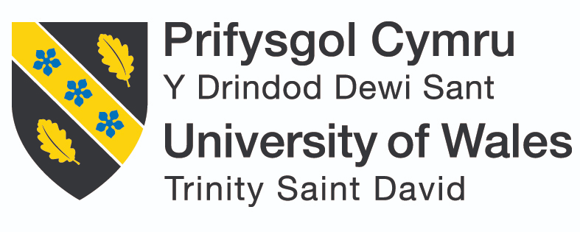

Case Study Report
By
Name: Pavlina Pavlova
Student ID: 2133271
Course: BA Leadership and Management
Module: Developing Workplace Critical Thinking
Module code: BMSW5101_BIRM
Module leader: Rebecca Stewart
UWTSD Birmingham

Contents
Introduction 3
Ethics in the workplace 3
Case Study overview of issues 4
Conclusion 5
Reference list 6

Introduction

This research defines "workplace ethics" as the combination of beliefs, attitudes, and values nurtured within an organization's work environment. We have used authoritative people's opinions on this topic for our analysis of these terms specified below. Our argument progresses with a discussion on Taylor Mason Plc- an eminent player involved in food retailing; we bring forth their case experience for further clarification. In subsequent chapter/s after this one you can read about how employees or customers grappled through ethical challenges because of their association with such companies which makes them exceedingly important stakeholders for these organizations who must act sensibly towards them; then comes our analysis about different outcomes (positive or negative) that may result from company's actions.

Ethics in the workplace

The intricacies of contemporary business surroundings afford workers several avenues for career growth and skill development. As such, it becomes imperative to consider how an employee's convictions, principles, and outlooks can impact their drive towards excellence. (Moise C., 2014).
Beliefs on the workplace
A belief is a mental state or behavior in which one has faith or confidence in someone or something (Meriamm Webster, 2023). A belief system is an explicit collection of organizational definitions that senior managers formally communicate and continually reinforce in order to give the organization's core values, purpose, and direction recording to Gerald A Cole and Phil Kelly (p.661, 2020).
The scenario that follows serves as an illustration of workplace beliefs. An Employment Tribunal determined that the British National Party was "peculiar" in Baggs v. Fudge, considered at a time when the 2003 Regulations expressly limited their protection to "religion, religious belief, or similar philosophical belief," and thus rejected an employee's claim that he had been discriminated against because he was a member. In contrast, British nationalism was disregarded as a philosophical perspective in Finnon v. Asda Stores Ltd. Claiming it did not replicate major religions (Clark P., 2013).
Values on the workplace
Workplace values are opinions or standards pertaining to a job or line of work. They discuss the issues that the workers feel are important to their careers (Water S., 2021). The guiding principles that are most significant to an employee regarding their working style are the workplace values. These firmly held beliefs serve as a guide for significant decisions and career decisions, helping them distinguish between the proper and improper ways of working (Mind Tools Content Team, 2023).
Here is an illustration of value in the workplace. Adidas' core values, also referred to as the 3Cs, are a group of attitudes that the company wants its employees to exhibit. Their guiding principles are self-assurance, teamwork, and creativity (Rossini F., 2023).
Attitude on the workplace
A working attitude refers to the feelings or behaviors an employee has towards the various aspects of the workplace. A positive attitude towards work is crucial in the workplace. Generally speaking, job satisfaction and organizational commitment are the two factors that can impact working attitude (Khun P., 2020).
Good Attendance and Punctuality are excellent examples of workplace courtesy. The employee's presence at the office and punctuality allows you to trust that he or she will be there each day. Employers are all too familiar with employees who frequently arrive late with a variety of excuses, possibly missing or at least being late for early morning meetings; therefore, an employee who is punctual and available will provide relief (Cooper M., 2019).

Case Study overview of issues

The ongoing cost of living crisis has had an enormous effect resulting in the company's shares experiencing a significant downturn. As a result, major investors have decided to sell their holdings with media reports bringing up questions on the viability of this organization moving forward. One consequence of such change involves moral challenges for clients and employees outlined within this case study. For employees in particular, it is expected that they almost always embody the values and mission as set out by this company even not knowing what is coming about financially; employees may find themselves under duress leading them to start considering compromises or other unethical shortcuts simply to attain their objectives or safeguard their jobs thereby losing sight of core principles.

Customers have the power and responsibility towards deciding whether a company's pricing policies contribute negatively towards escalating living costs; thus when making purchasing decisions should opt-in for service providers with fairer policies. It's valid that you may feel concerned about their maintaining high-quality products given their current economic state. However, integrity represents an essential trait for workers and consumers alike as common contributors towards society's betterment by promoting ethical practices regardless of external factors—today more than ever necessary considering recurring issues affecting environmental concerns and social justice matters. Businesses that emphasize sustainability and fair labor standards deserve patronage from consumers who support those same principles. Similarly, employees ought to weigh whether they should stand by an employer whose values diverge from their own moral framework Based on one's personal code of ethics if supported organization is crossing the line then individuals may decide either voicing concern about dubious behavior or depart altogether from job inflicting no harm on themself by doing so ultimately managing complicated ethical situations means taking difficult positions situating moral rectitude above mere ease or financial advantages Every person plays a role building an honest society regardless of whether as a customer or employee which involves owning up responsibility for their choices and actively contributing to an ethical future.

Conclusion

The report concludes by highlighting the pressing need for embracing morality and integrity in decision-making despite existing gaps. It recommends prioritizing these essential traits within corporate policies while urging individuals to take full responsibility for their conduct. Further emphasized is how working together towards creating an ethical society can enhance present-day living conditions as well as impact future generations positively. While working in such a community might come with hurdles, it remains profoundly beneficial.

Reference list

- Moise C. (2014), Importance of Beliefs, Attitudes and Values in the Frame of Human Resource Motivation, Available in: https://www.researchgate.net/publication/319228393_Importance_of_Beliefs_Attitudes_and_Values_in_the_Frame_of_Human_Resource_Motivation (Accessed: 3rd of June 2023)
- Gerald A Cole and Phil Kelly (2020), Management Theory and Practice. Andover: Cengage Learning. Available at: https://search-ebscohost-com.ezproxy.uwtsd.ac.uk/login.aspx?direct=true&db=nlebk&AN=2639388&site=ehost-live (Accessed: 4 June 2023).
- Clark P. (2013), Beliefs in the workplace,12th of April, Available at: https://bdaily.co.uk/articles/2013/04/09/beliefs-in-the-workplace , (Accessed: 4th of June 2023)
- Meriamm Webster (2023), Belief, Available at: https://www.merriam-webster.com/dictionary/belief#:~:text=%3A%20something%20that%20is%20accepted%2C%20considered,tenets%20held%20by%20a%20group (Accessed: 2nd of June 2023)
- Mind Tools Content Team (2023), Understanding Workplace Values, Available at: https://www.mindtools.com/ayjltrz/understanding-workplace-values (Accessed: 31st of May 2023)
- Rossini F. (2023), 45 company core values examples and steps to identify yours, 30th Of January, Available at: https://www.betterup.com/blog/core-values (Accessed: 1st of June 2023)
- Khun P. (2020), What is Working Attitudes?, 28th January, Linkiln Team, Available in: https://www.linkedin.com/pulse/working-attitude-refers-feeling-we-have-display-towards-pisey-khun#:~:text=Working%20attitude%20refers%20to%20the,may%20influence%20the%20working%20attitude. (Accessed:3rd of June 2023)
- Cooper M. (2019), Examples of Good Employee Behavior, 31st of January, Available at: https://smallbusiness.chron.com/happier-workplace-39412.html (Accessed: 4th of June 2023)

