Name: Nayani Gayathrika Gamage
Student No: 2222070
Module: BMMB7007

Table of content

Executive Summary

Human Resource Management goes all the way back more than two hundred and fifty years, when the industrial revolution occurred around 1800 (Simms, 2022). The company's success is intimately tied to the performance of its employees (Pavlović, 2021). Therefore, Human Resource Management performs an important function within the organisational structure. This assignment will cover the most significant component of Human Resources Management, which is the Recruiting, Selection, and Onboarding Process. This study was carried out for the Majid Al Futtaim Organization in the United Arab Emirates. This research will conduct a thorough examination of the company's current Recruiting, Selection, and Onboarding Process. Nonetheless, based on current practises, the author will critically evaluate the benefits and drawbacks of the current process and provide recommendations.

- Introduction
An organisation is composed of a number of departments. Every department contributes equally to the achievement of the corporate objective. However, Human Resources Management has a substantial commitment to contribute to the achievement of corporate objectives and the well-being of employees. The definition for Human Resource Management (HRM) is;
“A process of bringing people and organizations together so that the goals of each are met. It is part of the management process which is concerned with the management of human resources in an organization. It tries to secure the best from people by winning their wholehearted cooperation. In short, it may be defined as the art of procuring, developing and maintaining competent workforce to achieve the goals of an organization in an effective and efficient manner.”
Mahapatro (2022)

However, HRM falls within the purview of the HR Department; hence, the HR Department is always in the spotlight as it engages in a never-ending battle with individuals and procedures. HR department has the shared responsibility to screening the right fit for the organization. The recruitment process is a shared responsibility between the HR department and the respective department (Ekwoaba, Ikeije and Ufoma, 2015). Still, the HR department is responsible for the recruiting, selection, and onboarding of new employees. This study examines the significance of the recruitment, selection, and onboarding processes of Majid Al Futtaim LLC.

Figure 01 - Company Logo

Source: Majid Al Futtaim website

There are five primary sections in this document. The first section of the report provides the introduction and the background of the report. The second section will describe the organizational overview. The third section addresses the assignment's subject, which is recruiting, selection, and onboarding process of the organisation. The study's conclusion is presented in the fourth section, and the study's recommendations are presented in the final section.
- Organisational Overview
This study analyses the recruiting, selection, and onboarding processes for Majid Al Futtaim (MAF) Holding, a Dubai, United Arab Emirates-based company. MAF has a total of 42,000 full-time employees representing 110 nationalities, and the firm operates in 17 countries. (Please refer Annexure.01 for company’s structure and subsidiaries). The company has a centralised human resource management policy that applies across the entire group.
Figure 02 – Vision of founder

Mr.Majid Al Futtaim (Source:Majid AL Futtaim website)
The Human Resources Director reports to the Group Chief Executive Officer (C.E.O). Nonetheless, each subsidiary has a Human Resources Manager who reports directly to the Human Resources Director. All employment-related tasks and employee well-being are the responsibility of the HR department. (Please refer Annexure.02 for HR Department Responsibilities and Tasks).). Human Resources Management will cost AED3,888 million in 2022, accounting for 15% of overall operating expenditures. Humas Resources Management is critical to the company. Human resources management is with the personnel from onboarding through exit interviews, supporting them to do their jobs efficiently. (Please refer Annexure.03 for organizational HRM structure). Human Resources Management is focused across the organisation to establish a defined vision, goal, and objectives.
Figure 03 – Majid Al Futtaim Brands
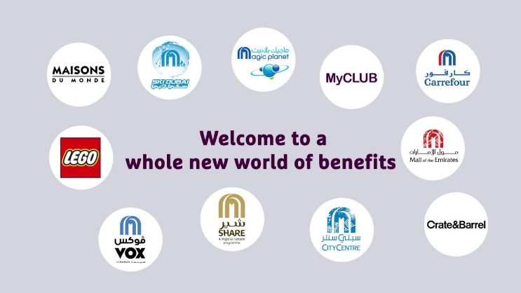
Source: Majid Al Futtaim website
- Majid Al Futtaim - Recruitment, Selection and Onboarding Process
In comparison to the ancient times, every organisation in the modern era places greater importance on human resource management (Ekwoaba, Ikeije and Ufoma, 2015). Organisation considers human resources to be a vital aspect of the entity, and if it prioritizes their well-being and provides them with sustainable perks and advantages, they will return efficiency at work, which will enhancing the company's performance (Pavlović, 2021; Cloutier, Felusiak, Hill and Pemberton-Jones, 2015). Therefore, it is crucial to hire the perfect applicant for the position. Employee onboarding is related to employee contentment, which is correlated with employee retention and employee turnover (Kirchner and Stull, 2022). Hence, the organization's recruiting, selection, and onboarding processes are the most crucial aspect of human resource management.

3.1 Analyse the Recruitment, Selection and Onboarding Process at MAF
Refer to the literature, new hiring can be happened due to various reasons (Anderson, 2022; Kirchner and Stull, 2022).
- Resignation/ Redundant/ Retirement of the current employees
- While the company is expanding
- Strategical changes in the organization (Eg: Company adopting digitalization)

3.2 Recruitment Process at MAF
Majid Al Futtaim is also hiring new employees for the reasons stated above. The first process in the recruiting process begins when a request is received from the respective department, with the human resources department requesting a "Requirement Form," with the HR department evaluating the cause for new hire. The department head should provide justification at this time. I've seen that occasionally we don't need a new employee since current workers can share the workload. But the department head has requested a new employee since there is a budget for it. This scenario, in my opinion, is attempting to manipulate present practice. The HR Department should do due diligence and examine the realistic requirements of the new employee before hiring them for the purpose of budget availability. The recruitment process is critical at Majid Al Futtaim since we have retail businesses (fashion stores and supermarkets) that demand personnel with a positive attitude. Since the organization is situated in an Arabic country, there is no opportunity for an employee union or other forms of disobedience (Mahajne, 2023). After receiving the "Requirement Form," the Human Resources department will advertise the position internally and attempt to fill it within the company. There are advantages to replacing the position internally rather than recruiting from outside (Wilden, Gudergan and Lings, 2010; Mohâ, 2023).
Advantages of internal employees’ replacement:
- There are no agency fees or recruiting costs.
- No training is required (As the employee has understanding of the organization, may be on the job training can be provided)
- The organisation will not suffer as a result of the departure of employees.
- Since the employee is aware of the corporate culture, there is no need for the employee to conduct specific training.

Case Study: The HR Department prioritises known persons when employing internal workers. For example, Majid Al Futtaim (Ventures), Finance Department gave an internal transfer to an employee who works at Majid Al Futtaim (Leisure & Entertainment) ticket’s counter. The individual does not meet the qualifications for the post. Nonetheless, he is known to the Director of Risk and Compliance. He was able to get a job as a Financial Accountant as a result of that influence.
Case Study: Since the company is located in an Arabic-speaking nation, they adhere to the Emiratization policy (Means, they encourage to hire UAE nationalities). Therefore, if an expatriate meets the qualifications throughout the internal recruiting procedure, the firm will prioritise UAE native personnel. Even although UAE national employees may not be competent at their jobs, the company would encourage and motivate them to continue working.

If the post cannot be filled internally within a month, they will hire an external applicant. The company will post employment openings on popular job websites such as LinkedIn, indeed, and Gulfjobs. Majid Al Futtaim has adopted RPA (Robotic Process Automation) for shortlisting and screening CVs generated by these platforms. After the AI (Artificial Intelligence) system has shortlisted the CV according to the basic criteria, the HR Executive will submit the top 10-20 CVs to the respective department head for additional screening and short listing. According to HR Policy, the HR Department shall unreservedly encourage and assist the department in its efforts to select the finest and most qualified applicant for the post.

3.3 Selection Process at MAF
Once respective department has compiled a shortlist, the CV's HR department will schedule interviews. There will be at least two to three interviews can take place. According to Schindler (2022), interviews may occur in a variety of forms, including informative interviews and open talks that lead to critical dialogues (Schindler, 2022). At Majid Al Futtaim, they conduct first interview over the phone by HR executive (Mostly this will be done by Talent Hiring Executive) and that would call the first screening test. In that conversation HR department will have conclude the basic information of the candidate such as salary expectations, notice period and travelling location. The second interview will be done by the respective department. Mostly the second interview can be a written exam or f2f (Face to face) interview at the office premises. After the pandemic most of the second interviews were conducted through the video call platforms across Majid Al Futtaim entities.
Type of the Interviews at Majid Al Futtaim:
- Telephone Interviews
- F2F Interviews
- Written Exams
Case Study: When Majid Al Futtaim (Fashion) stores recruited employees (for the position of Store Manager), the HR department did not conduct multiple interviews and issued the employment letter after the first phone interview. The reason was that the new General Manager had suggested some of his previous employees, who had been recruited by the HR Department.
Case Study: When an Internal Auditor post became available, the HR department selected a candidate who had previously worked as an External Auditor for Majid Al Futtaim. Normally, the company conducts a written exam for recruiting Auditors and Accountants, however they omitted it for this placement. This is an example of HR department violating its own code of conduct and the auditors’ independence.
Case Study: The company strictly adheres to the "Grade" policy. Moreover, each post has a maximum and minimum remuneration scale whereas the majority of promotions are done yearly, and the company does not adhere to the grading scheme. The directors of each department have an influence on this area, and they do not always treat all employees equally. When new employees are hired, they are paid something beyond existing employees of the same grade, resulting in a wage disparity among the employees.
The interview process will take at least two months. After the final candidate has been accepted upon by the respective department, the HR department will always seek two to three candidates as a backup in case the initial prospect declines the offer.
Company Policy: At Majid Al Futtaim, candidate may not get a chance to discuss the salary negotiation with the respective department, that mostly done through the HR department.
If the candidate agrees to the terms and benefits, the HR department will conduct reference checks, after which the HR department will issue the offer letter to the candidate.

3.4 Onboarding Process at MAF
During the recruiting and selection process, the HR department will encounter several political and societal influences. Despite that, Majid Al Futtaim has a very sophisticated onboarding procedure. The phrase "onboard" is new to the field of Human Resources Management. The concept of employee onboarding is that an organisation welcomes a new employee by integrating them into the company's culture and giving them with the information and resources they need to perform their job responsibilities (Maurer, 2019).
Majid Al Futtaim will provide the "Employment Contract" to successful applicants on their first day of employment. And will request that the employee complete all necessary documentation.
Mandatory Documents: (All these documents are completed electronically with e-signatures)
- Employee consent form
- Employee bank details/ Permanent address/ Visa document
- Insurance Documents
The HR department will enroll the employee in initial training and acclimatize the employee to the company's culture. Hence, the HR department has developed the following training programs for new employees. Training Programs for new joiners at MAF:
- Freezing and Unfreezing session
- Who we are and what we do at Majid Al Futtaim
- Greet and Meet Leadership Team
- How to market yourself
- Majid Al Futtaim Culture
- Health & Safety Workshop
In addition, the HR department will provide the following equipment on the employee's first day and will greet them with a modest goodie bag (Including sweets and a laptop bag, a coffee mug, and a personalised water bottle). The HR department will accompany the employee to their relevant department, where the department supervisor will introduce them to their new colleagues. Additionally, the HR department will send an email to all internal stakeholders introducing and greeting new employees.
Equipment at the first day:
- Access card
- Insurance card
- Laptop/ Monitor/ Stationery (This will vary based on the position)
- Safety Clothes

Case Study: The majority of the onboarding process occurs within the first week of the month. Unfortunately, employees in distant areas may not have the opportunity to attend training sessions. Furthermore, new employees are eager to learn the job, and in the majority of cases they skip training sessions. In addition, Majid Al Futtaim does not provide evidence that its non-executive and minor employees participate in training sessions. The executive workers will always be the primary focus of these training sessions. Yet because to the epidemic, the majority of trainings have been discontinued, and several workers have never met the leadership team.

- Conclusions

The Majid Al Futtaim company was established in 1970. And it has been in operation for almost fifty years. Nonetheless, the organisation faces several obstacles throughout the recruiting and selection procedures. The HR department plays a crucial role in the recruiting process; yet, owing to the influence and pressure exerted by some department heads, they are unable to do their duties with integrity and honesty. In the case study, I have shown many disadvantages of the recruitment procedure. The majority of internal positions are not advertised, and the HR department has shared the information with known individuals in private. And other roles are created in order to gratify well-known persons. The selection procedure is not documented. Various departments use different procedures when recruiting new employees. Sometimes, recruitments occur without the need for the increased workers. Choices are mostly based on influences. Especially if the director belongs to the same community as the applicant, he will press the HR department to employ him. The onboarding process is more developed than the recruiting and selection procedures. Unfortunately, the organisation lacks a document-based onboarding procedure that is available to all workers. The majority of employees have not had access to required documents and systems for months. The department of Majid AL Futtaim should implement standard operating procedures for the Human Resources Management department. They should publish employee-related paperwork and other forms through a digital platform.

- Recommendations

To strengthen the Recruiting, Selection, and Onboarding Process at Majid Al Futtaim Organization, I recommend implementing the following based on the aforementioned study.

Recruitment Process:
- MAF should not hire close relatives within the same entity. (Eg: Spouses cannot work where they share the same responsibilities)
- Internal Vacancies should be posted on the internal communication platforms and should share the outcome (Should have more transparency)
- MAF should stop paying incentives for new employee recommendations (Company is paying AED2000 to the existing employees in the case of introducing a new employee)
- MAF should document the recruitment process and publish on an internal flatform.

Selection Process:
- MAF should document what type of interviews will conduct based on the positions.
- HR department should have authority to reject any candidates, due to code of ethics.
- MAF should not play bias during the selection process and every candidate should treat equally.

On Boarding Process:
- MAF should document initial documents on share point, every new employees can have access to it.
- HR department should maintain a checklist for new joiners’ requirement on the first day and coordinate with IT department to ensure to complete them before new joiner’s arrival.
- Irrespective of the position and department, every employee should go through the mandatory training and HR department should closely monitor their attendance.

Reference

Anderson, N.E., 2022. Hiring Culture. In 2022 ASABE Annual International Meeting (p. 1). American Society of Agricultural and Biological Engineers.
Cloutier, O., Felusiak, L., Hill, C. and Pemberton-Jones, E.J., 2015. The importance of developing strategies for employee retention. Journal of Leadership, Accountability & Ethics, 12(2).
Ekwoaba, J.O., Ikeije, U.U. and Ufoma, N., 2015. The impact of recruitment and selection criteria on organizational performance. Global Journal of Human Resource Management, 3(2), pp.22-33.Management.
https://www.majidalfuttaim.com/
Kirchner, M. and Stull, F., 2022. Employee onboarding and satisfaction in US manufacturing companies. Industrial and Commercial Training, 54(2), pp.267-278.
Mahajne, I., 2023. Not on the agenda: investigatory notes on the institutionalised marginalisation of Arabs within the Israeli Social Workers’ Union. Critical and Radical Social Work, 11(1), pp.63-78.
Mahapatro, B.B., 2022. Human resource management. PG Department of Business
Maurer, R., 2019. New employee onboarding guide. Proper onboarding is key to retaining, engaging talent.
Mohâ, S., 2023. The Mediating Effect of Teams Cohesion in the Relationship between Internal Recruitment and Teams Effectiveness at Jordanians Industrial Shareholding Companies. International Journal of Business and Management, 16(4), pp.1-12.
Pavlović, N., 2021.IMPACT OF RECRUITMENT ON AN ORGANIZATION ‘S OPERATION. НАУЧНО-СТРУЧНА КОНФЕРЕНЦИЈА „УНАПРЕЂЕЊЕ ЉУДСКИХ ПОТЕНЦИЈАЛА У МЕДИЈСКИМ ОРГАНИЗАЦИЈАМА “Зборник радова, p.85.
Schindler, F., 2022. The Interview [MicroBusiness]. IEEE Microwave Magazine, 23(8), pp.16-17.
Simms, M., 2022. Employment Relations, Unionisation and the Future of Human Resource Management. In The Emerald Handbook of Work, Workplaces and Disruptive Issues in HRM (pp. 29-47). Emerald Publishing Limited.
Wilden, R., Gudergan, S. and Lings, I., 2010. Employer branding: strategic implications for staff recruitment. Journal of marketing management, 26(1-2), pp.56-73.

Appendices

- Majid Al Futtaim Company Structure

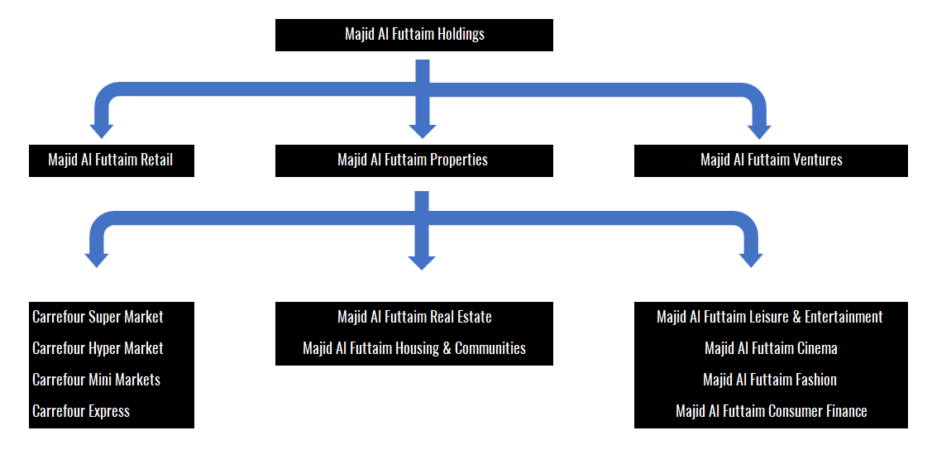

- Human Resources Department Responsibilities (Top 10 responsibilities)

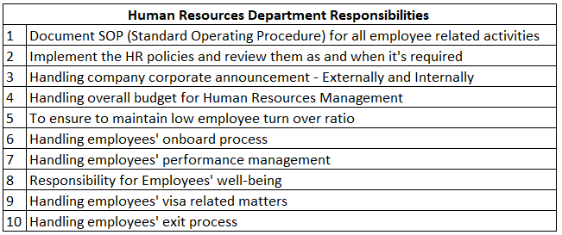

- Human Resources Department Hierarchy
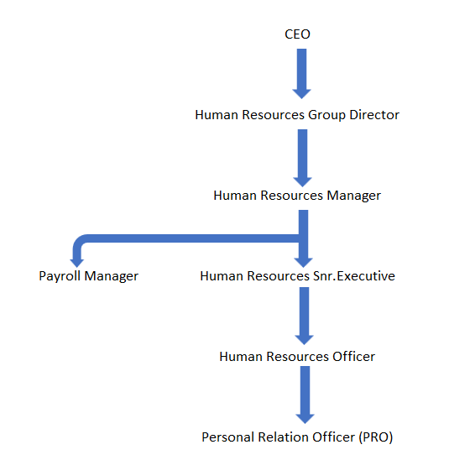
- Majid Al Futtaim – Values


