Attendance management system development project
Moij Gugarman (1704972)
University of wales Trinity Saint David
Major Project (Rework)

Table of Contents
Introduction 3
Background 6
Current system 8
Proposed system 8
Benefits of the proposed system 9
Comparative analysis of exiting attendance management system 9
Feasibility study 11
Purpose and Objective 13
Design Specification 13
Functional and nonfunctional requirements 16
System Design Phase 17
Design Goals 17
Performance Criteria 17
Dependability 18
Maintenance 18
End User Criteria 18
Mapping 19
Relationships among Tables 19
Use cases 20
Implementation 28
Development lifecycle 28
Incremental prototyping 29
Chosen Platform and language 31
System Modules 35
Testing 39
Chosen method of Testing 49
Limitations 53
Conclusion 54
References 56

Introduction
The objective of the project revolves around the Attendance Management System, which is a software developed for keeping a record of attendance data of students in college. The staff in the college taking control of the subjects shall be provided with the responsibility of the student’s attendance. The staff shall be provided with a username and a password for accessing the system based on the subjects considered. Based on this, an accurate report comprising student attendance is typically generated here on a weekly and monthly basis. The proposed system shall also analyze the attendance eligibility criteria of the students. Thus, the current objective is to design and develop the system which would reduce the paper work and enhance convenience among the users.
In the current era, the education system that is followed by the nation forms an integral part of the overall success and development. It is necessary to ensure that a strong educational foundation is provided to the Wenger generations of the country (Chandavarkar 2019). This shall help in developing a culture of open-mindedness who would act as a good citizen in the future which would secure the other important aspects. It has been found that the advancement in the areas of technologies that have been adopted today plays a key role in further shaping the process associated with education. This helps in promoting solidarity among the various elements of the education system.
Thus, education forms the backbone towards the various developments surrounding it. It acts as a strong and robust tool that aims for tackling the issue of poverty, inequality in the environment. Moreover, it establishes a robust foundation that can avail sustainable growth in the economy. It has been found that the government and institutions are aiming to put special focus on the educational industry and implement activities in the school such that the educational system can be improved. The other Key activities undertaken include the overall professional development of the teachers with continuous training and development activities. The schools have now been provided with adequate manpower as well as materials that forms the major element in the primary and higher secondary schools. Thus, these elements allow simply the actions which consider its major approach to entirely automate the school management system.
The Attendance management system as stated above performs various activities and tasks within the school premises. It focuses on registering students, generating performance reports, official transcript, and record-keeping attendances to control the absentees, and other such reports for the teachers as well as parents. In this regard, it can be stated that automating the process can help in leveraging the elements of education which would foster better development. Automation is the effective utilization of a new range of technologies that would effectively replace the workforce with the machine such as quick response and functioning of activities is obtained. With the automation documents that require storing in large rooms, it can be compressed and kept in databases and disks. The transcript images can be easily automated which would further help in ensuring reduction of time. It shall also foster quick retrieval of old transcripts within a few seconds. In this regard, it has been found that the government school of Addis Ababa does have automation for its school system. This requires the Teacher or Administrators for producing the possible transcripts as well as reporting on a manual basis. Herein the school administrators further imply their experience of trial and error approach for preparing the Attendance Sheets.
Challenge and motivation
It has been found in educational institutions, the source of attendance manual which requires huge time consumption and less security for gathering reliable data. There can be instances when the data might get lost due to which the overall system might get hammered. Certain institutions are implementing the punch card system for getting attendance; however, it becomes quite uneasy for the teachers to monitor the students. The use of a punch card can help the students or any of the friends to use the punch card to record attendance. Even when the student is absent or is late to the class, the data gathered is not reliable in any situation. Thus, for mitigating the issue, an improved system has been developed that is based on web facilities. It is entirely responsive where the users can access it through mobile or any other electronic device. Herein the data records are stored in a better manner and can be easily retrieved when required. It also fosters in securing the attendance information for the students in class without any time consumption. Apart from this, the attendance report is generated in an automatic manner.
In this regard, the achievement and success of the students can be easily promoted when the schools have been provided the complete access. It would automatically generate accurate as well as timely information regarding students. Automated systems offers various benefits to the educational institutions and one of them is easy retrieval of information from the electronic record system. Thus, automated systems is the most robust tool that can ensure the improvement of school activities by considering measures form the information needed.
As stated above, the school administrators implement the experience of trial and error for perfecting the tasks, timetable, and schedule of courses. This is pure wastage of precious time and effort of the workforce as there has been a lack of technology adoption in Addis Ababa. Thus, it can be stated that there is an urgent need for improving the technologies adoption in such institutions to ensure the effective delivery of education among the considered populations. Herein, the transcripts and resource material are prepared on a manual basis by the Teacher or Administrators as well as teachers. This further does not include the complexities and time consumption of the planned activities for the school children. Apart from this, the report cards are also prepared on a manual basis by the classroom teachers who also perform the task of recording the attendance. Thus, for collecting the attendance slips from the respective class teachers and compiling it one by one for each of the students is time-consuming. For the graduating students who have left the college some years ago, the retrieval of records becomes difficult as the entire process is manual. Thus, it becomes difficult to generate different reports based on the requirements that are required of the members of the educational institutions.
It has been found that the major administrative activity performed in school is timetable schedule framing. There are various subjects that are usually taught by the respected teachers shall be allocated based on classroom availability and the time slots as well as subjects to constraints.

Background
Analysis refers to the segmentation of any whole for finding out the possible nature and functioning of the systems. It aims at illustrating the designs which help in framing the primary sketches of the plans or patterns. The analysis also explains the plan and ways in which it is conducted by the specific artistic arrangement in a skillful manner. Thus, system analysis and its design form the key techniques and procedures that arouses a sense of interest in the community, culture as well as act as an intellectual orientation (Alkhaliand Oleiwi 2018). In the system analysis, various tasks are performed such as planning, organizing, conducting trade studies, cost-benefit analysis, framing alternative solutions, development of candidate solutions, and selling the system. Apart from this, it also aims for supervision, installation, and maintenance of the system. The system manages to draw the report creation as well as manual entry development of the students' attendance. In the first stage, the entry form of students, allocation of staff, and their time are designed. The project shall foster the overall development of a robust attendance system for their departments that world calculates percentages and generate reports for the eligibility criteria of the students for exams. Thus, the system shall successfully generate flexible reports for the students.
- The teachers and classes need to be present within the timetable for already defined periods
- There cannot be more than one teacher within the same class at a similar period
- At a time, there cannot be more than one teacher in one class
- There shall not be any uncovered periods that means there shall be no periods were no teachers has been assigned
The manual time table that is framed by the respective teachers in an interactive manner is considered. Herein each of the iteration phase and schedules the lesson. For this, there is a need to select the classroom which would be fixed for each student scion and a time slot shall be also selected so that the constraints are not violated. The timetable in school shall be required to arrange the meetings to be held so that the timetables are feasible as well as acceptable by the respective members (Alkhaliand Oleiwi 2018). The administrator in school prepares it with the hit/miss approach and thus, there are changes to automate the routine based on the simulations in the context of the human approach to problem-solving. These approaches are known as direct Heuristics which is based on successive augmentation. Thus, a draft timetable is further extended, lesson by lesson unless the lectures have been entirely scheduled. The idea beneath the approach lies in scheduling the constraints lectured initially. Teachers are allocated to the provided schedules subjects and the numbers are predefined for each of the subjects. Based On this, the overall load is calculated which is used by the constructor to assign the teacher-subject linkages to the respective classrooms in the provided time slots.
Thus, it can be stated that the manual solutions of mitigating the timetable issue need various skilled people to work in a coordinated manner. Even though the solution achieved might be unsatisfactory, however, it's necessary that the lessons should be distributed in a fair manner which would satisfy the constraints previously identified.

Current system
It has been found that the current system offers manual entry to the students in college. Registers are placed wherein the manual entries of the students are made. It is obvious that it becomes hard to maintain the large data sets in registers and a lot of human effort is invested. Apart from this, retrieving the data from the registers is not convenient and there are chances of data misplacement. On putting any wrong inputs, the application might stop to work which further creates a barrier in terms of its usage for the user.

Proposed system
The existing system offers various challenges and drawbacks and thus, a new system has been proposed. The system shall eliminate the tedious work and will save the valuable time of the workers through quick report generation for securing accurate results. Apart from this, the system offers an amazing UI which increases the convenience. Thus, reports can be generated through the currently proposed system.
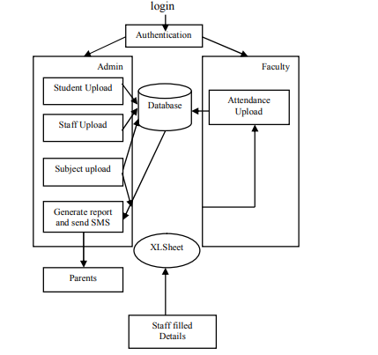
Figure: System Architecture

Benefits of the proposed system
The proposed system offers various benefits in comparison to the traditional system used in the college. The proposed system can be easily used with its interactive User Interface (Alkhaliand Oleiwi 2018). Moreover, an efficient report can be generated as it is a fast method for entering attendance. It is also reliable and delivers accurate results from the key users.

Comparative analysis of exiting attendance management system
In this setting the examination of Htar and Myaing (2019), help with motorizing the current manual attendance system. The examination has indicated that this participation framework can be checked and controlled indirectly. This paper gives definite information reliably. All these collected information can be saved and can be gotten to at whatever point. The explanation behind existing is to design a school site which contains front line information of the school. That should improve profitability of school record the chiefs.
The investigation of Mandal and Khan (2020), shows another illustration of attendance management system. This system is used Way to SMS programming. This item is used to send SMS successfully to their parent's. This structure can store their data about the understudies and those contemplations missing understudy nuances. It is a profitable procedure to store the investment in the Web Site as opposed to wasting the paper. It similarly revives the understudy report direct on the laborer reducing the staff's insight on logging from the PC.
Further, Hosur and Savakar (2016) have discussed another task. In this project, they offered induction to three customers for instance Administrator, Student, Others. This undertaking relies upon client specialist. Here, the worker is Tomcat and client is JSP. In this assignment instructors or the overseer will fill investment and sending message to the understudy who is absent. They will have preferred position to fill interest structure, update support structure, send message to the guard's record whose child is missing, furthermore that investment is under 75%, and they in like manner have bit of leeway to send message to the understudies whose charges are approaching. The staff can moreover observe the message at whatever point they need and besides can change the nuances of understudies. Watchmen have favorable position to see investment and to see message sent by the educator. Understudies furthermore have their record with the bit of leeway to see message sent by the subject instructor and to see the support.
Then again, the investigation of Chandramohan et al. (2017) have demonstrated that programming skeleton of the attendance management system created for an establishment has been expected to achieve most noteworthy efficiency and lessening the time taken to manage the taking care of development. It is planned to displace a current manual record structure accordingly reducing time taken for tallies and for taking care of data. The structure is adequately ready to withstand in reverse step by step undertakings under conditions where the data base is kept up and cleared all through a particular period of length. The execution of the structure in the affiliation will altogether reduce data section, time and moreover give instantly decided reports.
At last, the degree of the project as referenced by Chandavarkar (2019) is the system on which the item is presented, for instance the endeavor is made as an ANDROID application, and it will work for a particular foundation. Android is a versatile working system (OS) considering the Linux part and at present made by Google with a UI reliant on direct control. RAD approaches to manage programming improvement have put less complement on orchestrating endeavors and more emphasis on new development. It has revealed that an online system for recording and reporting understudies 'attendances is indeed a necessary application to make the cycle more gainful and proficient where over 70% of the model bundle assented to that issue.

Feasibility study
In the current project. It is necessary to analyze the feasibility which initiates after illustrating the goals. It initiates with the generation of a broad range of possible solutions that illustrates and defines the new look of the system. While developing the new system, creativity, as well as imagination, is given the highest priority. It is the responsibility of the analysts to bring new ways and thereby generate a new range of ideas. However, it has been also found that the solutions shall offers required information that would ensure to deliver an estimate of the project costs. This would further provide the information regarding the way in which the system fits in the college (Alkhaliand Oleiwi 2018). Thus, the analysts need to put effort at this stage to find out the feasibility of the project. This would provide the basic idea regarding the efficiency as well as the affordability of the system. In this regard, three areas of feasibility shall be determined namely operational, technical, and financial feasibility.
In terms of operational feasibility, it has been found that the system is convenient to operate and learn due to its interactive interface. There is no need for training for operating the system. The technical performances involve the issues with respect to analyzing the reliable information provided by the system for the department. This includes the details of the students and analyzing the appropriateness of the information delivery using the intranet services.
In terms of technical feasibility, it can be stated that the key requirement is economic and does not need other peripherals devices. The evaluation should further assess the technological up-gradation and availability of required skills for using it. The technology such as .Net supported windows-based application shall be further installed and upgraded. The application is highly dependent on the Microsoft Office database as well as intranet services through which the data is indeed and reports shall be generated to the excel sheet.
In terms of financial feasibility, it has been found that the proposed application which is to be developed for the college is highly feasible with respect to finance. However, there is a need for in-depth supervision that supports the environment. The system is also found to be cost-effective with respect to the way it eliminates the paperwork. The entire work has been automated which becomes highlight convenient for the user to implement the systems and take full advantage of it. Thus, the system proposed is highly feasible with respect to its effectiveness in faster data calculation. At the end of the month, the total attendance of the students can be easily generated as per the user requirement.

Purpose and Objective
The motivation behind the plan stage is to build up an away from of what the Application developer need individuals to pick up from his/her task. As We the engineer chip away at the task, the test for each plan choice ought to be "Does this element satisfy a definitive reason for the task?"
A reason articulation influences the plan cycle by clarifying what the Application developer needs the task to do, as opposed to portraying the venture itself (Chandavarkar 2019). The Design Document will check that the current plan meets the entirety of the express prerequisites contained in the Application model just as the verifiable necessities wanted by the client.
The general Application plan objective is to give an effective, particular plan that will diminish the Application's unpredictability, encourage change and bring about a simple execution. This will be cultivated by planning firmly attachment Application with insignificant coupling (Hosurand Savakar 2016). Also, this report will give interface configuration models that are reliable easy to understand and will give straight advance change through the different Application capacities.

Design Specification
Objective and aim
The developed system is entirely web-based, responsible, and flexible in nature which can be easily accessed from any electronic devices irrespective of place. The aim to develop the web-based attendance software for the different department focuses on registering the details of student, subject, teachers, and respective fields. In case the student is present, the checkbox is clicked and if absent, the absence of checkbox is clicked (Hosurand Savakar 2016). The save button on the website confirms to the information and stores it in the database. Based On this, the report can be generated with great accuracy and quickness.
Overview of the system
AMS (Attendance Management System) consists of modules that ensure appropriate functioning for the new batches. It shall easily perform activities such as entry of new students or faculty, subject updating when required, delivering notice to the employees and workforce. The users are provided with the right to daily attendances which would ensure report generations. There are two ways of taking the states namely the monthly and periodically.
Feasibility of the study:
The project shall be assessed based on three key areas of feasibility namely technical, behavioral, and economical. In terms of economic feasibility, the system which is developed is economic with regards to the point of the schools and other institutions. The software is cost-effective as this completely reduces paperwork and manual labor. Apart from this, it is highly time-efficient as the entire calculation is automated based on which the reports can be generated at the month-end as per the requirement of the authorities. In terms of technical feasibility, the system is economic and does not consider any peripheral devices (Hosurand Savakar 2016). In the case of behavioral feasibility, it is highly convenient to use and easy to learn with its interactive UI. Moreover, no such training is required to operate the system.
Operations performed by the current system
The entire work is done on paper and the season of the attendance is stored in the database based on which manual labor is required to generate reports. In the middle, no such report is generated as more time is required in calculations. Thus, after completing the sessions, students not fulfilling the 75% criteria of attendance get a notice.
Drawbacks of the current working system
- Lack of user-friendliness due to the slow data retrieval and absence of appropriate data maintenance
- There is a need for performing more calculations for generating the reports and hence it is produced at session’s end. The student herein gets a single chance for attendance improvement and thus there is a huge difficulty in report generations
- The calculation for report generation is done on a manual basis and hence there is a greater chance of errors
- There is the involvement of huge paperwork and losing even a single sheet of data can result in grave consequences
- It is quite a time-consuming approach as a lot of manual work is involved. Each of the operations is done on a manual basis and thus, the attendance report is not generated as per the requirement as it is quite time-consuming.
The proposed system characteristics: Attendance Management system
The system proposed in the paper is user-friendly as the data retrieval and its corresponding storage is convenient for the users. The entire process is moth and quick which ensures easy management of data. The GUI used in the system offers the users significant benefits and acts as the key element of the proposed system. This ensures that the users can easily deal with the system without any such difficulty. As far as results are concerned, it can be easily generated with the help of the proposed system. The reports can be generated as the user requirement without any delay or inconvenience. The officers can easily provide notice to the student who is irregular in the class and has less attendance. Thus, the overall possessor does not require to conduct any paperwork, and data can be integrated and stored within the system easily; the reports can also be generated when and wherever required. The work becomes quite easier as there is no requirement for keeping data on papers. The computer operator entirely controls the functioning and thus there are fewer chances of errors. In a nutshell, data storage and retrieval are quite easy with the system with faster as well as timely generations.
Feature hold by the proposed system
The proposed system shall be fulfilling the necessary requirements and mitigate the issue encountered in handling the attendance in institutions
- The system is user friendly which allows easy data retrieval and can be managed efficiently. The GUI of the system is interactive that makes it convenient for the users to implement the system and use it seamlessly
- It allows easy report generation as the data can be reached easily. Thus, reports can be produced whenever there is any user requirement. Apart from this, early notices can be also provided to the employees and students not being present at their respective places.
- The proposed system also needs less paperwork which saves the manual time and effort to prepare the documents, timetable, and reports. The computerized system generates the reports and no data is required to be arranged through paperwork

Functional and nonfunctional requirements
The UML models are used for illustrating the basic requirements for the proposed system.
4.1 functional requirements
In term of functional requirements, it shall require the following:
- Student registry
- Attendance Recording for students
- Generating reports
- Framing timetable
4.2 Non-functional requirements
In terms of non-functional requirements, meeting the security aspects is fundamental for the proposed system as data shall be stored in the database. There are chances of data breaches which news to be tackled. User validation needs to be performed while logging in which would ensure the validation of the user and shall have the access or permission data. The general users are provided with access through the UI. It shall have interface and certain buttons for various application forms. It shall also have a form centric interface that would allow it to view format and allow data entry. This would generate report formats for enhancing user-friendliness. The developer shall be maintaining a system or any trained person from the authorities. This shall allow faster report generation and farming of timetables.

System Design Phase
The previous chapter had helped in the identification of the functional and non-functional requirements while providing the model of analysis. In this chapter, discussion is made on the design goals, system architecture, system decomposition, deployment and database design.

Design Goals
The design goals are the system qualities which are used for optimization by the developers. These goals are gained from the non-functional requirements.
Design goals can be divided into five categories which include:
• Performance
• Dependability
• Maintenance
• End User Criteria

Performance Criteria
This involves the system to have fast or real time response by providing maximum throughput. At the same time, the system need not take up excessive memory space (Rahman, Rahman and Rahman 2018). The reason for the system to be interactive is because of the selection of fast response time over the throughput process. The timetabling subsystem need to be reliable so that limitations can be mitigated instead of the response time.

Dependability
It is necessary for the school to use systems that are highly dependable as the use is done by non-IT professionals. It is necessary that the system be robust as well as tolerant towards fault. Security need to the major concern as private information of the school is being put in. This is due to the accessibility of the subsystem via the web.

Maintenance
It is necessary for the system to be extendable as well as open opportunities for addition and modification of new functions in the future.

End User Criteria
Usability: Usability refers to the use of products so that specific goals can be attained with efficiency and satisfaction based on a specified context. The designing of the system needs to be such that it becomes easy to learn as well as use the system efficiently without errors.
The application of Trade-off is made to design goals. Examples of which is the security issue with that of the response time. The checking of user-id as well as password entered can create response time among the people (Rahman, Rahman and Rahman 2018). Another example can be the response time issue with quality. The system takes time to generate the timetable hence, it is for this reason that the waiting time of the user is more for getting results of quality timetable.
To reduce the complexity associated with a system, the application of subsystem decompositions can be used. The subsystems are packages that hold related classes or objects. From the figure below, evidence about the decomposition of the subsystems can be seen which are further decomposed. Some of the major subsystems that can be associated with the system includes “Report” subsystems, “ReportCard”, “StudentRegistration”, “Transcript”, “Login”, “Attendance” and “Timetable” and.
Every use is classified into roles. Based on the role of the user, the “Login” subsystem provides authenticity to grant access. Any student can be registered offline with the help from the “StudentRegistration” subsystem. It is used to record information about students in details which include information related to parents as well as person of emergency.
“For generating transcripts and report cards the use of subsystems Transcript” and “ReportCard” are done respectively.With the help from the “Timetable” subsystem a time for a subject or teacher can be generated for students.

Mapping
Objects in tables are mapped to store information regularly. Attributes are marked into fields for the same. For this, major tables that can be associated with DBMS are identified and displayed in the figure 5.5

Relationships among Tables
This is used to describe any relationship that are necessary in a table that can be used to store data regularly in a system. In a relationship data base three types of data are found. These include one-to-one, one-to-many and many-to-many relationships (Rahman, Rahman and Rahman 2018). The system that is analyzed presently consist of one-to-many and many-to-many relationships.
As such the Student and Subject tables consist of having many-to-many relationships. The purpose of the database system is to reduce any form of redundancy and thus the many-to-many relationship need to be reduced to one-to-one relationship. Another example of one-to-one relationship includes the Student and Academic Subject and days.

Use cases
In the developed application there are multiple roles for the users and following are their different use case flows.
Administrator: this user is responsible in order to manage student and teacher details in the system.
Use-case: Login into the application to carry out the required operations.
Brief Description: This utilization case is utilized when the overseer needs to get to the application to empower/cripple/update the individual subtleties of the understudy.
Preconditions: The Administrator must be signed onto the application in request for this utilization case to start.
Basic use case Flow:
- The Application prompts the overseer for the user name and secret password.
- The Administrator enters the user name and secret password.
- The Application checks the secret phrase and sets the user's approval.
- The Administrator is offered admittance to the Application to play out his application development projects.
Elective Flow: The user enters invalid username and secret phrase then he won't be permitted to continue further.
Post conditions: The application state is unaltered by this use case.
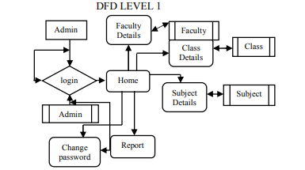
Figure: Activities of Admin
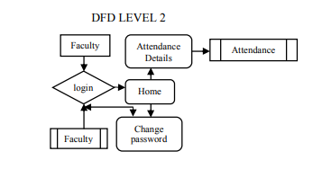
Figure: Activity of Teacher
Use case 2:
Use Case: Display understudy subtleties
Objective in setting: View the subtleties of an understudy
Brief Description: This utilization case is utilized when the executive needs to see the individual subtleties of the understudies previously existing in the information base on the screen.
Preconditions:
- The Administrator must be signed into the Application all together for this use case to start the operation.
- The subtleties of the understudy must pre-exist in the information base
- The understudy id must be entered accurately.

Basic Flow:
The Administrator signs onto the System.
The Administrator selects to list the attendance of the users from the database. The list will include, id first/last name, date and attendance status.
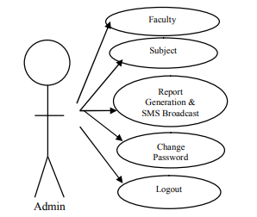
Figure: Use Case Diagram of Admin
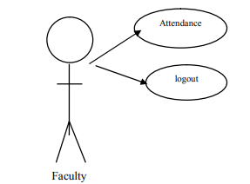
Figure: Use Case diagram for teacher
Description of Use case
Identity: Student registry
Actor: Teacher or Administrator
Brief: Registering them as school students
Pre-condition: For students to be eligible they should have completed pre-specified junior school (to be accepted by school)
Event flow
- Students desire to be regarded as one of the students in the school
- Eligibility criteria are verified by the Teacher or Administrator
- Students shall be provided with registration forms
- The registration is completed by the student that contain the personal details such as name, parent name, address, emergency contact number, and other such
- Teacher or Administrator conducts a check on the appropriate form filling by the student
- The form is filled and submitted by Teacher or Administrator to the system
- The system registers the form and student
- Use case closure
Post condition: A student who is registered
Identity: As shown in record attendance
Actors: Classroom teacher
Brief: Recording the student’s attendance in each day of the school
-16-
Pre-condition: The classroom teacher need to log in as the classroom teacher of the class for the appropriate recording of attendance
Event flow
- The classroom teachers record the absentees from the class
- The teacher fills up the attendance slips within the classroom
- The teacher logs into the record after having the attendance slip
- The absentees are recorded and submitted by the homeroom teacher
- The system after receiving records acknowledges
- Closure of Use Case
Other options flow event flow
Alternative flow Option C: The user of the user is not the classroom teacher of the concerned class
C3: The users cannot record the attendance for the concerned student's class
C4: Closure of Use case
Identity: generating the report card
Actors: Teacher or Administrator
Brief: Producing the report card for the universal student for each semester
Pre-condition: The concerned student needs to have the complete marks for the objects in each of the semesters
Event flow
- The Teacher or Administrator access the system and thereby selects the section wherein the student belongs
- The Teacher or Administrator herein seeks for the student who belongs to the class on the basis of pre-defined search criteria
- The system generates the report card
- It displays the result on the screen and the result is also printed
-17-
- Closure of use case
Alternative event flow
Alternative flow B: The user logged in the system is the Teacher or Administrator
B1: No report can be generated by the user
B2: Closure of use case
Alternative flow C: The student record show incompleteness in one of the subjects at least
C3: No report card can be generated by the user
C4: Closure of Use case
Identity: Produce a transcript
Actors: Teacher or Administrator
Brief: Generating transcript for the student based on the request
Pre-condition: The student needs or completes the semester for having the grade mark sheet

Event flow
- The student requires o get the transcript
- The Teacher or Administrator accesses the system and searches for the record form the database with the predefined search criteria
- The system generates the transcript
- The system efficiently displays and results is also printed
- Closure of Use case
Alternative event flow
Alternative flow B: The student has lacked to complete at least one subject
-18-
B3: There cannot be a generation of the transcript by the users
B4: Closure of Use Case
Identity Generating Timetable
Actors: Administrator
Brief: Generating the timetable for the teacher and student of the class
Pre-condition: The subject teachers for the respective classes needs to be present for whom the timetable is to be generated
Event flow
- Administrator news to produce the timetable
- Admin accesses the system
- Admin conducts registration of the teachers
- The administrators allocate the classes for the subject teachers through form filling and submit it
- The system effectively produces the timetable
- It then displays the results
- Closure of the use case
Other option of Event flow
Alternative flow A: The allocation of the teacher to the specific class is not registered
A5: No timetable is generated by the system
A6: Closure of use case
19
Identity: Viewing report
Actor: Teacher
Brief: viewing the student Status
Pre-condition: Parent needs to be registered as the student's parent
Event flow:
- The parent desires to see the student's status
- Parent accesses the system through login credentials
- The system shows the form for the student's search criteria
- Teacher fills up the form and thereby submit it
- Teacher selects the option to view the report
- The system shows the report
- Closure of Use case
Other option of Event flow
Alternative flow D: Teacher is not recorded as a registered parent for the concerned student
D2: Teacher cannot log in
D3: Closure of use case
Alternative flow C: Teacher fails to provide an appropriate name and details of the student
C5: No information about the Student is displayed
C6: Closure of Use Case

Implementation

Development lifecycle
A product life cycle depicts the improvement exercises of a product item. It alludes to an intelligent succession of all around characterized programming improvement measures, from origination to possible retirement throughout a product item's life expectancy. The different stages and exercises acted in each stage may fluctuate contingent upon the life cycle model picked. There are a few programming life cycle models portrayed in the writing. In any case, there is no single life cycle model that is most appropriate for each Attendance system development project (Hosurand Savakar 2016). Distinctive programming life cycle models may supplement each other on the same Attendance system development project during various phases of the advancement of a task. Picking the most suitable model for a specific programming Attendance system development project is testing.
Numerous elements for example, accessibility of assets, cut-off times, developer's expertise and so forth may impact the decision of a daily existence cycle. For the current project, there are apparent multitude of prerequisites of the Application toward the start of the task. Hence, the developer at first utilized a quick prototyping model to show the underlying arrangement of prerequisites by building up a discard model. This model helped the developer distinguish a large portion of the prerequisites of the Attendance system development project. In the wake of finding the most significant just as the arrangement of foreseen prerequisites and having input from the user, the Application developer principally utilized the gradual prototyping model for the remainder of the application development project.
The gradual introduction of the different functionalities in every stage adequate opportunity to the developers in order to conform to the Application while likewise taking into consideration change of desires furthermore, responsiveness to changes. This likewise enables the developer to test and troubleshoots the Application effectively and gets rude awakening from user input.

Incremental prototyping
After the initial prototype model, the development project begins. At the point when each subset of functionalities was done, the Application was cautiously unit-tried, and the engineer performed joining and Application testing too. The engineer at that point transferred the Application into his own Application worker with the goal that can test the Application and give an input to the Application developer (Hosurand Savakar 2016). The item was then refined as per the users' desires. By utilizing this model, the client got greater inclusion in utilizing the Application, and it likewise pushed the Application developer to intently coordinate with the functional requirements for the proposed system.
The Application was beta-tested by our friends the other generally by the’s Administrator and instructors first. All the functionalities in the Application mirror their manual day by day errands in the, and so they had the option to remark on changes and improvement. After a limited number of cycles and positive input, the last programming bundle was given to the client. All the functional requirements are tried to complete in the final prototype of the Application.
All the authentication and authorization measures were naturally upheld and done by Microsoft .NET system. Every client has his/her own username and secret phrase, and they can just play out a particular arrangement of functionalities dependent on their client jobs. For instance, understudy and educator users have restricted benefits thus would not have the option to see the budgetary data of the studio, for example, inventories/orders data.

Another component that gave to help security is that the client's secret word is just put away in the information base and is scrambled. This sort of encryption will guarantee that indeed, even the information base director can't figure or recover the secret key since it is a one-way encryption. The client can get to the framework just on the off chance that he/she enters a secret key furthermore, this secret key is hashed and coordinated to the one put away in the information base.

During the plan stage, the engineer dealt with information approval and confirmation on both customer side and worker side of the application. It is truly evident that customer side approval just isn't secure, in light of the fact that some vindictive users can see the code and change the content to attempt various qualities until something unapproved is uncovered. The designer has consolidated both and the customer side approval upheld by Microsoft .NET structure to confirm the information contribution by the users.
Users are additionally given instrument tips to each info field thus they have the direction when they don't know whether the information is legitimate. The data from the customer side will be passed to the application layer and afterward be checked one ore opportunity to check the accuracy. These means limit the risks to the framework made by the users.

Chosen Platform and language
Programming languages and the .NET Framework The .NET Framework is intended for cross-language similarity, which implies, basically, that .NET segments can collaborate with each other regardless of what upheld language they were written in initially. Thus, an application written in Microsoft Visual Basic .NET may reference a dynamic-connect library (DLL) document written in Microsoft Visual C#, which thus may get to an asset written in oversaw Microsoft Visual C++ or some other NET language.
This language interoperability stretches out to full object-situated legacy. A Visual Basic .NET class may be gotten from a C# class, for instance, or the other way around. This degree of cross-language similarity is conceivable due to the basic language runtime (Hosurand Savakar 2016). At the point when a .NET application is ordered, it is changed over from the language where it was composed (Visual Basic NET, C#, or some other .NET-consistent language) to Microsoft Intermediate Language (MSIL or IL). MSIL is a low-level language that the normal language runtime can peruse and comprehend. Since all .NET executable and DLLs exist as MSIL, they can openly interoperate.
The CLS characterizes the base guidelines to which .NET language compilers must adjust. Along these lines, the CLS guarantees that any source code effectively ordered by a .NET compiler can interoperate with the .NET Framework. The CTS guarantees type similarity between .NET parts. Since .NET applications are changed over to IL before arrangement and execution, all crude information types are spoken to as .NET sorts. Thus, Visual Basic Integer and a C# int are both spoken to in IL code as a System.Int32. Since the two programming languages utilize a typical kind framework, it is conceivable to move information among parts and keep away from tedious changes or elusive issues. Visual Studio .NET boats with programming languages, for example, Visual Basic .NET, Visual C#. We can likewise compose oversaw code for the - NET Framework in different programming languages. Outsider instruments and compilers
There are different tables that are used by the system which includes windows application and web application. In the case of window application, it is known as a thick client application and the latter is known as the thin client application. C# is one of the development languages in .NET which is object-oriented. It is used for developing windows.
In the sections below, the system implementation has been described which includes the user interaction with the system as well as the outcomes of the interaction with the concerned system as well as the screenshots has been illustrated.
A login screen is seen after the user starts the application as demonstrated in for user authentication. In case the user types the correct login credentials to log in the screen, the system thereby demonstrates the splash screens is also added. After this, the window appears with me menus as deposited. Herein the main window demonstrates the menus and other sub-menus based on the user role who has logged in.
Microsoft .NET model
Microsoft.NET model refers to the software present in the Microsoft Windows OS which acts as a computing platform. It simplifies the application development present in the distributed areas of the Internet. The model offers the platform to build the windows applications and ensures effective deployment as well as running the different applications. The model includes a plethora of elements ranging from the library of pre-coded solutions to programs, tools for configuration, and virtual machines.
The common language infrastructure forms the key aspect of the framework that allows the application to be coded in various .NET languages. It also allows it to be conducted on various platforms without any modifications. The strong features include application development as well as execution such as garbage collection, interoperability, exception handling, and security (Hosurand Savakar 2016). There are four key applications in CLR namely CTS (Common Type System) Immediate language (CIL), File format (PE), access to the OS through Win32 API as well as a base class library (FCL).
CTS offers objects, interfaces, type composition, safety, delegates, and so on. CLS forms the subset of CTS that needs first-class .NET model to share. However, CLR refers to the code managed area which is built on the framework and forms a garbage collected area. It is never interpreted while .NET implies byte codes which include Java. CIL code is needed to be compiled for the execution of JIT (Just in Time).
The metadata in CLR includes a description of methods, such as class, return types as well as method elements. It further includes data structure which is embedded in the CIL code explaining the higher-level codes. It also illustrates the classes as well as class members which need to be defined in the assembly, member, and class which ensure that the existing assembly shall call the other assembly.
.NET VES offers the execution platforms for the managed code that further assists in executing the CIL set of instructions. Direct support is achieved for the built-in data types and explains the hypothetical machines that exist with linked machine framework, control flow construction, and exception handling framework.
The intermediate language is further compiled JIT into the primary code when the key application runs in comparison to the time needed for application development. The technique enhances computer program performance and within the JIT area, the source code initially is translated into intermediate code which further gets translated into primary machine code.
Used tools
The developer uses the Microsoft Visual Studio that offers IDE (integrated Development Environment) for creating the data-driven as well as a distributed range of applications. It contains certain C# approaches as well as reusable controls. This is further implemented for developing the codes and GUI wherein the latter includes a different range of applications. The MS Visual Studio consists of debuggers and tools that makes the environment interactive as well as easy for code Editor, and designer. The VS 2012 has been updated for supporting features that are stated in the .NET model 2.0. There is a new range of features such as intelligence as well as refactoring of codes that are assisted by code editor, better environment for web publish, load testing for checking the performance, and assisting SQL Server 2012 database.
3.1.3 MS SQL server 2012
MS SQL 2012 refers to the RDBMS form Microsoft whose initial elements are SQLOS that offer simple services needed for the server operations. This involves thread scheduling, tables, query, stored procedures, I/O and memory management, Relational engine that implements RDMS elements, and a protocol layer which illustrates these typical elements. The primary query language refers to the Transact-SQL needs and high-performance data access which is already provided. The version refers to the coming generation of Microsoft data management as well as analysis software which shall offer improved scalability, availability as well as enhanced security for the enterprise data. The Major improvement that has been observed in SQL server 2012 which was lacked by its previous generation SQL server 2008 has been the successful integration of .NET languages such as C#, ASP.NET, or VB.NET for building objects. This allows the execution of application .NET core within DBMS that consider the benefit of the language functionality. The RDMS also has certain inbuilt capabilities that assist the data encryption which is stored within the user-defined databases that have been seen to lack in MS SQL 2008.
Apart from this, the framework also offers accessibility with the tools as well as namespaces that are known as MS ADO.NET wherein three key stages are present. This includes physical storage of data that can be SQL or XML file, DataSet that stores data disconnected on its local memory, and Data provider that further develops operation between the database and programs.

System Modules
Login Module: In this module the user can use Id and password to login to the system
First connect the database in the system
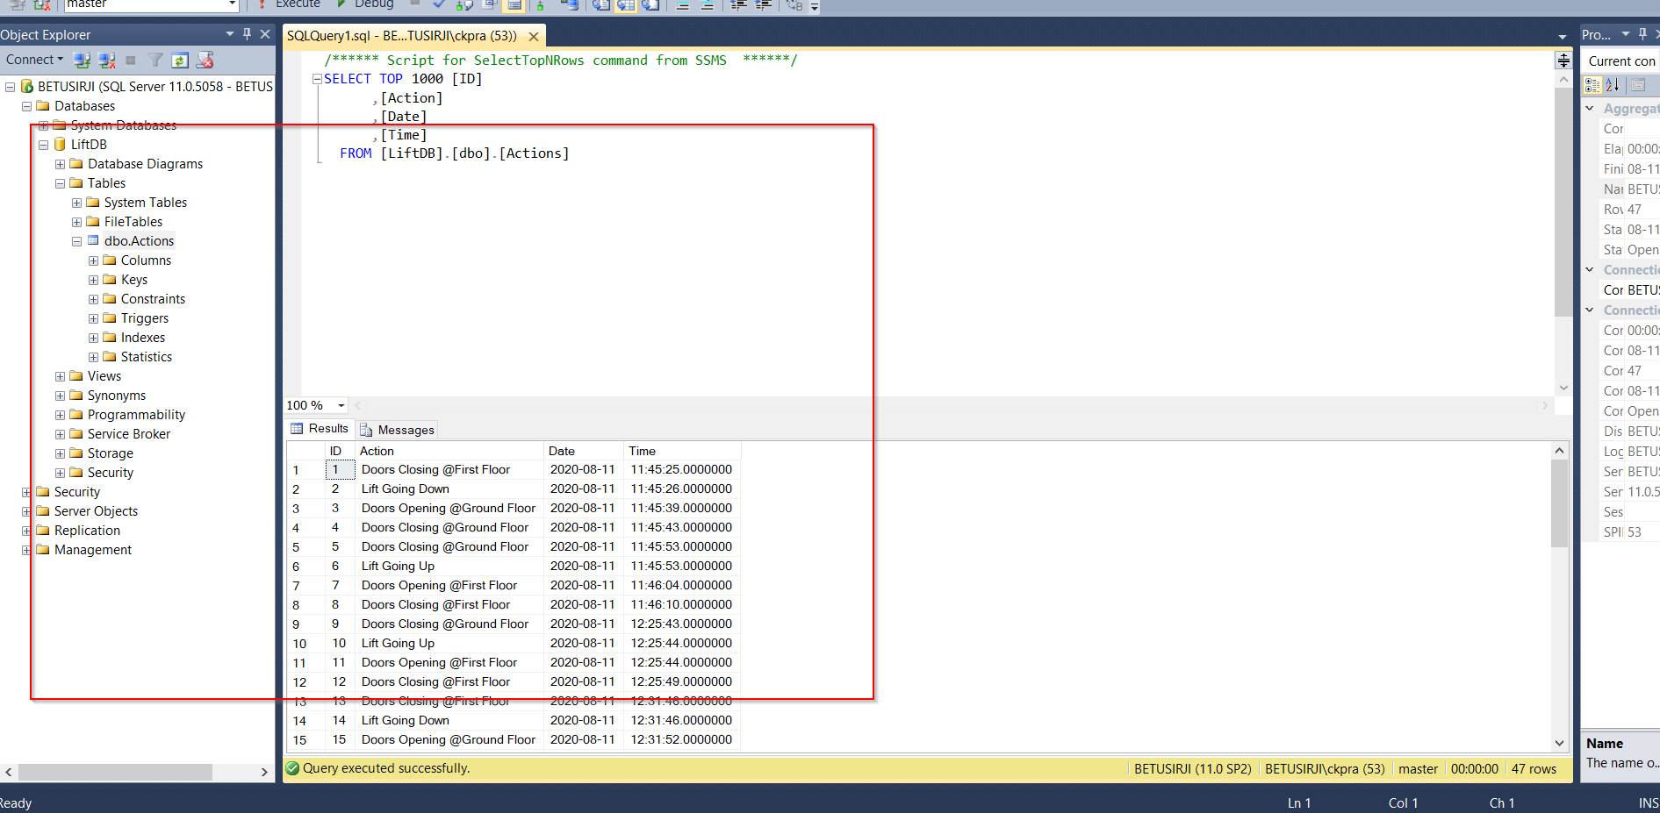
Import the solution in your visual Studio and click on run or start as depicted below;
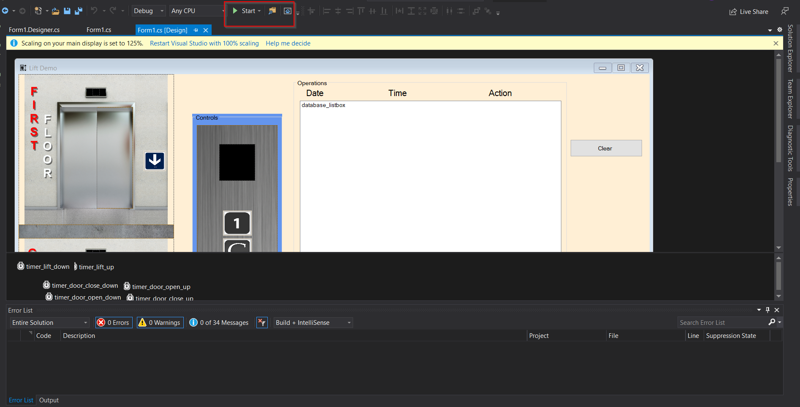
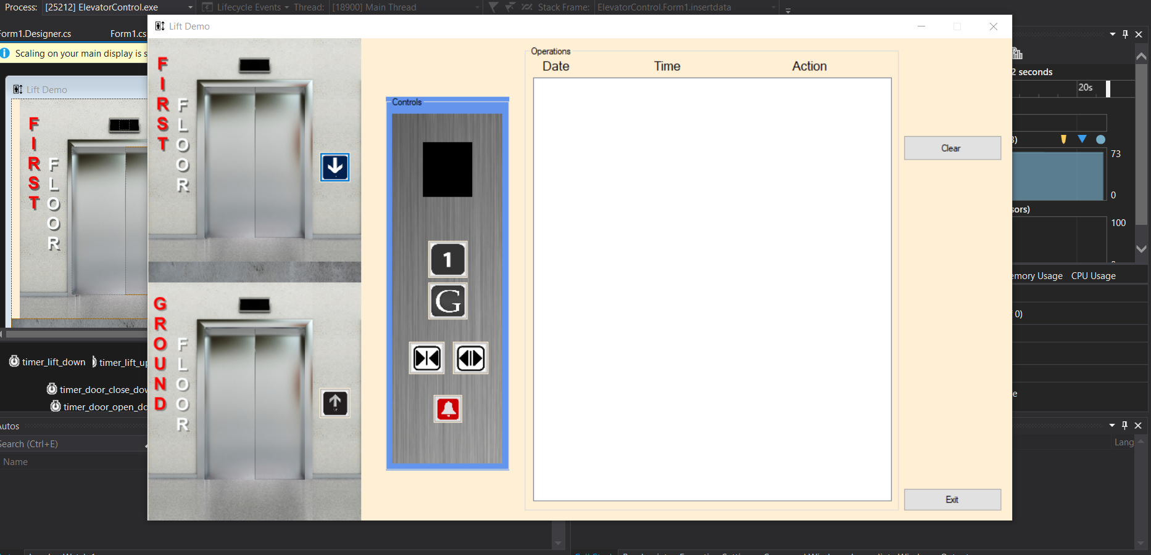

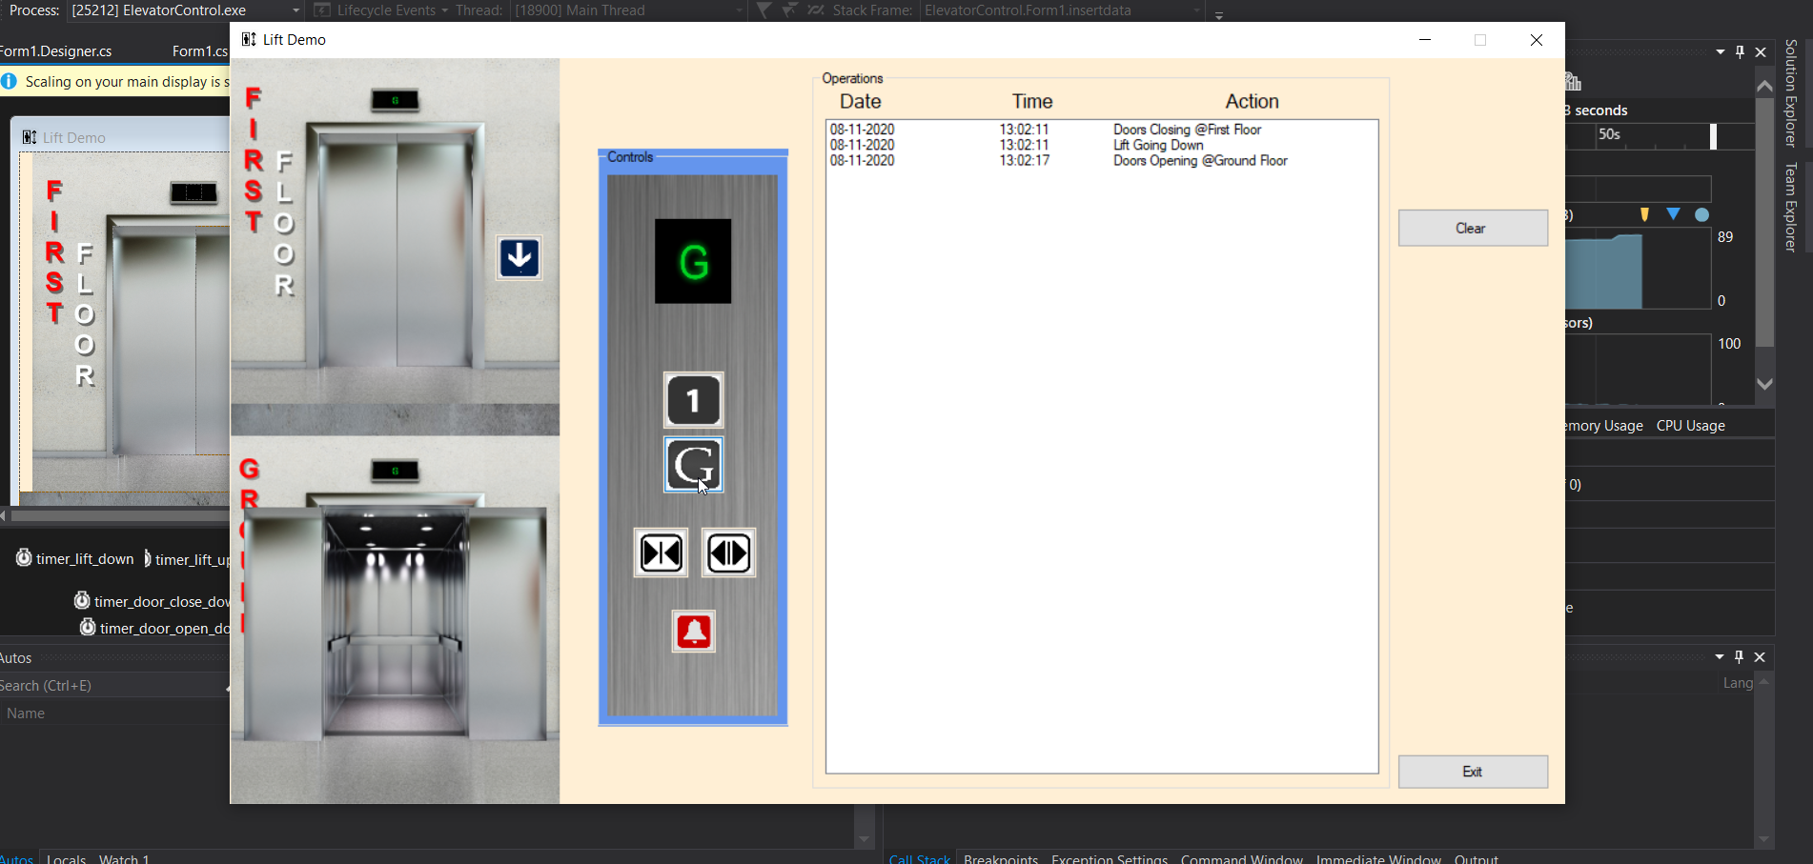
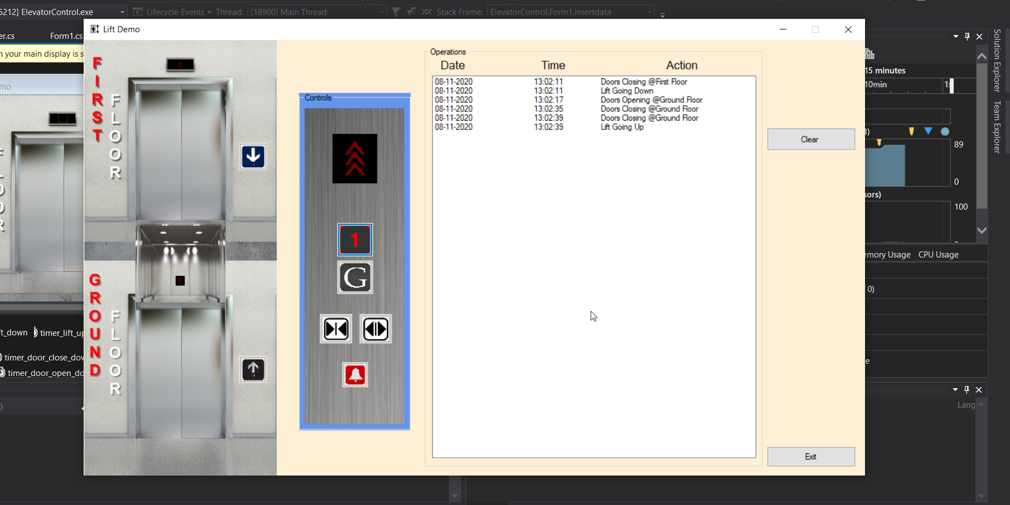

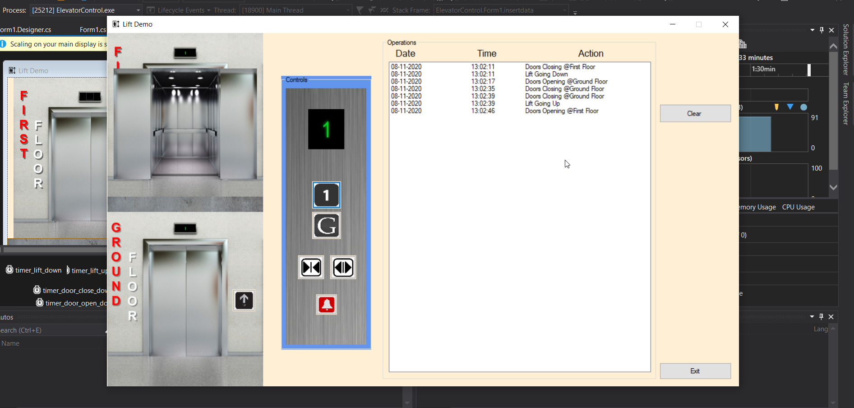
Once you login to the system then you update your attendance.

Testing
Testing
4.1 Prioritization of test cases
The software that has been developed for the police station assists in a wide range of functionalities listed below:
- Sub-windows
- Different Search criteria functionalities and shows results
- Forms that have varied text fields
- Interactions between application and database
The scenarios for the desktop applications have been tested as per the application functionality, for which the checklist has been considered from. It is entirely aligned with the needs and developed application functionality.
4.2 Test Scenarios on the general ground
- It is necessary that the mandatory fields should be valid and must be demoted with An Asterisk '*' symbols
- The valid errors need to be shown at the recent position through the message
- The initial entry drop-down needs to be blank or "select"
- It is necessary that the application should ask for any confirmation prior to record deletion
- The fields need to be at default value when a click is done on the reset button
- The highest field values for the field at input needs to be verified
- When the value crosses the maximum limit, it must generate a warning message and values should not be stored in databases
- The input field for the special characters must be ensured
- Ensure the standard style for the field labels
- Spell checking with identification of grammatical mistakes must be in forms
- Verify the button functionality on the forms
- Restrict double form submission
4.3 GUI and test scenarios for usability
- Alignment of the fields in the form
- Enabling the scroll bar as per requirement
- Standardization in style, font color, and size must be maintained
- Disabled fields must be grayed as well as a restriction in clicking the option
- While clicking on the text field, there must be changes in the mouse pointer to the cursor
- Manual typing of text by the user must be disabled within the drop-down list
- The filled data should remain intact in case any error is found in form submission
- The user must be able to submit the form again after making the corrections
- Sorted order of the values must be established for the drop-down field
- The correct form fields need to be shown and highlighted in case of any errors
- Display the confirmation message for any update or delete functions
- Single radio option news to be selected as well as multiple checkboxes
- Appropriate messages need to be displayed in case of invalid values seen for the filter criteria
4.4 Result grid test scenarios
- The final grid needs to be shown the searched parents
- The number of the outcomes retrieved needs or be displayed
- The searching criteria considered during searching needs to be displayed on the result grid
- The resulting grid should include the columns pre-specified with the appropriate values
- Appropriate spacing needs to be demonstrated for the columns and rows for the result grid
- The duplicate records need to be excluded from the resulting grid
- Dynamic columns need to be checked
4.5 Window testing scenarios
- Checking default window size
- While closing the parent window, the child window should be verified for closure
- The parent window cannot be used in case, the child window is open
- Checking the window functionalities such as maximize, minimize, and close
- Window resizing must be checked
- Scroll bar functionality must be checked
- Check for the child window it's cancel functionality
4.6 Test scenarios for database testing
- Saving of data must be cross-checked
- Checking of non-acceptance of null values for the columns
- The table key column needs to be checked
- The operation log for each activity must be maintained
- For the table in the database, indexes need to be added
- For successful operation, data must be committed for the database
- The radio button saving and proper listing of the drop-down list must be ensured
- Data length and types for the database fields must be checked
- Checking that the primary key and foreign key news to be implemented correctly
- Verifying whether the primary key is null
The user can access the system with the login screen that is to be present for the police officers which can be used for conducting functionalities such as insert, delete or update of the data.
- A Sign in as well as a link for the registry of the new user and a password reset option in the login screen
- At the right side, the login and exit button must be on the screen below the form fields
- Customer login in the name must contain the email-id that is registered with the username during the account creation
- Eight characters must be established as a criterion for password length wherein two-digits and one special character is mandatory. Password cannot be a username or email Id or all digits
- Stay login functionality should not be implied and automatic request for password must arise in case the system is not used for more than 15 mins
Checking for RE-001:
The login screen must be there for the user to login and perform the functionalities such as view, delete, and update of a record. It shall further have two key elements namely Sign in and sign up. On the right side of the screen below the form fields, exit, sign Up, and login button must be there. In terms of the login name, it can be an email id or registered CNIC no that is provided during account creation. The password criteria must be established as stated above in the point and they stay login functionality need not be implemented. The other functions must be placed on the left side of the form.

The main screen must be there for the police officer to perform functions.
- Form of navigation must be there which shall have buttons on the left
- Data grid should be present
- At the right side of the screen just after the search box, a search button shall be there
- On the left side, the button that proceeds words other forms must be there with other button functions such as update, edit and delete
- FIR number and CNIC number must be present with the search criteria

Checking RE-002
The main screen offers access to the system that allows easy navigation and performs functionalities. It shall have a search box and button. On the left side, the function and navigation buttons must be there prior to the form fields. The search results for the queries shall be displayed through a data grid.
Unit testing
Unit testing is necessary to be performed as it offers the cod author with the confidence that produces accurate results. NUnit refers to the port of JUnit mode, which is derived from Java as well as extreme programming. The framework considers .NET functionalities and implements an Attribute-based programming framework. The Nunit.exe program demonstrates the test cases within explorer and offers visual indicators for the test.
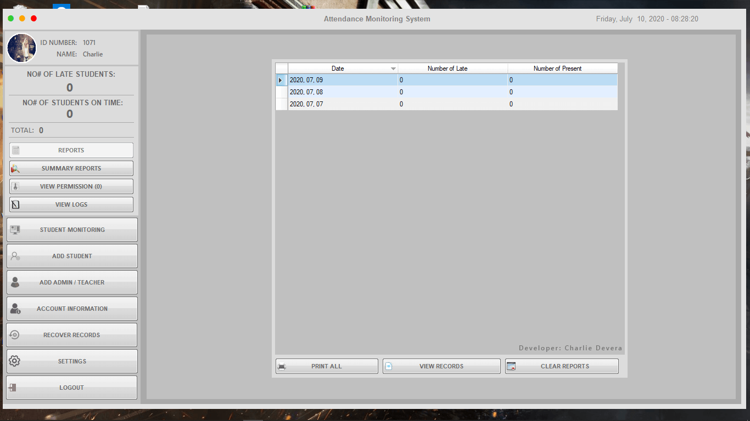
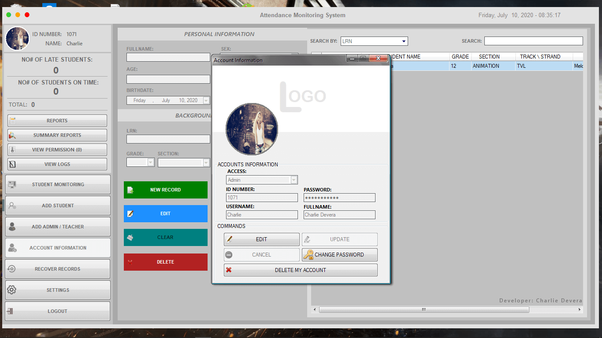
For the system under realistic test, the workload is simulated and submitted. Testing checks the target of test performance under varied conditions when the configuration remains constant that is done through stress testing when extreme conditions happen. Extreme loads are often used for testing the breaking point and in case of testing for load stress, the extreme load is used for making the application. This exposes the bugs that appear being under stress such as overflow of the buffer as well as data corruption.
It has been found that requirement gathering, as well as structure designing, forms the key challenge for giving it a new look. Concepts regarding new features are also to be implemented and make the listing search easier for the users. Thus, developing an undertaking regarding the application has been the biggest issue during project initiation. Defining the project scope has been a plus point for understanding features.
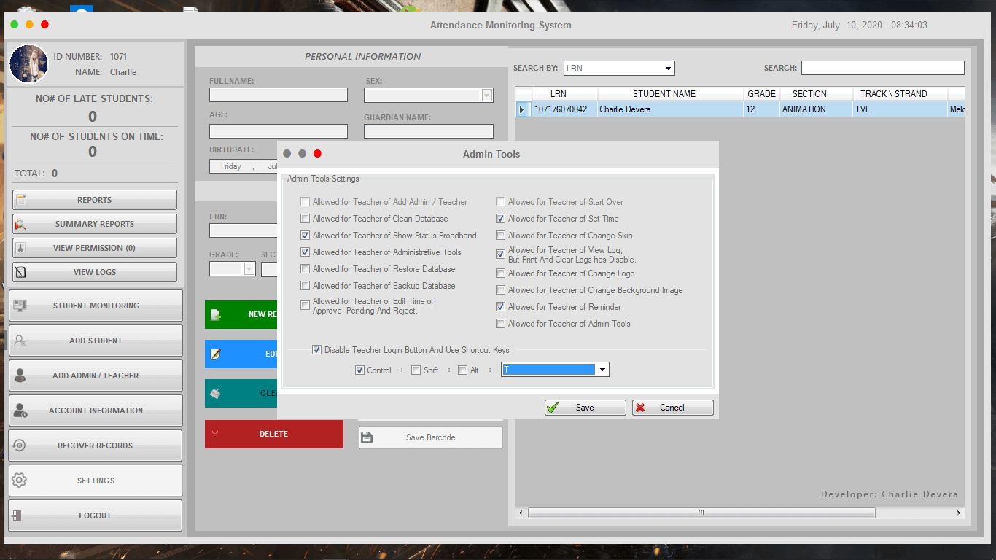
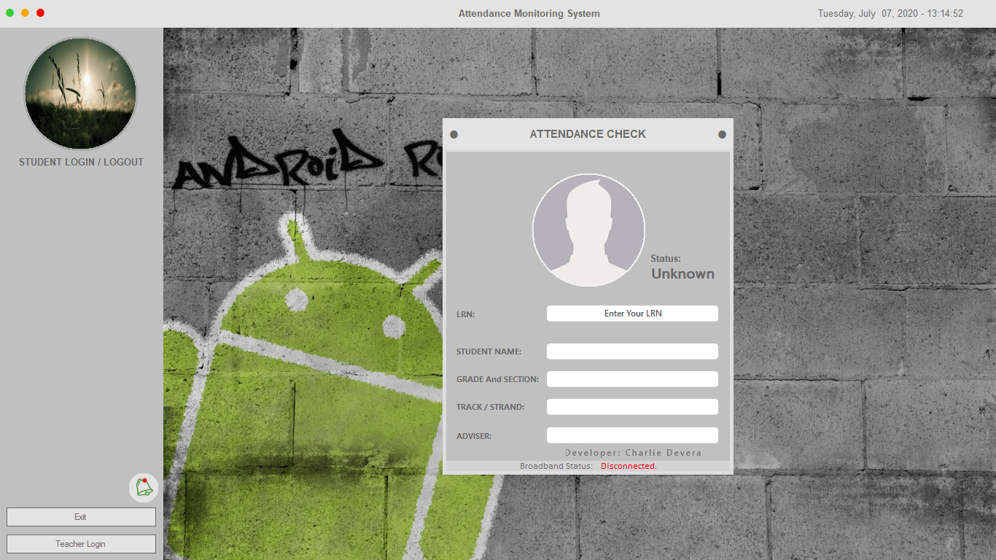
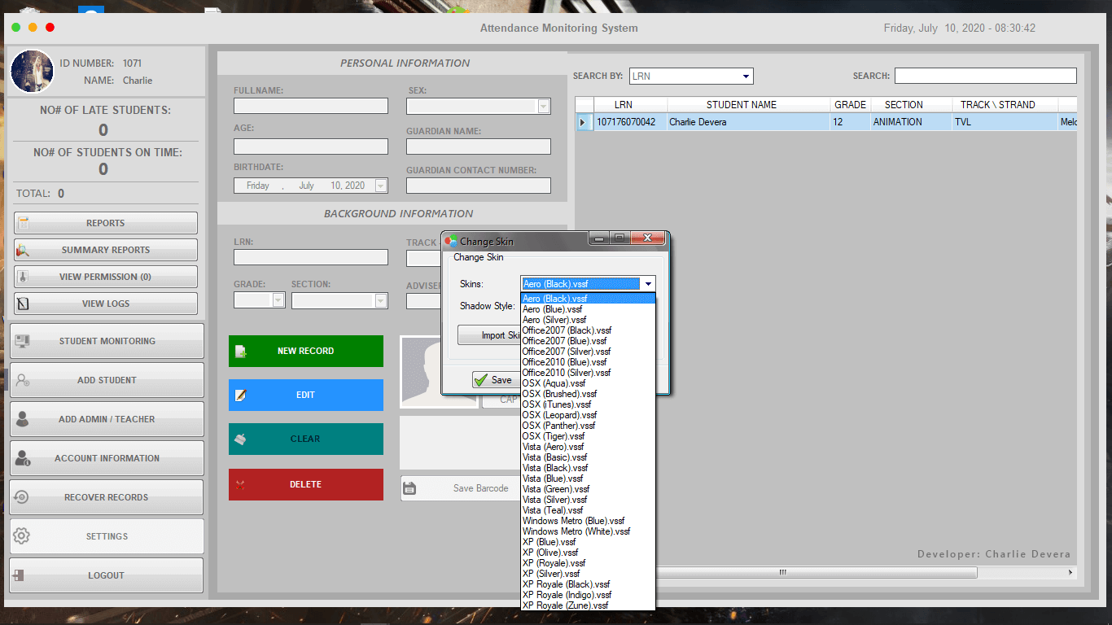
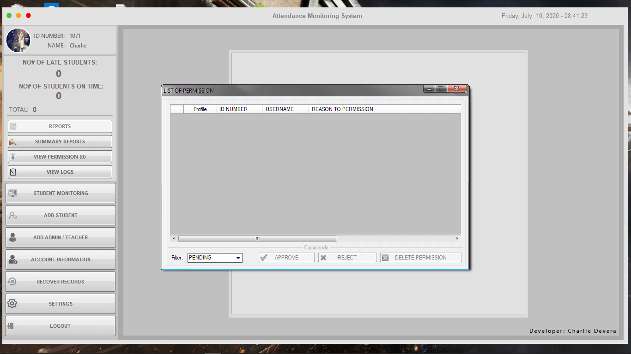
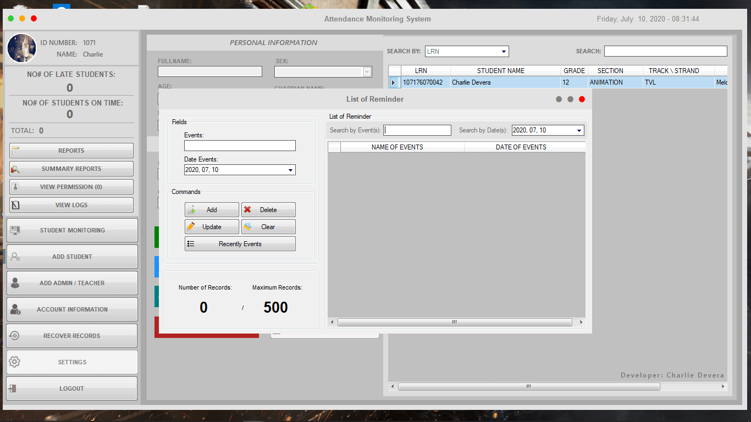
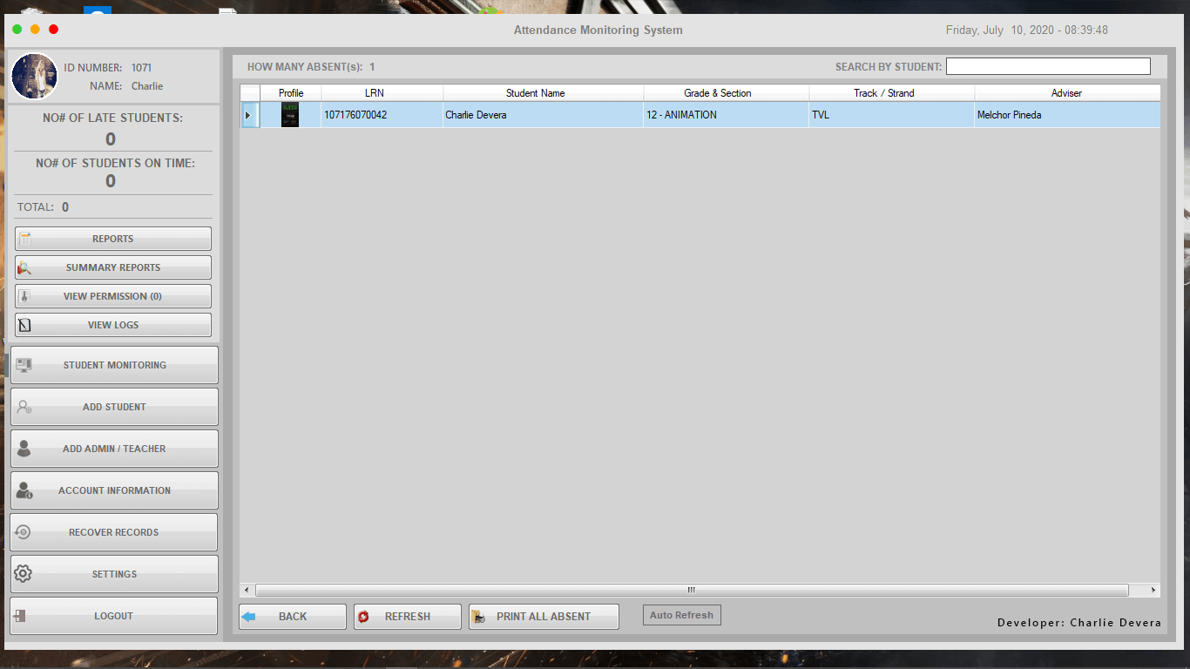
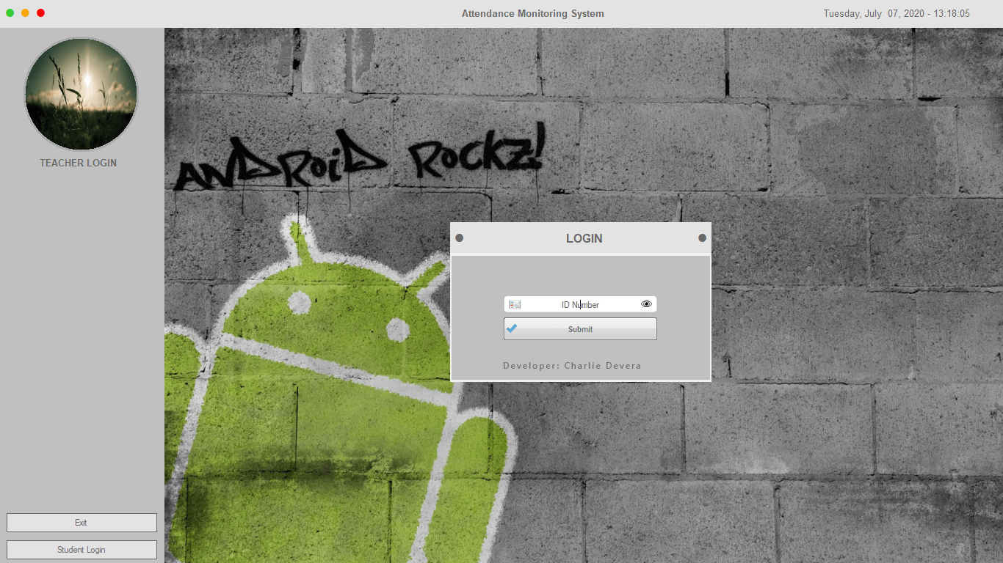
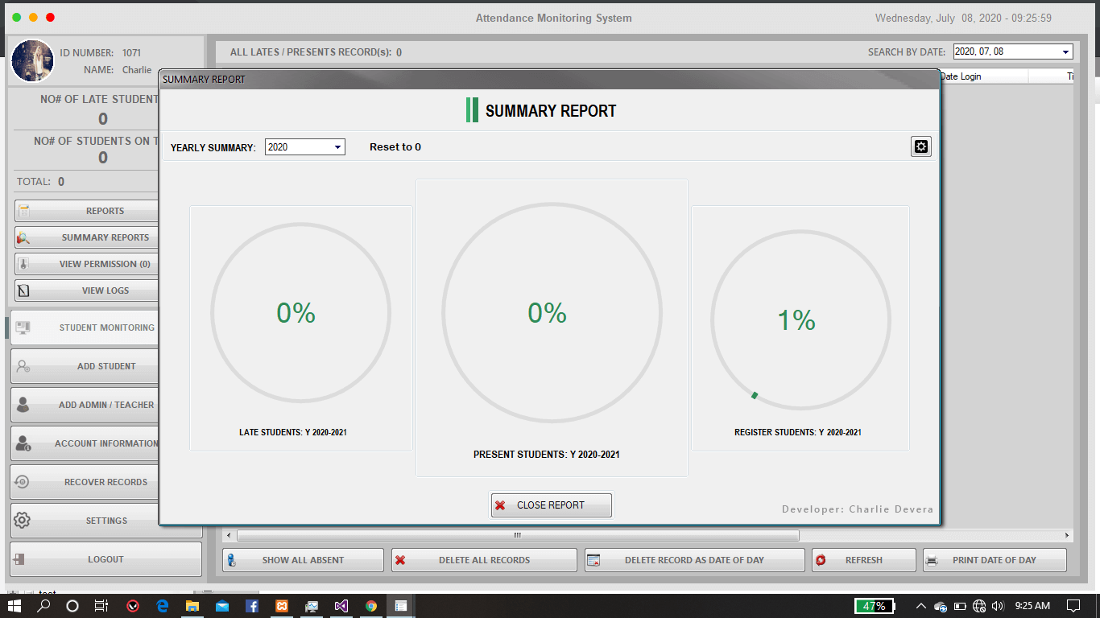

Chosen method of Testing
We have decided to use the black box testing. In this method we will input the data manually and check for successful output or an error from the system, deciding whether the code has been working properly or not. (Saurabh Rawat, 2020)
When we entered the system, we clicked on admin and the screen was successfully loaded to the next screen
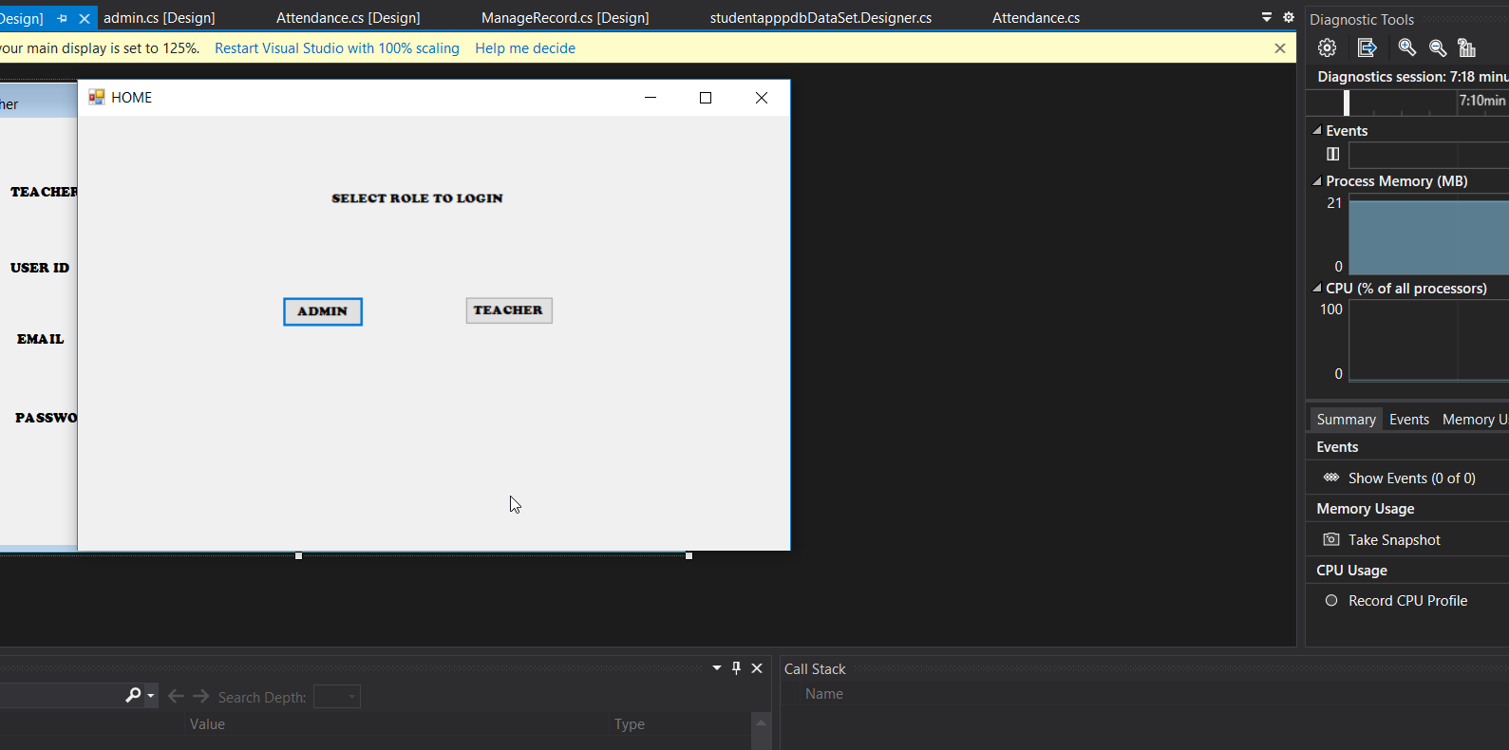

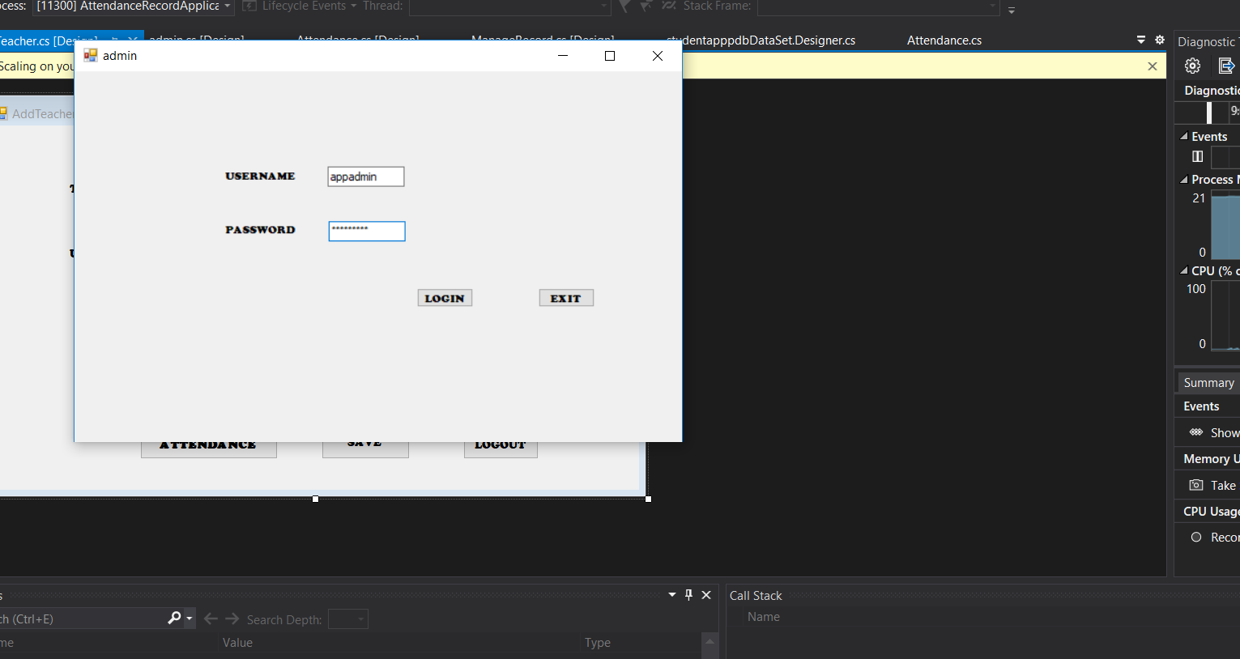
Then we entered our user Id and password, as correct data was entered the system allowed us to login. When we clicked on exit, we came back to the main screen again.

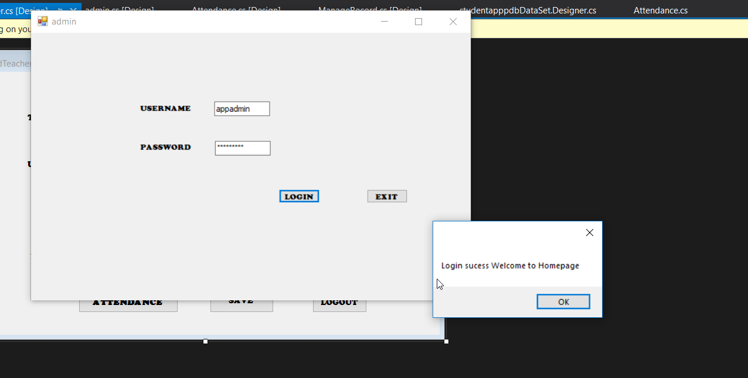
As correct credentials were entered, the message ‘Login success Welcome to homepage’ popped up. This means the login module works fine.
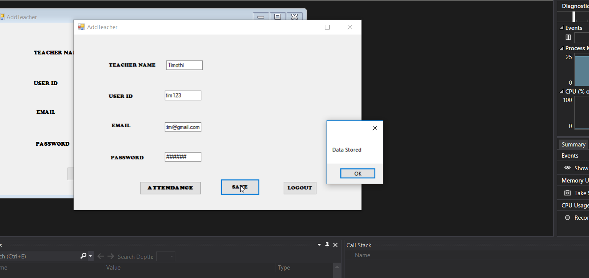
The admin then enters data and clicks on Save. As the data is correct the system gives Data Stored which then goes to the database and is checked every time the admin logs in.

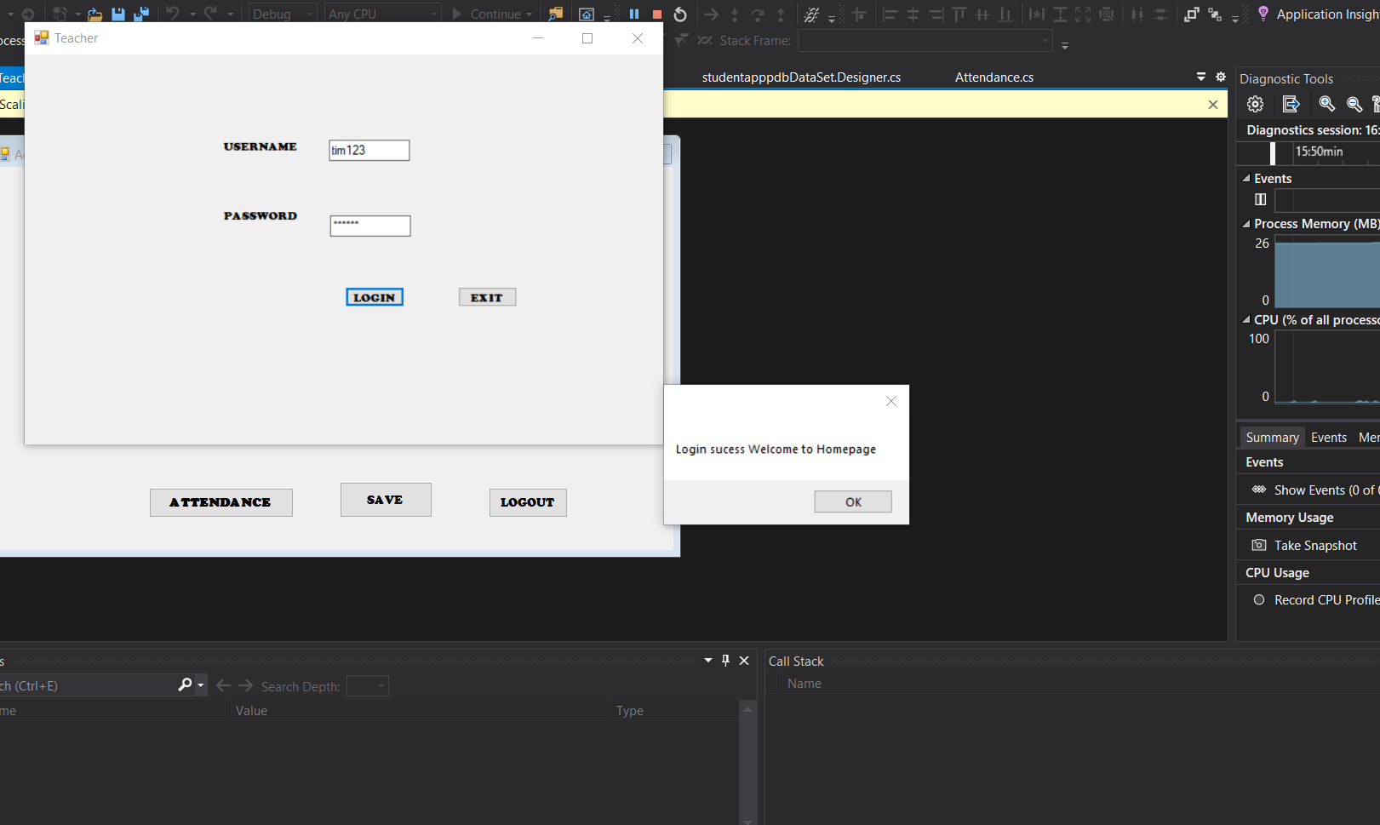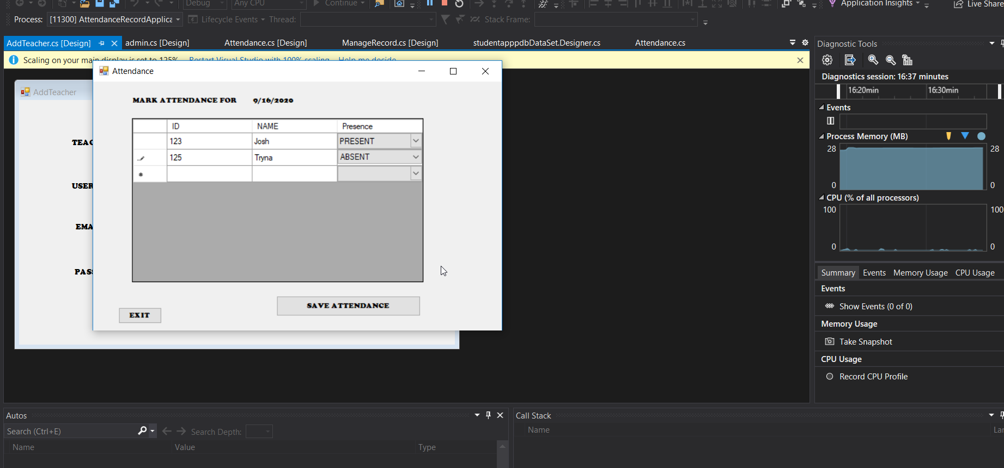

After the attendance is clicked on the attendance is saved in the system and can be retrieved. The testing stages were successful and all the output was as expected.

Limitations
The desired attendance Management System is one of the most important system components of the complete school management system which is the main Endeavour to computerize the complete work process inside the application just as to dispose of a progression of paper work required and lessen manual work time for educators and Administrator. While the Application has numerous abilities and favourable circumstances for the, it despite everything has a few restrictions: The GUI is simple and easy to utilize, however it isn't exactly alluring to the users.
After each school year, the administrator or teacher needed to erase the last year records manually which needs to be added as functionality. The administrator’s capacity to make his/her configurable profile is not upheld in this rendition. For instance, a user might need to change the current text style in the application to his/her top pick, or change the format and presence of the pages. Reports are not created by the developed applications and neither they are printable. In the event that the supervisors need to print this system will help them in utilizing the print include coordinated in the internet browsers or printers.
The subjective exploration was done around there of intrigue which included a direct of an overview as survey to roughly 50 students at the college who has had in any event one assessment in their course up until now. In view of the outcomes acquired from the review, the key and the high-need necessities were recognized which were then imagined and displayed utilizing the Unified Modelling Languages and models.
The convenience testing was later done after the execution of an electronic framework was finished. Similar understudies who took an interest in the principal review which was accomplished for prerequisites gathering were enlisted for the second overview for the convenience testing. The criticism got during the ease of use testing were positive as the understudies indicated their concurrence on how deliberate and intelligible the recently evolved online framework is in programming designing order, it is regularly said that the product is rarely finished, and the cycle is rarely wrapped up. With the presentation of different rising innovations in the separate field, there is consistently a space for programming advancement and for the combination of new highlights and functionalities. Because of the inaccessibility of assets, lacking specialized information and restricted timescale for the project.

Conclusion
The concerned project revolved around developing attendance managment project which shall manage the activities at schools. It has different applications that lie on the same database. Most of the activities such as a transcript, generating report card and framing timetable is done through window applications. Attendance recording by the classroom teacher, view reports, and student status, teachers are done through web applications.
The key issue that has been considered in the report is timetable framing which has been made quite simple through the technologies. The timetable is designed through the data structures. Here in the scheduler selects the subject teacher from the concerned database and thereby retrieves the classes allocated to the teachers. It calculates the load that should not be greater than the maximum load. It randomly selects one which would be allocated for doing one more lesson for the concerned subject. Based on this a free time slot shall be loaded as assigned for the lesson. The process is repeated by the scheduler unless the load becomes zero for the teacher. The results generated shall be stored in the database.
The system is capable enough to register the students with details of the parents, allows easy data retrieval in the context of the student, and thereby generates the desired report when needed. Apart from this, it also generates a master timetable which is feasible and thereby produces the timetable for the respective teachers. The web application of SMS helps in recording attendance by the classroom teacher. Even the parents view the children's status through the internet or intranet variables in the school.

References
Alkhali, F.F. and Oleiwi, B.K., 2018. Smart E-Attendance System Utilizing Eigenfaces Algorithm. IRAQI JOURNAL OF COMPUTERS, COMMUNICATION AND CONTROL & SYSTEMS ENGINEERING, 18(1), pp.56-63.
Arcuri, A., 2018. An experience report on applying software testing academic results in industry: we need usable automated test generation. Empirical Software Engineering, 23(4), pp.1959-1981.
CAPPELLO, P., 2017. A reference approach and an application profile to support the integration of chatbot systems with web information sources.
Chandavarkar, N.D., 2019. Technology Triggered Automated College Management System. Technology.
Chandramohan, J., Nagarajan, R., Dineshkumar, T., Kannan, G. and Prakash, R., 2017. Attendance monitoring system of students based on biometric and gps tracking system. International Journal of Advanced engineering, Management and Science, 3(3), p.239799.
Hosur, R. and Savakar, D.G., 2016. Attendance Management System. International Journal of Advanced Research in Computer Science, 7(2).
Htar, M.M.T. and Myaing, M.H.Y., 2019. Student Attendance Management System with Fingerprint (Software). International Journal of Trend in Scientific Research and Development, 3(5).
Mandal, N.K. and Khan, S., 2020. RFID BASED ATTENDANCE MONITORING SYSTEM. IJRAR-International Journal of Research and Analytical Reviews (IJRAR), 7(2), pp.614-616.
Omomule, T.G., Akingbesote, A.O., Bayode, O.O. and Aju, G.O., 2020. Development of Lecture Attendance System for Staff Performance Rating in a Tertiary Institution using Fingerprint Technology. Available at SSRN 3555637.
Raghuraman, A., Ho-Quang, T., Chaudron, M.R., Serebrenik, A. and Vasilescu, B., 2019, May. Does UML modeling associate with lower defect proneness?: a preliminary empirical investigation. In 2019 IEEE/ACM 16th International Conference on Mining Software Repositories (MSR) (pp. 101-104). IEEE.
Rahman, S., Rahman, M. and Rahman, M.M., 2018. Automated student attendance system using fingerprint recognition. Edelweiss applied science and technology, 1(2), pp.90-94.
Rawat, S. (2020). Direct-Indirect Link Matrix: A Black Box Testing Technique for Component-Based Software. Available: https://www.igi-global.com/article/direct-indirect-link-matrix/265139. Last accessed 7th Dec 2020.
Roy, A., 2018. School Management System (SCMS) (Doctoral dissertation, United International University).

