Primary PGCE

Student Number: 1800333

Principles of Pedagogy
M6X01438/C
Lecturer: Siân Brooks

‘Describe a learning event which has happened during your recent school experience. Reflect upon what took place, connecting events to theories of learning and teaching. Make recommendations about how you could improve your own practice in the light of this. Produce a poster to illustrate how you would develop the elements of an effective learning environment.’
Submission Date: 17/10/18

Words 5404

This essay on is based on play, experiential learning and use of the outdoor environment. It will describe a learning event which took place during a recent school bridging visit. The event will be described through observation and reflected upon, connecting relevant theories of learning and highlighting how this might improve future classroom practice. An academic poster will be included followed by a commentary outlining key elements of an effective learning environment considering the observations made.
The school in which the observation took place is based in a large urban area in Wales. The school caters for children aged three to eleven years. There are 385 pupils within the school. The school places strong emphasis on well-being and nurture. The following information has been taken from the schools most recent Estyn report. At the time of the report no pupils within the school spoke Welsh as a first language. 14% of pupils were from minority ethnic backgrounds, with 11% speaking English as a second or additional language. The school had identified around 52% of pupils as having additional learning needs. Approximately 39% of pupils were eligible for free school meals, which was above the national average (Estyn Report, 2014).
Throughout this essay the children will be referred to as Child A, B and C. They were between five and six years old. The school will be referred to as school X. All participants will remain anonymous in line with the guidelines set out in paragraph 40 of BERA (2018). Thus, recognising the entitlement of both institutions and individual participants to privacy and considering Article 16 of the United Nations Convention on the Rights of the Child (UNCRC, 2018).
Prior to my bridging visit at the school I decided that I would observe the children outside during playtime. I felt that this would be a good opportunity to reflect on the learning that takes place during a child’s free time and to link this learning to theory. Observations involve carefully watching and listening to children and making note of the findings. “Observing children is equally informative whether the observation takes place indoors or outdoors.” (WAG (a)2008). By carrying out observations in both the outdoor and indoor environment we can get a more holistic view of the child (WAG 2009). This is echoed in the Foundation Phase Profile, which states that to ensure we can build a broad picture of a child we should observe them in both settings (WG 2015).
During the time I was observing a learning event occurred spontaneously, whereby two children engaged in a free play. They were learning through independent play in a situation that had not been set up by a practitioner. The learning was visible, and the incident linked to several relevant learning theories and experiences. Therefore, I felt this would be an interesting event to base the assignment on.
The learning event was recorded using the written/unstructured method of observation as this appeared to be the most appropriate. This style of observation is referred to as ‘free description’ as it does not require planned templates and it is written in the present tense as it happens (Thomas and Lewis,2016, p.111). The only resources required are paper and a pencil. Sharman, Cross & Vennis (2004) suggests that unstructured recording is a good way of carrying out spontaneous observations, which occur as the result of something unplanned. However, these observations can be more difficult to evaluate, as notes jotted down in the moment may be difficult to decipher when later referred to (Sharman Cross & Vennis, 2004). This suggests that good practice would be to correlate the information as soon as possible while the memory of the observation is still fresh.
I situated myself on a tree stump which was close enough to hear the children’s conversation. The Welsh Assembly Government document ‘Observing Children’ suggests that practitioners can observe by positioning themselves near to the child and observing what the child is doing and how they are interacting with the learning environment (WAG(a)2008). According to Thomas and Lewis (2016, p.107) ‘non-participant observations’ requires the observer to separate themselves from their usual role and refrain from interacting with the child. It is also suggested that no eye contact is given as children who are aware they are being observed may change their behaviour. Therefore, I decided to not become involved in the activity and refrained from directing the play or asking any questions.
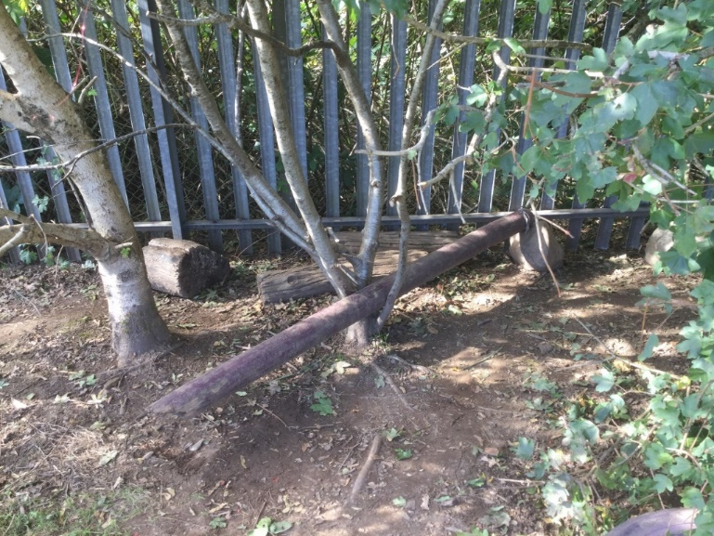
The playground area was well equipped and had several different elements and activities such as tricycles, small world play and ball games. There were several classes from within the foundation phase playing outside following lunch. Two pupils were observed playing on a log, which was located inside a hazel tree, near the
(Figure 1)

playground’s perimeter fencing. The log had been wedged between two of the lower branches allowing it to move up and down like a seesaw.
There was a large rock at one end, stopping the log from contacting the ground. I observed Child A standing on the log near to the centre and holding onto the hazel tree. Child A was moving up and down the log. This was causing the log to move and bang on the rock at the far end. Child A hung from the branches of the hazel. Child A then walked up and down the log still holding on but effectively balancing. Child A was then joined by Child B. The following is a transcript of their conversation:
Child B: No one will play with me.
[stands on the end of the log over the rock].
[Child A moves to the other side of the log. Looks at Child B but does not say anything. The log moves as Child A moves.]
Child B: We can play seesaw on here.
[The children are joined by a third Child. Child C climbs onto the log and starts to bounce up and down.]
Child A: Stop, we’re playing.
Child C: Ohhhhh, get off then if you’re scared.
Child B: He’s not scared your just blocking his way.
Child A: We can’t play.
[Child C reaches out and grabs at some small branches.]
Child C: Spikey one, watch out!
Child B: It won’t go up now, you move down there.
Child A: You’re not supposed to climb on trees.
Child C: You know my auntie Paul? He climbs trees in different places.
Child A: Move there.
[Child C walks away, Child A lies across the log.]
Child B: Be careful, don’t bang your head!
Child B: You are not a baby, be careful you don’t bang your head.
[Child A gets up stands on the end of the log]
Child B: Seesaw, seesaws.
Child B: Shall I do it to you? It’s a seesaw. You have to stand on the end.
[Child B climbs off and pushes the log down then lets it come back up repeating this action several times.]
Child A: You’re not supposed to push it! Don’t do it like that. Get on it.
[Child B gets back on the log.]
Child B: Yes, it is a seesaw. Seesaw, seesaw, seesaw.
[The children say seesaw, seesaw in a sing song voice like the tune of the nursery rhyme.]
Child A: I can go high.
Child B: Don’t bump it!
Child A: You can do it.
[The children walk along the log and swap places.]
The children continue to play on the log until the bell is rung to go inside.
It is important to note that for observation to be of any use we must reflect on it. It is this reflection which provides useful information regarding further planned activities and assessment. Grigg (2015), states that, ‘It is possible to improve the quality of observational skills through practice, discussion and critical reflection. In addition to this, reflection tools such as ‘Brookfield’s Four Lenses’ help develop a basis of thinking about how children experience learning and what impact the teaching methods and strategies we choose might have on their experiences. Brookfield (1995) suggests that we should look at a situation from four viewpoints: our own, our colleagues, our students, and theoretical literature.
The children were demonstrating several skills, the following table is representative of how observation could therefore be useful for assessment purposes:
Area of learning | Language Development and Communication Skills | Cognitive Development | Personal and Social Development Wellbeing an Emotional development | Physical Development
Child demonstrates  ability to… | Communicate ideas.  Ask questions.  Express their thoughts.  Use descriptive language. | Solve problems.  Work independently and with others.  Show an interest in their environment.  Experiment with new materials/resource.  Become actively involved in an activity.  Use thinking skills.  Communicate effectively. | Interact with peers.  Initiate play.  Show awareness of each other’s feelings.  Show care for their environment.  Show some understanding regarding keeping themselves safe.  concentrate for long periods of time on one activity. | Balance  Coordination  Adjust direction.  Demonstrate spatial awareness.  Use the space around them.  Hand to eye coordination.
(Figure 2 – WAG 2009)
Throughout the observation the children were engaged in experiential learning. This is an interesting and relevant area as it is deeply embedded in Foundation Phase provision in Wales (WAG(b) 2008). Experiential learning is the process of experiencing something for yourself to fully understand it. Bruce (1991) suggests that children need to reflect upon and wallow in their active experiences, feelings, ideas and relationships to become fully aware of what they may already know. This process is also referred to as metacognition.
The children would not have been able to play in this way inside the classroom. The children were spontaneously making use of the natural resources that were available to them. Children prefer to play outdoors, furthermore, they play in a different way outside. Children are encouraged to take risks that push them outside of their current abilities, challenging them cognitively, socially and physically (Cremin and Burnett, 2018)
This observation will impact on my future professional practice as I would not have considered the benefits of using outdoor space for continuous provision previously. However, having seen the learning potential I would incorporate the outdoor environment into my learning environment. Upon reflection it would have been interesting to observe child A in several different contexts to have been able to measure the impact of the environment on learning more accurately. In reflection I have learnt that good observations do not necessarily need to be set up with pre-determined outcomes. It is as important to observe children in unplanned activities as it is in structured learning experiences.
Observation is a common strand throughout learning theories, ideas that were initially based on observations are often supported by developmental theory (Pound, 2005). The children were investigating, taking risks, considering and learning. Furthermore, they were stimulated by their own inquisitiveness. Through using these techniques, they were able to construct their own meaning regarding what they were experiencing (Cremin and Burnett, 2018). The learning experience described in the observation links to many different learning theories relating to child development and education. However, for the purpose of this essay we will be looking at the learning incident using the lens of Social constructivist theories.
For many years it was widely believed that children were not active learners. The philosopher John Locke (1632-1704) is often quoted as referred to children as ‘blank pages’ or ‘empty vessels’, which suggested that they needed to be ‘filled’ with knowledge. In fact, it was the growth of ‘developmental psychology’ that assisted us to better understand how children learn (MacBlain, 2014). The nineteenth and early twentieth centuries saw many developments in learning theories and research into the way in which children learn. Hurst and Joseph (2000) state that throughout this century we have seen many educationalists, psychologists, theorist and philosophers inform our ideas on the best way to understand and provide education for children. Donaldson (2015) acknowledges this stating that changes have occurred in education due to developments in psychology, learning theories, and, neuroscience. Frobel, Montessori, Issacs, Piaget and Vygotsky are names that we frequently come across within education, their observations and learning theories are reflected within the learning and teaching pedagogies found within the Foundation Phase (WAG(b), 2008). September 2008 saw the introduction of the ‘Foundation Phase’ signalling a departure from a more formal, competency-based approach. The Foundation Phase was developed on evidence that an overly formal curriculum and extensive adult directed teaching in early years provision, had a long-term result of lower standards of attainment. It therefore placed a greater emphasis on the use of the outdoor environment and aimed to promote discovery and independence (Estyn 2017)

The word ‘play’ is one that we are all familiar with. However, it can be one of the most difficult words to define, even amongst theorists and researchers, as there are several different elements of play linked to learning theories (Pound, 2005). The conflict often arises regarding the level of structure and adult participation involved. However most agree that play should be ‘freely chosen’ and child led. Furthermore, it should be spontaneous and not have pre-determined rigid objectives (Cremin and Burnett, 2018). It is interesting to note here that the ‘word’ play appears to have been replaced by the word ‘experience’ in the ‘Successful Futures’ document (Griffith, 2018).
The learning event demonstrates the importance of learning through play and more noticeably children learning through investigating and experimenting. Thomas and Lewis (2016) note that a play-based approach to learning in the early years is not a new concept. When practitioners observe play for any length of time it becomes apparent that ‘play is a medium for learning’. Furthermore, when practitioners acknowledge and appreciate this it helps to enhance provision, inform planning, assessment and differentiation in line with the curriculum (Moyles,2010 pg. 10).
The constructivists view of learning in its most basic terms is an outcome of ‘mental construction’. Learning takes place when new information is added to an individual's previous knowledge, understanding and skills. (Pritchard, 2008). Rather than simply being told the answer children need to explore and find their own conclusions. In constructivism theories, the teacher or adult might use some direct teaching to facilitate the learning. However, this input tends to be limited and more time is spent monitoring and facilitating (Grigg 2015). This approach is applicable to the observation as the children were engaged in exploratory play and were indeed working together to enhance their own learning. This contrasts with the behaviourist theories which state that associations develop between ‘stimuli and responses. These theories give little consideration to an individual’s thinking or interaction with the world around them (MacBlain 2014).
Friedrich Frobel (1782-1852) has been extremely influential in early years education, famously stating that ‘play is a child’s work’ (Pound 2005, p.14). He is tremendously relevant as his ideas and theories had experiential learning and play as a central focus (WAG (b), 2008). Frobel viewed play as a reflection of transformations and inner processes and felt that adults should be sensitive in the way they intervened when children are learning through play (Wood and Attfield, 2005). Interestingly his theories also link to the observation regarding outdoor learning. He viewed kindergartens as the best type of learning environment, where children were encouraged to garden and appreciate nature (Thomas and Lewis, 2016). However, the freedom offered to the children in the outdoor environment contrasted with the somewhat formal education offered inside (Tovey 2007).
Maria Montessori (1870-1952) suggested that children learn through ‘hands-on’ experience, she believed that the outdoors should be used as an extension of the indoor environment and advocated educating the whole child through active learning, drawing similarity to Froebel’s ideas (Thomas and Lewis, p39 2016). This is reflective of the learning observed in the observation. However, she believed in a planned learning environment. Montessori advocated observing children using resources designed for specific purposes and then manufactured what she saw into her programme. However, some have argued therefore her approach was ‘empirical’ and that play was never actually involved (Smidt, p14 2011).
Susan Issacs (1885-1948) is particularly relevant as she recognises the importance of learning through play outdoors and actively encouraged children to use the outdoors for experimenting and learning (Thomas and Lewis, 2016). Like Frobel she believed in learning through doing and gave great importance to play in relation to learning. Issacs gave considerable importance to children’s emotional needs. This will be a prominent strand in the new curriculum, as seen in ‘Successful Futures’ as there is a great emphasis placed on mental and emotional wellbeing (Donaldson 2015). Issacs is particularly relevant to the observation as she was an innovator in encouraging children to follow their interests as opposed to being curriculum led (Thomas and Lewis 2016). However, there were some criticism of Issacs, as her sample group was relatively small and were all from “rich, well-educated families” (Thomas and Lewis 2016).
Jean Piaget (1896-1980) is arguably one of the most influential of the cognitive theorists. Piaget’s ideas recognised that children are active not passive learners, are independent in their learning (WAG(c) 2008). Piaget’s view was that, ‘Play is the work of childhood’ (Piaget,1962). His work had a strong emphasis on children being active in their learning. He favoured the idea of ‘construction rather than instruction’ and was sure that children learn best through doing things for themselves (Grigg, pg137.2015). This is relevant to the observation as the children were engaged in active learning through play and were independent in their learning. The overarching principle behind his theories was that people ‘construct knowledge’ as opposed to receive it. According to Piaget, there are specific stages of development and play, and children must progress through the stages in a prescribed order (Thomas and Lewis 2016). Piaget’s theories can still be seen within the foundation Phase where the focus is on purposeful learning relating to stages rather than age related milestones which Piaget discussed (Thomas and Lewis, 2016). However, Grigg (2015) states there are many who criticise Piaget suggesting that his theory that all children will automatically move to the next stage of development as they mature is inaccurate and that environmental factors and cultures play a role in development. Piaget did not recognise the importance of the influence culture and society has on learning. This contrasts with the findings of the observation as cultural influences were evident.
Lev Vygotsky (1896-1934) added to the constructivist approach, like Piaget he believed that children build knowledge through experiences. However, in contrast to what had come before, his theories emphasised the need for social interactions (Thomas and Lewis 2016). He developed the notion of the ‘Zone of Proximal Development’
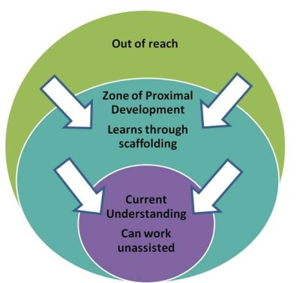
(Figure 3)
referring to the area in a child’s learning between what they could achieve independently and what they might achieve with the help of someone more knowledgeable than themselves (Vygotsky, 1978). This can be seen in practice today where children often work in pairs or groups with peers who are working at a slightly higher level than them (Griggs 2015) This type of peer interaction is also visible in the observation where Child B instructs Child A in certain aspects of their play. Vygotsky’s social learning theory has played a significant role in the developing an understanding of how children learn (Wag (b) 2008). Pound (2005) states that the idea of scaffolding children’s work, matching activities to the Childs abilities, comes directly from Vygotsky’s work. This approach is very much visible in the Foundation Phase curriculum we see today. Vygotsky’s theories also emphasised the importance of culture, context and traditions. Here he was referring to effects passed on through generations. ‘Cultural tools’ such as nursery rhymes, fairy stories and art (Gray and MacBlain, p95.2015). In the observation the children demonstrate this very clearly when they sing the nursery rhyme, they associate the rhyme with the action of going up and down on the seesaw, as this is how it would have been presented to them previously.
These learning theories indicate that learning is developmental and therefore learning experiences for children should be appropriate to their level of development. Some of this is linked to their age, although development level and age are not always the same thing (Cambridge Assessment 2018). There are common themes running through theory and these can clearly be seen in the observation and in present day practice.

The following digital poster is an interpretation of an ideal learning environment based on the observational findings:






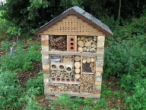


Mark making area
Shed/ Storage
Kiva – for interventions and quite reflective work

Laptop Trolley
Walk in Storage Cupboard
Beach
Path leading to woodland area with log circle with firepit
Allotment
Story Corner


Horseshoe Shaped Table - Focused Tasks
Guinea Pig Run
Quite Reflection area
Guinea Pig Cage
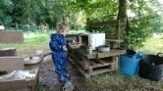
Mud Kitchen
Bi folding Doors
Teaching Assistants
AfL
Wild Area
Den Building
Undercover Outdoor Area.

Tuff tray – Small World Play
Messy Play Area with easy clean floor




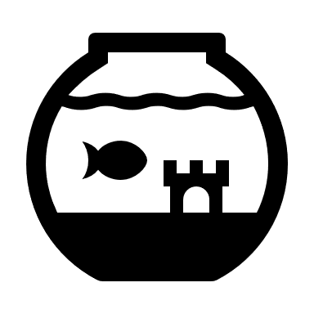
Stage
Interactive White board
Construction Area
Bug Hotel
Bean bags
Kitchen Area
Carpet Area
The following commentary explains and justifies the key pedagogical principles underpinning the provision provided in the Foundation Phase, Year 1 Classroom, illustrated in the poster. Due to the constraints of the essay I will focus the commentary on the key elements to the provision, which will incorporate experiential learning, within the three areas of provision seen in figure 4. The classroom will offer a broad range of activities, some activities will be planned by the teacher, including planned and structured play. There will also be areas for child led activities outside, which are a direct reflection of the observation in part 1.
The key physical feature in the learning environment is the entire wall of bi-folding doors, linking the inside and outside areas. The doors have blinds inside the windows, as previous experience shows that there are times throughout the day when light reflecting through windows can be detrimental to learning, particularly when using interactive whiteboards or computer screens. The doors have been incorporated as professional practice and research for this essay have led me to believe that the outdoor environment should be incorporated in the learning environment in a free-flowing manner. Vision and Values Partnership (2004) states that children should spend as much time outdoors as indoors and that they need well-designed, well-organised, integrated areas. Furthermore, these environments offer meaningfully different, but balancing, experiences to children. Thomas and Lewis (2016) state that within the Foundation Phase there is a strong focus on developing free-flow between the two learning environments. The learning environment reflects the value placed on outdoor provision and its role in pupil well-being, physical health, stimulation and creativity. In doing so it will reflect the four key purposes and pedagogy embedded within the ‘Successful Futures’ document (Donaldson 2015). Policy and guidance in England and Wales outline the expectation that children will be given experiences outside the classroom (Waller 2007). For example, the Department for Education and Skills (2005) states that children ‘should experience the world beyond the classroom as an essential part of learning and personal development’ (DfES, 2005, p. 11). The Foundation Phase Curriculum in Wales confirms this view ‘The Foundation Phase environment should promote discovery and independence and a greater emphasis on using the outdoor environment as a resource for children’s learning.’ (WAG, 2008, p.4). Furthermore, it is important to consider the pupils wellbeing, I would therefore consider elements such as weather and staffing arrangements when using the outdoor learning area.
Best practice suggests that there should be planning for continuous provision, enhanced provision and focused tasks in all classes within the foundation phase. However, Estyn’s (2017), report states that in many schools in Wales teachers do not have a good understanding of these three areas of provision. This appears to be a result of there not being a balance between experiential learning and formal teaching, particularly in years 1 and 2 where teachers continuing to invest too much time in the formal teaching. The Successful Futures document highlights areas of learning and experience. There is now a greater focus within the curriculum on experiential learning, problem solving and independent learning in both primary and secondary schools (Donaldson 2015). Therefore, focused tasks will not take president in this learning environment, much of the learning will take place through enhanced and continuous provision as the diagram suggests.

(Figure 4)
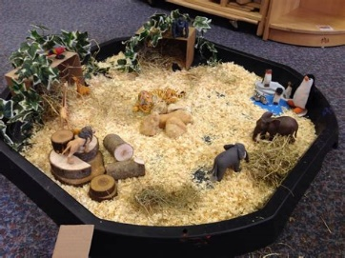
Continuous learning activities should consist of planned and unplanned learning areas in the indoor and outdoor environment (ESTYN 2011). The areas will include the beach, mark making area, water play, digging area/allotment, construction, small world and roleplay areas. They will continuously be available for the children and although certain elements will change according to class theme, these areas will predominantly remain the same in structure throughout the year. For the purpose of this essay they have been sign posted with separate headings. However, they would not be used in isolation of each other (WAG (c) 2008). The pupils in the observation were playing during lunchtime. Upon reflection I have incorporated a wild area in continuous provision. This area will be like that seen in Figure 1 and will be enhanced with natural materials and den building equipment. Small world play has been included as it is an important part of a foundation phase classroom. Children develop, apply and practise skills through a range of activities.

(Figure 5)

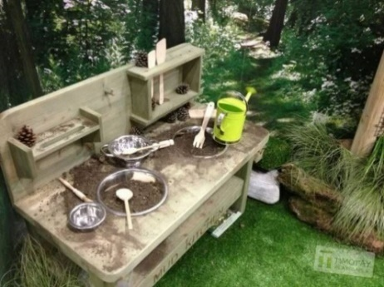
The mud kitchen will be part of the continuous provision outside. It will provide the opportunity to play with household kitchen equipment, usually found in the roleplay area, in a more creative way. There will be enough room for several children to play together, the surfaces will be at the right height for the pupils and a washing up area will also be available. The children will help to plan and build the kitchen as suggested by White (2014).
(Figure 6)
The beach area will be a large sand pit big enough for several children to play together. There would be deep sand, shells buckets and spades, drift wood and pebbles. The area will have a cover that will be light weight and easy to remove. Part of the beach area will be under the covered area outside to give shade in the summer and keeping part of the area dry in wet weather.
Enhanced provision will be planned enrichment to these areas, such as adding a challenge to the beach area or theming the role play area. Enhanced provision will be further developed by adding more challenge or breath to resources within these areas as the need arises. As shown below:
Can you make a circle?


How many buckets and spades can you see?

Find 4 shells.
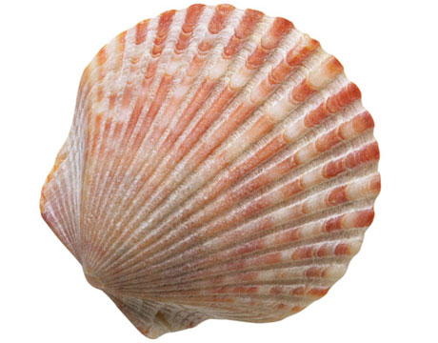

(Figure 7)
There will be frames around the perimeter that you will be able to place instruction cards inside. These will be changed as the pupil’s skills develop. Children should be encouraged to use literacy and numeracy skills independently through outdoor activities (Estyn 2017).
The woodland area will be accessed for Forest School. Forest school is a specific approach originating in Sweden in the 1950s and introduced to the UK in 1990 (Grigg 2015). The children will visit the woodland on a regular basis, where they will participate in engaging, motivating and achievable tasks and activities. They will be given opportunities to learn about the natural environment, how to handle risks and most importantly to use their own initiative to solve problems and co-operate with others. This approach helps to develop self-awareness, increased motivation, and improve communication skills along with promoting independence and positive mental attitudes (Forest School Association, 2018). This echoes the learning experience seen in the observation and fits in well with the key characteristics outlined in ‘Successful Futures’ (Donaldson 2015).
Focused tasks will be planned activities initiated and modelled by the teacher and will cover the areas of learning holistically (Thomas and Lewis, 2016). They will be reflected in the wider learning environment through continuous and enhanced provision and will usually, but not exclusively take place in the focus task areas. I have included horseshoe shaped tables which will be used to work on focused tasks. There will also be a large carpet area in front of the interactive whiteboard. Where the children will be introduced to new ideas, practice skills and develop knowledge through focused teaching and activities.
There are two Teaching Assistants (TA’s) included in the poster, they would make up part of an effective team. Although it has been argued that TA’s might not provide value for money much of these arguments are formed on the basis that TA’s have little impact on pupil progress. It is suggested that much of their time is spent managing the classroom behaviour and carrying out preparation tasks (Grigg 2015). However, it could be argued that this allows the teacher to focus on aspects such as learning and teaching. Professional experience suggests that TA’s are an invaluable resource and often bring many years of experience and knowledge to the classroom. Cremin and Burnett (2018) suggest that there are many examples of positive practice, where teachers and TA’s have worked as a team and that clarity of roles and good management enhances experiences and provision in the classroom.
Assessment for Learning (AfL) will be used to generate feedback and involve the children in their learning. Through activating and building on prior knowledge AfL strategies can be used to support learners to become more independent (Cambridge International Education Teaching and Learning Team, 2018).
Donaldson (2015) states that children inhabit a digital world, their lives are increasingly entangled with technology in countless ways. The modern-day world progressively demands high levels of digital competence. Therefore, I have included one laptop per child, an interactive whiteboard and digital cameras for taking photos and recording videos. in the learning environment. I would not however include iPads. Professional experience has shown that iPad are generally used as a reward or a camera and have little value educational. There is very little that can be done on an iPad that cannot be done on a laptop.
The environment will be language rich incorporating both Welsh and English with display boards and prompt question cards in key areas around the classroom. Children will be encouraged to use Welsh language. The fact that the classroom is in Wales will be celebrated and Welsh culture, heritage and history will be incorporated in line with ‘Curriculum Cymreig’(QCAAW,2003).
In conclusion the observation highlighted the importance of play and experiential learning. These were therefore incorporated and in the learning environment. The debate around how much adult led learning should take place is evident and there has also been evidence of differing views regarding the level of structure within activities. However, it has become increasing evident that there needs to be a balance between these things. There is not a one size fits all answer. Practitioners need to be creative and to follow the needs of the children in their classes.
In reflection good observations do not necessarily need to be set up with pre-determined outcomes. Furthermore, recording the critical event has reinforced my belief that observation is a vital part of everyday practice within education. Careful observation can be used to verify where children are regarding their learning. This information can subsequently be used to develop skills and to identify any potential areas of ‘difficulty or exceptional ability’ (WAG, 2015). However, it is important to recognise that the information recorded must be used productively to help inform planning and create a holistic picture of the child’s learning journey (WAG, 2009).
The theorists mentioned have been influential in the development of the Foundation Phase in Wales. There theories continue to influence educational practice and aspect such as well-being, building on prior knowledge and scaffolding are evident within documentation regarding the new curriculum. Unfortunately, it appears that a focus on attainment targets and producing evidence my still be having a detrimental effect on the amount of time given to experiential, learner led (Estyn, 2017). It is now a case of reversing this trend and re-education some practitioners who are still focused on heavily structured and formal teaching approaches.
Learning outdoors and experiential learning are invaluable tools in Foundation Phase Education. However, practitioners need to be aware of their role within the activities they set, creating a balance between child initiated and adult led learning. The observation and research suggest that allowing children control over their learning can produce extremely valuable learning outcomes. Knowledge of child development and individual pupil needs are crucial. In practice it is essential that children are encouraged to learn through a range of experiences enabling the four purposes outlined in Graham Donaldson ‘Successful Futures’ to be achieved.

Reference List
Brookfield, S. (1995). Becoming a critically reflective teacher (Jossey-Bass higher and adult education series). San Francisco: Jossey-Bass.
Bruce, T. (1991). Time to play in early childhood education. London: Hodder & Stoughton Educational.
Cremin, T., & Burnett, C. (2018). Learning to teach in the primary school (Fourth ed., Learning to Teach in the Primary School) Oxon: Routledge
Department for Education and Skills (DfES) (2005) Learning outside the classroom: manifesto. London: DfES
Donaldson, G. (2015). Successful Futures:Independent Review of Curriculum and Assessment Arrangemants in Wales. Cardiff: Crown Copyright
Estyn (2011) Literacy and the Foundation Phase: An evaluation of the implementation of the Foundation Phase for five to six-year-olds in primary schools, with special reference to literacy
Estyn Report (2014) Estyn report omitted for reasons of anonymity.
Estyn (2017) Active and experiential learning: Effective foundation phase practice in delivering literacy and numeracy in Year 1 and Year 2'
Griffiths. (2018) Play and Active Learning. UWTSD: Swansea
Gray, C., & MacBlain, S. (2015). Learning theories in childhood (Second ed.). Los Angeles: SAGE.
Grigg, R. (2015) Becoming an Outstanding Primary School Teacher. 2nd ed. Routledge: Oxon
Hurst, V and Joseph, J (2000) Supporting Early learning. Buckingham: Open University Press
Pritchard, A. (2008). Ways of learning: Learning theories and learning styles in the classroom (2nd ed.). London: Routledge.
MacBlain, S. (2014). How children learn (First ed.). London: SAGE publications.
Moyles, J. (2010). The excellence of play (3rd ed.). Berkshire, England: McGraw-Hill: Open University Press. Pritchard (2009) Ways of Learning. London: Routledge
Piaget, J. (1962) Play, Dreams, and Imitation in Childhood, New York: W.W. Norton
Pound, L. (2005) How Children Learn. Step Forward. Publishing Limited: London
Sharman, C., Cross, W., & Vennis, D. (2004). Observing children: A practical guide (3rd ed.). London: Continuum.
Smidt, S. (2011) Playing to Learn: The Role of Play in the Early Years. Routledge: Oxon
Thomas, A., & Lewis, A. (2016). An introduction to the foundation phase: Early years curriculum in Wales. London: Bloomsbury
Tovey, H. (2007) Playing outdoors: Space and Place, risk and Challenge. Maidenhead: Open University Press
Waller, T. (2007) ‘The Trampoline Tree and the Swamp Monster with 18 heads’: outdoor play in the Foundation Stage and Foundation Phase, Education 3–13, 35:4, 393-407, DOI: 10.1080/03004270701602657
Welsh Assembly Government (a) (2008) Observing Children. Cardiff, Crown Copyright
Welsh Assembly Government (b) (2008) Learning and Teaching Pedagogy. Cardiff, Crown Copyright
Welsh Assembly Government (c) (2008) Play/Active Learning. Cardiff, Crown Copyright
Welsh Assembly Government (2009) Outdoor Learning Handbook. Cardiff, Crown Copyright
Welsh Government (2015) Foundation Phase Profile Handbook. Cardiff, Crown Copyright
White, J. (2014). Playing and learning outdoors: Making provision for high quality experiences in the outdoor environment with children 3-7 (2nd ed.). London; New York: Routledge
Wood, E., & Attfield, J. (2005). Play, learning and the early childhood curriculum (2nd ed.). London: Paul Chapman.
Vygotsky, L (1978) Mind in Society, Cambridge, MA: Harvard University Press

Web Based Resources
British Educational Research Association [BERA] (2018) Ethical Guidelines for Educational Research, fourth edition, London. https://www.bera.ac.uk/researchers-resources/publications/ethicalguidelines-for-educational-research-2018
(Accessed 22/09/18)
Cambridge International Education Teaching and Learning Team (2018) [getting started with Assessment for Learning] https://www.cambridge-community.org.uk/professional-development/gswrp/index.html
(Accessed 14/09/18)
Forest School Association[Learn More] (2018) https://www.forestschoolassociation.org/#
(Accessed 12/10/18)
Qualifications, Curriculum & Assessment Authority for Wales [QCAAW] (2003), Datblygu'r Cwricwlwm Cymreig = Developing the Curriculum Cymreig. Caerdydd: Awdurdod Cymwysterau, Cwricwlwm ac Asesu Cymru
(Accessed 14/09/18)
UNCRC a summary of the un convention on the rights of the child https://www.unicef.org.uk/what-we-do/un-convention-child-rights/
(Accessed 22/09/18)
Vision and Values Partnership (2004) The Shared Vision and Values for Outdoor Play in the Early Years: http://outdoormatters.co.uk/wp-content/uploads/2011/03/eyfs_res_vision_outdoor_play1.pdf
(Accessed 21/09/18)

Appendix
Figure 1: Bridging Visit School X (2018)
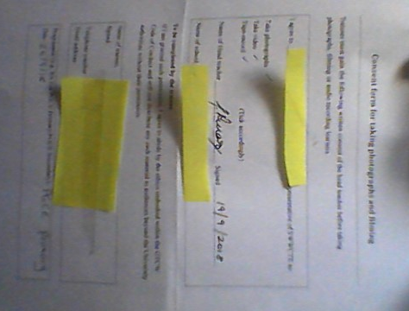

(Consent form for Photograph)

Figure 2: Table constructed for the essay using skills from (WAG 2009)
Figure 3: Zone of Proximal Development -Why should you care about Instrumental Enrichment and what does it mean for your students? Published: 2 Jul 2015https://www.villierspark.org.uk/wp-content/uploads/2015/07/8.-ZPD-Diagram-616x462.jpg (10/10/18)
Figure 4: Diagram created for essay
Figure 5: Small world play : Pinterest https://i.pinimg.com/originals/b6/6b/5e/b66b5e65964846a45a788bf719813b13.jpg
(6/10/18)
Figure 6: Example of a mud Kitchen - Top 20 of Mud Kitchen Ideas for Kids https://www.1001gardens.org/2014/07/20-mud-kitchen-ideas/ Last updated July 2018
Figure 7: Cards made for the purpose of illustration in the essay.

