Student Name: | Aleksandrs Pliseckis
Student Number: | 1814644
Module No: | BMSK4003
Module Title: | Digital Skills and Research Methods
Date: | 29/08/2019
Topic: | Availability of music education for children in East London

Table of Contents
Abstract 1
Introduction 2
Literature Review 3
Primary Research 4
Methodology 4
Ethical considerations 4
Limitations of the Study 4
Results 4
Conclusion 8
References 9
Appendix 10
Questionnaire 10

Abstract
This study addresses the issue of access to children's music education in East London. The study provides statistics and expert opinions from secondary sources that reflect the situation with the musical education of children in the UK. Parents were asked to answer the questionnaire, which covers several aspects:
- Do parents believe that music education contributes to the overall development of children?
- What interest do parents show in their children's music education?
- How do parents evaluate the accessibility of music education for their children?
The collected answers became the basis for the corresponding conclusions. We recommend this study to all those who are interested in the availability of children's music education.

Introduction
Studies show that music education helps develop many skills. Music helps children learn school subjects better. Nowadays, many parents want their children to have the opportunity to have a musical education. In the UK, a special government program has been developed so that children can learn to play musical instruments. Under this program, children in public schools have the opportunity to learn to play musical instruments for free. The purpose of this study is to examine the issue of access to music education for children in East London public schools. A survey was conducted of parents and guardians whose children attend school.

Literature Review
Lauren Martin (a Writer for Learning Liftoff) is opposed to curtailing music education in schools. Studies show that music education of children favorably affects their development. A study by Christopher Johnson, a professor of music education and music therapy at the University of Kansas, says that children show better results in English and math if they studied with good music programs. Singing and playing musical instruments teach children how to achieve their goal in a safe way. Children freely interpret their goals and learn to achieve these goals. In such a game, children develop their self-esteem. Musical education teaches you to count the rhythm. Children use their logic to count rhythm and bars. Dr. Eric Rasmussen, head of the Department of Early Childhood Music at the Peabody Preparatory at Johns Hopkins University, claims that playing musical instruments contributes to brain development. Musical skills develop creativity and critical thinking. Those who sing in a choir or play in an orchestra acquire team working skills and active listening skills. Music helps children with special needs find their way to developing communication skills (Martin, 2014).
Fiona Miller published an article on children's music education in the UK in The Guardian. The author evaluates the state of musical children's education as being in a dangerous condition. Seven years ago, there was a state program, according to which every child had the opportunity to learn how to play a musical instrument. According to recent studies, this program does not work in many schools. A survey of 1,000 music teachers, principals, and managers of music services confirms that the program does not work. Children from families in which parents earn less than £ 28,000 are less likely to learn musical instruments. About 89% of parents have to pay for their children's music education. The author concludes that music education is being squeezed out of the curriculum of schools. According to surveys, the number of music lessons in the north and in the south varies markedly. There are schools with very good provision for quality music education, and there are schools in which there is almost nothing. There is a desire of children and parents to have the opportunity to learn music during the school day. The authors of the report developed more than 30 recommendations for the government to correct the situation with school music education. Music should be the main subject in all schools. To do this, it is necessary to evenly distribute resources across all schools. The Department of Education is developing its plans with a view to improving music education (Millar, 2019).
Eleanor Busby, a correspondent for education, writes in Independent that children from poor families are at risk of not getting a music education at all. About 41% of families do not find funds in their budgets for music education for children. The government urgently needs to adopt budget changes so that poor households do not lose the opportunity to give their children a musical education. David Arnold, the composer who starred in the James Bond films, says he received his first musical education at his school without the free. A guitar teacher told the author that ten years ago he gave his lessons at a regular public school for free. Today, such classes at this school cost parents £ 80 for a group lesson (Busby, 2018).
The level of musical education of children depends on the level of musical education of parents. Parents with a musical education can help their children learn music. They understand that music helps children develop many abilities (Busby, 2018).

Primary Research

Methodology
To study the availability of music education for children in East London, respondents were asked to answer the questionnaire. Questions to respondents were asked by phone, sent by email and face-to-face. The respondents involved in this survey were people living in East London. Before the survey, respondents were informed about the topic of the study, as well as its objectives. The survey took place during daylight hours. All respondents were asked to answer the same questions in the order in which they are presented in this study. All questions are designed in such a way that respondents can express a positive, negative or neutral attitude to the subject of the study. In this study, both quantitative and qualitative research methods were used. For the analysis and interpretation of the obtained answers, the study used graphs. On the graphs, the results of the survey are presented in percent (Saunders, 2016), (Bell, 2005).

Ethical considerations
For this study involved participants who gave their consent. Only parents and carers were involved in the survey. All participants were informed about the topic, goals, and objectives of this study. Before the survey, participants had the opportunity to read all the questions from the questionnaire in the order in which they are presented in this study. If participants had questions on the substance of the issues, clarifications were given. Before the start of the survey, all participants received assurances that their data would remain anonymous. All respondents were informed that they have the right to refuse to participate in the study at any stage (Saunders, 2016).

Limitations of the Study
First of all, this study is limited in sample size. The sample size of this study is 50 respondents. The study was conducted over two weeks and negligible resources were spent on it. To make the study more representative, the study used qualitative research. The small sample size influenced the volume of analysis and does not provide a basis for determining unambiguous trends. These limitations have affected the topic and research method. Future studies on this subject need to consider these limitations (Saunders, 2016).

Results
This descriptive study was undertaken to find out how East Londoners rate the availability of music education for their children. During the study, fifty people were interviewed. Respondents answered eight questions from the proposed questionnaire.
Respondents answered the first question (What effect does music education have on your child?) almost unambiguously. 92% said that music education has a positive effect on their children. Six percent of respondents believe that music education can have a negative impact on their children. Two percent of respondents are not ready to answer the question.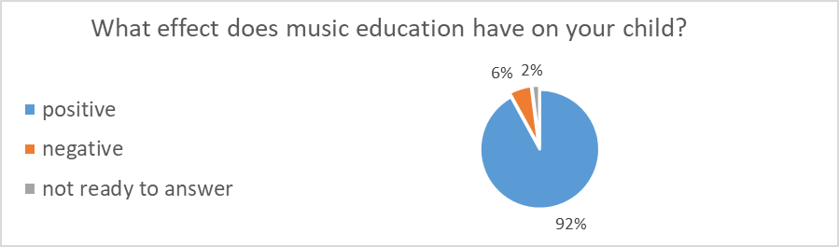
To the second question, the majority of respondents, namely 86%, answered that at the moment their children do not learn to play musical instruments. The largest indicator - 6% of children learn to play the guitar. None of the children learns to play the violin and flute (0%).
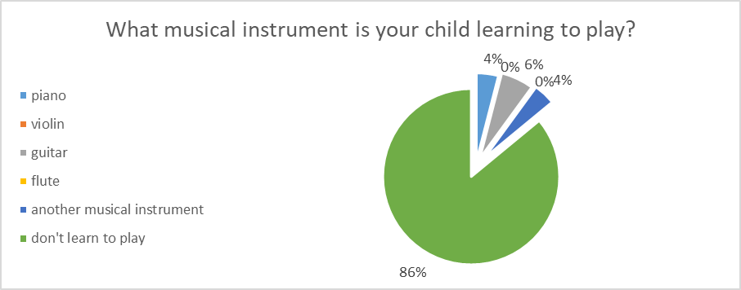
The level of music education, respondents rated as follows: - 40% poor, - 30% fair, - 24% good, - 6% very good. The respondents do not believe that the level of teaching music at school can be rated excellent (0%).
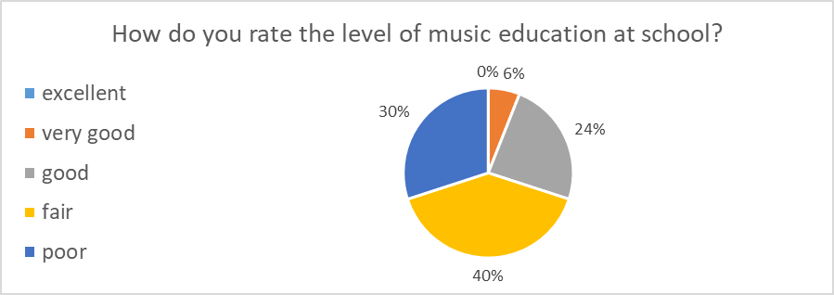
More than half (52%) of respondents do not have information about the state program. 24% of respondents believe that the program needs to be improved. 20% expressed a negative attitude toward the program. 4% of respondents expressed their positive attitude towards the state program jf music education for children.
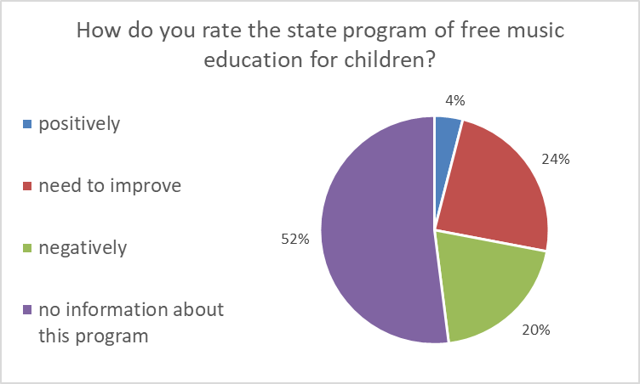
In the fifth question, respondents expressed their opinion on the attitude of their children to the process of learning music. 76% of respondents believe that their children love to learn music. The survey involved respondents who do not know how to answer this question (16%). Perhaps they do not know the opinion of their children or their children have not yet decided on their choice. 8% of respondents believe that their children do not like to learn music.
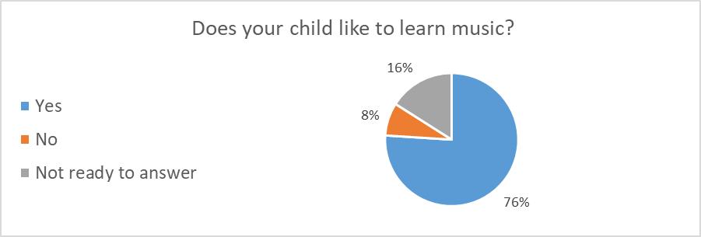
The vast majority of children do not attend free music lessons at school (80%). 16% of respondents for various reasons could not answer the sixth question. 4% of respondents said that their children attend free music lessons at school.
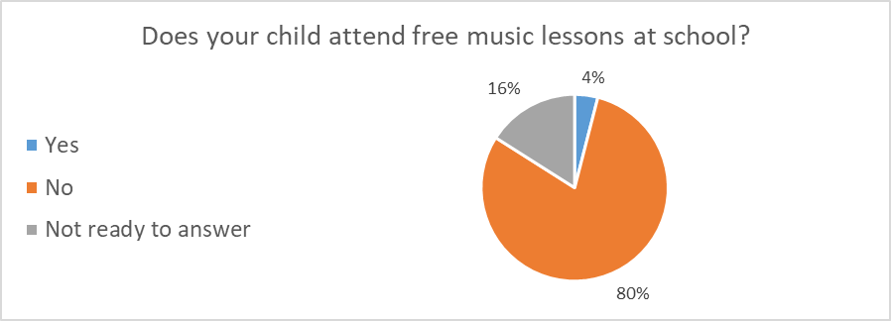
Most respondents are not ready to pay for music education. (46%). The seventh question caused difficulties for 34% of respondents. 20% of respondents are willing to pay for tuition from the family budget.
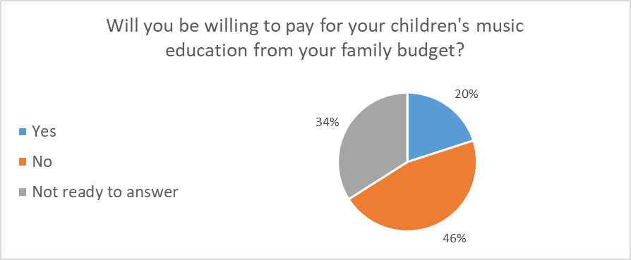
90% of respondents supported the idea that music lessons at school should be free. 6% of respondents have the opposite opinion. 4% of the respondents did not give a definite answer to the eighth question.
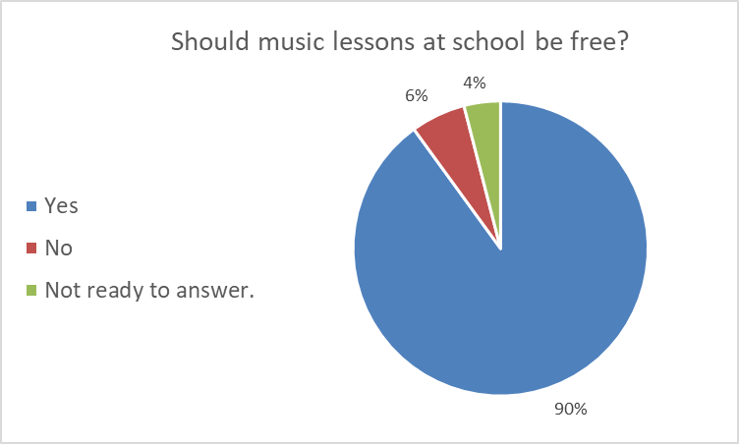
This study shows the difference between the public opinion of residents of the UK and residents of East London on Brexit issue.
According to published studies, only a small portion of the UK population (7%) believes that the government will be able to make a good deal with the European Union. Our study confirms these concerns.

Conclusion
Some schools teach children music for free. The availability of free children's music education depends on the distribution of financial resources. These resources are not evenly distributed. There are public schools in which children are not taught music. Not all children, attending public schools, have equal access to music education.
Most respondents recognize the importance of music education (92%) because music helps children develop their skills. Children are also interested in music education. According to the study, most children (86%) do not learn to play musical instruments at present. Firstly, this contradiction can be explained by the fact that parents are not ready to pay for the education of children (46%). Secondly, many parents are not aware of the existence of a state program to support children's music education. Assessment of the level of accessibility of music education demonstrates well the answer to the question about the assessment of education at school (question number three). Based on our study, we can conclude that the availability of music education for children in East London is low. This study requires further analysis to help find a solution to improve music education for children in East London.

References

Bell, J. (2005) Doing your Research Project: A guide for first-time researchers in education, health and social science. Maidenhead: Open University Press.

Busby, E. (2018) Poorer children in UK priced out of learning to play musical instruments, report warns. Independent [online]. Available from: https://www.independent.co.uk/news/education/education-news/music-lessons-school-instrument-tuition-musicians-union-poor-children-a8619201.html [Accessed 20/08/19].

Martin, L. (2014) 10 Benefits of Music Education for Students. Learning lift-off [online]. Available from: https://www.learningliftoff.com/ten-benefits-of-music-education-for-students/ [Accessed 19/08/19].

Millar, F. (2019) School music report reveals cuts, inequality and demoralised teachers. The Guardian [online]. Available from: https://www.theguardian.com/education/2019/apr/02/school-music-cuts-inequality-demoralised-teachers [Accessed 16/08/19].

Saunders, M., Lewis, P., Thornhill, A. (2016) Research methods for business students. Harlow: Pearson Education Limited.

Appendix

Questionnaire

Availability of music education for children in East London

A student at University of Wales Trinity Saint David conducts a survey on the availability of music education for children in East London. This work is carried out as part of the university curriculum. The data from this study will be used for a written report (coursework).

1. What effect does music education have on your child? Please circle one of the offered options.
Positive -Negative -Not ready to answer

2. What musical instrument is your child learning to play? Please circle one of the offered options.
-Piano -Violin -Guitar -Flute - Another musical instrument Don't learn to play

3. How do you rate the level of music education at school? Please circle one of the offered options.
- Excellent - Very good - Good - Fair - Poor

4. How do you rate the state program of free music education for children? Please circle one of the offered options.
Positively - Need to improve - Negatively -No information about this program

5. Does your child like to learn music? Please circle one of the offered options.
-Yes -No - Not ready to answer

6. Does your child attend free music lessons at school? Please circle one of the offered options.
-Yes -No - Not ready to answer

7. Will you be willing to pay for your children's music education from your family budget? Please circle one of the offered options.
- Yes - No - Not ready to answer

8. Should music lessons at school be free? Please circle one of the offered options.
-Yes -No - Not ready to answer

Thank you for taking time to help me.

