

Student name: | Peter William Smyth | Student Number: | 2316422
Programme: | MSc Cybersecurity and Digital Forensics (Distance Learning)
Module: | Data Security, Governance and Compliance
Module code: | ACCA7028
Assignment Title: | Apply the principles and practices of Data security, Governance and Compliance based on a given scenario

List of Acronyms i
List of Figures 2
List of Tables 2
1 Abstract 1
2 Introduction 1
3 Security Framework and Model Research 2
4 Proposed Approaches to Information System Security, Governance, and Compliance at NatureGarden (NG) 6
4.1: Govern 8
4.1.1 Obtain Management Support 8
4.1.2 Establish the project & Roles, Responsibilities and Authorities 8
4.1.3 Organisational Context 8
4.1.4 Risk Management Strategy 9
4.1.5 Policy 9
4.1.6 Oversight 9
4.1.7 Cybersecurity Supply Chain Risk Management 9
4.2: Identify 10
4.2.1 Asset Management 10
4.2.2 Risk Identification 10
4.2.3 Risk Quantification 10
4.2.4 Cyberinvestment Analysis 12
4.2.5 Improvement 12
4.3: Protect 13
4.3.1 Identity Management, Authentication and Access Control 13
4.3.2 Awareness and Training 13
4.3.3 Data Security 13
4.3.4 Platform Security 14
4.3.5 Technology Infrastructure Resilience 14
4.4: Detect 15
4.4.1 Continuous Monitoring 15
4.4.2 Adverse Event Analysis 15
4.5: Respond 16
4.5.1 Incident Management 16
4.5.2 Incident Analysis 16
4.5.3 Incident Response Reporting and Communication 16
4.5.4 Incident Mitigation 16
4.6: Recover 17
4.6.1 Incident Recovery Plan Execution 17
4.6.2 Incident Recovery Communication 17
5 Is it good practice to have new or updated regulations and standards? 18
6 Conclusion 19
7 References 20

List of Acronyms

Acronym | Meaning
AI | Artificial Intelligence
API | Application Programming Interface
CAF | Cyber Assessment Framework
CAT | Cybersecurity Awareness and Training
CIS | Center for Internet Security
COBIT | Control Objectives for Information Technologies
CSF | Cybersecurity Framework
CSIRT | Computer Security Incident Response Team
CVE | Common Vulnerabilities and Exposures
DevOps | Microsoft Work Management Tool
FIPS | Federal Information Processing Standards
GDPR | General Data Protection Regulation
IEC | International Electronical Commission
IGP | Indicators of Good Practice
InfoSec | Information Security
ISO | International Organization for Standardization
IT | Information Technology
KPMG | KPMG International Limited
MAM | Mobile Application Management
MDM | Mobile Device Management
MFA | Multifactor Authentication
NCSC | National Cyber Security Centre
NIST | National Institute of Standards and Technology
NG | Nature Garden
OWASP | The Open Worldwide Application Security Project
PCI-DSS | Payment Card Industry Data Security Standard
SASE | Secure Access Service Edge
SD-WAN | Software Defined Wide Area Network
SEIM | Security Event Information Management System
SP | Special Publication
VPN | Virtual Private Network
Wi-Fi | Wireless Fidelity

List of Figures

Figure Name | Page
CSF Functions | 2
Asset Classes from the CIS Controls | 3
Principles of COBIT 5 | 4
Example IGP | 5
Proposed Cyber Security Framework | 7
An example risk matrix showing three attack types | 11

List of Tables

Table Name | Page
Researched Resources | 2

1 Abstract

In this work I will research existing Cybersecurity Frameworks and discuss the key aspects that I have determined will help NatureGarden. I will describe how I have used these aspects to design my own framework. I will describe each stage of the design with reference to the problems currently faced by NG. Finally, I will critically analyse the importance of new regulations and standards.

2 Introduction

NatureGarden (NG) currently faces many problems with their cybersecurity. Meanwhile new threats are emerging such as advanced persistent threats and ransomware-as-a-service. With reference to existing Cyber Security Frameworks, guidance documents, standards and research articles, a customized security framework will be designed specifically addressing the challenges faced by NG.
In an enterprise the guidance documentation for configuring a firewall may be based on one of the enterprise's policies. Yet this policy isn't simply invented by the InfoSec team, it is written with careful reference to relevant regulations and standards. I will be reviewing some of the newer regulations and standards to evaluate their importance.

3 Security Framework and Model Research

Resource
NIST Cybersecurity Framework (CSF) 2.0
ISO 27001 / ISO 27002
CIS Critical Security Controls
Cybersecurity: Risk management framework and investment cost analysis
NCSC Cyber Assessment Framework
COBIT 5
Table 1. Researched Resources.

I researched overall security structures including the major process steps from ISO/IEC 27001:2013 [1] and the Core Function and Category Names from NIST’s CSF 2.0 [2].
NG’s current situation sounds volatile so using the NIST core functions and category names to divide the security program into six functional areas further divided into categories could make the work more manageable than the major process steps from ISO/IEC 27001:2013 which seems a longer and more complicated model.
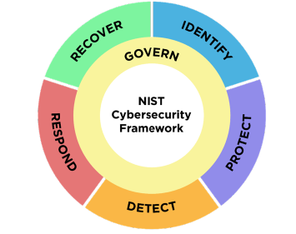
Fig 1. CSF Functions.

However, security is in disarray at NG and Furnell et al. note there are challenges finding suitably skilled cybersecurity professionals [3]. The first two stages of the ISO/IEC 27001:2013 major process steps: Obtaining management support and Establishing the Project which entails project planning, budget and a human resource plan do seem relevant to NG.
Additionally, the ISO/IEC model involves “communication with interested parties and records of communication” and “Monitoring and measurement and records of the results” at each of its stages which could help ensure the project stays on track.
The CIS Critical Security Controls [4] offer issue specific guidance. They are usefully aligned with the NIST CSF 2.0, and the Asset Classes diagram could really assist the asset inventory process.

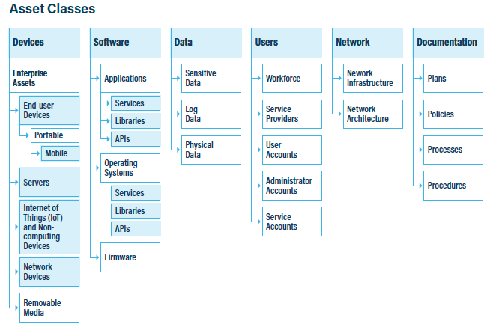 Fig 2. Asset Classes from the CIS controls.

While researching COBIT 5 [5] the five principles stood out as good objectives to include:

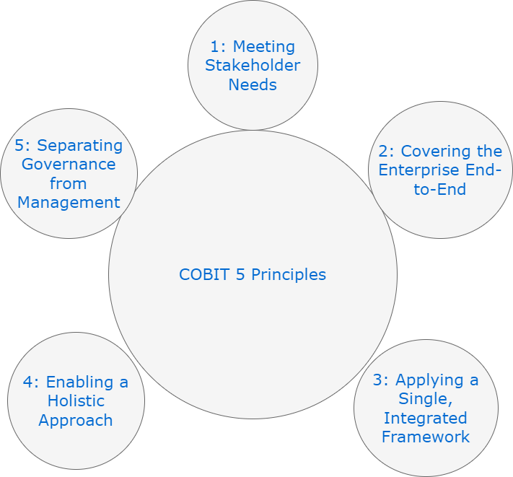
Fig 3. Principles of COBIT 5.

Lee’s Cyber Risk management framework [6] addresses both the human and technical aspects and could help us achieve principle four above as well as enhancing risk assessment. The NCSC’s Cyber Assessment Framework [7] provides indicators of good practice (IGPs) which form a useful checklist to ensure key deliverables are completed:

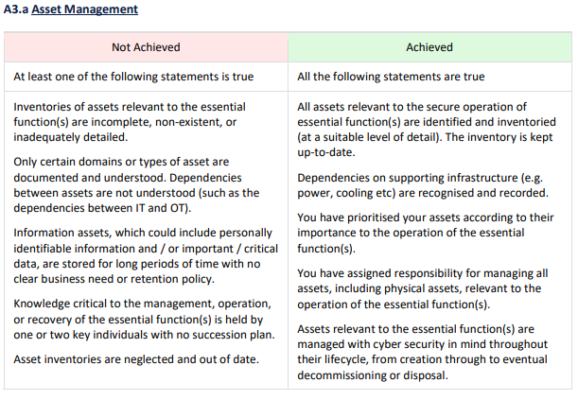Fig 4. Example IGP.

4 Proposed Approaches to Information System Security, Governance, and Compliance at NatureGarden (NG)

Following my research into security frameworks I have devised the following framework for NG that is mostly based on the NIST CSF with the following modifications:

- “Communication with interested parties and records of communication” and “Monitoring and measurement and records of the results” from ISO/IEC 27001:2013 will take place during each function.

- Obtain Management Support from ISO/IEC 27001:2013 is now the first category.

- Establish the Project from ISO/IEC 27001:2013 has been merged with Roles, Responsibilities and Authorities.

- At the end of each function work will be checked against the relevant IGP from NCSC’s CAF and we will consider if the relevant COBIT 5 Principle(s) have been met.

- The Asset classes from CIS Critical Controls will be used in the Asset Management phase.

- Risk Assessment has been replaced with Risk Identification, Risk Quantification and Cyberinvestment Analysis from the Cyber Risk management framework.

The IGP / COBIT 5 Principal checks at the end of each stage will take place in a meeting with relevant internal and external stakeholders. Work completed will be summarised, relevant IGPs and COBIT 5 principle(s) considered, and actions put on relevant staff to resolve any unmet priorities. As this will be the same for each stage they do not appear as subsections below.

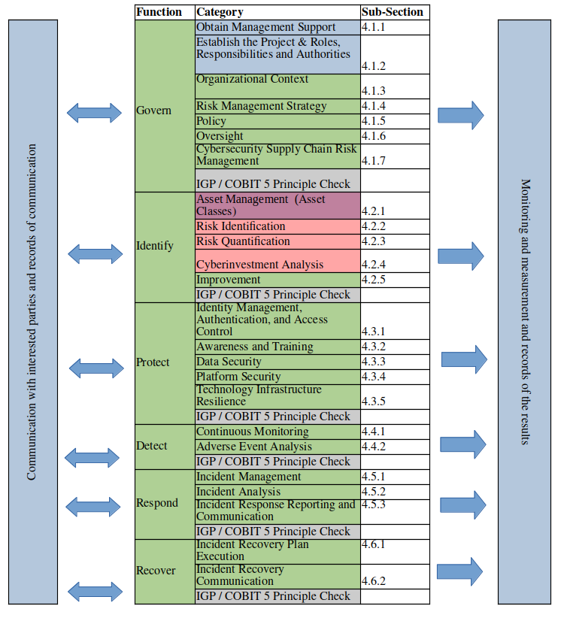
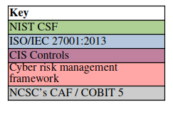
Fig 5. Proposed Cyber Security Framework.

4.1: Govern

4.1.1 Obtain Management Support

We will begin by presenting a factual but emotive case to senior leaders as suggested by Liu et [8].

4.1.2 Establish the project & Roles, Responsibilities and Authorities

A budget will be agreed, all existing InfoSec roles will be reviewed, A departmental restructuring will take place this may offer better value than an organisational reconfiguration [9] Where necessary new roles will be advertised. Responsibilities and authorities will be agreed [2].

4.1.3 Organisational Context

We will study NGs:
- Value, Mission and Vision statements [10].

- Strategy documents [10].

- Legal and regulatory documents from all regions of operation [2].

- Contractual obligations [2].

- Relationships with external stakeholders such as cloud service providers and ingredient suppliers [2].

- Needs of internal stakeholders (via meetings with heads of departments).

- Needs of customer’s and associated services e.g. external facing websites and online stores.

- Bring your own device user needs [11].

These activities will help us assess the cyberecosystem layer of NG [6].

4.1.4 Risk Management Strategy

The KPMG approach to understanding and articulating Risk Appetite [12] will be followed to ensure risk profiles are created for each major activity and future strategic plans. Risk appetite and risk tolerance statements will be created [2]. Lee’s cyber risk management Framework will be used to help categorize risk [6].

4.1.5 Policy

Based on the organisational context policy will be used to ensure reasonable user behavior from staff and customers. Specific details will include:
- A Bring Your Own Device Policy developed based on the NCSC guidelines [13].

- Expectable use policy to describe the use of all IT services.

- Privacy Statements (Based on GDPR guidelines) [14].

- Terms and conditions for the website to encompass ordering and payment policy written with reference to Hancock’s guide to PCI-DSS [15].

4.1.6 Oversight

Following the advice of Saeed et al. a comprehensive risk management strategy will be created that includes mitigations, risk transference and will facilitate international co-operation to help combat cybercrime [16].

4.1.7 Cybersecurity Supply Chain Risk Management

Service Level agreements with all cloud suppliers will be reviewed and where necessary revised. This activity will take place with reference to the NCSC’s cloud shared responsibility model [17] and their cloud service requirement from Requirements for IT infrastructure [18].

4.2: Identify

4.2.1 Asset Management

A manual process could be time consuming and complicated [19]. So, software that provides Automatic Asset Identification will be used [20] referring to the Asset Classes from the CIS Controls to ensure everything is accounted for [4]. This activity will help us assess the Cyber Infrastructure Layer of NG [6]. A ranking system will then be used to prioritize assets based on criticality [2].

4.2.2 Risk Identification

Having identified the types of assets to be protected we will identify vulnerabilities and threats from external and internal actors [6]. To achieve this, we will:
- Employ a penetration testing company to complete an external and internal penetration test.
- Use the CVE database to check all assets identified for vulnerabilities. Making use of the CVE API to automate the process [21].

4.2.3 Risk Quantification

To create our cyber risk matrix will first define the frequency of each cyberattack per year based on all previous cyberattack data held internally, and information gathered on each attack from external sources such as OWASP top 10 [22]. Using Lee’s formulas, we will derive an expected financial loss for each attack [6] and plot the results like so:

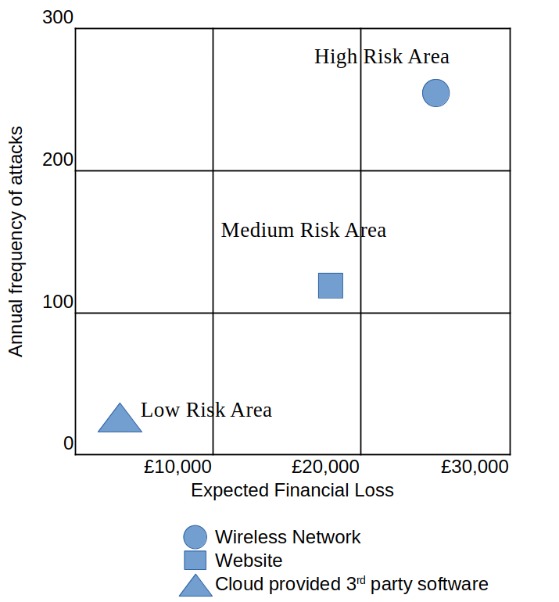
Fig 6. An example risk matrix showing three attack types.

4.2.4 Cyberinvestment Analysis

Lee’s formulas will be used to create a cost benefit analysis for each attack showing the cost of successful attacks versus the cost of defense [6]. Working with senior leaders we will decide to what extent to treat each risk.

4.2.5 Improvement

As the NIST CSF notes improvements to Risk Management process, procedures and activities can be made at any stage [2] integrating the working practice suggested in ISO/IEC 27001:2013 of “communication with interested parties and records of communication” and “Monitoring and measurement and records of the results” [1] will be our key methods of ensuring improvements are captured and this will be achieved by setting up meetings with key internal and external stakeholders and using DevOps for recording improvements.
The information gathered so far in this function will inform us as we write our incident response, incident recovery plans [2] and alert roster [23].

4.3: Protect

4.3.1 Identity Management, Authentication and Access Control

Permissions for all users and groups will be reviewed and amended where necessary. Taking inspiration from Rubis and Cardei we will create granular access control lists [24] based on our policies ensuring the principle of least privilege is followed [25]. Multifactor authentication (MFA) will be used to protect access to enterprise resources, and user activities will be tracked and monitored with mechanisms such as audit logs [26]. The policy will enforce users to set strong passwords.

4.3.2 Awareness and Training

An awareness and training programme will be set up for staff that includes web pages, online courses and in-person training addressing current issues such as home working. We will refer to resources such as the Cybersecurity Awareness and Training (CAT) Framework for Remote Working Employees [27]. Guidance will be provided to customers through web pages.

4.3.3 Data Security

To ensure confidentiality, integrity and availability of data, to prepare for Bring Your Own Device and to facilitate remote access we will implement a Secure Access Service Edge, Musthaler notes this could be preferable to a VPN [28]. MacDonald et al. note that a benefit of SASE is improved security, using content inspection sensitive data can be identified [29].
As per the NCSC’s Bring Your Own Device guidance, we will use mobile device management (MDM) to control devices that join the network and to block access to certain devices, e.g. based on location. We will combine this with Mobile Application Management (MAM) which will allow us to maintain control of work applications [30].
Data backups will be created and following the guidance of CIS control 11 we will ensure recovery data is protected with the same level of controls as the original data [4]. Data at rest, in transit and in use will be encrypted wherever possible.

4.3.4 Platform Security

Old hardware and software will be replaced. Platform Security Validation software will be used to ensure misconfigurations in systems and devices are managed [31]. To reduce the attack surface and prevent attacks such as war driving, we will transition all physical premises to wired connections. Wi-Fi will remain available in designated hot desk rooms.

4.3.5 Technology Infrastructure Resilience

To help protect the network from unauthorized access and use [2] we will implement the Checkpoint Next Generation Firewall as Nuriana et al. showed this effectively improves server security and protects against cyber-attacks [32]. We will also make use of Demilitarized Zones to protect key resources such as servers [33] and Network Segmentation [34] so if unauthorized access is gained to the network, it can be isolated to one segment.

4.4: Detect

4.4.1 Continuous Monitoring

A Security Event Information Management System (SEIM) will be implemented to help NG investigate, find and warn of possible fraudulent activities [35]. We will also ensure it can provide the following recommended functionality from NIST SP 800-215 [36]:
- A dashboard that shows network topology, key metrics such as latency and network traffic levels
- Identifies Interfaces
- Measure drift (e.g. bandwidth availability and unwanted traffic)
- Generates data needed by centralized management tools
- Generates network security alerts and threat intelligence feeds
- Artificial Intelligence (AI) based algorithms for monitoring networks for security related concerns

4.4.2 Adverse Event Analysis

Anomalies, indicators of compromise and other potentially adverse events will be identified by correlating information from the SIEM and checkpoint. A ticketing system will be used to:
- Store issue information
- Assign issues to staff
This will enable a chain of custody process [37] and DevOps will provide this functionality [38].

4.5: Respond

4.5.1 Incident Management

Incident response plans will be followed [2], we will refer to Incident Handling Checklists [39]. A Computer Security Incident Response Team will be called in [40]. We will be looking for a team that can demonstrate:
- Communication
- Problem solving
- Trust
- Knowledge Sharing
[41]. Incident response playbooks will also be followed, and they will be written with enough detail to be effective [42].

4.5.2 Incident Analysis

Real-time analytics will be used where possible to keep track of incidents [43]. Information will be collated from Checkpoint, the SIEM, DevOps, staff and the CSIRT.

4.5.3 Incident Response Reporting and Communication

As per our incident response plans internal and external stakeholders will be notified and sent information on the incident [2].

4.5.4 Incident Mitigation

After an incident we will ensure containment strategies are prioritized such as disabling compromised user accounts and reconfiguring the firewall before drastic strategies are needed such as powering down network devices [44]. As per the incident handling checklist we will ensure vulnerabilities exploited are addressed and discovered malware removed [45].

4.6: Recover

4.6.1 Incident Recovery Plan Execution

Recovery activities will take place such as verifying the integrity of backups and checking the integrity of restored assets [2]. Table-top exercises will be used to simulate this stage in order to prepare the NG team [46].

4.6.2 Incident Recovery Communication

As per our incident response plans relevant internal and external stakeholders will be notified and sent information on the incident [2].

5 Is it good practice to have new or updated regulations and standards?

Hodgins draws our attention to some serious drawbacks of regulation. California Senate bill 327 which calls for internet connected devices to be protected with “reasonable security” or the GDPRs mandate for a “reasonable level of data protection” without an accompanying definition [47] could both be viewed as ambiguous and could potentially lead to a variety of interpretations.
Ooijen and Vrabec argue there are several provisions in the GDPR that serve as helpful steps in enhancing consumer control over personal data [48]. Organisations are incentivized to be compliant to avoid financial penalties [49], also to the benefit of the consumer.
However, the benefits to the individual may not be at the detriment of the organisation. Arcuri showed a generally positive impact on the market share prices of European listed financial companies after the regulation came into force [50], economically benefiting companies was perhaps an unintended and unpredicted result.
It could be argued that it in the case of the GDPR its creation has been validated as good practice by the studies that clearly show an improvement to the individual and to the organisation such as the two noted above.
Djebbar and Nordström draw our attention to a difficulty faced by cybersecurity professionals: There are many standards all with some areas of overlap [51]; we can imagine the difficulty organisations must face integrating them into policies and working practices [52]. The UK government's Cyber Security Breaches survey published in 2023 found 27% of the businesses surveyed adhered to the PCI DSS. 27% of large businesses adhered to ISO 27001 and 15% of businesses adhered to NIST standards [53]. However, this is perhaps an improvement from 2017 as the UK government's Cyber security breaches survey found cyber security standards were not well known in the business community, only 21% of businesses surveyed were aware of ISO 27001 [54].
So, although organisations may be daunted by the multitude of standards or the areas of overlap, the UK government's survey data certainly supports the hypothesis that they are becoming more accepted as sources of good practice by organisations.
In NIST’s FIPS 205 a stateless hash-based digital signature is specified designed to provide resistance against attacks from large scale quantum computers [55]. A new version of ISO/IEC 27001 was released in 2022 which was aligned with the harmonized structure for management systems standard [56]. The first of these standards provides organisations with the methodology needed to keep ahead of the threat landscape the other improves on an existing standard. It could be argued that a new standard (whether it be focused on a technical issue or have a broader scope) can provide an organsiation with vital information needed to improve the security of its infrastructure and for this reason new standards must be seen as contributions of good practice.

6 Conclusion

There is a wealth of information available to today's InfoSec practitioner and conveniently for small to medium enterprises much of it is freely available. However, security frameworks are not one size fits all and there must be many enterprises like NG that have to carefully study the available material to produce a solution that fits their organisational context. In a real-world scenario mechanism to continually evaluate and improve the activities of the InfoSec function are no doubt incredibly important to its success. In addition to studying security frameworks, regulations and standards play a large part in dictating an enterprises modus operandi and a large part of any security programmes success must rest on an enterprises infosec and legal teams' ability to correctly interpret and translate these into optimal practices.

7 References

[1] M. E. Whitman and H. J. Mattord,Management of information security, Sixth edition Ed. Boston, MA: Cengage, 2019. P 416
[2] National Institute of Standards and Technology (2024) The NIST Cybersecurity Framework (CSF) 2.0. (National Institute of Standards and Technology, Gaithersburg, MD), NIST Cybersecurity White Paper (CSWP) NIST CSWP 29. https://doi.org/10.6028/NIST.CSWP.29
[3] S. Furnell, P. Fischer and A. Finch, "Can't get the staff? The growing need for cyber-security skills," Computer fraud & security, vol. 2017, no. 2, pp.5–10, Feb 1 2017. doi: 10.1016/S1361-3723(17)30013-1. Available: https://dx.doi.org/10.1016/S1361-3723(17)30013-1
[4] "CIS Controls Version 8.1", 2024, [online] Available: http://www.cis.org.
[5] M. E. Whitman and H. J. Mattord,Management of information security, Sixth edition Ed. Boston, MA: Cengage, 2019. P 429
[6] I. Lee, "Cybersecurity: Risk management framework and investment cost analysis," Business horizons, vol. 64, no. 5, pp.659–671, Sep 1 2021. doi: 10.1016/j.bushor.2021.02.022. Available: https://dx.doi.org/10.1016/j.bushor.2021.02.022
[7] National Cyber Security Centre, "Cyber Assessment Framework V3.2," Crown Copyright 2024, London, UK. 2024.
[8] G. H. W. Liu, E. T. G. Wang and C. E. H. Chua, "Persuasion and management support for IT projects," International journal of project management, vol. 33, no. 6, pp.1249–1261, Aug 1 2015. doi: 10.1016/j.ijproman.2015.03.009. Available: https://dx.doi.org/10.1016/j.ijproman.2015.03.009
[9] S. J. G. GIROD and R. WHITTINGTON, "RECONFIGURATION, RESTRUCTURING AND FIRM PERFORMANCE: DYNAMIC CAPABILITIES AND ENVIRONMENTAL DYNAMISM," Strategic management journal, vol. 38, no. 5, pp.1121–1133, Ma 2017. doi: 10.1002/smj.2543. Available: https://www.jstor.org/stable/45105028
[10] M. E. Whitman and H. J. Mattord,Management of information security, Sixth edition Ed. Boston, MA: Cengage, 2019. p 53, 127-128,
[11] National Cyber Security Centre. "Device Security Guidance." www.ncsc.gov.uk. https://www.ncsc.gov.uk/collection/device-security-guidance/bring-your-own-device/action-1-determine-your-objectives (accessed 03/12/24).
[12] ERM Initiative Staff. "Articulating Risk Appetite." erm.ncsu.edu. https://erm.ncsu.edu/resource-center/articulating-risk-appetite-video/ (accessed 03/12/24).
[13] National Cyber Security Centre. "Bring your own device (BYOD)." www.ncsc.gov.uk. https://www.ncsc.gov.uk/collection/device-security-guidance/bring-your-own-device (accessed 03/12/24).
[14] Information Commissioner's Office. "UK GDPR guidance and resources." ico.org.uk. https://ico.org.uk/for-organisations/uk-gdpr-guidance-and-resources/ (accessed 03/12/24).
[15] S. Hancock, PCI DSS Version 4.0, Place of publication not identified: IT Governance Publishing, 2024.
[16] S. Saeed, et al.., "Digital Transformation and Cybersecurity Challenges for Businesses Resilience: Issues and Recommendations," Sensors, vol. 23, no. 15, pp.6666, Jul 25 2023. doi: 10.3390/s23156666. Available: https://www.ncbi.nlm.nih.gov/pubmed/37571451
[17] National Cyber Security Centre. "Cloud security shared responsibility model." www.ncsc.gov.uk. https://www.ncsc.gov.uk/collection/cloud/understanding-cloud-services/cloud-security-shared-responsibility-model (accessed 03/12/24).
[18] National Cyber Security Centre, "Cyber Essentials: Requirements for IT infrastructure," London, UK. 2023.
[19] I. Kotenko, et al.., "Automation of Asset Inventory for Cyber Security: Investigation of Event Correlation-Based Technique," Electronics, vol. 11, no. 15, pp.2368, Aug 1 2022. doi: 10.3390/electronics11152368. Available: https://www.proquest.com/docview/2700539413
[20] K. Waedt, et al.., "Automatic assets identification for smart cities: Prerequisites for cybersecurity risk assessments," Sep 2016.
[21] "CVE." cve.mitre.org. https://cve.mitre.org/cve/search_cve_list.html (accessed 04/12/24).
[22] "OWASP Top Ten." owasp.org. https://owasp.org/www-project-top-ten/ (accessed 04/12/24).
[23] M. E. Whitman and H. J. Mattord, Management of information security, Sixth edition Ed. Boston, MA: Cengage, 2019. P 526
[24] R. Rubis and I. Cardei, "Permission based granular access control pattern," Sep 14, 2014.
[25] S. Jero, et al.., "Practical Principle of Least Privilege for Secure Embedded Systems," May 2021.
[26] M. E. Whitman and H. J. Mattord,Management of information security, Sixth edition Ed. Boston, MA: Cengage, 2019. p10
[27] M. Hijji and G. Alam, "Cybersecurity Awareness and Training (CAT) Framework for Remote Working Employees," Sensors, vol. 22, no. 22, pp.8663, Nov 1 2022. doi: 10.3390/s22228663. Available: https://www.ncbi.nlm.nih.gov/pubmed/36433259
[28] L. Musthaler, "SASE might be better than VPNs for quickly ramping up remote access," Network World (Online), March 30 2020. Available: https://www.proquest.com/docview/2384595376
[29] N. MacDonald, L Orans, J Skorupa, "The Future of Network Security Is in the Cloud," Gartner, 2019.
[30] National Cyber Security Center. "Device Security Guidance." www.ncsc.gov.uk. https://www.ncsc.gov.uk/collection/device-security-guidance/bring-your-own-device/action-4-deployment-approaches (accessed 05/12/24).
[31] M. E. Whitman and H. J. Mattord,Management of information security, Sixth edition Ed. Boston, MA: Cengage, 2019. P 608
[32] Nuriana, S. R., Sutanto, I., & Anwar, N. (2024). Implementasi Pengamanan Terhadap Server Menggunakan Next Generation Firewall (NGFW). Prosiding SISFOTEK, 8(1), 601 - 616. Retrieved from https://seminar.iaii.or.id/index.php/SISFOTEK/article/view/562
[33] M. Patel, "Demilitarized Zone: An Exceptional Layer of Network Security to Mitigate DDoS Attack," ProQuest Dissertations & Theses, 2020.
[34] N. Mhaskar, M. Alabbad and R. Khedri, "A Formal Approach to Network Segmentation," Computers & security, vol. 103, pp.102162, Ap 2021. doi: 10.1016/j.cose.2020.102162. Available: https://dx.doi.org/10.1016/j.cose.2020.102162
[35] J. M. López Velásquez, et al.., "Systematic review of SIEM technology: SIEM-SC birth," Int. J. Inf. Secur, vol. 22, no. 3, pp.691–711, Jun 1 2023. doi: 10.1007/s10207-022-00657-9. Available: https://link.springer.com/article/10.1007/s10207-022-00657-9
[36] National Institute of Standards and Technology "Guide to a Secure Enterprise Network Landscape: NIST Publishes SP 800-215," US Official News, 2022.
[37] G. Pestana and S. Sofou, "Digital chain of custody innovation management roadmap," Eur. Phys. J. Plus, vol. 139, no. 7, pp.633, Jul 19 2024. doi: 10.1140/epjp/s13360-024-05420-8. Available: https://link.springer.com/article/10.1140/epjp/s13360-024-05420-8
[38] "What is DevOps?" azure.microsoft.com. https://azure.microsoft.com/en-gb/resources/cloud-computing-dictionary/what-is-devops/?msockid=0fdf0d91a24667cd2a7518c0a391667b (accessed 10/12/24).
[39] P. Cichonski, et al.., "NIST SP 800-61: Computer Security Incident Handling Guide," National Institute of Standards and Technology, Gaithersburg, MD. 2012.
[40] M. E. Whitman and H. J. Mattord,Management of information security, Sixth edition Ed. Boston, MA: Cengage, 2019. p514
[41] J. Steinke, et al.., "Improving Cybersecurity Incident Response Team Effectiveness Using Teams-Based Research," SECP-M, vol. 13, no. 4, pp.20–29, Ju 2015. doi: 10.1109/MSP.2015.71. Available: https://ieeexplore.ieee.org/document/7180274
[42] R. Stevens, et al.., "How Ready is Your Ready? Assessing the Usability of Incident Response Playbook Frameworks," Apr 29, 2022.
[43] H. Naseer, et al.., "Enabling cybersecurity incident response agility through dynamic capabilities: the role of real-time analytics," European journal of information systems, vol. 33, no. 2, pp.200–220, Mar 3 2024. doi: 10.1080/0960085X.2023.2257168.
[44] M. E. Whitman and H. J. Mattord,Management of information security, Sixth edition Ed. Boston, MA: Cengage, 2019. p529
[45] M. E. Whitman and H. J. Mattord,Management of information security, Sixth edition Ed. Boston, MA: Cengage, 2019. p521
[46] G. N. Angafor, I. Yevseyeva and L. Maglaras, "Scenario-based incident response training: lessons learnt from conducting an experiential learning virtual incident response tabletop exercise," Information & computer security/Information and computer security, vol. 31, no. 4, pp.404–426, Oct 30 2023. doi: 10.1108/ICS-05-2022-0085. Available: https://www.emerald.com/insight/content/doi/10.1108/ICS-05-2022-0085/full/html
[47] M. W. Hodgins, "The perils of cybersecurity regulation," The Review of Austrian economics, Oct 2 2024. doi: 10.1007/s11138-024-00660-4. Available: https://doi.org/10.1007/s11138-024-00660-4
[48] I. van Ooijen and H. U. Vrabec, "Does the GDPR Enhance Consumers’ Control over Personal Data? An Analysis from a Behavioural Perspective," J Consum Policy, vol. 42, no. 1, pp.91–107, Mar 1 2019. doi: 10.1007/s10603-018-9399-7. Available: https://link.springer.com/article/10.1007/s10603-018-9399-7
[49] Information Commissioner's Office. "Penalties." ico.org.uk. https://ico.org.uk/for-organisations/law-enforcement/guide-to-le-processing/penalties/ (accessed 09/12/24).
[50] M. C. Arcuri, "General Data Protection Regulation (GDPR) Implementation: What was the Impact on the Market Value of European Financial Institutions?" Eurasian Journal of Business and Economics, vol. 13, no. 25, pp.1–20, May 1 2020. doi: 10.17015/ejbe.2020.025.01. Available: http://www.econis.eu/PPNSET?PPN=1700260022
[51] F. Djebbar and K. Nordstrom, "A Comparative Analysis of Industrial Cybersecurity Standards," Access, vol. 11, pp.1, Jan 1 2023. doi: 10.1109/ACCESS.2023.3303205. Available: https://ieeexplore.ieee.org/document/10210561
[52] M. Syafrizal, S. R. Selamat and N. A. Zakaria, "Analysis of Cybersecurity Standard and Framework Components," International journal of communication networks and information security, vol. 12, no. 3, pp.417–432, Dec 1 2020. Available: https://www.proquest.com/docview/2483980790
[53] E. Johns et al.., "Cyber Security Breaches Survey, 2023," 2023.
[54] R. Klahr et al.., “Cyber Security Breaches Survey 2017: Main Report,” 2017
[55] National Institute of Standards and Technology, "FIPS 205: Stateless Hash-Based Digital Signature Standard," National Institute of Standards and Technology, Gaithersburg, MD 20899-8900. 2024.
[56] ISO/IEC. "ISO/IEC 27001:2022." www.iso.org. https://www.iso.org/standard/27001 (accessed 10/12/24).

