Discuss project management processes and make recommendations for a suitable methodology in the workplace

Work-based Learning:
Project Management Process
DSAW7043

Student ID: 1714014
Awen Schiavone

Content

Introduction p. 3
Project Management Processes p. 4
- Initiation Process p. 6
- Planning and Design p. 7
- Project Execution p. 9
- Monitoring and Controlling p. 10
- Delivery, Closing and Control System p. 11
Conclusions p. 12
Bibliography p. 13
Appendices p. 15
Appendix A: In-Frame/Out-Frame Tool Applied to Workplace Project p. 15
Appendix B: Project Initiation Document (PID) Applied to Workplace Project p. 16
Appendix C: Risk Register Applied to Workplace Project p. 18
Appendix D: Critical Path Tool Applied to Workplace Project p. 20

Introduction

A project can be defined as ‘a unique set of co-ordinated activities, with definite starting and finishing points, undertaken by an individual or team to meet specific objectives within defined time, cost and performance parameters’ (BSI Standards 2010). A project therefore consists of a process within limitations in order to reach an objective, and this paper will discuss project management processes in order to offer a suitable methodology for the workplace.
As each project is unique and temporary, it has a defined scope with distinct resources, and a specific beginning and end time. Managing a project is therefore essential in finding the most efficient and effective path to a desired result for the benefit of the owner, and involves initiation, planning and control of activities in order to deliver a successful end result. There are several possible methodologies that project managers use in order to reach the ultimate project management objective – success. Some of these processes are well-known published methodologies such as PRINCE2, Agile, and Six Stigma; whilst some project managers might prefer an in-house methodology that meets their specific requirements better.
The workplace observed in this paper is a national centre for Wales that works in the adult education sector. The project in question involves the production of new educational materials for a specific subject.

Project Management Processes
Some of the different formal approaches one may come across in project management are: Waterfall; PRINCE2; Agile; Lean; Six Sigma; ‘Traditional’, Scrum, Kanban, and Managing Successful Programmes. Figure 1 demonstrates how some of these formal methodologies compare and contrast with regards to their composition of themes, principles, processes, and standards:

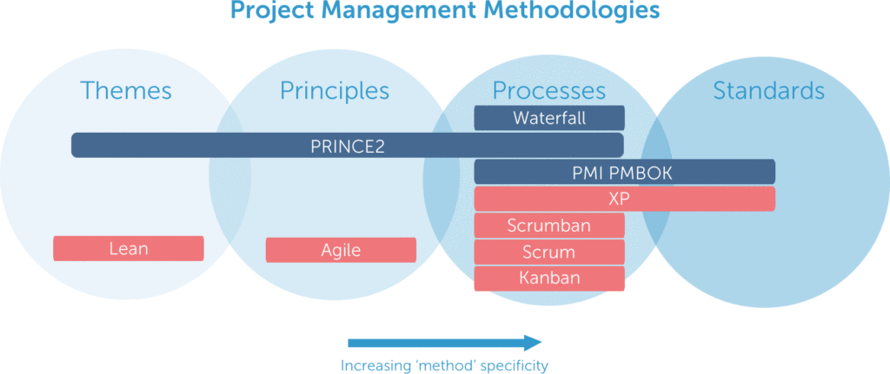
Fig. 1: Comparison of Project Management Methodologies (Anton 2007)

The emphasis of each of these methodologies differ, with the use of differing terminologies and stages; however, they are similar in the way that they encompass stages, and in that they share certain processes across these stages.
Although the order of phases may vary from methodology to methodology, the classic stages typically seen in a project are:
- Initiation
- Planning and Design or Development
- Production or Execution
- Monitoring and Controlling
- Delivery, Closing and Control system.

Fig. 2: Project Management Phases

There are links among process groups in a phase, and process groups may also overlap, as the following figures indicate:
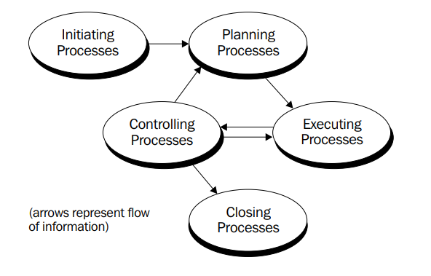
Fig. 3: Links among Process Groups in a Phase (Project Management Institute 2000, p.31)
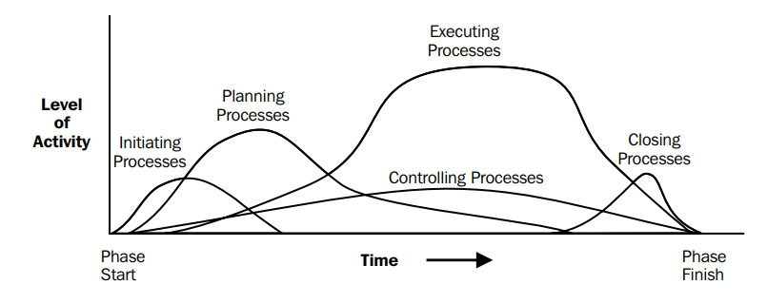
Fig. 4: Overlap of Process Groups in a Phase (Project Management Institute 2000, p.31)
To follow is an exploration of these processes, with reference to methodologies as relevant, as well as discussion of the workplace project in question.

- Initiation Process

According to Bentley (2002, p. 160), ‘however large or small the project, it is sensible to begin a project with what is referred to as an initiation stage’. At this stage, the nature and scope of the project should be determined. If this stage is not done properly, it is highly unlikely that the project will succeed in reaching its objectives – as Watson (200, p. 19) states: ‘a few minutes thought at this stage will save a lot of heartache … the first step in any project is to make time to think and to gain a clearer view of the project’. PMBOK and PRINCE2 methods note that at the start of a project, it’s important to outline the objectives, goals, plans, and to report and define roles. As well as determining what is included in the project, this stage should also highlight what is excluded from the project, and one way of clarifying the scope is by using the ‘In-Frame/Out-Frame’ tool as used in the Six Sigma’s Method:

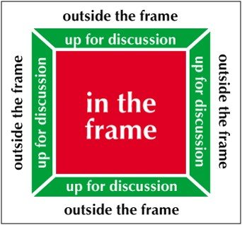
Fig. 5: In-Frame/Out-Frame

This is one method that will help the team stay focused, and Appendix A offers a workplace example. Another tool that can be used at this stage is the Project Initiation Document (PID), sometimes called a Project Charter. This is vital in order to capture the various aspects of the project in order to ensure all involved understand the project, and the PID can act as a contract between the project sponsor, key stakeholders and the project team. It will usually consist of:
- Business Case/Project Definition;
- Scope and deliverables;
- Objectives;
- Resources needed;
- Project plan, milestones and timeline;
- Costs;
- Risks and Issues; and
- Dependencies.
An example as applied to the workplace project can be seen in Appendix B, and Appendix C offers a Risk Register as applied to the workplace project. This stage offers a way of understanding the business environment and ensuring all necessary controls are incorporated into the project - it will highlight any deficiencies, and recommendations should be made at this stage in order to fix these before starting.

- Planning and Design

As the saying goes – ‘to fail to plan is to plan to fail’ – this stage is a crucial part of any successful project. Depending on the scale of the project, a plan could vary from a simple task list to ‘a package of related documents’ (Watson 2002, p. 41). This stage ‘is of major importance to a project because the project involves doing something that has not been done before’ (Project Management Institute 2000, p. 32), and consequently involves more processes (see Fig. 6 below). It may include selecting or confirming team-members; a kick-off meeting; confirmation of scope; decisions on planning detail needed; identification of activities needed; resources estimates; risk assessment; schedule plan; cost development and breakdown; communication plan; confirmation of deliverables; and phase sign-off (Gwyther 2018).
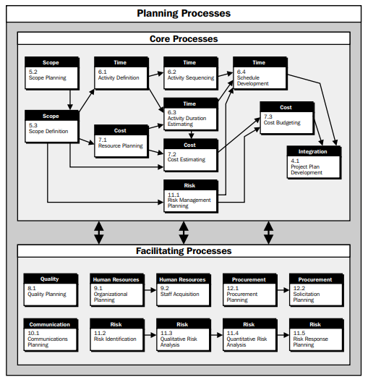
Fig. 6: Relationships among Planning Processes (Project Management Institute 2000, p.33)

There are available tools for Project Planning, some software based, and other simpler, manual tools – but it is essential to realise that whichever tool is used, it is only as good as the knowledge it is fed (Gwyther 2018). Some of the tools that can be used at this stage include:
- Work Breakdown Structure (WBS) – in order to break down tasks, assign responsibilities, schedule timing, improve resources planning;
- Gantt Chart – in order to plan time scale, estimate resources, and help to coordinate and track tasks as a visual management;
- Project Chart – such as in MS Project;
- Critical Path Analysis/Critical Network Analysis – in order to clarify linear or parallel tasks;
- Cost Breakdown Structure (CBS) – in order to achieve a detailed estimate;
- Stakeholder Analysis – in order to identify all involved, to document needs, and to assess and analyse interest and influence;
- Responsibility Matrix;
- Tension Chart;
- Mendelow’s Matrix; and
- Goal Tree.
For the workplace project discussed in this paper, a Gantt Chart would be especially beneficial as actual performance could be recorded and compared to the planned milestones. A Critical Path Analysis would also be beneficial, as demonstrated in Appendix D. It is important at this stage to remember that the objective of a project is to get the project done, therefore it is crucial not to focus too much on creating a complex plan.

- Project Execution

The next stage is a key stage as it is the part where the project management executes the project in order to achieve objectives. It involves assigning correct resources; communicating expectations; adjusting if needed; dealing with unknowns, and change management. PRINCE2 may reflect this stage with its ‘Controlling a Stage’ and ‘Managing Product Delivery’; whilst Agile’s similar stages are ‘Release’ and ‘Production’.
A detailed project schedule may be used to track project process, as each individual involved in the execution process carries out their own work at this stage with the aim of completing tasks within deadlines. Stakeholders may also wish to be informed on progress, and certain milestones may mark progress. At this stage a Responsibility Matrix would be of benefit in order to pin down team members’ responsibilities.
Another element to be tracked at this stage is effort and cost, in order to ensure project is progressing in and orderly manner. Assigning resources depends on the activity analysis (WBS) previously being done correctly; and at this stage prioritising tasks needs to be clear with Project Manager managing team’s tasks and ensuring they’re ‘per plan’. It is inevitable that schedule changes will occur, and therefore the assignment of tasks will modify as and when needed. It is clear that communication skills need to be at their best at this stage in order to succeed, and one could argue that ‘nothing is more important to the success of a project than effective communication’ (Rajkumar 2010).

- Monitoring and Controlling

This stage (sometimes referred to as Validation) is also key to success and is usually conducted parallel to project execution. It involves Monitoring Key Indicatiors (using KPI and other metrics), reviewing processes with the team and stakeholders in order to avoid scope creep, and possibly change control. At this stage, it is important to adhere to the decisions made during the initiation process.
Some possible control tools to use at this stage include:
- Gantt Chart;
- Project Scorecard (KPIs);
- Milestone Checklist;
- Project Reviews;
- Delivery Reviews;
- Budget Variation Charts; and
- Change Request Forms;
- many of which would be useful during the workplace project in question.
Again, following a Communication Plan is key to success at this stage, and conducting weekly meetings to discuss project plan updates is one way of keeping track of progress and managing risks and issues. Some may find task and activity planning sessions useful also.
Controlling budget is usually a critical part of this stage also; and managing project changes may be crucial in controlling inevitable changes. This can be done by Change Control Boards (CCBs) and it is crucial that documentation of change, such as Project Record Control, is kept.
Quality assessment is another essential part of this stage, and may lead to reviewing, adjusting and reworking if needed. This means that allocating time for improvements is crucial – ‘do not plan for unanticipated and undiscovered work, which will inevitably happen’ (Mohammad, 2017).

- Delivery, Closing and Control system.

The last stage is closing the project as it is delivered, and can include tasks such as those shown in Figure 7.
Post Project/Lessons Learned Review
Rewards and Recognition
Transferring Risk Management to Risk Register
Financials
Transferring activities to another process owner
Managing transitions of team-members
Resolve of transfer any remaining issues

Archiving documents

Closure documents (such as a Project Closure Report)

Fig. 7: Some Possible Project Closing Tasks

Some may overlook this process, but in actuality, ‘closing a project is as important as initiating it’ because ‘until and unless your project has been closed with the planned procedures, it officially provides no value to the organization’ (Dwevedi 2018). It is the stage that aims to ‘conclude all activities … to formally complete the project’ (Project Management Institute 2013, p.57). According to Aziz (2015), Project Closing is a combination of the following:

Fig. 8: Project Closing Features

Conclusions
The scope of this paper does not allow for a thorough discussion and comparison of all methodologies used in Project Management. However, as many approaches follow similar processes, the above clarifies a methodology that would work for the workplace project in question.
Few companies adopt one single, standard method of managing projects as it usually makes more sense to use a variety of approaches fitting with the business and project type. There are advantages and disadvantages to all methods, but the shared aspects that ascertain success are following the stages discussed in this paper. It is therefore recommended for the workplace project in question to follow the above processes whilst considering aspects of several project management methodologies. The other shared aspects that ascertain success in delivering a project are the Project Manager, the Project Team, a defined Project Scope and Timeline, and a Supportive Organisation. Luckily, the workplace project discussed in this paper has these aspects – there is, of course, always a stroke of luck involved in success!

Bibliography

Aston, B., (2007). 9 Project Management Methodologies Made Simple [online]. Available at: https://thedigitalprojectmanager.com/project-management-methodologies-made-simple/ [Viewed 09 September 2018].
Aziz, E. E. (2015). Project closing: the small process group with big impact [Paper presented at PMI® Global Congress 2015—EMEA]. Available at: https://www.pmi.org/learning/library/importance-of-closing-process-group-9949 [Viewed 09 September 2018].
Bentley, C., (2002). PRINCE 2: A Practical Handbook. (2nd ed). Amsterdam: Elsevier Butterworth Heinemann.
BSI Standards BS 6079-1 2010 (2010). Project Management – Part 1: Principles and guidelines for the management of projects. British Standards Institute Publication.
Chin, G., (2004). Agile Project Management: How to Succeed in the Face of Changing Project Requirements. New York: AMACON.
Dwevedi, P., (2018). How to close a project? [online]. Available at: https://www.simplilearn.com/how-to-close-a-project-article [Viewed 09 September 2018].
Dowdall, J., (2016). In or Out: A Helpful Tool [online]. Available at: https://www.catalystconsulting.co.uk/in-or-out-a-helpful-tool/ [Viewed 09 September 2018].
Gwyther, A., (2018). Work-based Learning: Project Management Process [Workshops & PowerPoint presentation]. University of Wales Trinity Saint David.
Mohammad, S., (2017). Quoted by Schiff, J., (2017).
Project Management Institute, (2000, 2013). A Guide to the Project Management Body of Knowledge (PMBOK Guide). Pennsylvania: Project Management Institute.
Rajkumar, S., (2010). Art of communication in project management. [Paper presented at PMI® Research Conference: Defining the Future of Project Management. Available at: https://www.pmi.org/learning/library/effective-communication-better-project-management-6480 [Viewed: 09 September 2018].
Schiff, J., (2017). 8 project management tips for setting and managing expectations [online]. Available at: https://www.cio.com/article/2378680/project-management/project-management-11-project-management-tips-for-setting-and-managing-expectations.html [Viewed 09 September 2018].
Watson, M., (2002). Managing Smaller Projects. (2nd ed). Hook: Project Manager Today Publications.
Webster, G., (1999). Managing Projects at Work. Cambridge: University Press.

Appendix A
In-Frame/Out-Frame Tool Applied to Workplace Project (example of notes)
Quality to be controlled internally only
Have XX months to complete project
Publishing books for child education sector
Not Stakeholders
Publishing online courses
Composing tutor notes for course books
Authoring new (adult learning) course books for Entry Level Welsh
Producing learning support materials, e.g. videos, audio files
Publishing all new materials – hard copies and digital copies
Stakeholders
Quality control to include approval by several committees (tutors, experts in field etc) and awarding body
Compile current course books and reproduce content
Have £XXX amount for project
Authoring new course books for Foundation, Intermediate, Advanced, Fluency Welsh Levels
Have 12 months to complete project
Have £XX amount for project
IN FRAME
OUT OF FRAME
OUT OF FRAME

Appendix B
Project Initiation Document (PID) Applied to Workplace Project (example of content)
Project Title: Welsh Entry Level Course books &Attachments
Defnintion
Business Case | One of the Centre’s aims is to support Welsh learners in Wales, and give all learners the same experience
Problem statement | There are currently 14+ different Entry Level Welsh course books and courses used in Wales. This makes it difficult for Welsh learners to choose a course, and it means that course contents vary significantly. This needs to be standardised.
Project Objective | All new Welsh learners will follow the same course book wherever they learn Welsh in Wales
Benefit Impact | All new Welsh learners in Wales will buy the Centre’s course book and use one central website to support their learning
Scope | - Production of one Entry Level Welsh course book to be used by all across Wales  - Production of materials to support learning, including audio and video  - Production of Tutor Guidelines for above  - Publication of the above in hard copy and digital  (See also: In-Frame/Out-Frame Document)
Resources | Project Manager; Two Course Authors; Curriculum Team; Committee of Tutors and Experts; Support and Expertise of Awarding Body; Material Producers (editors; designers; digital resources producers; print & publishing); Marketing Team, etc.
Schedule | Each unit within course book will follow the below milestones:  Work on units will take place concurrently, i.e. once one unit is authored, author can start working on second unit whilst all other steps take place, etc.
  Task | Time
  Research and Plan | 1 weeks
  Authoring | 1 weeks
  Feedback from PM + Editing | ½ week
  Feedback from Awarding Body + Editing | ½ week
  Feedback from Committee + Editing | ½ week
  Production of Tutor Guidelines + Plan Support Materials | ½ week
  Production of Support Materials | ½ week
  Feedback from External Editor/Expert + Editing | ½ week
  Publishing + Marketing | ½ week
Costs
  Description |  | Price
  Project Manager |  | £XX
  Author x2 |  | £XX
  Time of Curriculum Team |  | £XX
  Time of Award Body/Expert representatives |  | £XX
  Committee Costs (room, refreshments) – no time of committee member costs as it’s part of their work |  | £XX
  Expert Editor |  | £XX
  Designer |  | £XX
  Audio/Video Production |  | £XX
  Web Production |  | £XX
  Print Production |  | £XX
  Publishing Costs |  | £XX
  Time of Marketing Team |  | £XX
   | Total | £XXXX

Appendix C
Risk Register Applied to Workplace Project (examples)

Below is a sample of possible risks involved in the workplace project in question. Many of the other risks are similar to those below. For example, many of this risks would affect time – i.e. if any of those involved are not able to complete their tasks within the planned timeframe, this could affect the timing of the whole project, such as example 1 below. For number 5 and 6 below, completing a Risk Register such as this one would lead Project Manager to think of resolving possible risks pro-actively, i.e. the PM here should gain answers to these risks in the research period of the process – assuring that the designers and web content builders are aware in advance of what is needed, and any variation to what is envisaged should then be adjusted if required.

No. | Risk | Risk Category | Probability | Impact | Risk Score | Risk Ranking | Risk Response | Trigger | Risk Owner
1 | Author unable to complete writing within timeframe | Project Production | 5 | 10 | 50 | 1 | Gain support by additional author | Communication with author | Author, PM
2 | Feedback signifies more needed editing than envisaged | Project Production | 7 | 7 | 49 | 2 | Gain support by additional author/editor | Negative feedback | Authoring Team
3 | Actors unavailable for additional materials | Production of additional material | 1 | 7 | 7 | 5 | Ensure other actors | Actors unavailable | Audio/video production team
4 | Designers unable to produce envisaged materials | Project Production | 1 | 10 | 20 | 4 | Gain other designers’ input & re-think course content | Communication with designers | Authors, PM, Designers
5 | Web-page not able to hold materials | Availability of Support Materials > No support materials for learners | 3 | 7 | 21 | 3 | Communication with web developers > build supportive web page OR re-production of materials to fit web page | Communication with web developers | Web-developers, PM

Appendix D
Critical Path Tool Applied to Workplace Project (sample)
Project Kick-off

1 week
Research & Plan Unit 1

1 week
Author Unit 1

1.5 weeks
Feedback 1, 2, 3 & Editing

½ week
½ week
Feedback 4 + Editing
Author Guidelines + Plan Support Materials

1 week
½ week
Production of Support Materials
Research & Plan Unit 2

½ week
½ week
Publishing & Marketing
Author Unit 2

and so on for all units within course book…
This figure shows that the production of 1 unit from start to finish would take 5 weeks at minimum – this is the shortest duration (path) for 1 unit. As illustrated here, there are some linear tasks, as well as parallel tasks that can overlap when it comes to scheduling. A Gantt Chart would clarify a timeframe for the complete project.

