Economics of sustainability

(BMSP6007)
Tobacco industry in the UK – Negative externalities of consumption

Kirsty Thomas - (2014376)
Business and Management (BA)

Introduction
In 2022 the tobacco market hit 21.8 billion pounds in revenue in the UK alone and is also expected to reach 23.5 billion GBP by 2027 (Statisa, 2023). Smoking in the UK is considered to be one of the worst causes of illnesses and death. According to the NHS (2021) almost 76,000 people in the United Kingdom die every year due to smoking, leaving others who smoke live with illnesses related to smoking. Not only does this leave life threating risks to smokers but also to others around them due to passive smoking (NHS, 2021).
Tobacco holds toxic chemicals which is released into the environment, this pollutes oceans, soil, and rivers each year. Tobacco production contributes to the global warming through their transporting and their processing which means they produce carbon footprint (WHO, 2022). Tobacco industry is seen as negative to society as this is costly, tobacco taxes are considered to be a way to reduce health care cost and cigarette use (WHO, 2022.
This essay will include an insight into the market failure from the tobacco industry, the negative externalities caused by the consumers. It will also include solutions to correct market failure such as the government putting a ban on smoking in public places, banning advertising and changing packaging to spread awareness of any health risks. A demand curve will be included with an explanation of negative externalities of cigarettes. It will also include solutions such as indirect taxation and e-cigarettes which have been put in place to reduce smoking to help the environment and the cost non-smokers must pay due to health treatments and tax.

Market failure – Tobacco industry
In the UK, smoking is known as the worst contributor to cause illnesses and death, one market failure is the negative externalities from those who smoke and to those who don’t. The cost of cigarettes do not take into account the cost of peoples health to smokers and those around them, this means a rising cost to society due to health treatments needed due to smoke damage (Finch et al., 2020). Tobacco kills around 8 million people, around 7 million of those killed by tobacco are smokers themselves leaving around 1.2 million deaths caused by second hand smoke each year (WHO, 2022). Smoking causes cancer, lung disease, heart attack, diabetes, and stroke (The Science of air, 2023). In the UK there are roughly 6.9 million smokers (ASH, 2021).
Smoking also causes air pollution as is releases toxic chemicals. It contributes to toxic waste, water pollution, soil pollution and also wildfires (The science of air, 2023).
“Smoke primarily consists of particles and can include other gaseous air pollutants, including nitrogen oxides, carbon monoxide, and hydrocarbons that may be toxic (Reimagining Education, 2023)”.
Market failure with tobacco is seen as negative externalities as there is a financial burden added to non-smokers due to cost of health care. Also, environmental externalities from second hand smoking, fires that have started accidental and pollution (Laux, 2000). Negative externality is a financial cost a third party suffers with because of an economic transaction (Para, 2014).
Other negative externalities of smoking are that tobacco is addictive and can affect household income as addiction is costly and contributes to poverty, most of their income is spent on their addiction, with the price of cigarettes rising. There are other health problems caused by smoking such as stillbirth, and children experiencing health issues at a young age is a woman smokes during pregnancy. Young people smoking is seen as a market failure as it has a negative effect on society now and he future (Para, 2014). There is an issue with smoker littering, throwing their cigarettes on the floor. Plastic called cellulose acetate is found in cigarette filters, they are also left with nicotine and metals that are absorbed into the environment along with other chemicals (Root, 2009).
Marginal private cost and marginal benefits are considered by the consumer, the external costs are not so much taken into account. Third parties are the ones who pay for negative external cost and are affected by the negative spill over.
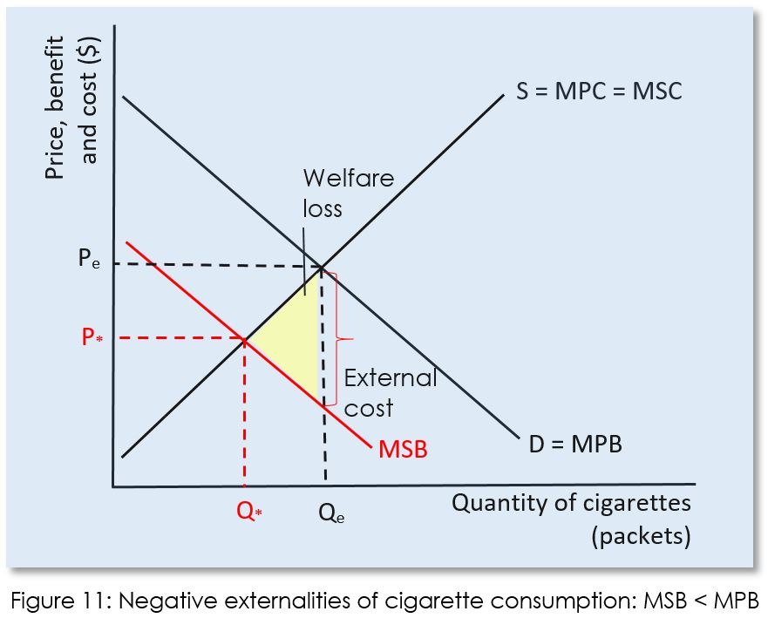

MPB – Is a measure of value a consumer puts on goods. It shows the amount of money they are willing to pay for the goods (CEOpedia, 2023).
MSB – Is the benefit to the society from consuming a good, also the external benefits that effect society (Study Smarter, 2023).

Figure 11 – The diagram reflects on the negative externalities of cigarette consumption. Smoking causes harm to society therefore the MSB curve is below the MPB curve. There are no positive effects shown on the diagram only negative, the yellow triangle on the chart is the external cost, this means the cost third parties have to pay for, although this is something they don’t participate in, this cost added to third parties is a responsibility of the consumers. Q* indicates the point which the MSB and the MSC meet, which is known as the equilibrium. However, because of the negative externality, there was an overconsumption in goods, which is considered as a possible welfare loss, shown with Qe (AP MICROECONOMICS, 2022).

Solutions to correct the negative consumption.

Solution one – Government regulations and Advertising

Government Regulations - Government can put rules and regulation in place to limit or put a stop to consumptions that have a negative spill over consequence on third parties. Consumption such as smoking and the extra cost due to healthcare services (AP MICROECONOMICS, 2022). There are regulations in place that cigarettes can only be sold to those who are 18 years old and over, however by 2030 they hope to change the age restrictions to 21 years and over (The Guardian, 2021). In 2006 became a ban on smoking in public places, smoking was not allowed to happen in pubs, clubs, restaurants, workplace, and any indoor area. The public smoking ban had seen a drop in smokers, in 2006, 22% of people smoked and by 2020 there was a decrease in smokers resulting in the figure dropping to 14.1% (Politics.co.uk, 2021).
Having such rules and regulations see a decrease in the demand curve, D1 - MPB curve will decrease and will overlap with D2 – MSB. The demand will decrease, resulting in Qe decreasing to Q*. Pe will reduce to P* (reduce in price) as they will have to lower prices to reduce excess supply (the surplus) of the negative goods (AP MICROECONOMICS, 2022). – (See figure 12 below)
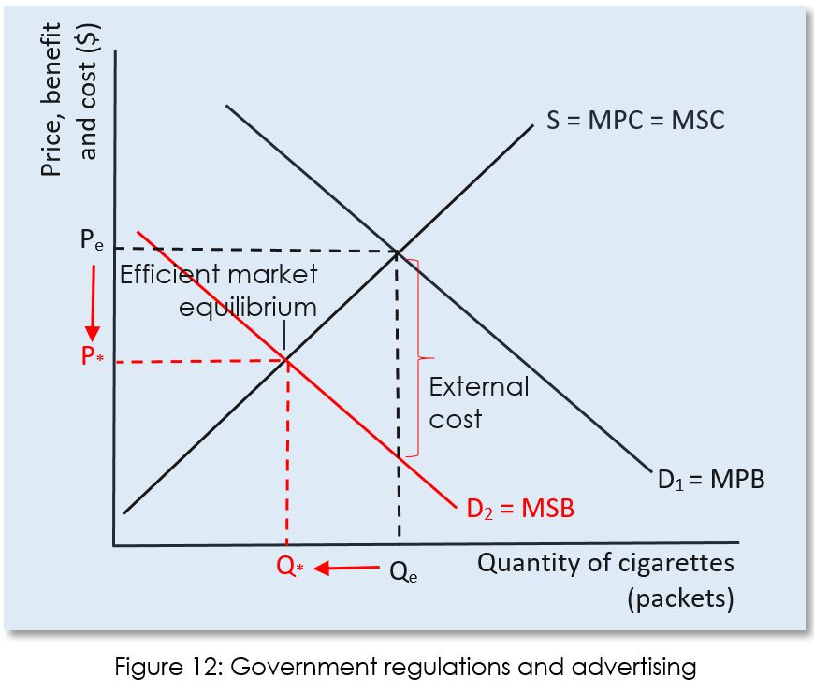

Advertising – In 2003 became the ban on tobacco advertising. Any advertising on billboard and vending machines came to a stop. Supermarkets had to hide any cigarettes on display and must be covered. In 1965 came the ban on television advertising in the UK. Cigarette packaging changed in 2016, boxes must not be branded and colourful, packaging must be plain with health warnings displayed on the boxes with photos and facts on health risks.
“According to the Office of National Statistics the number of smokers fell from 15.8% to 14.1% of the population between the introduction of standardised packaging in 2016 and 2019” (Politics.co.uk, 2021). There are also anti-smoking advertising put in place in hope to stop consumers purchasing cigarettes. Having such advertising in place that highlights the health risks will reduce the demand for tobacco (AP MICROECONOMICS, 2022). As explained above the demand curve will decrease the same as explained in Government Rules and Regulations. Please see above information. (See figure 12 above)
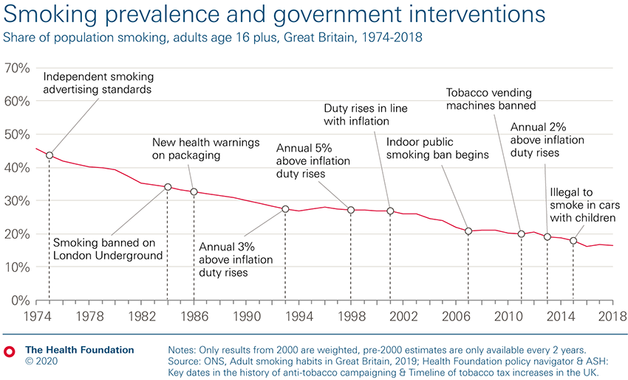
(Finch et al., 2020).

The outcome of banning smoking in public please

The government decided to put some rules and regulations in place to stop people smoking in public as explained above, this resulted in fewer people being admitted for heart attacks in hospitals and the air quality improved. The ban also resulted in a decrease of smokers, 22% of adults smoked in 2006, and in 2015 this reduced to 18%. Before the ban, cigarette smoke pollution in the UK bars was much higher than the unhealthy standard for outdoors air quality. The ban resulted in the air pollution in UK pubs reduce by 93% (BHF, 2023).

“In the three months after the ban there was a 6.3 per cent drop in the volume of cigarettes sold in England” (BHF, 2023).

Solution two - indirect Tax

To help reduce consumption, indirect tax was introduced in 1976 by the UK Government (PHDessay, 2023). There has been an increase in tax through the years in hope to correct market failure of cigarettes. In 2021 there was a tax increase of 2% above inflation. A packet of cigarettes was subject to tax at a rate of £262.90 per 1,000 cigarettes, plus 16.5% of the retail price in 2022. A pack of cigarettes was subject to tax at a rate of £269.90 per 1,000 cigarettes plus 16.5% of the retail price in 2022. The cost of a packet of 20 increased by 54 pence. For example if someone was to buy a packet of cigarettes for £9, they will be paying around £7.20 in tax, leaving 80% of the price to purchase a pack of cigarettes is mostly tax. If someone purchases three packs of cigarettes each week, they will be paying £1,00+ each year in tax (Politics.co.uk, 2021).

By requiring both the consumer and the consumer to pay the marginal external cost of pollution, indirect taxes aim to achieve an efficient result. The indirect tax is split between producers and consumers, but because cigarettes are addictive, the demand curve is inelastic, therefore consumers are expected to bear most of the burden. The reason for this is that the amount required for inelastic products and services declines more slowly that for more elastic goods and services. As a result, more customers continue to buy the goods and pay the tax (AP MICROECONOMICS, 2022).

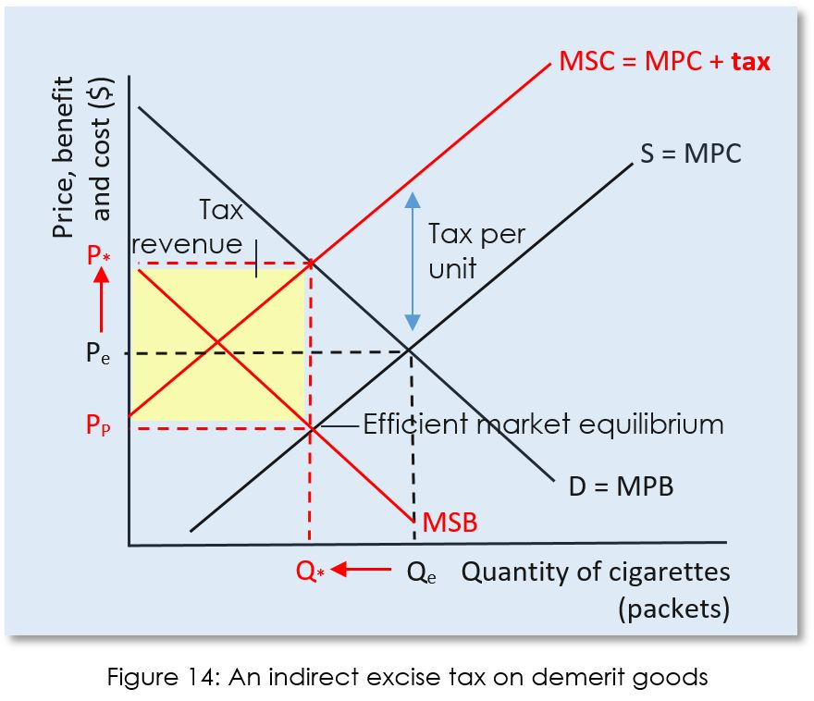

After the tax is implemented, a new equilibrium is reached at the point where the demand curve and the MSC cross. (MPB). Consumers pay a higher price (P*) because of the tax, while producers receive a lower price (PP). At the higher price, an allocatively efficient amount of the good is produced and consumed. Consumption's negative externality has therefore been internalised (AP MICROECONOMICS, 2022. (See figure 14 above).
The most economical strategy to lower health care expenses and cigarette usage, particularly among young people and low-income individuals, is to impose tobacco taxes, which also boost revenue in many nations. The tax increases must be significant enough to raise prices above the rate of income growth. A 10% increase in cigarette pricing results in a 4% drop in high-income nations and a 5% drop in low- and middle-income countries' tobacco consumption (world health organisation, 2023).
Solution 3 - Vaping to quit smoking.
E-cigarettes became available in the UK in 2005, in hope to help smokers quite cigarettes. Vaping means inhaling nicotine as a vapour through the use of e-cigarette, they do not burn tobacco or release smoke. Cigarettes produce harmful chemicals such as carbon monoxide and tar, e-cigarettes don’t produce these chemicals. They have become very popular over the years with people vaping instead of smoking a cigarette (Asthma + Lung UK, 2023).
E-cigarettes become in many shapes, colours and sizes, the issue recently is that vaping has become a trend with teenagers using them adding many different flavours to their E-cigarettes which make vaping taste nicer. With many people believing vaping was safe to use with no risks, according to experts vaping can cause severe lung disease. It has been confirmed that 2,807 people suffered with lung injury and 68 deaths. E-cigarettes do in fact contain nicotine along with other dangerous toxins such as metals (Brazier, 2022).
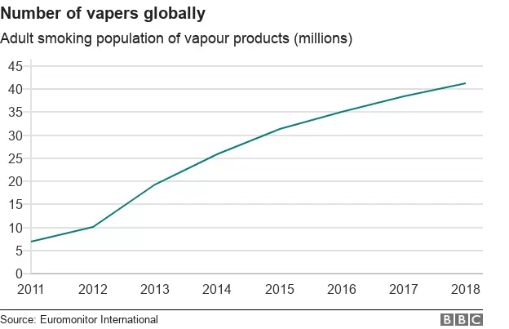
However, for those who consider vaping as a method to help quit smoking cigarettes they need to be aware of the risks that come with it, people believed that vaping had no risks to health, but study shows there are health risks such as, brain development, second hand smoking, teens who vape could potentially become addicted to nicotine and smoke cigarettes instead (Shmerling, 2021). The graph below shows the popularity of vaping rising over the years.

A graph of vapers globally (BBC, 2019)
In 2020 around 14.0% of people aged 18+ smoked cigarettes and since vaping this percentage reduced to 13.3%. E-cigarette was used the most by those who are currently smokers at 25.3% and those who quit smoking cigarettes to vaping at 15.0%. 1.5% of people that have not once smoked before now vape (BBC, 2022).
Ban of tobacco
A country called Bhutan became one of the first to ban the sale of tobacco in 2004. They consider smoking to be a sin and their aim is to make their community a health place to live for their local people and the future. Selling or smuggling tobacco in Bhutan is a criminal offence and other places such as Denmark and Malaysia are also considering the sale of tobacco (Norris, 2022). Having such strict rules in place such as Bhutan’s ban could be the only way to put a stop to smoking and to put people’s health first and to also save the NHS.

Conclusion
Tobacco industry does not take into account the risks and harm it causes to the environment and to humans, it is costly due to those who need medical care caused my smoking whether this is someone who smokes themselves or caused by second hands smoking. Market failure with the tobacco industry is seen as a negative externality, it is costly for smokers and non-smokers. Smoking can cause illnesses such as cancer, lung disease, brain development and risks in pregnancy. Smoking is an addiction, however the government can put rules and regulations is place to be able to reduce the risks and to help reduce smoking all together. Banning smoking in public places has shown to help reduce smoking, especially with banning smoking in places such as pubs, restaurants and more. Advertising also made a change, photos are now displayed on packets of cigarettes to show the harm smoking causes. Another solution was to increase tax on cigarettes, this can lower health expenses.
Other solutions such as vaping was anther method that was brought in, in hope to help those to quite smoking. However study has shown that vaping isn’t as risk free as those believe, this could be adding another failure rather than improving market failure. Putting a ban on tobacco sales such as Bhutan could be the only way forward to making a change, as this is an addiction, people will struggle. More solutions can be put into place in hope to keep reducing the use of tobacco.

Reference

ASH. (2021). Smoking statistics. Retrieved April 04, 2023, from
Smoking Statistics - ASH

AP MICROECONOMICS. (2022). Externalities - AP Microeconomics. Retrieved April 11, 2023, from
Externalities - AP Microeconomics - AP MICROECONOMICS (microeconomicsap.com)

Asthma + Lung UK. (2023). Vaping and e-cigarettes. Retrieved April 20, 2023, from
Vaping and e-cigarettes | Asthma + Lung UK

Brazier, Y. (2020). E-cigarettes: How they work, risks and research. Retrieved April 20, 2023, from
E-cigarettes: How they work, risks, and research (medicalnewstoday.com)

BBC. (2022). Number of smokers drops as vaping rises, data shows. Retrieved April 24, 2023, from
Number of smokers drops as vaping rises, data shows - BBC News

BHF. (2023). How has the smoking ban changed our health?. Retrieved April 20, 2023, from
How has the smoking ban changed our health? - BHF

BBC. (2019). Vaping: How popular are e-cigarettes. Retrieved April 24, 2023, from
Vaping: How popular are e-cigarettes? - BBC News

CEOpedia. (2023). Marginal private benefit. Retrieved April 11, 2023, from
Marginal private benefit - CEOpedia | Management online

Finch, D., Briggs, A., Tallack, C. (2020). Improving health by tackling market failure – The Health Foundation. Retrieved April 04, 2023, from
Improving health by tackling market failure - The Health Foundation

Laux, F. L. (2000). Addiction as a market failure: using rational addiction results to justify tobacco regulation. Journal of Health Economics, 19(4), 421-437.
Addiction as a market failure: using rational addiction results to justify tobacco regulation - ScienceDirect

Norris, T. (2022). What can New Zealand learn from Bhutan’s tobacco ban?. Retrieved April 24, 2023, from
What Can New Zealand Learn from Bhutan’s Tobacco Ban? | TalkingDrugs

NHS. (2022). What are the health risks of smoking?. Retrieved April 04, 2023, from
What are the health risks of smoking? - NHS (www.nhs.uk)

Politics.co.uk. (2021). Smoking Ban UK – The Impact So Far – calls for an extension. Retrieved April 11, 2023, from
Smoking Ban UK - The Impact So Far - Calls For An Extension (politics.co.uk)

Politics.co.uk. (2021). Tobacco Advertising – All you need to know. Retrieved April 11, 2023, from
Tobacco Advertising - All you need to know - Politics.co.uk

PHDessay. (2023). What is the history of UK tobacco taxation policy, what are the outcomes from the past to date?. Retrieved April 20, 2023, from
What is the history of UK tobacco taxation policy, what are the outcomes from the past to date? - PHDessay.com

Politics.co.uk. (2021). How much is cigarette tax – is such a high taxation justified?
How Much is Cigarette Tax - Is Such High Taxation Justified? (politics.co.uk)

Para, M. N. A. (2014). Negative externalities in demerit goods as a cause of market failure–case study of British American Tobacco.
Market failure in tobacco - Google Scholar

Reimagining Education. (2023). How does smoking contribute to pollution? Retrieved April 04, 2023, from
How does smoking contribute to pollution? - Reimagining Education

Root, T. (2009). Cigarette butts are toxic plastic pollution. Should they be banned?
Cigarette butts are toxic plastic pollution. Should they be banned? (nationalgeographic.com)

Statista. (2023). Revenue from the tobacco market in the United Kingdom from 2014 to 2027. Retrieved April 04, 2023, from
Tobacco market revenue UK 2014-2027 | Statista

Study Smarter. (2023). Social Benefits: Definition, Types & Examples. Retrieved April 11, 2023, from
Social Benefits: Definition, Types & Examples | StudySmarter

Shmerling, R. (2021). Can vaping help you quit smoking?. Retrieved April 24, 2023, from
Can vaping help you quit smoking? - Harvard Health

The science of air. (2023). Does smoking cause air pollution?. Retrieved April 04, 2023, from
Does smoking cause air pollution? - The science of air
The Guardian. (2021). Raise age for sale of cigarettes to 21 and stop ‘tobacco epidemic’, says UK MPs. Retrieved April 11, 2023, from
Raise age for sale of cigarettes to 21 and stop ‘tobacco epidemic’, say UK MPs | Smoking | The Guardian

World Health Organization. (2022). WHO raises alarm on tobacco industry environment impact. Retrieved April 04, 2023, from
WHO raises alarm on tobacco industry environmental impact

World Health Organization. (2022). Tobacco. Retrieved April 04, 2023, from
Tobacco (who.int)

