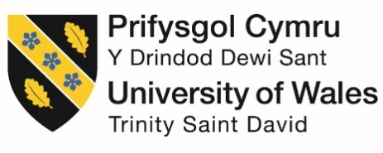

Programme: Master of Business Administration (MBA)

Module: Human Capital Management

Module Code: LCMB7023

Assessment Component: Individual Report - HR Strategy

Topic: Integrated Human Capital Blueprint - HR Strategy Report’

Lecturer’s Name: Gladius Kulothungan

Student Name: Maame Pinamang Bonsu

Student ID : 2217127

Date of submission: 20th March 2026

Table of Contents
Introduction 3
Part 1 - Re-Engineering Performance and Job Design 3
1. Current Performance Appraisal Practices in Technology Firms 3
2. Job Design Approaches in Technology Firms 4
3. A Modern Performance Management System for Aether Innovations 5
4. Job Analysis and Job Design for Key Leadership Roles 6
5. Integrating Performance Management and Job Design 8
Part 2 - Reflective Analysis 10
1. Reflective Learning Using Gibbs’ Reflective Cycle 10
2. Staying Relevant in the Age of Artificial Intelligence 13
References 16

Introduction
This report provides an Integrated Human Capital Blueprint of Aether Innovations which is an outgrowing technology firm that has also reported a decline in performance, high staff turnover and customers’ dissatisfaction. It critically incorporates the concept of strategic human resource management theories to redesign its performance management systems and job structure to result in enhancement in innovation, engagement, and alignment in its organization. Another source of reflection writing in the report is related to technological and future-based practice which includes reflectively looking on the professional learning and career relevancy as a way of creating sustainable competitive advantage relative to professional learning and continuous development.

Part 1 - Re-Engineering Performance and Job Design

1. Current Performance Appraisal Practices in Technology Firms
Traditional performance management systems in the majority of technology companies has been heavily reliant on the hierarchical evaluation models and annual performance review. Such systems are inclined to pay more attention to the retrogressive measurement of performance rather than its sustenance. Whereas the functions of these models had been regarded as pertaining to administrative control, they become less applicable in addressing the needs of the organizations, which are agile and innovation-driven (Nuraydin, 2021).
The majority of companies are still using the Key Performance Indicators (KPIs) and the managerial appraisal meetings that are conducted once or twice a year. These systems often focus more on the short-term output of systems compared to collaborative innovation outcomes (Graffius, 2024). This has the effect of ensuring that the workers will concentrate on the attainments that can be evaluated easily, instead of contributing to the innovations that are long-term.
It has been revealed that some works of technology employees feel old-style appraisal systems are bureaucratic and fail to correspond to real project results. Such attitudes reduce the interaction and the turnover intention, particularly in industries that are knowledge-based, because employees are aware of the significance of autonomy and self-development (Sharma, Singh and Arya, 2021).
Besides, the conventional appraisal systems are not frequently suited to team work in innovation. Technology development process often assumes the existence of cross functional teams, knowledge and rapid experimentation sharing. However, the systems of individual-oriented assessment are more likely to damage the risk-taking habit and willingness to experiment as the workers are afraid of being graded with low marks (Zierock, Blatz and Karcher, 2024).
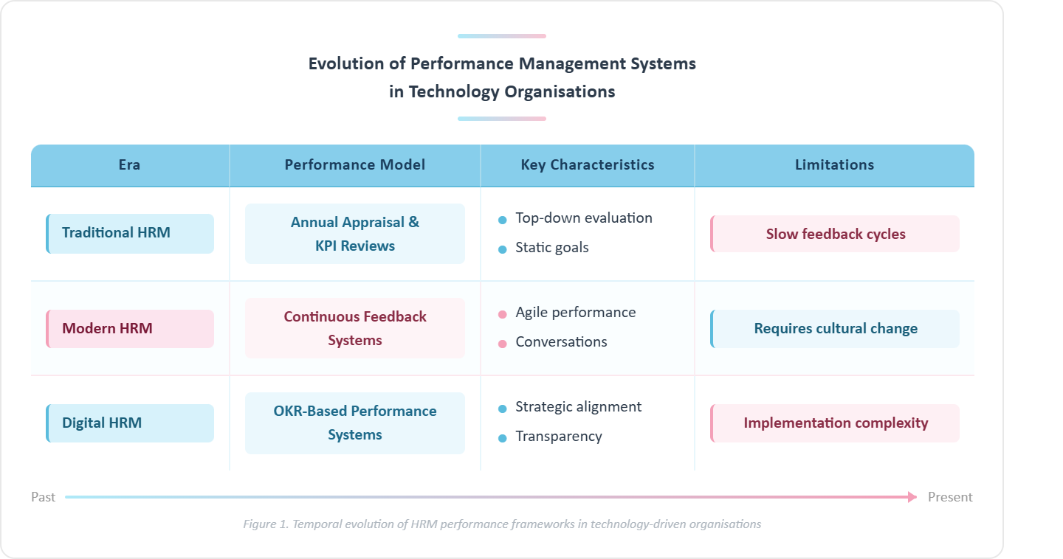
figure 1 - Evolution of Performance Management Systems in Technology Organisations (self-created)
(data source: Graffius, 2024; Cosenz, 2026; Lehto, 2023)

2. Job Design Approaches in Technology Firms
Job design plays very essential role in deciding motivation of employees and their innovation potential. According to Job Characteristics Model (JCM), five broad dimensions of jobs namely which includes skill variety, task identity, task significance, autonomy, and feedback are very significant since they have substantial effects on employee motivation and performance.
Technological companies are known to have project-based structures, yet many organizations fail to maximize the ideas of enriched job design. The demands to expand at high rates are reported to divide jobs into activities and specialize them. Even though specialization results in increased efficiency, an excessive fragmentation of tasks can lower employee creativity and ownership.
The degree of involvement, it turns out, is the most successful with knowledge workers in the technological sectors as the job description becomes more inclusive to cover a broader range of duties, independence in decision-making, and ability to innovate (Aduwo et al., 2021). Strict job descriptions on the other hand, restrict the flexibility of the employees in exploring new ideas.
The other weakness that prevails in most growing technology firms is absence of skills based job design wherein the job design is conceived in line with the emerging capabilities rather than predetermined job descriptions. Skills-based models assist organizations to tap the dynamic re-deployment of the talent as they respond to the emerging challenges of innovation (Ekom-Effeng et al., 2025).
Therefore, for Aether Innovations, job design reform must prioritize:
- enhanced autonomy
- cross-functional collaboration
- innovation accountability
- skill development pathways.

3. A Modern Performance Management System for Aether Innovations
To address the downsides of conventional appraisal models, Aether innovations should embrace Objectives and Key Results (OKR) performance management system and 360-degree feedback systems.
The OKRs represent a goal-setting method that is used in technologically thriving organizations. The framework applies to the balance between individual and organizational objectives and provides transparency in the inter-team levels (Celen, 2021).
Key Characteristics of OKR Systems
- Strategic alignment
- Transparent goal tracking
- Quarterly performance cycles
- Team-based accountability
- Continuous feedback loops
The system of ideas and practices (OKR) has proved to have a significant effect on the alignment of the organization, as well as the skill to innovate in case of working on complicated projects (Zierock, Blatz and Karcher, 2024).
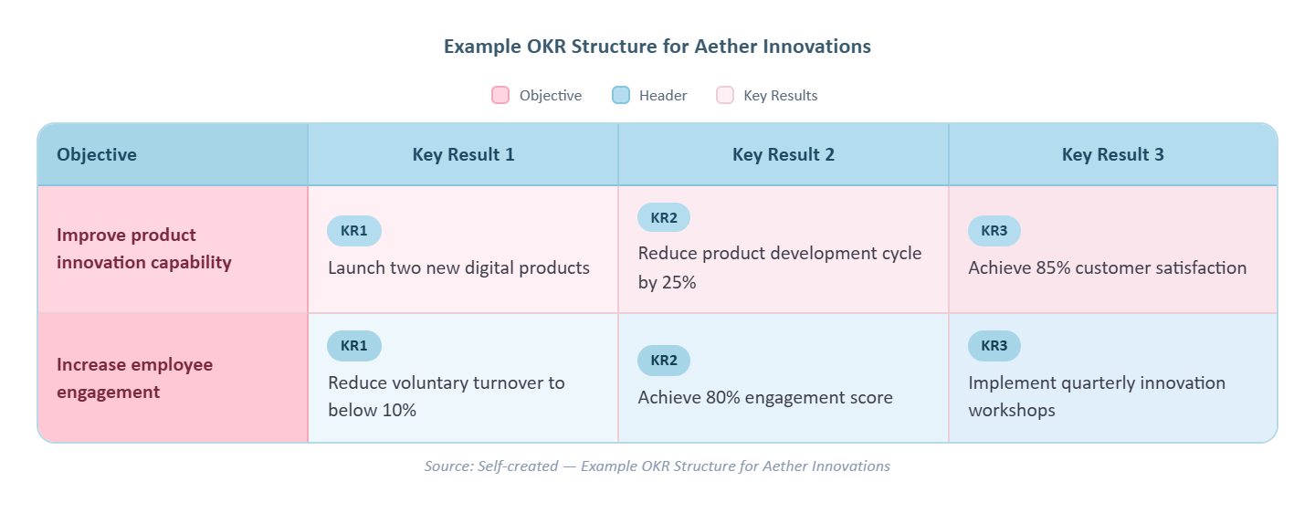
figure 2 - Example OKR Structure for Aether Innovations (self-created)
(data source: Lehto, 2023; Wu, 2023)

The 360-degree feedback mechanisms should be adopted in the organization together with OKRs. The 360-degree feedback (not the traditional supervisor-centered tests) collects data about an individual at a one-on-one level based on the peer, subordinate and supervisor feedback sources. Such a type of system improves leadership and fosters collective accountability (Brunner Candrian, 2025).
The research has indicated that multi-source feedback enhances leadership and contributes to the continued professional growth of knowledge organizations (Cosenz, 2026).

4. Job Analysis and Job Design for Key Leadership Roles
There are six leadership strategic positions and require stipulated roles and competencies to support innovation and change within organizations.
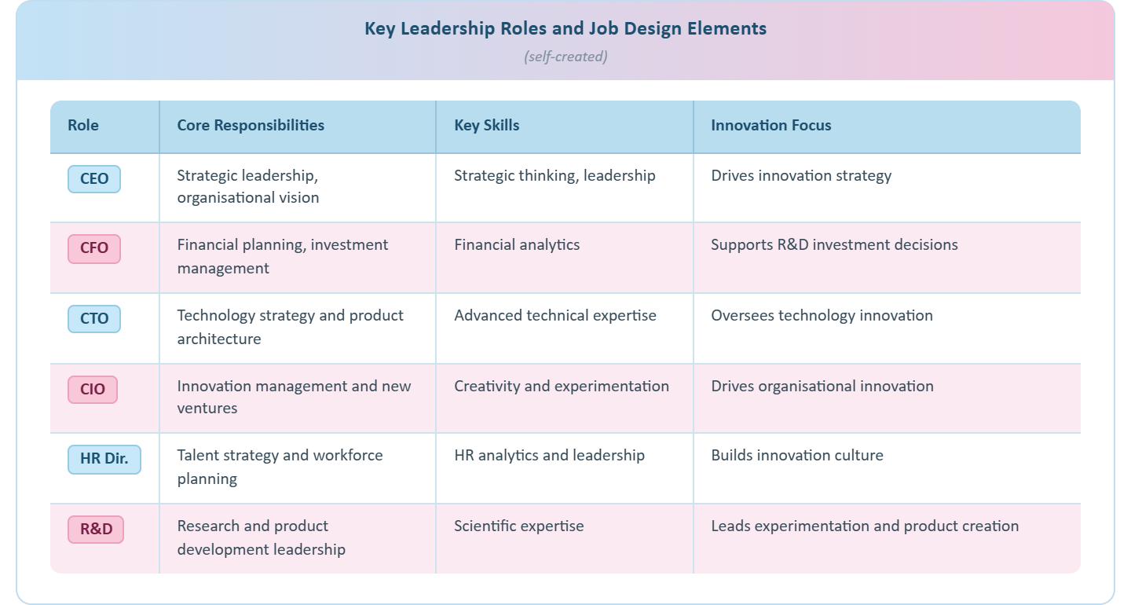
figure 3 - Key Leadership Roles and Job Design Elements (self-created)
(data source: Ekom-Effeng et al., 2025; Taiben, 2024)

CEO
The CEO is expected to establish the strategic path of the organization and ensure that there is co-ordination among the aim of innovation and the performance of the organization. This post requires a visionary leadership, strategic management and management skills among the stakeholders.
CFO
The CFO controls financial management and strategic investment. In technology companies, financial leaders should pay attention to investment in innovation and control resources in the research and development projects.
CTO
Chief Technology Officer should ensure that technology is being developed and ensure that technology infrastructure is developed to enable organizational innovation. This job comes with expertise regarding software architecture and product development and emerging technology.
CIO - Chief Innovation Officer
Innovation programs that CIO spearheads include exploring new products and experimentation programs. The position is geared towards innovation of ideas into business opportunities.
HR Director
The HR Director will brainstorm talent management, leadership development and work force analytics. Strategic HR leadership brings about fitness between the ability of employees and organizational goals.
Head of Research and Development
The head of the research is the head of R and D and he will lead product development teams. This role has ensured that the technological research is aligned with the market opportunities and organizational strategy.
All the jobs must involve high level of autonomy, skill variety, and task importance unlike in the Reality Model.

5. Integrating Performance Management and Job Design
Mechanisms that are to be integrated to bring sustainable organizational transformation are a performance management system and a job design structure.
The OKR system provides the equilibrium in the strategic objectives, and the enriched job design forms allow the employees to seek new solutions as well. It is more likely that behaviors that lead to proactive problem-solving are built when the employees are autonomous and their performance targets are well established (Yeboah, Kumi and Asamoah-Appiah, 2025).
The strategic HRM research shows that organizations enjoying an advantage over others possess human capital systems that reinforce innovative behaviors and collaborative learning (Hoichuk and Lyubomudrova, 2024).
At Aether Innovations, maximum integrated human capital blueprint should be an amalgamation of:
- OKR-based strategic performance management
- enriched job design structures
- leadership accountability
- continuous feedback systems.
When these factors are matched, the organization will manage to come up with a performance focused culture where the employees will be given the freedom to be innovative, but they must be answerable to ensure that they achieve quantifiable outputs.
Conclusion
The identified weaknesses in the organizational environment of Aether Innovations through performance management and job design practices can be interpreted in the declining growth, the high-employee turnover, and the low level of customer satisfaction. The constraint job design and the old appraisal system repress the ability of innovation and employee engagement in the technology organizations.
The new human capital approach is a blend of the modern-based performance management practice and a principle of enriched job design. The use of the OKR based performance systems, strengthened by the 360-degree feedback systems, will also demand strategic alignment and the transparency of organizations. At the same time, the redesign of the leadership positions with the assistance of the Job Characteristics Model will lead to the rise in autonomy, innovative potential, and motivation of the employees.
With these systems, Aether Innovations will have an easy time fostering a performance-oriented culture that converts organizational targets into the potential of the workers. It will facilitate the entire output of innovation, not only the rate of maintaining employees, but ultimately the rate of customer satisfaction.

Part 2 - Reflective Analysis

1. Reflective Learning Using Gibbs’ Reflective Cycle
The Human Capital Management module of the hospital provided an opportunity to critically understand the strategic role of the people management in organizational performance. Based on the Reflective Cycle proposed by Gibbs, the reflection addresses the opportunity to apply the gained knowledge to establish the future professional development and leadership potential.
Description
Analyzing strategic HR structures has revealed in the module that the alignment of capabilities of the employees with the organizational strategy is essential. The Aether Innovations assignment scenarios showed that the ineffective organizational human capital practices directly contributed to the organizational fall. The resignation rates are high, and the rate of decreased customer satisfaction that normally charges at deeper rooted defects in the performance management systems, crucial power, and work design modelling.
Scholarly research claims that companies in the modern world must accept the idea of integrated HR platforms that would aid mercilessly in the development of employees or innovation within the organization (Cosenz, 2026). Because this relationship has been created, it was used to explain the contribution of HR strategies to the long term competitive advantage.
Feelings
First, the intellectual aspect of studying multi-faceted HR structures and applying them to the organizational problems appeared to be the challenge. However, the strategic HR thinking principle became more significant during the process of taking the module. Learning assisted in the affixation of the fact that human capital management has ceased to be desired administrative role but strategic capability that defines organizational performance.
It is known that companies that embrace outstanding HR leadership practices achieve significantly improved positive innovation outcomes and employment engagement rating (Yeboah, Kumi and Asamoah-Appiah, 2025). This identification is what helped me to advance my comprehension of the strategic value of HR members in organizations that are technology-focused.
Evaluation
Among the most significant things that were learned in the process of taking the module, I would present the fact that workplace culture, leadership behavior, and job design exert a very strong influence on organizational innovation. The Job Characteristics Model demonstrates that an increased degree of autonomy and skill mix, a greater level of task importance contribute to employee motivation and engagement (Aduwo et al., 2021).
Objectives and Key Results (OKRs) are also other contemporary performance management tools that have been highlighted in the assignment. Research has also revealed that organizations that adopt the OKR systems have higher levels of alignment between the individual goals and plans that an organization has (Graffius, 2024). Such systems also facilitate agile innovation practices on changing business environment.
Analysis
The learning process taught me that technological strength is not the sole need of implementing an innovation culture. There is also the need to develop leadership disposition in organizations that is receptive to learning, feedback that is continuous as well as professional development.
Studies indicate that those companies who make investments in learning and developing their employees also demonstrate the significantly improved performance in terms of innovation and retention of the employees (Ekom-Effeng et al., 2025). This eye-opener is an indication that it is necessary to create a systematic learning and development (L&D) path that can make an employee renew his/her competencies on a continuous basis.
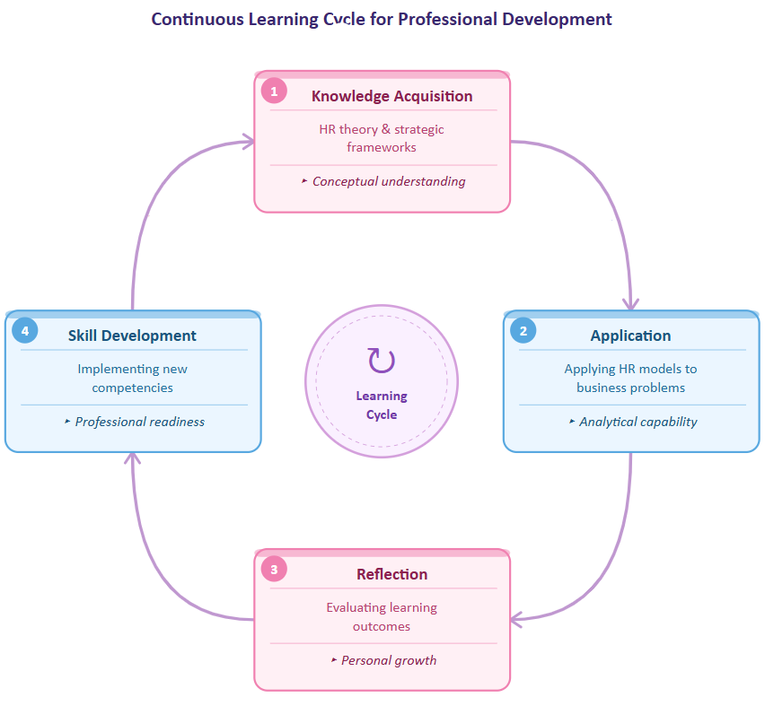
figure 4 - Continuous Learning Cycle for Professional Development (self-created)
(data source: Kolb, 1984; Cosenz, 2026)

Conclusion
The module also helped to believe that the HR professionals should be able to combine analytical thinking and strategic leadership capabilities. The professional applicability within the constantly evolving business environment should be maintained in assistance with the cultivation of the growth mentality and life-long learning.
Action Plan
The information obtained during this module would guide their career development in the future in the following ways:
- Developing stronger HR analytics capabilities to support data-driven decision-making.
- Engaging in continuous professional learning through HR research and industry reports.
- Strengthening leadership and communication skills to effectively influence organizational strategy.

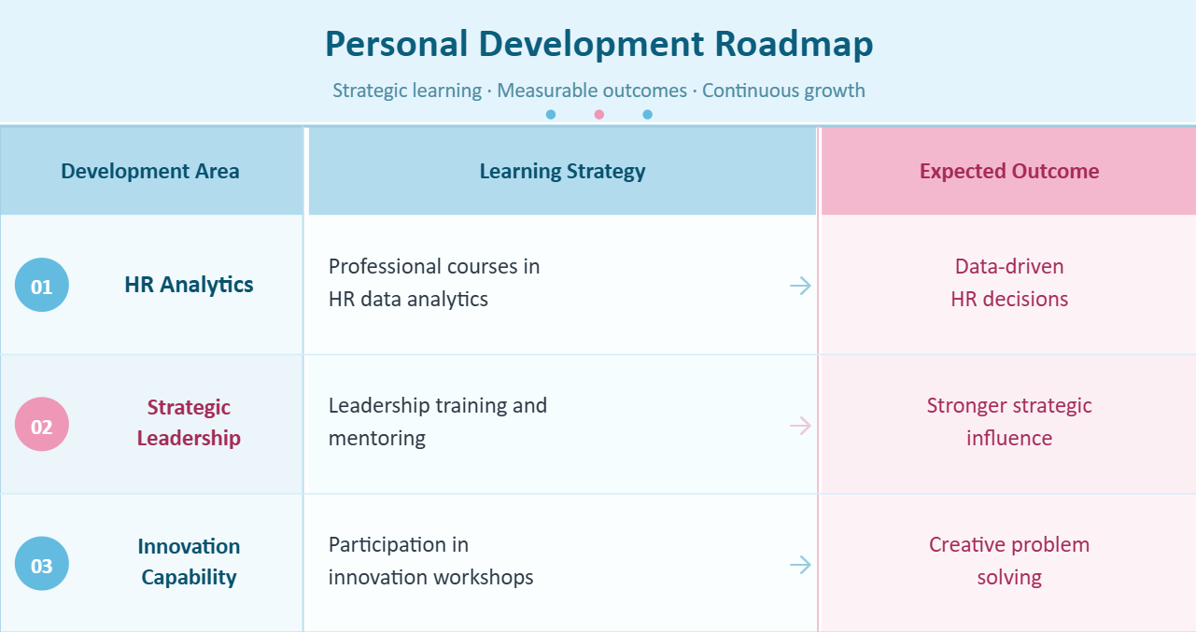
figure 5 - Personal Development Roadmap (self-created)

2. Staying Relevant in the Age of Artificial Intelligence
Most of the industries are changing their work nature due to the rapid development of artificial intelligence. More and more jobs that were once regarded as the fields of human expertise are being handled by intelligent systems, including data analysis, automating the administration process, and making predictions (Wu, 2023).
However, research has shown that AI can automate cognitively ordered processes but facing difficulty in the imitation of complex human processes like strategic choices, moral judgement, and innovation in finding the solution (Zierock, Blatz and Karcher, 2024). These are the competences that have occupied the leadership and human capital management stance.
Consequently, the notion of collaboration with AI is to be considered by practitioners rather than be perceived as a threat in the first place.
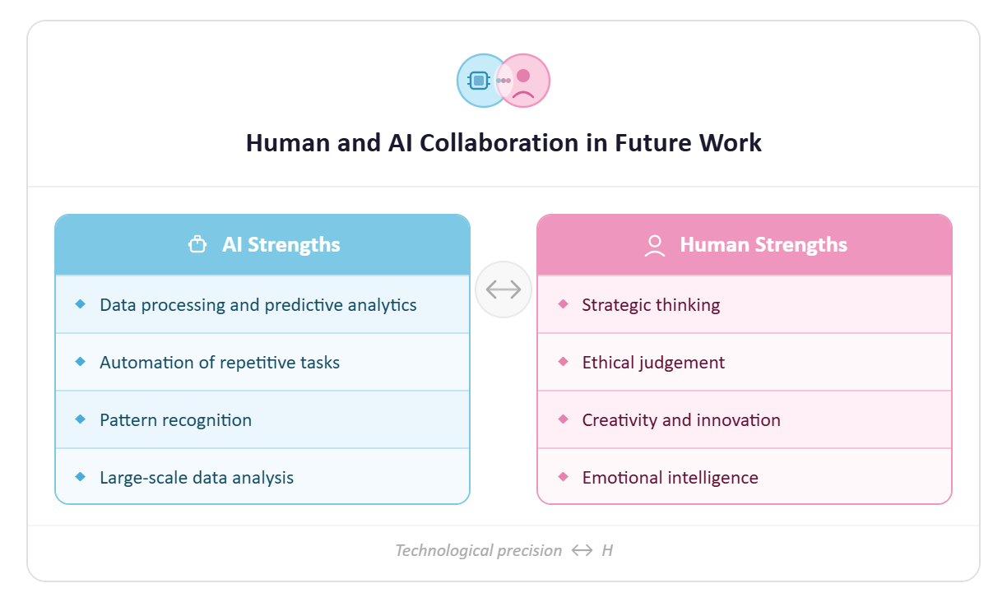
figure 6 – Human and AI Collaboration in Future Work (self-created)
(data source: Wu, 2023; Taiben, 2024)

In practice, AI might be employed to advance HR practices with more workforce analysis, recruit, and skill forecasting. However, there must be human skill in strategic interpretation of this information. HR professionals would, therefore, gain a higher level of analytical skills without compromising their openness with other individuals and leaders.
Due to the combination of human ingenuity and analytics supported by AI, the experts will be able to devise more efficient organizational models and remain valuable contributors to the technological-oriented companies.
Conclusion
One can reflect on the way the Human Capital Management module has illuminated knowledge about the strategic HR practices and their role in the organizational performance through reflective learning process. Learning obtained is providing the background to continue the further professional development based on the lifetime learning, leadership, and innovation.
At the same time, the rise of artificial intelligence is a sign that there is a need to pay specific attention to developing the uniquely human abilities, such as strategy, ethical decision making, and creative problem solving. As the incorporation of these functions is happening in parallel with the application of AI-aided tools, professionals have chances to be topical, as well, and become valuable participants of the new workplace.

References
- Aduwo, E., Mbohwa, C. and Pretorius, J. (2021) ‘Enhancing innovation capability through strategic human resource management in technology organisations’, South African Journal of Industrial Engineering, 32(2), pp. 35–48.
- Armstrong, M. and Taylor, S. (2020) Armstrong’s Handbook of Human Resource Management Practice. 15th edn. London: Kogan Page.
- Becker, B. and Huselid, M. (1998) ‘High performance work systems and firm performance: A synthesis of research and managerial implications’, Research in Personnel and Human Resources Management, 16, pp. 53–101.
- Boxall, P. and Purcell, J. (2016) Strategy and Human Resource Management. 4th edn. London: Palgrave Macmillan.
- Brunner Candrian, C. (2025) ‘Leadership development through multi-source feedback systems’, Human Resource Development International, 28(1), pp. 44–61.
- Brynjolfsson, E. and McAfee, A. (2017) Machine, Platform, Crowd: Harnessing Our Digital Future. New York: W.W. Norton.
- Celen, S. (2021) ‘Performance management through objectives and key results (OKRs) in digital organisations’, Journal of Business Strategy, 42(6), pp. 402–410.
- Cosenz, F. (2026) ‘Strategic performance management systems and organisational innovation’, Management Decision, 64(1), pp. 91–107.
- Davenport, T. and Ronanki, R. (2018) ‘Artificial intelligence for the real world’, Harvard Business Review, 96(1), pp. 108–116.
- Doerr, J. (2018) Measure What Matters: How Google, Bono and the Gates Foundation Rock the World with OKRs. New York: Penguin.
- Ekom-Effeng, J., Akpan, E. and Inyang, B. (2025) ‘Human capital development and organisational competitiveness in knowledge-based firms’, International Journal of Human Resource Studies, 15(2), pp. 70–88.
- Graffius, S. (2024) ‘OKRs and modern performance management: Enhancing alignment in agile organisations’, Journal of Strategy and Performance Management, 12(2), pp. 25–39.
- Hackman, J. and Oldham, G. (1976) ‘Motivation through the design of work: Test of a theory’, Organizational Behavior and Human Performance, 16(2), pp. 250–279.
- Huselid, M. (1995) ‘The impact of human resource management practices on turnover, productivity, and corporate financial performance’, Academy of Management Journal, 38(3), pp. 635–672.
- Hoichuk, O. and Lyubomudrova, N. (2024) ‘Strategic HR management as a driver of organisational innovation’, Management Science Letters, 14(3), pp. 115–128.
- Kolb, D. (1984) Experiential Learning: Experience as the Source of Learning and Development. New Jersey: Prentice Hall.
- Nuraydın, F. (2021) ‘Modern approaches to performance appraisal in knowledge-based organisations’, International Journal of Management Studies, 28(4), pp. 65–79.
- Sharma, R., Singh, S. and Arya, V. (2021) ‘Employee engagement and retention in technology organisations’, International Journal of Human Capital and Information Technology Professionals, 12(3), pp. 45–59.
- Taiben, A. (2024) ‘Strategic HRM and organisational performance in technology firms’, Journal of Organizational Effectiveness, 11(1), pp. 67–83.
- Wright, P. and McMahan, G. (2011) ‘Exploring human capital: Putting human back into strategic human resource management’, Human Resource Management Journal, 21(2), pp. 93–104.
- World Economic Forum (2023) The Future of Jobs Report 2023. Geneva: World Economic Forum.
- Yeboah, M., Kumi, E. and Asamoah-Appiah, W. (2025) ‘Human capital management and organisational innovation’, International Journal of Productivity and Performance Management, 74(2), pp. 302–320.
- Zierock, H., Blatz, M. and Karcher, P. (2024) ‘OKR adoption and innovation performance in digital firms’, Technological Forecasting and Social Change, 198, 122990.

