
CertHE Computing Skills for Workplace
ASSIGNMENT

Name: Henry Ogunde
Student ID: 2522133
Module Name: Software Solutions for Business
Module Code: ACCA4026
Lecturer: Osman Elgawi
Date of Submission: 25/03/2026
University Name: University of Wales
Campus Name: Birmingham

Task 1. e-Commerce Website builders/software solutions (Approx. 500 words)
Give a description of two contemporary e-Commerce website builders/software solutions (approx. 2/3 sources)

Shopify E-Commerce
Shopify is an e-commerce platform designed to support the creation, management, and expanding of online retail operations for businesses of varying sizes. Shopify has grown into one of the most widely adopted e commerce solutions, powering millions of merchants globally across different sectors [1]. Its main functionality integrates storefront development, product catalogue management, payment processing, and multi-channel sales into a single system, enabling users with limited technical experience to operate a fully functional online store.
The platform’s architecture articulates accessibility and standardization. Shopify provides templates and themes that allow users to design professional storefronts without professional programming knowledge. For users requiring deeper customization, Shopify supports development through Liquid—its proprietary templating language—and through a comprehensive API ecosystem. The Shopify App Store enhances friendly Add-on by offering thousands of third-party users that support logistics, marketing automation, analytics, and customer relationship management [2].
A central element of Shopify’s backend is Shopify Payments, a built-in payment processor that streamlines transaction handling and lessens dependence on third-party services. Shopify supports multi-channel retail by allowing merchants to sell across social media, online marketplaces, and store front using Shopify POS. This method mirrors wider market trend, where delivering smooth, consistent experiences across channels has become a cornerstone of successful e-commerce.
Shopify showcases its ability to scale through a structured, multi-level service. Shopify Plus, for instance, caters to big businesses that need sophisticated automation, deep customization, and the capacity to handle large transaction volumes. Shopify ventured into fulfilment with the Shopify Fulfilment Network—a move designed to streamline shipping and delivery for merchants experiencing high-volume operations.
Overall, Shopify’s combination of usability, extensibility, and multi-channel integration has positioned it as a central driver in the global e-commerce ecosystem, contributing significantly to the digital transformation of retail.

Wix E-Commerce
Built within the broader Wix website-building ecosystem, Wix eCommerce is a cloud-based platform designed for online retail. It is tailored to small and medium-sized enterprises, allowing users to build, personalize, and run digital storefronts without needing to write code. The platform is structured as a modular, composable system, bringing together storefront design, inventory management, payment processing, and cross-channel sales within a single interface [3]. With its intuitive drag-and-drop interface, along with an extensive library of templates and third-party integrations, merchants can create visually striking and fully functional online stores with ease.
One of Wix eCommerce's standout features is how easily it can be extended. Through its extensive app marketplace, the platform provides access to more than 250 free and paid applications designed to expand store capabilities across marketing, analytics, inventory control, and customer interaction [4]. Furthermore, Wix offers a flexible backend architecture that includes APIs, service plugins, and customizable checkout elements, allowing businesses with more complex needs to achieve a higher degree of tailored functionality [3a].
Wix eCommerce comes equipped with a range of core retail functionalities, including secure payment processing, built-in digital transactions, tools for recovering abandoned carts, multi-language site capabilities, and designs that adapt seamlessly to mobile devices. On the multichannel front, merchants can list their products across outside platforms like Instagram and various online marketplaces, helping to broaden their audience and strengthen customer acquisition efforts [4a]. When it comes to inventory management, the system supports product variations, stock monitoring, and connections to fulfillment services. However, there are certain gaps—such as the lack of native low-stock notifications—that push merchants to turn to external tools or add-ons [4b].
Taken as a whole, Wix eCommerce strikes a balance between ease of use and robust features, making it especially well-suited for entrepreneurs and small business owners who want a solution that is both intuitive to work with and flexible in terms of design. By bringing together a modular architecture, strong support for selling across multiple channels, and a vast ecosystem of third-party applications, it holds its own as a strong contender in the rapidly changing world of e-commerce.

[1] Shopify, “About Shopify,” Shopify.com. Accessed: Mar. 25, 2026. [Online]. Available: https://www.shopify.com
[2] L. Shoykov, “Reinventing E-commerce: The History of Shopify (2004–2024),” E-commerce Insights, Feb. 2024.
[3] Wix Dev Center, “What Is the Wix eCommerce Platform?” Accessed: Mar. 25, 2026.
[3a] Wix Dev Center, “What Is the Wix eCommerce Platform?” Accessed: Mar. 25, 2026.

[4] J. Le, “Wix Review: Pros & Cons and Features (2026 Updated),” LitCommerce, Dec. 2025.
[4a] J. Le, “Wix Review: Pros & Cons and Features (2026 Updated),” LitCommerce, Dec. 2025.
[4b] J. Le, “Wix Review: Pros & Cons and Features (2026 Updated),” LitCommerce, Dec. 2025.

Task 2. Mind-map of contemporary software applications (Approx. 500 words).
- Describe mind mapping and explain the benefits of using mind mapping in business operations (approx. 2/3 sources).
- Create a mind map of contemporary software applications that are used to support day-to-to-to-today business/ Organisation operations.

MIND MAPPING
Mind mapping is a visual approach to organizing information, structured around a single central idea from which related concepts branch outward. These branches form a hierarchical web that captures themes, details, and associations in a way that mirrors natural cognitive processes. Typically, the main topic sits at the center of the diagram, with subsequent layers of subtopics radiating outward to show how different elements connect, relate, or fall within a broader framework [1]. Unlike linear formats such as traditional outlines or paragraph-based notes, this method aligns with the brain’s innate tendency to think associatively and non-sequentially. As a result, mind mapping proves especially useful for learning, strategic planning, and tackling complex problems. By translating dense or abstract information into a visual format, it allows users to deconstruct broad subjects into smaller, more digestible pieces, uncover underlying patterns, and generate fresh insights more effectively than conventional text-based approaches.
Within business operations, mind mapping has grown in importance largely because it strengthens clarity, sparks creative thinking, and fosters teamwork. A key advantage lies in how it boosts both understanding and memory retention. By prompting users to interact directly with material—through clustering connected concepts, building meaningful links, and arranging knowledge in a visual format—mind maps encourage more intensive cognitive engagement, which in turn leads to stronger recall. This proves especially valuable in corporate settings, where employees often need to rapidly grasp new subject matter, navigate unfamiliar areas of expertise, or reach sound conclusions when time is limited [1].
Another area where mind mapping proves valuable is in facilitating more productive brainstorming and idea generation. Because its format is open-ended and adaptable, teams can freely explore concepts without being confined to the rigidity of linear documentation. This not only encourages creative thinking but also helps reveal connections that might otherwise go unnoticed. According to research, mind mapping can clarify intricate relationships, enabling business professionals to better grasp interdependencies, pinpoint strategic openings, and craft innovative approaches [3]. Consequently, it has become a common tool in areas such as project planning, new product development, and strategic assessment.
A further major advantage is a noticeable boost in productivity. By enabling users to grasp information more quickly and move fluidly between related ideas, mind mapping reduces mental strain and supports smoother workflows. In a business context, this often leads to better-structured meetings, more straightforward communication, and more efficient handling of projects. To illustrate, teams can employ mind maps to lay out project deliverables, visualize how work breaks down into components, or chart connections among stakeholders—all of which help keep everyone on the same page and maintain organizational clarity.
Collaboration also sees marked improvement using mind mapping, particularly within remote or cross-departmental teams. When information is laid out visually, it becomes simpler for team members to track conversations, offer input, and see how their own contributions relate to the larger picture. This visual transparency helps minimize confusion and fosters decision-making that takes a wider range of perspectives into account. Moreover, cloud-based mind mapping platforms support simultaneous editing, allowing teams spread across different locations to work together with greater ease.
Lastly, mind mapping strengthens problem-solving by allowing professionals to examine issues from various angles. Through the visual representation of challenges, limitations, and possible courses of action, teams can pinpoint underlying causes, weigh different options, and construct more well-rounded plans. Such a comprehensive perspective proves especially useful in intricate business settings, where decisions often need to consider a wide array of factors and interested parties.
In summary, mind mapping serves as a flexible and effective instrument that aids in learning, sparks creativity, boosts productivity, and strengthens teamwork within business operations. By making complex information more manageable and supporting deeper cognitive engagement, it has become an indispensable approach for contemporary organizations aiming to enhance both operational efficiency and their capacity for innovation.
References
[1] S. Peek, “How Mind Mapping Helps Entrepreneurs Succeed,” Business.com, Jan. 2026.
[3] P. VanZandt, “10 Benefits of Mind Mapping,” IdeaScale, Jul. 2023.

B. Create a mind map of contemporary software applications that are used to support day-to-to-to-today business / Organization operations.

MICROSOFT TEAMS

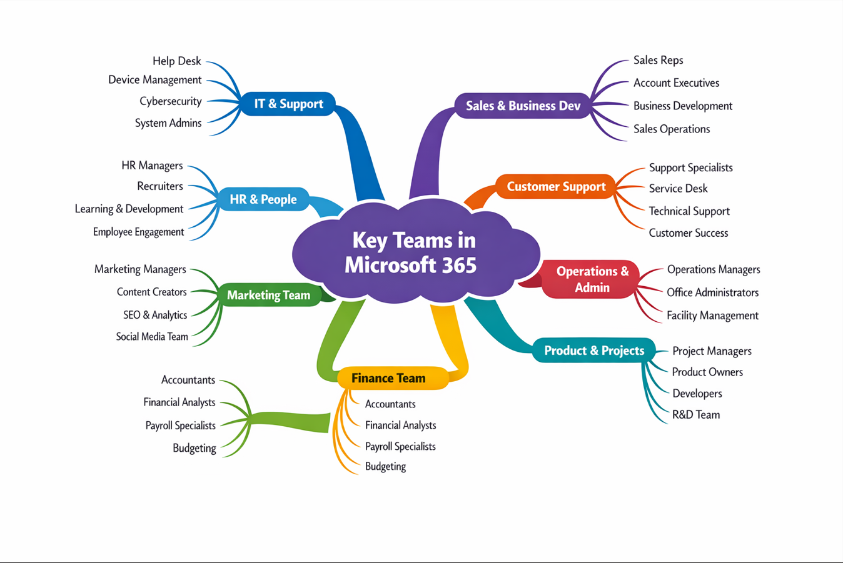
Task 3. Office Applications for creating, storing, presenting, and analysing information/data (Approx. 2000 words).
- Explain four office software solutions for business operations (MS Word, MS PowerPoint, MS Excel, and MS Access), highlighting their major features, benefits, and limitations (if there are any). You can use some images in addition to text (approx. 4/5 sources).
- Test any two features from the following Mail merge, IF Function, VLOOKUP, Pivot Table, Goal Seek in MS Excel, and document several screenshots with accompanying description to provide evidence of practical use.

MICROSOFT WORD
Overview of Microsoft Word in Business Operations
As a key tool within the Microsoft 365 ecosystem, Word is a widely used program that helps organizations craft, refine, and share professional materials. Its straightforward layout, robust editing capabilities, and seamless operation across various devices have cemented its role as a trusted solution for business communication.[1]
Core Features Supporting Business Use
Document Creation and Formatting: With its sophisticated styling, layout, and formatting features, Word allows users to create everything from contracts and reports to proposals, memos, and marketing content.
Templates: Pre-designed and adaptable templates simplify the process of producing uniform materials such as invoices, meeting agendas, and formal correspondence.
Collaboration Tools: Features such as live collaboration, edit tracking, and feedback comments allow for smooth group work, particularly in virtual or mixed workplace settings.
Cloud Integration: Through its connection with OneDrive and SharePoint, users can safely view, modify, and distribute files from virtually any device.
Security and Compliance: With capabilities like password security, document versioning, and regulatory compliance tools, Word provides the safeguards needed when working with confidential business data.

Benefits for Business Operations
Enhanced Productivity: Employees can work more efficiently and maintain high document quality using automated tools like spelling correction, writing suggestions, and pre-saved content snippets.
Improved Communication: Word files often function as a common format for both internal and external messaging, helping to maintain clarity and a polished appearance.
Cross-Platform Compatibility: Because Word files work seamlessly on various devices and operating platforms, sharing documents between users is straightforward and hassle-free.
Consistent Branding: By offering adjustable page headers, footers, and formatting presets, Word enables businesses to uphold a uniform brand identity throughout their materials.
Workflow Integration: Smooth connectivity with Excel, Outlook, and PowerPoint helps create cohesive processes across different teams within an organization.
Strategic Applications
Proposal Writing: Organizations rely on Word when putting together in-depth proposals that incorporate graphs, data tables, and graphic elements.
Policy Documentation: Word is a go-to tool for human resources and regulatory teams when creating materials such as staff manuals, safety procedures, and legal paperwork.
Client Deliverables: For consultants and those in client-facing service roles, Word serves as a key platform for producing deliverables such as client summaries, written reports, and presentation materials.

Reference (IEEE Style)
[1] J. Post, "The Best Ways to Use Microsoft Word for Business," Business.com, Jan. 30, 2026. [Online]. Available: https://www.business.com

MICROSOFT POWERPOINT
As a popular platform for building dynamic slide-based content, Microsoft PowerPoint serves a broad range of purposes—from classroom lectures and corporate presentations to personal projects. By accommodating everything from text and images to animations, charts, and video, it offers a flexible solution for organizing and presenting information clearly.[1]
Major Features of Microsoft PowerPoint
1. Slide Designer & Templates
Intelligent design recommendations help users arrange slides with a polished, professional look.
A vast collection of pre-made themes and ready-to-use layouts helps simplify the design process.
2. Data Visualization Tool
Visual tools such as SmartArt graphics, data charts, and tables make it easier to present complex information clearly.
Users can incorporate data visuals and informational graphics directly into their slides.
3. Multimedia Integration
Users can add and play back video clips, audio files, and screen captures without leaving the slide view.
Motion effects and scene changes can be applied to bring presentations to life.
4. Real-Time Collaboration
Multiple users can collaborate on the same file simultaneously when working through OneDrive or Microsoft Teams.
Files can be accessed from various devices, with team members able to edit simultaneously through cloud storage.
5. Presenter Tools
During presentations, speakers can view their own notes on a private screen while the audience sees only the slides.
While presenting, users have access to on-screen highlighting, digital pens, and tools for moving between slides.
6. Export & Compatibility Options
Users can save their work as PDF files, video clips, or still images depending on their needs.
The application functions seamlessly whether accessed on a computer, through a browser, or via a smartphone or tablet.
Benefits of Microsoft PowerPoint
1. Enhances Visual Storytelling
With its combination of imagery, motion effects, and organized slide structures, PowerPoint enables users to present their ideas in a clear and compelling way.
2. Highly Customizable
Individuals have the flexibility to adjust typefaces, color schemes, slide arrangements, and rich media content to suit either corporate identity or individual preferences.

3. Easy to Use
Thanks to its simple drag-to-place functionality and easy-to-use features, the platform is approachable for both newcomers and experienced users alike.
4. Supports Collaboration
Simultaneous editing enhances collaboration among team members and helps eliminate problems related to managing multiple file versions.
5. Widely Accessible
The software runs on Windows, macOS, web browsers, iOS, and Android, offering users a consistent experience across different devices and operating systems.
Limitations of Microsoft PowerPoint
1. Not Fully Free
Access to all features depends on having an active Microsoft 365 subscription.
2. Can Encourage Overloaded Slides
When presenters pack slides with excessive text or too many elements, the overall impact of the presentation can suffer.
3. Performance Issues on Low-End Devices
Older computers or devices may experience performance slowdowns when running presentations that contain large amounts of video, audio, or other rich media.
4. Learning Curve for Advanced Features
Although getting started is straightforward, becoming proficient with motion effects, design features, and rich media takes time and hands-on experience.
REFERENCES
[1] Microsoft 365 Glossary – PowerPoint, “What Is Microsoft PowerPoint? Features & Access Guide.” Accessed: Mar. 25, 2026.

MICROFT EXCEL
As a powerful tool for working with data, Microsoft Excel allows users to arrange, compute, examine, and display information in spreadsheet format. Its adaptability and robust set of analytical features have made it a staple in industries ranging from business and education to finance and scientific research.[1]
Major Features of Microsoft Excel
1. Data Organization & Management
Users can arrange extensive datasets into clearly organized worksheet formats.
The tool includes options for clean, well-organized layouts that make information easier to read and understand.
2. Formulas and Functions
The software handles everything from basic arithmetic like adding and subtracting to more advanced mathematical and financial computations.
Users can streamline calculations by taking advantage of pre-programmed formulas and functions.
3. Charts and Graphs
Information can be transformed into visual representations like bar charts, line graphs, and other diagram types.
This functionality assists in spotting key insights and data movements, which can be useful when putting together reports or putting together slides.
4. Data Analysis Tools
With PivotTables, users can group, filter, and examine information from various angles to generate meaningful summaries.
The platform connects with OLAP databases, enabling more sophisticated data analysis and reporting capabilities.
5. Security Features
Users have the option to secure files with passwords to keep sensitive information private.
Users can establish security credentials either manually or by using Visual Basic programming.
6. Integration & Compatibility
The software works smoothly alongside other programs within the Microsoft Office family.
Files can be distributed through email and accessed on the majority of mobile phones.

Benefits of Microsoft Excel
1. Decision-Making
With Excel, individuals can examine information and arrive at well-founded conclusions—a valuable capability in both educational settings and corporate environments.
2. Easy Data Sharing
Users can send worksheet files through email, produce physical copies, or view them on smartphones and tablets.
3. Widely Available
Because Excel is included with many new computers through the Microsoft Office package, users can get started with minimal setup time.
4. Strong Security Options
Using passwords helps keep sensitive information secure from unauthorized access.
5. Training and Support
A wide range of educational resources, including workshops and structured courses, exists to support individuals in building their proficiency.

Limitations of Microsoft Excel
1. Learning Curve
Getting comfortable with more sophisticated functions takes time, and newcomers often find working with formulas challenging at first.
2. Human Error Risks
Mistakes when inputting information can produce unreliable outcomes, particularly when working with extensive collections of data.
3. Time-Consuming Data Entry
When dealing with large volumes of information, entering data by hand tends to be time-consuming and less efficient.
4. Performance Issues with Very Large Files
When working with very large worksheet files, performance can begin to lag and navigating the content may become cumbersome.

REFERENCES
[1] H. Soffar, “Microsoft Excel advantages, disadvantages, review and features,” Science Online, Jun. 27, 2015, updated Jul. 10, 2024. Accessed: Mar. 25, 2026.

