

Module name: Introduction to Public Health
Module code: LCHS4008
Lecturer name: Jolly Nwankwo

Report on Health Issue - Dementia

Student name: Nicoleta Stoican
Student ID:2513275

Content page

INTRODUCTION……………………………………………………page 3

Approaches to Measure and Monitor Dementia……….…….….page 3

How Dementia is Controlled.......................................................page 4

Consequences of Dementia on Individuals and the Community.................................................................................page 4

Health and Social Care Support Services..................................page 5

CONCLUSION...........................................................................page 6

References…………………………………………...….………….page 7

Appendix 1……………………………………….………………….page 9

Appendix 2 ……………………………………...…..………………page 9

INTRODUCTION

Memory, thinking, language, and behavior are all affected by dementia. Dementia is an umbrella term for a number of progressive neurological conditions. As a result, brain cells cannot communicate effectively due to damage. The most common type of dementia is Alzheimer's disease. Signs and symptoms of this condition generally present as memory loss, confusion, difficulties in communication, and mood and behavior changes that tend to worsen with time (National Institute on Aging, 2022). Dementia is rapidly gaining recognition as an increasing major public health concern worldwide. The World Health Organization has stated that over 55 million people are living with dementia worldwide, and nearly 10 million new cases are diagnosed every year (Alzheimer's Society, 2021). Indeed, at this moment, at least 982,000 people in the U.K. have dementia, but by 2040, this number is expected to have risen to 1.4 million (Alzheimer's Disease International, 2024).

Approaches to Measure and Monitor Dementia
Measurement and monitoring of dementia include clinical assessments, cognitive tests, and neuroimaging. Memory, attention, language, and orientation are evaluated with the Mini-Mental State Examination (MMSE). Another frequently used assessment specifically designed to unearth even the mildest forms of cognitive decline is the Montreal Cognitive Assessment (MoCA) (NICE, 2022).
Moreover, structural changes in the brain can be visualized by brain imaging techniques, such as MRIs and CTs, in view to identify atrophy or vascular damage. Differentiation in the types of dementia and other diagnoses may need these two tools (NHS, 2023).
It is also important to monitor the progression of dementia over time with regular follow-up assessments. The National Institute for Health and Care Excellence (2018) suggests that functional assessments can be used to assess a patient's ability to perform daily activities, such as dressing, eating, and managing finances.In addition, public health organizations maintain epidemiological data monitoring the level of dementia in populations. Such data enables national registries and surveys to be used in planning suitable health care services informed by the governments on trends (WHO, 2023).

How Dementia is Controlled
In the present day, there is no cure for dementia, but several strategies are used to manage symptoms and slow the progression of the disease. The use of cholinesterase inhibitors (e.g., donepezil) and memantine is one of the pharmacological treatments for this condition. The role that non-pharmacological interventions also can play in the management and treatment of dementia is quite significant.
CST (Cognitive stimulation therapy) is one of the major ones that have been suggested to help in giving improved memory and quality of life. Further, lifestyle changes that include such things as regular exercise, a healthy diet, social engagement, among others, may offer additional benefits by either reducing the risk of developing or slowing down the development of dementia (Douglas, James, & Ballard, 2018).
Preventive actions are just as important. Public health strategies could target the reduction of risk factors such as smoking, high alcohol intake, physical inactivity, and poor diet. For example, according to the World Health Organization, up to 40% of dementias might be associated with preventable risk factors; hence, prevention matters (Alzheimer’s Research UK, n.d.).

Consequences of Dementia on Individuals and the Community

Dementia can be devastating for the person affected, their family, and ultimately the community at large. At the individual level, it is associated with a steep decline in cognitive and functional abilities, which finally results in independence loss (Cipriani et al., 2020). Most suffer anxiety, depression, and frustration upon realization of cognitive deterioration (Alzheimer’s Society, 2023).
Families and caregivers face a huge impact. Taking care of a dementia-affected person is very demanding, both physically and emotionally. Most people who tend to people who are not in their right minds suffer from caregiver stress and burnout. Besides, informal caregivers are often family members who go through significant financial distress from either staying at home with less working hours or leaving their work entirely (Bloodworth, 2025).
At the local level, the burden of dementia often becomes very strong for health and social care systems. Dementia care is expensive because of the medical treatment, long-term care, and supporting services that come with it. It is estimated that dementia will become one of the leading causes of disability and dependency among older people in the UK by 2024 (NHS England, 2024).

Health and Social Care Support Services

Those with dementia require comprehensive health and social care. Health services would include GPs, neurologists, and psychiatrists or specialist nurses who, after diagnosis, will provide continued treatment. Memory clinics are essential for early diagnosis and case handling (The Health Foundation, 2011). On an equal footing are the social care services: home care support, day care centres, respite care, or care homes and nursing homes for people more seriously affected by dementia. Their aim is to maintain independent living, quality of life, and give support to carers.
Community-based support is also very imperative. Organizations such as the Alzheimer's Society offer information, helplines, and support groups to both patients and families. In addition, community dementia-friendly initiatives are run to create an understanding and reduce stigmatization so that sufferers can still stay active members of society. This integration of care calls for a combined approach towards health and social services to help in the coordination and person-centered care being given, which is recommended and increasingly so in view of the long-term, complex needs of people living with dementia.

CONCLUSION

Dementia is a slowly progressing, usually complex syndrome with extremely negative influences on an individual, family, and wider community. It is characterized by cognitive changes in memory, thinking, and behavior that result in loss of independence and reduced quality of life. There is no single cure for dementia to date; its treatment often involves the use of medicines, non-pharmacological interventions, and preventative strategies to manage symptoms and slow their progression. Moreover, the rising prevalence of dementia exerts huge pressure on health and social care systems to develop effective monitoring, earlier diagnosis, and integrated support services. The increasing numbers of people with dementia across the globe indeed call for the establishment of public health initiatives to reduce risk and improve care. Indeed, coupled with comprehensive policies in support of those living with the condition, their families, and caregivers, dementia is a global public health priority.

REFERENCES

Age UK (2018). Dementia Support. [online] Age UK. Available at: https://www.ageuk.org.uk/services/in-your-area/dementia-support/.
Alzheimer’s Research UK. (n.d.). Eliminating 12 modifiable risk factors could reduce dementia cases by 40%. [online] Available at: https://www.alzheimersresearchuk.org/news/12-modifiable-risk-factors-could-reduce-dementia-40/.
Alzheimer's Society (2021). How many people have dementia in the UK? [online] Alzheimer’s Society. Available at: https://www.alzheimers.org.uk/blog/how-many-people-have-dementia-uk.
Alzheimer's Disease International (2024). ADI - Dementia statistics. [online] Alzint.org. Available at: https://www.alzint.org/about/dementia-facts-figures/dementia-statistics/
Bloodworth, M. (2025). Caregiver Burnout: Causes, Symptoms, and Coping Strategies | Our Blog - South London and Maudsley. [online] Slam.nhs.uk. Available at: https://slam.nhs.uk/estiacentre-blog/caregiver-burnout-causes-symptoms-and-coping-strategies-4938.
Cipriani, G., Danti, S., Picchi, L., Nuti, A. and Fiorino, M.D. (2020). Daily Functioning and Dementia. Dementia & Neuropsychologia, [online] 14(2), pp.93–102. doi:https://doi.org/10.1590/1980-57642020dn14-020001.
Douglas, S., James, I. and Ballard, C. (2018). Non-pharmacological interventions in dementia. Advances in Psychiatric Treatment, 10(3), pp.171–177. doi:https://doi.org/10.1192/apt.10.3.171.
National Institute for Health and Care Excellence (2018). Recommendations | Dementia: Assessment, Management and Support for People Living with Dementia and Their Carers | Guidance | NICE. [online] Nice.org.uk. Available at: https://www.nice.org.uk/guidance/ng97/chapter/Recommendations.
National Institute for Health and Care Excellence (NICE) (2022) Dementia: assessment, management and support for people living with dementia and their carers (NG97). Available at: https://www.nice.org.uk/guidance/ng97 (Accessed: 20 April 2026).
National Health Service (NHS) (2023) Dementia overview. Available at: https://www.nhs.uk/conditions/dementia/ (Accessed: 20 April 2026).
NHS England (2024). NHS England» RightCare dementia scenario. [online] England.nhs.uk. Available at: https://www.england.nhs.uk/long-read/rightcare-dementia-scenario/.
National Institute on Aging (2022). What Is Dementia? Symptoms, types, and Diagnosis. [online] National Institute on Aging. Available at: https://www.nia.nih.gov/health/alzheimers-and-dementia/what-dementia-symptoms-types-and-diagnosis.
The Health Foundation (2011). Identify Innovate Demonstrate Encourage DEMENTIA CARE A Health Foundation improvement report Spotlight on. [online] Available at: https://www.health.org.uk/sites/default/files/SpotlightOnDementiaCare_fullversion.pdf.

APPENDIX 1

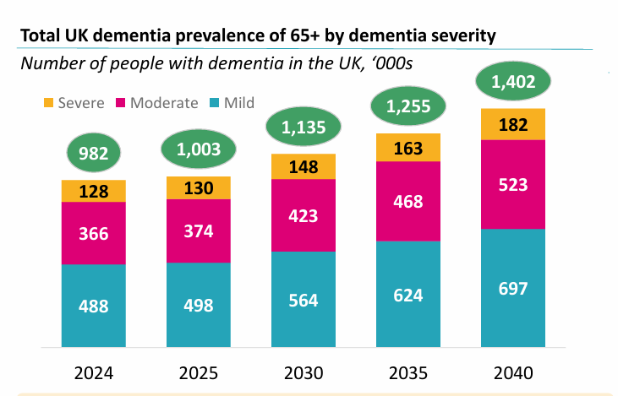

APPENDIX 2


