Intercultural Competence Report

Student name: Luminita G Marinescu Student ID number:2212680
Module: Cultural Awareness
Module code: BMIH5003
Lecturer:Giulia Chifari

1.0 Executive Summary
As the assistant manager for Diversity Hotel and Spa hotel, I consider intercultural competence an important factor for the success of the hotel’s chain in China. I developed this report to examine the cultural differences between China and the UK. The Chinese and British cultures differed in various ways, such that Chinese culture values respect for authority and motivation towards success and is less individualized and indulgent compared to British cultures. Based on Globe's project culture visualization, Chinese culture scored higher in uncertainty avoidance, in-group collectivism, humane and performance orientation, while UK culture scores higher in assertiveness, future orientation, gender egalitarianism, and power distance. Based on Globe's leadership visualization, Chinese leaders scored higher in self-protectiveness, humane orientation, and autonomous domains. The British leaders scored higher in participative, charismatic, and team-oriented domains. This report also identified the intercultural challenges that may affect leaders. They included language barriers, differences in professional etiquette, and conflicting working styles.

2.0 Table of Contents
Contents
1.0 Executive Summary 2
2.0 Table of Contents 3
3.0 Introduction 4
4.0 Cultural Differences between the UK and China 4
4.1 Figure 1: Comparison of Chinese and British cultures. Source Hofstede Insights, 2024. 6
5.0 Globe’s Project 6
5.1 Culture Visualisations 6
5.1.1 Figure 2: Globe Culture scale. Source GLOBE Project, 2020. 7
5.1.2 Figure 3: Globe Culture scale. Source GLOBE Project, 2020. 7
5.2 Leadership Visualisations 7
5.2.1 Figure 4: Globe Leadership Scale for Chinese and British Cultures. Source GLOBE Project, 2020. 8
6.0 Challenges of Intercultural Leadership 9
7.0 Conclusion 9
7.1 Recommendations 10
8.0 List of References 11

3.0 Introduction
Intercultural competence entails an individual’s potential to function appropriately across different cultures. Savicki (2023) observes that interculturally competent people should be able to act and communicate effectively with people from other cultures while respecting their cultural identities. I prepared this report to explore the cultural differences between the UK and China, analyse the cultures based on the Globe’s project, and identify the intercultural leadership challenges likely to affect the general manager's activities.

4.0 Cultural Differences between the UK and China
Understanding cultural variations across different dimensions will make it easy for the general manager to interact effectively with China’s Diversity Hotel and Spa hotel chain employees. For instance, power distance can help the manager understand the Chinese people's attitudes towards the inequalities among the population. 80% of the Chinese population believes that individuals should not aspire beyond their ranks, so the relationship between subordinates and superiors should be respected (Hofstede Insights, 2024). Kajanus, Afshordi and Warneken (2020) explain that Chinese culture deeply respects authority and rank. In contrast, only 35% of English people believe in respect for authority (Hofstede Insights, 2024). This means that the manager should expect more respect from the employees in the Chinese hotel chain compared to those at the London hotel.
Besides, based on individualism, the Chinese are a less individualised society, with 43% believing in the need for individuals to act in the group's interest. In contrast, British society is highly individualised, with 78% of the population believing in the need to act in the group's best interest (Hofstede Insights, 2024). Wang et al. (2020) illustrate that the manager should expect Chinese employees to be more committed to their colleagues than the organization and corporation to be high among in-groups than with out-groups. Their long-term orientation indicates a 77% chance of saving, investing, and persevering to achieve positive results (Hofstede Insights, 2024).
Moreover, motivation towards success is the same in Chinese and British cultures, with 66% of the workers from both cultures ready to make sacrifices to achieve success (Hofstede Insights, 2024). Also, Chinese and British cultures score low on uncertainty avoidance, indicating flexibility in adhering to societal laws (Hofstede Insights, 2024). The manager should understand that the Chinese are comfortable with ambiguity, can easily adapt, and are more entrepreneurial. The British are also creative and innovative. In this case, the manager can leverage the Chinese deep respect for authority and flexible respect for authority to introduce new brand standards (Kajanus, Afshordi & Warneken, 2020). Lastly, British culture is more indulgent (69%) than Chinese culture (24%) (Hofstede Insights, 2024). This is because Chinese society is more restrained by social norms than the British culture.
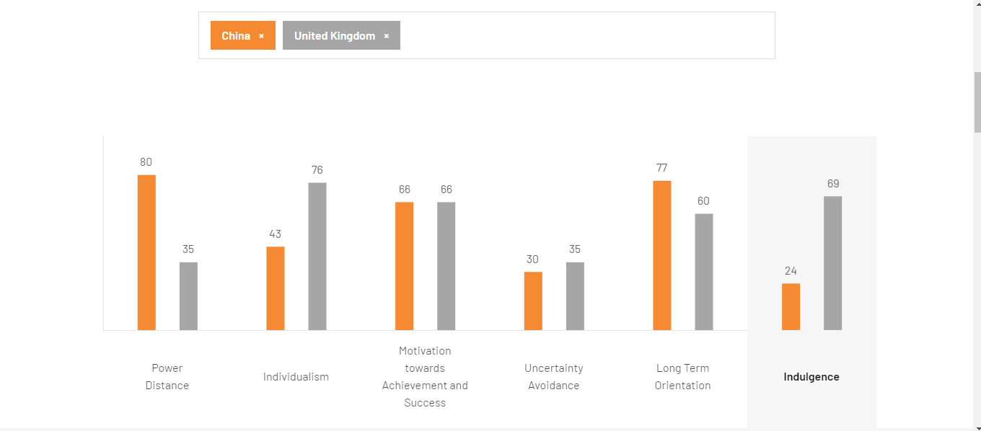

4.1 Figure 1: Comparison of Chinese and British cultures. Source Hofstede Insights, 2024.

5.0 Globe’s Project

5.1 Culture Visualisations
The Globe’s project analyses the cultural and leadership performance of Chinese and British leaders based on various dimensions. The culture visualisations indicate that Chinese culture scored higher in uncertainty avoidance practices (4.94 vs 4.65), in-group collectivism (4.77 vs 4.27), humane orientation (4.36 vs 3.72) and performance orientation (4.45 vs 4.08) than the British culture (GLOBE Project, 2020). The higher scores indicate that the Chinese leaders stressed social norms, the need for pride and loyalty and fair rewards for individuals who performed better or excelled in their duties. In contrast, the British culture scored higher in gender egalitarianism (3.67 vs 3.5), assertiveness (4.15 vs 3.76), future orientation (4.28 vs 3.75), and power distance (5.15 vs 5.04) (GLOBE Project, 2020). The higher scores in British culture indicate that the leaders stressed aggressive relationships with others, engagement in future-oriented behaviours like planning, and endorsement of authority and power differences in workplaces.

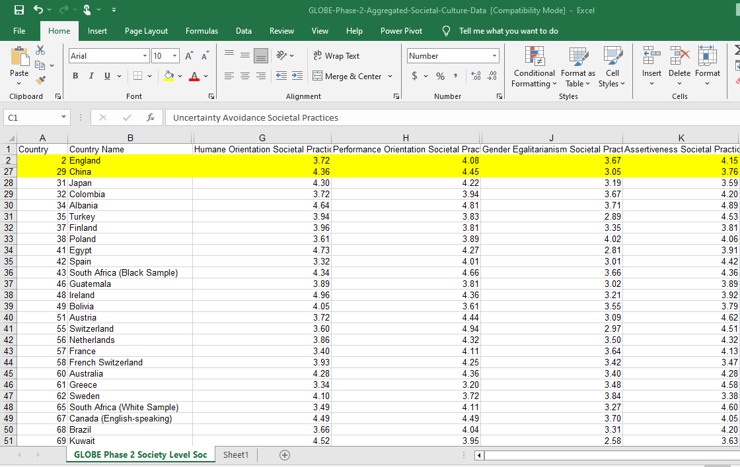

5.1.1 Figure 2: Globe Culture scale. Source GLOBE Project, 2020.
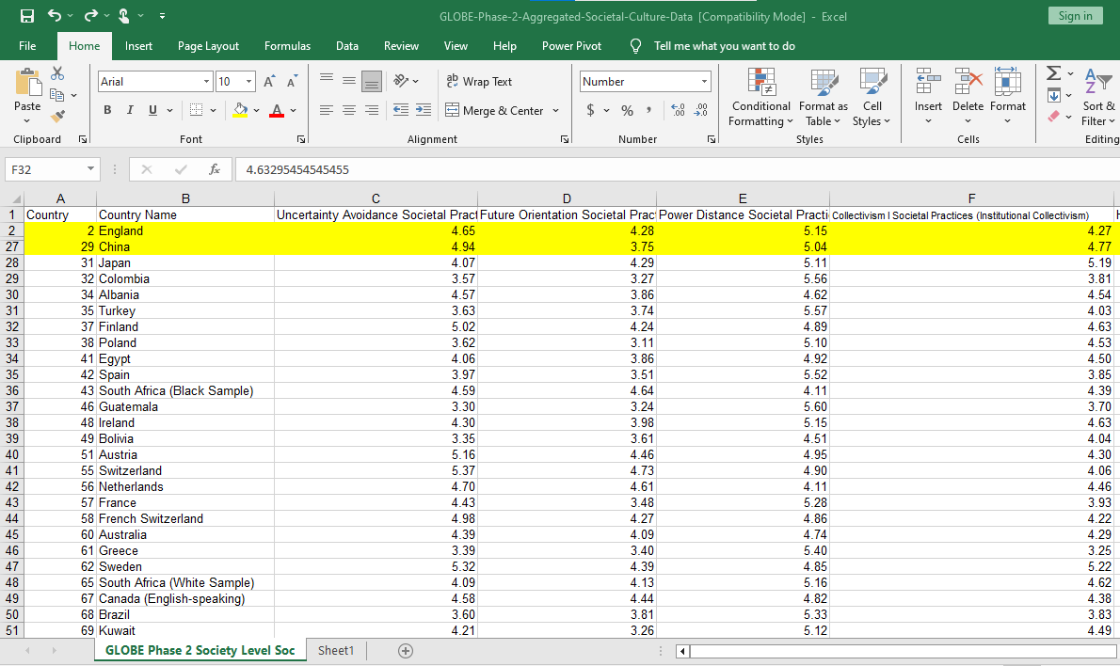

5.1.2 Figure 3: Globe Culture scale. Source GLOBE Project, 2020.

5.2 Leadership Visualisations
Based on leadership visualisations, the Chinese leaders scored higher in self-protective (3.80 vs 3.04), humane-oriented (5.19 vs 4.90) and autonomous domain (4.07 vs 3.92) (GLOBE Project, 2020). The higher scores indicate that the Chinese leaders stressed the safety and security of individuals and groups, as well as considerate and individualistic leadership that promotes compassion and generosity. In contrast, British cultures scored higher in participative (5.68 vs 4.76), charismatic (6.01 vs 5.56), and team-oriented (5.71 vs 5.57) domains (GLOBE Project, 2020). The higher scores indicate that British leaders stressed the involvement of employees in decision-making, the need to motivate and inspire performance, and the emphasis on team building at the workplace.
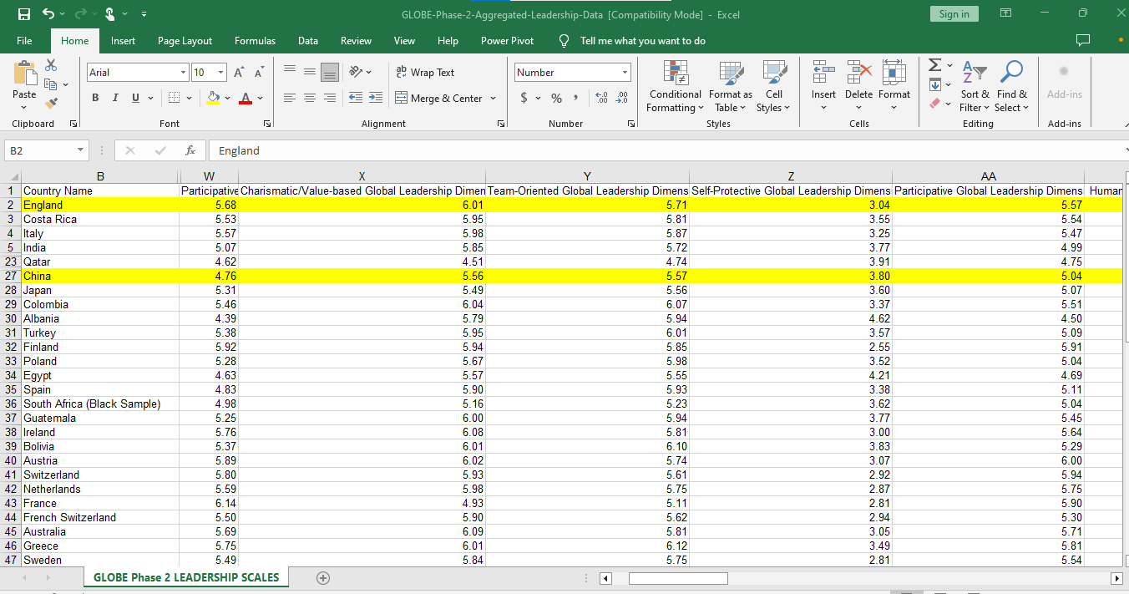

5.2.1 Figure 4: Globe Leadership Scale for Chinese and British Cultures. Source GLOBE Project, 2020.
5.2.2 Figure 5: Globe Leadership Scale for Chinese and British cultures. Source GLOBE Project, 2020

6.0 Challenges of Intercultural Leadership
Intercultural leadership is marred with many challenges, such as language barriers, which may inhibit the manager from communicating effectively with the employees (Rabiul & Yean, 2021). Besides, variations in professional etiquette also affect intercultural leadership. Eid and Agag (2020) observe that misunderstanding cultural values like respect for rank and authority, as evident in Chinese cultures, may create perceptions in the manager that the employees are being mistreated, which may create laxity among employees if the manager changes the conditions. Additionally, conflicting working styles may also impede intercultural leadership. The new leader may find it challenging to recognise and account for the attitudes towards cultural values, like approaches to teamwork and collaboration, which differ between China and the UK. Chinese cultures value collaboration in achieving specific goals, while British cultures value individualism and independence towards work objectives.
Therefore, the hotel personnel should develop cultural sensitivity and intelligence to help recognise and accommodate different cultural perspectives and values towards work (Lam, Cheung & Lugosi, 2022). It also reduces misunderstandings of different cultures or communication breakdown among employees. It can also help address cultural biases like gender bias, which may affect employee performance (Russen, Dawson & Madera, 2021). Thus, cultural sensitivity is integral in navigating culturally diverse workplaces.

7.0 Conclusion
I developed this report to illustrate the differences between Chinese and British cultures. It shows that Chinese and British cultures differ in various ways. For example, Chinese culture values respect for authority and motivation towards success and is less individualized and indulgent compared to British cultures. I also reviewed Globe's project culture visualization and found that Chinese culture scores higher in uncertainty avoidance, in-group collectivism, humane and performance orientation, while UK culture scores higher in assertiveness, future orientation, gender egalitarianism, and power distance. Additionally, the report on Globe's leadership visualization indicate that Chinese leaders scored higher in self-protectiveness, humane orientation, and autonomous domains. The British leaders scored higher in participative, charismatic, and team-oriented domains. I also found that the intercultural challenges that may affect leaders include language barriers, differences in professional etiquette, and conflicting working styles.

7.1 Recommendations
Based on the analysis, I recommend the hotel to adopt the following measures:
- Introduce cross-cultural training to enhance the cultural competence of employees and managers (Yurur et al., 2021).
- Introduce cultural awareness campaigns to promote cultural sensitivity and intelligence among employees (Manoharan, Gross & Sardeshmukh, 2021).
- Integrate culturally appropriate work practices in the hotel operations to create a work environment that values cultural diversity (Yurur et al., 2021).

8.0 List of References
Eid, R. and Agag, G., 2020. Determinants of innovative behaviour in the hotel industry: A cross-cultural study. International Journal of Hospitality Management, 91, p.102642. https://doi.org/10.1016/j.ijhm.2020.102642
GLOBE Project. (2020) An overview of the 2004 study: Understanding the Relationship Between National Culture, Societal Effectiveness and Desirable Leadership Attributes. Available at: https://globeproject.com/study_2004_2007.html (Accessed: 27 May 2024).
Hofstede Insights. (2024). Country comparison tool. Available at: https://www.hofstede-insights.com/country-comparison-tool?countries=china%2Cunited+kingdom (Accessed: 27 May 2024).
Kajanus, A., Afshordi, N., and Warneken, F. 2020. Children's understanding of dominance and prestige in China and the UK. Evolution and Human Behaviour, 41(1), 23-34. https://doi.org/10.1016/j.evolhumbehav.2019.08.002
Lam, R., Cheung, C., and Lugosi, P. 2022. The impacts of cultural intelligence and emotional labour on the job satisfaction of luxury hotel employees. International Journal of Hospitality Management, 100, 103084. https://doi.org/10.1016/j.ijhm.2021.103084
Manoharan, A., Gross, M.J. and Sardeshmukh, S.R., 2021. Antecedents and outcomes of a culturally diverse workforce in hotels. Journal of Hospitality & Tourism Research, 45(8), pp.1383-1416. https://doi.org/10.1177/1096348020986906
Rabiul, M.K. and Yean, T.F., 2021. Leadership styles, motivating language, and work engagement: An empirical investigation of the hotel industry. International Journal of Hospitality Management, 92, p.102712. https://doi.org/10.1016/j.ijhm.2020.102712
Russen, M., Dawson, M., and Madera, J. M. 2021. Gender discrimination and perceived fairness in the promotion process of hotel employees. International Journal of Contemporary Hospitality Management, 33(1), 327-345. https://doi.org/10.1108/IJCHM-07-2020-0647
Savicki, V. Ed. 2023. Developing intercultural competence and transformation: Theory, research, and application in international education. Taylor & Francis.
Wang, C., Xu, J., Zhang, T. C., and Li, Q. M. 2020. Effects of professional identity on turnover intention in China's hotel employees: The mediating role of employee engagement and job satisfaction. Journal of Hospitality and Tourism Management, 45, 10-22. https://doi.org/10.1016/j.jhtm.2020.07.002
Yurur, S., Koc, E., Taskin, C. and Boz, H., 2021. Factors influencing intercultural sensitivity of hospitality employees. International Journal of Hospitality & Tourism Administration, 22(1), pp.26-44. https://doi.org/10.1080/15256480.2018.1547236

