
University of Wales Trinity Saint David
School of Engineering

Vehicle to Grid Technology
Automotive Materials & Sustainability
ACHA6012

Joshua Edward Watson
1900149
Date: 22/11/2021
Contents
1 Introduction 1
1.1 What is V2G? 1
1.2 The theory behind V2G 1
2 Application 2
2.1 FIM MotoE World Cup 2
2.2 Isle Of Man TT Zero 3
2.3 Clubman level racing 3
3 Advantages of utilising V2G 4
4 Limitations of using V2G 4
5 Current demand solutions and grid capabilities 5
5.1 Current energy demand solutions 5
5.2 Wind Farms 5
5.3 Motorsport/Motorcycle Context 6
5.4 Use of Solar Energy at race venues 7
6 Ethical issues 9
6.1 The use of Lithium 9
6.2 Battery recycling 10
6.3 Infrastructure needed for V2G 10
7 Conclusions 11
8 Bibliography 12

Table of Figures

Figure 1- Schematic of V2G stages (Schmidt, 2017). 1
Figure 2- FIM MotoE machine. (Lieback, 2019) 2
Figure 3- Mugen TT Zero machine in 2017 with Guy Martin onboard (RK Takasago Chain, 2017). 3
Figure 4- Dogger Bank Wind Farm Location off the coast of East Yorkshire, UK. It is made up of three separate sites, named A , B and C (Dogger Bank Wind Farm, 2021). 7
Figure 5- Large scale solar parks could be a solution to carbon offsetting at motorsport venues (Eco Planet Energy, 2016). 9
Figure 6- Mined material needed for batteries by 2050 (Joungn, 2019). 10
Figure 7- Dismantling a lithium-ion battery is a delicate job and very time consuming (Woollacott, 2021). 11

Introduction

What is V2G?
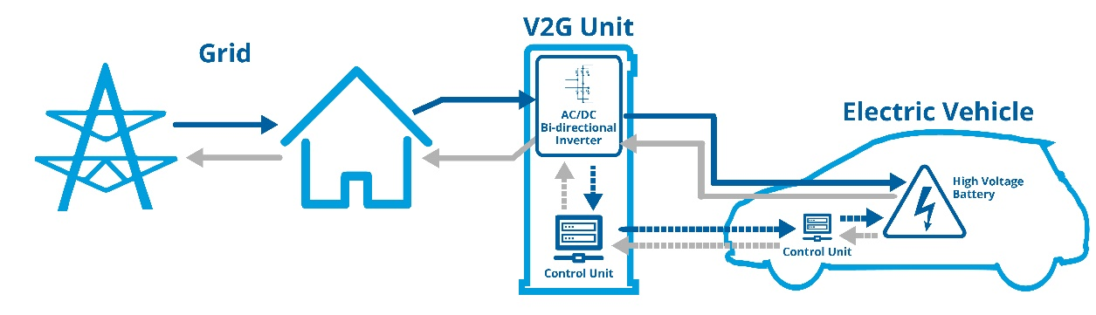
Vehicle-to-Grid technology (V2G) is the process of returning stored energy, back into the national grid from electric and hybrid-electric vehicles. This technology is used to boost the national grid supply in times of high demand when the grid may be struggling, I.e., at peak times in the evening when people return home from work and begin using appliances etc within their homes. (Topping, 2021)
Figure 1- Schematic of V2G stages (Schmidt, 2017).

The theory behind V2G
Vehicle to Grid technology was created with the aim to allow the national grid to utilise more renewable energies and less fossil fuels to generate the nation’s energy. It is used to balance out energy demand, reducing stress on the grid.
Most of the energy in electric vehicle (EV) batteries does not get used for a large amount of the time. Meaning that there is a surplus of energy being stored in EV battery packs that could be utilised elsewhere, whilst still leaving enough energy to complete journeys comfortably.
V2G doesn’t work with ordinary household electric sockets, therefore specialist V2G bi-directional charging points must be installed. Which at this early stage of V2G, choices of charging points are slim, therefore often relating to a high additional cost. (Bonnici, 2020)

Application
Whether V2G could be incorporated into professional, clubman level racing is the question that will be explored within this report by analysing the pros and cons and exploring the feasibility of V2G In this context.
If only a few vehicles make use of V2G, then the impact it would have will be negligible, however if millions of vehicles made use of V2G, the impact would be greater, meaning outsourcing energy is less, therefore saving money.
In the MotoE world championship, the machines are only used for a fraction of the time that they are at the venue, meaning they could be potentially used for V2G when idle and not in use. However, the amount of energy being transferred should be controlled.
The use of pit vehicles like scooters is huge within the paddock for team members etc to move around the venue. Switching to electric alternatives, would be a simple and relatively cost-effective way to reduce the number of emissions, and to make use of V2G.

FIM MotoE World Cup
The FIM MotoE World Cup, which is the worlds premier, and only official electric motorcycle racing series, held in conjunction with the FIM MotoGP series, that has been running since 1949.
In the Federation Internationale de Motocyclisme (FIM) environmental code report for 2021, they pledge to “Monitor advances in technology and environmental best management practices and apply them as appropriate.” (Federation Internationale de Motocyclisme , 2021)
The above suggests that the MotoE World Cup would be an ideal place to consider implementing V2G technology, this will be reviewed in detail later in this report.
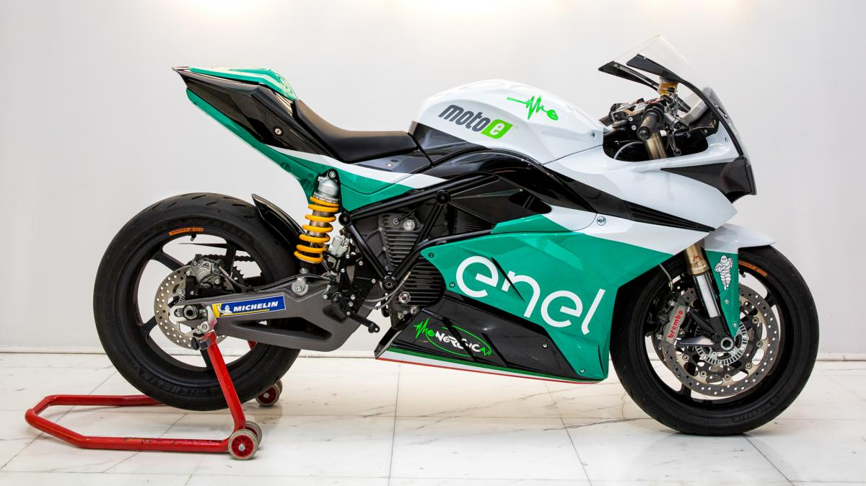
Figure 2- FIM MotoE machine. (Lieback, 2019)

Isle Of Man TT Zero
Alternatively, the world-famous Isle of Man TT has a history of running the ‘TT Zero’ race. This is a high-level event that V2G could potentially be utilised at, and V2G would be a brilliant way to ensure the event is as green as possible.
Including this technology in the above-mentioned scenarios, although it would offer a range of benefits, it would also raise some issues that would need to be considered for it to be fully successful, these will however be reviewed in later sections of the report.
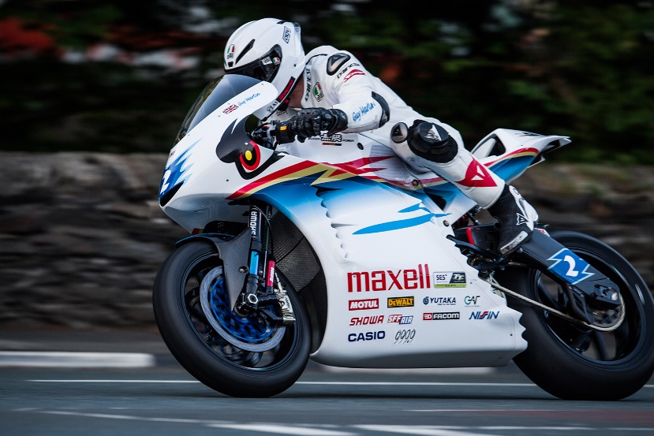

Figure 3- Mugen TT Zero machine in 2017 with Guy Martin onboard (RK Takasago Chain, 2017).

Clubman level racing
In terms of clubman level racing, which is often known to be the lower end of the racing spectrum, there is little to no electric motorcycle involvement at any racing clubs around the United Kingdom. Which does suggest that V2G wouldn’t be as good a utilisation compared with the previous two examples given.

Advantages of utilising V2G
The advantages of using V2G are that it is a suitable means of reducing the amount of demand on the national grid by giving back excess energy from a vehicle at times when it isn’t needed.
Some manufacturers and energy companies offer incentive-based schemes for the use of V2G. This is a big draw to using V2G for most.
It is also worth knowing that in the use of electric vehicles, the cost of energy used to fuel the battery packs, is cheaper than fuel used in ICE vehicles, therefore saving the team a large cost in fuel over a period. Which in racing, is great!

Limitations of using V2G
Obvious limitations that come to mind when talking of V2G, are the costs that are involved with setting up the infrastructure needed, and the supply of the necessary vehicles, which for some teams/corporations, is not possible due to budget limitations etc.
In large scale championships, where there are often events known as ‘fly away’ events, the use of EV’s for team transportation may not always be possible, due to the need for travelling large distances to get to events, often taken by aeroplane or boat, which greater proves the requirement for carbon offsetting.
The machines used for electric motorcycle racing, often require all their energy stored inside the battery packs to complete their race. This means that the use of V2G may not be possible all the time, this could depend on the length of the race, and the number of laps that the race is held over. V2G could end up taking too much energy away from the machine, therefore leaving not enough energy in the battery pack to complete the race, making it pointless for teams.
The infrastructure required for venues to offer V2G capability is huge, and requires a lot of cost, land, and time. That simply some venues do not have. This therefore limits the venues that can offer V2G usage, which could affect the running of the championship.
The limitations of battery packs themselves, would be a big problem in the use of V2G, since like mentioned, the machines being used in these motorcycle championships, require a large amount of energy, which at present, there isn’t a chance to remove any of this energy, as then there wouldn’t be enough in the battery packs to complete the events.

Current demand solutions and grid capabilities
One of the main proposals to combat the current energy demand crisis in the UK is for the national grid to switch from using fossil fuels to generate energy, to more renewable sources of power, therefore reducing the amount of fossil fuels being used, reducing the amount of greenhouse gases being emitted into the earth’s atmosphere.
It is said that our dependence on gas and oil energy sources are responsible for a 1.7% increase in carbon dioxide gases into our atmosphere, in the energy sector alone. (Gosheva, 2021)

Current energy demand solutions
In terms of reducing the demand for energy we need in the UK. The first main consideration should be given to aiming to reduce the amount of energy being used. Especially energy that has been generated using non-renewable fuel sources. It is critically important that more and more of the energy being used is coming from a renewable fuel source.
Renewable energy sources like solar, wind, hydro, tidal, geothermal, and biomass energy sources should be used more to produce energy that can be used to reduce the amount of non-renewable energy being used in our society.
The transport sector contributes very little in terms of the usage of renewable energy sources in the UK, with only 3.8% renewable energy sources being used compared to 12% in the heating sector and 30% in the electricity sector. (Gosheva, 2021) This further proves the point that the vehicle/transport industry needs to use more renewable energy sources.

Wind Farms
In the UK, around 47% of our electricity share is generated through renewable sources. 30% of this 47% was generated on wind turbine farms placed around the UK and in surrounding waters.
There are plans for another huge project called the Dogger Bank wind farm, which will be built around 80 miles off the UK coastline, complete with some of the worlds biggest wind turbines with blades of up to 100m long. It is predicted that this wind farm can provide energy of around 3.6 Gigawatts which is enough to power 4.5 million homes in the UK, and around 5% of the UK energy demand. (FIA Formula E, 2020)

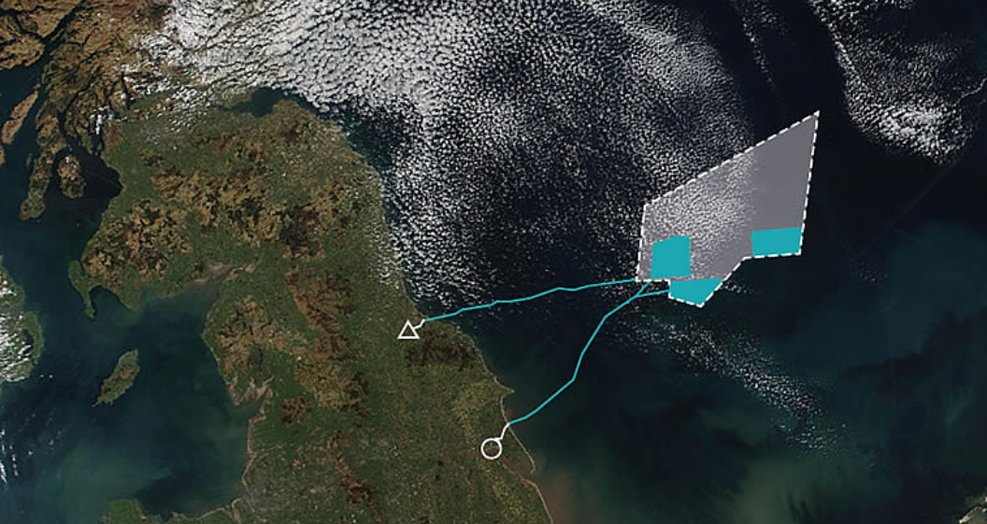
Figure 4- Dogger Bank Wind Farm Location off the coast of East Yorkshire, UK. It is made up of three separate sites, named A , B and C (Dogger Bank Wind Farm, 2021).

Motorsport/Motorcycle Context
In a motorsport/motorcycle context, it is difficult to drastically reduce the amount of fossil fuels being burned in racing series, without switching the infrastructure of the championship to electric, like the events outlined earlier within this report. This is due to the costs and changes that would be implemented with the switch from ICE engines and infrastructure to electric, alternative fuel-based equipment.
Reducing the number of emissions within a race team however can be done through a range of various adjustments, whether this be at the team headquarters or at the racetrack, test facility etc. Unoccupied rooms shouldn’t be lit, this can be done by installing detectors in all rooms, that only then light the room when motion is detected. This is a simple, relatively cost-effective way to immediately reduce the amount of energy being used. As previously mentioned, electricity being used in buildings should come from renewable sources, like wind farms or solar panels installed on the building itself.
Carbon Offsetting is a big thing that again, should be at the forefront of any professional motorsport entity. This is done through offsetting the amount of carbon being contributed the atmosphere, by reducing the number of emissions being released in areas that it would not have otherwise taken place, due to it sometimes not being possible in the actual racing events.
Motorsport teams and corporations must attempt to ensure that the emissions they are emitting through their racing activities are offset through alternative ways to ensure they remain as close to carbon neutral as possible.
Ways that teams and corporations can offset their carbon emissions are through things like ensuring as many as possible of their logistical vehicles are running on the highest efficiency fuel they can, and possibly converting vehicles to compressed gas fuel wherever possible. They could also consider reducing the amount of travel, by holding meetings, conferences, and other events remotely wherever possible, to reduce the number of cars on the road, therefore reducing the amount of energy needed to fuel them and reducing the amount of travel on aeroplanes, boats, trains etc is also reduced.
These simple methods of reducing emissions should be taken seriously by the team management, so that they are having an impact on producing a more efficient future for the UK.

Use of Solar Energy at race venues
Given the often large areas of baron land that the majority of race venues within the UK are built upon, it is a reasonable suggestion that there could be a possibility of building large scale ‘Solar Parks’ on the land for which the energy generated could be used to power the buildings and infrastructure at these venues, therefore allowing the venues to become nearer to carbon neutral, which would be seen as a great advantage for championships such as MotoGP and Formula 1.
Large scale solar parks could be built wherever possible, at these venues allowing for a higher percentage of their energy usage to come from renewable energy sources, therefore offsetting the amount of carbon being emitted to the earths atmosphere via the events that take place at these venues.
This suggestion, paired with the teams and corporations’ efforts to reduce their emissions, would be a great advantage that would help in providing a greener future for motorsport and motorcycle racing.
There are some disadvantages to the above suggestion however, in that the amount of land required to construct such solar farms is vast, and although at most venues this wouldn’t be a problem, it would be at some. There are also great costs involved with starting such a large-scale operation, and when it comes to deciding who funds the project, this could be something that some teams etc wouldn’t feel they could afford. So, then it would fall on the feet of the organisers of the championship, which again, is a large outlay of funds which they may not have.
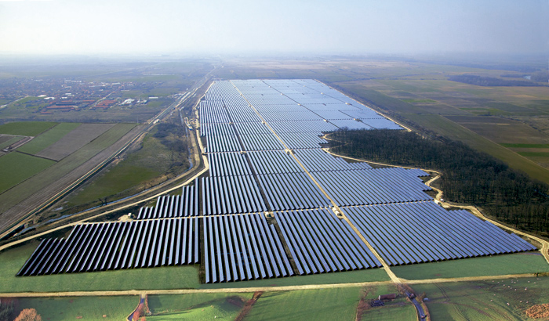
Another disadvantage, if a championship decided that they wanted all their member venues to have some form of solar park, if a venue couldn’t meet this requirement for any reason, this would leave the venue with a severe lack of revenue due to the championship using a different venue, and the championship would be at a loss as they would lose a venue. (Harlow, 2020)
Figure 5- Large scale solar parks could be a solution to carbon offsetting at motorsport venues (Eco Planet Energy, 2016).

Ethical issues

The use of Lithium
Lithium is used for Lithium-ion batteries, which in terms of moving toward electric based racing series, is what is used within the battery packs of the vehicles being used. The market for use of Lithium-ion batteries is projected to grow from $30 Billion USD in 2017, to $100 Billion USD in 2025. (Nature.com, 2021)
Unfortunately, it is known that worldwide, children are used for labour in the extraction of raw materials (Lithium), with them often being subjected to unfair and unsafe work conditions. Child labour is obviously not acceptable, and this is something that should be revised moving forward to allow for ethical mining of Lithium to use in our vehicle’s battery packs. Especially when the projection for the use of Lithium batteries is so high. (Nature.com, 2021)
There are many cobalt mines in countries like Congo, where the national average salary is low, meaning that the opportunity for employment attracted a vast number of people, including children. In 2019, a large-scale lawsuit was launched by several families from Congo, against EV manufacturer Tesla and other large scale tech companies, stating that they had children who had died or were seriously injured on cobalt mines, in which the cobalt that was being mined was being used in Tesla vehicles. (Vasil, 2020)
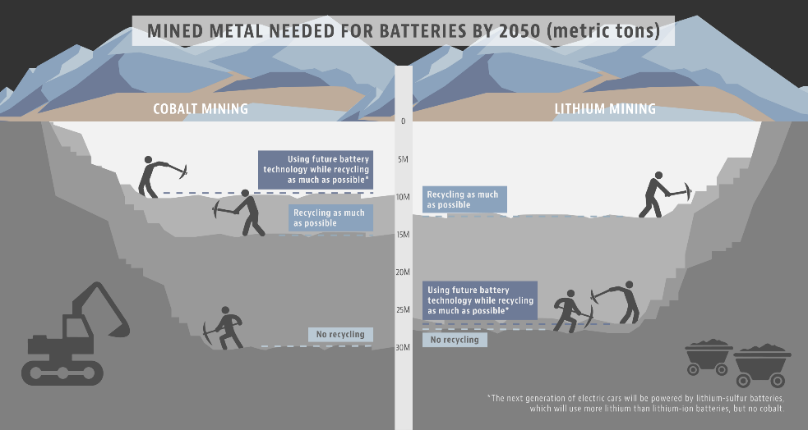
Figure 6- Mined material needed for batteries by 2050 (Joungn, 2019).

Battery recycling
The recycling of lithium-ion batteries that are used within electric vehicles is difficult as they contain hazardous chemicals that can often be hard to dispose of and handle. They can explode when not handled correctly, which obviously is a big danger to anyone who is responsible for dismantling these lithium-ion batteries. Currently , it is predicted that only around 5% of used lithium-ion batteries are recycled, meaning that the remaining 95% are often disposed of incorrectly. (Woollacott, 2021)
Vehicle manufacturers are slowly starting to introduce dedicated battery recycling departments and plants within their organisation to ensure that their battery packs are being recycled correctly and not just being dumped at the end of their life.
Since this job is so delicate and requires extra care to be taken, this adds an additional cost to the company as the staff conducting the tasks would be paid more due to handling hazardous materials and chemicals, due to extra training required before they can begin etc.
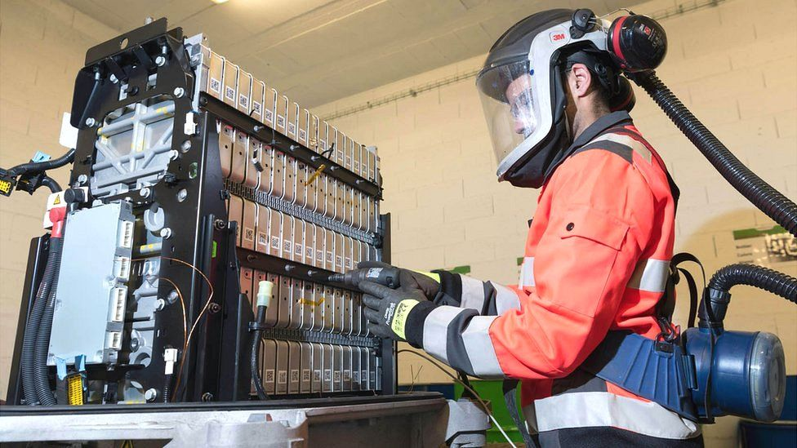
Figure 7- Dismantling a lithium-ion battery is a delicate job and very time consuming (Woollacott, 2021).

Infrastructure needed for V2G
The infrastructure needed for V2G can be seen as a problem for some users in a general context, for instance, not everyone has the access to EV charging facilities based on where they live, if a user lives in an apartment block, these buildings often have limited facilities, meaning that EV’s are often not a feasible option. Some workplaces often don’t have the correct parking facilities to house the number of EV charging points that would be required for V2G to be a success for their employees. Meaning that even if the company wanted to make use of V2G, they may not physically have the resources/infrastructure for it to be a success.

Conclusions
Based on the information shown in this report, and the advantages and issues discussed on V2G, is can be said that at present, V2G wouldn’t be a feasible option in professional level motorsport/motorcycle racing championships. It certainly wouldn’t be an option in clubman level racing.
This is due to the large costs required to convert to using V2G, and the infrastructure needed.
It could be said that in the professional racing industry, such technology could be incorporated, although a lot of variables would need to be amended before it could be used successfully. The fact that most venues around the world do not have enough space for their car parks to be fitted with enough EV chargers for V2G to be used.
In pit lane, especially for the MotoE championships, each garage would have to be fitted with the required chargers that are connected to the grid so that V2G can be used.
The capability of the electric racing machines in these championships isn’t currently advanced enough to make use of V2G, based on what has been discussed in this report. It is known that large advances are projected for the capability of these machines and the battery packs themselves, therefore in future, it could be a possibility that V2G could be used in these championships. And if this is paired with the infrastructure at the venues, with the carbon offsetting efforts by teams and corporations, then there could quite easily be a very green future in motorcycle racing. The main question, given the current climate crisis that there is in the world, these changes should come earlier, rather than later.

Bibliography
Bonnici, D. (2020, October 13). Vehicle-to-grid technology explained. Retrieved from www.whichcar.com.au: https://www.whichcar.com.au/car-advice/what-is-vehicle-to-grid-charging
Dogger Bank Wind Farm. (2021, November 8). About the Project. Retrieved from doggerbank.com: https://doggerbank.com/about/
Eco Planet Energy. (2016, April 1). Brazil builds the largest solar farm in Latin America. Retrieved from https://ecoplanetenergy.com/tag/solar-parks-en/
Federation Internationale de Motocyclisme . (2021). FIM Environmental Code . FIM.
FIA Formula E. (2020, July 24). How motorsport is accelerating the switch to renewables. Retrieved from fiaformulae.com: https://www.fiaformulae.com/en/news/2020/july/watch-renewables
Gosheva, R. (2021, September 9). 14 Alternative Energy Sources That Can Make a Difference. Retrieved from greenmatch.co.uk: https://www.greenmatch.co.uk/blog/alternative-energy-sources
Harlow, D. (2020). Racing Towards Carbon Neutrality. Race Tech Mag- Green Tech, 50-51.
Joungn. (2019, June 14). More electric cars can mean more damage to mining communities. Retrieved from pbs.org: https://www.pbs.org/wnet/peril-and-promise/2019/06/electric-cars-mining-lithium/
Lieback, R. (2019, March 27). 2019 MotoE World Cup Calendar: Revised Schedule (Post Fire). Retrieved from ultimatemotorcycling.com: https://ultimatemotorcycling.com/2019/03/27/2019-motoe-world-cup-calendar-revised-schedule-post-fire/
Nature.com. (2021, June 29). Lithium-ion batteries need to be greener and more ethical. Retrieved from nature.com: https://www.nature.com/articles/d41586-021-01735-z
RK Takasago Chain. (2017, June 14). Isle of Man TT 2017 TT Zero Wins with RK Chain. Retrieved from global.rk-japan.co.jp: http://global.rk-japan.co.jp/info/isle-of-man-tt-2017-tt-zero-wins-with-rk-chain/
Schmidt, E. (2017, October 2017). The Latest in Vehicle to Grid (V2G) Charging. Retrieved from www.fleetcarma.com: https://www.fleetcarma.com/latest-vehicle-grid-v2g-charging/
Topping, C. (2021, February 16). Vehicle-to-Grid (V2G) Explained: What it is and how it works. Retrieved from www.ovoenergy.com: https://www.ovoenergy.com/guides/electric-cars/vehicle-to-grid-technology
Vasil, A. (2020, January 20). The EV revolution will take batteries, but are they ethical? Retrieved from corporateknights.com: https://www.corporateknights.com/mining/ev-revolution-needs-batteries-ethical/
Woollacott, E. (2021, April 27). Electric Cars: What will happen to all the dead batteries? Retrieved from bbc.co.uk: https://www.bbc.co.uk/news/business-56574779

