University of Wales Trinity St Davids
Development of a Boeing Seat Jack Tool
Morgan Daniel Evans
BEng Mechanical and Manufacturing Engineering
31/5/2026

Contents
1 Abstract 3
2 Aims and Objectives 4
3 Timing plan 8
4 Research 11
4.1 Load Retention and Prevention of Falling Loads 11
4.2 Stability and Load Distribution 13
4.3 Ergonomic Design and Operator Safety 15
4.4 Centre of Gravity Control 17
4.5 Human Factors Engineering and Operator Confidence 19
4.6 Material Protection and Damage Prevention 22
5 Work Carried Out 27
5.1 Credenza 27
5.2 FWD shroud 29
5.3 AFT Shroud 34
6 Results 37
7 Conclusion 43
7 Recommended further work 46
7.1 Extended Operational Testing 46
7.2 Increased Component Standardization 46
7.3 Material and Weight Optimization 47
7.4 Enhanced Component Protection 47
7.5 Structural Analysis and Validation 47
7.6 Design for Manufacture and Assembly 48
7.7 Expansion to Additional Applications 48
7.8 Human Factors and Ergonomic Assessment 48
7.9 Summary 49
8 References 50

1 Abstract
The goal of this project was to provide a better jack tool for installing parts of the Boeing aircraft suite, such as the credenza, FWD shroud, and AFT shroud. A number of operating problems, including component instability, installation damage risk, decreased operator confidence, and safety difficulties due to insufficient load restraint, have been linked to the current Boeing-approved lifting tool. The project's goal was to create a solution that would enhance stability, safety, and operating effectiveness while adhering to Boeing's stringent specifications, which prohibited changing the current wheel assembly and lifting system.
Load retention, load distribution, center of gravity control, ergonomic design, human factors engineering, and material protection were among the pertinent engineering principles that were thoroughly reviewed. The results of this study guided the creation of several modular brackets, support blocks, and fastening configurations intended to enhance component support and minimize undesired movement during installation.
A standardized technique that maximized part commonality and permitted modifications for various suite components was used to develop the final tooling design. Both Boeing and Safran operators evaluated the tooling during a practical trial at Boeing's airplane mock-up facility in Seattle. The system offered steady, regulated movement during installation activities, and the results showed that it was easy to assemble and operate. When compared to the prior tooling arrangement, operator comments indicated notable gains in usability, safety, and efficiency, and all key components were successfully installed without damage.
By providing a useful and efficient tool solution that improves installation performance while fully adhering to Boeing's operating restrictions, the project effectively met its goals. The work offers a solid basis for further development and application in aircraft manufacturing settings.

2 Aims and Objectives
The goal of this project was to solve the long-standing operational and safety issues with the lifting tool that Boeing currently provides for handling and installing airplane shrouds. Despite fulfilling Boeing's initial functional requirements, the lifting tool has been in use for a long time. However, operator feedback and workplace incidents have shown that the design no longer offers the best level of safety, stability, or efficiency during operation.
The handling of aircraft components in aerospace manufacturing and maintenance settings necessitates incredibly high levels of accuracy, dependability, and procedural control. During installation operations, aircraft shrouds must be carefully maneuverer into position because they are frequently big, oddly formed, and generally delicate components. There is a serious risk of component damage, operator injury, or installation process disruption with any instability during lifting or placement. Even very small hits or surface damage may make a component unfit for installation until additional inspection, repair, or replacement has been completed because of the stringent tolerances and quality standards found in the aerospace sector.
Simplicity was a top goal when designing the current lifting equipment that Boeing has authorized. Although this streamlined design offers basic operating performance and convenience of manufacturing, it has also resulted in several practical constraints. Once the shroud is raised into place, the current instrument provides very little direction or constraint. Because of this, the shroud may become unstable during transit, alignment, or installation processes, especially if operators need to make minor positional adjustments. Numerous instances when the shroud has abruptly shifted or slipped from the jack during operation have been caused by this instability.
These incidents have had several detrimental effects on the workplace. The shroud's physical damage from being dropped or poorly supported is the most pressing problem. The production of aerospace components is costly and frequently requires specialized materials, intricate fabrication techniques, and stringent inspection protocols. Therefore, damage to a shroud can result in significant financial losses due to additional labour needs, material waste, repair effort, and replacement expenses. Before work may proceed, damage may occasionally necessitate additional engineering evaluations or quality control inspections.
These mistakes not only have a direct financial impact but also lead to operational inefficiencies. Installation work usually needs to be stopped when an event happens so that the component and lifting equipment can be checked for damage or misalignment. This interruption can affect production schedules, delay assembly operations, and reduce overall productivity within the working environment. Even brief delays can lead to more extensive scheduling issues and higher operating costs in the highly time-sensitive and departmentally coordinated aircraft production industry.
Another major concern associated with the current design is operator safety. If a shroud slips or falls unexpectedly, personnel working nearby may be exposed to serious injury risks caused by falling loads, pinch points, or sudden component movement. The current tool design still mostly depends on operator control and manual stabilization during several installation stages, even though safety standards and current practices help lower these hazards. This places unnecessary responsibility on personnel and increases the possibility of human error contributing to an accident or near miss.
The need for change has been further highlighted by comments received from operators and technicians. Concerns about the efficacy of the current tool have been voiced by several users, especially when handling shrouds in awkward or constrained installation situations. Operators have reported problems with the equipment's overall confidence, stability, lack of support, and trouble maintaining alignment. In engineering environments, operator confidence is an important factor, as uncertainty during lifting operations can reduce efficiency and increase the likelihood of cautious or inconsistent handling practices.
Therefore, the main goal of this project is to develop or enhance the lifting tool in a way that maximizes operating effectiveness, safety, and stability while completely adhering to Boeing's engineering requirements and procedural constraints. The intention is not to completely replace the existing lifting system, but rather to enhance the overall functionality of the tool through carefully considered design improvements that address the shortcomings identified during practical use.
A key aspect of the project is the strict set of constraints imposed by Boeing. These restrictions state that neither the tool's wheel assembly nor its current lifting mechanism may be altered. Changing these components can necessitate lengthy revalidation, recertification, or regulatory approval procedures because they are probably already certified and approved for operational use. Consequently, the project must focus entirely on improving other aspects of the tool without interfering with the approved lifting mechanism or mobility system.
This limitation introduces a significant engineering challenge, as any improvements must integrate around the existing structure while maintaining compatibility with current operational procedures. Therefore, within a limited design envelope, the redesign process must consider elements like structural support, load distribution, component restraint, ergonomics, ease of operation, material selection, and manufacturability. Any suggested changes must also refrain from adding new risks, needless complexity, or exorbitant production expenses.
The project must adhere to a structured engineering design process that includes research, concept formulation, design evaluation, and testing to accomplish these goals. Existing problems with the current tool will first be analysed to identify the root causes of instability and operational failure. After that, possible design ideas might be created to enhance the shroud's support and retention during lifting and installation. These concepts may include features designed to better secure the component, improve balance and alignment, or reduce unwanted movement during operation.
After concept generation, suggested solutions can be assessed based on important engineering standards such manufacturability, safety, dependability, ease of use, maintenance needs, and adherence to Boeing's regulations. Designs that demonstrate the greatest potential for improving operational safety and efficiency can then be further refined using modelling, calculations, prototyping, or testing procedures where appropriate.
Ultimately, the successful outcome of this project would provide a safer and more effective lifting solution that reduces the likelihood of shroud damage, improves operator confidence, minimizes workplace risk, and enhances overall installation efficiency. The project intends to provide a workable engineering solution that will benefit the company and its employees in the long run by correcting the shortcomings of the current design while staying within Boeing's operational constraints.

3 Timing plan
This timeline describes the development of the Boeing shroud lifting tool redesign project from its inception in August 2025 to the current phase in May 2026. The project was created to solve operational and safety issues with the lifting equipment currently in use during shroud installation processes.
Enhancing safety, stability, and operational efficiency while adhering to Boeing requirements has been the project's key goal. The following are the main project limitations listed by Boeing:
- No modification to the existing lifting mechanism
- No modification to the wheel assembly
- Full compatibility with current installation procedures
- Improved safety and retention of the shroud during handling
The timing plan below details the key phases completed throughout the project.
Month | Project Activities | Key Outcomes
August 2025 | The project was started. Initial conversations on persistent problems with the current Boeing lifting tool were held. Project goals and limitations were noted. | Defined project scope and understanding of Boeing limitations.
September 2025 | Studies on the design of current lifting tools, how they are used, and instances of shroud instability or slipping off the jack in the past. Feedback from operators was collected. | Identification of key design weaknesses and operational safety concerns.
October 2025 | examination of occupational hazards and the performance of present tools. examination of the reasons behind component movement and instability during installation. First problem statements were generated. | Root causes of failures and safety risks identified.
November 2025 | Design specification developed outlining functional requirements, safety improvements, dimensional restrictions, and compliance requirements. | Finalised project requirements and engineering criteria.
December 2025 | first stage of concept generation. Several design concepts and possible support systems were sketched and assessed considering Boeing's limitations. | Several potential design concepts developed.
January 2026 | Evaluation techniques include manufacturability concerns, safety assessments, and feasibility comparisons are used in the concept selection process. | Most suitable design concept selected for further development.
February 2026 | Detailed design development and CAD modelling are finished. improved restraint techniques, support locations, and structural elements. | Detailed design produced and prepared for review.
March 2026 | stage of design evaluation and improvement. modifications made to enhance interoperability with current equipment, stability, and operator usefulness. studied material considerations. | Improved final design with enhanced safety and functionality.
April 2026 | phase of planning and preparation for the prototype. Testing considerations, assembly specifications, and manufacturing techniques were examined. Updated risk assessment. | Design prepared for prototype manufacture and evaluation.
May 2026 | final assessment of the project's development. Evaluation of whether project goals and Boeing limitations have been met. Documentation and report writing are finished. | Completion of project documentation and presentation of final design solution.

4 Research

4.1 Load Retention and Prevention of Falling Loads
One of the most important safety factors in any lifting and handling operation is load retention, especially in aeronautical engineering settings where components are frequently costly, delicate, and geometrically complicated. Instability and unintentional shroud displacement during installation processes have been frequent problems with the existing Boeing shroud lifting equipment. These occurrences show that the current design might not offer enough support or physical constraint to ensure safe load control during operation.
Lifting equipment must be built and used in a way that keeps loads from slipping, falling, or accidentally moving while being transported or positioned, according to the UK Health and Safety Executive (HSE) (HSE, n.d.). The HSE goes on to say that poor control over the load's centre of gravity, insufficient support surfaces, or inadequate restraint systems are often the causes of unstable loads. Because aerospace components frequently have curved surfaces, asymmetrical geometries, and unequal weight distributions that make them challenging to stabilize using traditional support techniques, this advice is extremely useful to aircraft shrouds.
Falling loads continue to be one of the most frequent reasons for industrial handling mishaps and equipment damage in manufacturing settings, according to additional research from the Canadian Centre for Occupational Health and Safety (CCOHS, 2024). The organization emphasizes that when operators must manually reposition or align the load during installation operations, insufficient load retention mechanisms can allow components to shift during movement. Even slight movements can greatly raise the danger of instability under such circumstances.
The International Labour Organization (ILO) has conducted research that highlights the significant risks associated with poorly restrained loads at work and suggests using mechanical stabilization techniques and secondary restraint devices whenever feasible (ILO, 2021). This is especially important in aerospace settings, where handling operations often involve expensive parts that cannot withstand impact damage or misalignment.
Operators may need to rely significantly on manual intervention to maintain stability during installation because the existing Boeing lifting tool appears to offer rather little containment of the shroud once elevated. This raises the potential of human mistake overall as well as the physical demands on operators. Because manual stabilization requires operators to spend more time and focus on limiting unwanted movement during positioning processes, it may also decrease installation efficiency.
Engineering research published by the American Society of Mechanical Engineers (ASME) further explains that modern lifting systems increasingly incorporate integrated retention features specifically designed to reduce dynamic movement and prevent accidental load release during operation (ASME, 2021). Such features may include mechanical restraints, adjustable support arms, anti-slip interfaces, or modular containment systems capable of adapting to different load geometries.
Within the context of this project, the research strongly supports the implementation of additional support and restraint features surrounding the existing lifting mechanism. Potential design improvements could include:
- adjustable retaining arms,
- side support brackets,
- padded locating guides,
- anti-slip support materials,
- or modular containment systems.
These additions would increase load security without going against Boeing's rules that forbid changing the wheel assembly or lifting mechanism.
Lifting attachments must minimize uncontrolled movement and prevent inadvertent release during operation, according to research from the British Standards Institution through BS EN 13155:2020 (BSI, 2020). In aircraft applications, where lifting failures may result in significant safety consequences in addition to financial loss, adherence to such requirements is particularly crucial.
Therefore, there would be several operational advantages to improving load retention inside the modified lifting tool. Among them are:

- reduced likelihood of dropped components,
- lower repair and replacement costs,
- improved operator confidence,
- reduced installation delays,
- and improved overall workplace safety.

4.2 Stability and Load Distribution
The distribution of forces in a lifting system is essentially related to load stability. During handling operations, unequal stress concentrations, rotational instability, and uncontrollable movement can result from poor load distribution. Stable load distribution is crucial for both safety and operational effectiveness in aerospace manufacturing settings, where components need to be precisely aligned and positioned.
One of the main reasons for instability during industrial lifting operations is uneven weight distribution, according to research done by the Occupational Safety and Health Administration (OSHA) (OSHA, n.d.). According to OSHA, tipping moments and rotational forces greatly rise when a load is not adequately supported throughout its structure, especially during movement or alignment processes. Because their centre of gravity might not naturally line up with the lifting system, components with irregular shapes are particularly vulnerable.
In this regard, aircraft shrouds are especially difficult because of their non-uniform manufacture and aerodynamic geometry. The component appears to be supported by the present Boeing lifting tool at very few points of contact, which could lead to concentrated loading and inadequate control over rotating movement. According to research released by the Institution of Mechanical Engineers (IMechE), lifting stability is much enhanced by expanding support coverage and distributing forces more uniformly across the component (IMechE, 2022).
Balanced multi-point support configurations offer more resilience to abrupt movement and dynamic instability, according to engineering research on industrial lifting systems (ASME, 2021). The system is more resilient to rotational forces produced during operator handling or component alignment when support forces are distributed symmetrically.
This research strongly supports the integration of:
- wider support cradles,
- distributed load-bearing surfaces,
- adjustable support positioning,
- contoured support interfaces,
- and symmetrical support layouts.
Contoured supports may be particularly beneficial because they would allow the lifting tool to conform more closely to the geometry of the shroud, improving both stability and force distribution during handling.
Research from Materials Handling Institute (MHI) additionally highlights that poor stability during manual alignment tasks often leads operators to apply compensatory forces to maintain control of the load (MHI, 2023). This creates additional ergonomic strain while simultaneously increasing the likelihood of sudden instability if the operator loses grip or balance.
By improving load distribution and overall stability, the redesigned lifting tool could significantly reduce unwanted movement during installation procedures. Improved stability would also enhance positioning accuracy, reduce reliance on manual correction, and improve installation consistency within the workplace environment.
From an engineering standpoint, better distribution can also lessen stress concentrations inside the lifting structure itself, which could increase long-term durability and lower equipment maintenance needs.

4.3 Ergonomic Design and Operator Safety
Because bad ergonomics can have a detrimental impact on operator safety, performance, productivity, and long-term physical health, ergonomic design is a significant engineering factor in industrial lifting equipment. Technicians in aerospace industrial settings are often required to do repetitive handling tasks in small places with incredibly high precision. Therefore, operator fatigue, musculoskeletal problems, and an increase in handling errors may be caused by poorly constructed lifting equipment.
According to OSHA research, the main causes of occupational injuries during lifting operations are uncomfortable postures, excessive manual force application, repetitive correction actions, and unstable loads (OSHA, n.d.). According to the organization, physical workload increases dramatically when workers are forced to make up for unstable equipment. This may lead to a decrease in performance due to weariness and a higher risk of accidents.
Shroud alignment and stabilization seem to require a significant amount of manual operator participation with the existing Boeing lifting tool. It might be necessary for operators to physically position the shroud while also managing undesired movement. During installation operations, this results in significant cognitive and physical demands.
Systems needing constant manual correction increase operator workload and decrease overall handling precision, according to the Chartered Institute of Ergonomics and Human Factors (CIEHF) (CIEHF, 2021). Additional research shows that a heavier workload impairs operator decision-making during intricate technical jobs and lowers focus.
The National Institute for Occupational Safety and Health (NIOSH) has undertaken additional ergonomic studies that suggest building handling systems that minimize difficult body positions and avoid needless manual involvement with suspended loads (NIOSH, 2020). NIOSH emphasizes that ergonomic advancements in industrial settings not only increase worker safety but also boost productivity and lower long-term injury-related expenses.
Ergonomic enhancements to lifting systems can greatly boost operator confidence and lessen muscle strain during repetitive industrial activities, according to research published in the Applied Ergonomics journal (Robertson et al., 2019). During testing, systems with enhanced operator interfaces and guided positioning features consistently generated reduced levels of physical workload.
The following are some ergonomic enhancements that could be applied to this project:
- improved handle positioning,
- guided alignment systems,
- operator-controlled restraint mechanisms,
- adjustable positioning controls,
- and simplified support adjustment systems.
Both operator safety and installation consistency would probably be enhanced by requiring less manual stabilization during installation. Instead of constantly correcting undesired movement, operators could concentrate more efficiently on precise positioning.
By lowering technicians' levels of physical tiredness and repetitive strain injuries, ergonomic advancements may help support long-term labour sustainability. This is especially crucial in aircraft settings where installation processes could be repeated a lot over long manufacturing times.
Additionally, by cutting down on the time needed for positioning and alignment operations, better ergonomics may boost operating efficiency. In addition to the safety advantages, productivity gains could be attained if operators can finish installations more comfortably and confidently.

4.4 Centre of Gravity Control
Because it immediately affects load stability, operator control, and general safety during movement and positioning processes, control of the centre of gravity is one of the most crucial engineering issues in lifting and handling activities. During operation, the load may tilt, rotate, shift abruptly, or become unstable if a component's centre of gravity is not correctly aligned with the lifting system's support structure. Uncontrolled movement can result in major operational delays, expensive component damage, and major safety risks in aerospace production environments where installations need to be exceedingly precise.
According to the UK Health and Safety Executive (HSE), to minimize instability and stop uncontrolled load movement, operators must maintain effective control over the centre of gravity throughout lifting procedures (HSE, n.d.). The guidelines go on to say that weights with asymmetrical mass distribution or irregular geometry need special attention because their centre of gravity could not naturally line up with conventional lifting methods.
The aerodynamic design and uneven structural geometry of airplane shrouds make this problem extremely pertinent. Because aerospace components often have curved surfaces, non-uniform weight distribution, and different material thicknesses, the centre of gravity may change based on the component's orientation or placement during installation. The system's capacity to maintain stable centre-of-gravity alignment during operation may be compromised by the existing Boeing lifting tool's apparent lack of adaptation to different shroud geometries.
Poor centre-of-gravity management is one of the main reasons for instability in industrial lifting systems, according to research published by the American Society of Mechanical Engineers (ASME) (ASME, 2021). According to the organization, when support points are positioned wrongly, loads with unequal weight distributions produce rotational forces. These rotating forces make tilting or abrupt movement more likely, especially when doing manual alignment chores or changing directions while in transit.
Adjustable support systems are very effective in enhancing centre-of-gravity control because they enable operators to modify the lifting arrangement to suit various load geometries and mass distributions, according to additional engineering research from the Institution of Mechanical Engineers (IMechE) (IMechE, 2022). By distributing support forces more equally around the centre of gravity of the weight, adjustable supports can enhance equilibrium.
Incorrect centre-of-gravity placement can result in dynamic instability during lifting operations, especially when loads are moved or repositioned during installation procedures, according to research by the Crane Industry Council of Australia (CICA) (CICA, 2021). Dynamic instability is particularly risky since movement can happen abruptly and without warning, raising the possibility of operator harm as well as equipment damage.
Within the context of this project, improving centre-of-gravity control could significantly reduce unwanted rotational movement during shroud installation. Potential improvements supported by the research include:
- adjustable support arms,
- repositionable restraint systems,
- modular support brackets,
- balanced multi-point support layouts,
- and guided positioning systems.

While adhering to Boeing's limitations on altering the lifting mechanism and wheel assembly, these characteristics would enable operators to more precisely align the support structure with the centre of gravity of various shroud designs.
The significance of centre-of-gravity control and load balance in lifting operations is further supported by research released by the International Organization for Standardization (ISO). The ISO 4301 lifting equipment standards emphasize that lifting systems should be built to minimize the possibility of unintentional movement during operation and to preserve stability under a variety of loading conditions (ISO, 2020).
Improved centre-of-gravity control would provide several operational advantages within the redesigned lifting tool. These include:
- improved load balance,
- smoother positioning during installation,
- reduced operator intervention,
- improved handling precision,
- and lower risk of accidental displacement.

From an engineering standpoint, improved centre-of-gravity alignment may help lessen stress concentrations in the supported component and the lifting tool. The possibility of localized overloading or structural deformation may be decreased by more evenly dispersing stresses.
In order to improve centre-of-gravity control, boost operational stability, and improve workplace safety, the research generally strongly supports the incorporation of adjustable and balanced support systems into the revised lifting tool.

4.5 Human Factors Engineering and Operator Confidence
Because it focuses on how operators interact with machinery, systems, and work environments, human factors engineering is becoming a more significant field within aerospace and industrial engineering. Equipment design must support safe, effective, and dependable human operation in addition to meeting functional performance criteria in safety-critical industries like aerospace production. In addition to increasing cognitive strain and lowering operator confidence, poorly designed systems can directly cause mistakes and accidents at work.
According to research from the European Union aircraft Safety Agency (EASA), a large percentage of operational failures in aircraft production and maintenance settings are caused by human factors (EASA, 2022). According to the organization, operator confidence, equipment usability, and operational clarity all have a significant impact on the overall safety and effectiveness of technical work. Inconsistent handling techniques and a greater physical and mental stress are frequently the outcomes of systems that operators believe to be unstable or unreliable.
The frequent complaints about the present Boeing shroud lifting tool indicate that the instability and handling constraints of the current design may already have a detrimental impact on operator trust. Operators may compensate with extensive manual intervention, slower movement, or extremely cautious operating approaches if they have concerns about the security or predictability of the lifting mechanism. Even though these actions can seem safer at first, over time they may increase operator fatigue and decrease efficiency.
According to research by Shorrock and Williams (2023), in safety-critical engineering situations, cognitive effort is greatly increased by uncertainty and low confidence in technological systems. Decision-making, focus, and the possibility of human error during difficult tasks can all be negatively impacted by an increased cognitive stress. This is especially crucial in aircraft installations, where operators frequently have to carry out exact alignment processes while keeping an eye on equipment behaviour and safety hazards.
Additionally, the Chartered Institute of Ergonomics and Human Factors (CIEHF) emphasizes that decreasing workplace stress and preserving operator trust depend on predictable system behaviour and intuitive equipment design (CIEHF, 2021). Unnecessary mental strain is placed on workers by equipment that requires constant adjustment or has unpredictable operating characteristics. This can lead to long-term weariness and decreased performance.
Further research published in Applied Ergonomics demonstrates that operator confidence improves significantly when lifting systems provide:
- stable load behaviour,
- clear positioning feedback,
- simplified adjustment controls,
- and reduced manual correction requirements (Robertson et al., 2019).
Because the existing design seems to require significant operator engagement to maintain shroud stability during installation, this research is extremely pertinent to the Boeing lifting tool. Continuous manual stabilization may put technicians under more physical and mental strain, especially during lengthy or recurrent installation processes.
Potential human-factor improvements supported by the research include:
- visible alignment indicators,
- guided positioning systems,
- smoother adjustment mechanisms,
- ergonomic control layouts,
- simplified restraint systems,
- and improved support visibility during operation.
Reducing needless operator workload enhances task efficiency and safety in aerospace operations, according to research from NASA's Human Factors Division (NASA, 2021). Instead of making up for equipment flaws, systems built with strong human-factor principles enable operators to concentrate more efficiently on the main task.
Improving operator confidence within the redesigned lifting tool could provide several significant operational benefits. These include:
- improved handling consistency,
- reduced installation time,
- reduced mental and physical fatigue,
- improved safety awareness,
- and lower likelihood of human error during operation.
Furthermore, greater trust in the lifting system may enhance technician collaboration and communication during installation processes, further improving workplace productivity and safety.
Long-term, by lowering stress-related fatigue and enhancing general working conditions in the manufacturing setting, human-factor enhancements may help support workforce sustainability.
In order to enhance usability, boost operator confidence, and lower workplace danger during shroud installation processes, the research generally strongly supports the incorporation of human-factor-cantered design concepts inside the modified lifting tool.

4.6 Material Protection and Damage Prevention
In the aerospace business, preventing damage to aircraft components during handling, transit, and installation is a crucial engineering requirement. Advanced materials, specialized fabrication techniques, and closely monitored assembly procedures are used to create aircraft structures to incredibly tight tolerances. Therefore, even relatively small surface flaws, localized deformation, or impact damage can have a significant influence on operations and finances.
Because aircraft shrouds are frequently lightweight, geometrically complicated, and made of materials that can be susceptible to concentrated loading or abrupt impact pressures, they are especially vulnerable during installation procedures. Because component damage in aircraft production may not always be readily apparent, even relatively minor handling accidents may necessitate further inspections, non-destructive testing methods, or engineering evaluations before the component is authorized for further use.
According to SAE International research, one of the main causes of manufacturing inefficiencies and rework expenses in aerospace production settings is handling-related damage (SAE International, 2021). According to the study, handling damage during installation and transportation operations is frequently caused by unstable lifting methods, inadequate load restraint, inadequate support coverage, and focused contact forces. Such harm could consist of:
- surface scratching,
- denting,
- structural deformation,
- edge damage,
- coating failure,
- or localised stress cracking.
Because aircraft components must adhere to stringent structural and aerodynamic performance standards, these problems are especially significant in the field of aeronautical engineering. Because of the possible consequences on corrosion resistance, fatigue life, or aerodynamic performance, even cosmetic surface damage may need to be thoroughly inspected or repaired.
Because of the comparatively small support and restraint systems included in the design, the existing Boeing shroud lifting tool may raise the risk of component damage. Impact loading may happen at isolated support points or restraint locations if the shroud moves unexpectedly during lifting or alignment procedures. Concentrated strains may result from these parts of the component structure.
Localized stress concentrations within aircraft structures can be greatly increased by concentrated support forces and unstable handling situations, according to research from the American Institute of Aeronautics and Astronautics (AIAA) (AIAA, 2021). Because stress concentrations can produce deformation or fatigue damage under repeated handling circumstances, they are especially problematic for lightweight aeronautical materials.
According to additional research by the National Institute for Aviation Research (NIAR), non-conformance problems during aircraft assembly processes are often caused by incorrect handling and insufficient support measures (NIAR, 2022). According to the organization, to minimize deformation and avoid surface damage, aeronautical components should be supported in a way that equally distributes stresses across structurally relevant locations.
Because curved surfaces and unequal weight distribution may limit the possible contact area between the component and the lifting tool, the shape of aircraft shrouds poses additional difficulties. Loads may become concentrated in small locations if the support system does not adequately adapt to the component's shape, raising the possibility of instability or pressure damage.
Research into industrial material handling systems consistently recommends the use of:
- padded contact surfaces,
- compliant support materials,
- distributed support structures,
- energy-absorbing restraints,
- and anti-slip interfaces
to minimise handling damage during lifting operations (SAE International, 2021).
Because they lessen direct metal-to-metal contact between the lifting tool and the aircraft component and help distribute stresses more uniformly, padded or rubberized support surfaces are especially advantageous. This lessens the possibility of coating degradation, indentation, or surface scratching during positioning processes.
Soft-contact support materials can considerably lower localized compressive stresses in lightweight aircraft structures, according to research published by ASM International (ASM International, 2020). According to the study, compliant interfaces lessen the transfer of vibration or shock loading into the component during movement by absorbing minor impact pressures.
Protection against unintentional hits or abrupt movement during installation may also be enhanced by the installation of energy-absorbing restraining systems. Compliant restraint materials may help disperse kinetic energy and lessen the intensity of contact pressures acting on the structure if the shroud moves unexpectedly during positioning.
Another crucial factor is distributed support systems. Increasing the effective support area enhances load distribution and lowers localized stress concentrations within supported components, according to research from the Institution of Mechanical Engineers (IMechE) (IMechE, 2022). Wider support structures may therefore increase both component protection and overall lifting stability concurrently.
Within this project, several design improvements supported by the research could significantly improve material protection during handling operations. These include:
- rubberised support pads,
- padded retaining arms,
- contoured support surfaces,
- compliant restraint materials,
- wider load-bearing contact areas,
- and adjustable support positioning systems.
Because they would enable the lifting tool to fit more precisely to the shroud's design and minimize gaps between the support structure and the component surface, contoured supports may be particularly advantageous. During installation procedures, this would enhance load stability and force dispersion.
Vibration and micro-movement during handling and shipping are also linked to surface wear and coating degradation in aerospace structures, according to research by NASA's Materials Engineering Division (NASA, 2021). Therefore, enhancing load restraint and minimizing undesired movement inside the lifting tool may offer more long-term defence against cumulative handling damage.
Additional operational benefits of improved material protection may include:
- reduced repair and rework costs,
- fewer installation delays,
- improved production efficiency,
- reduced inspection requirements,
- improved product quality consistency,
- and reduced material waste.
In the production setting, minimizing handling-related damage may also enhance workflow continuity. Production may need to halt while inspections or repairs are carried out if a component is broken during installation. These delays can have an impact on several departments and raise total operating expenses in closely coordinated aerospace production systems.
Improved material protection systems may help lessen the possibility of abrupt instability brought on by sliding or unanticipated component movement from a safety standpoint. The new lifting tool may concurrently increase component and operator safety during installation processes by enhancing both support quality and restraint efficacy.
The incorporation of distributed load-bearing structures, compliant restraint systems, and protective support materials into the revised lifting tool is generally strongly supported by the research. These enhancements would improve overall stability, operational efficiency, and long-term manufacturing dependability while drastically lowering the possibility of aeronautical component damage during handling operations.

5 Work Carried Out

5.1 Credenza
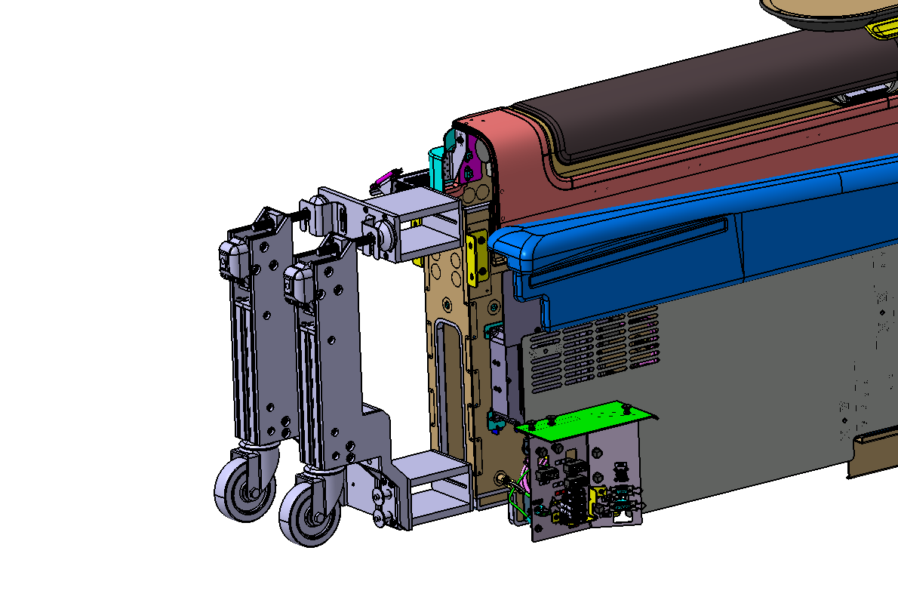
Figure 1
The jack tool's improvements are seen in the above figure. The extra blocks that are placed between the tool and the credenza are meant to be added before the jacking process and taken out once the part is successfully attached to the aircraft. During lifting and positioning tasks, these blocks serve as intermediate support components that enhance stability, load distribution, and alignment.
Because of their universal design, the blocks can be utilized for both the top and lower parts, requiring only slight modifications based on the intended purpose. As a result, fewer unique parts are required, increasing assembly processes' flexibility. Operators can shorten setup times, streamline installation procedures, and lessen the possibility of choosing the wrong component by developing a more flexible design. As a result, the jack tool's improvements enhance its usability, boost installation efficiency, and offer a more workable alternative for managing various installation configurations.
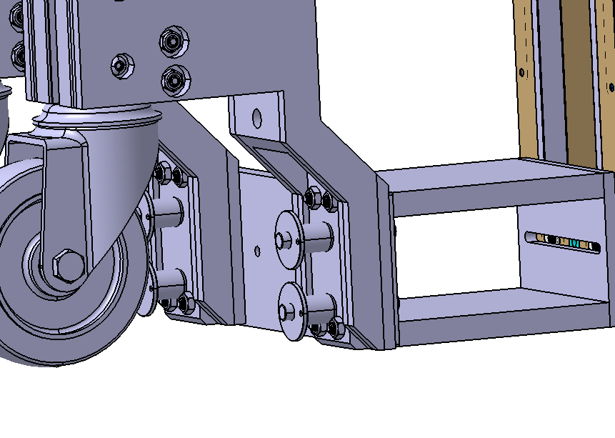 Figure 2
In Figure 2 above, the bottom piece of the jack can be seen connected securely to the block using quick-release pins. These pins, which come with the jack tool assembly, offer a dependable way to hold the parts together while it's in use. speedy-release pins provide speedy installation and removal, cutting down on assembly and disassembly time while preserving a secure connection.
Because the pins offer positive retention and reduce the possibility of inadvertent movement or separation during lifting and positioning operations, their design guarantees increased productivity without sacrificing safety. Furthermore, the quick-release mechanism makes handling easier for operators, eliminating the need for extra equipment and simplifying the setup procedure overall. Improved usability, quicker deployment, and a more efficient installation process are all benefits of this fastening technique.
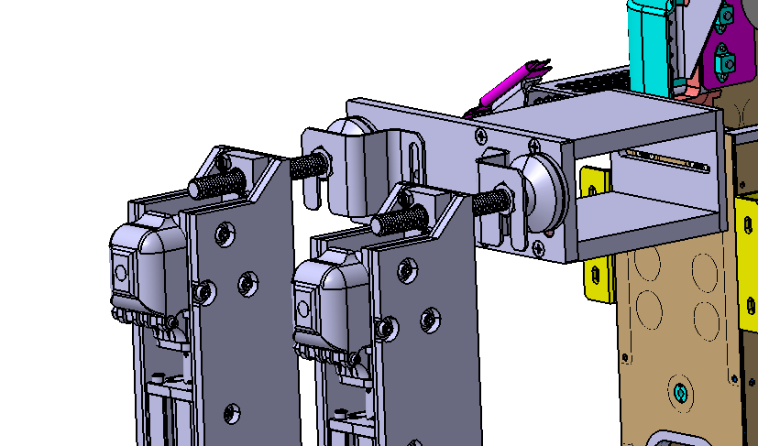 Figure 3
The top portion of the tool is attached to the credenza assembly as seen in Figure 3. Two new brackets that are specifically made to slide over the touch pad before being fastened directly to the block have been added to the same block design as in Figure 2. This fastening technique keeps installation and removal simple while offering a safe interface between the tool and the component.
The addition of these brackets enhances the assembly's overall placement and stability during lifting and installation procedures. The revised design provides a safer solution than earlier techniques by more efficiently dispersing weights and minimizing the chance of movement while in operation.
The new fastening arrangement has been designed with operator usability in mind in addition to safety advantages. Quick placement and fastening are made possible by the sliding bracket system, which shortens setup times and streamlines the installation procedure. This leads to a system that is suitable for frequent use in operating contexts where efficiency and usability are crucial factors, in addition to being safer and more dependable.

5.2 FWD shroud
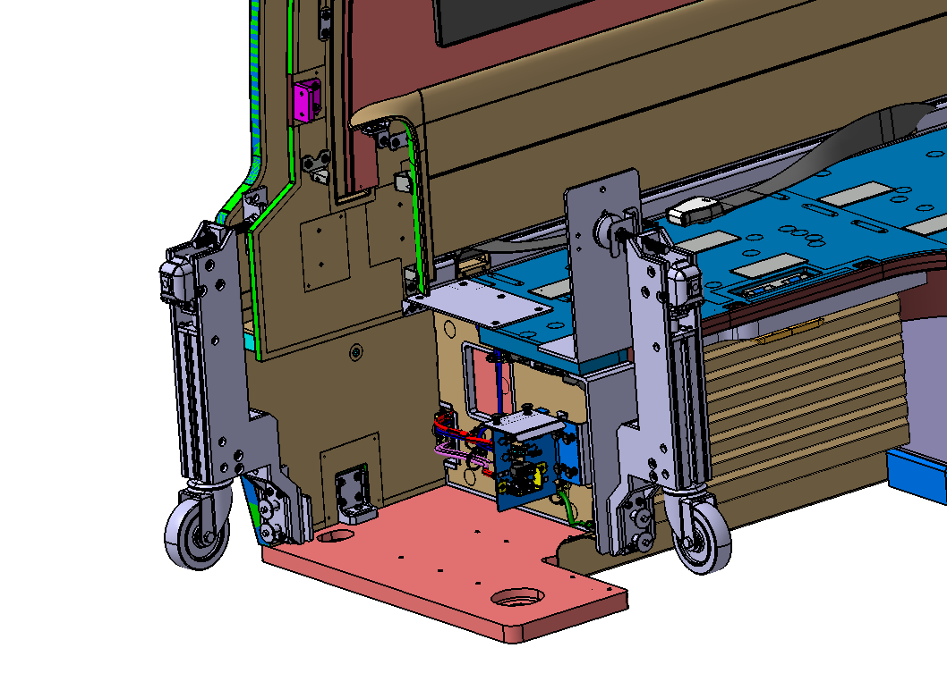 Figure 4
The first two jacks are placed on the left side of the FWD shroud in the above image. The basic concepts of attachment and support are used in a manner similar to that of the credenza installation process; however, distinct block designs have been added to account for the special geometry and characteristics of the shroud assembly.
In order to ensure proper load distribution and stability during lifting and positioning operations, these modified blocks have been specially engineered to interact with the component. The requirements of various component configurations are satisfied while maintaining consistency throughout installation procedures by modifying the block geometry rather than the overall jacking methodology.
During installation, operators can efficiently position and align the FWD shroud thanks to the location of the jacks and the use of component-specific blocks. This strategy ensures that the tooling is still flexible enough to accommodate a greater variety of aircraft components and installation circumstances while preserving the advantages of the current system, such as ease of assembly, operator familiarity, and quick setup times.
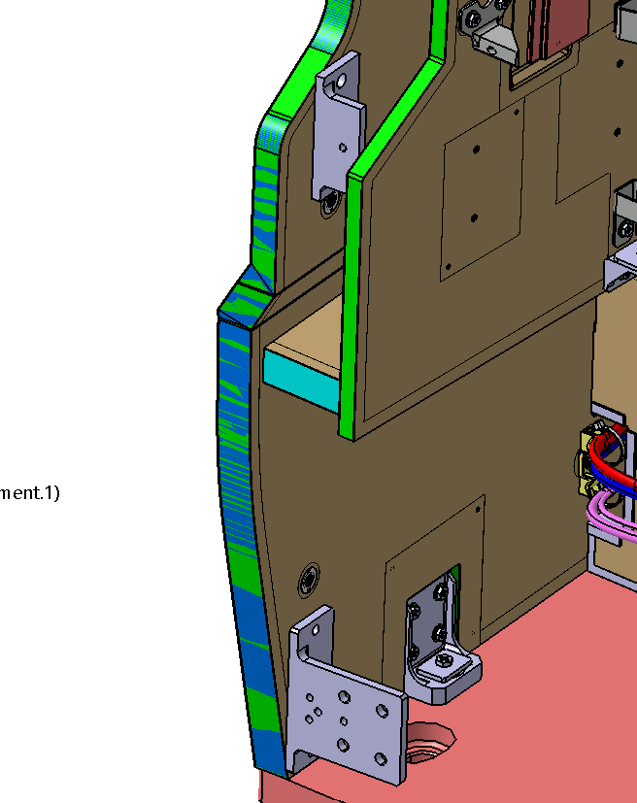 Figure 5
The brackets used on the jack located on the left side of Figure 4 are depicted in Figure 5. With adjustments made to accommodate the unique characteristics and geometry of the shroud assembly, the design adheres to the same fastening principles as the earlier tooling designs. During lifting and installation activities, these modifications guarantee that the brackets interface with the component correctly while preserving stability and safe load transmission.
Without altering the general installation process, the bracket arrangement has been modified to fit the shroud's shapes and connection locations, enabling operators to use well-known techniques for a variety of component types. The upper bracket structure, as utilized on the credenza layout, will also incorporate the slotted bracket configuration from earlier assemblies. Operators can obtain a more accurate fit during installation thanks to the extra adjustability this offers during positioning and alignment.
The bracket system continues to be flexible, user-friendly, and appropriate for frequent operational usage by incorporating feature-specific improvements while upholding consistent design principles. While maintaining the effectiveness and ease of use of the current jacking procedure, the modified arrangement enhances compatibility with the shroud assembly.
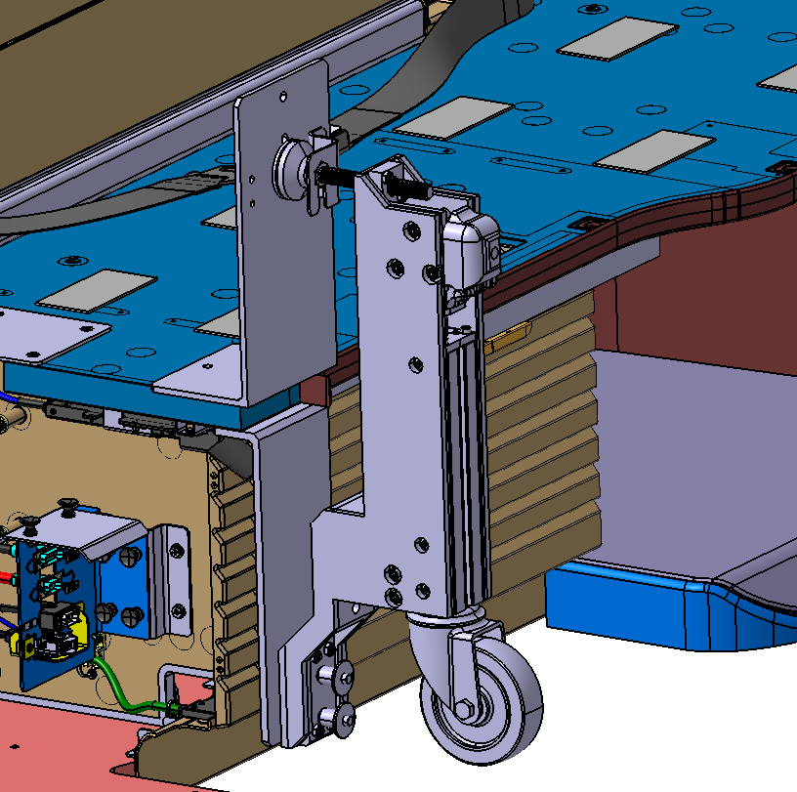 Figure 6
The jack is located on the right side of Figure 4 in Figure 6. To fit the features and geometry of the ottoman component, the brackets in this arrangement have been built with a much longer profile. To ensure stability during lifting and installation operations and to offer appropriate reach and engagement with the requisite attaching sites, the bracket length must be increased.
The jacks' placement has been carefully chosen to guarantee that the tools can be readily disassembled after installation without endangering the component or nearby structures. To reduce the possibility of interference during assembly and disassembly procedures, access restrictions and removal routes were considered during the design phase.
Even if the brackets' shape is different from earlier designs, the same fastening methods that were applied in earlier configurations still hold true. The tooling allows operators to apply well-known techniques while meeting the needs of the ottoman assembly by maintaining a consistent approach to positioning, supporting, and securing the component. The approach offers flexibility and operational efficiency without sacrificing safety or usability by expanding the bracket design while maintaining tried-and-true installation techniques.
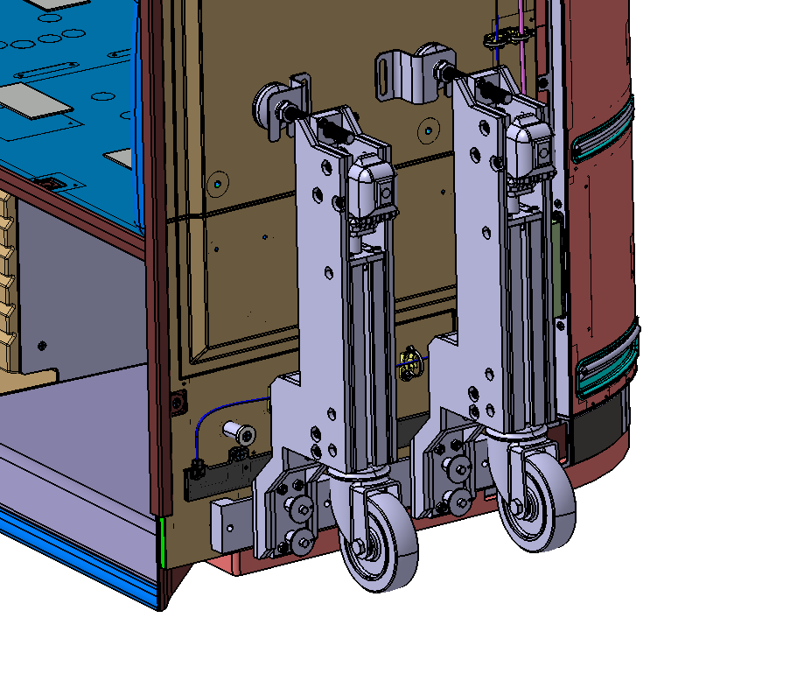 Figure 7
The jacking points on the right side of the FWD shroud are depicted in Figure 7. The general fastening methodology is like the configurations depicted in the earlier figures, guaranteeing continuity in both tooling operation and installation operations. To account for the unique geometry and structural characteristics found on this side of the shroud assembly, however, changes have been made to the block designs utilized at the fastening interfaces.
These modified blocks are designed to provide appropriate load distribution during lifting and positioning operations while offering appropriate contact surfaces and safe engagement locations. The technique maintains consistency across various installation configurations while being flexible to changing component requirements by customizing the block geometry to the component features rather than altering the overall jacking approach.
There are benefits for operator familiarity, assembly efficiency, and implementation simplicity when the same fastening principles are used throughout the tooling design. The redesigned blocks ensure that the components may be fitted and removed securely, effectively, and without adding needless complication to the procedure, all while maintaining the jacking system's versatility.
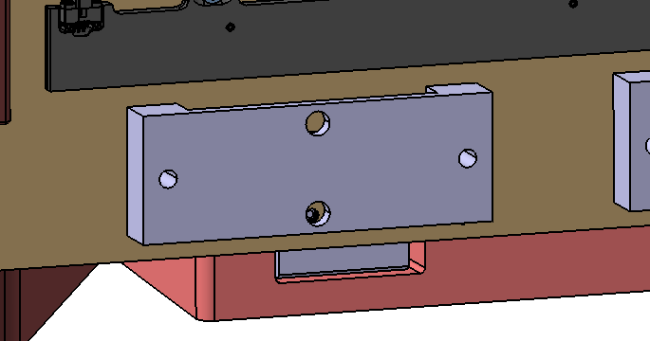 Figure 8
In figure 8 is the bottom block used for fastening the back to.

5.3 AFT Shroud
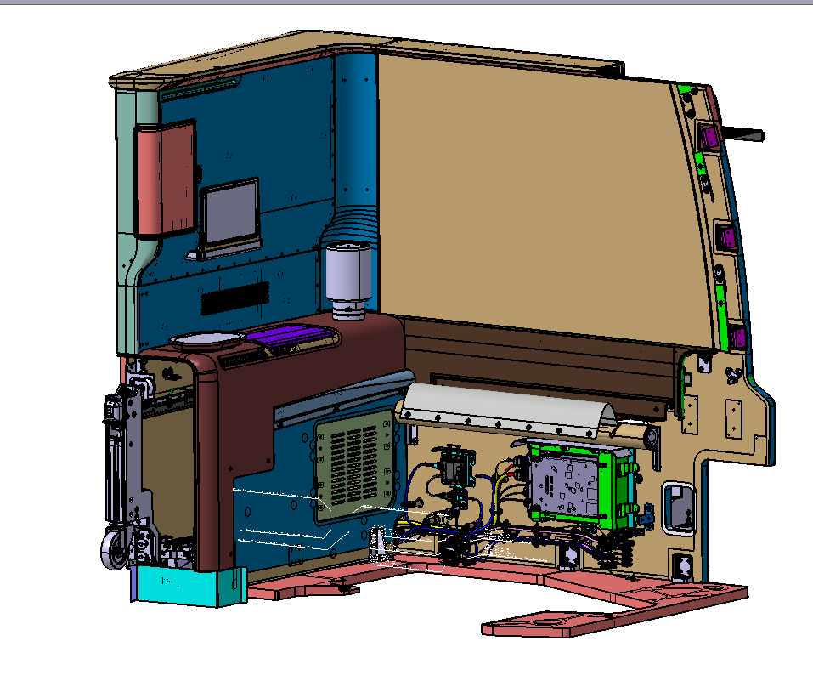 Figure 9
Figure 9 shows where the first jack tool is located on the AFT shroud.

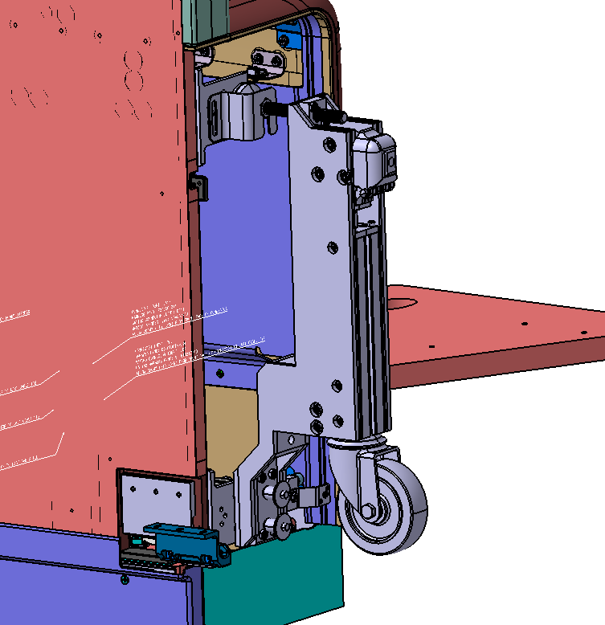 Figure 10
With just slight changes to the upper block design, the jack assembly in the more detailed image above is nearly the same as that depicted in Figure 5. These modifications have been made to keep the same general installation method while accounting for the minor variations in component geometry and fastening requirements.
A significant amount of the tooling design and fastening technique may be applied to both assemblies due to the similarities between the AFT and FWD shrouds. Because of this commonality, fewer entirely new tooling solutions are required, and previously created parts and procedures can be continued with little change.
When feasible, reusing pre-existing hardware and design concepts increases production productivity, shortens development times, and streamlines installation processes for operators who are already acquainted with the tooling configuration. The minor adjustments made to the upper block maintain uniformity throughout the jacking system design while guaranteeing compatibility with the features of the assembly.
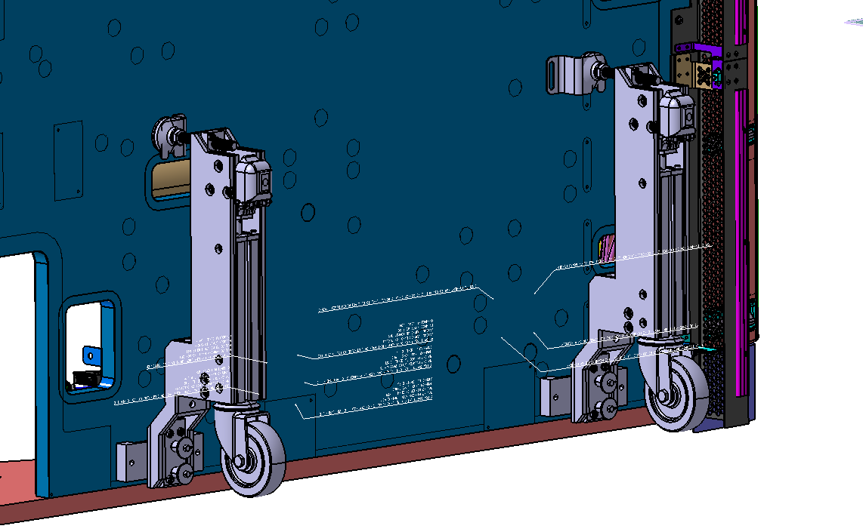 Figure 11
The final two jacks are in the back portion of the AFT shroud, as seen in Figure 11. This configuration makes use of the same setup as that depicted in Figure 7, which enables the reuse of the same block design principles, fastening arrangement, and bracket configuration across several installation locations.
Tooling management and assembly operations are made simpler by using a similar setup, which drastically lowers the variety in parts needed throughout the installation process. Reducing the number of distinct parts enhances system standardization and facilitates operator identification, assembly, and maintenance of the tooling.
Additionally, this method has benefits from an operational and manufacturing standpoint since fewer custom parts are needed, which simplifies production and may save costs. The installation process maintains the necessary levels of stability, safety, and component support during installation operations while remaining effective, repeatable, and simpler to perform when proven configurations are reused.

6 Results
To test out how well the new tools would work a trial was held in Seattle at Boeing’s plane mock-up to have a realistic demonstration of how the tools would perform.
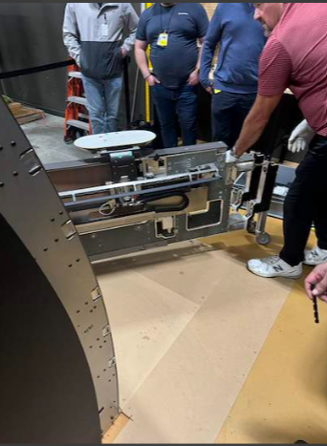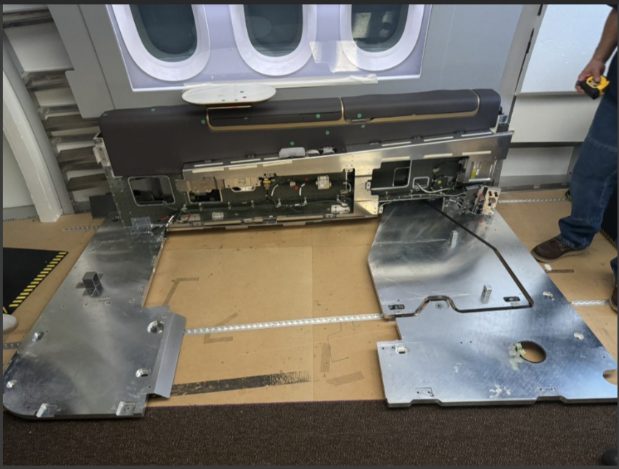
Figure 12&13
The installation of the credenza, which would be the next part to be installed during the construction process after the bottom piece of the suite has been placed down, is depicted in the pictures above. No mobility-related concerns were found during the installation, nor were there any problems observed during the jacks' assembly. The system's components fit together effectively and with little effort, making it both practical and easy for operators to install. The design is user-friendly and appropriate for effective deployment in a working environment, as seen by the shorter installation time and increased ease of handling that resulted from the assembly process' simplicity. Furthermore, the components' mobility and placement enabled workers to efficiently manoeuvre and align the credenza, facilitating a seamless and regulated installation procedure.
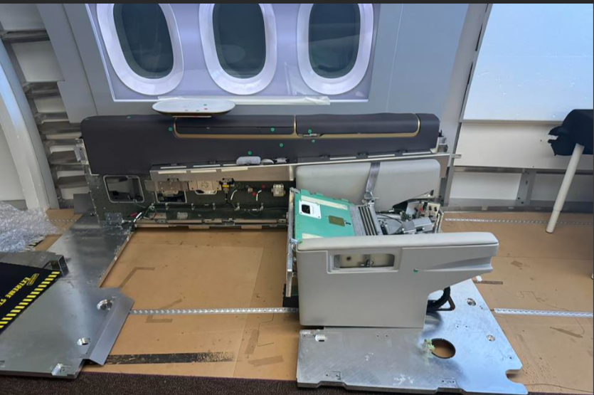 Figure 14
Figure 14 depicts the TSO (seat) component, which is quite light and easy to handle, negating the need for a specialized jacking system. This component can be safely handled and positioned manually by two workers without posing major handling challenges, in contrast to the bigger suite components that need lifting help and specialized tooling.
As a result, the TSO's installation procedure is streamlined, cutting down on setup time and the requirement for extra equipment. Removing the need for a jacking system also lowers the number of components needed for installation tasks and simplifies tooling.
Standard manual handling procedures should be followed even in the absence of mechanical lifting help to guarantee the component is moved and positioned safely. By demonstrating that not all suite components require specialized lifting solutions, the ability to install the seat solely with operator handling frees up resources and tooling for larger or more complex assemblies where extra support is necessary.
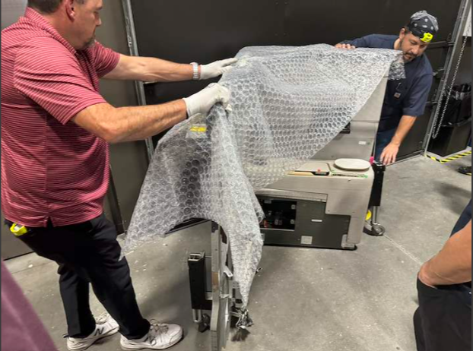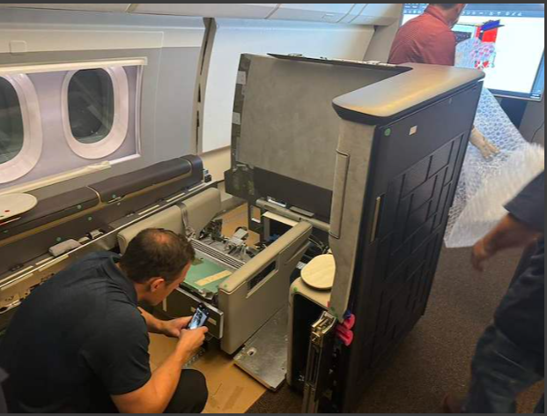
Figure 15&16
The jack system's connection to the AFT shroud during installation is depicted in Figure 15. Operators from both Safran and Boeing assessed the tooling and concluded that the fitting process was simple, efficient, and simple to complete. Because of the setup's simplicity, the jacks could be swiftly fitted while offering the stability and support needed to handle the component. According to operators, the tools worked well with the installation procedure and did not cause any major problems when assembling, positioning, or adjusting the shroud.
The design effectively achieves its goal of offering a useful and user-friendly installation option, as seen by the good feedback from both organizations. Standardized fastening techniques and well-known tooling configurations boosted operator confidence and lowered the equipment's learning curve.
After installation, the AFT shroud is successfully positioned inside the aircraft, as seen in Figure 16. Without causing any harm to the shroud, surrounding aircraft structure, or nearby cabin components, the component was effortlessly moved into position. Operators were able to align the component effectively and finish the installation with little effort because to the jack system’s-controlled movement and precise positioning throughout the process. The successful installation confirms the tooling design's efficacy and shows that it can facilitate the AFT shroud's safe, repeatable, and damage-free installation in the aircraft environment.
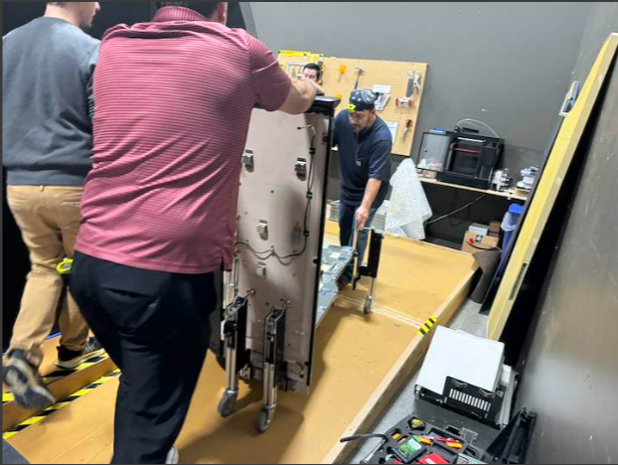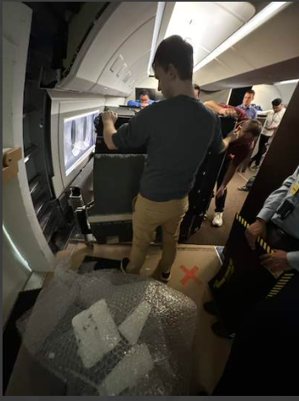
Figure 17&18
The jack system's attachment to the FWD shrouds during installation is depicted in Figure 17. In comparison to earlier tooling designs, operators found the setup to be quite simple and effective. The new attaching configurations and standardized parts made it possible to swiftly and easily attach the jacks, cutting down on preparation time and streamlining the installation process.
The FWD shrouds were said to move steadily, safely, and under control during the lifting and positioning process. Because of the jack system's reliable support, operators were able to move the component with assurance and precise alignment. The enhanced stability increased operator confidence and overall safety by lowering the possibility of inadvertent movement and facilitating a more seamless installation process.
The installation of the FWD shroud, the last significant part to be installed as part of the suite assembly, is depicted in Figure 18. The installation went well, and the part was precisely positioned without causing any harm to the surrounding aircraft structures or the shroud. A tight fit within the aircraft was ensured by the jacking system’s-controlled movement, which allowed operators to make fine modifications during alignment.
The FWD shroud's successful installation confirmed the advancements made during the development phase and provided additional evidence of the tooling design's efficacy. When compared to earlier techniques, operator feedback showed that the system significantly improved handling performance, efficiency, and usability. The tooling solution's ability to facilitate the safe, repeatable, and damage-free installation of all major suite components within the aircraft environment was validated by the completion of the final installation.
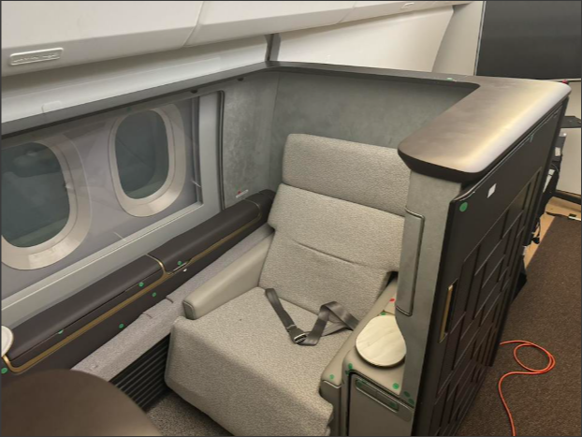 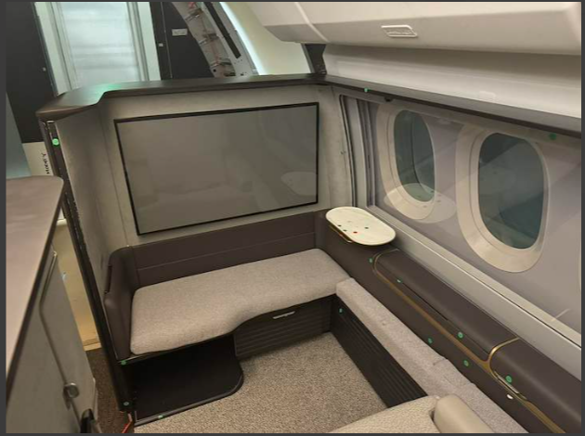 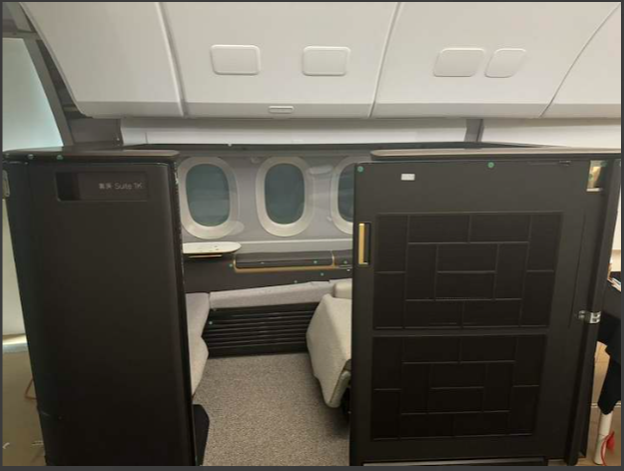 Figures 19,20&21
The designed tooling system is used to fully build the shroud within the aircraft, as shown in the pictures above. An important accomplishment for this trial is the successful installation of every component, which shows that the tooling idea can efficiently support the assembly process. Throughout the installation process, the tools provide the stability, control, and accessibility needed to precisely position the parts without causing harm to the assemblies or the surrounding aircraft structure.
Many of the design choices made during the tooling's development, such as the adoption of standardized fastening techniques, flexible block designs, and reusable bracket configurations, are validated by the shroud installation's successful completion. Operators reported that, in comparison to earlier installation techniques, the tooling was easy to construct, easy to use, and provided observable increases in efficiency.
Even though the trial's results can be regarded as a significant accomplishment, it's crucial to acknowledge that further effort and improvement might be necessary. There are still chances to improve component standardization, optimize specific design elements, and, if feasible, increase usability. Future development efforts might also concentrate on cutting setup times, minimizing part variation, and incorporating more trial-related feedback.
Overall, the findings show that the tooling solution offers a useful and efficient way to assist with the shroud assembly installation. The trial's successful conclusion offers a solid basis for future development and application in the airplane assembly environment.

7 Conclusion
This project's main goal was to solve the operational issues with the current jack tool to create a better lifting and installation solution for Boeing aircraft suite components. The project was started in response to persistent worries about component instability, the possibility of damage during installation, decreased operator trust, and safety risks brought on by inadequate load retention and support. A major engineering difficulty was given by Boeing's demand to keep the current lifting mechanism and wheel assembly. This meant that all enhancements had to be made within a limited design envelope while still being completely compatible with the current installation processes.
The main elements influencing lifting and handling operations in aircraft production environments were thoroughly investigated to guarantee that the suggested solution was founded on strong engineering principles. Load retention, load stability, center of gravity control, ergonomic design, human factors engineering, and material protection were among the topics examined. To lower workplace danger and enhance installation performance, the results repeatedly showed the significance of regulated load movement, efficient support distribution, safe restraint devices, and operator-focused design. The final tooling concept was built around these principles.
The goal of the development process was to minimize the number of special parts needed while producing a flexible and modular system that could accommodate several suite components. A tooling system that could be tailored to the credenza, FWD shroud, and AFT shroud while retaining a high degree of commonality was created using interchangeable support blocks, specialized brackets, quick-release attaching techniques, and standard installation principles. In addition to increasing operational flexibility, this strategy simplified tooling administration, decreased manufacturing complexity, and enhanced operator usability.
The project's ability to successfully strike a balance between standardization and adaptation was a major accomplishment. Although distinct geometries and attachment points necessitated interfaces for each component, the system's basic installation process was the same. Operators' learning curve was lowered by this consistency, which also made it possible to repurpose tested design elements in many applications. This approach was further reinforced by the commonalities found between the FWD and AFT shrouds, which allowed for significant component reuse and decreased the requirement for custom solutions.
The most important phase of the project was the tooling's practical validation. Experiments carried out at Boeing's airplane mock-up facility in Seattle offered a chance to evaluate the design under actual installation circumstances. The tooling functioned as planned throughout the testing, offering steady and regulated support for lifting, positioning, and installation tasks. Boeing and Safran operators reported that the tooling was much easier to use than the current system, easy to build, and easy to adjust. The enhanced stability of the parts during movement and the ease of achieving precise alignment were also commended.
Strong proof that the project's goals had been achieved was provided by the credenza, FWD shroud, and AFT shroud's effective installation without any documented damage to the parts or surrounding aircraft structure. The equipment showed that it could enhance handling performance without sacrificing the accuracy and safety needed in the aerospace sector. A significant milestone was reached with the final installation, which produced a completely completed suite inside the airplane mock-up and validated the design concept's feasibility.
The tooling provided a number of wider advantages in addition to the project's immediate goals. Increased stability decreased the amount of manual intervention required during installation, reducing operator’s workload and boosting confidence all along the way. The design's modularity allowed for future adaption to similar aircraft components, while the use of standardized parts and fastening techniques reduced assembly and maintenance requirements. These advantages could boost output, shorten installation times, and cut expenses related to component damage and rework.
Even though the project was successful, there are still chances for improvement. To lower the total number of components, increase manufacturability, and further standardize bracket and block designs throughout the system, more optimizations could be done. Extensive testing in real-world settings would also yield important long-term information about operator experience, maintenance needs, and durability. To further increase usability and performance, future iterations might investigate using lighter materials, better protective interfaces, or extra adjustable options.
Given the circumstances, this study has shown that it is possible to significantly increase safety, stability, and operational effectiveness without changing Boeing's authorized lifting mechanism or mobility system. The final design is practical, affordable, and simple to use while effectively addressing the fundamental flaws of the original tool. The created tooling solution is a significant improvement over the current arrangement, as confirmed by the favorable feedback obtained during testing and the successful, damage-free installation of all major suite components.
In summary, the project has achieved its goals and objectives and produced a solid engineering solution that improves the installation processes for airplane components. The created jack tooling system boosts handling stability, lowers installation risk, boosts operator confidence, and facilitates more effective assembly processes. Consequently, the concept offers a solid basis for future improvement and integration into Boeing aircraft installation programs.

7 Recommended further work
Although the project's outcomes show that the produced tooling system effectively enhances the installation procedure for Boeing suite components, there are still a number of areas that might be improved. Both Boeing and Safran expressed satisfaction with the tooling's performance during trials. When compared to the current system, the successful installation of the credenza, FWD shroud, and AFT shroud without causing any damage validated the whole design approach and demonstrated that the tooling could provide better stability, safety, and operator trust. Like any engineering development project, there are some areas where more effort may improve the design and make it more appropriate for long-term use in aircraft production settings.

7.1 Extended Operational Testing
Trials in Boeing's airplane mock-up facility were the main method used to validate the tooling. Even though these tests effectively illustrated the design's usability, safety, and functionality, more testing ought to be conducted in an actual production setting. The demands of daily production operations, where tooling is subjected to frequent use, varied operator methods, time constraints, and various installation scenarios, cannot be adequately replicated by the conditions encountered in a trial setting.
Extensive operational testing would yield important data about component wear, maintenance needs, long-term durability, and dependability. Additionally, it would make it possible to get quantifiable information about maintenance intervals, operator effort, and installation times. It would be possible to find any design flaws and ascertain whether changes are needed to extend service life by keeping an eye on the tooling over an extended length of time. Furthermore, getting input from more operators would give a more comprehensive picture of how the tooling functions in a range of installation scenarios and working conditions.

7.2 Increased Component Standardization
The effective reuse of components across various tooling setups was one of the project's major accomplishments. In example, the FWD and AFT shrouds' commonalities made it possible to share a number of brackets and attachment techniques, which decreased the number of special parts needed. This method improved operator familiarity with the tools while streamlining manufacturing and assembly.
Even with these successes, there is still need for more standardization. Future research should investigate the possibility of combining more brackets and support blocks into universal designs that can accommodate many component kinds with little modification. It would be easier to manage inventories, lower manufacturing costs, and require fewer resources to replace and maintain tooling components if there were fewer distinct components. If the tooling is used across several aircraft programs or installation environments, greater standardization would also help future scalability.

7.3 Material and Weight Optimization
Functionality and dependability were the main factors in the design of the existing tool. Because of this, some parts might be heavier than is required for the loads they encounter while in use. Future research should investigate ways to optimize the design by using varied materials and taking steps to reduce weight.
In addition to improving handling during setup, storage, and transit, lowering the tooling's weight would lessen the physical strain on operators. This could be accomplished by using optimized steel sections, lightweight aluminum alloys, or different manufacturing processes that eliminate extraneous material from low-stress areas. To guarantee that performance and safety are not jeopardized, each weight reduction program should be backed by a thorough structural analysis. The tooling system's usefulness would be further improved by striking the ideal balance of strength, weight, durability, and production cost.

7.4 Enhanced Component Protection
Reducing the possibility of aircraft component damage during installation was one of the project's main goals. The successful trial proved that the tools could precisely and safely position parts without harming the surrounding aircraft construction, shrouds, or credenza. Even though this is a significant improvement in the current setup, future designs might include more defensive elements.
At crucial interface points, additional development can involve the incorporation of protection pads, compliant surfaces, or specialized contact materials. These improvements would minimize localized contact pressures during installation operations and lower the possibility of cosmetic damage. When working with painted surfaces, decorative treatments, or lightweight composite structures, these enhancements might be especially helpful. An extra degree of security and a further decrease in the possibility of component rework or repair would result from the installation of improved protective measures.

7.5 Structural Analysis and Validation
Further analytical validation could boost trust in the design, even though practical testing offered compelling proof of the tooling's efficacy. To better understand stress distributions and loading conditions during operation, a thorough Finite Element Analysis (FEA) of important brackets, support blocks, and fastening arrangements could be conducted.
Such study would assist in determining locations that would benefit from further reinforcement or where material could be deleted to decrease weight. Additionally, it would make it possible to verify safety aspects in a variety of loading scenarios, including the worst-case installation scenarios. A more thorough grasp of the tooling's structural performance could be attained by fusing in-depth engineering analysis with practical testing. This would bolster upcoming certification initiatives and offer more support for deployment in real-world settings.

7.6 Design for Manufacture and Assembly
Although the project's main goals were to increase operator safety and installation performance, future research could investigate ways to optimize the tooling from a production standpoint. The concepts of Design for Manufacture and Assembly (DFMA) could be used to simplify fabrication and boost productivity.
Opportunities to lower machining requirements, streamline welded assemblies, standardize fastening techniques, and minimize the total number of parts may be found by a thorough examination of manufacturing processes. These modifications could preserve the functional benefits shown during testing while reducing production costs. If demand increases across several installation programs, improved manufacturability will also enable the creation of multiple tooling sets in the future.

7.7 Expansion to Additional Applications
This project's modular design philosophy has shown a great deal of adaptability and flexibility. The same technical ideas might be used to be used to other aircraft interior components, even though the equipment was created especially for the installation of the credenza, FWD shroud, and AFT shroud.
Future research should look at whether the fastening, bracket, and support block ideas created for this project may be modified for usage on additional monuments, storage units, partitions, or cabin furnishing assembly. Expanding the application of the tooling concept to a greater variety of components will enhance uniformity throughout installation processes and optimize the benefits of previously finished development work. Additionally, it might lessen the requirement for custom tooling solutions in upcoming aircraft projects.

7.8 Human Factors and Ergonomic Assessment
Both Boeing and Safran employees reported increases in stability, usefulness, and general confidence, which was a major factor in evaluating the tooling system's effectiveness. Although the response was overwhelmingly positive, a more thorough ergonomic evaluation of the tooling could be part of future development.
Operator posture, physical workload, setup times, and perceived effort during installation operations could all be assessed in structured human factors research. This data could be utilized to find further ways to enhance component accessibility, fastening techniques, and handling qualities. In addition to increasing safety, lowering operator fatigue and enhancing usability may help boost installation operations' consistency and productivity.

7.9 Summary
The tooling system created for this project has effectively shown that it can increase installation efficiency, safety, and stability while still being completely consistent with Boeing's operational requirements. The concept offers a substantial improvement over the current tooling arrangement, as evidenced by the installation trial's successful conclusion and the operators' helpful feedback. The experiment has demonstrated that straightforward adjustments, centered on component interface design, support, and constraint, can yield significant advantages without necessitating revisions to the authorized lifting mechanism or mobility system.
Even if the current design can be regarded as a successful solution, more work would enable the tooling to become even more mature. The system may become more effective, simpler to produce, and appropriate for a greater variety of uses with further testing, analysis, standardization, and optimization. The Boeing trial's exceptional performance offers a solid basis for future development and encourages the tooling's possible inclusion in aircraft assembly and installation programs.

8 References
American Institute of Aeronautics and Astronautics (AIAA) (2021) Aerospace structural handling and support systems. Reston, VA: American Institute of Aeronautics and Astronautics.
American Society of Mechanical Engineers (ASME) (2021) ASME B30: Below-the-hook lifting devices. New York: American Society of Mechanical Engineers.
ASM International (2020) Materials performance and stress protection in aerospace handling systems. Materials Park, OH: ASM International.
British Standards Institution (BSI) (2020) BS EN 13155:2020 Cranes – Safety – Non-fixed load lifting attachments. London: British Standards Institution.
Canadian Centre for Occupational Health and Safety (CCOHS) (2024) Materials handling and safe lifting.
Chartered Institute of Ergonomics and Human Factors (CIEHF) (2021) Human factors and workplace safety.
Crane Industry Council of Australia (CICA) (2021) Load stability and centre of gravity management.
European Union Aviation Safety Agency (EASA) (2022) Human factors in aviation maintenance. Cologne: European Union Aviation Safety Agency
Health and Safety Executive (HSE) (n.d.) Lifting equipment at work.
Institution of Mechanical Engineers (IMechE) (2022) Engineering safety in load handling systems. London: Institution of Mechanical Engineers.
International Labour Organization (ILO) (2021) Occupational safety in material handling operations. Geneva: International Labour Organization.
International Organization for Standardization (ISO) (2020) ISO 4301: Cranes and lifting appliances classification. Geneva: International Organization for Standardization.
Materials Handling Institute (MHI) (2023) Load stability and industrial handling systems. Charlotte, NC: Materials Handling Institute.
National Aeronautics and Space Administration (NASA) (2021a) Human factors engineering and aerospace safety systems. Washington, DC: National Aeronautics and Space Administration.
National Aeronautics and Space Administration (NASA) (2021b) Materials engineering and aerospace handling protection systems. Washington, DC: National Aeronautics and Space Administration.
National Institute for Aviation Research (NIAR) (2022) Aerospace component handling and structural protection. Wichita, KS: National Institute for Aviation Research.
National Institute for Occupational Safety and Health (NIOSH) (2020) Ergonomic guidelines for manual material handling. Atlanta, GA: Centers for Disease Control and Prevention.
Occupational Safety and Health Administration (OSHA) (n.d.) Heavy lifting ergonomics guidance. Washington, DC: Occupational Safety and Health Administration.
Occupational Safety and Health Administration (OSHA) (n.d.) Load handling guidance for powered industrial trucks. Washington, DC: Occupational Safety and Health Administration.
Robertson, M., Huang, Y.H. and Lee, J. (2019) ‘Improvements in industrial lifting ergonomics and operator performance’, Applied Ergonomics, 78, pp. 145–154.
SAE International (2021) Aerospace handling and component protection standards. Warrendale, PA: SAE International.
Shorrock, S. and Williams, C. (2023) Human factors in safety-critical systems.

