
Library & Learning Resources

- Finding Resources

- To start your search, type UWTSD or http://www.uwtsd.ac.uk/ into your internet explorer. Select Quick Links and then select Swansea Library and Learning Resources. Or you could go straight to the library website: http://www.uwtsd.ac.uk/library/

- To search for books / e-books

- Select Catalogue from the left-hand side of the screen. Scroll down the page and select Search Swansea Campuses. Type in the title of the book you want or the topic you are researching. To find the shelfmark of the book select Check availability.

- To find an ebook (an online book), search on the Catalogue as you would for a book, by typing in the title or topic. Scroll down to Format on the left-hand side and select e-Book. Select the book you want by clicking on Check availability. Then select Click here to view the e-book. You will be asked for your user name and password before you can view the ebook.

- Your user name is the P number from your student ID card.
- Your password will be the same as you use to login to Moodle to access your course information, and is usually your date of birth in 6 digits (day, month and the last two digits of the year so e.g. if your birthday was 25th July 1994, you would type in 250794. If you have problems with your password, please contact the IT Helpdesk: Telephone: 0300 500 5055 or email: ITServiceDesk@uwtsd.ac.uk

- Once you have entered your P number and password, you may need to click on an icon which looks like a mini-lectern to access the ebook:



- To search for online journal articles

The Digital Library is a good place to start if you are searching for online peer-reviewed, academic articles. Again, you will need to go to the Swansea Library and Learning Resources page: http://www.uwtsd.ac.uk/library/

- To access the Digital Library, select Online Library from the left-hand side of the screen. Select Swansea Online Library. Then select the Digital Library by clicking on the link: Click here to perform a one-stop search of the Swansea Online Resources via our Digital Library.

*In the search box, type keywords from the topic you are researching, or if you know the title of the article you are searching for, type in the title of the article.
*If you are searching for a topic, you can refine your results on the left hand-side of the screen by selecting full-text articles, limiting to scholarly and peer-reviewed articles and by selecting journals. You can also refine the date.
*You can read a summary by selecting the spyglass and by selecting the folder, email the article to yourself.
*To read the whole article, select Full Text Online. If you are accessing the resources from home, you will be asked to type in your P number and password.

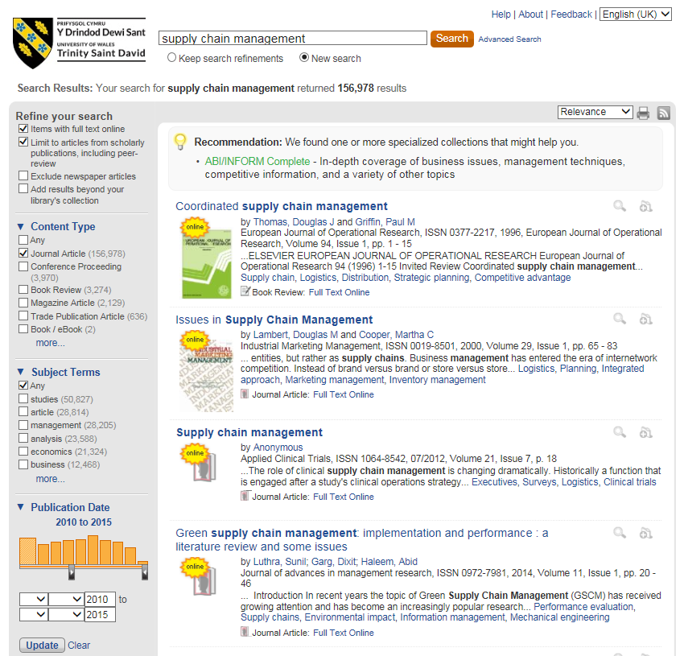

- For more specific journal article searching, try the databases

To find the databases, again go to the Swansea Library and Learning Resources page, select Online Library from the left-hand side of the screen, then select Swansea Online Library. Then under the heading A-Z Listings of Online Resources, click on the box Databases A-Z. If you hover your cursor over each title, you can view descriptions of the databases. http://www.uwtsd.ac.uk/library/online-library/swansea-online-library/databases-a-z/

- For more specific searching use the databases, e.g. GreenFILE, Springer Journals, IHS and Science Direct. You may also find JSTOR, ABI/INFORM Complete, Westlaw, Sage Premier and NewsBank useful for your research.

- ProQuest Dissertations & Theses has abstracts of theses, including references, which you may find useful.

- Search Strategies

- Think about the search terms the author may have used. Look at articles to identify the key words others have used and try those words in your online search.

- If you find a good article, look at the references to see if the articles listed would be useful for your work. If you find a relevant article, copy and paste the title into the Digital Library search box to see if it is available through the library.

- Depending on your assignment, you may have to broaden or narrow your search. Welsh Journals Online has a page to help students which includes Effective searching tips which can be applied to most databases and search engines:

http://welshjournals.llgc.org.uk/content/students

- Refining searches made on the web

- Google can be really useful if you are looking for government, company or association documents. Below are some tips to help refine the amount of results your search may generate.

- To search for an academic or government site use the word ‘site’ e.g:

site:ac.uk for British academia
site:edu for American academia
site:gov.uk for UK government
filetype:pdf or filetype:pdfx for a pdf document
filetype:ppt or filetype:pptx for a PowerPoint
filetype:xls or filetype:xlsx for a spreadsheet
filetype:doc for a document

e.g. supply chain filetype:pdf will find supply chain pdfs.
agricultural occupational UK filetype:xlsx will find spreadsheets on this topic.
- Put phrases in speech marks to keep the phrase as a whole. Take care with names though, e.g. “Carl Rogers” may be referenced as “Rogers, C.” in the text.
- Use forward looking language e.g. “DEFRA expects” “EA intends”.
- Adding * to the stem of a word can widen your search e.g. environ* will bring up environment and environmental.... It can work for different spellings too e.g. counsel* = counseling, counselling, counsellor….
(Extracts adapted from Karen Blakeman 2014.)

- Evaluating information found on the web

- There are millions of resources available through internet search engines. However, it is important to remember that anyone can put information on the web and the information you find may not be backed by research, may be biased or inaccurate. To ensure that the resources you find on your internet search engine, e.g. Google, are suitable for your research, please refer to the search tips found in Welsh Journals Online. The link ‘Evaluating web sources’ at the bottom of their search tips page links to the Oxford Brookes University Library web page, http://www.brookes.ac.uk/library/webeval.html , which has a comprehensive list of how to evaluate information placed on the web.

- SCONUL If you would like to use other university libraries, have a look at the SCONUL website:
http://www.sconul.ac.uk/sconul-access

- Keeping up-to-date with the latest resources

- To find out about the latest articles in your area of interest, you could sign up for email updates/RSS feeds from publishers, e.g.

Sage: https://uk.sagepub.com/en-gb/eur/email-alerts
Taylor &Francis: http://www.tandfonline.com/page/help/account-features
- You might find JournalTOCs (tables of contents) useful for keeping track of journal articles from a range of publishers: http://www.journaltocs.ac.uk/
- You could search for Open Access Research articles or theses. Some Open Access Research articles are available in the library databases. Others can be found on your internet explorer.

- Some examples of open access research repositories:

http://nora.nerc.ac.uk/
https://www.repository.cam.ac.uk/
http://ora.ox.ac.uk/
http://cadair.aber.ac.uk/dspace/

- You could also explore other university websites to find links to further useful websites. E.g.,

http://www.exeter.ac.uk/esi/research/
- You could use Twitter to follow professionals and organisations in your subject area.

- Storing the articles you find

- Using sites such as Delicious, https://delicious.com/, will enable you to access your resources from any device with internet connection.

- Cloud storage is great for accessing your information from different places e.g. Dropbox, OneDrive, Amazon Cloud, Google Drive...

- Extra information

- Please bring your Student ID card with you when you come to the library. You’ll need it to be able to borrow and renew books and to print from the computers.

- As a postgraduate you can borrow up to 20 items altogether.

- Books to help with writing skills for your research can be found on the shelves in the section starting at 808. You’ll also find helpful books in 300.72.

- If a book you need is in another of our Swansea libraries, Townhill Library, Griffith Library or Swansea Business School Library, please ask at counter. We can have it sent to Owen Library for you.

- If you can’t find the book or article you want, please let us know. It may be possible to obtain the item you want using an Inter Library Loan.

- You’ll find our opening hours via this link: http://www.uwtsd.ac.uk/swansea-libraries/ If you are making a special journey to the library on a weekend or evening, please ring in advance, in case of library closure.

- My contact details

- If you need help finding information for your research, please contact me by coming into the Owen Library and asking for me at the counter, or telephone or email.

Suzanne Taylor Subject Librarian

(01792) 481141 suzanne.taylor@uwtsd.ac.uk

