ADOBE ILLUSTRATOR TOOLS PANEL

Create a New File

FILE – NEW - DIMENSIONS – 400mm x 100mm
USE the BLOB BRUSH Tool to create laser cut stitches for pattern making.

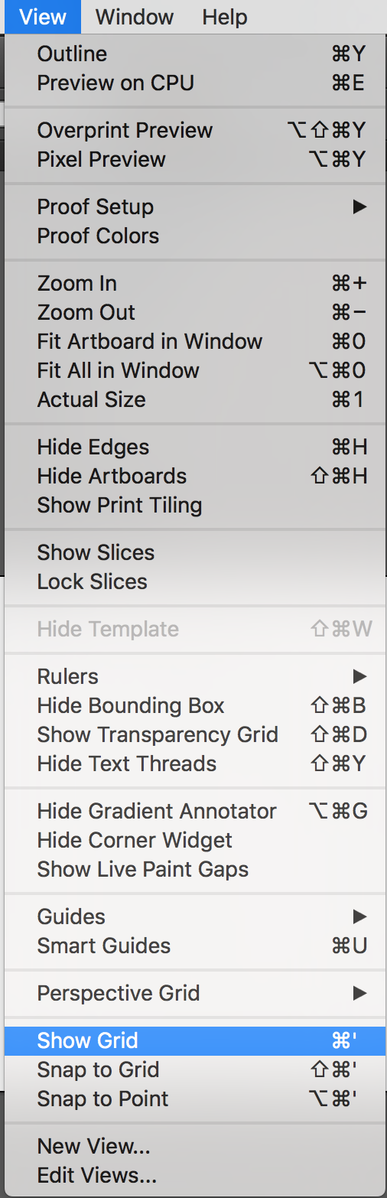
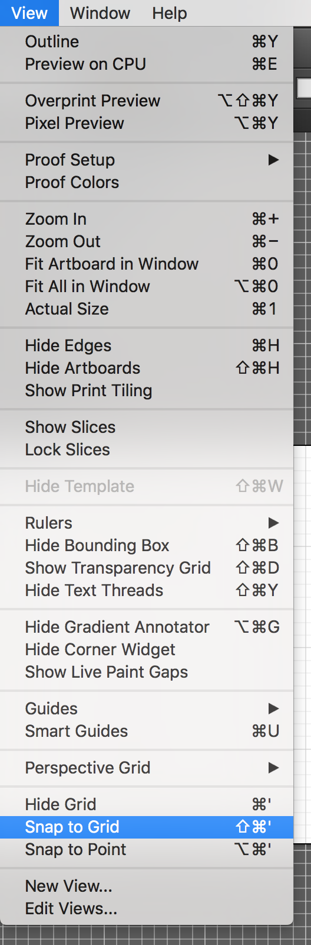

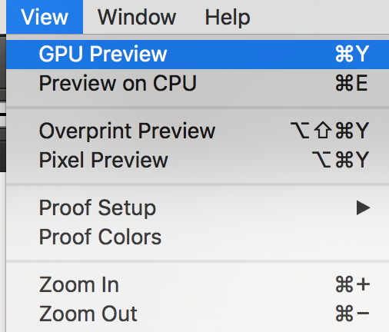
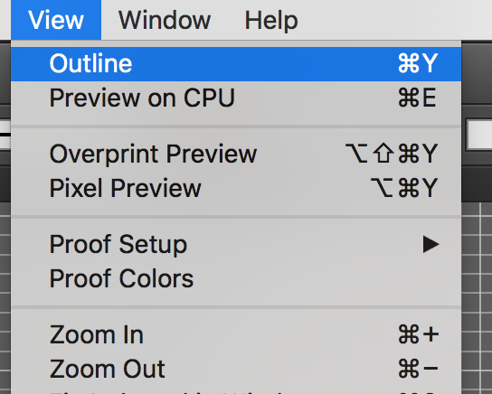

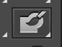

Select the Blob Brush Tool

Double click on it and check settings below

Ensure the stroke colour is as below to draw the stitches

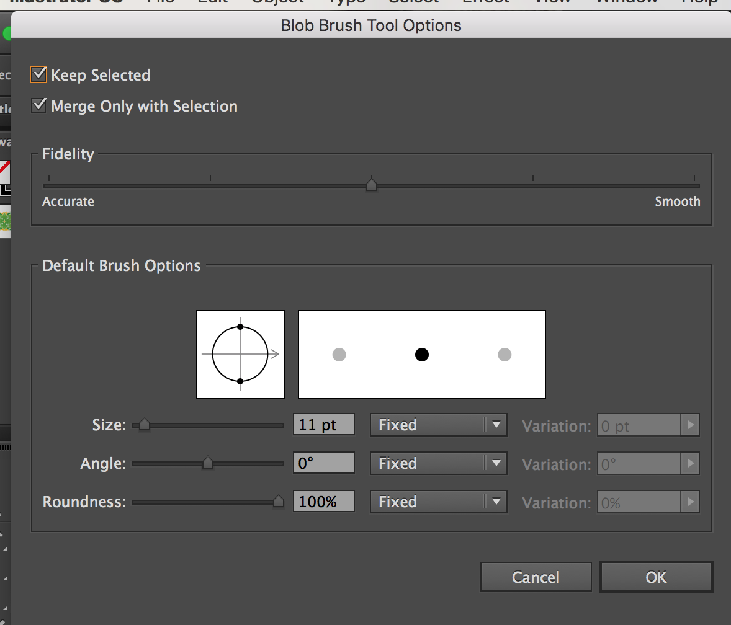
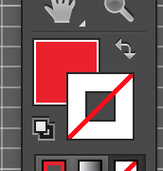

Create the design; and use the following steps to ensure your design is ready to laser cut:

Select All:
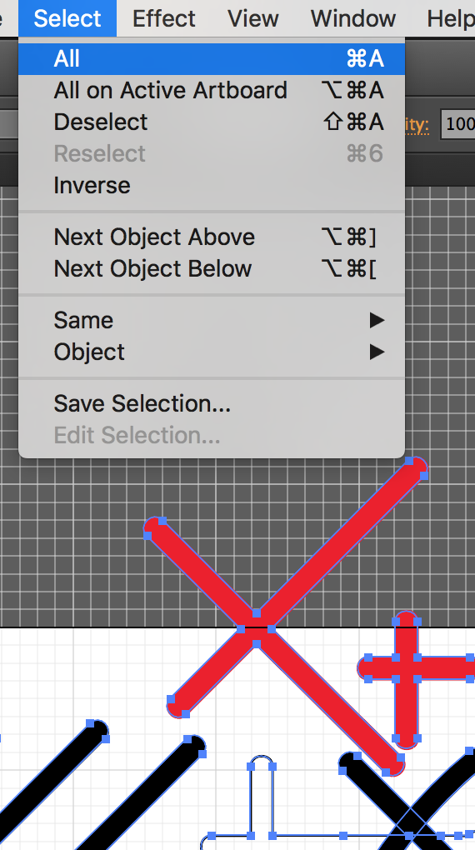
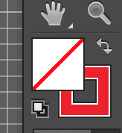

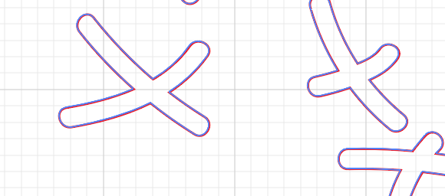

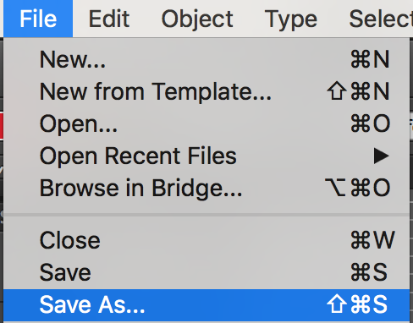
File – Save As



