Assignment 1
Assignment Title: Portfolio 4 components (25% weighting per component)
Name: Md Mustakim Miah Burhani
Student Number: 2246150
Module: Foreign Languages & Cultural Awareness
Module code: BMIH5003
Programme: BA (Hons) International Hotel Management
Lecturer’s Name: Giulia Chifari BA(Hons)
Submission deadline:17th May 2024 by 23:59 PM (Drafts:10th May 2024 by 5 pm)
Word count (or equivalent): 2000

Component 1 - Professional reflection (500 words)

Scenario:
Mr Smith was a Brazilian hotel guest at the time. I am working as a receptionist. The guest would often feel deeply offended by my repeated requests for them to saying ‘’please’’.
In terms of people's backgrounds, linguistic heritage, and places of origin, our society is immensely diverse. A theorist was what Geert Hofstede referred to as "the software of the mind." My perspective of the world and my behaviour are influenced by my home culture and beliefs, even down to what we consider to be right or wrong behaviour.
I repeatedly asked the guest to please show me the booking reference, pay with a card, please, and take the key please, during the check-in process, but I felt that the guest was offended. I have severed another guest using a similar world.
They were both offended. I asked the hotel manager, and he served the rest of the customers with no problem. I decided to reply in a more courteous manner: Good morning, please come in. I put this problem away in the "figure it out later" folder, and the following week, I inquired at work as to why I was struggling so much. Portuguese was a language I knew before moving to England.
My manager asked me to elaborate on what I was saying and then said that prank calls are a major issue in Brasilia and that people do not typically say "please." I tried to be polite, so people assumed my talk was a joke. I just said, "Show me a reservation," to a Brazilian customer I was serving at the moment. worked like a charm for the subsequent one when I discovered he was straight from Brasilia and there was no, please.
Brazilians often prefer to say yes to proposals, but this can lead to disappointment for foreigners who move to the country. This highlights the importance of cultural sensitivity in hospitality, as recognising and respecting a guest's national identity is crucial for building rapport and ensuring comfort.
This mistake negatively affects the guest's experience and the hotel's commitment to attentive and personalised service. To improve cultural awareness, the author plans to participate in training sessions on geographical and cultural distinctions and implement a personal double-check system before addressing nationality-related comments.
This strategy will help prevent similar incidents and promote a more inclusive and respectful environment for all guests. In addition to cultural awareness training, the author will prioritise cultural sensitivity and attention to detail in their interactions with guests, ensuring they accurately identify their nationalities or cultural backgrounds. Engaging in ongoing cultural awareness training can help avoid unintentional offences and promote genuine respect and understanding.

Component 2 - Training plan (500 words)
A training plan is a written document that outlines the steps needed to achieve a specific goal, be it creative or business-related, team building exercises, staff orientation, or personal pursuits. It holds individuals accountable for their actions to achieve a larger goal. A training plan can be used by various business roles, including managers, staff, employees, IT, support representatives, trainers, instructors, and the entire organization. It is also a common tool used by colleges and universities to monitor progress towards an objective.
Advantages of a Training Programme: A training programme is essential for achieving project goals, onboarding, skill development, or other objectives. It provides a roadmap for success, ensuring tasks are completed and milestones are reached. A robust training programme supports in creation of goals, requirements, plans, and curriculum for participant training. It enhances the experience of both trainers and participants by offering a clear plan of action. Each training session is thoughtfully organized, beneficial, and motivating, allowing for the acquisition of experience and expertise. These advantages make achieving objectives easier, contribute to organizational revenue, dominate competition, and foster a thriving work culture.
How Is a Training Programme Designed? A training programme is designed to align with the objectives and skills of the workforce. It involves strategic planning and developing a programme structure that aligns with the project's industry and nature. To create a suitable training program, it is essential to determine the training needs, establish learning objectives, provide training materials, and use practical strategies to make the program more effective. Conducting a training needs assessment helps identify the necessary steps and activities to achieve these objectives. Providing training materials, such as online or printed documentation, games, and quizzes, can improve learning and retention. Lastly, putting the training plan into action involves recording progress and any issues that arise. Using a training plan template can help facilitate execution and ensure the program is effective.
How Do I Write One?
The design and documentation of a training plan will depend on the organization's unique objectives and the training plan itself. Templates in this article offer various structures and styles for creating a written training plan. Key items to include include objectives, length, venue/facility, dates/times, and activities and learning strategies.
Objectives should specify and quantify goals, while the length should be adaptable and provide an approximate length for participants to expect and managers to assess performance. The plan should also include details about the venue and facility, such as directions and special instructions. Dates/times should be listed if staff need to attend specific meeting times.
Activities and learning strategies should be detailed in the plan, depending on the comprehensiveness of the plan. Smart sheet, an adaptable HR platform, can help develop and maintain the best workers by making it simple to plan, capture, manage, and report on work from any location. It provides roll-up reports, dashboards, and automated workflows that report on critical metrics and provide real-time visibility into work.
Conclusion: A training plan is a strategic document for achieving a specific goal, used by various roles in business, including trainers, managers, staff, and employees. It outlines actions needed to achieve objectives, improve participants' experience, ensure well-planned sessions, and provide expertise. Designing a training program involves identifying needs, setting objectives, creating materials, and executing the plan.

Component 3 - Student self-reflection (500 words)
Introduction:
People from many countries, backgrounds, and cultures are constantly travelling, discovering new places, and immersing themselves in other cultures in today's globally interconnected world. As a result, being culturally aware has become essential for success in the hospitality and tourism sectors. It is essential because it helps people develop a sense of self and makes them aware of the similarities and differences between their cultures, which facilitates communication.
Increases Contentment with Customers:To guarantee that clients feel appreciated, understood, and welcomed, cultural sensitivity is essential. The ability to identify and understand cultural differences allows hospitality workers to customise their offerings to the particular requirements and tastes of a wide range of clients.
Generates Genuine Experiences:Travellers frequently look for genuine experiences that let them fully engage with the culture of the place they are visiting. Embracing cultural diversity adds value and enhances the overall travel experience, whether it be through the provision of traditional cuisine, the planning of cultural events, or the creation of opportunities for visitors to interact with locals.
Fosters Fruitful Cross-Cultural Exchanges: Employees who receive cultural awareness training are better prepared to interact politely with individuals from diverse cultural backgrounds. This increases tolerance, lessens miscommunication, and fosters an open mind. By fostering cross-cultural understanding, hospitality, and tourism industry contributes to a more inclusive and harmonious global community.
Expands Commercial Prospects:Travel destinations and companies with a strong cultural sensitivity can draw in a greater number of foreign guests. Companies in the hospitality and tourism industries can obtain a competitive advantage in the market by customising goods and services to meet the needs of particular cultural groups.
Maintains Cultural Legacy:The ability to conserve and safeguard cultural heritage lies with the hospitality and tourism sector. Businesses can aid in the preservation of customs, artwork, and historical sites by fostering cultural awareness. This builds a sustainable tourism model that values and supports local communities in addition to preserving the authenticity of a destination. Delivering outstanding experiences to guests in the hospitality and tourism industry now requires cultural awareness as a necessary skill. The tourism industry can promote inclusivity, improve customer satisfaction, and establish significant relationships with global visitors by embracing cultural diversity. Additionally, cultural sensitivity encourages eco-friendly travel methods and helps to protect cultural assets. Success in this global marketplace will depend heavily on cultural sensitivity as the industry develops further.
I am interested in expanding my knowledge on tourism and hospitality as well as helping to safeguard my neighbourhood, economy, and culture for future generations. The best starting point for me would be an associate's degree in tourism studies for hospitality studies!
Conclusion: Cultural awareness is crucial in the hospitality and tourism industry, as it fosters identity, enhances customer satisfaction, creates authentic experiences, builds positive cross-cultural interactions, enhances business opportunities, and preserves cultural heritage. By embracing diversity, the industry can create meaningful connections with visitors, promote sustainable tourism practices, and contribute to a more inclusive global community.

Component 4 – Training presentation (5 Minutes)

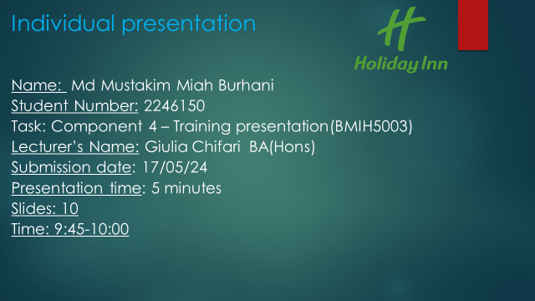

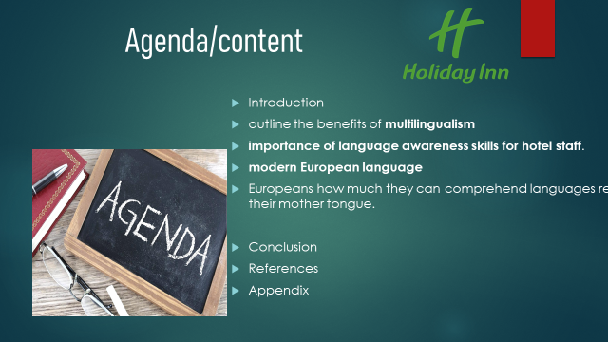

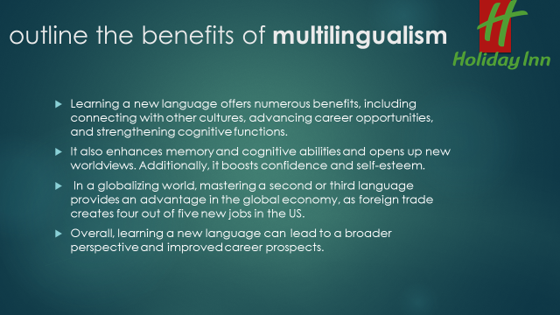

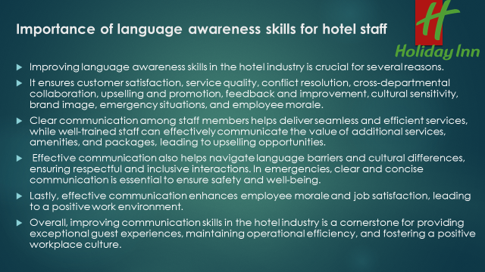



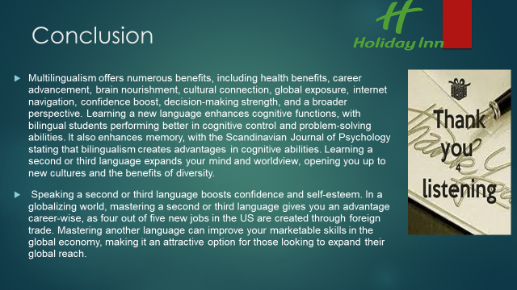

Create a training presentation in which you outline the benefits of multilingualism and the importance of language awareness skills for hotel staff.
Refer to a modern European language of your choice for examples:
Where is the language spoken? Is it hard to learn? What is considered to be polite/impolite in a business context? Provide direct examples from the hotel industry. The presentation is a working document for your Level 4 Placement Hotel. Add the hotel name/logo.
10 slides

Benefits of Multilingualism Why learn another language?
Learning a new language offers numerous benefits, including connecting with other cultures, advancing career opportunities, and strengthening cognitive functions. It also enhances memory and cognitive abilities, and opens up new worldviews. Additionally, it boosts confidence and self-esteem. In a globalizing world, mastering a second or third language provides an advantage in the global economy, as foreign trade creates four out of five new jobs in the US. Overall, learning a new language can lead to a broader perspective and improved career prospects.

Multilingualism offers numerous benefits, including health benefits, career advancement, brain nourishment, cultural connection, global exposure, internet navigation, confidence boost, decision-making strength, and a broader perspective. Learning a new language enhances cognitive functions, with bilingual students performing better in cognitive control and problem-solving abilities. It also enhances memory, with the Scandinavian Journal of Psychology stating that bilingualism creates advantages in cognitive abilities. Learning a second or third language expands your mind and worldview, opening you up to new cultures and the benefits of diversity. Speaking a second or third language boosts confidence and self-esteem. In a globalizing world, mastering a second or third language gives you an advantage career-wise, as four out of five new jobs in the US are created through foreign trade. Mastering another language can improve your marketable skills in the global economy, making it an attractive option for those looking to expand their global reach.

