Name: Charlie Macdonald
Student number: 2304849
Module: Tourism, Events and Leisure Industry
Lecturer: Deborah Jenkins
Assessment: UK Tourism Event

Assessment 2: UK Tourism Event

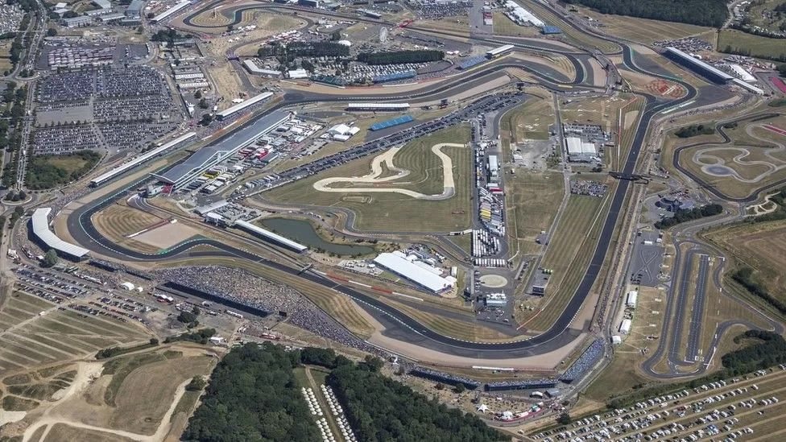
Silverstone F1 Race

(BBC, 2023)

Introduction
Silverstone is one of the most famous race tracks around the world and it hosts the British Grand Prix every year. In 2023 480,000 people attended the event in July and it’s getting more popular year by year as 400,000 people attended in 2022 (Silverstone, 2023).
The first Grand Prix was held at Silverstone in 1948 after the second world war, during the war Silverstone was used as a RAF base. Three years later the British Racing Driver’s club took over the track and turned it into a permanent track and since 1987 it has hosted the F1 race every year (Marca, 2023).

Impact of the visitors
In 2022 the race generated over £100 million for the local economy and the 2023 race is expected to beat that by some margin. Lots of the local businesses were glad to see the race return back to normal in 2022 after the Covid-19 pandemic affected the race in 2020 and 2021. When it’s race weekend all of the local hotels, campgrounds and bed and breakfasts are all fully booked as well as all of the local restaurants and pubs (ITVX, 2022). Silverstone also has a museum which attracts lots of people all year round and is a big tourist attraction. The museum opened in 2019 and since then 120,000 people have visited the museum, the museum is an interactive experience and it also includes a simulator so people can have a go at racing the track (Silverstone Museum, 2023).

Impact on locals
During the race weekend the local roads get very busy and it causes a lot of problems for locals of they are trying to travel somewhere. As there are nearly 500,000 people attending the amount of traffic in the area increases massively. The local council ensured that there would be extra traffic officers in the area for the event to help ensure people get to the right place and to make it as safe as possible (Norris, 2023).
Silverstone circuit also has a big effect on the environment but in the last 5 years the track has not sent any rubbish to landfill and by 2026 they are planning to bring in all recyclable products. The track has recently won Motorsport UK’s 2023 Environmental Award and by the year 2030 the track will be completely carbon neutral this part of F1’s plan to be completely carbon neutral to help the environment (Smith, 2023).
Over the course of a F1 season it releases approximately 256,000 tonnes of carbon dioxide as there are 20 cars going round the track and there are 23 races in a season around the world. In the recent years the F1 organisers have begun plans to make the sport carbon neutral by 2030 included in these plans are planting trees at the circuits and creating electric batteries for the cars, they have also changed the schedule to insure there is less travelling by making the races in the same continent the same time then moving on to another continent (Formula 1, 2022).
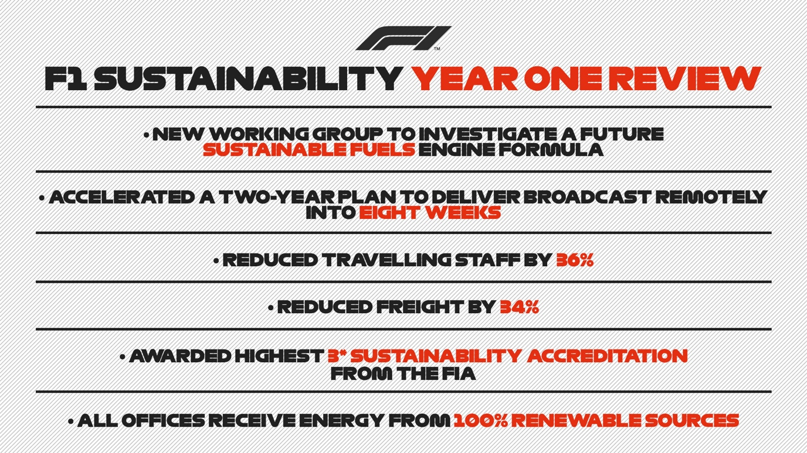
(Formula 1, 2020)

Trends and Impacts of Future Planning
Currently Silverstone’s contract with F1 runs until 2024 but it is highly likely that the contract will be extended as the negotiations are reaching the end. It is not yet clear how many more years the contract will be extended, in 2019 Silverstone signed a £100 million contract with F1 for 5 years. Silverstone is one of the most sustainable races of the year as 7 out of the 10 teams are based near Silverstone so there’s no flights for them and around the track there are 2,700 solar panels which are powering the paddock club. As Silverstone is one of the most sustainable tracks it’s important for F1 to keep the track if it wants to reach it’s target of being carbon neutral by 2030 (Blackbookmotorsport, 2023).

Visitor typology
There are a lot of sub-types of tourism and people who attend Silverstone are usually classed in one out of three sub-types. The three are sports and activity holiday tourism, extreme sports and experience tourism or event tourism. The most common visitor to Silverstone is a male aged between 25-34, 70% of the guests that attend Silverstone are male and 30% are Women. The number of women attending the event is rising every year but it is still most popular with men at the moment (Simlilarweb, 2023).

Maslow Theory
Maslow’s theory discusses what people need to have a good holiday, in the theory there are five different categories which are:
- Physiological needs
- Safety needs
- Belonginess and love needs
- Esteem needs
- Self-actualization
Physiological needs and safety needs fall under the basic needs bracket as they include having food, water, rest and security, these are all crucial factors for having a good holiday.
The next category is psychological needs and belongingness and love needs and esteem needs fall under this category, these categorise are about who you go on holidays with for example friends or family. It also includes prestige and feeling of accomplishment, if you feel like you have accomplished something on holiday then it shows that it was a holiday worth going on and if you are there with friends or family it is even better. The last category is self fulfillment needs and self-actualization falls under this category, this means that you have achieved your full potential and have done many activities. If you feel like your holiday reached it’s full potential then it was an amazing holiday and for most people a once in a lifetime trip. In my opinion Silverstone falls under all of the categories as safety is a big part of the event and it is an event to enjoy with your family or friends and you would feel like it was an accomplishment to attend, also it would make you feel that your holiday reached it’s full potential if you were lucky enough to attend (McLeod, 2018)

McClelland Theory
McClelland’s theory states that everyone is driven by one of three needs which are achievement, affiliation or power. The main difference between Maslow and McClelland’s theory is McClelland’s theory is more often used in a managerial context whilst Maslow’s theory is used more generally. From a tourism point of view McClelland’s theory can be used to find what jobs suit different people this would allow the business to be more organized and successful. In Silverstone McClelland’s theory can be used to help keep the event running smoothly as it can help people find the right job for them as not everyone can be a manager and it’s important to find people for all jobs to make sure the operation goes to plan (McClelland, 1987)

Butler’s Tourism Area Life Cycle Model
Butler’s model is designed to help understand the different stages that a tourism attraction goes through. It can help people who are developing a new business to understand what they have to do to make the attraction successful and it shows how places can change depending on the demands of tourists. The model shows seven different stages an attraction goes through it starts of as an exploration as it is something new people will want to check it out, the next stage is involvement as the number of tourists increases more people will get involved to take the attraction to the next level, the next stage is development after some time and with the number of tourist still increasing it is important for the attraction to keep improving to make sure people still want to attend. The next step is consolidation this is a very important part as the number of new tourists is fading slightly and it is important to ensure that the attraction is stable and that it will continue being popular. The next stage is stagnation this occurs when the number of tourists stops increasing and just stays at the same level this is a critical time for the attraction because what it does at this time can either make sure the number of tourists rises again or it starts to fall. The next stage is split into two categories rejuvenation or decline, the attraction could either rejuvenate sharply and the number of tourists would increase very fast or it could be more gradual. On the other hand it could decline sharply which would be a disaster for the attraction as once the numbers start to decline quickly it is hard to recover or it could decline more gradually this would give the attraction some time to try and salvage the situation before it gets worse. At the moment Silverstone is in the development stage as the number of visitors are rising each year and the event is growing with more things happening across the race week and weekend (Butler, 1976).
MICE Tourism
In tourism MICE stands for meetings, incentives, conferences and exhibitions. Formula 1 does all of these things as they are a massive company they hold several meetings every year to discuss way to improve. They also have lots of incentives to make sure the sport continues to grow, the drivers also have conferences every race weekend which allows the press and public to ask them questions it also helps the organizers discover the opinions of the drivers and what they need to improve. On most circuits now there are exhibitions for the fans to attend and give them the chance to see some of the most famous cars and to learn about their history (Dwyer and Forsyth, 1997).

Conclusion
Silverstone is one of the biggest events in the UK and last year alone nearly 500,000 people attended the event and the figures are rising every year which shows that the event is still growing and becoming more popular. However to improve the event in the future the organizers could do more to help the locals over the weekend and control the traffic more this would keep the locals happier. Another way they could improve is to make the event more environmentally friendly by making sure people don’t leave their rubbish behind and they need to make sure they reach F1’s goal of being carbon neutral by 2030 if they achieve this then the event will be able to continue growing and the local environment won’t be affected.

Reference List

(BBC, 2023)
BBC (2023). F1 British Grand Prix: Silverstone track invaders risked harm, court hears. BBC News. [online] 25 Jan. Available at: https://www.bbc.co.uk/news/uk-england-northamptonshire-64401380 [Accessed 24 Nov. 2023].
(Butler, 1976)
Butler, R. (1976). including photo- copying, recording, storage in an information retrieval system, or otherwise, without prior permission of the publisher. Design and setting by CTR Tourism Area Life Cycle. [online] Available at: https://docenti.unimc.it/gianluigi.corinto/teaching/2020/22106/files/pdf_lectures/toursim_area_life_cycle_original.pdf.
(Dwyer and Forsyth, 1997)
Dwyer, L. and Forsyth, P. (1997). Impacts and Benefits of MICE Tourism: A Framework for Analysis. Tourism Economics, 3(1), pp.21–38. doi:https://doi.org/10.1177/135481669700300102.
(Formula 1, 2020)
Formula 1 (2020). Formula 1 (@F1) | Twitter. [online] Twitter.com. Available at: https://twitter.com/f1.
(Formula 1, 2022)
Formula 1 (2022). F1 continues push to hit Net Zero Carbon by 2030 target | Formula 1®. [online] www.formula1.com. Available at: https://www.formula1.com/en/latest/article.f1-continues-push-to-hit-net-zero-carbon-by-2030-target.7fGtPCNCwOnMFFt9Ys1HAa.html.
(ITVX, 2022)
ITVX (2022). ‘Biggest ever’ F1 British Grand Prix to help drive £100m economic boost. [online] ITV News. Available at: https://www.itv.com/news/anglia/2022-06-30/biggest-ever-f1-british-grand-prix-to-help-drive-100m-economic-boost.
(MARCA, 2023)
MARCA. (2023). British GP: Has the British Grand Prix always been at Silverstone? [online] Available at: https://www.marca.com/en/f1/2023/07/07/64a7c8d222601d557a8b4592.html# [Accessed 24 Nov. 2023].
(McClelland, 1987)
McClelland, D. (1987). Putting theory into practice: David McClelland’s Need Theory | News | Warwick Business School. [online] Warwick Business School. Available at: https://www.wbs.ac.uk/news/putting-theory-into-practice-david-mcclellands-need-theory/.

(McLeod, 2018)
McLeod, S. (2018). Maslow’s Hierarchy of Needs. [online] Canada College, Simply Psychology, p.1. Available at: https://canadacollege.edu/dreamers/docs/Maslows-Hierarchy-of-Needs.pdf.
(Norris, 2023)
Norris, M. (2023). Police and National Highways plan for half a million visitors at British Grand Prix. [online] Oxford Mail. Available at: https://www.oxfordmail.co.uk/news/23629271.british-grand-prix-national-highways-urges-drivers-plan-ahead/ [Accessed 25 Nov. 2023].
(Silverstone Museum, 2023)
Silverstone Museum (2023). Silverstone Interactive Museum celebrates its second anniversary with record number of half term visitors. [online] www.silverstonemuseum.co.uk. Available at: https://www.silverstonemuseum.co.uk/about-us/our-organisation/latest-news/silverstone-interactive-museum-celebrates-its-second-anniversary-with-record-number-of-half-term-visitors/#:~:text=It%20has%20been%20two%20years [Accessed 25 Nov. 2023].
(Silverstone, 2023)
Silverstone. (2023). The 2023 British Grand Prix in numbers. [online] Available at: https://www.silverstone.co.uk/news/2023-british-grand-prix-numbers#:~:text=Recording%2Dbreaking%20attendanceThe%202022 [Accessed 24 Nov. 2023].
(SimilarWeb, 2023)
SimilarWeb (2023). SimilarWeb Identity. [online] secure.similarweb.com. Available at: https://pro.similarweb.com/#/digitalsuite/websiteanalysis/audience-demographics/.
(Smith, 2023)
Smith, D. (2023). Silverstone’s ‘Shift to Zero’ wins Motorsport UK’s 2023 Environmental Award. [online] Motorsport UK. Available at: https://www.motorsportuk.org/silverstones-shift-to-zero-wins-motorsport-uks-2023-environmental-award/.

(www.blackbookmotorsport.com, 2023)
www.blackbookmotorsport.com. (2023). New British GP contract ‘just a matter of time’, says Motorsport UK chairman. [online] Available at: https://www.blackbookmotorsport.com/news/british-grand-prix-silverstone-contract-f1-motorsport-uk#:~:text=However%2C%20a%20five%2Dyear%2C [Accessed 26 Nov. 2023].

