18 November 2023

Gareth Jenkins
Student no. 99091195

Archaeology as politics. Is the Use of archaeology on postage stamps political?
Introduction to Archaeology. HPAR4002.

Archaeology as politics. Is the use of archaeology on postage stamps political?

“A picture is worth a thousand words." A simple phrase that implies that a single still image can more effectively communicate a complicated idea, and often more than one idea, than a verbal description can. Many sources attribute this expression to a Frederick R. Barnard, who published a 1921 article in the advertising trade journal Printers' Ink on the effectiveness of graphics in advertising with the title “One look is worth a thousand words” (Book Browse, 2023).
Despite the modern origin of this popular phrase, earlier writers have expressed the same sentiment. For example, Leonardo da Vinci wrote that a poet would be "overcome by sleep and hunger before [being able to] describe with words what a painter is able to [depict] in an instant" (Janson, H.W.; Janson, A., 2001). The Russian writer Ivan Turgenev wrote, "For a picture may instantly present what a book could set forth only in a hundred pages" (Turgenev, I. S., 1921 p.114). Pictures can be paintings or drawings, photographs, or computer-generated images. They can be two-dimensional or three-dimensional. They can provide a concept or an idea, an expression, or a point of view. Inevitably they become a means of propaganda. A means of promoting a cause, sometimes of a biased or misleading nature.
This essay will examine one type of imagery that has long been used to impress and persuade modern human beings, the humble postage stamp. It will examine the use of archaeological themes on postage stamps throughout the world as a means of political propaganda and self-promotion. This essay will not provide a history of postage stamps per se but will examine the political advantages gained by using archaeological images on postage stamps. The essay will assess the variety of archaeological images used and identify any similarities or differences in approach within different countries.
Almost invisible by their presence, postage stamps due to their very nature have a common and very ordinary place in society. But they are implicit in their unconscious messages to people. Postage stamps are seen as a government’s silent ambassadors, conveying concepts, images, and frequently politically sensitive messages to both domestic and international audiences. Are they therefore intrinsically political?
The first postage stamps ever produced were the Penny Black and Two-penny Blue of Great Britain, which were issued on sixth May 1840. An example of a Penny Black can be seen at Figure 1. Both stamps had the side profile image of the then monarch, Queen Victoria (XLCR Stamp Finder, 1969). The image evokes Empiricism and the power of monarchy and are therefore early examples of politics being used by a country to promote its status in the world.
Once the concept of the postal stamp was established other countries began to produce their own stamps, and within ten years stamps were in use in all the countries around the world. It is quite telling that the use of postage stamps should become a worldwide phenomenon in such a short space of time. Were they immediately seen as a tool to advise the people, or a means of manipulation?
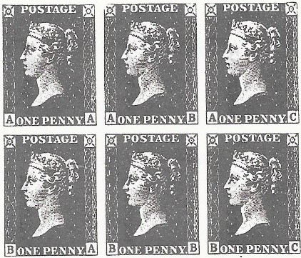
Figure 1. Facsimile copies of Penny Black postage stamps. (Authors own collection.)
Countries have used images of their national symbols or their rulers on stamps for decades, but soon discovered there were more interesting ways to promote themselves. Archaeology turned out to be a lucrative platform for self-promotion. Eventually, stamps featuring archaeologists and artefacts from ancient places became commonplace (Foss, C. 1999).
One of the first countries to promote their ancient history on stamps was Egypt. From 1867 until 1914 Egypt frequently showed images of the pyramids of Giza and the Sphinx on their stamps (Foss, C. 1999). Figures 2 and 3 are examples of the use by Egypt of these ancient sites on early postage stamps.
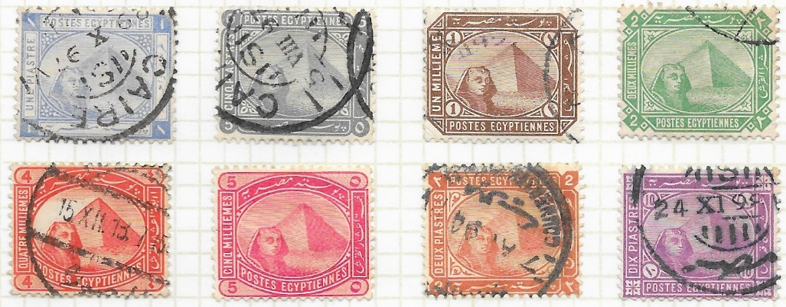
Figure 2, Examples of Egyptian stamps issued between 1884 and 1906 promoting the Giza pyramids and the Sphinx. (Authors own collection.)
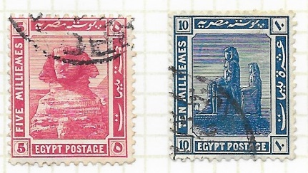
Figure 3, Examples of Egyptian stamps issued 1914. (Authors own collection.)
Following its independence in 1923 Egypt began to forge a national identity and started alluding to old pharaonic customs on their postage stamps. In 1926 to advertise a Navigation Congress being held in Cairo a series of stamps were issued using an image of Queen Hatshepsut’ barge from around 1498-1483BC. In 1937 to promote an Ophthalmological Congress in Cairo a series of stamps were issued using the Eye of Ra (Fosse, 1999). Figure 4 are examples of the barge image used in 1923 and Figure 5 are examples of the Eye of Ra used in 1937.

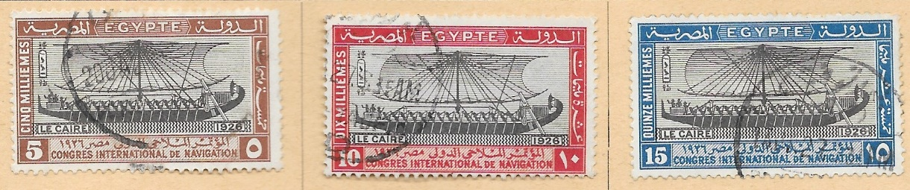
Figure 4, 1926 Egyptian stamps using the image of Queen Hatshepsut barge to advertise a Navigation Congress in Cairo. (Authors own collection).

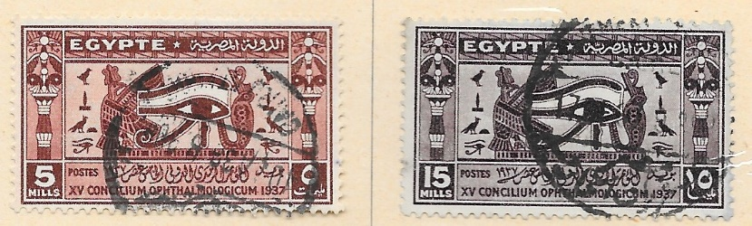
Figure 5, 1937 Egyptian stamps using the Eye of the sun god Ra to promote an Ophthalmological Congress in Cairo. (Authors own collection).

It is apparent that sovereignty and nationalism became important in Egypt and that by using ancient archaeological themes on their postage stamps they could create a collective identity that would be appealing to their people. It resulted in an anti-colonial independence movement which ended British rule in Egypt. Similar movements have occurred in other countries. Archaeology in contemporary Israel contributed to the construction of a shared past, helping to shape a collective identity. Israelis encounter archaeology-related motifs and symbols on bank notes, coins, medals, and stamps on a regular basis. Archaeology has also assisted in finding the locations referenced in the Bible to support territorial claims and give them credibility (Zahavy, 2009 p. 13-15).
The three revolts in Jewish history that led to their independence were represented on the first Israeli stamps. The Hasmonean revolt against the Seleucid Empire between 167-160BCE, the First Revolt against Roman rule in 66CE and the second revolt against Roman rule, the Bar-Kochba revolt in 132CE. Images of ancient coins from the periods of these revolts were used due to their importance as an expression of political power (Zahavy, 2009 p. 23). Figure 6 are examples of the early use of stamps using images of ancient coins by Israel.
“Of the 1512 stamps issued by the State of Israel between the years 1948-1995, 154 of them have archaeological motifs, that is 10%.” Of these 154 stamps, 66.3% have archaeological artefacts and 33.7% have archaeological sites depicted on them (Zahavy, 2009 p. 63).
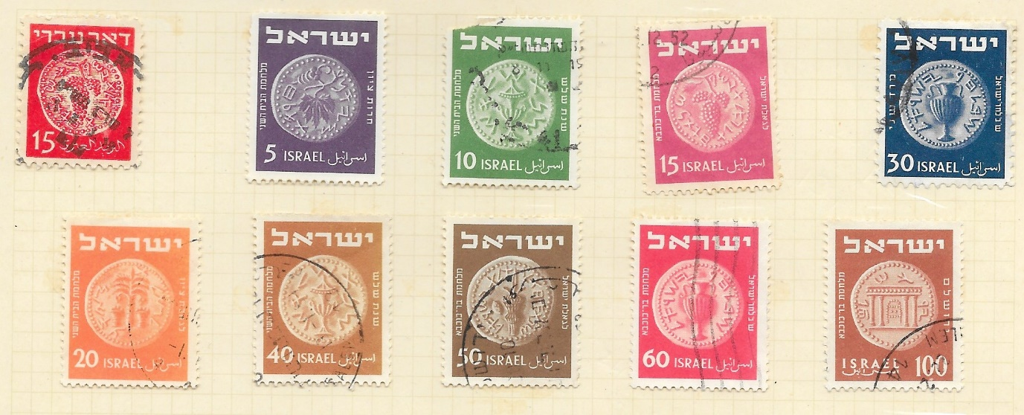
Figure 6, Israeli stamps with images of ancient coins discovered during the time of the three revolts in Jewish history. (Authors own collection).

A common tactic used by leaders during conflict to politically bolster their positions is the use of symbolic iconography. In Ireland (Eire), there had long been a dispute over British rule. It was believed in Eire that by removing the image of a ruler, that is, the King of England, from their postage stamps and replacing them with images representing their pre-Norman and Gaelic past they could evoke a sense of Irish pride. Images such as a Celtic cross or the harp (Irish Studies, 2018).
Ireland went through a period of civil conflict from 1922 to 1923 following Partition. Figure 7 provides examples of stamps issued during this period. The map of Ireland stamp was the first printed following partition. Other stamps in the series featured the Cross of Cong (Celtic Cross), the Sword of Light, and a shield bearing the arms of all four provinces. The name of the maternal goddess of Ireland, Éire, reflects the country's pagan, Gaelic past and is depicted on this map of Ireland as the island nation in the centre of an arch (Irish Studies 2018).
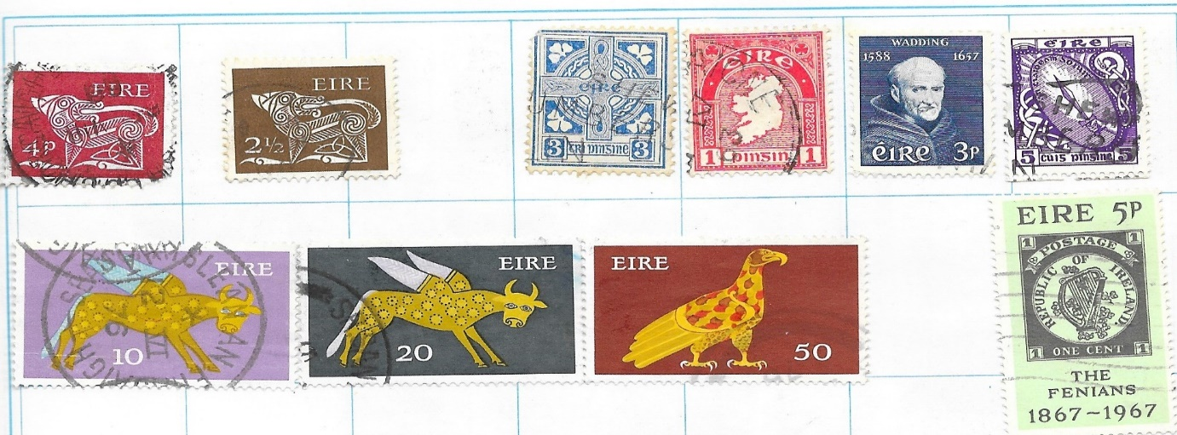
Figure 7, Eire stamps using Gaelic iconography, the Celtic cross and the Map of Ireland stamp all contribute to independence rhetoric. (Authors own collection).

In the Republic of Cyprus, attempts have been made to establish a "Greek" hegemony by presenting a past that is both Greek and Orthodox in the media, and state imagery, including postage stamps. The Republic of Cyprus government has attempted to build distinct identities associated with nationalism and colonialism by drawing on the history and archaeology of Cyprus. Nationalism and colonisation have therefore both been important in the establishment and growth of Greek Cypriot identity. Education, the media, museums, and national history have all contributed to this (Michael, 2005 p. 7-16).
One such example is the Department of Postal Services Cyprus 1980 Presentation Pack (See Figure 8 below) showing the new definitive stamps to be issued that year. They were called “Archaeological Treasures from Cyprus Museums” (Republic of Cyprus, 1980). The stamps depict various themes related to Hellenistic archaeology found on the island.
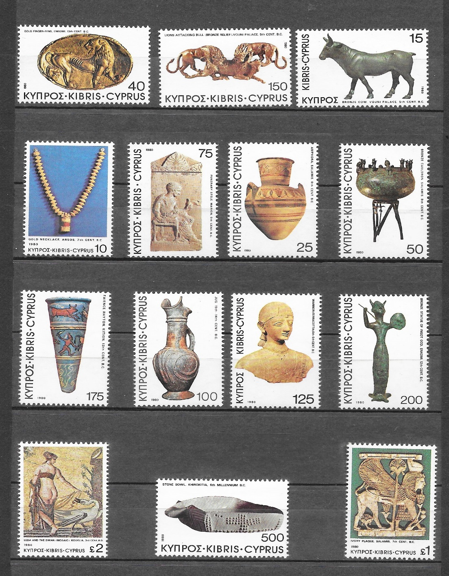
Figure 8, 1980 Definitive Issue stamps entitled, Archaeological Treasures from the Cyprus Museums. (Authors own collection).
Postage stamps have historically served as symbols of both geopolitical strategy and culture in the United States of America (USA). In 2021 the US Postal service issued a new set of postage stamps showing topics honouring American history and culture, such as The Raven Story. The Raven story stamp designed by a member of the Alaskan Tlingit tribe portrays one of the numerous legends surrounding Raven, a figure of huge significance to the Indigenous peoples of the Northwest Coast. Raven is an integral part of traditional narratives, especially creation stories, among the civilizations in the area (Laird, 2021).

Figure 9 is a copy of the Raven story stamp painted by Tlingit artist Rico Worl. (Copied from the site of the US Postal Service, 2020)
The Tlingit settled in Alaska around 10,000 years ago. The many Raven stories among the origin stories of the Tlingit are important in establishing their cultural heritage (Swanton, 1909). The use of this stamp design has therefore two political uses. The first by the Tlingit people to highlight their ancient origins and importance of traditional narratives. The second an attempt by the US Government to show support for Indigenous people. This may also be interpreted as sign of atonement by the Government for past treatment which has often been seen as unjust.
Similarly, in 1955 the Canadian Post Office Department released the "Eskimo Hunter" stamp. It is among the first stamps with an Indigenous theme released by the Canadian Post Office Department. The stamp features an Inuit hunter sitting on a qajaq (kayak) at rest on placid Arctic waters, with an iceberg in the distance and an aircraft passing overhead (Please see Figure 10). It is suggested that this stamp, represents an attempt by the federal government to depict the Arctic as an important geographic area that is part of the Canadian imagined community while also incorporating Inuit as full citizens of the state (Dumas, 2023). There are familiar political messages here, a central government’s attempt to assert their authority but also a need to show support for Indigenous people.
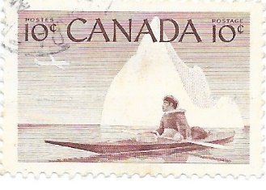
Figure 10, a copy of the “Eskimo Hunter” stamp issued by Canada in 1955. (Authors own collection.)
Historically in Britain, stamps with archaeological images were not a widespread practice. It only became popular from the 1990’s onwards. In 1991 a series of definitive stamps were issued in a set of four booklets, depicting archaeological discoveries. These discoveries were made by Sir Arthur Evans, Howard Carter, Sir Austen Layard, and Flinders Petrie. (See Figure 11). The booklets are uniquely political, in that they assert the prominence of British archaeologists who have contributed to many of the great archaeological discoveries, particularly in the Middle East.
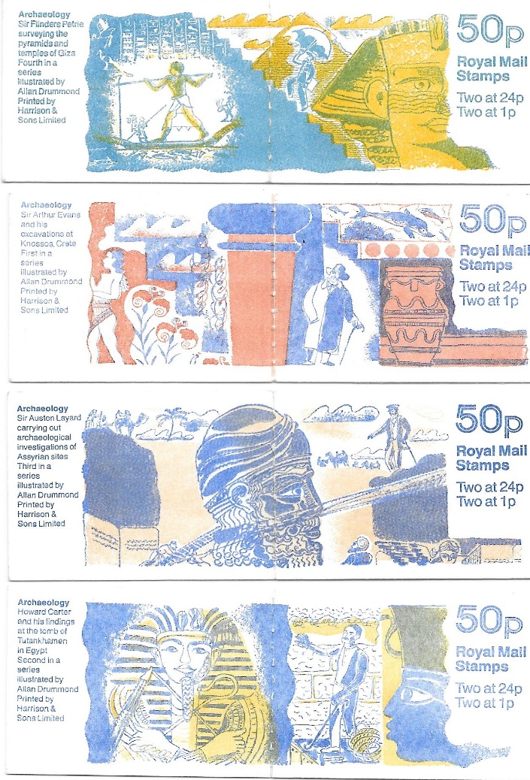
Figure 11, Definitive stamp booklets issued in 1991 with an archaeology theme. (Authors own collection).
In 2003 the British Museum celebrated its 250th. Anniversary, with a set of six stamps highlighting the archaeology held at the museum. Images of Greek, Egyptian, Aztec artefacts are shown with an image of the Sutton Hoo helmet. Due to the politically sensitive nature of the acquisition of some of these artefacts it can be suggested that this a justification of their existence as an institution. (See Figure 12).
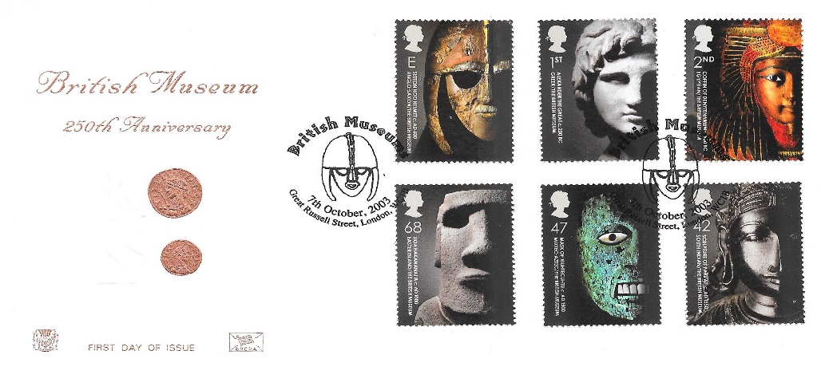
Figure 12, British Museum 250th anniversary first day of issue cover. (Authors own collection).
Industrial archaeology (see Figure 13), Roman life and culture, and Ancient Britain (see Figure 14), have all featured on British stamps within the last 25 years. They are a commemoration of British history, and a reminder to the British people of their long, distinctive, and unique heritage. They have a very political underlying message of nationhood which may not be inherently obvious.
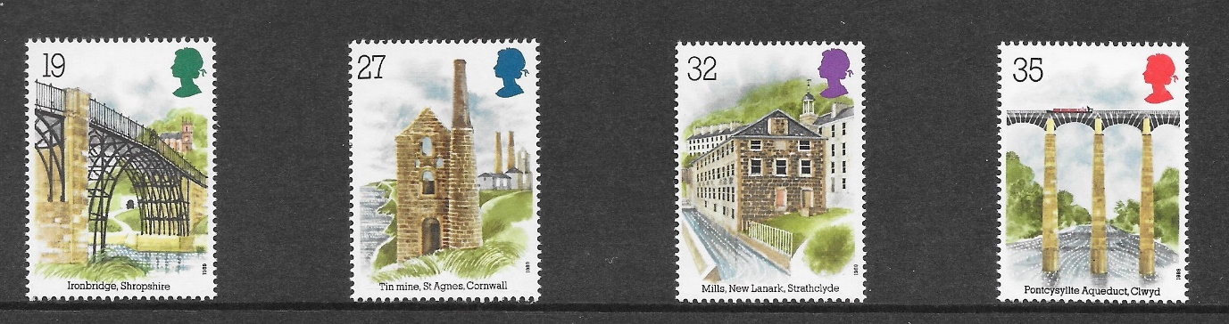
Figure 13, British ‘Industrial archaeology.’ (Authors own collection).

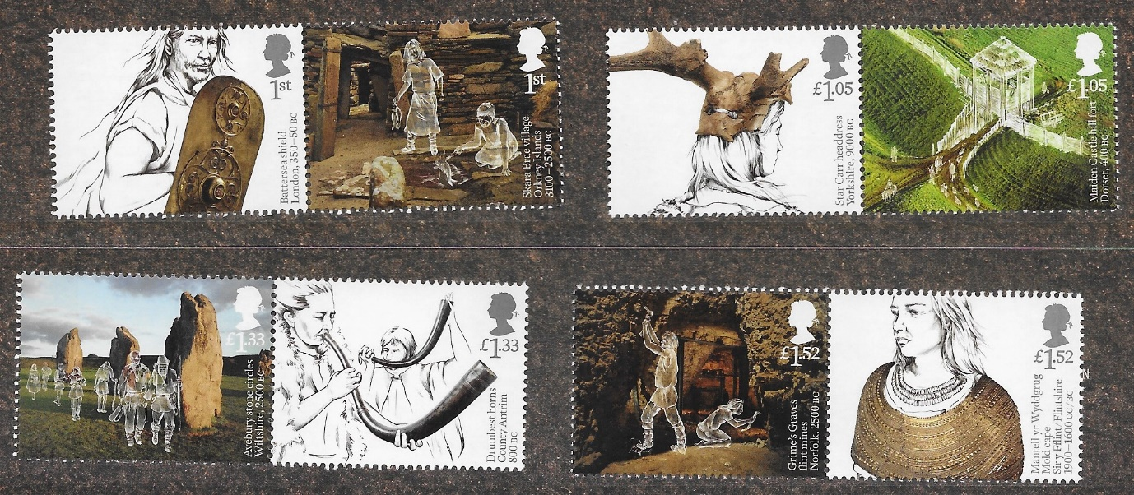
Figure 14, ‘Ancient Britain’ archaeology. (Authors own collection).
Postage stamps are presented to the public as representations of many different themes, including, remembrance, history, archaeology, a celebration of achievement, scientific endeavour, of exploration, of diversity, landscape, art, music, and many others. The messages within these themes are not always interpreted as immediately political, but on closer examination their hidden messages may be seen. It has not been possible in this essay to examine every politically motivated, archaeological themed, postage stamp from around the world. There are many. However, the small sample that has been examined has shown that they have a deeper political meaning. Archaeological themed postage stamps have been used by most countries to enforce cultural, nationalistic, and ancestral origins, and to celebrate freedom from colonialism, whether it be the Indigenous people of North America, or the Middle East, or the United Kingdom. They offer a potent platform for the impression and persuasion of the human mind and are a very well used tool for promoting heritage, for propaganda, and manipulation. Their use therefore is intrinsically political.
(2,200 words)
Bibliography.
Abdi, K. (2022) ‘Hominid Stamps: The Philatelic Medium as a Tool Contributing to Nationalism.’ Iranian Journal of Archaeological Studies Vo.12, no.1 pp. 53-64. University of Sistan and Baluchestan. Available at: DOI: 10.22111/IJAS.2022.7517 (Accessed on 10 November 2023).
Adedze, A. (2004) ‘Commemorating the Chief: The Politics of Postage Stamps in West Africa.’ African Arts, Vol. 37, No. 2, pp.68-73+96. UCLA James S. Coleman African Studies Center. Available at: https://www.jstor.org/stable/3337964 (Accessed on 7 November 2023).
Book Browse (2023) A Picture is worth a thousand words. Available at: https://www.bookbrowse.com/expressions/detail/index.cfm/expression_number/565/a-picture-is-worth-a-thousand-words (Accessed: 10 November 2023).
Child, J. (2005) ‘The Politics and Semiotics of the Smallest Icons of Popular Culture: Latin American Postage Stamps.’ Project Muse. Latin American Research Review, Vol. 40, no. 1, pp.108-137. Available at: https://doi.org.10.1353/lar.2005.0003 (Accessed on 6 November 2023).
Deans, P., & Dobson, H. (2005) ’Introduction: East Asian Postage Stamps as socio-political artefacts.’ East Asia Vol 22(2), 3-7. N.J. Piscataway. Available at: https://doi.org/10.1007/s12140-005-0006-6 (Accessed on 10 November 2023).
Dumas, D. (2023) Place them on a stamp: Inuit, banal colonialism, and the “pioneer experiment “of the High Arctic Relocations. Political Geography, Volume 105.
Available at: https://doi.org/10.1016/j.polgeo.2023.102919.
(https://www.sciencedirect.com/science/article/pii/S0962629823000975) (Accessed 17 November 2023).

Foss, C. (1999) ‘Postal Propaganda.’ Archaeology Vol. 52 (2), p.70-71. Available at: https://archive.archaeology.org/9903/abstracts/stamps.html (Accessed: 10 November 2023).
Irish Studies (2018) Postage Stamps. Available at: https://irishstudies.sunygeneseoenglish.org/postage-stamps/ (Accessed: 10 November 2023).
Janson, H. W., & Janson, A. F. (1997). History of art (5th ed. rev.). Thames and Hudson
Jenkins, E. (2012) ‘Showcasing South African rock art on postage stamps.’ Critical Arts: South-North Cultural and Media Studies. Vo. 26 (4), 466-483, Routledge Taylor & Francis Group. Available at: DOI:10.1080/02560046.2012.723801 (Accessed on 10 November 2023).
Laird, K. (2021) ‘Then Hidden Political Life of Postage Stamps,’ The Black Sheep Agency [blog]. 3 April. Available at: theblacksheepagency.com/blog/the-hidden-political-life-of-psoateg-stamps (Accessed: 5 November 2023).
Limor, Y. & Zelkovitz, I. (2012) ‘Politics, Nationalism and Economics: The Postage Stamps of the British Mandate in Palestine, 1920-1945.’ Israel Studies, Vol. 26, no. 3, p.196-217. Indiana University Press. Available at: doi.10.2979/israelstudies.26.3.12 (Accessed on: 5 November 2023).
Meharry, E. (2018) Politicization of Afghanistan’s Archaeological Postage Stamps. Washington: Smithsonian National Postal Museum. Available at: https://postalmuseum.si.edu/politicization-of-afghanistan’s-archaeological-postage-stamps (Accessed on 10 November 2023)
Michael, A. S. (2005) Making Histories: Nationalism, Colonialism, and the Uses of the Past on Cyprus. Published PhD Thesis. University of Glasgow. Available at: core.ac.uk/download/pdf/281579/pdf (Accessed on 16 November 2023).
Reid, D. M. (1984) ‘The Symbolism of Postage Stamps: A Source for the Historian.’ Journal of Contemporary History, Vol. 19 No. 2, pp.223-249. Sage Publications Ltd. Available at: journals.sagepub.com/doi/epdf/10.1177/002200948401900204 (Accessed on: 10 November 2023).
Scarre, C. (2017) Editorial. Antiquity Vol.87 (335) p. 285-288. Cambridge: Cambridge University Press. Available at: https://doi.org/10.15184/aqy.2017.26 (Accessed on: 10 November 2023).
Swanton, J. R. Ed. (1909) Tlingit Myths and Texts. Washington: Government Printing Office. Available at: publicdomainreview.org/collection/Tlingit-myths-and-texts-1909 (Accessed: 16 November 2023).
The Heritage Journal (2021) Ancient Sites in British Philately. Available at: https://heritageaction.wordpress.com/2021/03/11/ancient-sites-in-british-philately/ (Accessed: 17 November 2023).
Turgenev, Ivan S. (1921) Translated from the Russian by C. J. Hogarth. Fathers and Sons Chapter 16, p 114. London: J.M.Dent & Sons.
US Postal Services USPS. (2020) National News. Available at: https://about.usps.com/newsroom/national-releases/2020/1117-usps-announces-upcoming-stamps.htm (Accessed: 16 November 2023).
Walz, J. R. (2005) ‘Archaeopolitics and Postage Stamps in Africa.’ African Arts, Vol. 38, No.2, pp.8+88+96. UCLA James S. Coleman African Studies Center. Available at: https://www.jstor.org/stable/3338080 (Accessed on 6 November 2023).
XLCR STAMP FINDER and Collector’s Dictionary (1969) England: Thomas Cliffe.
Zahavy, Y. (2009) Archaeology, Stamps and Coins of the State of Israel. USA.

