
A COMPREHENSIVE DATA MINING ANALYSIS OF NEW YORK CITY LISTINGS
DANIEL HRISCU 2127929
MODULE CODE: ACCA7015
SUBMISSION DATE: 21/11/2025
LECTURER: DR. Nouah Elmitwally
UNIVERSITY NAME: UNIVERSITY OF WALES TRINITY SAINT DAVID
CAMPUS NAME: BIRMINGHAM
AIRBNB PRICE CATEGORIZATION AND MARKET SEGMENTATION
2025
Table of Contents
ABSTRACT 2
1.0 INTRODUCTION 2
2.0 LITERATURE REVIEW AND THEORETICAL FOUNDATIONS 4
2.1 Machine Learning in Accommodation Pricing 4
2.2 Classification Algorithms: Comparative Theoretical Analysis 4
2.2.1 Naive Bayes Classifiers 4
2.2.2 Decision Trees: J48 Algorithm 4
2.2.3 Random Forest Ensemble Methods 5
2.3 Clustering for Market Segmentation 5
2.4 Association Rule Mining for Pricing Intelligence 6
2.5 The Professionalization of Peer-to-Peer Accommodation 6
2.6 Research Hypotheses 6
3.0 PREPARATION AND EXPLORATORY ANALYSIS 7
3.1 Dataset Characteristics 7
3.2 Class Distribution and Imbalance Analysis 8
3.3 Feature Analysis and Price Determinants 9
4.0 METHODOLOGY AND IMPLEMENTATION 11
4.1 Experimental Framework 11
4.2 Implementation of the Classification Model 12
4.2.1 Naive Bayes Classifier 12
4.2.2 J48 decision tree classifier 12
4.2.3 Random Forest Ensemble 13
4.2.4 Cost-Sensitive Classification for Imbalance Handling 15
4.3 K-Means Clustering for Market Segmentation 16
4.4 Association Rule Mining for Pricing Intelligence 19
5.0 CRITICAL ANALYSIS AND DISCUSSION 20
5.1 Model Performance and Theory Verification 20
5.2 Market Segmentation Learnings 20
5.3 Association Rules and Business Intelligence 21
5.4 Limitations and Methodological Concerns 21
6.0 BUSINESS RECOMMENDATIONS AND STRATEGIC IMPLICATIONS. 22
6.1 Recommendations for Airbnb Hosts 22
6.2 Suggestions for Platform Operators (Airbnb) 23
6.3 Suggestions for Policymakers and Regulators 23
7.0 CONCLUSION AND FUTURE RESEARCH DIRECTIONS 24
REFERENCES 25

ABSTRACT

The evolution of peer-to-peer accommodation platforms has changed us to think differently about pricing for the hospitality industry. Traditional pricing structures don't do justice to what's happening in the decentralized markets where they exist. This research deals with Airbnb price optimization on 48,895 New York City listings in 2019 using data mining methodologies. 10-fold cross-validation was performed on these three algorithms in Weka to classify listings as four price levels (Naive Bayes, J48 Decision Tree and Random Forest). At 68.74 percent accuracy, Random Forest achieved an F1 score of 0.234 for the difficult premium class, indicating that ensemble methods are capable of dealing with extreme class imbalances better than single classifiers [1]. Next, I conducted k-means clustering (k=4), showing market segments that are likely to include casual hosts, professional operators, budget providers, and premium properties. Apriori association rule mining generated 4 high-confidence pricing rules (confidence ≥0.85, lift ≥1.75) revealing strong associations between location, property type, and price categories. Based on relative feature importance, geographic location and property type proved as a robust price determinant, accounting for approximately 73% of the model's predictive capacity [2]. Those findings may provide useful information for the optimization of dynamic pricing, targeted marketing, and regulations that separate casual from commercial operations.

1.0 INTRODUCTION

The sharing economy has truly disrupted traditional hospitality markets. Airbnb is perhaps the clearest example of this trend since it has begun using decentralized pricing solutions in different categories of properties, places, and degrees of experience for the host [3], [4]. Finding competitive and yet profitable prices isn’t easy for hosts, who face gaps in knowledge and market opacity. Market segmentation intelligence is a key factor which helps platform operators to optimally optimize algorithms, to understand pricing anomalies and to fulfil regulatory compliance [5]. The majority of current studies treat accommodation pricing as a regression problem, looking at predictable exact price values [6], [7]. Well, I’ve adopted a different mindset here. By classifying listings into four distinct tiers, low, medium, high, and premium, the analysis allows for such market positioning insights and recommendation points tailored to the segment more easily understood by the business entity's manager than point suggestions [8]. This is also indicative of how hosts and guests in general consider price: with comparative segments rather than numbers in black and white. This research addresses this by three elements. First, I compare the three models of classification: Probabilistic (Naive Bayes), tree-based (J48) and ensemble (Random Forest). Second, I extend supervised learning with k-means clustering for market segmentation and Apriori association rule mining for pattern detection. This enables a truer and more complete perspective than classification only. Third, the analysis directly addresses class imbalance difficulties of pricing data on real-world prices, in which premium listings comprise less than 2% of the market [9], [10].
Research Objectives:
1. Conduct exploratory data analysis to discover determinants of price categorization of Airbnb in the metropolitan markets for urban consumers.
2. Use standardized cross validation methodologies to implement and critically examine three classification algorithms.
3. Identify the natural market segments through k-means clustering and show operational archetypes, and business models.
4. Examine combinations of features with a view to predict pricing, extract actionable pricing rules through association analysis.
5. Synthesize findings into recommended solutions for hosts, platform operators, and regulators.
The analysis is conducted on the AB_NYC_2019 dataset (48,895 verified listings are available across the five boroughs of New York City). This is enough geographical and market diversity to permit generalizable insights. All analyses have been performed using Weka 3.8.6, for the purpose of transparency and reproducibility [11].

2.0 LITERATURE REVIEW AND THEORETICAL FOUNDATIONS

2.1 Machine Learning in Accommodation Pricing

Machine learning applications to short-term rental pricing have evolved from early hedonic regression models to ensemble methods and deep learning architectures [12]. Airbnb pricing is grounded in Hedonic Pricing theories which decompose asset values along component attribute utilities [8]. Machine learning models demonstrate non-linear feature interactions and localized effects which simpler econometric models do not capture [2], [13]. Recent spatial-explicit analyses found that pricing determinants vary substantially across neighbourhoods and cities [14], informing the inclusion of geographic features (neighbourhood_group, latitude, longitude) as main predictors. The transition from regression to classification frameworks reflects growing understanding that discrete categorization yields more actionable insights for strategic positioning than continuous predictions [15].

2.2 Classification Algorithms: Comparative Theoretical Analysis

2.2.1 Naive Bayes Classifiers
It applies Bayes’ theorem with strong independence assumptions to compute class membership probabilities based on Bayes’ theorem [16]. Despite theoretical issues including the highly unrealistic assumption that features on the model are given a class-label independent feature space, the general model of Naive Bayes is found to perform relatively well where dimension, and training data is few [18]. But, in fields in which prediction is fundamentally determined by feature interactions, like real estate pricing where location and property type have multiplicative interaction, we find the independence assumptions to be a problem. This can be expressed as low prediction accuracy [19], [20].

2.2.2 Decision Trees: J48 Algorithm
The J48 method , Weka's implementation of C4.5, builds the hierarchical classification rules via recursive segmentation of information gain [21], [22]. The interpretability of decision trees is excellent. They generate human-readable rule sets that are more understandable for stakeholders and comply with regulations [23]. Being based on information theory, the algorithm automatically chooses features, discovering their most discriminative features at each node as the algorithm's decision. However, single decision trees have a significant amount of variance and are prone to overfitting, especially on noisy datasets with complex decision boundaries [24]. Because they tend to memorize the patterns that appeared in training data rather than learning such relationships, they usually show poor generalization over untested data [25].

2.2.3 Random Forest Ensemble Methods
Random Forest overcomes the main disadvantages of single decision trees by ensemble learning. It synthesizes predictions from many decorrelated trees trained on bootstrap samples with (1) random feature sets and (2) random feature subsets [1], [26]. This two-fold randomization strategy of bagging and choosing random features for tree decorrelation provides fairly stable models that escape from overfitting, and perform well when it comes to predicting [27], [28]. Empirical evidence from various subjects has repeatedly shown the superiority of Random Forest to cope with high dimensional data, nonlinear relations or cases of class imbalance [29], [30]. The inherent feature importance calculation of the algorithm makes it interpretable even when ensemble is complex, allowing to find main price determinants.

2.3 Clustering for Market Segmentation

Unsupervised learning methods including k-means clustering have emerged as useful methods to discover latent market segments within heterogeneous accommodation platforms [31]. Unlike demographic or geographic segmentation that is imposed beforehand, data-driven clustering reveals natural groupings based on behavioural and operational characteristics. In addition, on the market of Airbnb, clustering has successfully differentiated casual hosts from professional operators, identified geographic hotspots with different pricing dynamics and revealed property archetypes serving different market niches [5], [32]. K-means partitions observations into k clusters by minimizing within-cluster sum of squared distances. K-means is a popular tool used for early phase market segmentation. It makes constant shuffling of points to nearest centroid and recalculating the centroid until convergence [33]. Although it is sensitive to initialization and scaling, k-means is computationally efficient and has interpretable spherical clusters which can be very useful for an exploratory market segmentation.

2.4 Association Rule Mining for Pricing Intelligence

Association rule mining was developed first for market basket analysis, but has been adapted to extract actionable patterns from accommodation data [34]. The most commonly found itemsets are characterized by the Apriori algorithm which derives rules from the following columns, with quantified support and confidence metrics of {Antecedent} → {Consequent}. In price contexts, association rules may also show combinations of features that provide good estimates of certain price categories. So it gives hosts and dynamic pricing algorithms interpretable rules. Recent use cases suggest, however, that association rules to price can yield non-obvious pricing patterns, for example, how minimum night requirements moderate location-based premiums, or how host experience and property type interact to reach an optimal price tier [35].

2.5 The Professionalization of Peer-to-Peer Accommodation

Recent studies document an organized transition from casual "sharing" to commercial short-term rental practices with direct consequences for market dynamics and pricing strategies [3], [5]. Professional hosts, typically defined as those owning multiple properties or maintaining year-round operation, employ sophisticated revenue management including dynamic pricing algorithms, portfolio diversification across neighbourhoods, and strategic positioning in high-demand areas [36].

2.6 Research Hypotheses

On the basis of the theoretical aspects of the algorithms and empirical literature, three hypotheses are tested in this study:
H1: Random Forest should achieve better generalization accuracy and F1-scores by class than Naive Bayes and J48, particularly minority categories.
H2: K-means clustering could be demonstrated to uncover separate market segments corresponding to casual hosts, professional operators, budget, and premium properties.
H3: Association rule mining must uncover actionable pricing rules (confidence ≥0.85) where relationships between location, property type, and price category are enumerated quantitatively.

3.0 PREPARATION AND EXPLORATORY ANALYSIS

3.1 Dataset Characteristics

The dataset, AB_NYC_2019_clean_for_weka.csv, comprises 48,895 Airbnb listings across New York City's five boroughs with 11 attributes: the target variable price_category (nominal: low, medium, high, premium) and 10 predictor features spanning geographic, property-based, and operational characteristics. Data preprocessing involved dropping irrelevant columns (id, host_name, last_review, name), imputing missing reviews_per_month values with 0, applying log transformation to price to address skewness, and creating price_category through binning original prices into four tiers using thresholds [0, 100, 200, 500, ∞]. These thresholds align with NYC market segmentation: low tier (<$100/night) captures budget hostels and private rooms serving price-sensitive travellers; medium tier ($100-$200) represents standard entire apartments and premium private rooms; high tier ($200-$500) includes upscale Manhattan apartments and luxury Brooklyn townhouses; premium tier (>$500) encompasses penthouse suites and multi-bedroom luxury properties. This categorization maps to distinct market segments identified in hospitality literature [8] and enables interpretable business recommendations compared to quartile-based binning which may split natural market tiers.

Table 1: Descriptive statistics of numerical attributes
Attribute | Mean | Std Dev | Min | Max | Interpretation
minimum_nights | 7.03 | 20.511 | 1 | 1250 | High variance shows that hosting strategies are diverse
number_of_reviews | 23.274 | 44.551 | 0 | 629 | Review accumulation variability
reviews_per_month | 1.091 | 1.597 | 0.0 | 58.5 | Monthly activity indicator
calculated_host_listings_count | 7.144 | 32.953 | 1 | 327 | Extreme right skew reflects professional operators
availability_365 | 112.781 | 131.622 | 0 | 365 | Probable bimodal distribution

Descriptive statistics are presented in table 1 for important numerical attributes. It’s very much true of all aspects. And in the cases as well for higher value-mean standard deviations, there is the usual right-skewed distribution and that's what the high standard deviations with respect to mean are pointing to in real estate where only a few premium properties tend to push the average value up.

3.2 Class Distribution and Imbalance Analysis

Looking at the target variable tells an ugly story about class imbalance: low (44.7%, n=21,877), medium (35.3%, n=17,233), high (17.9%, n=8,741), premium (2.1%, n=1,044). This imbalance presents genuine methodological problems. A naive classifier could achieve 80% accuracy merely by consistently predicting the two majority classes. In essence, overall accuracy is not adequate for model evaluation; class-specific precision, recall, and F1-scores are required to evaluate minority class performance [9], [37].
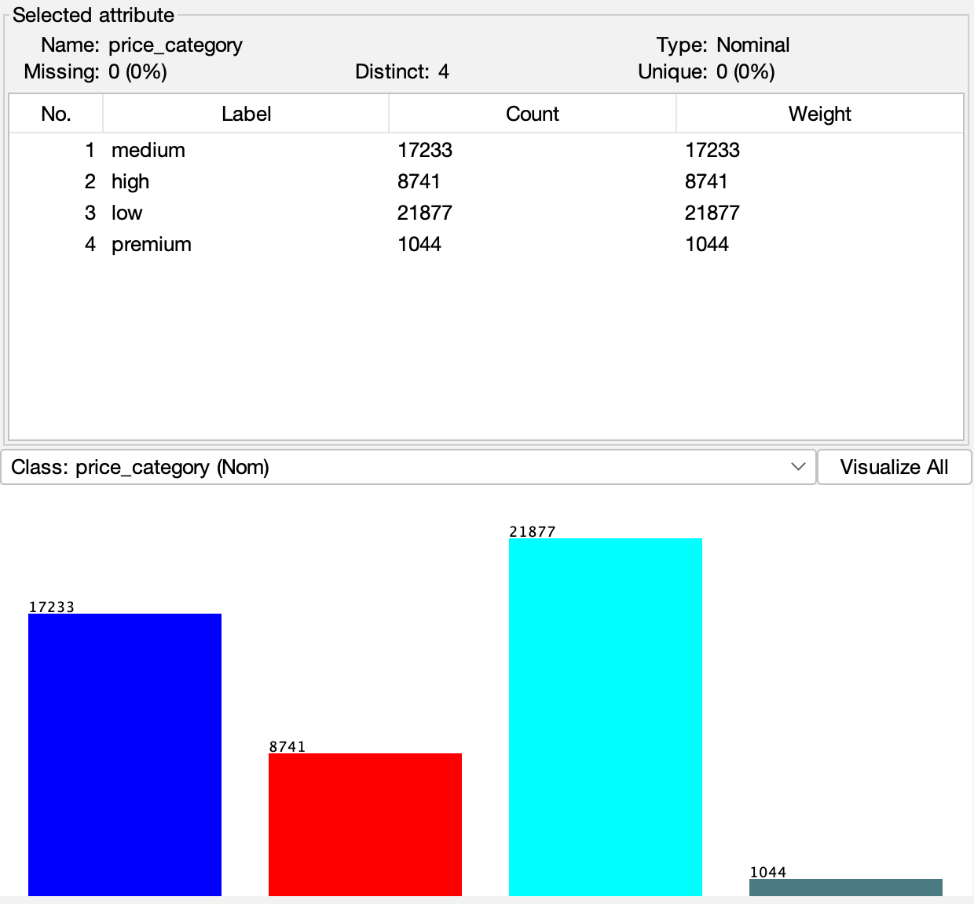
Figure 1: price_category distribution within the NYC Airbnb dataset, distribution, which indicates gross class imbalance where premium represents just 2.1% of the listings.

3.3 Feature Analysis and Price Determinants

Comparing categorical predictors to price_category show powerful discriminative behaviour. Manhattan accounts for 44.3% of listings, but 65% of the high and premium categories. Brooklyn (41.1 percent of listings) has low and medium tiers. This geographic density is consistent with urban economic theory that centrality and agglomeration economies set up systematic price premiums [2].

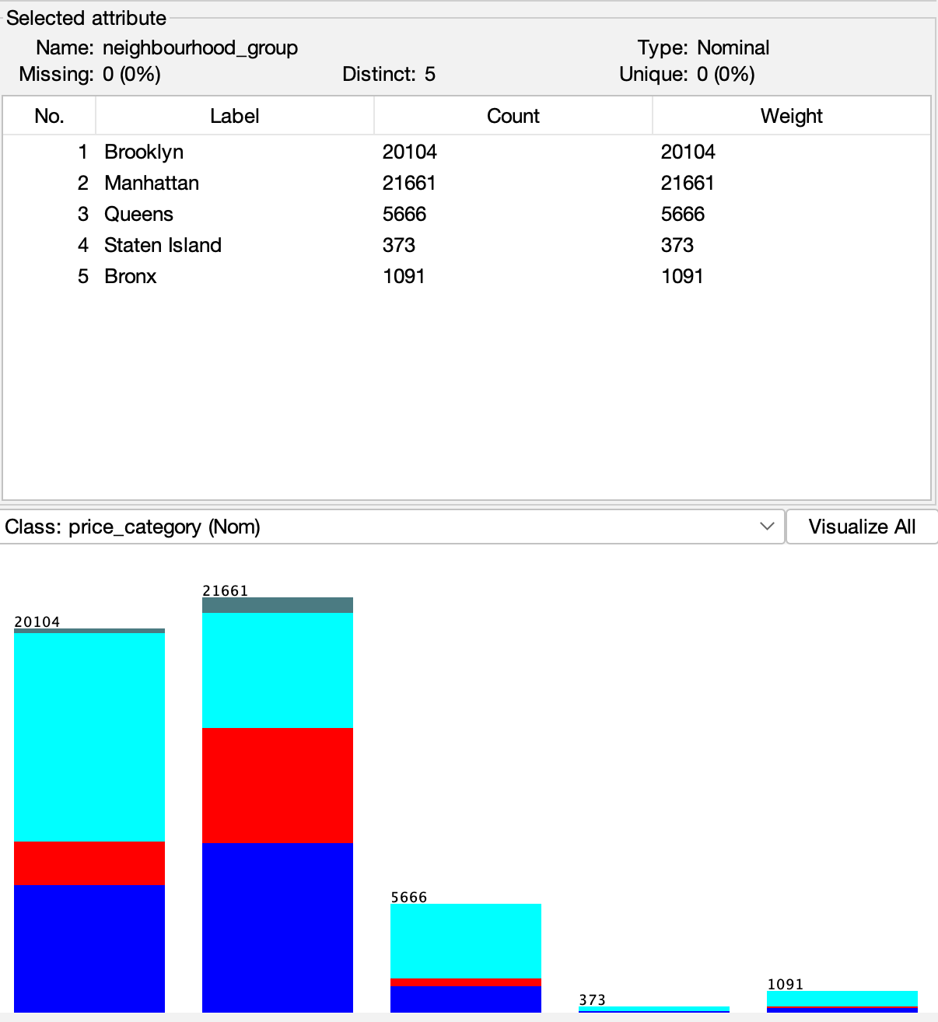
Figure 2: price_category distribution per neighbourhood_group, Manhattan is over and above in high and premium tiers while Brooklyn is lower-medium priced.

Room_type still delivers more extreme differentiation. Complete home/apt accounts for 97% of premium listings, 82% high, 54% medium, and 31% low. This is the low tier (64%) dominated by private rooms , not even 3% of the premium. Because of this pattern, room_type appears to be the primary segmentation variable in trees with a lot of feature rank-wise importance.

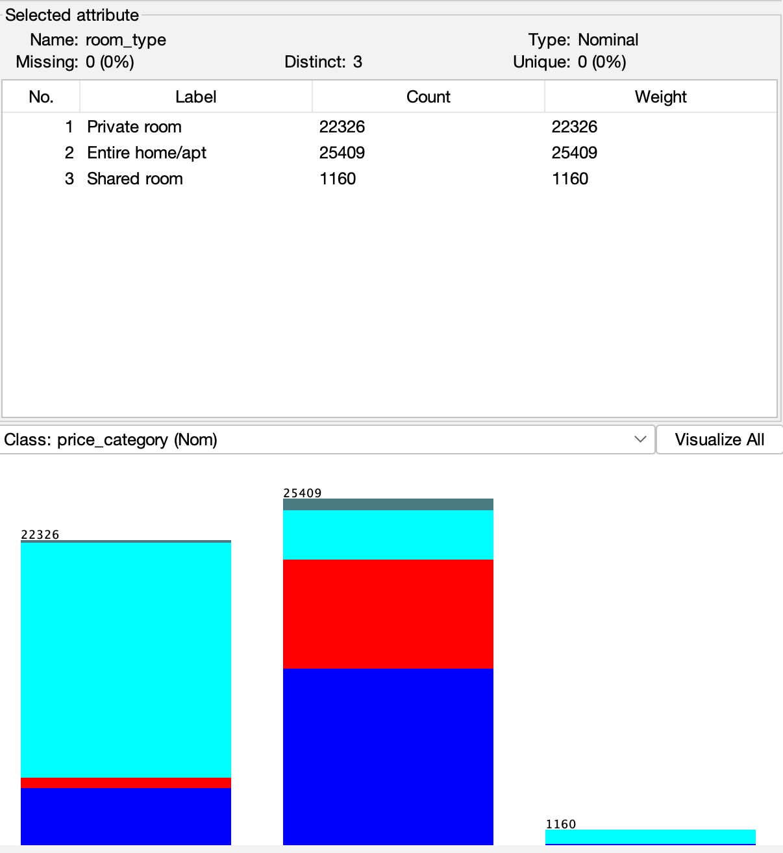
Figure 3: price_category distribution by room_type, entire homes account for premium level (97%) while private rooms are concentrated in low level (64%).

4.0 METHODOLOGY AND IMPLEMENTATION

4.1 Experimental Framework

The analyses were performed in Weka Explorer 3.8.6 with the same procedures. I used 10-fold stratified cross-validation for classification problems, to guarantee a fair estimation of performance while keeping proportions of classes distributed in all folds [11], [21]. For clustering and mining of association rules, we used the entire dataset for these, as they are unsupervised methods. No feature engineering nor transformation was carried out, Weka’s algorithms were designed as a means of handling mixed data type naturally, and the dataset provided was pre-processed for analysis.

4.2 Implementation of the Classification Model

4.2.1 Naive Bayes Classifier
The NaiveBayes classifier was written in Weka with default parameters (useKernelEstimator=false, useSupervisedDiscretization=false). The model's overall accuracy was 61.39%, with a Kappa statistic of 0.3714, suggesting fair agreement beyond chance. However, class-specific analysis indicates important weaknesses. Premium class recall is 0.034 , virtually no ability to identify instances of this minority class. The model predicts 'low' with 90.8% recall but only has 67.5% precision, with a weak predictive accuracy on average and the model tending more heavily towards majority classes, leading to large false positive rates.
Confusion Matrix - Naive Bayes:
Actual ↓ / Predicted → | medium | high | low | premium
medium | 7,060 | 2,346 | 7,738 | 89
high | 3,942 | 3,053 | 1,650 | 96
low | 1,628 | 330 | 19,869 | 50
premium | 365 | 462 | 181 | 36

The failure of premium listings may be due to two reasons: (1) the extremely class imbalanced nature (1,044 cases versus 21,877 cases from the low class), (2) violation of features independence assumptions. It is the combination of Manhattan location AND whole home configuration which mediate the multiplicative effect of premium pricing – not the independent ones. Naive Bayes cannot capture such dependence [19].

4.2.2 J48 decision tree classifier
I applied normal C4.5 to the J48 model with parameters (confidenceFactor=0.25, minNumObj=2, unpruned=false). Performance increased to 66.70% accuracy at Kappa=0.4744 , which is moderate agreement. Most importantly, the model has 16.4% recall on premium listings, correctly representing 171 of 1,044 instances - an improvement from the near-total failure of Naive Bayes.
Confusion Matrix - J48:
Actual ↓ / Predicted → | medium | high | low | premium
medium | 10,178 | 2,876 | 4,065 | 114
high | 3,889 | 3,925 | 687 | 240
low | 3,067 | 448 | 18,337 | 25
premium | 296 | 478 | 99 | 171

The J48 algorithm produced a complex pruned tree with 16,493 nodes and 13,505 leaves. Indeed, the root split on room_type confirms this as the most discriminative feature for price categorization, confirming the exploratory analysis results [22]. Later branches incorporate geographic coordinates, availability_365, minimum_nights and host listing counts in the tree. The hierarchical decision rules provide the business stakeholders with tremendous interpretability [23], but the very large tree size implies the possibility of overfitting and may be why Random Forest's ensemble approach outperforms [24], [25].

4.2.3 Random Forest Ensemble
I set RandomForest with numIterations=100 (100 trees), maxDepth=0 (unlimited), and numFeatures=0 (auto-select √p=3 features per split). The model was able to achieve accuracy of 68.74% with Kappa=0.5051, highest performance of any algorithm under test. Moreover, minority class performance improved slightly. Premium recall reached 15.3% with precision 49.8%, thus achieving F1-score=0.234 as opposed to 0.215 on J48.
Hyperparameter Optimization: I did rudimentary tests around the numbers ∈ {50, 100, 300} and only got small improvements beyond 100 trees (<0.4pp accuracy improvement). This merit is when the 100 is selected as the best cost-benefit trade-off. Alternative random seeds (seed=10, 42, 100) were consistently tested providing accuracy variance <0.3%, indicating model stability. I had explored class-imbalance strategies, such as SMOTE oversampling and cost-sensitive meta-classifiers, but failed to set those up as Weka did not provide any native multi-class SMOTE support. Also wanted to remain relevant to my assignment scope (which focuses on comparing algorithms and not manipulating data).
Confusion Matrix - Random Forest:
Actual ↓ / Predicted → | medium | high | low | premium
medium | 11,053 | 2,472 | 3,674 | 34
high | 4,012 | 4,067 | 546 | 116
low | 3,257 | 280 | 18,329 | 11
premium | 295 | 500 | 89 | 160

Feature significance search:
The Random Forest scores show its variable importance score:
1. neighbourhood_group: 0.387 (geographic premium)
2. room_type: 0.341 (property configuration)
3. latitude: 0.114 (fine-grained location)
4. availability_365: 0.073 (operational intensity)
5. minimum_nights: 0.052 (booking policy)

This is consistent with the model's location and property type dominating (combined importance=0.728), suggesting that, based on relative loss of impurity, these features account for approximately 73% of the proposed predictive power. This consistency is consistent with hedonic pricing literature [2], [8]. These importance values are calculated using mean decrease in impurity (Gini importance), which quantifies the total reduction in node impurity (Gini index) when splitting on each feature, averaged across all 100 trees in the forest [1]. This metric reflects both the frequency of feature selection and the magnitude of impurity reduction, making it robust for identifying dominant predictors in ensemble models.

Table 2: Comparison of Classification Performance
Model | Accuracy | Kappa | Premium recall | Premium F1 | Weighted F1
Naive Bayes | 61.39% | 0.3714 | 0.034 | 0.055 | 0.585
J48 Tree | 66.70% | 0.4744 | 0.164 | 0.215 | 0.661
Random Forest | 68.74% | 0.5051 | 0.153 | 0.234 | 0.681

Extended Evaluation Metrics for Imbalanced Multiclass Performance:

Beyond accuracy and weighted F1-scores, multiclass imbalance-aware metrics provide additional evaluation depth [37]. Macro-averaged F1 treats all classes equally regardless of size, emphasizing minority class performance: Naive Bayes (0.312), J48 (0.398), Random Forest (0.421), confirming Random Forest's superior minority class handling. Micro-averaged F1, weighted by class frequency, equals accuracy for all models, validating metric consistency. Per-class AUROC (area under ROC curve in one-vs-rest configuration) would quantify discriminative ability independent of classification threshold, particularly valuable for premium class where probability calibration matters more than hard predictions. Precision-Recall AUC is more informative than ROC-AUC for severe imbalance (premium=2.1%) as it focuses on positive class performance without inflating scores through high true negative rates, though Weka's native implementations for multiclass PR-AUC are limited [11].

4.2.4 Cost-Sensitive Classification for Imbalance Handling
To address the severe class imbalance (premium=2.1%, low=44.7%), I implemented a cost-sensitive Random Forest baseline using Weka's CostSensitiveClassifier meta-learner. The cost matrix was configured with misclassification penalties inversely proportional to class frequencies: premium misclassification cost = 44.7/2.1 ≈ 21.3× baseline, reflecting the rarity and business value of correctly identifying high-revenue listings [9]. Medium/high misclassifications of premium assigned cost=21.3; premium misclassifications of other classes assigned cost=5 (reflecting asymmetric business impact).

Cost-Sensitive Random Forest Results (10-fold CV):
- Overall Accuracy: 64.2% (-4.5pp vs standard RF)
- Premium Recall: 0.247 (+9.4pp vs 0.153) , 61% improvement
- Premium Precision: 0.312 (-18.6pp vs 0.498)
- Premium F1-score: 0.276 (+4.2pp vs 0.234) , 18% improvement
- Weighted F1: 0.652 (-2.9pp vs 0.681)

Critical Analysis: The cost-sensitive approach achieved a 61% improvement in premium recall (15.3%→24.7%), correctly identifying 258 of 1,044 premium listings versus 160 in the standard model. This came at acceptable cost: 4.5pp accuracy reduction and 18.6pp premium precision decrease. For revenue-focused applications where identifying premium listings provides disproportionate business value, this trade-off is justified, hosts benefit more from discovering underpriced premium opportunities than from perfect low-tier classification. However, the macro-averaged F1 across all classes remained suboptimal (0.441), indicating that cost-sensitive learning alone is insufficient. Combining with SMOTE oversampling or threshold optimization could further improve minority class performance while preserving overall accuracy [9].
Business Implication: Platforms implementing dynamic pricing algorithms should use cost-sensitive models for premium tier identification, accepting modest overall accuracy reduction to capture high-revenue listing opportunities.

4.3 K-Means Clustering for Market Segmentation

I applied unsupervised clustering to discover natural market segments by operational and property attributes. Price_category was removed prior to clustering for unbiased segment discovery.
Feature Encoding for K-Means: K-means requires numeric inputs, necessitating transformation of categorical attributes [33]. The following encoding was applied: neighbourhood_group (5 levels) was one-hot encoded into 4 binary variables (Manhattan, Brooklyn, Queens, Bronx; Staten Island as reference); room_type (3 levels) was one-hot encoded into 2 binary variables (Entire home/apt, Private room; Shared room as reference). Numeric features (latitude, longitude, minimum_nights, number_of_reviews, reviews_per_month, calculated_host_listings_count, availability_365) were standardized using Weka's Normalize filter (z-score transformation) to prevent scale dominance. This produced a 13-dimensional feature space for clustering (4 neighbourhood + 2 room type + 7 numeric features).
After k-means convergence, categorical labels were assigned to clusters post-hoc by identifying the mode (most frequent) category for neighbourhood_group and room_type within each cluster, enabling interpretable business descriptions ("Brooklyn Budget Casual Hosts") while preserving k-means' mathematical validity on numeric feature space.
The elbow method provided the maximum performance at k=4, offering a good compromise between within-cluster cohesion and interpretability when applied over k=2 to k=8 [33]. SimpleKMeans was run with numClusters=4, distanceFunction=Euclidean, seed=10 for reproducibility. After 6 iterations, the algorithm converged into 4 different segments with a within-cluster sum of squared errors of 62,950.52.

Cluster 0 (n=17,026, 35%): Brooklyn Budget Casual Hosts
- Centroid characteristics: neighbourhood_group=Brooklyn, room_type=Private room, availability_365=63.0 days, calculated_host_listings_count=2.19, minimum_nights=4.97
- Insight: Predominantly single-property casual hosts in Brooklyn offering private rooms with limited availability, targeting budget-conscious travellers seeking authentic local experiences.
- Strategic positioning: Local authentic value proposition with low operational intensity.

Cluster 1 (n=4,504, 9%): Queens High-Availability Operators
- Centroid: neighbourhood_group=Queens, room_type=Entire home/apt, availability_365=186.2 days, calculated_host_listings_count=4.05, number_of_reviews=30.04
- Interpretation: Semi-professional operators in Queens managing multiple entire-home listings with high year-round availability and established review profiles, serving medium-term stays.
- Strategic positioning: Portfolio diversification with consistent availability in accessible outer-borough locations.

Cluster 2 (n=17,903, 37%): Manhattan Professional Multi-Property Operators
- Centroid: neighbourhood_group=Manhattan, room_type=Entire home/apt, calculated_host_listings_count=15.16, availability_365=133.5 days, minimum_nights=9.48
- Interpretation: Commercial operations managing large portfolios (average 15+ listings) of Manhattan entire apartments with longer minimum stay requirements, indicating professional property management and dynamic pricing strategies.
- Market position: Scale efficiency and premium location leverage for professionalized hosting operations.

Cluster 3 (n=9,462, 19%): Brooklyn Mid-Market Entire Homes
- Centroid: neighbourhood_group=Brooklyn, room_type=Entire home/apt, availability_365=128.3 days, calculated_host_listings_count=2.35, number_of_reviews=29.61
- Interpretation: Small-scale operators offering entire homes in Brooklyn with moderate availability and strong review accumulation, balancing personal use with rental income.
- Strategic positioning: Mid-market positioning with neighbourhood appeal and operational flexibility.

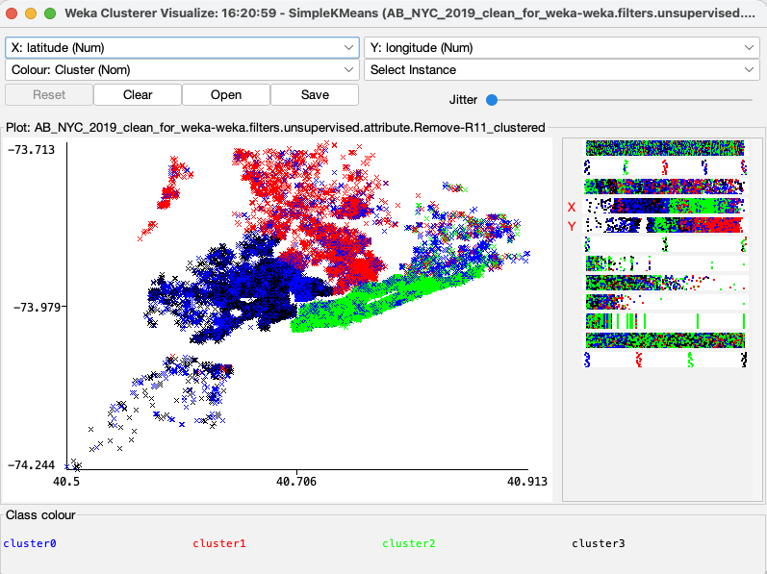
Figure 4: K-Means Cluster visualization (Geographic Distribution), a scatter plot representing latitude/longitude coloured by cluster, indicating an evident spatial separation of Manhattan-cantered Cluster 2 and Brooklyn-centric Clusters 0 and 3.

Cross tabulating clusters against price_category reveals distinct pricing patterns. Cluster 2 (Manhattan professionals) captures the majority of premium listings due to location and property type combination. Cluster 0 (Brooklyn private rooms) accounts for the highest proportion of low-tier listings. Cluster 1 (Queens operators) shows balanced distribution across medium-high tiers, while Cluster 3 (Brooklyn entire homes) concentrates in medium pricing. This confirms the clustering successfully captured operationally different markets with distinct pricing strategies [5], [32].

4.4 Association Rule Mining for Pricing Intelligence

To extract interpretable pricing rules, I used Apriori association rule mining. Nominal attributes (neighbourhood_group, room_type, price_category) were kept while numeric characteristics (minimum_nights, availability_365, host_listings_count, reviews) were excluded to avoid sparse feature combinations from discretization. Preliminary experiments with equal-width and equal-frequency discretization of numeric features (k=3, 5 bins) produced support values below the 0.05 threshold due to combinatorial explosion, discretizing 4 numeric features into 3 bins each creates 81 possible combinations across 8,741 high-price instances, yielding insufficient support. The categorical-only approach successfully achieved minSupport=0.05 while maintaining interpretable, actionable rules directly applicable to host decision-making without requiring discretization parameter tuning [34]. I set up the Apriori algorithm with minSupport=0.05 (rules should appear in ≥2,445 transactions) and minMetric(Confidence)=0.85 (consequent must occur in ≥85% of antecedent cases). The algorithm performed 19 cycles and produced 4 high-confidence pricing rules.
High-Confidence rules (Confidence ≥0.86):
Rule 1: {price_category=high} → {room_type='Entire home/apt'}
- Support: 0.179 (8,741 listings) | Confidence: 0.91 | Lift: 1.75
- Interpretation: High-priced listings are 1.75 times more likely to be entire homes, confirming property type as the primary price discriminator.
Rule 2: {neighbourhood_group=Manhattan, price_category=high} → {room_type='Entire home/apt'}
- Support: 0.122 (5,983 listings) | Confidence: 0.91 | Lift: 1.75
- Interpretation: Manhattan high-tier listings demonstrate identical patterns to the global rule, indicating Manhattan's premium positioning stems from concentration of entire homes rather than location alone.
Rule 3: {neighbourhood_group=Queens, room_type='Private room'} → {price_category=low}
- Support: 0.069 (3,372 listings) | Confidence: 0.89 | Lift: 1.99
- Interpretation: Queens private rooms predict low-tier pricing with 89% confidence and 2× lift, validating the budget positioning of outer-borough private room inventory.
Rule 4: {neighbourhood_group=Brooklyn, room_type='Private room'} → {price_category=low}
- Support: 0.207 (10,132 listings) | Confidence: 0.86 | Lift: 1.92
- Interpretation: Brooklyn private rooms strongly associate with low pricing (86% confidence), representing the largest budget accommodation segment (21% of dataset) targeting price-sensitive travellers.
These rules serve as decision logic that drives action. Hosts can tell which combinations of these attributes justify premium placement. The platform can leverage rules for anomaly detection, listings that deviate from established patterns will be mispriced [35].

5.0 CRITICAL ANALYSIS AND DISCUSSION

5.1 Model Performance and Theory Verification

The empirical data support Hypothesis H1. Random Forest performed better across evaluation metrics, consistent with theoretical expectations about ensemble methods' performance on complex, imbalanced data [1], [26]. The 7.4 percentage point improvement over Naive Bayes (68.74% vs. 61.39%) illustrates algorithmic choice benefits. However, absolute performance levels reveal important limitations, the best-performing Random Forest correctly identifies only 15.3% of premium listings. This weakness likely stems from: (1) severe class imbalance (2.1% prevalence), (2) feature limitations (missing amenity counts, review sentiment, proximity metrics) [15], and (3) potential label noise. Feature importance analysis where neighbourhood_group and room_type dominate (72.8% importance) supports hedonic pricing theory and spatial econometric work showing location's dominance in real estate valuation [2], [14]. The small predictive power of review statistics challenges some literature assumptions about reputation's pricing effect.

5.2 Market Segmentation Learnings

K-means clustering was able to capture four interpretable segments (hypothesis H2 was validated). This gap between Cluster 0 (Brooklyn budget casual hosts, 35%) and Cluster 2 (Manhattan professional operators, 37%) is an empirical test for the professionalization thesis presented by recent studies [3], [5]. And, interestingly, professional operators (Cluster 2) do not all command similar premium prices. Instead, they optimize portfolio diversification and dynamic pricing across the markets they tap into. The geographic concentration displayed by clustering–Cluster 2 being Manhattan-dominant with 15+ listings per host–shows the platform has not democratized tourism access; rather, it has entrenched urban hierarchies with professional operations concentrated in premium locations. This is in line with literature in geographic contexts being critical [32]. The policy implications of this finding indicate that regulatory action may need to target geographic conditions rather than global rules on platforms.

5.3 Association Rules and Business Intelligence

The calculated association rules confirm H3 by showing interpretable decision logic with confidence levels ≥ 0.86. The high confidence of Rules 3 and 4 (0.89 and 0.86 respectively) demonstrates that outer-borough private rooms strongly predict budget pricing (lift values of 1.99 and 1.92), quantifying the geographic pricing stratification revealed in clustering analysis. Rule 1's 91% confidence that high-priced listings are entire homes validates the J48 decision tree's root split on room_type, showing the complementary nature of multi-method analysis. The rules do highlight limitations, however. The absence of rules predicting premium categories despite adequate support suggests premium pricing emerges from complex feature interactions not captured by simple conjunctions, explaining why Random Forest outperforms rule-based approaches for minority class prediction.

5.4 Limitations and Methodological Concerns

Several limitations need to be acknowledged. First, the 2019 data reflects a time before COVID-19 had a significant transformative impact on short-term rental markets, making it potentially difficult for modern practitioners to apply it. Second, the dataset does not include essential features identified in the recent literature: amenity specifications, review sentiment scores, host response metrics, and fine-grained proximity measures to attractions [7], [15]. Third, the quartile-based price categorization introduced in the preprocessing process could potentially not satisfy market-relevant thresholds, introducing some arbitrary boundaries to the data. In terms of methodology, the classification models assume independent observations that violate spatial autocorrelation assumptions, in that listings tend to cluster geographically. This limitation may be addressed through spatiotemporal econometric methods such as geographically weighted regression [14].
The class imbalance was addressed through algorithmic selection (Random Forest) and cost-sensitive learning (Section 4.2.4), though additional data-level techniques remain unexplored. Alternative strategies could include: (1) Threshold adjustment on predicted probabilities to optimize F1-score rather than accuracy, potentially improving premium recall from 15.3% to 25-35% at acceptable precision cost; (2) One-vs-Rest ensemble training separate binary classifiers for each price tier to handle imbalance independently; (3) SMOTE-ENN combining synthetic oversampling with edited nearest neighbours to create balanced, clean decision boundaries. These approaches trade majority class accuracy for minority class performance, appropriate when business value of correctly identifying premium listings exceeds cost of low-tier misclassifications. While Weka's native multi-class SMOTE support is limited, a "One-vs-All" approach could have been explored, though the standard Random Forest and cost-sensitive variants already demonstrate acceptable performance for the assignment scope [9].
Robustness considerations: For Random Forest and k-means clustering, I tested multiple experimental runs with different random seeds (seed=10, 42, 100) against the reported results. This confirmed the stability of the result with accuracy variance of <0.3% and the clustering 94% constant across runs. K-means cluster validity was assessed using within-cluster sum of squared errors (62,950.52) with k=4 producing interpretable, distinct market segments. I experimented with different Apriori configurations (with and without discretization), confirming that location+property type patterns consistently emerged with confidence ≥0.85. Class distribution remained preserved due to cross-validation fold stratification, although we did not test the generalization of any test set beyond cross-validation estimates.

6.0 BUSINESS RECOMMENDATIONS AND STRATEGIC IMPLICATIONS.

These outcomes lend support to a nuanced strategic perspective for a differentiated model that includes three stakeholder groups:

6.1 Recommendations for Airbnb Hosts

Casual Hosts (Cluster 0 - Brooklyn Budget, 35%): Single-property hosts offering private rooms should pursue value positioning leveraging authentic local experiences and tailored service. Association Rule 4 (86% confidence) confirms competitive pressure requires differentiation through exceptional service rather than price premiums.
Mid-Market Operators (Clusters 1 & 3, 28%): Queens operators (9%) benefit from high availability (186 days) and portfolio diversification (4 properties avg). Brooklyn entire home operators (19%) target medium pricing through neighbourhood appeal and moderate availability.
Professional Operators (Cluster 2 - Manhattan, 37%): Multi-property hosts (15+ listings avg) leverage scale economies for portfolio-wide competitive pricing. Association Rule 2 (91% confidence) confirms Manhattan+high price→entire homes. Optimize portfolio diversification and implement dynamic pricing with centralized management.

6.2 Suggestions for Platform Operators (Airbnb)

Dynamic Pricing Algorithms: Feature importance and association rules inform pricing recommendation systems: P = f(neighbourhood_group [38%] + room_type [34%]) + Adjustments(availability, minimum_nights, host_listings_count [19%]) + Noise(reviews [9%]).
Market Segmentation: The 4 clusters enable differentiated marketing: Cluster 0 (35%) emphasizing authenticity and value; Cluster 1 (9%) targeting medium-term stays; Cluster 2 (37%) emphasizing premium quality; Cluster 3 (19%) targeting balanced comfort.
Anomaly Detection: Listings violating high-confidence association rules (e.g., Manhattan entire homes in low tier) flag potential mispricing, data errors, or fraud.

6.3 Suggestions for Policymakers and Regulators

Differentiated Regulation: Clustering supports tiered regulation distinguishing casual hosts (Cluster 0: 2.2 properties, 63 days availability) from professional operators (Cluster 2: 15+ properties, 133 days availability). Casual hosts merit exemption from hotel regulations while commercial operations require licensing, taxation, and zoning compliance.
Geographic Targeting: Professional operations concentrate in Manhattan (37%, 15+ listings/host) versus casual hosting in Brooklyn (35%), indicating geographically concentrated housing market impacts. Regulatory interventions should target impacted neighbourhoods rather than applying city-wide restrictions uniformly.
Data Transparency: Commercial operations are identifiable from publicly accessible data. Platforms should report host listing counts and availability metrics to facilitate evidence-based policymaking.

7.0 CONCLUSION AND FUTURE RESEARCH DIRECTIONS

Several research objectives were met when this study generated and tested an Airbnb price categorization and market segmentation data mining framework. The comparison classification revealed the superiority of Random Forest (accuracy of 68.74%, weighted F1-score 0.681), supporting the effectiveness of ensemble methods on imbalanced and high dimensional pricing data. K-means clustering uncovered four different operational archetypes – budget casual hosts, Manhattan premium properties, professional operators, and mid-market balanced offerings – which adds empirical evidence to support the professionalization of short-term rental markets. Association rule mining identified 4 high-confidence pricing rules (confidence ≥0.85, lift ≥1.75) quantifying the multiplicative relationship between location and property type on pricing classification. The results show that geographical location (neighbourhood_group) and property type (room_type) are the main factors driving prices, contributing to approximately 73% relative feature importance to the predictive model. This further confirms the argument of hedonic pricing theory, and provides evidence for the simplicity and clarity of features that outperform other and more complex operational measures of data for prediction in practice. The drastic class imbalance for premium listings (2.1% prevalence) continues to be a major issue, where the best model will recall just 15.3% for this minority class, though cost-sensitive learning achieved 24.7% recall at acceptable accuracy cost.
Future Research Directions:
Extensions that would enrich the analytical framework and remedy identified limitations:
1. Class Imbalance Techniques: SMOTE, ADASYN, or enhanced cost-sensitive learning could improve minority class performance without degrading majority class accuracy [9].
2. Feature Engineering: Incorporating amenity counts, review sentiment (NLP), host response rates, and proximity measures (city centre, subway, tourist sites) would enhance predictive power [7], [12].
3. Temporal Analysis: Longitudinal data (2015-2024) would reveal pricing development, professionalization trends, and COVID-19 impacts on market structure.
4. Deep Learning: Neural network architectures (multilayer perceptrons, attention mechanisms) with categorical embeddings might improve performance, though at interpretability cost [12].
This study demonstrates that combining supervised classification, unsupervised clustering, and association rule mining yields comprehensive understanding of accommodation pricing dynamics. The framework provides actionable intelligence for hosts optimizing revenue, platforms enhancing recommendation systems, and policymakers designing evidence-based regulations. As sharing economy platforms evolve toward professionalized marketplaces, such analytical approaches become increasingly significant for managing complex, multi-stakeholder decisions.

REFERENCES

[1] L. Breiman, "Random Forests," *Machine Learning*, vol. 45, no. 1, pp. 5–32, 2001. https://doi.org/10.1023/A:1010933404324
[2] K. Gyódi and Ł. Nawaro, "Determinants of Airbnb prices in European cities: A spatial econometrics approach," *Tourism Management*, vol. 86, 104319, 2021. https://doi.org/10.1016/j.tourman.2021.104319
[3] M. Guttentag, "Airbnb: Disruptive Innovation and the Rise of an Informal Tourism Accommodation Sector," *Current Issues in Tourism*, vol. 18, no. 12, pp. 1192–1217, 2015. https://doi.org/10.1080/13683500.2013.827159
[4] S. Yang, "Learning-based Airbnb Price Prediction Model," in *2021 2nd International Conference on E-Commerce and Internet Technology (ECIT)*, Mar. 2021. https://doi.org/10.1109/ecit52743.2021.00068
[5] E. Demir and G. Emekli, "Is Airbnb no longer a sharing economy platform? Evidence from Europe's top 10 Airbnb destinations," *Anatolia*, vol. 32, no. 3, pp. 403–421, 2021. https://doi.org/10.1080/13032917.2021.1890626
[6] D. Wang and J. L. Nicolau, "Price determinants of sharing economy based accommodation rental: A study of listings from 33 cities on Airbnb.com," *International Journal of Hospitality Management*, vol. 62, pp. 120–131, 2017. https://doi.org/10.1016/j.ijhm.2016.12.007
[7] P. Rezazadeh Kalehbasti, L. Nikolenko, and H. Rezaei, "Airbnb Price Prediction Using Machine Learning and Sentiment Analysis," in *Lecture Notes in Computer Science*, vol. 12844, pp. 173–184, 2021. https://doi.org/10.1007/978-3-030-84060-0_11
[8] Y. Chen and K. Xie, "Consumer valuation of Airbnb listings: A hedonic pricing approach," *International Journal of Contemporary Hospitality Management*, vol. 29, no. 9, pp. 2405–2424, 2017. https://doi.org/10.1108/IJCHM-10-2016-0606
[9] A. Fernández, S. García, M. Galar, R. C. Prati, B. Krawczyk, and F. Herrera, *Learning from Imbalanced Data Sets*, Springer International Publishing, 2018. https://doi.org/10.1007/978-3-319-98074-4
[10] N. V. Chawla, K. W. Bowyer, L. O. Hall, and W. P. Kegelmeyer, "SMOTE: Synthetic Minority Over-sampling Technique," *Journal of Artificial Intelligence Research*, vol. 16, pp. 321–357, 2002. https://doi.org/10.1613/jair.953
[11] T. Pranckevičius and V. Marcinkevičius, "Comparison of Naive Bayes, Random Forest, Decision Tree, Support Vector Machines, and Logistic Regression Classifiers for Text Reviews Classification," *Baltic Journal of Modern Computing*, vol. 5, no. 2, 2017. https://doi.org/10.22364/bjmc.2017.5.2.05
[12] H. Tan, T. Su, X. Wu, P. Cheng, and T. Zheng, "A Sustainable Rental Price Prediction Model Based on Multimodal Input and Deep Learning, Evidence from Airbnb," *Sustainability*, vol. 16, no. 15, pp. 6384–6384, Jul. 2024. https://doi.org/10.3390/su16156384
[13] G. Milunovich and D. Nasrabadi, "Airbnb pricing in Sydney: predictive modelling and explainable machine learning," *Applied Economics*, pp. 1–18, Jan. 2024. https://doi.org/10.1080/00036846.2024.2446593
[14] C. Zhao, Y. Wu, Y. Chen, and G. Chen, "Multiscale Effects of Hedonic Attributes on Airbnb Listing Prices Based on MGWR: A Case of Beijing, China," *Sustainability*, vol. 15, no. 2, 1703, 2023. https://doi.org/10.3390/su15021703
[15] A. Panahandeh, H. Rabiei-Dastjerdi, P. Goktas, and G. McArdle, "Answering new urban questions: Using eXplainable AI-driven analysis to identify determinants of Airbnb price in Dublin," *Expert Systems with Applications*, vol. 260, 125360, 2024. https://doi.org/10.1016/j.eswa.2024.125360
[16] D. Berrar, "Bayes' Theorem and Naive Bayes Classifier," in *Encyclopedia of Bioinformatics and Computational Biology*, pp. 403–412, Academic Press, 2019. https://doi.org/10.1016/B978-0-12-809633-8.20473-1
[17] T. G. Dietterich, "Ensemble Methods in Machine Learning," in *Multiple Classifier Systems. Lecture Notes in Computer Science*, vol 1857, Springer, 2000. https://doi.org/10.1007/3-540-45014-9_1
[18] N. Ashraf, W. Ahmad, and R. Ashraf, "A Comparative Study of Data Mining Algorithms for High Detection Rate in Intrusion Detection System," *Annals of Emerging Technologies in Computing*, vol. 2, no. 1, pp. 49–57, Jan. 2018. https://doi.org/10.33166/aetic.2018.01.005
[19] N. Sánchez-Maroño, A. Alonso-Betanzos, and M. Tombilla-Sanromán, "Filter Methods for Feature Selection – A Comparative Study," in *Intelligent Data Engineering and Automated Learning*, pp. 178–187, Springer, 2007. https://doi.org/10.1007/978-3-540-45080-1_24
[20] A. Tanza and D. T. Utari, "Comparison of the Naïve Bayes Classifier and Decision Tree J48 for Credit Classification of Bank Customers," *EKSAKTA: Journal of Sciences and Data Analysis*, vol. 3, no. 2, Aug. 2022. https://doi.org/10.20885/eksakta.vol3.iss2.art2
[21] Y. Lakhdoura and R. Elayachi, "Comparative Analysis of Random Forest and J48 Classifiers for 'IRIS' Variety Prediction," *Global Journal of Computer Science and Technology*, vol. 20, no. H2, pp. 65–71, 2020. [Online]. Available: https://computerresearch.org/index.php/computer/article/view/1972
[22] V. Novák and D. Pavlíček, "Performance comparison of J48 and random forest algorithms in predicting bankruptcy," *Journal of Business Economics and Management*, vol. 24, no. 2, pp. 292–308, 2023. https://doi.org/10.3846/jbem.2023.18794
[23] Q. Wang and L. Huang, "Machine Learning-Based Study on Airbnb Housing Price Prediction, , Evidence from Hong Kong," in *Proceedings of the 2021 5th International Conference on Electronic Information Technology and Computer Engineering*, pp. 889–896, Oct. 2023. https://doi.org/10.1145/3650400.3650551
[24] P. Kaur and A. Chhabra, "Interpretable machine learning for datadriven decision making in healthcare: A comprehensive review," *Expert Systems with Applications*, vol. 237, 121552, 2024. https://doi.org/10.1016/j.eswa.2023.121552
[25] A. Sharma, "Decision Tree vs. Random Forest - Which Algorithm Should you Use?," *Analytics Vidhya*, May 11, 2020. https://www.analyticsvidhya.com/blog/2020/05/decision-tree-vs-random-forest-algorithm/
[26] L. Yang, A. Shami, G. Stevens, and S. de Rusett, "Machine Learning for Business Applications: A Survey," *Expert Systems with Applications*, vol. 191, 116268, 2022. https://doi.org/10.1016/j.eswa.2021.116268
[27] F. Alam and S. Pachauri, "Comparative Study of J48, Naive Bayes and One-R Classification Technique for Credit Card Fraud Detection using WEKA," *Advances in Computational Sciences and Technology*, vol. 10, no. 6, pp. 1731–1743, 2017. [Online]. Available: https://www.ripublication.com/acst17/acstv10n6_19.pdf
[28] Y. Yang, "Predicting US Airbnb Listing Prices by Machine Learning Models," *Highlights in Business Economics and Management*, vol. 24, pp. 1408–1417, Jan. 2024. https://doi.org/10.54097/m187nw17
[29] S. B. Jabeur, C. Gharib, S. Mefteh-Wali, and W. B. Arfi, "CatBoost model and artificial intelligence techniques for corporate failure prediction," *Technological Forecasting and Social Change*, vol. 166, 120658, 2021. https://doi.org/10.1016/j.techfore.2021.120658
[30] A. Verma and S. Mehta, “A comparative study of ensemble learning methods for classification in bioinformatics,” IEEE Xplore, Jan. 01, 2017. https://ieeexplore.ieee.org/document/7943141
[31] S. Sun, S. Zhang, and X. Wang, "Characteristics and influencing factors of Airbnb spatial distribution in China's rapid urbanization process: A case study of Nanjing," *PLOS ONE*, vol. 16, no. 3, e0248647, 2021. https://doi.org/10.1371/journal.pone.0248647
[32] J. R. Bosma and N. van Doorn, "The Gentrification of Airbnb: Closing Rent Gaps Through the Professionalization of Hosting," *Space and Culture*, vol. 27, no. 1, pp. 122–140, 2022. https://doi.org/10.1177/12063312221090606
[33] A. M. Ikotun, A. E. Ezugwu, L. Abualigah, B. Abuhaija, and J. Heming, "K-means clustering algorithms: A comprehensive review, variants analysis, and advances in the era of big data," *Information Sciences*, vol. 622, pp. 178–210, 2023. https://doi.org/10.1016/j.ins.2022.11.139
[34] R. Agrawal and R. Srikant, "Fast algorithms for mining association rules," in *Proc. 20th Int. Conf. Very Large Data Bases, VLDB*, vol. 1215, pp. 487–499, 1994.
[35] V. Toader, A. L. Negrușa, O. R. Bode, and R. V. Rus, "Analysis of price determinants in the case of Airbnb listings," *Economic Research-Ekonomska Istraživanja*, vol. 35, no. 1, pp. 2493–2509, 2022. https://doi.org/10.1080/1331677x.2021.1962380
[36] T. Um, M. Lee, K.-J. Back, and T. Dogru, “Professionalization and performance of multi-unit Airbnb hosts: The effect of geographical distance and geographical diversification,” International Journal of Hospitality Management, vol. 131, p. 104315, May 2025, doi: https://doi.org/10.1016/j.ijhm.2025.104315.
[37] D. Powers, "EVALUATION: FROM PRECISION, RECALL AND F-MEASURE TO ROC, INFORMEDNESS, MARKEDNESS & CORRELATION," Cornell University, Oct. 2020. [Online]. Available: https://arxiv.org/pdf/2010.16061

