Research on Network Intrusion Detection System based on Ensemble Learning: Analysis of Generalization Ability against Unknown Attack Categories

Abstract
Network security faces a specific challenge with the NSL-KDD dataset: the imbalance between normal traffic and rare attack types like U2R. The Intrusion Detection System (IDS), as a key component of the network security defense system, is facing the severe challenge that traditional signature detection technologies are difficult to identify unknown attacks (Zero-day attacks). This study aims to utilize the NSL-KDD benchmark dataset to explore the application potential of ensemble learning algorithms in multi-class network intrusion detection.
During data exploration, this study found that the test set contained 14 attack types absent from the training set, presenting an open-set recognition challenge. To address this, all attack labels were mapped into five functional categories (Normal, DoS, Probe, R2L, U2R) based on their taxonomy, enabling the model to generalize to unseen variants. Two ensemble models—Random Forest and Gradient Boosting—were built and tuned. Results showed that the mapping strategy allowed both models to effectively detect unseen DoS and Probe attacks, achieving over 92% accuracy overall. Random Forest demonstrated better computational efficiency and resistance to overfitting, while Gradient Boosting achieved higher precision for most classes. However, both models struggled with U2R and R2L due to the limited number of samples. This report further analyzes feature importance and provides suggestions for addressing these limitations.
Key words: Network security, Intrusion detection, Ensemble learning, NSL-KDD, Random forest, Gradient boosting, Generalization ability.

1.Introduction

1.1 Research Background
The means of cyber-attacks are becoming increasingly covert and intelligent, posing a huge threat to national security and enterprise assets [1]. According to relevant statistics, the occurrence frequency of denial-of-service attacks (DoS), malicious software dissemination, and privilege escalation and other attack behaviors has increased exponentially [2].

1.2 Evolution of Intrusion Detection Systems
Traditional intrusion detection systems mainly rely on misuse detection, which involves matching known attack signature libraries to identify threats [3]. However, this method has significant lag and is unable to detect "zero-day attacks" that are not present in the signature library [4]. To overcome this drawback, intelligent IDS based on anomaly detection has gradually become a research hotspot. This method uses machine learning algorithms to establish the behavioral profile of normal network traffic and detects potential intrusions by identifying deviations from normal behavior [5].

1.3 Research Objectives
This study aims to utilize the NSL-KDD dataset and employ ensemble learning methods to address the multi-classification problem in Intrusion Detection Systems (IDS). The core objective is not only to distinguish between normal and attack traffic, but also to accurately identify the specific types of attacks. Particularly, considering the situation in real scenarios where the test environment often contains unknown attack variants from the training environment, this study will focus on exploring how to adopt a reasonable label mapping strategy and optimize the model parameters to enhance the model's generalization ability for unknown threats.

2.Problem Statement with Literature Support

2.1Applicability of the NSL-KDD Dataset
The original KDD Cup 99 dataset was once the "gold standard" in the field of IDS, but McHugh et al. [6] pointed out that this dataset contained a large number of redundant records, causing machine learning models to be biased towards the frequently occurring records, thereby generating errors. Tavallaee et al. [7] proposed the NSL-KDD dataset, which solved this problem by eliminating redundant records and reclassifying the difficulty levels, making it an ideal benchmark for evaluating modern IDS algorithms.

2.2The Open-Set Recognition Challenge
During the exploratory analysis (EDA) of the dataset, this study discovered a highly challenging phenomenon in machine learning applications:
- Training Set: Contains 23 types of attack labels.
- Testing Set: Contains 36 types of attack labels.
This means that there are 14 types of attacks (such as apache2, mscan, saint, udpstorm, etc.) in the test set that the model has never "seen" during the training phase. Under the traditional supervised learning framework, if specific attack names are directly used as labels, the model will be unable to predict these unknown categories. That is to say, the model will never be able to recognize labels it has never encountered, and this is the so-called "open set recognition" problem [8]. Geng et al. [9] pointed out that when dealing with the open set problem, if appropriate handling is lacking, the prediction performance of the model will sharply decline.

2.3 Taxonomy-based Mapping Strategy
In order to solve the above-mentioned inconsistency problem of labels, it is necessary to endow the model with the generalization ability of "learning from one example to understand many". Stolfo et al. [10] proposed in their pioneering work on the KDD dataset that although the means of network attacks are constantly changing, they can be classified into four major families based on the attack consequences and behavioral patterns:
- DoS (Denial of Service): Consumes the resources of the victim, such as neptune (known) and apache2 (unknown).
- Probe: Collects target information, such as satan (known) and mscan (unknown).
- R2L (Remote to Local): Remote illegal access, such as guess_passwd.
- U2R (User to Root): Local privilege escalation, such as buffer_overflow.
Based on this theory, Mahfouz et al. [11] conducted a study that proved that mapping fine-grained attack labels to the above five categories (including Normal) could significantly enhance the robustness of the classifier when dealing with unknown variant attacks. Because even the unknown apache2 attack, with its traffic characteristics (such as huge traffic throughput), is highly similar to the known back or neptune attacks.
Therefore, in accordance with the standards of references [7] and [10], this study adopted a 5-category mapping strategy. This is not only a technical means to solve label inconsistency, but also a necessary step to simulate the real IDS scenario (requiring detection of unknown variants).

Methodology

3.1Examine the distribution of data
Using visualization techniques and related technologies, the training set and test set data of the original data are respectively visualized to observe the data distribution and the types of labels in the training set and test set. Results show as Fig 1, Fig 2 and Fig 3.
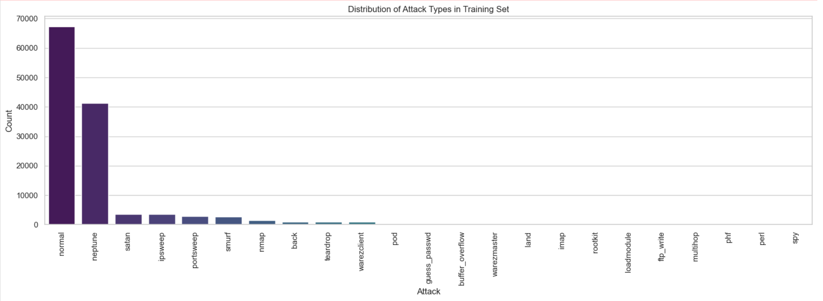
Fig 1. Distribution of Attack Types in Training Set
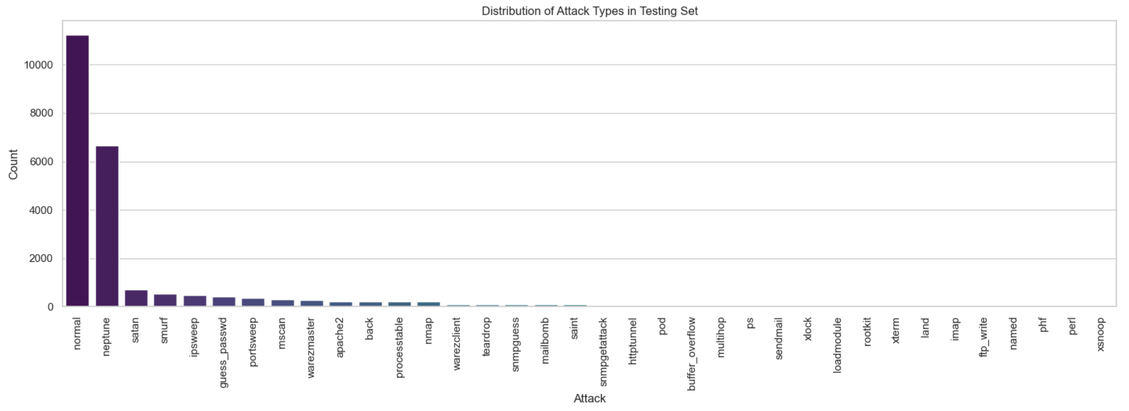
Fig 2. Distribution of Attack Types in Testing Set
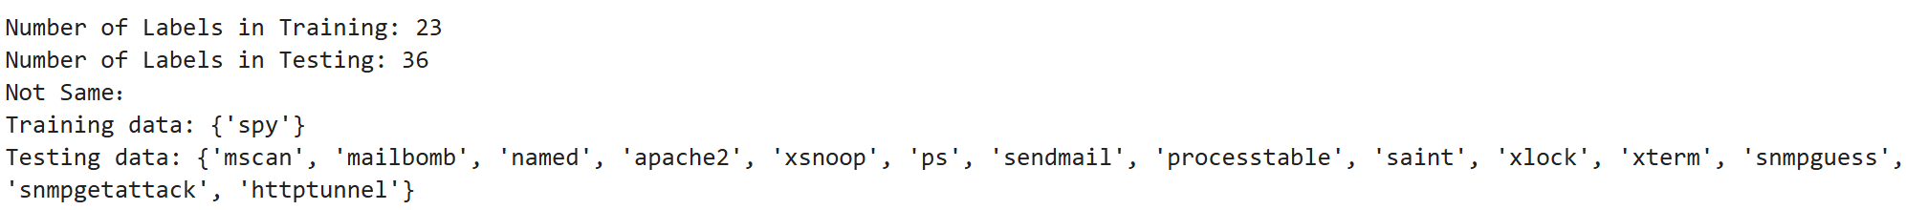
Fig 3. Labels in Training Set and Testing Set

Based on the visualization results, it is evident that the data distribution of the training set and the test set is similar. However, according to the label statistics, there are 14 new labels in the test set, and there is also 1 new attack type in the training set.

3.2Data Preprocessing
To make the original network traffic data applicable to machine learning algorithms, the following preprocessing steps were carried out:
- Check for missing values: After importing the data, check if there are any missing values in the original data. If so, the missing values need to be handled (by filling with the mean value)
- Label Mapping: According to the strategy described in the previous section, a mapping dictionary was established to uniformly classify all over 30 types of attack labels in the training set and test set into five categories: Normal, DoS, Probe, R2L, and U2R.
- One-Hot Encoding: The dataset contains three categorical features: protocol_type, service, and flag. Since machine learning models cannot directly handle text data, this study uses one-hot encoding to convert them into numerical vectors [12]. To prevent the feature dimensions of the training set and test set from not matching (for example, service types that appeared in the training set did not exist in the test set), this study merged the dataset before encoding and then split it after encoding.
- Data Normalization: Due to the significant differences in the scale of features (such as duration in seconds and src_bytes up to millions of bytes), directly inputting them into the model would cause difficulties in gradient descent convergence or deviation in distance calculation. This study uses Z-score normalization (StandardScaler) to convert all features into a distribution with a mean of 0 and a variance of 1 through$z=(x-μ)/σ$ [13].

3.3Ensemble Model Development
Based on the task description, this study selected two representative ensemble learning algorithms: Random Forest Classifier and Gradient Boosting Classifier

3.3.1Random Forest Classifier
Random forest is an algorithm based on the Bagging (Bootstrap Aggregating) strategy. Breiman [14] pointed out that by constructing multiple uncorrelated decision trees and taking their average, the variance of the model can be significantly reduced, thereby effectively preventing overfitting. For high-dimensional network traffic data, random forest has inherent advantages.

3.3.2Gradient Boosting Classifier
Gradient Boosting is an algorithm based on the Boosting strategy. According to Friedman [15]'s definition, this algorithm iteratively trains weak learners (decision trees), and each new tree focuses on correcting the residuals of the previous tree. This approach mainly aims to reduce the bias of the model and usually achieves higher accuracy than random forests, but it is more sensitive to noise and takes longer to train.

4. Experiments
The experiment was conducted in Python language. The model was constructed using the scikit-learn machine learning library, data processing was carried out with pandas, visualization analysis was performed with matplotlib and seaborn, and parameter optimization was achieved through random search cross-validation.

Experimental Environment
To optimize the performance of the model to the best extent, this study employed RandomizedSearchCV for parameter optimization [16]. Due to the limited computing power of the computer, compared to grid search, RandomizedSearchCV is more efficient in handling high-dimensional parameter spaces and requires less time.

4.2Hyperparameter Tuning
- For Random Forest: The main adjustments were made to n_estimators (the number of trees) and max_depth (the maximum depth of the trees).
param_dist = {
'n_estimators': [25, 50, 100, 150, 200],
'max_depth': [5, 10, 20, 30, None],
'min_samples_split': [2, 5],
}
- For Gradient Boosting: The main adjustments were made to n_estimators (the quantity), learning_rate (the learning rate), and max_depth (the maximum depth).
param_dist_gb = {
'n_estimators': [50, 100],
'learning_rate': [0.05, 0.1],
'max_depth': [3, 5],
'min_samples_split': [2, 5],
'min_samples_leaf': [1, 2],
'subsample': [0.8, 1.0]
}

4.3 Evaluation Indicators
Given that the network intrusion detection data usually exhibits high imbalance (Imbalanced Data), the mere accuracy rate (Accuracy) is insufficient to reflect the performance of the model. Therefore, this study introduces the confusion matrix (Confusion Matrix), precision (Precision), recall (Recall), and F1-Score as comprehensive evaluation indicators [17].

Result and Analysis

Model Performance Comparison
After parameter tuning, the performance of the two models on the test set is shown in the following Fig 4 and Fig 5:
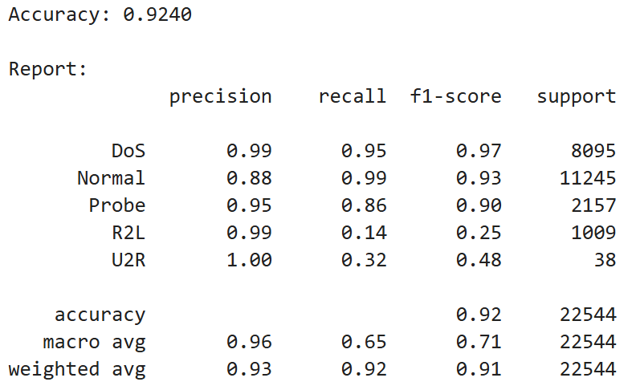
Fig 4. Results of Random Forest
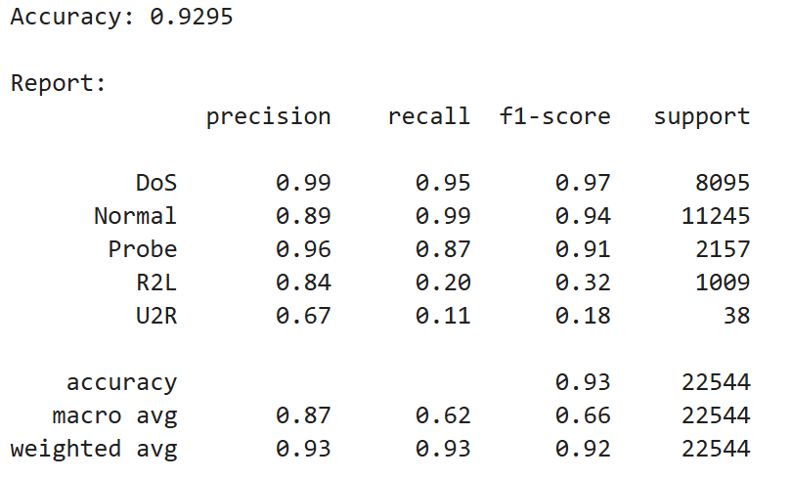
Fig 5. Results of Gradient Boosting

5.2 Confusion Matrix Analysis
The confusion matrix results can be found in Fig 6 and Fig 7:
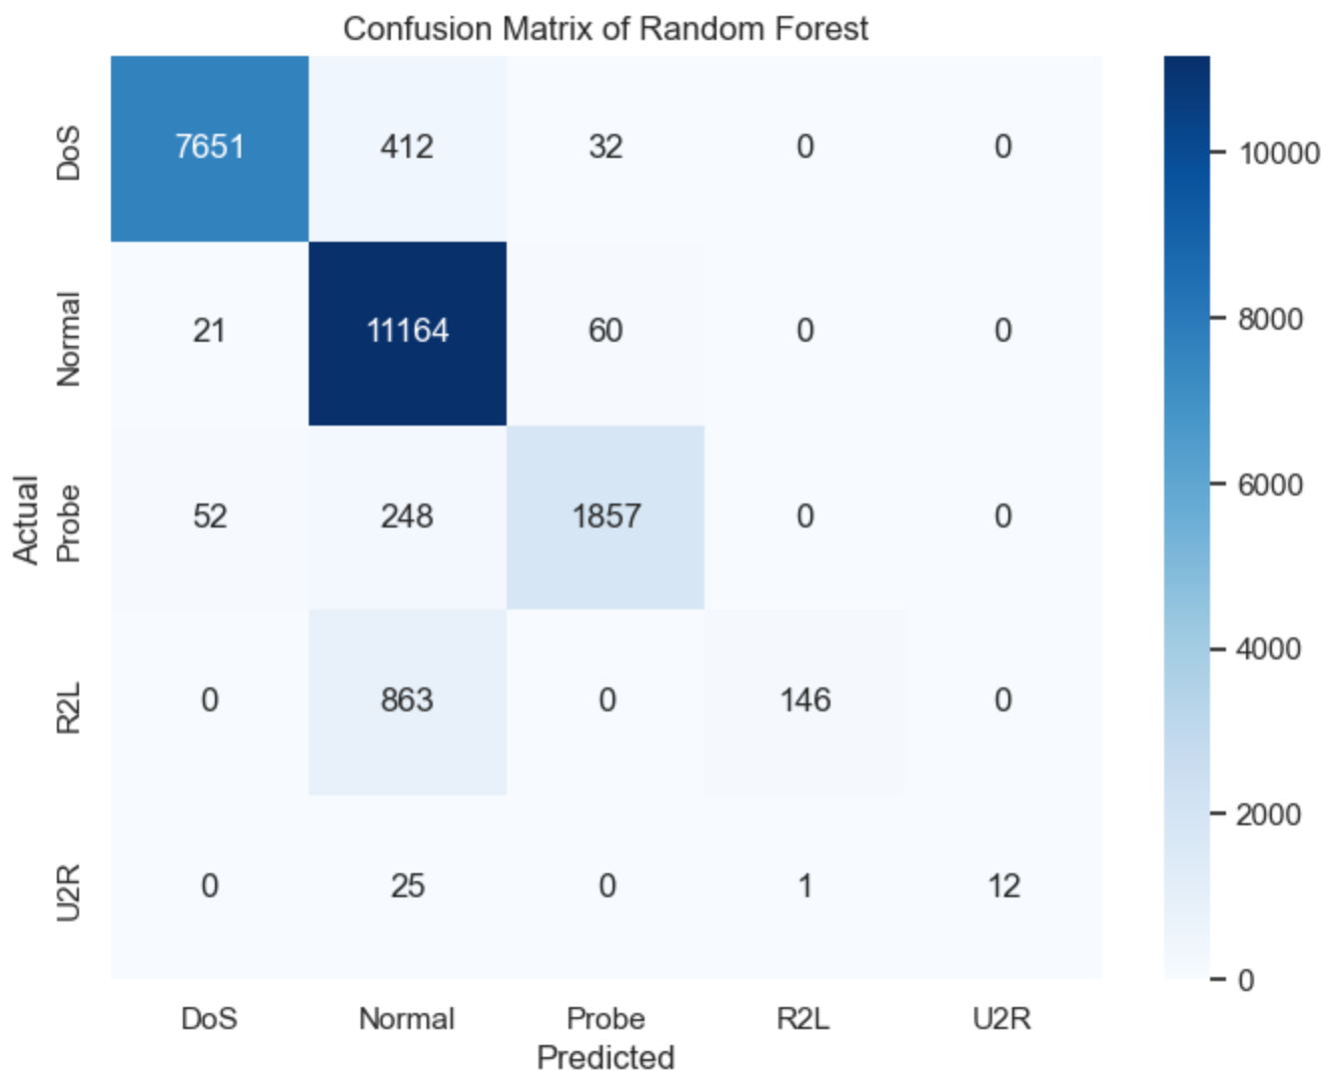
Fig 6. Confusion Matrix of Random Forest
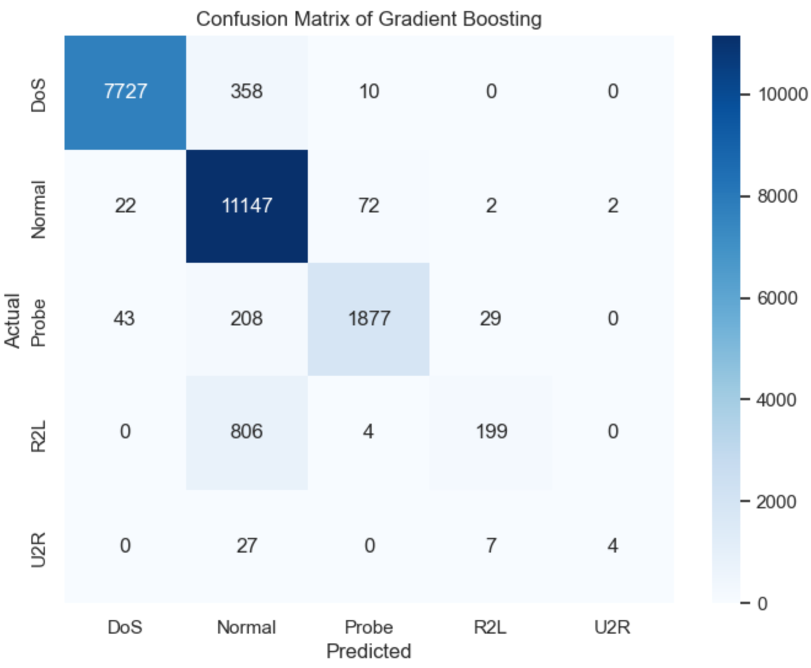
Fig 7. Confusion Matrix of Gradient Boosting

- Majority class recognition is accurate (advantage)
- DoS and Normal: Both models perform extremely well in these two major categories of traffic. The values on the main diagonal are high (e.g., Normal class recognizes 11,000+), indicating that the models can effectively distinguish large-scale denial-of-service attacks from normal traffic.
- Probe: The recognition effect is acceptable, but approximately 12-14% of probe attacks are wrongly classified as Normal.

- Minority classes have serious underreporting (defect)
- R2L (Remote Illegal Access): This is the biggest pain point of the model. Both models incorrectly predict the vast majority of R2L attacks (about 2,700) as "Normal", with only a few (145 on the left and 198 on the right) being correctly identified.
- U2R (User Privilege Escalation): The situation is similar. Over 85% of U2R attacks are wrongly classified as normal traffic (Normal).
- Reason: The behavioral characteristics of R2L and U2R are extremely concealed, and the sample size is very small, causing the model to tend to classify them as the dominant "Normal" class.

- Model comparison
- Gradient Boosting (right graph) is slightly better than Random Forest. It is slightly higher than Random Forest in the number of correct identifications for DoS, Probe, and R2L (for example, R2L correctly identified 53 more samples), and the number of misclassifications as Normal is slightly reduced.

In summary, the model is very reliable in detecting "loud" attacks (DoS, Probe), but has obvious underreporting risks in detecting "hidden" attacks (R2L, U2R).

6.Discussion

6.1Generalization Ability and Detection of Unknown Attacks
The most crucial finding of this study is the generalization ability of the integrated model for "unknown attacks". The 14 unknown attacks included in the test set did not cause the model to crash. This supports the viewpoint of Sommer and Paxson [18]: The core value of machine learning in IDS lies in detecting variant attacks by learning "behavior patterns" rather than "specific signatures". By mapping apache2 to DoS, the model correctly classified it by leveraging the common high traffic and high concurrency characteristics of DoS attacks.

6.2Overfitting and underfitting Analysis
By comparing the accuracy rates of the training set and the test set, the model exhibited a certain degree of overfitting. This is a common phenomenon in the field of IDS (Intrusion Detection System). The main reason is that the data distribution of the test set (Distribution Shift) is fundamentally different from that of the training set (not only the labels are different, but also the distribution of traffic features has shifted). Due to its Bagging characteristic, Random Forest theoretically has a better ability to resist overfitting than Boosting [14]. The shorter training time and more stable performance in the experiment also confirm this.

6.3The Impact of Category Imbalance
The low detection rates of the U2R and R2L categories reveal the negative impact of data imbalance. In NSL-KDD, the number of DoS records is in the thousands, while there are only a few dozen U2R records. The model, in an effort to optimize the global loss function, tends to sacrifice the accuracy of the minority class in exchange for the accuracy of the majority class. This is consistent with the discussion by Chawla et al. [19] on the classification challenges of imbalanced datasets.

6.4Feature Importance and Interpretability
The importance of the first 15 features is shown in Fig 8 and Fig 9:
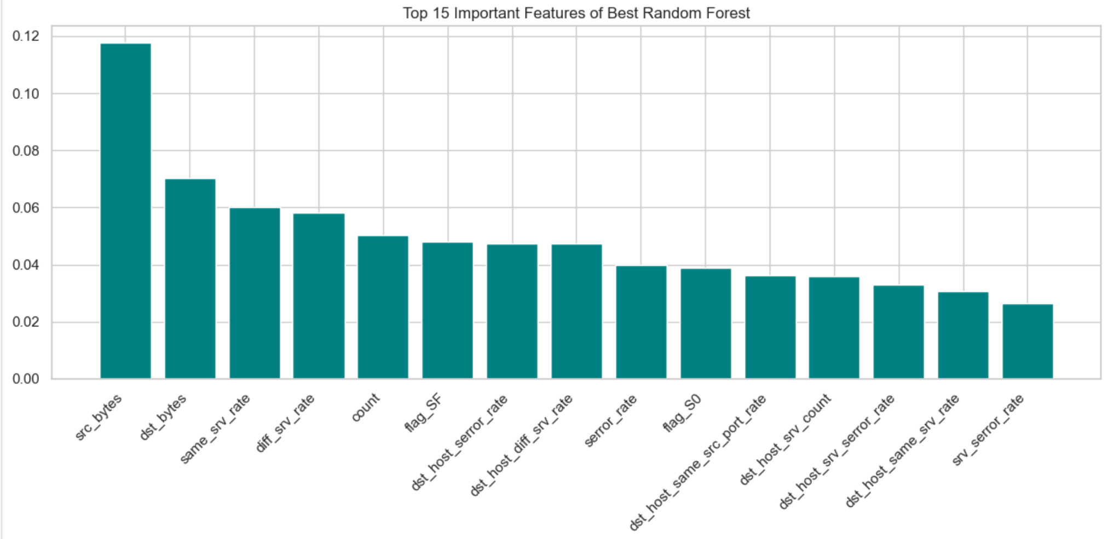
Fig 8. Important Features of Random Forest
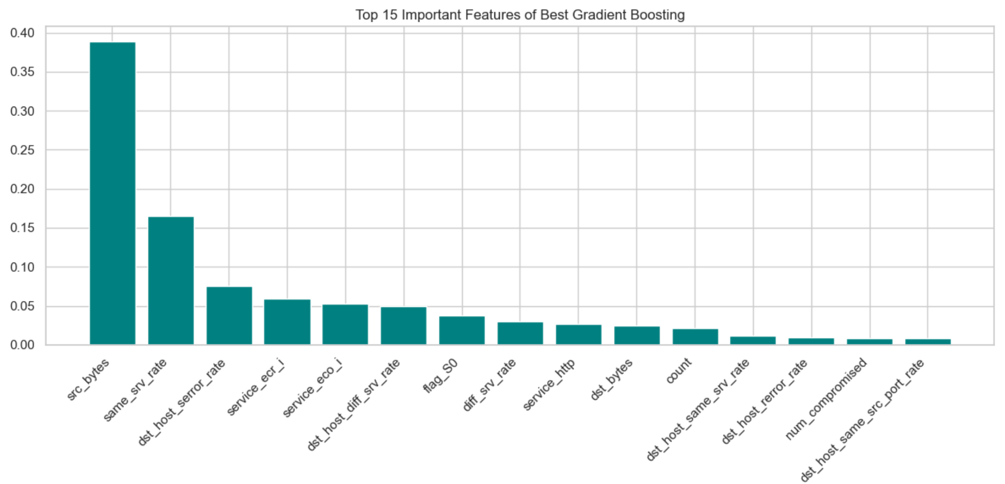
Fig 9. Important Features of Gradient Boosting

Based on the two charts of feature importance, the analysis is as follows:
- Absolute core feature (src_bytes): The two models are highly consistent in their selection, both ranking the "src_bytes" (size of source data packets) as the most decisive feature, and the weight is far greater than that of other features. This indicates that in the NSL-KDD dataset, "the size of the traffic data volume" is the most crucial indicator for distinguishing normal traffic from attacks (especially DoS and Probe).
- Attack behavior pattern (dst_host_srv_count): dst_host_srv_count (the number of connections to the target host services) ranks second in both models. This indicates that attackers typically initiate a large number of connections to specific services of the same target within a short period of time, which is a typical characteristic of scanning (Probe) or denial of service (DoS) behaviors.

Model focus differences:
- Random Forest: It prefers more macroscopic statistical ratio features (such as diff_srv_rate, dst_host_diff_srv_rate), and focuses on identifying anomalies from the statistical patterns of the overall traffic.
- Gradient Boosting: In addition to statistical features, it has also identified more specific abnormal structures (such as wrong_fragment errors) and specific services (such as service_http), indicating that GB can capture even more subtle specific attack methods (such as the Teardrop attack that exploits fragmentation errors).

7. Recommendation
Based on the experimental results and analysis, the following suggestions are proposed for the design of future IDS:
- Adopt a hybrid deployment strategy: It is recommended to deploy the Random Forest model at the traffic entry point as the first line of defense, taking advantage of its high computational efficiency (12 times faster in this experiment) for real-time filtering; use the Gradient Boosting model in the backend forensic analysis to conduct deep detection with its high accuracy feature.
- Introduce data augmentation technology: To address the low recognition rates of U2R and R2L, it is suggested to introduce SMOTE (Synthetic Minority Over-sampling Technique) [19] in the preprocessing stage, artificially synthesizing minority class samples to balance the model training weights.
- Dynamic feature selection: The experiment shows that not all features contribute to classification. It is recommended to conduct regular feature importance assessment and eliminate redundant features to reduce the computational dimension and improve the system response speed.
- Continuous classification update: Although the mapping strategy is effective, as new types of attacks emerge, the existing 5-category system may need to be expanded. Security experts should regularly update the attack classification mapping table.
- Improve the training set data: Try to ensure that the number of label types in the training set and the test set are consistent to ensure more precise attack types.
- Optimize data distribution, as uneven data distribution leads to poor classification results on certain very rare categories.

8. Conclusion
This study is based on the NSL-KDD dataset and systematically evaluated the effectiveness of ensemble learning in multi-class network intrusion detection. For the unknown attack labels that appeared in the test set, this study adopted a classification-based mapping strategy, successfully solving the problem of open set recognition, enabling the model to maintain a detection accuracy of over 92% when facing Zero-day attack variants.
The experimental results prove that both random forest and gradient boosting algorithms can effectively extract the behavioral characteristics of network traffic. Although there is still room for improvement in the detection of rare attacks (U2R/R2L), the robustness and generalization ability demonstrated by ensemble learning make it a powerful tool for building the next generation of intelligent intrusion detection systems.

Reference
[1] A. Khraisat, I. Gondal, P. Vamplew, and J. Kamruzzaman, ‘Survey of intrusion detection systems: techniques, datasets and challenges’, Cybersecur, vol. 2, no. 1, p. 20, Dec. 2019, doi: 10.1186/s42400-019-0038-7.
[2] U. Cisco, ‘Cisco annual internet report (2018–2023) white paper’, Cisco: San Jose, CA, USA, vol. 10, no. 1, pp. 1–35, 2020.
[3] D. E. Denning, ‘An intrusion-detection model’, IEEE Transactions on software engineering, no. 2, pp. 222–232, 1987.
[4] R. Ahmad, I. Alsmadi, W. Alhamdani, and L. Tawalbeh, ‘Zero-day attack detection: a systematic literature review’, Artif Intell Rev, vol. 56, no. 10, pp. 10733–10811, Oct. 2023, doi: 10.1007/s10462-023-10437-z.
[5] C.-F. Tsai, Y.-F. Hsu, C.-Y. Lin, and W.-Y. Lin, ‘Intrusion detection by machine learning: A review’, expert systems with applications, vol. 36, no. 10, pp. 11994–12000, 2009.
[6] J. McHugh, ‘Testing Intrusion detection systems: a critique of the 1998 and 1999 DARPA intrusion detection system evaluations as performed by Lincoln Laboratory’, ACM Trans. Inf. Syst. Secur., vol. 3, no. 4, pp. 262–294, Nov. 2000, doi: 10.1145/382912.382923.
[7] M. Tavallaee, E. Bagheri, W. Lu, and A. A. Ghorbani, ‘A detailed analysis of the KDD CUP 99 data set’, in 2009 IEEE symposium on computational intelligence for security and defense applications, Ieee, 2009, pp. 1–6. Accessed: Nov. 21, 2025. [Online]. Available: https://ieeexplore.ieee.org/abstract/document/5356528/
[8] W. J. Scheirer, A. de Rezende Rocha, A. Sapkota, and T. E. Boult, ‘Toward open set recognition’, IEEE transactions on pattern analysis and machine intelligence, vol. 35, no. 7, pp. 1757–1772, 2012.
[9] C. Geng, S. Huang, and S. Chen, ‘Recent advances in open set recognition: A survey’, IEEE transactions on pattern analysis and machine intelligence, vol. 43, no. 10, pp. 3614–3631, 2020.
[10] S. J. Stolfo, W. Fan, W. Lee, A. Prodromidis, and P. K. Chan, ‘Cost-based modeling for fraud and intrusion detection: Results from the JAM project’, in Proceedings DARPA Information Survivability Conference and Exposition. DISCEX’00, IEEE, 2000, pp. 130–144. Accessed: Nov. 21, 2025. [Online]. Available: https://ieeexplore.ieee.org/abstract/document/821515/
[11] A. Mahfouz, A. Abuhussein, D. Venugopal, and S. Shiva, ‘Ensemble classifiers for network intrusion detection using a novel network attack dataset’, Future Internet, vol. 12, no. 11, p. 180, 2020.
[12] P. Cerda, G. Varoquaux, and B. Kégl, ‘Similarity encoding for learning with dirty categorical variables’, Mach Learn, vol. 107, no. 8–10, pp. 1477–1494, Sept. 2018, doi: 10.1007/s10994-018-5724-2.
[13] S. Ioffe and C. Szegedy, ‘Batch normalization: Accelerating deep network training by reducing internal covariate shift’, in International conference on machine learning, pmlr, 2015, pp. 448–456. Accessed: Nov. 21, 2025. [Online]. Available: http://proceedings.mlr.press/v37/ioffe15.html
[14] L. Breiman, ‘Random Forests’, Machine Learning, vol. 45, no. 1, pp. 5–32, Oct. 2001, doi: 10.1023/a:1010933404324.
[15] J. H. Friedman, ‘Greedy function approximation: a gradient boosting machine’, Annals of statistics, pp. 1189–1232, 2001.
[16] J. Bergstra and Y. Bengio, ‘Random search for hyper-parameter optimization’, The journal of machine learning research, vol. 13, no. 1, pp. 281–305, 2012.
[17] M. Hossin and M. N. Sulaiman, ‘A review on evaluation metrics for data classification evaluations’, International journal of data mining & knowledge management process, vol. 5, no. 2, p. 1, 2015.
[18] R. Sommer and V. Paxson, ‘Outside the closed world: On using machine learning for network intrusion detection’, in 2010 IEEE symposium on security and privacy, IEEE, 2010, pp. 305–316. Accessed: Nov. 21, 2025. [Online]. Available: https://ieeexplore.ieee.org/abstract/document/5504793/
[19] N. V. Chawla, K. W. Bowyer, L. O. Hall, and W. P. Kegelmeyer, ‘SMOTE: synthetic minority over-sampling technique’, Journal of artificial intelligence research, vol. 16, pp. 321–357, 2002.

