A critique into the way in which political ideology has influenced recent policy
This submission will focus on identifying an area of political ideology and critique the way it has influenced recent policy. Although over the ages there has been a large number of studies surrounding political ideas, it is only more recently that there have been studies surrounding political ideologies. The ideologies that have influenced political actions are said to be those which are more action-oriented, as explained by Robert Leach in their Publication “Political Ideology in Britain” (2015). The chosen area will be that of the UK public health movement, with aspects of poverty, its effect on housing practice and the speculated potential impact of migration on the health system. Stewart (2005) expresses the changes in the way in which the movement had originally developed as a direct result of the industrial revolution, with there initially being a bias towards the medically based need. He then goes on to explain how this later changed and evolved to encompass the new way of thinking, which was to promote improving health with preventative measures. This allowed for those researching to observe a correlation between poor housing conditions and other situations that could explain a vast array of health conditions (Appendix I). Although there is also evidence to suggest that health issues can also be associated with areas known for high levels of air pollution (WHO, 2022).
Grogan (2012) states that there has been a dark relationship historically between the responsibility of the Government with regards to the Health Policy and the influence on ideology. It has long been stated that the “government's ability to create favorable outcomes” (Grogan, 2012), could show that there is a potential for bias on decisions due to investment within certain areas of healthcare. Although this may be able to be dismissed as hearsay within an article that is open to heavy bias by the author to prove their opinion. The Stewart article (2005) goes on to discuss the changes to the public health workforce and the surrounding organisations and policies that have been implemented over the years to further the promotion of good health practice. This also included the implementation of community-based partnerships through local pharmacies treating minor ailments, thus taking some of the pressure off the ever-increasing strain on doctors’ practices, along with accident and emergency departments. The Conservative government proposed the importance of the pursuit of public health reforms to include preventative measures on healthcare and multi-agency involvement in line with the Health and Social Care Act 2012. (Maggetti, 2021). New Labour also included a determined bid to improve public health provision and as a result of this drive, was able to bring into fruition the parties social justice agenda, of which one of the main aspects was to combat health inequalities. Although Alonso & Andrews (2018) had argued three years prior that it was their opinion that the ideology of authorities led by the Conservative Party were viewed as purists. Where in contrast, those who were led by the Labour opposition were focused on combating the potential resistance to the overhaul and modernisation to many policies which were viewed as becoming outdated.
Other organisations that are breaking ground within the increasingly strained National Health Service (NHS), were considered to be that of the Environmental Health Commission. That could potentially be attributed to the emerging evidence of the local housing authorities increasing neglect of property maintenance standards, which was said to be especially prevalent within more deprived communities nationwide. This would seem to have caused somewhat on a cumulative effect to the health of those within those communities, yet there is now an increased awareness to this not being isolated to just deprived areas.
An ever-increasing number of migrants and asylum seekers entering the United Kingdom has placed further strain on the NHS, as many illnesses and viruses which had been eradicated are now prospectively re-entering the country undetected, with there being historical evidence that the Conservative government has been requesting mandatory health testing to be conducted on all migrants entering the Uk for some time (Heathcot Amory, 2003), which is something many other nations already have in place. Which then was attributed to increased health issues across many of the different class levels in society, which was said to be further exacerbated by the widespread health issues over the last three years i.e., Ebola, Tuberculosis, hepatitis and various Covid-19 variants.
Following the Covid-19 pandemic there would seem to be further issues that have been attributed to the recent pandemic. As everyone was advised to work from home and stay indoors to reduce the risk of contracting the virus. This has resulted in a somewhat reduced immunity to common illnesses that most of the population without any confirmed health condition would have fought off with relative ease had it been prior to the pandemic. An article written by Vasco Santos (2021) highlighted the governments political ideology surrounding the public health policy and Covid-19, in which it states the need for the discussion of where the government is situated on the left-right axis with regards to how political ideology could “influence public health policies in response to pandemics” (Vasco Santos, 2021). It can be said that the ruling political parties’ ideological commitments are usually a strong indication of the choices in their policies, with the common consensus being that if the party is thought to be left-wing then the policies will be more antagonistic with regard to provision but more likely to have a positive effect on the amount of housing available. Whereas if the party is right-wing then the policies will instead favour the allocation of goods and services and thus likely to be linked with reform (Alonso & Andrews, 2018). That being said other finding show that policy reform procedures often change with the elected parties resulting in differentiating ideological orientations (2021)
During the final months of 2020 there was a death recorded of a two-year-old boy by the name of Awaab Ishak. The inquest into his death heard how the young boy had passed away due to a respiratory condition, that was said to have been caused by the presence of black mould within their home. A UK newspaper by the name of The Mirror published an article covering the findings of an inquest that had been held looking into the circumstance under which the young boy had passed away. The article explains how the boy had lived with his parents in a one-bedroom flat, with the parents contacting the local authority who was responsible for their housing maintenance on multiple occasions, along with many health professionals, explaining their concerns but yet the family reported they had received little or no assistance (2022).
Gareth Swarbrick who was a chief executive for Rochdale Borough Housing (RBH) at the time of the inquest was reported to have said;
"We didn't recognise the level of risk to a little boy's health from the mould in the family's home. We allowed a legal disrepair process, widely used in the housing sector, to get in the way of promptly tackling the mould”.
(Gareth Swarbrick as cited in, Topping & Katie-Weston, 2022)
This statement alone highlighted the need for a review of the legal disrepair process, yet as is often the case there is still a major issue with regards to the discovery of damp and mould within properties and the housing sector processing the request, acquiring funding and then being given permission to treat it accordingly. As is frequently still the case in these matters, the tenant’s lifestyle is questioned, with the cause regularly being attributed to condensation in cold spots of the property. Other statements given at the inquest suggested the lifestyle of the tenants had possibly been a contributing factor and likely the cause of the presence of the mould, but the coroner associated with the case discredited this suggestion by stating how the other evidence available clearly showed how the occurrence of damp and mould being found at unacceptable levels within local authority accommodations was not just an isolated case within RBH housing stock but could also be found in many other areas across the UK. At the time of publication, the housing secretary Mr Michael Gove commented that despite financial difficulties being faced by local authorities there was absolutely no excuse for housing conditions to fall to a standard that is considered unfit for human habitation. Despite this incident and many other similar issues coming to light since this tragedy, these sorts of health issues which can be attributed to the individuals of family’s living conditions continue to be an issue across the UK.
To further investigate the relevance firstly it should be defined. To begin, what is black mould and why is it such a problem within the UK? This type of mould is described to be a widespread problem within the UK, especially during the winter months when the weather is cooler, as this provides optimal conditions for the mould to grow. During these months most tenants will have their windows closed and the heating running to stay warm, and this then allows for the mould to thrive due to the combination of poor ventilation alongside increased moisture levels to condense in the cooler areas within the home which are subject to higher levels of humidity (Rentokil, 2022). Black mould is not only a health risk, but it also causes damage to the property, this type of mould is a fungus and as such releases mould spores. If left untreated these spores enter the airways and or irritate the skin, leading to health issues and in prolonged cases even death.
Local authorities often blame reduced funding for the delays in the assessment and treatment of issues within local authority properties and although this may often be the case it is far from acceptable for people to pay for this short fall with suffering poor health or as was the case with the young boy losing his life. The presence of damp and mould is a fundamental problem for those with pre-existing health conditions such as allergies, respiratory problems and or asthma. This group who are already said to be at a disadvantage health wise, should be listened to without delay to avoid the risk for serious health repercussions. It is most common that the infirm and children are most at risk, yet there is also evidence that the presence of this kind of mould can cause issues with the immune system, thus reducing the bodies capability to fight off the associated infections that follow (NHS, 2022).
The political ideology surrounding health and the housing issues allows for the current political party in charge of the government to project their truth of what ideas and beliefs they wish the nation to accept, although what they are conveying can often be part of some hidden agenda. This can be viewed as a shrewd attempt to distort and shape the things in a way that will allow those in power to remain to some extent without blame if the situation gets out of hand (Crawford & Flint, 2015). Crawford & Flint go on to discuss how the government have historically used appeals to redirect any potential for inquiry from established ideologies associated with current housing practice. Political ideology can be attributed predominately to a need for an epistemic approach to the situation in question (Feldman & Johnston, 2013).
This submission investigated the effect of political ideologies on recent health policies, along with the potential cumulative effect to certain aspects of housing practice. Although there is an indication the ideologies play a part in how policies are designed, it can be noted that there are many other contributing factors for how the completed policy will eventually be structured with a great deal of consideration being given to the community and the purpose it will serve. It has repeatedly been the case under the rule of the Conservative Government that political ideology has resulted in reducing the factors which would allow for substantial economic growth, potentially reducing the capital which would have built the foundation for funding the improvement of various areas including housing repair and health services (2021). It was only under the power of New Labour that a reform of the policies were considerably speed up, which led to the advancement of the battle against inequality within the health care sector. Future research should consider repeating a previously mentioned study with a view to further investigating the housing provision and its condition for those migrants that have sought asylum within the UK.
References
Alonso, J.M. and Andrews, R. (2018) “The Politics of Public Housing Reform: Local Government Stock Transfer in England,” International Public Management Journal, 21(3), pp. 392–412. Available at: https://doi.org/10.1080/10967494.2018.1427160.
Crawford, J. and Flint, J. (2015) “Rational fictions and imaginary systems: Cynical ideology and the problem figuration and practise of public housing,” Housing Studies, 30(5), pp. 792–807. Available at: https://doi.org/10.1080/02673037.2015.1013092.
Feldman, S. and Johnston, C. (2013) “Understanding the determinants of political ideology: Implications of structural complexity,” Political Psychology, 35(3), pp. 337–358. Available at: https://doi.org/10.1111/pops.12055.
Grogan, C.M. (2012) “The murky relationship between ideology and the role of government in health policy,” Journal of Health Politics, Policy and Law, 37(3), pp. 361–364. Available at: https://doi.org/10.1215/03616878-1573058.
Heathcot Amory, E. (2003) Migrants blamed for diseases, Daily Mail Online. Associated Newspapers. Available at: https://www.dailymail.co.uk/health/article-191209/Migrants-blamed-diseases.html (Accessed: December 30, 2022).
Leach, R. (2015) Political ideology in Britain. London: Palgrave Macmillan.
Maggetti, M. & Trein, P. 2021, "More is less: Partisan ideology, changes of government, and policy integration reforms in the UK", Policy & Society, vol. 40, no. 1, pp. 79-98.
NHS (2022) Can damp and mould affect my health?, NHS choices. NHS. Available at: https://www.nhs.uk/common-health-questions/lifestyle/can-damp-and-mould-affect-my-health/ (Accessed: December 30, 2022).
Rentokil (2022) Black mould | help and advice | Rentokil property care, Rentokil Black Mould. Available at: https://www.rentokil.co.uk/damp-proofing/black-mould/ (Accessed: December 31, 2022).
Stewart, J. (2005) “A review of UK Housing policy: Ideology and public health,” Public Health, 119(6), pp. 525–534. Available at: https://doi.org/10.1016/j.puhe.2004.07.006.
Topping, S. and Katie-Weston, T.M. (2022) Boy, 2, died due to black mould in home from hell that was 'unfit for humans', mirror. Available at: https://www.mirror.co.uk/news/uk-news/boy-2-died-due-black-28494815 (Accessed: December 29, 2022).
Vasco Santos, J. (2021) “Government political ideology and covid-19 public health policy responses,” European Journal of Public Health, 31(Supplement_3). Available at: https://doi.org/10.1093/eurpub/ckab164.379.
WHO (2022) How air pollution is destroying our health, World Health Organization. World Health Organization. Available at: https://www.who.int/news-room/spotlight/how-air-pollution-is-destroying-our-health (Accessed: December 31, 2022).
Appendices
Appendix I.
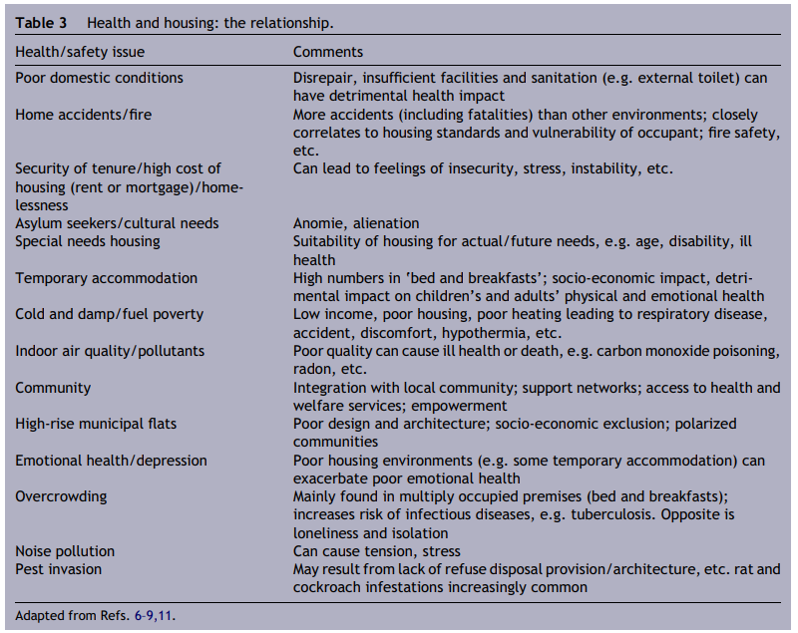
(Stewart, A review of UK Housing policy: Ideology and public health 2005)

