Critically evaluate your creativity and enterprise dispositions in terms of the Entrecomp framework and how you might develop these to the next level and demonstrate progression.

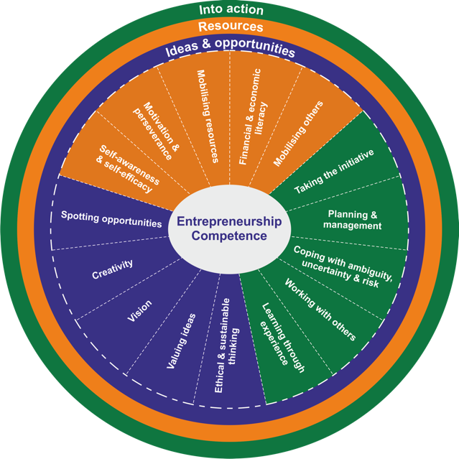
What is creativity? Is there a definitive meaning of the word ‘creativity’, or are there various perceptions of what it could mean? Naiman (2018) defines creativity as the process of turning original and unique ideas into reality. Additionally, there is the art of creative thinking, which can be adapted by both the teacher and the learner. Creative thinking is where the individual “looks at something in a new way” (Doyle, 2018), therefore not being restricted to what could be written down on paper but using one’s initiative to ‘think outside the box’. It has been identified by Thorne (2007) that being creative and having the ability to develop ideas has often been observed “as something outside the normal realm of behaviour”.
Creativity lies under the ‘ideas and opportunities’ section of the EntreComp framework, a new initiative that has been introduced to ensure more entrepreneurship in schools. In terms of ‘where we stand’ with our interpretations of creativity, “[creativity] may not have an exact nature” (Fisher, 2009: 7). I feel that there is an explanation for creativity, but not an indefinite reason that out-classes other theorist’s interpretations. There have been a number of trialled procedures that schools have tested to try and ensure pupil progress, such as Ysgol Cynwyd Sant, Maesteg. They have utilised the freedom and openness that creativity offers, with a DVD presentation to the children’s parents and they found that 82% of the students achieved their target grades (Estyn, 2016). So, in relation to where schools and teachers may stand with the use of creativity in schools, the discussed school seems to have proven the opportunities for a diverse curriculum that creativity offers, whilst maintaining relevance to Donaldson (2015: 28) where he states that “creativity and enterprise are central features of modern life that should be developed and extended throughout a school career”. There is room to believe however, that creativity can sometimes prove a distraction within education and could possibly hinder progression. Discussed by Higonia (2016), sometimes the more ideas that a child could have, the more difficult it becomes to “identify the gold amongst the scree”.
Figure 1.1 – EntreComp framework

The EntreComp framework has yet to have been attempted properly in schools and this could be for a number of reasons. Initially, there is potential that there is a lack of pedagogical strategies and clear learning outcomes that are available to the teachers (EE-HUB, 2018). In addition to this, there is the issue of promoting entrepreneurship as a competence, because of “the lack of a common understanding of what it means to be entrepreneurial” (EE-HUB, 2018). Nevertheless, this does not mean that the EntreComp framework is unserviceable. By ensuring that children and young people have an understanding of entrepreneurship, through a key understanding of the competences, there is a strong chance that they will be more successful in finding a job in the future (EE-HUB, 2018). The two main areas of focus for this essay shall be ‘Creativity’ and ‘Motivation and Perseverance’ and I feel that they support each other in a manner that reflects the way I teach.

As previously stated, creativity may not have an exact nature – but I feel that it is an extremely important aspect of school life. Ensuring creativity is a well-practiced aspect of the curriculum can re-develop the interest of some pupils who may have ‘switched off’ from the way that the school delivers content. Also, it keeps teachers on-track, who too have ‘switched off’ from the culture of control and order (Fisher, 2009: 11). In addition to this point, Fisher (2009: 11) claims that creativity is central to the improvement of functionality within societies and schools. Furthermore, there is more emphasis placed within the workplace for creativity. It was discovered that more and more businesses and ‘big-tech companies’ are using what is known as the 20% rule, where employers are assigned to 20% of their time in work to creative thinking and to explore new ideas (Hicks, 2015). The most important fact being, children feel that creativity is personal to them, thus providing them with a potential sense of belonging. Quoted from a child in Westbury Park School in Bristol, the child justifies that “creativity comes from me”, indicating that it is of value (Fisher, 2009: 12). Considering all of the lessons that I have taught, and how they were delivered, I would like to feel that I am within Level 4 of the EntreComp framework. The area I implemented the most creativity both for a teacher and the children, would be through the expressive arts. Whilst on PTE in second year in a Year three class, a music session took place where the theme was ‘Emosiynau y Ddraig’ (Dragon’s Emotions), where the children were presented with a picture of a dragon in groups (see appendix 1), and they had to create sounds using the instruments provided, so that they could replicate the emotion. The rest of the class would have to work out which emotion was being presented. For this session, it was clear that the children would have to use their imaginations to depict what a dragon could sound like if it were to be sleeping for example. Creativity is heavily reliant on imagination, allowing children to explore their thoughts, opinions and ideas - something which is not already available to their senses (University of Pennsylvania, 2018). In the discussed session, I wanted the children to use their imaginations to try and demonstrate what a dragon might sound like, thus enhancing their creativity. However, it occurred to be after the session that their imagination was not tested enough. In order to enhance my teaching for creativity, and move into Level 5, more room for imagination should be implemented into that session – instead of providing the children with various types of emotions, I allow the children to develop their own. This then allows for the children to “re-shape open ended problems” in order to meet their skills (Bacigalupo, Panagiotis, Punie & Brande, 2016), to adapt a heutagogical style of learning and to “encourage more open-ended, student-centred learning” (Fisher, 2009). In prospect that I am able to make an improvement towards the next level of the EntreComp framework, it would be prudent to try and vary my introductions to lessons. As can be seen by appendix 2, the introduction to the session was for the teacher to play the ‘bore da/prynhawn da’ song on the guitar, thus varying the style of introduction to a session that the children would normally receive. In order for my lessons through creative teaching to improve to that of Level 5, more engaging introductions such as this should be used – children can have musical introductions to sessions, regardless of whether it is a music session or not, as Piedra-McKenzie (2015, 2017) argues that “music is an essential part of every child’s development”, and it can “help instil a sense of confidence”. It can therefore act as sound motivation for the children to preserver in learning.

Continuing on from the topic of motivation, the other aspect of the EntreComp framework that I wish to discuss and offer room for my improvement is ‘Motivation and Perseverance’, which lies within the ‘resources’ section. This is an area that I believe holds a strong connection with creativity, and both rely on each other for successful implementation within a classroom. Through research, I feel more equipped to offer lessons through the EntreComp framework and have been able to critically reflect on my teaching experience to date.

Children require a sense of reassurance when they are being taught, a reminder that what they are going to be learning will be beneficial in their lives. They may ask questions such as ‘What will I gain from this?’, ‘Is there anything in it for me?’ etc. (Gilbert, 2002). It is a teacher’s responsibility to ensure that the children understand why they are completing a certain piece of work, before they learn how, and in doing so, learning to understand where the child’s natural motivation can derive from in order to use in lessons (Gilbert, 2002).

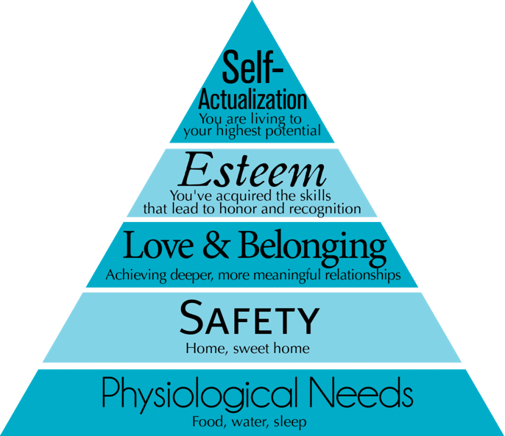
It is believed by Maslow (1943) that all people follow a set of desires in which their motivation derives from. Known as ‘Maslow’s Hierarchy of Needs’, it is a selection of five needs that people are motivated to achieve in their lives. I believe that by following this concept of motivation, and why children wish to persevere with their desires, it will aid my progression into a higher EntreComp Level. For example, highlighting the ‘Esteem’ section, I could ensure that the children are motivated by their intrinsic esteem, such as achievement in a certain activity for themselves. In order for one to become an outstanding teacher, one must first establish key motivation for the children to succeed. In order for children to be motivated on a daily basis, teachers must establish themselves as motivators of learning. In the words of Scheidecker and Freeman (1999):
Figure 1.2 – Maslow’s Hierarchy of Needs

“…a teacher wishing to be a legend can manipulate the educational environment in such a way to make student motivation a part of the regular classroom routine”.

In addition to this, a foundation based upon mutual trust and respect must be established before any form of motivation can be achieved (Scheidecker and Freeman, 1999), as recognition of each of the teacher’s students can prove a fundamental aspect of the child’s inclusion in the classroom, and therefore uplifting their motivation. In addition to this, it is believed that by adapting a ‘we’ approach to teaching, and by sharing responsibilities with the children for their achievements and failures, children see that the teacher is in partnership with the learning experience – something that their peers and friends participate in. Therefore, the children will become motivated as they want to please their friends, those they respect and who approve of their ideas (Scheidecker and Freeman, 1999). This would then ensure my progression within the EntreComp framework, even to that of a Level 6. Taking heed of appendix 3, one can notice that I failed to share with the children an example of the task that I had completed, providing them with some excitement and motivation as to what they were about to undergo. This could have caused a negative effect on their motivation, as they had no example to go by, and it has been highlighted by McLean (2009) that “Pupils need guidance”. In order for my progress within this field of the EntreComp framework, I feel that it would be prudent to adhere to the points raised in order for me to “inspire others to work hard on their goals by showing passion and a strong sense of owner- ship” (Bacigalupo, Panagiotis, Punie & Brande, 2016).
Motivation is not something that is within each individual learner. It is an aspect of learning that occurs within the operation between the learner and the task or context (McLean, 2009). Therefore, as previously stated it is the teacher’s responsibility to ensure that the student is motivated to persevere with the task, because children will be more engaged with the teacher if the teacher shows how engaged they are with the children (McLean, 2009).
From my experiences on Professional Teaching Practice (PTE), I would like to think that I can engage with any class to which I am placed. However, I am aware that my engagement with younger children in the school, such as reception, is not as well established as in Year 3, the only Key Stage 2 year group I have worked with over my two PTEs so far. May I first establish that it is not the children that are difficult to teach, but more that I feel that I am unable to establish that connection, discussed by Scheidecker and Freeman (1999), with the children when they are as young as four. This is a significant area of my teaching in regard to the EntreComp framework that I feel is vital and should be improved upon.

In order for me to move forward and develop my motivation skills to foundation phase children, I need to understand that “children are strongly motivated to play and can experience deep satisfaction and deep learning in play” (The Department for Children, Schools and Families [DCSF], 2009: 14). Drawing one’s attention to appendix 4, one will notice that there is a substantial lack of ‘play’ on the lesson plan. This could be down to the style of teaching that I am more used to, which is Year 3. Additionally, I may have found it difficult to include a style of play within the area of learning that I was teaching. However, I realise that children of this age require playful and enjoyable activities in order for high levels of engagement to occur (DCSF, 2009: 14), and could have interpreted some form of directed play within the session, as it is understood that play can aid with the child’s development of cognition and being able to understand what actions to take in different situations (Piaget, n.d. cited from Burgemeester, 2017). Furthermore, utilising a different approach to introducing the session could prove to be a step towards a higher level within the EntreComp framework, as remaining with the ‘traditional’ method of simply explaining the task could potentially not motivate the children to wish to persevere with the task, and it is also lacking creativity. For me to be able to progress, using a method of introduction via an iPad and hologram of my face, or a ‘character’ from a children’s television show, could inspire the children to unlock their creativity, or motivate them to wish to continue. This would fall under Level 5 of the framework, where I can search for results that could “improve the value-creating process” (Bacigalupo, Panagiotis, Punie & Brande, 2016).

In connection with creativity, motivating the children to preserver with their creativeness is what I believe to be a vital aspect of their education. One of the key aspects to creativity is motivation. Encouraging students to want to complete a creative task, not because they have to – but because they want to, could potentially be the difference between a happy child, or an unhappy child (Fisher, 2009). Additionally, in order for a child to thrive upon their creativity, adults within the classroom, such as the teacher or indeed a parent or volunteer, need to encourage their children to think creatively, and not force it upon them. In order for my progression to be achieved, I will look to uphold motivational creativity towards the children that I will teach in the future. This shall be established in order for me to progress to a higher level within the EntreComp framework, and hopefully “actively search for new solutions that improve the value-creating process” (Bacigalupo, Panagiotis, Punie & Brande, 2016) – for an improved creative style of teaching towards my pupils.

An interesting fact that links this argument about motivation and creativity, is the sense that creativity should be motivated, not be pushed onto children.

“The moment I’m forced to do something creative is when I stop being creative”.

(Christensen, 2014)
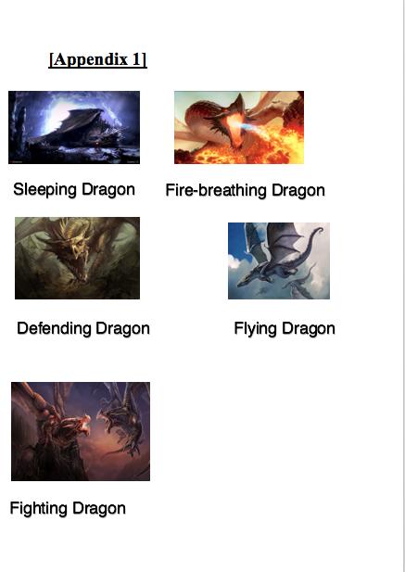
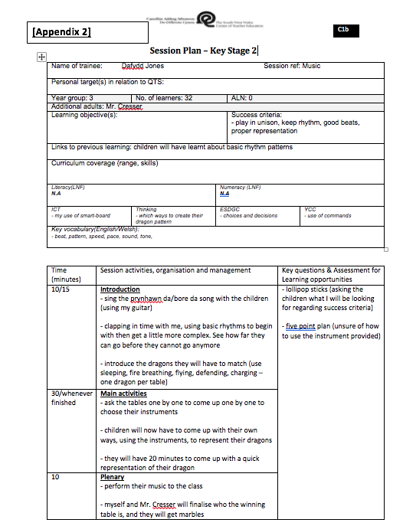

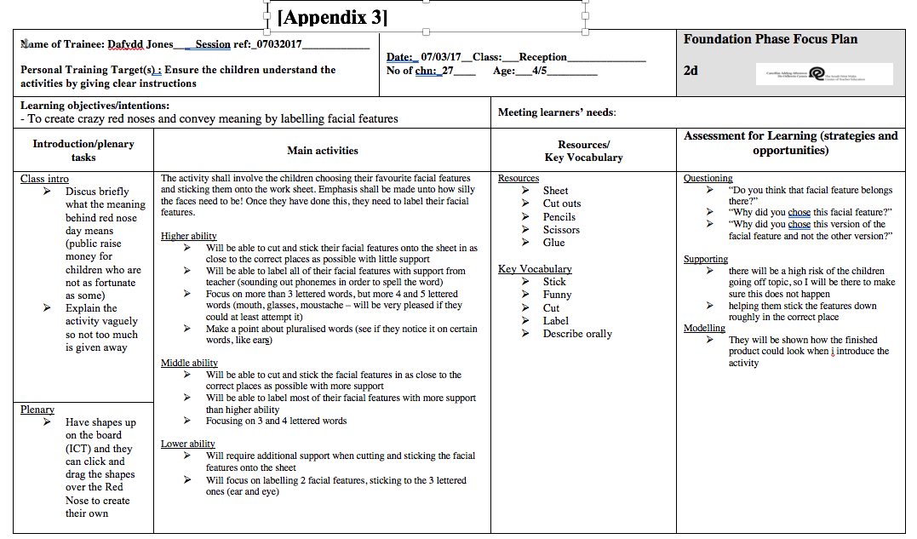
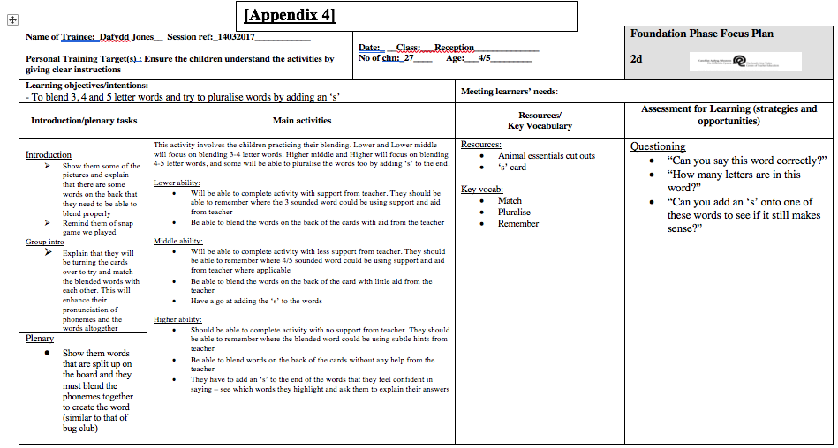

Reference List:
- ‘EntreComp Framework’ (2018) [image] available at: https://www.google.co.uk/url?sa=i&rct=j&q=&esrc=s&source=images&cd=&ved=2ahUKEwjD09Tgo7LZAhVKBcAKHW8TCq0QjRx6BAgAEAY&url=https%3A%2F%2Fconnections.etf.europa.eu%2Fwikis%2Fhome%2Fwiki%2FW378d5d78c6ff_4124_8483_e2904a5a9c1d%2Fpage%2FEuropean%2520Entrepreneurship%2520Competence%2520Framework%3Flang%3Den-gb&psig=AOvVaw32_Xv7KK4_EllN4NV2JiP_&ust=1519140029340967
[Accessed: 19th February 2018]
- ‘Hierarchy of Needs’ (2018) [image] available at: http://www.unity.org/sites/unity.org/files/images/UMag/Articles/2013/HeirarchyOfNeeds.png
[Accessed: 20th February 2018]
- Christensen, T. (2014) ‘You may not be able to force creativity but you can certainly invite it’ [online] available at: https://creativesomething.net/post/72765232045/you-may-not-be-able-to-force-creativity-but-you
[Accessed: 20th February 2018]
- Donaldson, G. (2015) ‘Successful Futures: Independent Review of Curriculum and Assessment Arrangements in Wales’. Cardiff: Welsh Government.
- Doyle, A. (2018) ‘Creative Thinking Definition, Skills, and Examples’ [online] available at: https://www.thebalance.com/creative-thinking-definition-with-examples-2063744
[Accessed: 19th February 2018]
- EE-HUB (2018) ‘EntreComp: The Entrepreneurship Competence Framework’ [online] available at: http://content.ee-hub.eu/EE-HUB/Instruments/EntreComp-The-Entrepreneurship-Competence-Framework
[Accessed: 19th February 2018]
- Estyn (2016) ‘Improving literacy through creative learning’. Cardiff: Welsh Government, available at: https://www.estyn.gov.wales/effective-practice/improving-literacy-through-creative-learning
[Accessed: 20th February 2018]
- Fisher, R. & Williams, M. (2009) ‘Unlocking Creativity: Teaching Across the Curriculum’. Oxon: Routledge.
- Gilbert, I. (2002) ‘Essential Motivation in the Classroom’. London: RoutledgeFalmer
- Hicks, K. (2015) ‘Why Creativity in the Classroom Matters More Than Ever’ [online] available at: http://www.edudemic.com/creativity-in-the-classroom/
[Accessed: 20th February 2018]
- Higonia, K. (2016) ‘The Advantages and Disadvantages of being creative and what if Schools kills creativity???.....’ [online] available at: https://httpschoolskillscreativitykevinhigonia.wordpress.com/2016/08/12/the-advantages-and-disadvantages-of-being-creative-and-what-if-schools-kills-creativity/
[Accessed: 20th February 2018]
- Maslow, A. H. (1943) ‘A Theory of Human Motivation’. Psychological Review, 50(4), 370-96, cited from McLoed, S. (2017) ‘Maslow’s Hierarchy of Needs’ [online] available at: https://www.simplypsychology.org/maslow.html
[Accessed: 20th February 2018]
- McLean, A (2009) ‘Motivating Every Learner’. London: SAGE
- Naiman, L. (2018) ‘What is Creativity?’ [online] available at: https://www.creativityatwork.com/2014/02/17/what-is-creativity/
[Accessed: 19th February 2018]
- Piaget, J. (n.d.) cited from Burgemeester, A. (2017) ‘Jean Piaget’s Theory of Play’ [online] available at: https://www.psychologized.org/jean-piagets-theory-of-play/
[Accessed: 20th February 2018]
- Piedra-McKenzie, C. (2015, 2017) ‘Why music is key to your child’s development’ [online] available at: https://www.theglobeandmail.com/life/health-and-fitness/health-advisor/why-music-is-key-to-your-childs-development/article23515934/
[Accessed: 20th February 2018]
- Scheidecker, D. & Freeman, W. (1999) ‘Bringing Out the Best in Students: How Legendary Teachers Motivate Kids’. California: Corwin Press.
- The Department for Children, Schools and Families (2009) ‘Learning, Playing and Interacting: Good practice in the Early Years Foundation Stage’. Nottingham. DCSF Publications, available at: https://www.keap.org.uk/documents/LearningPlayingInteracting.pdf
[Accessed: 20th February 2018]
- Thorne, K. (2007) ‘Essential Creativity in the Classroom: Inspiring kids’. Oxon: Routledge.
- University of Pennsylvania (2018) ‘Creativity and Imagination’ [online] available at: https://www.authentichappiness.sas.upenn.edu/learn/creativity
[Accessed: 19th February 2018]

