Elvis Liviu Nassiri Basti
Student number :2112789
Module BMSW4005
LECTURER MR MUHAMAD ISLAM

Table of Contents
Introduction 2
Purpose 2
Objective 2
Recruitment 2
Step 1- Planning and forecasting 3
Step 2 – Recruiting 3
Step 3 -Developing and Using Application Forms 3
Step 4 – use of selection tools for screening 3
Assessing my skills: Personal SWOT 3
Strength 4
Weakness 4
Opportunities 4
Threats 4
JOHARI'S WINDOW 4
Employment law 6
Part 2 Reflective essay 6
Gibbs reflective cycle 6
Description 7
Feelings 7
Evaluation 8
Analyses 8
Conclusion 8
Action plan 8
References 8

Personal development plan

Introduction

The purpose of a Personal Development Plan (PDP) is to enhance self-knowledge, identify and develop talent, build human capital, improve employment prospects, and enhance the quality of life. “Is now a nationally required part of undergraduate and postgraduate education in the United Kingdom”( Quinton,2008)
In addition to self-development, the concept includes formal and informal activities that help others develop as well. Finally, as personal development occurs within institutions, it refers to the methods, programs, tools, techniques, and assessment systems that support human development at the individual level.

A personal development plan is a meticulously designed program which uses psychology to create an understanding between a reviewer and an employee of an organization on important development areas, while also considering how these needs might be met.

Purpose

The purpose of this reflective report is to create a personal development plan to be a successful manager, focusing on the areas that I need to work on in order to achieve short, medium and long-time objectives.

Objective

Short-term – using strong key points to improve performance, attend courses, reviews and feedback from senior management using all this o improve my skills and constantly evaluate them.

Medium-term – to improve working abilities to be able to perform a day-to-day task consistently at a certain level.

Long-term – using self-evaluation and feedback with strong and weak components to help to build, sustain and keep growing.

Recruitment

According to Edwin B. Flippo, “Recruitment is the process of searching the candidates for employment and stimulating them to apply for jobs in the organization” (Kapse,2012)
These days companies are using a large variety of selection tools when employing people, trying to find the right candidates for the positions, and after defending roles based on the job criteria using internal and external methods, the recruitment process is been split into 4 steps.

Step 1- Planning and forecasting

This is the process when the company are deciding what positions they have to fulfil and who are the perfect candidates based on overall personnel needs inside and outside.

Step 2 – Recruiting

Recruiting can be very challenging trying to choose an effective method and fulfil the legal recruitments associated with employment laws.

Step 3 -Developing and Using Application Forms

Using application forms, CVs and selection tools like tests to screen out most of the applicants who do not meet the organisation's criteria.

Step 4 – use of selection tools for screening

This process based on well-defined criteria helps the companies to identify the perfect candidates for the job role and to ensure that it fits into the organisation also. A good understanding of the screening process can be really helpful to separate the good candidates from the ones who don’t fulfil company requirements.
Careful selection is important in organizations to reduce costs and keep up with the performance to deliver high-quality services.

Assessing my skills: Personal SWOT

swot “is one of the most important tools for strategic planning, especially
in the stage of extracting strategies” (Ghazinoory,2007)

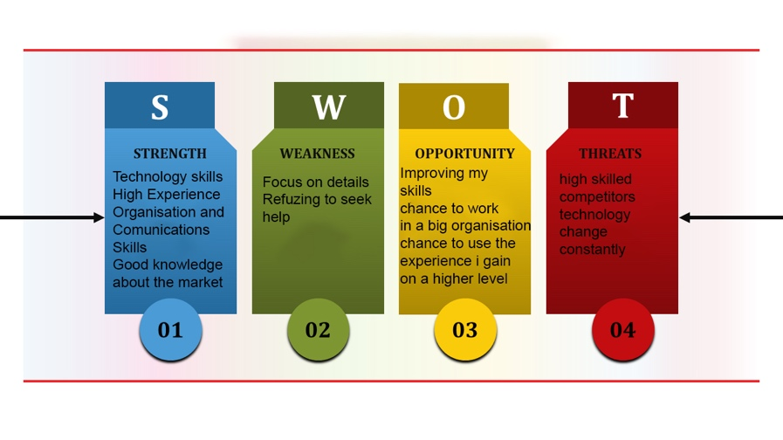

Strength

I am a very ambitious person with great experience in the food industry and extensive knowledge of customers in England and Wales. I also have good relationships with suppliers, I can speak 4 languages ​​fluently I am also a student at a professional university where I constantly improve my skills.
With good communication skills, I love team working and I am able to operate with all kinds of people in any situation.

Weakness

I am focused too much on detail during projects, I am a detailed orientated person and a deadline is not always helpful, I try to be more mindful in situations like this and learn to focus more on the end goal of projects that I am responsible for. I find it difficult to ask others for help when need it because I take great pride in my work and when I encounter problems, I try to figure it out myself whoever I do understand it will be more beneficial to seek advice from other more experienced and taking steps to improve that area.

Opportunities

Is a great opportunity for me to work in a big company where I can use the experience, I gain so far in this industry to follow my path in a career I love and I think it suits me the best.

Threats

In a big company are very high expectations and many competitors

JOHARI'S WINDOW

Organisations are built around people that’s why communication is the key to success, efficient communication keeps the organisation together.” The Johari Window- is a conceptual tool for illustrating the interaction between what is known/unknown to oneself and to others” (Newstrom,1983)

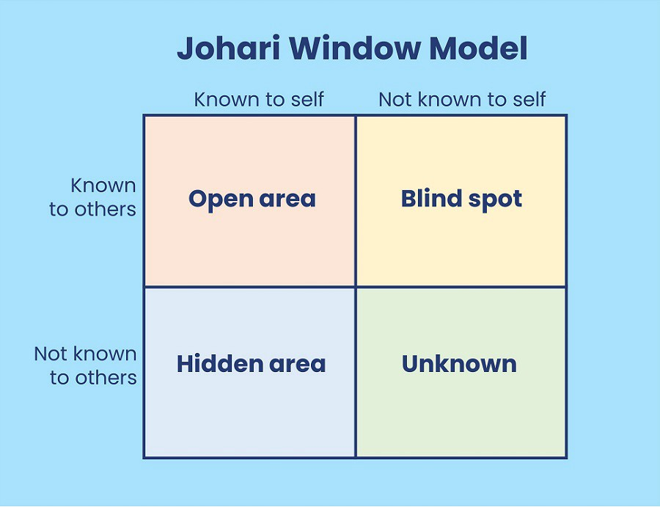

In the Johari window, the knowledge of two or more people about each other is at the forefront. This information is in the form of four windows. We can describe these windows as the following open areas, blind spots, and hidden and unknown areas:

Open area It includes both what a person knows about himself and what others know, includes consciously observed movements and expressions, and information that a person does not hesitate to say. This is the area that will have the most scope for effective communication and group processes. Open-minded people are masters of communication and good team players. In addition, these people are comfortable, natural, self-confident, develop emotional skills and have high emotional intelligence.

Blind spot, describes an area that a person does not know about, but is known to others. Feelings of fear, anxiety and jealousy arise in this area. People with a wide blind spot have limited emotional competence, for these people the feelings and thoughts of the people around them are not important.

Hidden area It includes characteristics that are known to the individual but not known to others, and contains information that the individual does not want to share and consciously hides. In this area, there are attitudes, characteristics and behaviours that a person knows about himself, but others do not know or are not aware of. They accept constructive criticism without criticism.

Unknown includes human characteristics unknown to himself and others. It is impossible to predict what people will do with such a largely unknown territory. They are tough, distant and closed boxes. People with a wide range of unknowns hide their behaviour and thoughts and avoid conflict.

Employment law

Employment law regulates the relationship between employer and employee. It regulates what employers expect from employees, what employers can ask employees to do and what rights employees have in the workplace which can be: discrimination, bullying and harassment, equal pay for the same work, health and safety, etc….

Part 2 Reflective essay

Gibbs reflective cycle

In the university sometimes students are asked to write effective essays. Some of the students may find this part very difficult and very challenging because reflective writing is very different from other assignments. In reflective writing you will have to talk about something that is already happened, you will need to look back in time and try to explain what you felt about it how difficult or challenging it was for you and how this will help you to do things differently in the future, using Gibbs reflective cycle as a guide it will take me through the process of writing my todays reflective essay

“Gibbs’ reflective cycle is a good framework to be used by the students in
writing reflections upon literary works they are working on.”( Adeani,2020)


Gibbs reflection circle is a simple 6-step process which is helping me to reflect on the experience I had it over this academic term.

Description

The first week felt very comfortable because I knew Mr Muhamad Islam, our lecturer from a previous term but the discussion we had in the first lesson regarding the 10 weeks module was a bit confusing especially when we reach the part when we had found a job which suits me and that I must create a cv and have a mock interview but after I realise it was a very good experience. It did help me a lot also because when I was going through details made me think about my weak points which didn’t make me think before

In week 2 we talk about how to improve self-awareness; it was very fascinating and also easy to understand because I was familiar with SWOT analyses and I was really attracted by Johari's Window

In week 3 we spoke about employment opportunities which make me go back in the past and start thinking about my strong points and what are my key points for the future if I will decide to go for another job in a new company and was surprised to see things in me which I never realised how powerful makes me in the domain I am working.

In week 4 we had the open book assignment which was something new for me but not very excited about it especially since I felt very frustrated because I didn’t have the chance to do it properly as my laptop was on low charge so I had to rush it. I feel bad about it because it was an easy 10% which I could gain but.

Weeks 5 and 6 were the most expected I was trying to get prepared as much as I could for my mock interview, so excited that I applied for a real job in the same domain I am working and, was not a big surprise for me but I actually I got the job (for half of my earnings) which was very offending and made me think a lot why someone who needs me so much would offend me in such a bad way. On the other part made me feel very good because I showed him, I know my value is not enough for someone to only offer a job and every company when advertising jobs must create a full packet for that job not only daily tasks and projects.

In week 7, the mock interview I was very confident and fully prepared to succeed in the second attempt to get the job, I didn’t feel any pressure during the interview this was because I was fully prepared, I was prepared also the first time when I went for the job, but the second time I felt more relaxed which made me think that people should go in special centres with the job descriptions and get a mock interview to release all the pressure, I looked in the internet for places like this and I have seen there is no any and after I was thinking….but this is another story.

Week 8 I had to review it online because of a personal problem I could not come and week 9 was more of a recap because I was familiar with the employment legislation.

Feelings

It was a very interesting module and now after I finished my report it answered many questions, I download every single session because I would love to review it because it is very important in my career

Evaluation

On a scale of 1 to 10, I think overall I was about 6 because I didn’t have too much free time, my plans were destroyed anyway when I had to leave the country for a personal problem and like this, I lost 12 precious days and I also missed to write the personal logs in time which I still have left to do. I missed the chance to have my reports reviewed by my lecturer and I think this will reflect on my final result, I know I could get at least another 20% more on my final result if I would have feedback to retouch it.

Analyses

I need to earn more time, probably the best thing to do is to start on the first week to make a note on my final report and after every lesson to start some research and start writing my ideas on a piece of paper and as we go forward to start writing my assignment.

Conclusion

For the next term, I must enrol on a morning class, I realised in the afternoon classes I only lose time because the class is in the middle of the day and I cannot do anything. In my next term, I will choose morning classes like this after class I can go home and have some rest and after I can work for 2 hours on my research to be better prepared for the next week's class and also for my final week.

Action plan

In my next term, I will join the morning class, after studies, I will go straight home I will relax for a few hours and after I will spend 2/3 hours on research and going again through the lesson, it is crucial to find 2 or 3 hours more during the week to keep me connected.

References

Quinton, S. and Smallbone, T., 2008. PDP implementation at English universities: what are the issues?. Journal of Further and Higher Education, 32(2), pp.99-109.

Beausaert, S., Segers, M., Fouarge, D. and Gijselaers, W., 2013. Effect of using a personal development plan on learning and development. Journal of Workplace Learning.

Ghazinoory, S., Esmail Zadeh, A. and Memariani, A., 2007. Fuzzy SWOT
analysis. Journal of Intelligent & Fuzzy Systems, 18(1), pp.99-108.

Kapse, A.S., Patil, V.S. and Patil, N.V., 2012. E-recruitment. International Journal of Engineering and Advanced Technology, 1(4), pp.82-86.

Newstrom, J.W. and Rubenfeld, S.A., 1983, March. The johari window: A reconceptualization. In Developments in Business Simulation and Experiential Learning: Proceedings of the Annual ABSEL conference (Vol. 10).

Adeani, I.S., Febriani, R.B. and Syafryadin, S., 2020. USING GIBBS’REFLECTIVE CYCLE IN MAKING REFLECTIONS OF LITERARY ANALYSIS. Indonesian EFL Journal, 6(2), pp.139-148.

