Ordinance, Munitions & Explosives (Degree Apprenticeship)
The design of an autonomous lawn mower”
ACDA6006 - Systems
Lawrence Groom
[Date]

Contents
No table of figures entries found. 1
Introduction 2
Key customer requirements 3
Stakeholder map 3
Gathering requirements 3
Critical system functionality 4
Types of functions 4
QFD 1? – What is it how does it work and how does it use information from the above. 4
Concept derivation and design choices 4
Func means analysis 4
Pugh matric 4
QFD2 4
Potential failure modes 5
Critical design features 5
The manufacturing processes 5
Critical process steps 5
Process control measures. 5
References 8

Figure 1 Customer Requirements example 4
Figure 2 QFD 1 example 6
Figure 3 FFMEA example 7

No table of tables entries found.

Introduction

The goal of systems thinking is to provide a holistic approach from first principles, so any design concepts conceived as a result have the best chance of for filling, and exceeding, all requirements. By left shifting the design effort into the early stages of a systems design life cycle, potential design failures, customer dissatisfaction, and safety hazards can be avoided. Additionally, solving potential issues in the early stages of a design is considerably more cost effective and easier than in later stages.
The author was tasked with the design of a golf courses autonomous lawn mower. Several concepts were designed to meet customer requirement utilising systems thinking and assorted tools. These tools allowed the author to not only collect useful information from stakeholders but also build functional requirements that were then assessed and analysed to produce several differing concepts. These were then further and refined using systems tools and thinking from a manufacture prospective.
.

Key customer requirements

Gathering requirements is an iterative process, and it is expected that all customers will issue requirements which fall into various levels of the v-diagram design pathway. It is important to collect all requirements but equally important to priorities and determine their location.
Without correctly capturing, understanding, and validating customer requirements it would be impossible to design a successful system.
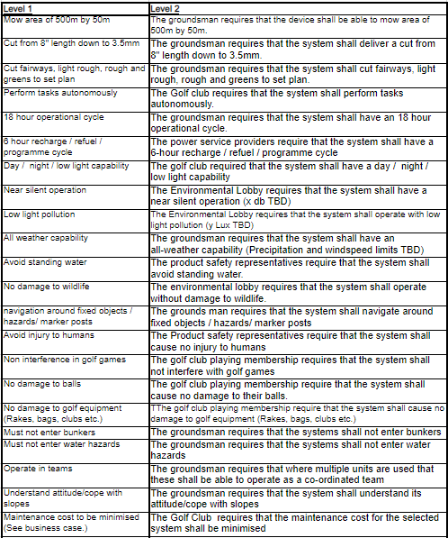
Figure 1 Customer Requirements example

Stakeholder map
Arguably the most important first step is to understand who the customers are and where they are positioned in relation to the system under design. From this it is possible to begin assessing for key requirements.
To determine who the stakeholders might be an influence map was drawn up. This allowed for the capture of potential stakeholders and their interaction with both each other and the system. These individuals were then grouped depending on their role regarding the system, for example the service provider group was comprised of mechanical maintenance companies as well as software providers and power companies.

Gathering requirements
By assessing the stakeholder map it was possible identify not only which groups to potentially focus on as key customers but also how may be best to begin gathering requirements from these groups. Tools such as affinity diagrams can be used for this collection of ideas and information and is particularly useful when used with groups of individuals as it allows for personal interaction and all parties comments to be noted. This additionally allows for the capture of the customers actual words, thereby removing any potential misinterpretation.
By use of the Kano model, it is understood that customers/stakeholders are likely to only give expressed requirements, it is the task of the systems thinker to analyse, interpreter and further engage with the customer to reveal additional requirements which might become delighters.
The gathering of requirements is an iterative process which should be conducted throughout the system design and lifecycle phases. In the design phase, regular engagement with customers allows for any changes in requirement to be accounted for and necessary adjustments made in the early stages. This further assist the system thinker in “left-shifting” design issues and deal with them in a cost effective and efficient manner.

Requirement’s importance table
This compares stakeholder requirements directly one another to determine inter-requirement relationships. These relationships and their strength assist in the building of functional requirements.

Critical system functionality
Once stakeholder requirements are gathered, top level functional requirements for the system can begin to be determined. These are the generic functions the system has to perform for example, “cut grass” is a generic function of the autonomous lawn mower. Whilst this function is fixed it can be implemented in several different ways.

Types of functional requirements
Functional requirements
Functional requirements outline what the system must do to be successful and meet stakeholder requirements. For example, the autonomous lawn mower must be able to adjust cut-height. This can be identified as a functional requirement through the use of verb noun construct.
Non-functional performance requirements
Linked to functional requirements by detailing how well any given function must perform. These can imply functional requirements but do not contain the noun, verb construct to make them such. For example,
Non-functional implementation requirements
Typically solution-based requirements, these originate from the customer requirements or legislation and define how or what a system is to use; such as a specific technology. It is important to identify and assess these types of requirements as they may be a result lazy decision making earlier in the systems thinking process, or a solution-based requirement taken directly from a stakeholder.
Non-functional system requirements
Defined as constrains that affect the system as a whole, such as a weight limit or maintenance intervals. These types of requirements will flow through system, sub-system and component processes. For example with a weight limit, every component must be assessed to ensure minimal contribution to weight.

QFD 1
Using QFD 1 it was possible to assess stakeholder requirements against functional requirements, this visualises which stakeholder and functional requirements have a relationship and how strong said relationship is. A QFD 1 also shows out which, if any, requirements are not being met and where potential re-assessment may exist. In contrast it also allows for the identification of critical functionality by proving which functional requirements meet multiple stakeholder requirements. For example, the functions “detect moving object” and “detect stationary objects” both meet, and have, a very strong relationships with multiple stakeholder requirements. This suggests that these functions are critical to the success of the system and therefore may need further assessment or more time to develop solutions.
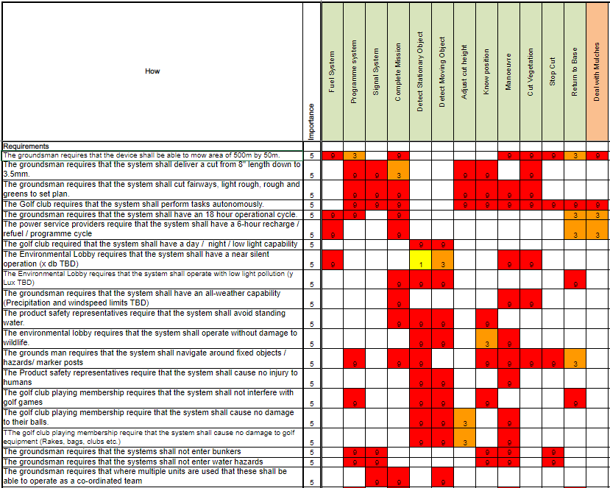
Figure 2 QFD 1 example

Concept derivation and design choices
Function means analysis
In order to build initial concepts a function means analysis table was produced. This allows multiple concepts to be mapped by selecting from a list of possible solutions (means) against the identified functions. Creating multiple solutions to any given function, and visualising them in one location, allows for the opportunity to innovate and explore several solutions simultaneously. this tool is most productively used in groups as this allows for discussion during solution selection which may assist in identifying less desirable solutions.

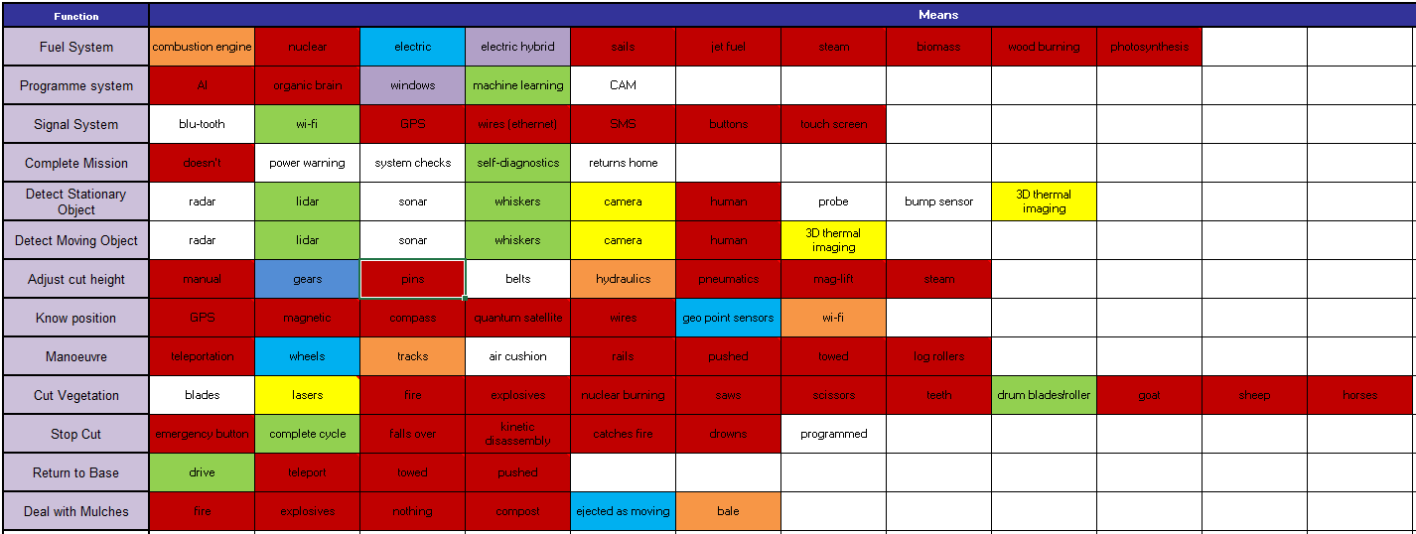
Figure 3 Function means analysis
Pugh matrix
From the Function Means Analysis table a Pugh matrix was then drawn up. This enables selected concept solutions to be assessed against customer requirements and scored on their ability to meet those requirements. It is also possible to introduce a currently existing solution to the matrix in order to further assess the concept solutions against an in-use solution.
The autonomous mower concept solutions for the fuel system function were compared to the customer requirements, no existing solution was introduced as the concept solutions proposed were of a standard nature.
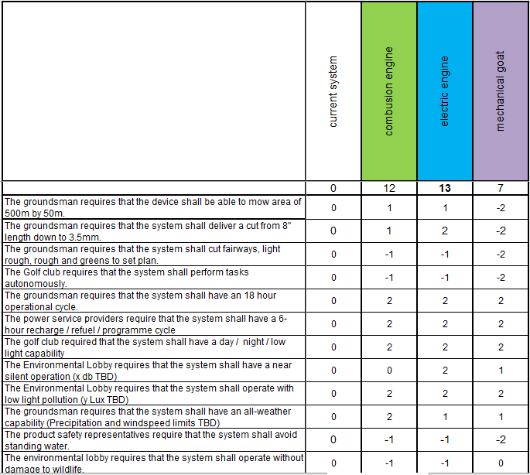
Figure 4 Pugh Matrix
A Pugh matrix can be carried out on every functional solution in order to determine the strongest potential concept, this can then be carried forward into QFD 2 where

Potential failure modes
To assess and identify potential failure modes a Functional Failure Modes Effect Analysis (FFMEA) was carried out. This tool enables the discovery of not only how a function could fail, but what the effects of its failure are, what the causes may be and how this failure can be detected and prevented. It also allows for the assessment of mechanisms that may already be in place to prevent failure. Each section is scored with the total representing severity.

There are 5 main failure modes present in every system, these may not be present in every function assessed however and several iterations of assessment will need to be undertaken to ensure any interpretations of failure modes are captured.
- Intermittent function
- Over function
- Under function
- Unintended function
- Never function
Examples of these found within the autonomous mower system would be the functional requirement to adjust cutter height, taken from the stakeholder requirement for the system to cut to various lengths.

- Intermittent – the cut height changes constantly
- Over – the cut height is too great, resulting in not cut or over cut
- Under – the cut height it too low, resulting in an undercut or damaged surface
- Unintended – cut height changed unintentionally resulting in the above outcomes
- Never – cut height never adjusted resulting in same cut and a failure to perform function correctly.
It is noteworthy that any potential failure mode may have multiple causes and effects. Whilst it would be beneficial to carry out an FFMEA table on ever function, the tables can become significant in size. This coupled with the long timescales to complete may result in the use of QFD 1 to assist in identifying critical functions which require in depth analysis.

Critical design features
The Function Means Analysis carried out when deriving concepts allows for concept designs to be separated and individually assessed. This assessment can be undertaken using QFD 2
QFD 2 assesses functional requirements against solutions and allows for the assessment of their interactions though a score, with a total score for each solution indicating criticality to the design. One design concept produced the highest score for a central processing system, this solution had a strong relationship with most functional requirements which identifies this solution as critical and therefore subject to a higher level of assessment. Whilst still at the system level, this information can be caried forward to subsystem and component levels, an action that may not need to be taken with a lower scoring solution. This assessment and discovery of critical features further allows system thinkers to left shift potential error detection into a cheaper and more accessible period of the design cycle.

It is possible to further analyse a critical feature through the use of a P-diagram, this enables the identification of noises and controls present in the function.

The manufacturing processes

By progressing into the manufacturing stage of a system design cycle, several further iterations of previously used tools, techniques and assessments is expected. For example, the re-assessment and further engagement of stakeholders in order to identify those with an impact and influence on systems manufacture is necessary and allows the creation of manufacturing functional requirements.

It is important to ensure the manufacture requirements of a system be assessed fully to ensure earlier design choices and solutions are still applicable and not detrimental to efficient and cost-effective production.

Critical process steps
From QFD 3, it is possible to identify critical process steps. This is done through the relationship between the manufacturing process steps and critical design parameters taken from QFD2 and any what-why diagrams used previously. As with QDF1 and 2 the scoring system used in the table matrix identifies strong relationships and which process step may need further scrutiny to ensure resilience. Foe example by assessing the blade manufacturing process steps against its design parameters the heat treatment of the blades was identified as a critical process. From this is was possible to investigate this process more thoroughly by applying P-diagrams and what/why tables and assessing the controls and noises produced. This ensures the design parameters are met and product quality is maintained.

Process control measures.
Having identified critical process steps using QFD 3 it is important to ensure adequate control measures are in place to monitor, maintain and correct the process under assessment. In order to achieve this, process control planning is required. This outlines how the process will be controlled, what measurements are needed and how often as well as what corrective actions may be selected.
QFD 4 allows for such assessment by comparing process parameters taken from the what/why table and assessing them against operational evaluation parameters and planning requirements. For example the assessment of the blade heat treating process, identifying process parameters such as oil temp and blade angle of entry were assessed against planning requirements such as in process inspection, process instruction and oil temperature measurement. These were compared via operational evaluation assessments of difficulty, frequency and detectability. By doing this, process controls can be identified that meet multiple process parameters thereby indicating where multiple layers of control inspection is present. This can then be further assessed to determine if this is reasonable.
A Process orientated FMEA can also be carried out. This allows for the assessment of process failure modes which in turn produces prevention and control measures. Additionally, a P diagram can be drawn up which will outline noises to a process and identify how these may be controlled.

Conclusion
Through the design of an autonomous lawn more, various systems tools and techniques were utilised and key features in the design phase have been identified.
System thinking it is not a process suited to specific specialism, rather a diverse group of various backgrounds. This enables different fields to have an impact not only on there area of interest but on the wider system as a whole, further increasing the processes utility and user understanding. It is an iterative process and should be continually assessed throughout not only the top system life cycle but sub-system and component levels as well.
Systems tools have multiple applications at various stages and can be used in various orders in order to achieve design success.

