Module: Workplace Culture and its impact on Organisational Efficiency
Code: BMSK 5005
Assignment Title: Individual project report with practical (oral) performance
Student: Ubaidullah Shameem
Number: 1711708
Lecturer: Eric Osei
Submission deadline: Report – 08/11/2019
Task one

Executive Summary

Positive workplace culture is important for company’s success and efficiency. This report designed to identify the culture of the University Hospitals Birmingham NHS trust, using different analysis tools of internal, external and organisational culture. The report also discussed about comparison with similar organisation culture.

Table of Contents
Executive Summary 1
Introduction 2
PESTLE Analysis of NHS 4
Political Factors 4
Economic Factors 4
Social 4
Technological 5
Legal 5
Environmental 5
McKinsey’s 7s 6
Strategy 7
Structure 8
System 9
Skills 9
Staff 10
Style 10
Shared values 10
Ethical Stance 11
Comparison 13
Conclusion and recommendation 14
Reference 14

Introduction
Workplace culture of a company is important for its efficiency and success. Employees will enjoy and work better if they fit in their workplace culture. A positive workplace culture improves teamwork, raises the morale, increases productivity and efficiency, and enhances retention of the workforce. Job satisfaction, collaboration, and work performance are all enhanced. But, most importantly, a positive workplace environment reduces stress for employees. There are many factors which affects the organisational cultures such as company’s beliefs, values and attitudes, as well as the impact of internal and external factors.
This academic report will analyse some of the factors which affect the workplace culture. These factors could be internal or external. They will be analysed using the appropriate analysis tools.
The organisation that will be discussed in this report is Heart of England NHS Foundation Trust. Heartland Hospital is situated in Bordesley Green Birmingham. The hospital was founded in 1895 and was known as Infectious Diseases Hospital. It was named as East Birmingham Hospital in 1963 followed by Heartland Hospital in 1993 (Birmingham Archaeology, 2016). The hospital was merged with many other institutions such as East Birmingham hospital, and Heart of England NHS Trust. However, in April 2019, it merged with the University of Birmingham NHS Trust. Currently it is named as University Hospitals Birmingham NHS foundation Trust (NHS, 2018). The UHB is one of the largest hospital trusts in the NHS which includes Birmingham Heartland, Solihull, Good Hope, Birmingham chest clinic and Queen Elizabeth Hospital.

Organisational culture is how things are practiced in the organisation, the rules which are not written but are followed by everyone and the impact it has on individual and group behaviour. Issues that affect organisational culture could be the structure of the organisation, system, employee’s behaviour and attitude, as well as companies’ values and leadership style.
It is important that the organisation has the right culture which is suitable for the employees because if the employees are not comfortable with the organisation culture they will not enjoy working in their workplace. This will affect company’s goals and objectives.
In order to understand more about the culture of the University Hospitals NHS Trust, it is important to analyse the internal and external factors that affect the NHS. This will identify the culture of NHS and its performance.

There are many tools available for external analysis of the Organisation such as Porter’s Five Forces and Benchmarking. However, the most popular one is PESTLE analysis tool. PESTLE is for Political, Economic, Social, Technological, Legal and Environmental.

PESTLE Analysis of NHS

Political Factors
Political factors are those that affect business due to the government plan and decision. Currently the UK Government’s main priority is to deliver Brexit. The UK is scheduled to leave the EU on 31 January 2020. If this happens as planned, this will most likely have an impact in the NHS in many ways: there might be a shortage of staff in the NHS because the EU nationals may be moving back to the EU. There were approximately 1.9 million people employed in NHS in 2018, 88% of these were British, while 6% were EU nationals and 6% were non- EU nationals (National Statistic,2019) This figure will significantly drop after the Brexit as some of them are already leaving the UK , this will create pressure on the NHS.

Economic Factors
Economic factors are those that affect the economy, as a result affect the business. This could be changing the interest rate, exchange rate and inflation.
Currently the UK economy is in steady mode. However, after Brexit, it may change dramatically and maybe increase in inflation and interest rate may change as the Bank of England (November,2019) had predicted. As a result, investors may not invest. This will impact the NHS.
Although the NHS budget has increased steadily from 127.8 billion in 2015/16 to 139.3 billion in 2019/20, however this increase is not enough to reduce the current waiting times and not sufficient enough to provide better care for the patients (The Kings Fund,2019).

Social
Social factors are those which affect individual’s personality, attitude, behaviour and lifestyle (Business dictionary, 2019).
The population is growing and people’s life expectancy is also higher than before, as Piers Morgan (2018) has stated that the UK population has grown by a third since the start of the NHS, and is likely to grow to 74 million and another 10 million by 2039. The current UK population is estimated 65.6 million (2016), however by 2039 it is estimated to rise to 72.5 million. NHS will find it challenging to treat them in the future.
People’s life expectancy has also has increased. Now people live longer with good health than before. Currently in UK, there are half a million people at the age of 90, this figure is two and half times more than the number was in 1985. Though life expectancy has increased, nevertheless, older people aged 65 and over are now suffering more with long-lasting illnesses such as dementia, diabetes and arthritis (Public Health England, 2017), to treat such patients would be costly.

Technological
Technological Factors are those that affect businesses due the advancement of technology.
Technology is advancing faster than ever before. Currently, most activities can be done on mobile phones such as sending emails, shopping, paying bills, collecting data and storing it on iClouds etc. By introducing new apps, it allows patients to receive treatment faster and easier as some surgeries are already offering videos, phone calls and email consultations with the doctors. People are using new technologies such as Apps and other communication tools to do their regular activities. Therefore, NHS need to be aware of new technology advances so they can provide better care to its patients.

Legal
Legal Factors are those factors that affect business due to introducing or changing of laws such as employment, immigration and tax laws.
As a result of Brexit, many UK laws and regulations will have to be changed, because after Brexit, the European law will no longer be applicable to the UK. This may affect the NHS with the existing law such as medicine supply, as UK is currently part of the European Medicines Agency which approves the medicine before it goes to the EU market.

Environmental
Environmental factors are those which affect businesses due to the environment. For example, climate change.
NHS will face environmental factors in the future as climate is changing. Temperature will increase as a result of global warming. This increased in temperature will lead to heat related diseases and death. Air pollution and burning fuel will also cause disease (Camille Oung, 2019).

The external factors impact the organisation and its performance, similarly the internal factors will also impact the organisation. Therefore, it is important to analyse the internal factors too. There are many tools available for internal analysis. However, the most popular tool is McKinsey’s 7s.
There are seven internal features of an organisation that need to be adjusted and commonly strengthened to make progress.

McKinsey’s 7s
This tool was introduced by McKinsey’s consultants Tom Peters, Robert Waterman and Julien Philips with a help from Richard Pascale and Anthony G. Athos in 1980 and is used by academics and practitioners widely for their strategic plan and in many other situations such as implementing new strategy and to identify how each area of organisation may change in the future.
These 7 factors can be categorised into two groups; hard factors which are tangible and easier to define because they are documented in reports and strategy statement such as strategy, structure and system. Soft factors which are not tangible and hard to define because they are related to culture and norms such as skills, staff, style and shared values. Both groups are important for the organisation success.

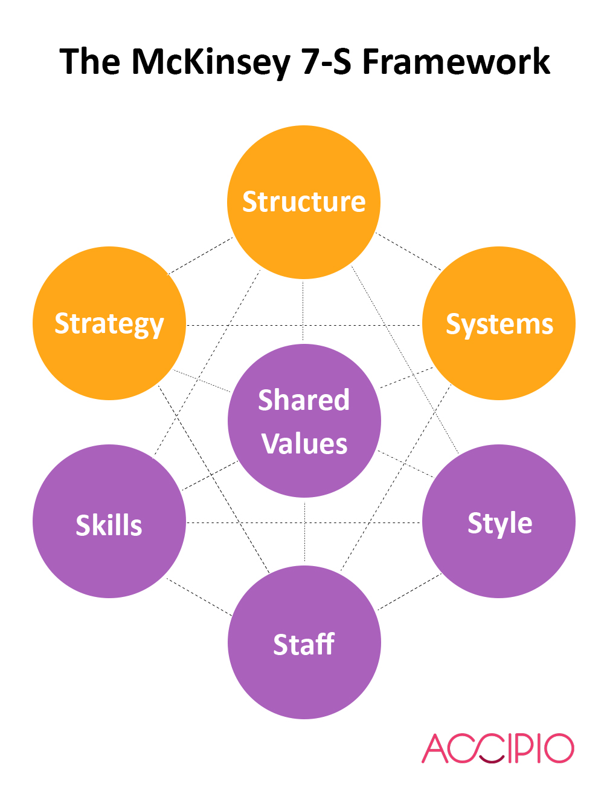

Source: Accipio

Strategy
Strategy is a long-time plan to achieve companies’ goals and objectives. Strategic plan is important as it gives a sense of direction, helps to make day to day decisions and outline measurable goals.
According to the University Hospitals Birmingham Trust (2019), strategy for the trust are; to continue to provide high quality care for patients, be excellent as a hospital and to be excellent as a group of hospitals. These plans will be achieved with the following actions;
Leaders, staff at all levels and sites of UHB works as a single and unified organisation by collaborating with each other and with NHS partners. Everyone’s aim should be for quality improvement, performance and activity, investment, income generation and CIPs. Trust will be digitalised by introducing a single digital platform and patient record system for all hospitals in the trust.

Structure
Structure is the organisational chart or chain of command such as manager to the employees. In other words, hierarchy within the organisation and how different departments work together in order to achieve the goals of an organisation. Structure helps to monitor the company’s activities and increase productivity. Structure can be different depending on the size of the company. Some companies may have a simple structure with less department, others have traditional structures with many departments and units.
The UHB Trust has few structures such as Board of Directors structures, division 1-6 structures and division management structures.
The functional structures of Board of Directors of UHB NHS Trust are as follows:
Chair  Rt. Hon. Jacqui Smith | Chief Executive  Dr David Rosser

Executive Directors
Chief Transformation Officer  Cherry West | Medical Director  Professor Simon Ball | Chief Operating officer Jonathan Brotherton | Chief Workforce and International officer  Kevin Bolger | Chief Nurse Lisa Stalley Green | Chief Financial officer Mike Sexton | Chief Innovation officer  Tim Jones

Directors
Director of Partnerships Andrew McKirgan | Director of Corporate Affairs David Burbridge | Director of Communications Fiona Alexander | Director of Finance Julian Miller | Director of Strategy, Planning & Performance Lawrence Tallon | Director of Quality Development Mark Garrick

Non-Executive Directors
Non-Executive Director  Catriona McMahon | Non-Executive Director  Harry Reilly | Non-Executive Director Jackie Hendley | Non-Executive Director  Jane Garvey | Non-Executive Director  Jason Wouhra

Non-Executive Director  Jon Glasby | Non-Executive Director  Karen Kneller | Non-Executive Director  Mehrunnisa Lalani | Non-Executive Director  Michael Sheppard

Source: University Hospitals Birmingham NHS Trust
This is a sample of UHB functional structure. However, the full trust structure is long and can be found by visiting on: https://www.uhb.nhs.uk/trust-structures.htm.
As UHB is a massive trust, therefore working with different departments in different hospitals, are often difficult. Similarly, getting in touch with the top is also hard, one must go through few chains and commands.

System
System is an internal process and procedure of the company that employees use to do their job. These could be formal systems such as Finance and IT etc or informal such as communication process.
The UHB NHS trust internal communication system is very good, effective and helps to do the job. Lots of information is available on trust website such as finding a patient’s name, ward, department, education and training. A patient’s information is kept safe and secure in a secure device. Confidentiality of the patient is important, and training is provided regarding this.

Skills
Skills are the abilities, talent that employees use to perform well in the workplace. There are many skills employees need to achieve companies’ goals and objectives. According to Alison Doyle (2019), there are the top five skills that the employer wants from the candidate such as communication skills, team working and problem-solving and listening skills. The UHB Trust offer free online training courses to its staff to build their skills or to upgrade the existing skills which include manual load handling, fire and safety and information Governance. These skills are mandatory to update in every two years. According to Care Quality Commission Inspection Report (2018), ‘’Managers at all levels in the trust had the right skills and abilities to run a service providing high-quality sustainable care’’.

Staff
Staff are people who work in the company. With regards to the staff, it should be considering who the key people in the company are and what their strengths and weaknesses are for achieving the company’s goals. Also, to check what personal development training is available for employees to reach their potential.
UHB staff are skilled and trained. There are many trainings available for different staff in the NHS, such as statutory training which is required by law, others are mandatory trainings which is compulsory and set out by the organisation to deliver service safely and efficiently. With regards to the bank and temporary staff, there are some essential trainings to ensure that they work in a safe manner such as data protection, health and safety at work, fire safety awareness, infection control, manual handling and safeguarding children. Mandatory training is updated annually depending on the role and organisational requirements (Royal College of Nursing, 2019).

Style
Style is the way the company is managed. For example, how employees interact with one another and solve problems. In other words, leadership in the company is autocratic or democratic or bureaucratic.
Style in the NHS is bureaucratic as hospitals are under the government system and most of the decisions are made by the government. However, it is normally run by the leaders who have the hierarchy and authority of implementing the decisions.

Shared values
Explicit or implicit fundamental beliefs, concepts, and principles that underlie the culture of an organisation, and which guide decisions and behaviour of its employees, management, and members (Business Dictionary).
The University Hospitals Birmingham (2019) have five values or principles:
Collaborative, honest, accountable, innovative and respectful.
The culture in the hospital is diverse, equal and fair. The positive side of the workplace is that staff are friendly and work together as a group. There are many staff from same culture and belief.

Ethical Stance
The word ethics is derived from Greek word ‘ethos’ which means practice, habit, character or disposition (BBC,2014)
In business, ethics means the business policies, code of conduct, principles, practices, values and norms that govern the actions and behaviour of an individual in the business organisation.
There are different models available to describe the organisational culture. The most effective one is ‘cultural web’ introduced by Johnson & Scholes in 1993, which describes the basic points of the organisational culture.

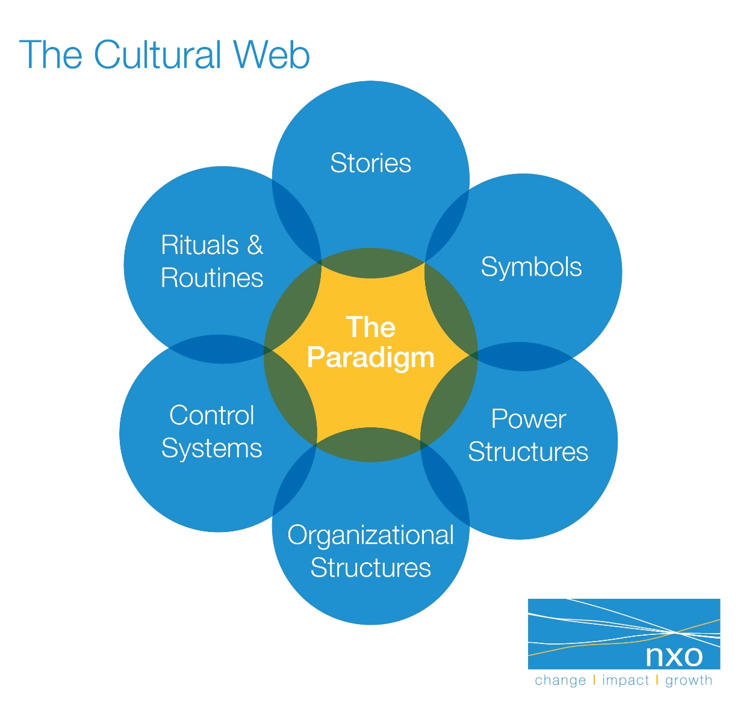
Source: NXO

Paradigm: The control system
Symbols: Symbols are the elements that distinguish the uniqueness of the company such as logo, dress and colour etc.
Power structure: The type of power in the organisation, who is in charge of what and how power is distributed in the organisation.
Organisational Structures: The hierarchy position of the organisation and what the relationship is between the other department.
Control systems: The way an organisation is managed and controlled.
Rituals and routines: Rituals and routine are the events which is important to the organisation. For example, prayer in the morning or singing together before starting work.
Stories: Past events of the organisation about the heroes and successes or failures of the organisation.
The UHB has the culture of openness, transparency and honesty. In order to practice this culture, all staff are required to follow the staff code of conduct set by the trust and show personal behaviour. This code explains the issues and matters that staff face while doing their daily duties. The policies are many. However, few policies are mentioned in this report which are essential to all staff such as data protection, confidentiality policy, dress and uniform policy, health and safety, prevention of bullying and harassment at work, equality and diversity and risk management policy (UHB,2019).
Although policies and procedures are in place but some of the policies are not taken in to action as Care Quality Commission Report (2019) suggested the following regarding Heartland Hospital.
Mandatory training is not provided to all staff in some departments. Also, not all staff have proper level 2 safeguarding training.
There was lacking in infection control, staff keep themselves clean but the equipment and sites is not all ways clean.
With regards to the concerns and complaint handling, complaints are taken seriously but not always investigate timely. If any mistakes are made in the managerial role, lessons learnt from mistakes is not shared with all staff. Inspectors are also believed that Some of the staff are not clear about their roles and responsibilities.

Comparison
The National Health Service (NHS) is the largest health organisation in the UK funded by the UK government, and it has very few competitors and substitutes. However, there are some private health care which are available such as BUPA, AXA PPP Healthcare etc.
British United Provident Association (BUPA) is a private health company that started in 1947 in UK, since then its business has expanded globally. Currently it has 16.7 million health insurance customers. BUPA also provide health services such as clinics, hospitals, dental care and aged care (BUPA, 2019).
The workplace culture in the NHS and BUPA are quite similar. However, there are some differences. As BUPA is a private health care and it has no shareholders, employees are less compared to the NHS, so the leadership style is autocratic whereas in NHS it is bureaucratic. Staff in BUPA are team oriented resident focused, in the NHS care provided in the hospitals. BUPA is a private health care so patients are treated as soon as possible, whereas the NHS has long waiting so patient’s treatment is delayed.
NHS is a massive organisation. Most resources are available on its website, many issues are solved by visiting the website including online mandatory training, whereas BUPA, staff need to attend face to face training.

Conclusion and recommendation
Workplace culture has impact on organisation success and failure. It is important for the management to provide positive culture where employees enjoy working. This will increase company’s productivity and achieve its goals and objectives. Most importantly it will reduce stress for the employee. It is recommended that trust policies and procedures should be explained clearly to the staff so they know what trust to expect from them and this should be checked every year. Another point is that trust should share information to all staff if they learnt any lessons from a mistake, so all employees can benefit from the lesson.

Reference
Office for National Statistic (2019). International migration and the healthcare workforce. Available at: https://www.ons.gov.uk/peoplepopulationandcommunity/populationandmigration/internationalmigration/articles/internationalmigrationandthehealthcareworkforce/2019-08-15 (Accessed on 30.10.2019).
NHS England (2018). New Birmingham hospital Trust formed by merger. Available at: https://hgs.uhb.nhs.uk/new-birmingham-hospital-trust-formed-by-merger/ (Accessed on 28.10.2019)‌
Cambridge Dictionary (2019). Culture. Cambridge University Press. Available at: https://dictionary.cambridge.org/dictionary/english/culture (Accessed on 26.10.2019)
Schein, E.H. (1996). Organizational learning: what is new? Available at: https://dspace.mit.edu/bitstream/handle/1721.1/2628/SWP-3912-35650568.pdf (Accessed on 31.10.2019)
Bank of England (2018). Inflation Report - November 2018. Available at: https://www.bankofengland.co.uk/inflation-report/2018/november-2018 (Accessed on 23.10.2019)
The Kings Fund (2019). The NHS budget and how it has changed. Available at: https://www.kingsfund.org.uk/projects/nhs-in-a-nutshell/nhs-budget (Accessed on 15/10/ 2019)
Public health England (2017). life expectancy and healthy life expectancy. Available at: https://www.gov.uk/government/publications/health-profile-for-england/chapter-1-life-expectancy-and-healthy-life-expectancy#fn:6 (Accessed on 24.10.2019)
Archaeology Data Service (2016). Ward Block 10, Heartlands Hospital, Bordesley Green East, Birmingham, West Midlands: Historic Building Record. Available at: https://archaeologydataservice.ac.uk/archives/view/bufau2045_2016/index.cfm (Accessed on 20.10.2019)
Spencer-Oatey, H. (2012) What is culture? A compilation of quotations. Global PAD Core Concepts. Available at GlobalPADOpen House http://www.warwick.ac.uk/globalpadintercultural (Accessed on 28.10.2019)
Business Dictionary (2019). shard Values. available at: http://www.businessdictionary.com/definition/shared-values.html
University Hospitals Birmingham (2019). vison, purpose and values. Available at: https://www.uhb.nhs.uk/vision.htm
Doyle, A. (2019) 5 social skills For Workplace susses. The balance careers. Available at: https://www.thebalancecareers.com/top-social-skills-for-workplace-success-4142848 (Accessed on 30.10.2019)
University Hospitals Birmingham (2019). our strategy to build healthier lives. Available at: https://www.uhb.nhs.uk/Downloads/pdf/Bod0419StrategyBuildHealthierLives.pdf (Accessed on 30.10.2019)
Royal College of Nursing (2019). Training: statutory and mandatory. Available at: https://www.rcn.org.uk/get-help/rcn-advice/training-statutory-and-mandatory (Accessed on 30/10/ 2019)
Johnson, G., Scholes, K. and Whittington, R., 2008. Exploring corporate strategy: text & cases. Pearson education.
BBC (2014). Ethics: A general introduction. Available at: http://www.bbc.co.uk/ethics/introduction/intro_1.shtml (Accessed on 30/10/2019)
Care Quality Commission (2019). University Hospitals Birmingham NHS Trust inspection Report. Available from: https://www.cqc.org.uk/sites/default/files/new_reports/AAAH7530.pdf ( Accessed on 01.11.2019)
BUPA (2019). Who we are. Available at: https://www.bupa.com/corporate/who-we-are (Accessed on 01.11.2019)
NHS Digital (2019). systems and Services. Available at: https://digital.nhs.uk/services (Accessed on 27.10.2019)

