What is criminal profiling, and would nature v nurture play an important part in this?
By Melenie Jane Box.
Independent project – (BMPS6012).

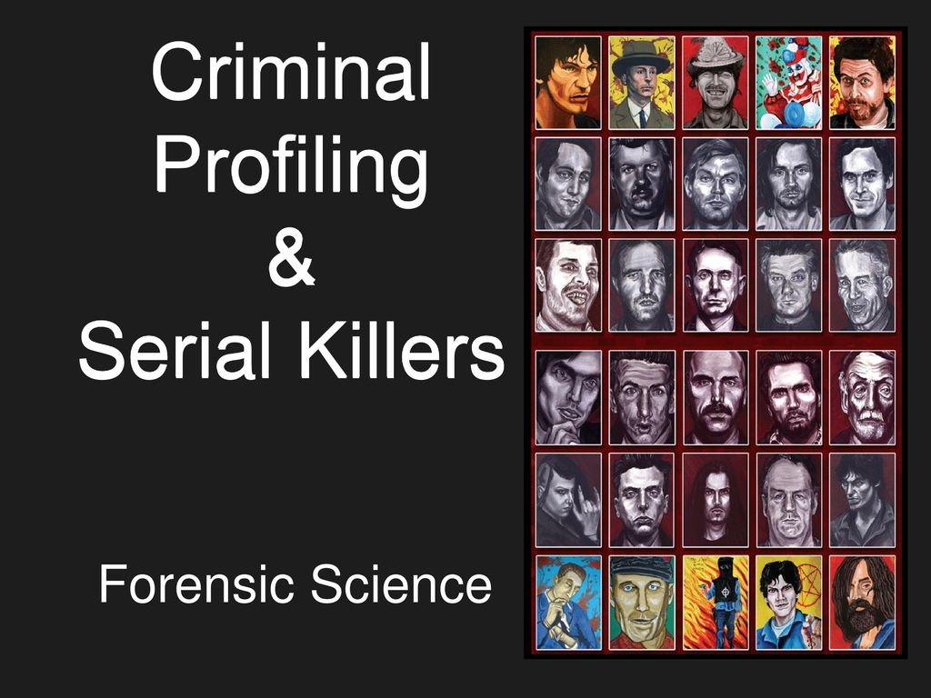
The process for profiling a criminal can be defined with a technique that would be used to identify a perpetrator of many a violent crime. This will identify their behavioural characteristics and personality based upon the analysis of the crime which has been committed.
This process goes on to involve an evaluation of the criminal act, with a very comprehensive evaluation of the specifics of the scene, victim and the preliminary reports made by the police themselves. There are to be additional steps to these evaluations too, like the post – mortem protocol made by the medical examiner as well as the profile of offender characteristics. Plus, there would also be an investigative suggestion which is predicted upon the construction of the criminal’s profile.
Criminal profiling is rather useful when used in situations like being held hostage, sexual murders, rapists and arsonists to name a few. Criminal profiling is not very suitable for detective work but is more of a tool that they use to try and help solve forms of violent crimes. (Douglas, J.E & Burgess, M. 1986).
Since time began, criminals have been unwelcomed within our society. For most of the time, research was only directed towards the identity of the physical characteristics of criminals. This approach had very little value of any investigation or the prevention of any crimes. As times have moved on, interest was formed about the workings of the human mind, then all attention turned to either ways of identifying the thought process of these criminals or looking towards any possibilities of the criminals’ subsequent reform.
Within the last century, law enforcements have begun to now realise that the analysis of the behaviour of any subject that is identified can give out clues as to their age, social status, education, physical appearance and so on. These factors would then help the authorities to narrow down their inquiries.
With present day usage of computers, it has now made it more possible to handle masses of data on which the analysis can be based.
Originally it was named psychological profiling, but now better known as offender profiling. The first systemised usage of this technique came about when the Federal Bureau of Investigation or FBI for short, Behavioural Sciences Unit in 1972 and the Department of Violent Criminal Apprehension programme in 1984. (Innes, B 2003).
The Italian physician born Ezechia Marco Lombroso (Cesare Lombroso) was born on the 6th of November 1835, Verona, Austrian Empire (now in Italy) was known to be the godfather of criminology. Cesare was to state that all criminals can be identified by physical characteristics and that their behaviour was known to be hereditary. Criminal psychologists have since disagreed that Lombroso’s theory, but the fact that you can still construct a physical, plus psychological profile of a criminal has now struck today. Most law enforcements around the globe would rely upon these detailed profiles to help them with their investigations.
Criminal profiling has brought to justice the likes of devious and dangerous criminals. These would range from rapists, kidnappers, serial killers and assassins too. (Innes, B 2003).
Why I chose to do my dissertation on criminal profiling is not just down to the fascination of psychology, or criminals but the facts for me are simple. It would be great to be able to look upon someone and state that as they get older, they would change and become a homicidal maniac, or a thief for example. These philosophers and so-called psychologists of the past had great ideas, but now it is time to reassess their works and try to focus upon whether it is nature or nurture or just pure driven evilness within these people. In some twisted sort of way, it could well be a cry for help.
Psychopaths are not the same as sociopaths. For example, a psychopath would more than likely end up being in trouble with the law, where as a sociopath tries to blend in with society. They may share some traits like antisocial personality disorder, but this is known to be less severe within a sociopath. The question I would like to find answers to is would the brain structure of a psychopath be the same or different to the average person, if so how and why?
Is it true that all psychopaths are killers or is this just a reflection of how today’s media have portrayed them?
Do the public perceive this to be true, should we believe in everything that the media throws at us?
Should there be actual evidence which can be backed up by the media, or are we fast becoming mushrooms, kept in the dark and fed on crap.
We as a nation are fast becoming gullible and too reliant to be able to think for ourselves. We need to try and stamp this out, look at it from every angle and have the correct evidence before we can determine that someone is a psychopath or a sociopath, as having been labelled this for life could have far reaching devastations for this person. Great reform is needed to tackle the number of criminals within the justice system, make sure we get to the ROOT cause of why these people are frequently offending and to make sure that justice is served correctly and that the wrong people are not imprisoned for a crime which they did not commit.

Ian Brady and Myra Hindley. (The Moors Murders).
A serial killer is usually a loner, one person who will murder their victims over time, with gaps in-between each of their killings. Many of these killers would kidnap and torture their victims just like a wild animal would do prior to killing their pray. It is not always evident as to what motivates a killer to commit such horrendous acts, maybe an abnormal psychological process or even anti-social behaviours could be to blame.
Within our society killers have the fear and the fascination for murder. A prime example of this would be Ian Brady and Myra Hindley. Myra was so infatuated with Brady that she was in fear of losing him so did as he asked. Ian Brady was fascinated with murder. He started his murderous spree by killing small animals and then progressed by joining the Nazi Youth group but wanted bigger and better. Brady was the brains behind these killings, but needed an accomplice, so decided to enlist the help of Myra. This was to be known as a Crime of Passion, and together they were to be known throughout the land as the “Moors Murderers”. (Psychology Today,2023).
The profiles of these offenders are only as accurate as the information that would be given to the profiler, these need to be regarded as a tool to be used by the police with help to catch the criminal.
There are two approaches to this. The first one is known as the top – down approach which is used only in America, where any data gathered at the crime scene can be identified by the characteristics of an offender. The offender is then categorised as an organised or even a disorganised offender. This is known as a top – down approach as it tries to fit the crime details under any pre – existing categories. (Typologies).
This approach was first used in the early 1970s, it was pioneered in America by Burgess and Douglas who worked for the FBI’S Behavioural Sciences Unit.
These two pioneers interviewed sexually motivated killers, the likes of Ted Bundy. The questions they asked were related to things like triggers and any early warning signs. With this gathered information they were able to identify typologists. These are groups of offenders who have different attitudes and behaviours.
The British approach is different and known as the bottom – up approach. This starts with small details and then goes on to create a bigger picture, no assumptions are made about the approach used or the offender too.
If you are known to be an organised offender then your crime is always premeditated and organised, show self-control, leave hardly any clues and attempts to control their victim who is normally a targeted stranger. These are the characteristics of a murderer. If you are known as a disorganised criminal, then there would be no planning or preparation you wouldn’t hide any evidence at the scene either and you would have disorganised behaviour as well as random. There is also something known as post – offense behaviour where the offender would return to the crime scene. If you are disorganised then this could be known as a crime of passion, as there would be no evidence of any premeditation and they may leave evidence like semen or blood maybe even a murder weapon too. These criminals are more than likely to be unemployed.
The bottom up or British approach was coined by two psychologists in 1990 by David Canter and Paul Britton. This approach tends to look for any consistencies in offenders’ behaviour during their crime spree. In the 1980s John Duffy or the ‘Railway Rapist as he was known to the authorities carried out a staggering twenty – four sexually motivated attacks as well as three murders of women in North London possibly near to a railway station. From the evidence and the location Canter was able to secure an accurate profile, but this profile did not lead to John Duffy’s direct arrest. A crucial typology approach is interpersonal coherence. This is to do with the way the offender would behave while in the process of committing a crime. There was also a second theory given by Canter, this would be known as spatial consistency. This was down to an assumption that all offenders would operate in well known areas by themselves. In 1993 Canter teamed up with Larkin and sought two more categories of offenders. Number one is a marauder who would only commit crimes near to where they live as it made them feel safe and secure and the other one would be commuters who commit crimes nowhere near where they live, and it would also be done over larger areas.
All the above approaches can be useful to aid the police to narrowing down their search of a criminal, but it would require up – to – date data on any offense which has been committed within a certain area. This would pose a problem too at times due to the under – reporting of any crimes by the public as they could well be too scared to report them.
Although the British Approach may seem to sound great, there is a lack of consistency to this. There are more individuals in the United Kingdom that now provide psychological profiles to the police and most of these individuals have very different ideas and backgrounds within psychiatry and psychology so they each will use their very own approach on how to deal with this. (Mcleod, S, PhD, 2023).
The nature v nurture debate is never ending, what are the factors that contribute to the formation of the human’s identity. People have been known to argue over whether it is down to our genes which determine who we are, or could it be the environment that surrounds us from the day we are born, until the day we die.
Some psychologists think it is a mixture of both nature and nurture, but there is little or no evidence to really prove this theory.
Can nature and nurture be inseparable?
These intertwine to weave a tapestry so complex that would be every human being known to man would not understand. Nature is who we would be, but nurture is the blueprint into what builds a person. This depends on the blueprint itself and as to whom has built it. It can form from many different people or can come from just the one blueprint. Our genes. There is no us without genes, just like there would be no software without a computer code to underline it. With inheritance and certain mutations, genes go on to create a unique person of just who we are.
There also must be a counter argument. Our genes work somewhat like a computer game, they are our code, but then the environment in which we are in can take us from possible person to just a person. Embryos are just a genetic code as genes do not exist otherwise in a vacuum. Without a phenotype there is to be no genotype either, or phenotypes depend solely upon our environment. Once we have developed from an embryo we are then known as a phenotype, so both our genes and the environment create us and makes us who we are. So, in a sense, genes are not important within this counter argument. 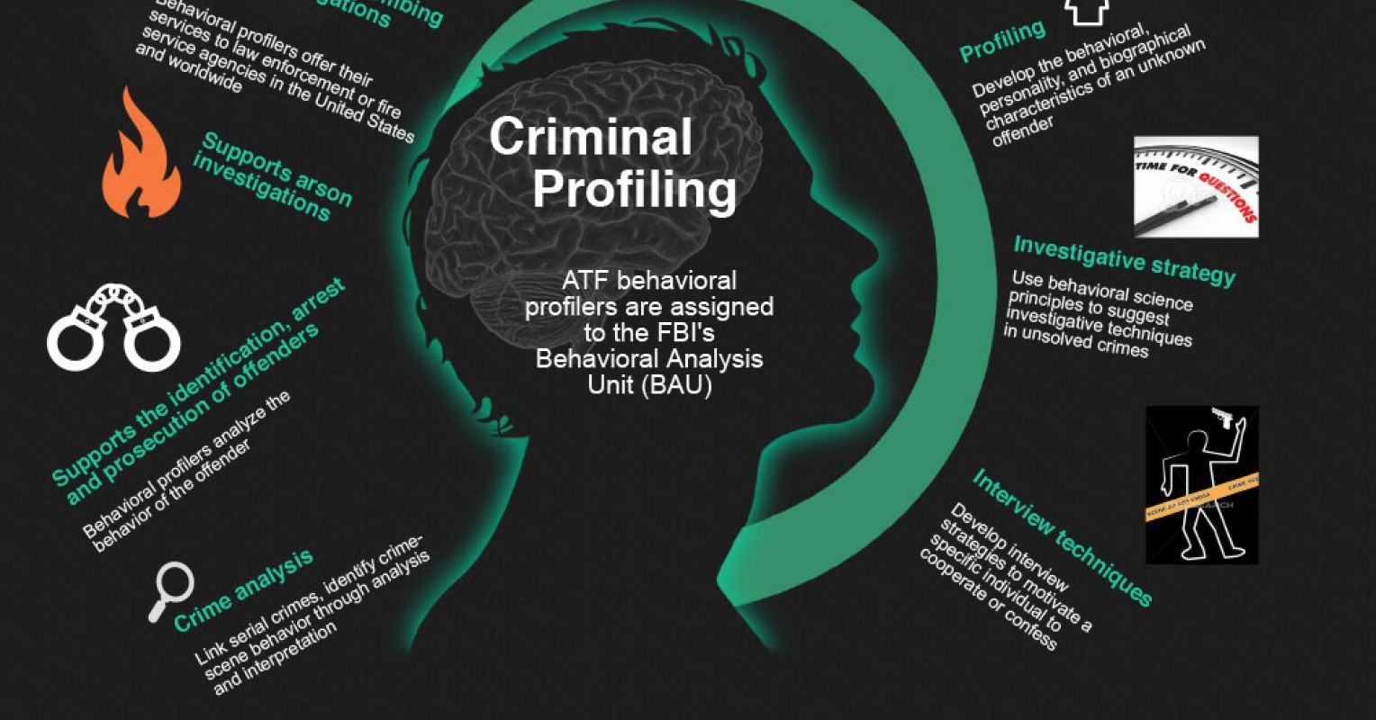
Criminal profiling needs scientific methods and applied understanding of logic and the ability to know when someone is in the wrong. Also, you need to have some sort of understanding on bias. A criminal profile only gives a glimpse of the person who may or may not have committed the crime. There’s no actual evidence to support or prove the validity or even its reliability of any criminal profiling within solving these types of crime. It hasn’t been denied that this sort of profiling has been proven to be of help to the authorities albeit exceptional cases. It really needs to have more research done on it, before profiling can become a valuable forensic tool.
Criminology and psychology have strong connections within history, they both originated in the 19th century. In the 20th century, psychology began to expand and take off, the discipline for this was to come from Leipzig University around 1879.
Criminal profiling, or as it is now known to be offender profiling, is a controversial technique that has started to fast develop over the years with television shows like CSI or Touch of Frost, which are all too misleading and we tend to believe them way too much. Not everything in life is like the tv programmes we all like to watch.
Alison et al, (2007) stated that in the 1880s one Doctor Thomas Bond tried to profile the personality of Jack the Ripper. During World War 2, Walter Langer was asked by the Americans if he could profile Adolf Hitler. Profile origins can be described as in the work of James Brussel, who was to become involved in an investigation into serious criminal in 1956 known only by the name of the ‘New York Bomber’. Brussels did a study of the crime scene, and he was a trained psychoanalyst, so used his training to help to describe what he thought the bomber would be like. He went on to say that the offender was male, middle aged, heavy set, single and living with a brother or sister. The ‘New York Bomber’ turned out to be George Metesky who was of course male and lived with two siblings. A profile is all about the offender’s characteristic patterns or any uniqueness that many individuals would have differently from the rest of the population. (Hazelwood and Douglas,1980).
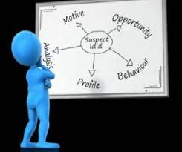
Profiling comes under different names or terms which can include behavioural evidence analysis, biopsychosocial profiling, and psychological profiling to name just a few. This type of profiling would normally add depth to the investigation of the crime scene. Important information can become apparent at the crime scene, this in turn could reveal any of the criminal’s information as to whether they are a psychopath or sociopath etc.
There tends to be a difference between psychopaths and sociopaths. Doctors do not actually diagnose someone with these problems, they would use the term antisocial personality disorder. A psychopath tends not to have a conscience and if they are to steal from you then they have no moral qualms about doing this, but they pretend to. They watch other people and try to act like they do and hope that they are not noticed. A sociopath tends to have a weak conscience, they know that what they are doing is wrong, but do not try to stop this behaviour. Both kinds of traits have no ability to stand in someone else’s shoes to see how this other person is feeling at the time, plus they both lack any sort of empathy too. Psychopaths have less regard for people and normally see them as objects of use towards their own beliefs and benefits. (Robinson, K, M – 2022).

Does the environment play an important role within our behaviours?
Our norms and values do play a vital role within our behaviours, these would be learn/taught by peers/parents and siblings or our extended families. Genes can increase the chances of becoming a psychopathic killer, but the environment will shape if we were to become one. Understanding psychopaths is now leading scientists beyond the prison walls. Julius Koch (1841 – 1908), a German psychiatrist coined the term psychopath. Koch went on to state that psychopathy arose from a flaw within one’s construction at birth. These symptoms can include shallow effects, which are lack of empathy, guilt and remorse, irresponsibility, poor planning and decision making. (Kiehl and Hoffman, 2011).
One of the oldest arguments within the history of psychology is the ‘Nature V ‘Nurture debate. Each of these sides have their good points that is hard to decide upon whether a person’s development is predisposed in their deoxyribonucleic acid or DNA for short or could a majority of this be influenced by their choice of lifestyle, life experiences and the environment. In the past, debates over the relative contributions of nature versus nurture often took very one-sided approaches, with one side arguing that nature played the most important role and the other side suggesting that it was nurture that was the most significant. Today, most experts recognise that both factors play a crucial role. Not only that, but they also realise that nature and nurture interact in important ways all through life. (Cherry, K – 2022).
The later development of profiling was introduced in the United Kingdom (UK) in the 1980s and the 1990s. This was known as ‘statistical’ or ‘actuarial’ profiling, this implies or places less emphasis on the aspects of trying to recognise any offender characteristics. This would focus more upon analysing any patterns of available evidence.
David Canter, one of the world leading profilers, has explored relationships between the characteristics of criminals and a murder crime scene. Salfati and Canter (1999), found that on average, that offenders were younger than the victims themselves, that they were also male and that they tend only to commit these murders on an evening. Nearly half of the victims are to be found in their own homes too. Canter also believes that vital clues are left behind and that the personality of the criminal/ offender will show through in the end. (Newburn, T – 2007). 
The earliest recording of psychological evidence heard in a court room was done by a man named Albert Von Schrenk – Notzing in 1896, he was to testify at a case where a man had been accused of killing three women. Using his research into suggestibility and memory, he was to state that any pre – trial media publicity would say that witness’s memories are really all that reliable, they cannot tell the difference from what they saw and to what they reported. This would have been known as retroactive memory falsification. (Webb, D, 2013).
Now known as an eyewitness testimony, people who accuse an innocent bystander are not lying, they really do believe that what they are saying to be true. Elizabeth Loftus coined the term ‘eyewitness Testimony’, has done research into other things too, like the human memory and explanations for forgetting things, to name a few. Elizabeth’s mother died from drowning when she was only fourteen, thirty years later, her uncle was to tell her a story of how she found her mother’s body floating in the pool. Elizabeth remembered so little about this tragic incident, but after the talk with her uncle slowly the details began to resubmerge. It was her aunt that found her mother floating in the pool and not herself. All it can take to set off a chain of false memories can be a passing comment from a family member or even a friend. This can illustrate very easily that the human memory is influenced by the suggestion of others. (Cherry, K, 2020).

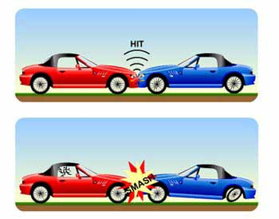

‘What the police need is a net with smaller holes in it, so that the villains can’t swim through. (Chief Superintendent Vince Mc Fadden, MBE).
Every investigation of a murder should begin with a very careful study of a report which is made out by a medical examiner. This will give the cause of death and explain the wounds and to check for signs of any sexual assault. You would then require a reading of the police report, which describes the crime scene in as much detail as possible when it was first attended. The police report would then be supported by eyewitness testimonies. The location would no doubt inform an investigator of where the offender would feel comfortable, while the victim betrays any level of risk, they were willing to take. This type of investigation can lose all focus due to the amount of information that can be available on every victim, so all relevant photographs or maps must be left on display. There must be an important aspect with the above type of presentation. This is to make sure that all the photographs and details of the victim or victims are displayed in the order in which they were murdered, and not in the order that they were found. Unless the victim was targeted for a violent attack, the forensic team will have to start studying relationships, background and lifestyle in detail. This could be due to an absence of any suspects, so the significant clues may be on the choice of victims that they chose. If the body of a victim has been mutilated after the estimated time of death, this could tell the forensic team that the offender/ killer would be more experienced and a lot older. This could also indicate that this is not their first murder. Any investigators must know the difference between pre – mortem and post – mortem mutilations. If it is a post – mortem incision, then the edges of this incision would be very dry and bloodless too. If the victim is female, and her breasts were cut open and something was placed inside of them while the woman was still alive, then this would be evidence of torture. Only sociopaths do this sort of assault while their victims are still alive. The location of the killer (secluded or open) and any evidence which they leave at the crime scene can determine if they were forensically aware and of any low or high average to their own intelligence. The killer will show contempt for his victim if they have made no attempt to conceal the murder, if a body has been dragged then just dumped by the killer, then this will intentionally inform the investigators that they were wanting to delay any findings until they were clear of this area and that he may cover his tracks too. A first-time killer would not be so precise, if there were no tracks other than the killers, then this would be safe to say that the victim was carried to the location and placed there. If the victim was presentable and the killer had tried to restore some dignity in death, then this is known as ‘restitution’. This type of thing is not evident within sociopaths or even in psychotics but can be found in obsessive – compulsive personalities. This may mean that the killer was known to the victim personally. A disorganised killer would use whatever object is at hand to injure or kill their victim, it also means that they have acted upon an impulse rather than an organised killer. The organised killer plans and prepares his crimes by bringing the weapons and tools of their choice along with them. (Roland, P,2007).
Some of the well-known disorganised criminals are Jack the Ripper, Jeffrey Dahemr and Edmund Kemper. These have been studied and the arising patterns from their background would initially say that they are disorganised criminals.
It was in 1980, that Hazelwood and Douglas were to make a distinction between organised and disorganised crime. If you are an organised criminal then you would plan and execute your actions with meticulous intent, because this type of offender is a methodical individual who is also deliberate and very scheming too. If you are an organised criminal, you are to be known as an absorbed psychopath, who tends to lack in remorse or even empathy. Organised offenders are pleasant, well spoken and very outgoing, so your neighbour for example maybe like this and hiding the fact that they are organised criminals. They are not as easy to spot in other words. They can be non – threatening at first but go on to target their victims by choosing strangers who they will try to con by asking them for assistance with something or cash.
‘The organised offender is a crafty wolf, while the disorganised offender is more like a wild dog’. (Stephen, G, Michauld & Ray Hazelwood, The Evil That Men Do, (1998).
Offenders who are disorganised have very poor social skills and tend to be loners too. They cannot hold on to friendships, feel inadequate and cannot maintain long loving relationships also. These offenders become messy in their home and minds and are rather untidy in general with their looks. They would have a misuse of drugs, alcohol or a mental disorder which makes their crimes rather impulsive at times. A disorganised criminal will attack the ones they know, like neighbours, friends or family, and these victims do not get any sort of warning to say that they will quickly become incapacitated and left for dead. They use items at the crime scene to kill or harm their victims and then make little or no attempt to hide the body or weapons they may have used. These types of criminals leave a chaotic mess behind them as well. (Module 5- Criminal Profiling).
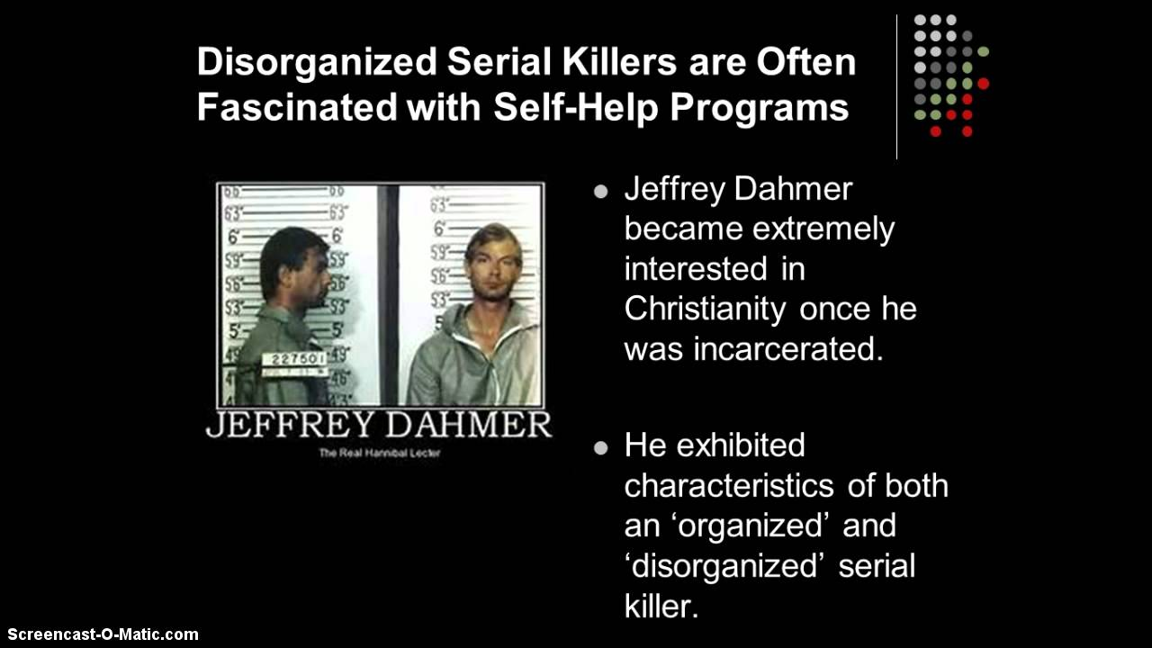

Since sometime within the 19th century, investigators have found that work of most criminals may be recognised by what is known as a method of working, or the ‘modus operandi’. This goes on to state in which way a victim was mutilated, captured or killed. These modus operandi or MO for short can give investigators clearer indications that these crimes were committed by the same person. More often than not, serial killers have a signature trademark, this may be some unusual evidence or even the way a body is disposed of at the crime scene. The modus operandi is not the same as the signature trademark of the criminal / offender. The MO is a behaviour that is learnt by the criminal which will become natural and perfected as they gain more experience. A signature trademark of the criminal is what this criminal must do before they are able to potentially reach an emotional fulfilment. They do not have to fully accomplish the crime in hand, but it is one of the reasons why they commit the crime in the first place. (Innes, B,2003).
In the 20th century, criminologists began to turn their attention to the mental processes and away from the physical characteristics of the criminal type. This is the psychology that would lead certain people to a life of crime. This came about from Carl Jung and Sigmund Freud at the Vienna school of Psychologists. Doctor Charles Goring was one of the first critics of the then theories of Lombroso. Goring said that he had found many cases of physical types as described by Lombroso in English university students as among the convicts. Goring was to write a book in 1913 called the English Convict, he went on to argue that most of these criminals had no intelligence, and that they could initially make the connections between this and crime. Goring could also identify what he had named the ‘lone wolf’, or what Karl Marx had instantly named the ‘alienated man’. An alienated man, or lone wolf is someone who feels like they have been isolated or kept from within their society. They are also misunderstood, so therefore they believe that they are justified to follow their own rules of conduct and behaviour. The concept of being alienated is now a very strong and important part within the psychological assessment of criminality. In other words, the world or society in which we live in today has massively let these people down. (Innes, B, 2003).
Profiling is a waste of time to the police and has no real – world values according to the psychologist Professor Craig Jackson, this in turn may bring forensic psychology into some form of disrepute. The well-known television series called Cracker, played by Robbie Coltrane, was based upon the real-life forensic psychologist Paul Britton. Britton was involved in cases of murder in the 1980s and the 1990s. These included Rachel Nickell, Fred and Rose West and also the murder of James Bulger too. Profiling within the United Kingdom by this time had become damaged by the involvement of Paul Britton in the search for Colin Stagg for the murder of Rachel Nickell in 1992. Stagg walked his dog upon Wimbledon Common, and he was among other men to be interviewed by the police. He fit into the offender profile that Britton had put together. Britton had a strategy which was named operation Edzell, where a young undercover female officer by the name Lizzie was set up. Lizzie went on to inform Stagg of her sexual fantasies to try and exploit him. This did not work as he denied any prior knowledge to the murder of Rachell Nickell. Stagg was acquitted a year later due to the Lizzie ‘honey trap’ that was to be criticised by the Judge in this case. Eventually a review into old cases or cold cases as they are known, led to a DNA discovery. This then led the police to one Robert Napper. Napper did not fit Britton’s offender profile. Napper is now being held in Broadmoor secure hospital for the responsibility of manslaughter on the grounds of diminished responsibility. Britton was charged by the British Psychological Society with disciplinary offences, but this case was to fall through as it would not have had a fair hearing. This is how criminal, or offender profiling can go wrong. (The Newsroom, 2010). 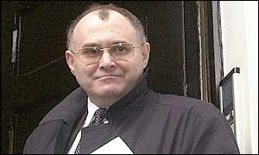
The argument with regards to nurture, can suggest that things within our society and also the environment which we grow up in, plays an important part in our lives. This would be things like poverty, peer pressure, drug or alcohol misuse, which ar4e more than likely to make some people more prone to committing crimes.
In the 1950s, criminologist Robert Merton was to argue that when people are not given an opportunity to succeed in life with things like good education and great jobs to name a few then some of these people will turn to crime to achieve their goals in life. Most of these criminals will or may have had a very deprived upbringing, and if there is poor parenting or they are left on their own or the parents rely too much on drugs and alcohol to get through the day, then these children are far more likely to become involved in crime as they get older. This does not mean to say that every child who experiences these problems are to become embroiled in crime. If a child is deprived of any maternal love within their early years of life, then it is said that this can have a detrimental effect on them. If they are cared for with a proper loving stable background, then that child would have more positive self – esteem and good relationships with other people too. They will go on to do well in their later life, but if there is no or little relationship between child and parents then the child will not care about their own wellbeing, let alone anyone else’s. They tend not to respect other people and their property or get along with other people too. Psychologists believe that any child who has experienced anything like this would be more than likely to be deviant or have some sort of criminal behaviour. (BBC, Bitesize,2023).
On the practice of profiling, there are ethical difficulties within the use of personality and psychological theories to a way or means of directing or moving the outcome from a criminal investigation. The media do like to look at criminal profiling as a heroic or romantic profession. This gives an inaccurate image of the role of a profiler; this job may attract people who are not really suited to this type of practice. If profiling is not accomplished credibly, it will cause some harm which can be very serious or to also cause delays for the solution of a particular case by suggesting wrong directions of the investigation. Trying to find a suspect who fits what is suggested by the profiler, then what is very different than the actual perpetrator would result in wrongful arrest of innocent parties. There are no official ethical standards to the practice of profiling. (Cengage,2019).
An element within an analysis of violent crimes can be known as ‘staging’. This is what some killers do to take the heat off them for a while, it keeps the investigators at bay. An example of this could be husband and wife, where one has killed the other in anger and cover it up by saying they had had a break in, and that the burglar had killed that person. Staging can also be used in fraudulent insurance claims too.
A case abroad led to a new system for the police and profilers to use, due to the Henry Lee Lucas case who had lied about how many killings he had committed. The VICAP or the Violent Criminal Apprehension Programme was adopted. This type of system could analyse information which may concern senseless and random murders, attempted murders and the kidnapping of young innocent children. This data went on to be analysed at a local place and compared to anything that they already hold on their files. Over thirty years ago, newspapers were studied to help with the investigations. There is a real tragedy that police forces still use this type of method today. There is no ability within the forces to even analyse the crime information they already have and communicate amongst each other, this is what VICAP is about. The VICAP form was made to be analysed by computer. They had roughly one hundred and eighty – nine questions that needed answers, then these had to be divided under forty – two subheadings. Up to a certain time, FBI agents had to rely on the use of photographs which had been taken at the scene of the crime to aid them with trying to give a good or detailed description of a crime and the surrounding environment in which the crime was committed. The agent is then required to provide any information on one of several crimes, murder, attempted murder, suspected homicide victims, an unidentified body, missing persons or even kidnapping. This part of the VICAP also wanted to know if the offender had previously killed before, or if the case is related to drug trafficking. Next would be all the case details, dates, times, marital status, education and employment. They must then try to identify the victim with a physical description of them, things like tattoos or birthmarks and their clothing too. The next process that is required would be all the information on anyone that the investigators have cause to believe are responsible for the crime. Also, anyone at the present time who is in custody plus any details of vehicles that were involved in the crime. Requests for a profile on a criminal evaluation cannot be submitted via a VICAP form. This type of request must or should be submitted to the co – Ordinator of criminal profiling who has been appointed as field division of the FBI. They would then look at all the present information, and if this request gets approved, they will submit the whole profile of the criminal to the National Centre for the Analysis of Violent Crime or NCAVC for short. (Innes, B, 2003).
The GDPR or the General Data Protection Regulation within the United Kingdom (UK) has to give you rights, like not being subjected to automated decisions which include profiling, this has a legal effect upon them. The provisions for this can restrict when you are able to carry out this kind of processing and will give the individuals rights within the cases. Under Article 22 (1) the circumstances are limited in where you can make solely automated decisions which based on offender profiling, these may also have a legal effect upon the individuals. This is what Article 22 (1) states. ‘The data subject to a decision based solely on automated processing, including profiling, which produces legal effects concerning him or her or similarly affects him or her’. Solely automated is a process which is automated and has no influence with the outcome from humans. If human input for the data is processed it may be still known as solely automated, but then the decision for this will be carried out by the automated system. It is not solely automated if it is weighed up by someone who interprets these results of a decision which has been an automated decision based upon the facts that they have not been applied to the individual. An example of this could be someone who will be paid which is linked to their productivity which is then automatically monitored. The decision is then based upon how much wages the person will get for the amount of shifts they have done. This is done automatically by looking at any data which is collected about the workers productivity. (ICO – Information Commissioners Office, accessed – 28/04/2023).
The third generation of investigative science would be known as criminal or offender profiling. Scotland Yard in the 19th century started with the study of clues, then the scrutiny of this crime would be followed, then the concept of trying to analyse the offender’s psyche. Profiling techniques go back as far as Jack the Ripper’s time of 1888 in London. Thomas Bond examined the case of the Ripper and looked at the post-mortem notes and one of the mutilated victims. From this, Bond was able to create a profile of the murderer for the police but only based upon the offenders modus operandi and any of his personal traits. This was made out to be a cool, daring and strong man who was believed to be a man of attacks of the homicidal kind and erotic mania. Bond could also state that this offender may suffer from a sexual condition which is like satyriasis.
Modern day profiling was done in the 1950s by a Doctor (Dr.) James A. Brussel, from New York. Brussels was able to make out a profile on the ‘Mad Bomber’ or George Metesky, whom the police had not been able to capture for over sixteen years. Doctor James went on to examine the crime scene pictures and the notes left by the ‘Mad Bomber’, then he was able to say that the bomber was in his 50s, unmarried, paranoid, self – educated and also foreign-born living with a sibling in Connecticut. Paranoia will peak in an individual around the age of thirty – five. In 1957, the Mad Bomber’ was found and arrested, nearly all of the predictions that Doctor Brussel’s gave about the offender, turned out to be true. The process of criminal or offender profiling within a nutshell would include gathering any basic details by a profiler. It goes on to include the time and type and location of crimes, choice of their victims, the state of the crime scene and any or all communications that have been left by the suspect at the scene. Other factors are also taken into account like mental status, race, age or any other characteristics of the offender. These are all then put together by the criminal/ offender profiler to make a criminal profile. (Incognito Forensic Foundation – Accessed: 28/042023).
The trouble with criminal profiling is that it does not seem to actually work at all, if it did, then it would be a misallocation of intellectual energy. In 2007, Malcolm Gladwell made his trademark narrative. The literature is strange, but the consensus for profiling does not seem to be very effective. Profiling any such sympathetic people is normally down to arguing that most of the profiles of criminals taken by the so-called professionals are more correct than if a complete untrained stranger were to do them. Profilers only do slightly better than someone off the street at finding the traits of offenders, profiling is known as a ‘pseudoscientific technique’, of any value to the investigators. (Matthew, D, 2018).
Popular belief is that most criminal profiling work was not conducted by members of the FBI. Only 7% of the profiling publications would be done by FBI special agents and their profilers. The majority of these profilers are really psychologists (43%) or criminologists (17%), most of the offender profiling publications were released within the last decade, between 2006 to 2016. There was a big divide between authors, some of the profilers would use a process which involves statistical analysis of the data of crimes and any responsible offenders. Some of the other profilers would use a more clinical process where any of the profiles that were developed by using experience, intuition and very thoroughly educated guesswork. A study was to find that over half of publications on offender profiling would use no statistical analysis, whereas one quarter were found to be using advanced statistics and data, which helped them to develop their offender profiles further. Do the different methods and the background used for profiling impact its accuracy? Two studies have been done and measured offender profiling in this field, other studies went on to try and examine profiling and its accuracy via other methods. The police were asked by one Anthony Pinizzotto to go through and evaluate all of the one hundred and ninety-two profiles which had been created from 1971 right up to 1981 by the FBI. It is said that just 17% of the profiles did aid with identifying suspects, but another 17% said that the profiles were useless and no good at all. In England, 83% of officers said that any profiles they had were useful, but only 14% of these profiles went on to help solve the crime or case.
The famous study of ‘Coals to Newcastle’ found out that any predictions that had been made by profilers were about 66% of the time correct. The profiles only went on to lead to an arrest in just five of one hundred and eighty- four cases. So, all in all, there was only a 2.7% success rate when these profiles were applied out within the field of profiling. If the police had not used the offender profiling, then how many crimes would, or could they have solved? (Psychology Today, 2023).
Postmodern criminology is the modern theory of studying the causes, prevention and correction of any criminal behaviour. This tends to see crime as a social construct which will arise from individual’s interactions which will co – produce their environment. This then goes on to reproduce behaviours and crimes. The explanation of crime as a social construct can be defined by institutions and laws that most people established towards harmful behaviour. If this behaviour does occur, it can reduce and repress people’s abilities to actually take part in human development, which then becomes a crime. (Study.com, 2003).
There seems to be no legal limits to the work that profilers undertake, but there does seem to be clearer rules upon the presentation of any of the expert’s evidence used within the courts. Profiling information is the crucial decisions about any admissibility of any such evidence. If the purpose is used to identify an offender, then profiles are more than likely not to be used. Profiles are more likely admissible if their purpose goes under on or even more of the following categories. (Alison et al…, 2007). Number one, that the profiler could testify about any part of the crime scene. Number two, that any of the profiles can be used as a comparative crime scene analysis, and last but not least number three. This is to decide whether defendant A or defendant B committed the crime, which they are both being charged upon. Howitt (2002), states that any such activities that are not carefully thought out can and will lead the police in a very unhelpful direction with regards to their case. This will go on to focus any attention and nearly all of their resources upon the wrong offender, as there is little or no evidence to do so. Once the police have a suspect then they are brought in to be interviewed and a statement will be taken too. In an actual practice it is not just the police who can use or conduct an interrogation, but also the military, security services and HM Revenue and Customs. It has been noted that any focus of an interrogation is an extraction of a confession from a suspect (Putwin and Sammons, 2002) and this has been the focus of the police since the start of the 1990s. The interview or the interrogation will all depend upon whether it is a witness, suspect or a victim who is being questioned. All suspects will be questioned under caution and the search for a confession is hopefully a realistic goal, this will of course not apply to any witnesses or to any victims. Sometimes, the police may use a strategy to begin the interview of a suspect and then later do a more thorough interrogation under caution. (Newburn, T, 2007).
With regards to nature verses nurture within this dissertation, then there are no right or wrong answers. The concept of criminal or offender profiling, psychology will also play an important part within this. For the nature verses nurture part, it is fifty- fifty, each author states either much the same or slightly different. There does not seem to be much wiggle room between them. Criminologists are just little-known theorists that do not always get things right the first time around, just like Paul Britton. Trying to gather information from people with a questionnaire never went as planned due to the fact no one actually filled it in, so there is no analysis for this part of the dissertation. Finding the information has been very hard going, but the majority of what is out there was already known as been reading a lot of crime books over the years. More needs to be done to help with forensics and profiling to make sure that it is used correctly, and further training should be undertaken too.
Too many of these criminals do not receive the required help and treatment. They end up in prison, (and this system is under breaking point) without any sort of intervention to stipulate the reasoning behind this. We are all human, not robots, we all have feelings, needs and wants. So now is the time to help these offenders and really dig deep and get to the actual root cause of why they are turning to crime. Children tend to lean more to crime as the government have taken things away like youth clubs, or they are born into a life of crime following in their parent’s footsteps. There really needs to be reform to try and improve things for everyone who is involved.

https://ioc.org.uk/for-organisations/guide-to-data-protection/guide-to-the-general-data-protection-regulation-gdpr/automated-deciso... (Accessed: 28/04/2023).
https://ifflab.org/criminal-profiling-insight-criminals-mind (Accessed :28/04/2023).
https://www.vox.com/future-perfect/2018/11/12/18044688/criminal-profilers-mindhunter-hannibal-criminal-minds#:~:text=The%20resea... (Accessed :27/04/2023).
https://www.psychologytoday.com/gb/blog/real-criminal-profiling-dead-should-it-be#:~:text=Results%20of%... (Accessed: 25/04/2023).
https://study.com/learn/lesson/postmodern-criminology-analysis-theory-examples.html#:~:text=The%20postmodern%20criminal%... (Accessed: 29/04/2023).
https://simplypsychology.org/offender-profiling.html (Accessed: 15/04/023).
https://www.verywellmind.com/what-is-nature-versus-nurture-2795392 (Accessed: 10/04/2023).
https://www.psychologytoday.com/us/basics/nature-vs-nurture (Accessed: 05/04/2023).
https://www.verywellhealth.com/nature-vs-nurture-5323408 (Accessed: 31/03/2023).
https://www.psychologytoday.com/us/basics/serial-killers#:~:text=Most%20serial%20killers%20demonstrate%20antisocialfor%20either%20psy... (Accessed: 31/03/2023).
https://criminologyweb.com/cesare-lombroso-theory-of-crime-criminal-man-and-atavism (Accessed: 29/03/2023).
https://www.verywellmind.com/genes-and-development-2795114 (Accessed: 27/03/2023).
https://www.sciencedirect.com/topics/social-sciences/criminal-profiling (Accessed: 25/03/2023).
https://www.webmd.com/mental-health/features/sociopath-psychopath-difference#:~:text=Some%20experts%20see%2050... (Accessed: 24/03/2023).
Students' Section (psychopathysociety.org) (Accessed:19/03/2023).
https://www.verywellmind.com/what-is-nature-versus-nurture-2795392 (Accessed: 20/03/2023).
Profiling, Ethical Issues | Encyclopedia.com (Accessed: 18/03/2023).
Elizabeth Loftus Career and Biography (verywellmind.com) (Accessed: 17/03/2023).
https://moodlehub.ca/mod/book/view.php?id=5293&chapterid=8834 (Accessed: 17/03/2023).
https://www.scotsman.com/news/character-assasination-how-profilers-got-it-wrong-2442068 (Accessed:16/03/2023).
Profiling, Ethical Issues | Encyclopedia.com (Accessed: 10/03/2023).
https://www.ojp.gov/ncjrs/virtual-library/abstracts/criminal-profiling-viable-investigative-tool-against-violent-crime#:~:text=The%20criminal%2... (Accessed: 08/03/2023).
Newburn, T,2007, Criminology, Willan Publishing, Devon.
Roland, P,2007, In the mind of murders, Arcturus, London.
Innes, B,2003, Profile of a criminal mind, Silverdale Books, Leicester.

