DIGITAL SKILLS AND RESEARCH METHODS
Kayes Miah
ID:1808001

Executive Summary
This current report has focused on an organisation that has different implication smart technology in a workplace. This study consists of different options that are included in this study along its benefits. Smartphone and tablets along with cloud file storage are included in this study. Cloud file storage is easy to access as it can be accessed through internet from any devices. These are safer than storage devices as these are it can’t be damaged or stoles by any particular sources. It also includes it advantages and disadvantages of these tools.
Table of Contents

Introduction 4
LO1 4
Evaluating appropriate use of technology for improving efficiency in workplace 4
Describing how the options can be used in workplace 4
Comparing and contrasting two different providers for each option 5
Discussion how each option would help in improving efficiency in workplace 137 5
Explaining the options that might increase employability 6
LO2 6
Demonstrating appropriate use of technology and its implication in workplace 6
Which of the following network helps in search for work? 6
How to use each in workplace 7
Advantages and disadvantages of using these in workplace 7
Implications with regards to personal and professional security 8
Describing the preferred network 8
Conclusion 9
Reference list 10

Introduction
Smart technology in workplace helps an organisation to perform their task in an efficient manner. It also helps in saving money and energy by using technology in a strategic way such as it provides comfort in workplace. In this study, proper use of technology has been included and comparing them with each one for proper utilisation in workplace. It also includes its advantages and disadvantages along with following preferred network. It also helps in implication of each in regards to personal security and workplace and also helps in increasing employability. This study includes tablets and Smartphone along with cloud file storage has been included for its assessment.

LO1

Evaluating appropriate use of technology for improving efficiency in workplace

Describing how the options can be used in workplace
Cloud file storage along with tablets and Smartphone has been using in workplace for better outcome from it. Tablets and Smartphone can be used in workplace for proper utilisation of these technologies in day to day business. In recent years, Smartphone and tables has been developed at a certain level through which most of the tasks might be performed by using these particular devices. As per Corner (2017), these devices are small and portable in nature and are almost same efficient as computers. Moreover, cloud file storage has been used in different workplace in recent years as it is internet based storage system and doesn't require any storage devices. Google drive and iCloud are the most used cloud file storage in a workplace as these are user friendly and easy to access. Cloud file storage are mainly preferred in workplace as it is safe from theft and can’t be damaged physically because it can only be accessed through internet.

Comparing and contrasting two different providers for each option
Tables and Smartphone has several providers that provide these devices to the user in various types and different configurations. The following table shows the comparison and contrasting of two different providers in a workplace.
Points | Tablets and Smartphone | Cloud file storage
Storage | It stores file up to a limited capacity | It stores file almost unlimited capacity
Disadvantages | Highly fragile and low storage | Only accessible through internet
Evidence | These cannot be used as evidence for long run | These can be used as evidence for long run
Importance | These are efficient in nature and these are the results of technological development. These can be used from anywhere and requires a physical storage device for storing its files. | Cloud file storage is recently introduced and is replacement of physical storage devices such as flash drives, hard disks and others.
Table 1: Difference between tablet and Smartphone and cloud file storage
(Source: Influenced from Watson et al. 2017)

Discussion how each option would help in improving efficiency in workplace
Tablets and Smartphone are portable in nature and are almost same potential as computers. In recent years, these devices have developed rapidly and would replace computers in some years. According to De Greef et al. (2015), tablets and Smartphone helps giving presentation to the clients in a workplace and also helps in maintaining work pressure in a workplace. These particular devices helps in effective communication in an organisation as these devices does not care about any natural barrier that might affect their overall process of communication (Watson et al. 2017). Moreover, Smartphone and tables provides better experience to an employee as they can perform their task from anywhere at any time. On other hand, cloud file storage is easy to access as it can be accessed through internet from any devices. Earlier, storage devices are used for storage purpose of files of a workplace but with help of cloud file storage it has become easier to access the files through help of internet. Dodel and Mesch (2018) have stated that storage devices might get damages and information can be lost but with cloud storage it can’t be damaged and more secure than storage devices.

Explaining the options that might increase employability
Mobile devices such as Smartphone and tablets help employees of an organisation by accessing different information that relates to an organisation. Jara et al. (2015) mentioned that employee can do their work from their home and can visit their clients to increase their productivity of an organisation. It allows them to use mobile devices that are related to work related purposes along with encouraging them to use their devices. Employees can do their work more effectively and efficiently for an organisation that helps in increasing their efficiency of doing tasks at a particular time. Siddiq et al. (2016) opined that special skills are required to perform tasks with these devices, as it requires lot of expertise for an employee to perform more efficiently. Moreover, cloud file storage helps in increasing employability as the employee requires only internet to access those important information which are easily accessible than storage devices. These are safer than storage devices as these are it can’t be damaged or stoles by any particular sources.

LO2

Demonstrating appropriate use of technology and its implication in workplace

Which of the following network helps in search for work?
There are different social networks that helps in employability along with provides different important information to people. In this study, Facebook, LinkedIn and Twitter have been considered along with their se and implication in workplace. Facebook is social networking site that are mainly used for sharing different information and also for personal usage. LinkedIn is also a social networking site where people mainly upload their respective curriculum vitae for searching their particular jobs. Inspired from van Laar et al. (2017), this particular site helps an organisation to search skilled and talented employees for their organisation. Moreover, Twitter is also a social networking site that is mainly used for providing information to different people by tweeting them in their site. These technologies are implicated in a workplace that helps in providing skilled and talented employees to an organisation. Therefore, LinkedIn is the most useful social networking site that helps employees in search of their work (van Laar et al. 2017).

How to use each in workplace
Use of Facebook in a workplace can be utilised by considering its resources of an organisation as it consist of different important information of an individual. Based on the viewpoint of Yu et al. (2017), this particular social networking site helps in collecting important information in a workplace as it provides different sources of information by the users. Managers of an organisation might post their required requirement on Facebook through which different skilled and talented employees might get their opportunity to work for that particular organisation. Twitter also plays an important role in a workplace as recruiters of an organisation might tweet their requirement of their post in the social media site. It is most secure social media site as personal information is difficult to access from this particular site. On other hand, LinkedIn is the most useful site that is used in a workplace as it includes professional information of an employee that can be gathered for different purpose. In the viewpoint of Corner (2017), it consists of several information that are useful for an organisation to hire an efficient employee for better execution of tasks that are allocated to them.
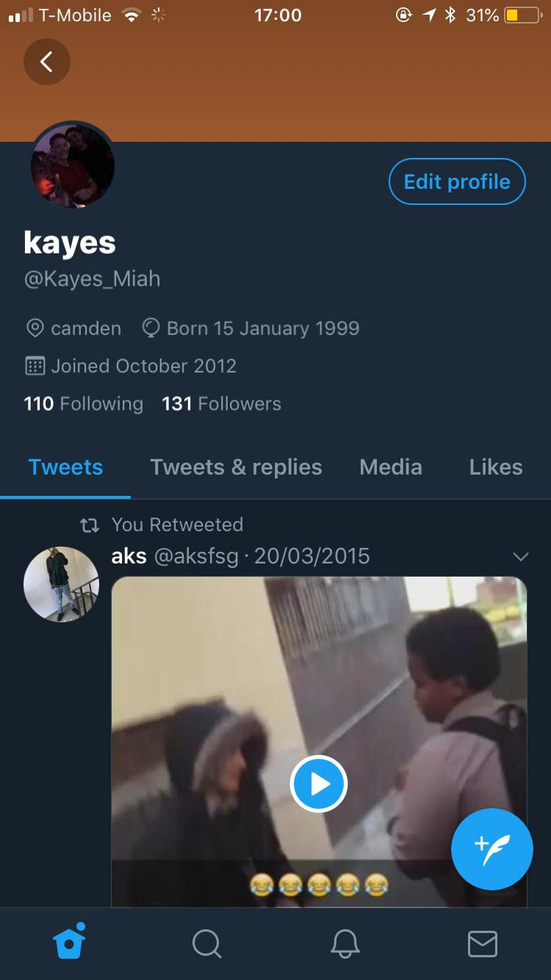

Advantages and disadvantages of using these in workplace
Facebook has several advantages as well as disadvantages for a workplace as it provides important information to the recruiters of an organisation such as by posting their recruitment status or any launch of new product or services. Inspired from the viewpoint of Dodel and Mesch (2018), this provides in increasing their brand value of the company which ultimately increases their overall revenue of the company. The disadvantages of using Facebook are distraction of employees that might lead to decrease in low productivity. Twitter has advantages by increasing their total amount of sales by attracting different types of customers along with identifying trends for their competitors. Siddiq et al. (2016) opined that it has also some disadvantages to an organisation by facing harassment to their employees. LinkedIn has advantages by increasing their visibility of their brands along with gathering information that are required for an organisation. It has also disadvantages by conveying wrong information about the organisation and also creates misunderstanding among different job seekers.

Implications with regards to personal and professional security
Smart technology has made conducting various tasks in an easy manner along with increase in quality rate. However, one of the major negative impacts, which can be observed in the field of smart technology, is the process of data breach. As opined by Dehghan et al. (2014), hacking can result in the process of breach of data. This causes release of sensitive information to third party who can use it according to their will, even for illegal purposes. Since all these network sources are available online, an effective hacker can break through the barriers of such network. Additionally, they can learn personal and professional information of people living all over the world (Watson et al. 2017). On top, of that, lack of effective countermeasures can lead to increase of the already drastic situation. Thus, data breach is the biggest threat which can lead to various implications.

Describing the preferred network
The process of searching for jobs require the help of accessing various networks, however, it leaves the potential risk of data breach which can occur through hacking. In order to understand this aspect, thorough assessment is required to be done through which authentic network can be identified. As forwarded by Kashmiri et al. (2016), secured network can help in careful assessment of job security. Therefore, LinkedIn can be considered an effective network for job searchers where a vast source of open job opportunities can be identified. How, as viewed by Ablon et al. (2016), LinkedIn sometimes falls short when it comes to security, therefore the second best choice is Twitter as it has a high range of security. Through utilisation of hash tags best choices of job employment can be effectively searched through the aid of this system. Therefore, in order to find effective job, LinkedIn and Twitter can be considered as the preferred choices.

Conclusion
From the above study, it can be concluded that appropriate use of technology helps an organisation to increase their overall efficiency and employability. Cloud file storage are mainly preferred in workplace as it is safe from theft and cannot be damaged physically because it can only be accessed through internet. Tablets and Smartphone helps giving presentation to the clients in a workplace and also helps in maintaining work pressure in a workplace. Employee can do their work from their home and can visit their clients to increase their productivity of an organisation. Cloud file storage is safer than storage devices as these are it cannot be damaged or stoles by any particular sources. Facebook is social networking site that are mainly used for sharing different information and also for personal usage. Twitter also plays an important role in a workplace as recruiters of an organisation might tweet their requirement of their post in the social media site. These technologies are implicated in a workplace that helps in providing skilled and talented employees to an organisation.

Reference list
Ablon, L., Heaton, P., Lavery, D.C. and Romanosky, S., (2016). Consumer attitudes toward data breach notifications and loss of personal information, 3(2), pp.12-47.
Corner, F., (2017). Preface. Spark: UAL Creative Teaching and Learning Journal, 2(2), p.84-85.
de Greef, M., Segers, M., Nijhuis, J., Lam, J.F., van Groenestijn, M., van Hoek, F., van Deursen, A.J., Bohnenn, E. and Tubbing, M., (2015). The development and validation of testing materials for literacy, numeracy and digital skills in a Dutch context. International review of education, 61(5), pp.655-671.
Dehghan, N., De Mestral, C., McKee, M.D., Schemitsch, E.H. and Nathens, A., (2014). Flail chest injuries: a review of outcomes and treatment practices from the National Trauma Data Bank. Journal of trauma and acute care surgery, 76(2), pp.462-468.
Dodel, M. and Mesch, G., (2018). Inequality in digital skills and the adoption of online safety behaviors. Information, Communication & Society, 21(5), pp.712-728.
Jara, I., Claro, M., Hinostroza, J.E., San Martín, E., Rodríguez, P., Cabello, T., Ibieta, A. and Labbé, C., (2015). Understanding factors related to Chilean students' digital skills: A mixed methods analysis. Computers & Education, 88(1), pp.387-398.
Kashmiri, S., Nicol, C.D. and Hsu, L., (2016). Protecting Retailers Against Contagion: Exploring the Shielding Role of Marketing in the Negative Spillover of the Target Customer Data Breach. In Celebrating America’s Pastimes: Baseball, Hot Dogs, Apple Pie and Marketing, 5(2), pp.309-309.
Siddiq, F., Scherer, R. and Tondeur, J., (2016). Teachers' emphasis on developing students' digital information and communication skills (TEDDICS): A new construct in 21st century education. Computers & Education, 92(1), pp.1-14.
van Laar, E., van Deursen, A.J., van Dijk, J.A. and de Haan, J., (2017). The relation between 21st-century skills and digital skills: A systematic literature review. Computers in human behavior, 72(1), pp.577-588.
van Laar, E., van Deursen, A.J., van Dijk, J.A. and de Haan, J., (2018). 21st-century digital skills instrument aimed at working professionals: Conceptual development and empirical validation. Telematics and informatics, 35(8), pp.2184-2200.
Watson, J.A., Englum, B.R., Kim, J., Adibe, O.O., Rice, H.E., Shapiro, M.L., Daneshmand, M.A. and Tracy, E.T., (2017). Extracorporeal life support use in pediatric trauma: a review of the National Trauma Data Bank. Journal of pediatric surgery, 52(1), pp.136-139.
Yu, T.K., Lin, M.L. and Liao, Y.K., (2017). Understanding factors influencing information communication technology adoption behavior: The moderators of information literacy and digital skills. Computers in Human Behavior, 71(1), pp.196-208.

