Student Name: Ayofemi Holloway
P Number: 1811214
Programme of Study: Contextual Studies
Module: M4X01560

Tasks in the order I received them:
Task One: jon Pugh-Reflective Writing
task = 554
Task Two: ryan Moule-Observational Writing
task = 513
Task Three. Julia Lockheart-Manifesto Writing
ask= 549

Task 1: Jons

Black lives matter!

The black lives matter movement has been going on for decades and still is today; be it the freeing of slaves in the 18th century, The tireless efforts of people like Martin Luther King, Nelson Mandela and now the #BlacklivesMatter movement. Much has changed over the years and has moved forward but the fight against institutionalised racism has been going on for decades.
Slavery began around the 16th century where many black people were taken from their home countries and sold into slavery. This continued for about 4oo years. Most of the time when you think of slavery, you think of places like America, but the British side of slavery has seemed to be swept away with the ‘Slavery Abolition Act in 1833’ (The Guardian, 2015).

In the 20th century we are still fighting for equality within society.
The #BlcacklivesMatter movement still hopes to stem the perpetual racism stereotype of today. The movement first started in 2013 in the US because of the death of Trayvon Martin’s (Herstory, 2013). It soon gained speed globally. In the UK peaceful protests were held in solidarity with the movement. One of those protests saw civilians outside Nottingham shut down part of the city centre tram and bus services. There was disbelief and irritation and a handful of arrests due to the fact people felt this was Americas problem. Natalie Jeffers, a co-founder of Black Lives Matter UK, stated in the Guardian newspaper ‘There might be fewer guns used in the UK, she said, “but there is a war going on against black people” (The Guardian, 2015).

Institutional racism is as much part US as it is here in the UK. Such as the Steven Lawrence case. Institutional racism is racial bias, when people associate one type of behaviour with a certain race. For instance, why black men are more likely to be stopped and searched. This is because according to ‘implicit racial bias’ they are mainly associated with knife and gun crime (Crime and justice.org). The Steven Lawrence case was a highly publicised case. Where a young black man was attacked and killed. This led to a close look at the way institutionalised racism played a part into the inquiry of his case being missed handled and led to the ‘Macpherson report’ commissioned by the then home secretary Jack Straw. The Report uncovered not only the combination of “professional incompetence, institutional racism and a failure of leadership within the Metropolitan police.” (The Guardian, 2019)

Overall it saddens me that racism is still prevalent in this day age. Whether it be anti-Semitism in parliament or casual racism between members of the general public. Institutional racism will for now still be part of society until we can finally take away its power and better teach equality to all from a young age.

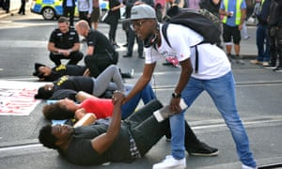
Activists outside Nottingham Theatre Royal, Black Lives Matter. Photograph: Edward Smith/PA, 2016

References

- Crime and justice.org Available at https://www.crimeandjustice.org.uk/publications/cjm/article/implicit-racial-bias-and-anatomy-institutional-racism - Dr Jules Holroyd is Assistant Professor, Department of Philosophy, University of Nottingham and Principal Investigator on Leverhulme Trust Project Grant 'Bias and Blame' RPG-2013-326
- The Guardian- Macpherson Report: what was it and what impact did it have? (2019), Available at https://www.theguardian.com/uk-news/2019/feb/22/macpherson-report-what-was-it-and-what-impact-did-it-have
- The Guardian (2016), Available at https://www.theguardian.com/uk-news/2016/aug/06/black-lives-matter-uk-found-vital-social-justice
- Herstory (2013) , Available at https://blacklivesmatter.com (Accessed 10 November 2019)
Bibliography

The history of British slave ownership has been buried: now its scale can be revealed - Available at (https://www.theguardian.com/world/2015/jul/12/british-history-slavery-buried-scale-revealed

Implicit racial bias and the anatomy of institutional racism – Available at https://www.crimeandjustice.org.uk/publications/cjm/article/implicit-racial-bias-and-anatomy-institutional-racism

- Macpherson report - Available at https://assets.publishing.service.gov.uk/government/uploads/system/uploads/attachment_data/file/277111/4262.pdf

Task 2: Ryans
DayBreak: Netflix Original Series 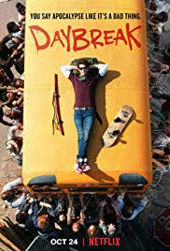
Image available at: (https://images.app.goo.gl/PMutNM1Hc63apuvJ6)

Daybreak is a teenage series about a boy looking for his lost love in a post-apocalyptic future where all adults have turned into the walking dead and teens rule the planet after huge nuclear bio war fare has taken hold of the earth.

Denotation: The Daybreak Poster shows the main character, a boy on top of an American school bus surrounded by barbed wire and adults who look like they are trying to climb the bus. He has his skateboard. He also appears to be lying on top of a backpack and a samurai sword to his right. The title in red written in spray paint with the caption in black.
Connotation: The title expresses the morning after the night before, ‘DAY BREAK’. The red being the signified, symbolising the blood shed spilt not only by the nuclear fallout but also the blood spilt by the ghoulies and fighting between the teenagers. It also is a little childish in the way it is written in spray paint. The way he is posed also follows lends itself to symbol childish behaviour, not taking things seriously even though he is surrounded by danger. Feeling safe because of the barbed wire, relaxing on top of a school bus which revels in the notion that they are all still children after all and they don’t take life seriously. The school bus is a Metonym of America. A symbol of the children of America.
The sword is being shown in red also represents bloodshed. The skateboard extends itself to symbol of adolescence. A mode of transport mainly used by teenagers. A symbol of carefree ways.
The ghoulies (aka zombies) represent the fall of humanity, brought down to one basic instinct, to feed! Adults are supposed to be the protectors of society but in this they are nothing more animals, clambering to reach their prey on top of the bus.
Overall the signifier ‘Day break’ in blood red meaning death and the signified ‘you say apocalypse like it’s a bad thing’ = ‘The end of Humanity as we know it’, This is the message I feel the poster is trying to convey.
Ferdinand de Saussure a linguist who believed, one such basic semiotic concept is the distinction between the “two inseparable components of a sign: the signifier, which in language is a set of speech sounds or marks on a page, and the signified, which is the concept or idea behind the sign.” (Britannica, 2019)
but Charles Sanders Pierce believed in the icon, index, symbol (Tom Nicholas, (2017). An icon the physical resemblance of what the poster is trying to convey (the picture showing the zombies), index the title which directly relates to the picture depiction, and the symbol the idea that zombies symbolise the end of the world. The word Apocalypse also represents a Symbol in the poster because as a society we have collectively decided this means the end of the world.

Reference:
1. Ferdinand de Saussure (November 2019), (https://www.britannica.com/science/semiotics)
2.Tom Nicholas, (2017), Avaliable at https://www.youtube.com/watch?v=0JtJu9HdQVM

Bibliography

1. Semiotics for Beginners, Daniel Chandler , http://visual-memory.co.uk/daniel/Documents/S4B/sem02.html
2. Tom Nicholas, (2017), Avaliable at https://www.youtube.com/watch?v=0JtJu9HdQVM

3. John Berger (1972) ﻿Reissued as part of the Penguin Design Series 2008. Ways of Seeing (Penguin Modern Classics) . Penguin Books Ltd. Kindle Edition.

Task3: Julia

- I live for equality within the work environment, equal pay for all
- I live for diversity within social standing. No matter what ethnicity, colour or gender you are
- I live for truth and the freedom of speech. The freedom to say how you feel without judgement
- I live for social media and its ability to bring others together
- I live for fair trade. That people are paid fairly for their goods and services
- I live for technology and the its advances in modern society
- I live for happiness with mental health. Mental health can be devastating and, in this day and age when we strive for more than we have, depression and anxiety can take hold so easily
- I live for anti-racism be it within politics with the anti-Semitism within politics, institutionalised racism or casual racism between friends

2. Diversity
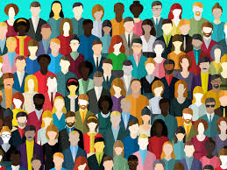
Nick Mansell, 11 December 2019, http://www.infrastructure-intelligence.com/article/dec-2019/diversity-–-less-buzzword-more-buzz

Diversity covers such a large spectrum of society. We all aren’t the same which in itself makes us diverse. A great way of putting this into simple term is:

‘that each individual is unique and recognizing our individual differences. These can be along the lines of race, ethnicity, gender, sexual orientation, socio-economic status, age, physical abilities, religious beliefs, political beliefs, or other ideologies.’ (Gladstone.uoregon.edu)
Diversity is part of the Equality act of October 2010 that came into Law to cover all discrimination law which protects individuals from unfair treatment and promotes a fair and more equal society. (Equality Human Rights, 19 Jun 2019)

Diversity realise on us all treating each other fairly and equally. We as a nation need to be mindful of how we treat others as it can have such an impact on others and may skew other people’s perception of the world and us. To be mindful and respectful of other disabilities or sexuality. Only us as humans have this ability and thus should take heed and acknowledge our differences.

- Social Media
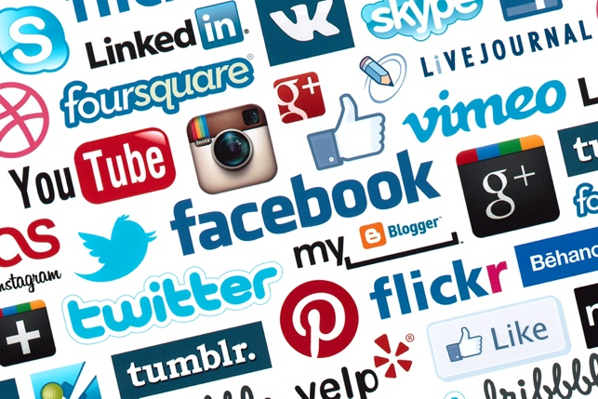

Image taken from Google: https://makeawebsitehub.com/social-media-sites/ (accessed on the 12th, December 2019)

Social media plays such a big role in our day to day lives. Social media can help people who are lost, people looking for like-minded companionship or even help the sick. Bringing us closer together as a society. In just over a decade most of us now can easily keep in touch with a click of a button. Like Instagram, Facebook and or Twitter has managed to bring the world even closer together and allowed us to share our thoughts and feelings. We now even use social media to find love. Its no wonder most people feel that most relationships will begin online, rather than the traditional ways like meeting in a bar.

Once you get past the bullying and the fake news, social media has helped people connect to solve issue like the #MeToo movement, #BlacklivesMatter movement and even #ExtinctionRebellion movement. Without social media, theses movements may not become as big as they are, as fast as they did.

7. Mental Health

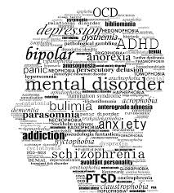

Image taken from google: https://en.wikipedia.org/wiki/Mental_disorder

Mental Health seems to be more prevalent in this day and age. Whether it’s because of social media or that we as society are now paying more attention to the devastating affects mental health may have on an individual as a whole. Approximately 1 in 4 people in the UK are affected by mental health (mind.org.uk, April 2017). As we are unable to cope with life stresses with things like money, jobs and even lifestyle.

Mental Health affects so many of us. Anxiety and Depression affects 7.8 in every 100 of us here in the UK (mind.org.uk, April 2017).

I myself suffer my mental health and battle through one day at a time. As we all go through life and strive for happiness in this time of turmoil and stress. We should all look into ourselves and realise we can’t change what is not in control and try to the best of what we have.

Reference:
- Mind.org (April 2017) https://www.mind.org.uk/information-support/types-of-mental-health-problems/statistics-and-facts-about-mental-health/how-common-are-mental-health-problems/#.XfORky2cY0o (Accessed: 13 December 2019)
- Equality Human Rights (June 2019) https://www.equalityhumanrights.com/en/equality-act-2010/what-equality-act (Accessed: 12th December 2019)
- Gladstone, (https://gladstone.uoregon.edu/~asuomca/diversityinit/definition.html) Accessed on the 12th December 2019)

Bibliography

Mind.org (2013), Available at https://www.mind.org.uk

Wen Wales (2018), Avaliable at https://www.wenwales.org.uk/wp-content/uploads/LR_11509-WEN-Manifesto-20pp-A4-English.pdf
Walker Art (1961), http://www.walkerart.org/magazine/2013/claes-oldenburg-i-am-for-an-art-1961

