MODULE SYLLABUS

CLASSICS PROJECT
CLCL5005

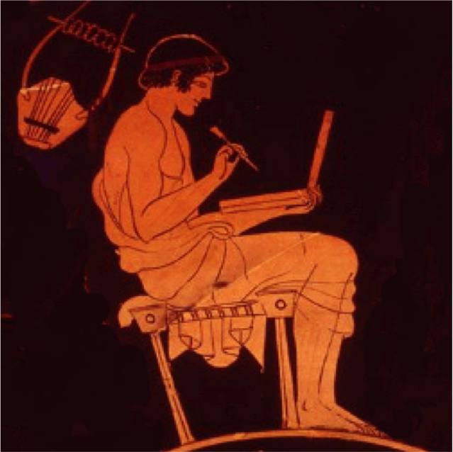
Module Code: CLCL5005
Credit points: 20
Pre-requisites/restrictions: None
Taught: Semester 2
Lecturers: Dr Matthew Cobb

GENERAL INFORMATION
The module guides students to learn how to research independently an aspect of the ancient world from a specific selection of subjects under close supervision. Students are given a range of topics, from literature, history and culture that are related to the research interests of members of staff, and are guided to designing their own title according to their interests within one of the specified topics. Topics in any given year might include The Athenian Empire, early Roman history, the history of the high Roman Empire, the ancient economy, love poetry, the second sophistic, etc. Students then research their chosen title independently with the workshops and lecturers/supervisors providing guidance and help in developing and honing research skills and independent learning. The module is essential preparation for the Classics Dissertation module in Level 6.

AIM(S)
- To enable students to study independently in detail an aspect of the ancient world from a specific selection of subjects under close supervision

LEARNING OUTCOMES
By the end of this module all students should be able to:

- demonstrate a secure understanding and knowledge of the subject of choice
- evaluate and analyse the different methodologies for the subject of choice
- evaluate critically the main sources and scholarly debates regarding the subject of choice
- plan and develop under supervision a critical presentation of the subject of choice

OFFICE HOURS/HOW TO CONTACT US
Please feel free to come and me if you would like to discuss any problems you may have concerning this module. Try, if at all possible, to come during my office hours which are posted on our departmental office doors. If you come to see me at another time and I am not in because of teaching or other commitments, please email (m.cobb@uwtsd.ac.uk). You can also ask questions (not confidential) in the discussion board available in the Moodle space for this course.

STRUCTURE AND ORGANISATION
This 20-credit module has 30 contact hours, comprising lectures, workshops and seminars. If you cannot make a class because of illness or other good reason, you need to inform the Faculty Office and your personal tutor about this.

Lectures and workshops take place on: Friday 9-12.

Course Outline:
Title | Content
Introduction | Introduction to the module
Choosing an area | How to get into an area of study
Choosing a title | How to get a good title
How-to: plan, bibliography and abstract | Why is an abstract important? Writing bibliographies and abstracts. How to construct a draft structure
Taking stock I | How is your research progressing?
Collating the process of research | Past and present of your research
Using the ancient sources | Primary sources for research
Dealing with scholarship | Debates, issues re the subject
Taking stock II | How is your research progressing?
Originality and its dangers | How to be original and what originality really means
Writing a longer piece of work | Structure and content
Handling your reader | References, presentation
Taking stock III | How is your research progressing?
When to stop and how | How to stop oneself from going on a tangent
Learning from the experience of independent research | Reflecting upon one’s research and research processes. How not to make the same mistake twice

ASSESSMENT

Coursework
1 – A project plan: draft structure, abstract and bibliography (equivalent of 1,000 words) 20%
3 – A 4,000-word essay on student’s chosen topic 80%

Coursework
Coursework 1: A project plan: draft structure, abstract and bibliography (equivalent of 1,000 words) (worth 20%)
To be submitted via the turn-it-in link on Moodle by 16th of February no later than 23:59.

Coursework 2: A 4,000-word essay on student’s chosen topic on one of the subjects below (worth 80%)
To be submitted via the turn-it-in link on Moodle by 4th of May no later than 23:59.

SUBJECTS TO CHOOSE FROM:
- Ancient Sicily
- Medicine
- Heroism
- Utopias

General assessment information: coursework
Coursework submission for this module will be through Moodle. Please follow the instructions on the module’s Moodle page for how to submit your work. The deadline for submission will be at 3 pm on the day given above. You will also need to retain a second electronic copy of your work to be submitted, if deemed appropriate, to the module convenor.

Word count
Please be aware that if you go significantly over or under the word limit (i.e. more than 10%), you may be penalised.

REMEMBER that the word count includes everything apart from the bibliography, titles or captions. You must provide the word count clearly on the cover sheet.

Welsh First language
If your first language is Welsh and you would like to submit any assessed coursework in Welsh, please see the School Office as soon as possible to make arrangements for this.

Special needs / requirements
If you have any special needs (e.g. dyslexia, visual impairment) that need to be taken into account for the teaching of this module, please make sure that our Student Welfare Officer, Dr Ruth Parkes (r.parkes@uwtsd.ac.uk), is made aware of this so that we can make sure that we fully support you in your studies.

Returning of work
Your coursework will be returned electronically through Moodle. Detailed feedback is given on the essay cover sheet but if you would like to discuss your work in more detail, do come and see me during one of my office hours (see times given above).

Some extra assignment/essay guidelines
Help for the writing of coursework is available in the TSD and School of Classics Reference Guides, as well as through the Student Support Moodle page. You are advised to read the relevant sections carefully.

Marks will be deducted if your piece of coursework is not presented properly (e.g. double-spacing, font 12 is needed). Note that all coursework needs to be word-processed; hand-written work will not be accepted. Assessment criteria can be found at the back of this Module Syllabus.

*** You need to watch plagiarism whenever you use secondary literature (ALL coursework will be submitted to a Turn-It-In analysis). Please consult the Classics Reference Guide for advice on how to reference secondary literature.

In case of problems….
Do come and see us during office hours if you have any problems with the writing or planning of your piece of coursework. You are also welcome to see your personal tutor for advice.

Bibliography
You will need to create your own bibliography according to the topic you have chosen. More information about building a bibliography will be provided during the first weeks of the module.

Course Materials and Moodle
All information regarding this course, including lecture, workshop and seminar hand-outs, PowerPoints, this module syllabus, the bibliography, assessment assignment details and lecture podcasts will be available in the Moodle space for this course. Further, the Moodle space for this course will offer you a discussion board, where you can ask questions and discuss aspects of the course with your fellow students and me.

If you have trouble accessing any of this material or the Moodle space for this course in general, please contact as soon as possible, Dr Errietta Bissa (e.bissa@tsd.ac.uk).

