Research question: Can Box Breathing help to reduce Music Performance Anxiety in adolescent female singers?

Table of Contents Page

Project proposal…………………………………………………………………………………………..1
Introduction………………………………………………………………………………………………..4
Literature review………………………………………………………………………………………….5
Methodology………………………………………………………………………………………………8
Presentation of findings…………………………………………………………………………………11
Discussion and limitations………………………………………………………………………………23
References……………………………………………………………………………………………….26
Appendices………………………………………………………………………………………………35
A – MPA Questionnaire Session 1……………………………………………………………35
B – MPA Questionnaire Session 2…………………………………………….……..37
C – Final MPA Questionnaire………………………………………………..39
D – Observation notes……………………………………………….41
E – Ethics form……………………….. ……………………..43

Project Proposal
The context

Simon Balle is a secondary school in Hertfordshire where I teach singing to students aged 11-18. Music is a high achieving department at Simon Balle and there is a high level of student attainment and expectation. Most students who participate in individual music lessons take exams and are presented with regular performance opportunities. High expectations can often lead to anxiety and stress in less resilient young people (Mazzone et al, 2007) and I have noted Music Performance Anxiety MPA) to be a common problem for singers in my practice often becoming a barrier to performance enjoyment and achievement. Many students experience great distress in the run up to a performance in the anticipation to and some often avoid performance opportunities altogether many exhibiting the nervous system arousal symptoms associated with MPA in anticipation of a performance (Kenny, 2011).

The justification

The impacts and management of MPA has not been widely researched in school aged children (Ryan, 2004) yet studies suggest that up to 75 - 80% of young people experience stress when performing (Britsch, 2005; Su, 2010). There is a prevalence of onset in adolescence with female singers being particularly vulnerable to MPA (Cina, 2021; Kenny and Osborne, 2006; Ortiz-Brugues, 2019). This study will be focusing on female students aged 14-16 who may benefit from some targeted support in MPA management. Early intervention is important to act as a preventative measure for the onset of MPA (Spahn, 2015) and teacher-led strategies have been found to be effective in some smaller recent studies (Daubney, and Daubney 2017; Shaw et al, 2020). Breathing exercises to reduce anxiety have been widely explored (Gerritsen and Band, 2018; Sengupta, 2012, Brown and Gerbarg, 2005; Cazden, 2017; Porges, 2007) and some studies that use breathing techniques combined with other exercises (such as visualisations and desensitisation) proved effective in reducing anxiety (Deen, 1999; Kim, 2005). Su’s study (2010) looked at using breathing to minimise MPA in school aged children (9-11 years) but there is a lack of research into the benefits of breath work as an independent strategy for MPA in the adolescent age range.

The intended impact

This study’s objective is to explore the efficacy of breathwork as a MPA management to produce an MPA management programme for school aged children. The wider intention is to share my findings with other practitioners and the wider music community in music as part of their MPA management strategies.

The Outlined Intention

I will be completing a literature review that investigates the most effective breathing techniques that use elongated exhalations in conjunction with anxiety reduction. This is a mixed methods study that will be using a combination of quantitative questionnaires and qualitative interviews to assess the impact of breathwork on the reduction of MPA during a solo vocal performance.

I will be inviting 10 female singing students that have weekly individual singing lessons to complete an online screening assessment questionnaire to register interest and to assess eligibility (24/04/23). All respondents that indicate experience of MPA will be invited to participate. It is a small sample and narrow in nature which will act as an initial pilot study towards a wider goal in exploring MPA management strategies.

From this sample the participants will be expected to perform twice: a baseline performance without breath work intervention and a second performance which follows a breath work warm up for comparison. Breathwork exercise will be taught in the interim period between performances during weekly singing lessons to help embed the techniques. Data will be gathered by means of a questionnaire immediately after each performance which will give us some tangible quantitative information for interpretation. The questionnaires will use the Likert Scaling system to generate discrete quantitative data that also expresses a degree of opinion (Jebb et al 2021). This scaling system is accessible and age appropriate for the participants and will provide clear comparative parameters to interpret.

After both performances all participants will be invited to complete a final questionnaire to generate qualitative data to compare to the quantitative results. The questions will be open ended with some prompts to support the participants with their answers. Observation notes will be taken throughout the performances, transcribed, and coded using Descriptive and In Vivo coding techniques. These themes and references will be linked from the performances to the qualitative data from the final questionnaire and then to triangulate all research results (Morse & Richards, 2002). A mixed method convergent parallel comparative analysis methodology will be applied to presenting and analysing the data where quantitative and qualitative data is collected concurrently, analysed independently, and interpreted simultaneously (Creswell & Pablo-Clark, 2011).
Insider research and ethics
Due to the potential for participants to experience MPA during the research process priority will be placed on safeguarding the wellbeing of the singers. Transparency of the research process and objectives will be communicated from the outset; anonymity and confidentiality of participants will be protected (Saunders et al, 2015). Participants also have the option of non-participation at any point throughout the process.
Practitioner researchers often have unique insight and a pre-existing rapport which may help with participant trust towards the process. I acknowledge my position of power may result in participants censoring their answers (Costley et al, 2010), questionnaire anonymity may counter this issue to enable participants to answer authentically to provide credible data (UKSA, 2022).
Expected learning outcomes:
- Ascertain the efficacy of breathwork in the reduction of MPA.
- To improve my researcher skills to continue my study in this area.
- Use the research to produce a wider MPA management strategy for young performer.

Introduction

Simon Balle All-Through School is a secondary school in Hertfordshire that has a thriving and high-performing music department. There are many music performance opportunities for students and high achievement expectations from the music team. In my practice I have observed first-hand how Music Performance Anxiety (MPA) is prevalent in adolescent singers (Kenny and Osborne, 2005) especially in a high-level performance environment (Su et al, 2010). Currently there is not a strategy to support musicians with this challenge. Up to 80% of young people experience MPA with adolescent girls being particularly vulnerable (Ryan 2005). Students currently must manage these symptoms alone or with the help of their teacher, but there appears to be a distinct lack of strategy in this area. MPA symptoms may include physiological symptoms such as a shortness of breath, rapid heart rate, sweating, shaking, stomach upsets as well as psychological, cognitive, and emotional responses such as fear of making mistakes, self-efficacy doubts and feelings of worry and stress (Kenny, 2009). Young people have been somewhat overlooked in the empirical studies on MPA (Ryan, 2005; Kenny and Osborne, 2006). This study sought to pinpoint the efficacy of breath work to manage symptoms of MPA in adolescent girls with the aim to help form part of a wider study into MPA management strategies for singers. This study seeks to form the initial stage of research to create a MPA symptom management system that can be utilised by performing musicians and educators of performers. By providing some clarity into breathwork and MPA, the process allowed me to develop my skills as a practitioner researcher from design, methodology, ethics and all the potential challenges researching from an insider perspective can bring. (Winter, 2020)
Based on the research there is emerging evidence to suggest breathwork can be an effective strategy for MPA management. This study sought to strengthen and corroborate current knowledge as well as investigating and building upon areas in the research that appear to need further exploration.

Literature Review

MPA is the experience of anxiety and apprehension associated with music performance. It is multifaceted and has many components that include an individual’s genetic predisposition and experience, emotional capacity for regulation and resilience, as well as cognitions and behaviours (Kenny, 2011).
Indicators of MPA include age and gender with young female performers being more vulnerable than their counterparts (Steptoe and Fiddler, 1997; Osborne and Kenny: 2008, LeBlanc et al, 1997; Urruzola and Bernaras, 2020). I witness this in my practice with adolescent girls appearing to be more disproportionately affected by MPA, impeding both achievement and enjoyment of performance. (Kokotsaki and Davidson, 2003).
The physiological symptoms of MPA are linked to a nervous system response to a perceived threat. Rapid breathing, increased heart rate, sweating, trembling (Gerritsen & Band, 2018) are some examples of the physiological manifestations that require strategies to help regulate this sympathetic arousal. The role of breathwork in regulating the nervous system has long been recognised, despite the lack of understanding of the mechanical underpinnings (Zaccaro et al, 2018). One of the very first studies into the effects of breathing and nervous system response Johannes Heinrich Schultz’s research (1932; Linden; 2007) connected breathwork to modulations in physiology concerning blood pressure, relaxation levels and heart rate. Breathing exercises are commonly advised as strategy for performance nerves management but without detail about application and depth of understanding. Research has concluded that diaphragmatic breathing with elongated, slow exhalation promotes the parasympathetic response which is involved in reducing the heart rate and putting us into a more relaxed state which inhibits the sympathetic symptoms often associated with MPA (Porges, 2017; Komori, 2018; Cazden, 2017; Gerritsen, 2018; Sengupta, 2012). The Box Breathing technique involves a systematic sequence of inhaling, holding breath, exhaling and holding again and has been reported to both reduce stress and increase focus in performance (Ahmed et al, 2021). Box breathing originates from ancient Pranyama yogic breath control techniques which have well researched efficacy in nervous system regulation and anxiety reduction (Mooventhan & Nivethitha, 2017; Jayawardena et al, 2020; Gerritson & Band, 2018; Sengupta, 2012).
This technique uses the box visualisations of controlled inhalations interjected with holds and extended exhalations. It can be applied successfully in any environment, calm or otherwise (Norelli et al, 2022), ideal for young performers in a busy school setting. There is a need for accessible, simple, and easy to apply techniques and the clear visual associated with box breathing may be attractive to a young performer seeking a MPA management strategy that can be applied in the dynamic school environment (Bentley et al, 2022).
Studies into adolescent MPA management in a school setting are minimal and rely heavily on techniques of exposure, building self-efficacy and are mostly self-directed such as visualisations, affirmations, and expectation management (Burin and Osorio, 2018). The techniques revealed some success but highlighted the need for further research especially for self-directed strategies which often require more scaffolding and direction for younger learners which is often not provided (Robinson, et al, 2020).
There is a growing body of research into breathwork and anxiety management within an education setting that suggests its efficacy and warrants further investigation (Cornett and Urhan; 2021) with a focus on early intervention in young musician’s education being key (Nagel, 2009).
Recent studies have revealed MPA as an area of concern for young musicians with a distinct lack of support and appropriate strategies (Fehm and Schmidt, 2006; Ryan and Andrews, 2009). Studies have further impressed the importance of teacher-led strategies to help young people to manage their unwanted MPA symptoms and to improve performance outcomes and overall experiential enjoyment (Shaw et al, 2020: Daubney, 2017). Many combined studies, which involve breathwork as a part of a mixed strategy to manage MPA symptoms, have supported the effect of breathing exercises on MPA management. Combined strategies included breath awareness with (Deen, 2000), desensitisation exercises and improvisation (Kim, 2005), biofeedback, muscle relaxation and visualisations (Wren et al, 2021; Sweeney-Burton, 1998; Ballester, 2015). It is difficult to assess the specific value of these exercises when the studies were measuring the efficacy in conjunction with other methods.
Research on slow exhalation breathing as a MPA strategy supports its viability to be used in an education setting, however the details on application and implementation are unclear and may lack specificity when being taught to a young performer (MacAfee and Comeau, 2023). The few specific studies into breathwork and MPA with school aged children include Kurth et al’s (2020) German study into mindful breathing for primary children found some mixed results despite the data supporting the hypothesis that breath work reduced anxiety overall. The Taiwanese investigation by Su et al (2010) explored the effects of relaxation breathing techniques on MPA levels in school aged children before and in the duration preceding a performance. The study showed the techniques to be effective and accessible tools for MPA but only immediately before the performance with no effect when applied in advance. This could suggest that the techniques only had efficacy within a close proximity to the performance and that long term breath work as a singular strategy may not be effective. This study will be focusing specifically on the effects of Box Breathing on adolescent female students who experience MPA immediately before and during performances. It will also be investigating the participants’ perception of performance achievement and enjoyment with relation to MPA reduction and Box Breathing; two factors that can be impacted by MPA (Spahn et al, 2021).

Methodology
MPA by its very nature is experienced differently and will involve multiple realities when investigating the impact of strategies to manage it. Ontologically aligning within a constructivist system my belief is that reality is made up of multiple truths. Within a tightly structured education setting there isn’t always adequate resources or time to fully support individuals’ experience and truths. It could be argued that there is a necessity for peripatetic teachers to incorporate this support in their teaching. Most UK secondary schools seek to foster inclusivity and diversity, however, they are limited by personnel resources and inflexible timetables (O’Reilly, M., Svirydzenka, N., Adams, S. et al. 2018) thus not allowing for these multiple realities to always be adequately recognised or supported. This conflict of ontology may prove challenging but supports the context to find some accessible and simple MPA management strategies that young people can learn and apply individually. Peripatetic teachers (and other teaching support staff) are in a unique position to support and enrich student’s experience (Harris, 2020) and can fill in gaps in support for more specialist subjects like MPA management.
This is a mixed methods study that sought to provide some objectivity and concrete comparative data to work with but to also explore the insights of individual participant experience by mixing quantitative and qualitative data. A pragmatic design and paradigm offers flexibility and a looser framework for a novice researcher to work with to utilise methods that are most appropriate for the study (Winter, 2020; Haywood-Rolling Junior, 2010). By avoiding the pitting of quantitative vs qualitative (Feilzer, 2010) the research design benefitted from the methods that were most suitable when dealing with the research question in context (Saldana, 2011). A novice researcher may benefit from more of a tighter framework with more robust theoretical underpinnings but a reflective approach to the process and dedication to creating a pragmatic methodology can allay some of these concerns (Schon,1987, Morgan, 2007, Woodley & Mazzoli-Smith, 2021). By combining quantitative and qualitative data collection and deductive and inductive thought processes the study attempted to follow a hypothesis and develop one simultaneously should developments present themselves in the data (Buthe, 2014). To present and analyse my findings I followed a convergent parallel design which involved gathering all data simultaneously, analysing each method separately and interpreting together to draw conclusions (Creswell & Pablo-Clark, 2011).
Fig 1.Convergent Parallel Mixed Methods Design (Creswell, 2014)

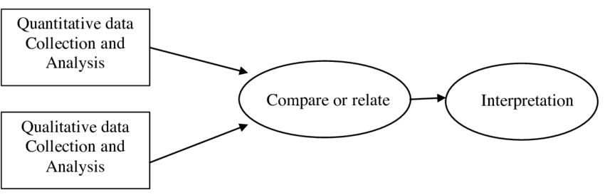
The participants' samples were selected using a convenience and purposeful approach which supported the research that adolescent females were particularly vulnerable when it comes to experiencing MPA. Ten students in Years 10 and 11 (ages 14-16) were invited to participate and six agreed to be part of the study.
Quantitative Data
The participants performed twice; once without breathwork intervention and the second time with. The performance venue was the school rehearsal room, and the audience was composed of family, friends, and staff members. After each performance the participants completed an online performance questionnaire to measure their experience of MPA. Quantitative questions were used for time and resource efficiency and to produce clear, easy to interpret data (Stewart et al, 2015). The performance questionnaire design used a self-reporting Likert psychometric scaling system (Likert, 1932), commonly used in social science research to provide data from questions where the participant can offer ‘some level of opinion or the option of not at all’ (Willits et al, 2016 p 349). The Likert scaling system can provide clean data that is comparable and accessible to the participants who will be completing the questionnaires anonymously and independently (Polovin, 2020). The Likert scale provides flexibility in design and simple format to apply. There are well-documented problems with the Likert scale; the participants may feel forced to answer even if their preferred response isn’t listed, or they may sit somewhere in between answers or feel that one answer does not represent their experience (Hodge and Gillespie, 2003, Orvik, 1972). (I will be expanding on the challenges encountered during the research analysis.) That said, the initial idea was that the quasi-quantitative approach was a useful starting point to measure feelings of experience which provides extra detail and colour to the quantitative data and to support the field notes (Chimi and Russell, 2009).
Observation notes
Observation notes were conducted during each performance to collect ‘time-stamped event data’ (Tomasi, 2018, p 210) and further context for analysis (Creswell, 2013). The observation notes focused on the following areas as a continuous thematic concern: MPA before and during performance, performance achievement and performance enjoyment. Performance achievement will be measured and observed subjectively by the researcher and will be considering the following criteria derived from Stanley et al’s (2002) research into music performance assessment criteria: accuracy of performance, intonation, breathing, style, and musical communication. Descriptive codes from the observation notes supported the qualitative data analysis and gave focus to the analysis of the qualitative data (Crabtree and Miller, 1999).
Qualitative Data
At the end of the data gathering phase the participants were invited to complete a final questionnaire with open-ended questions to provide a further insight into their experience. The questions included some prompts to support the participants that allowed for more detailed responses. In line with a convergent parallel mixed methods design the qualitative data was coded and interpreted independently using both Descriptive and In Vivo coding. The inductive style of coding enabled the research to be cross referenced against the observation notes and provide a deeper insight on experience. The in vivo coding provided some interesting quotes from the participants' own words (Turner, 2016).
All data was analysed using methods of content analysis which observed themes, relationships, patterns in the research and cross referenced the characteristics of the data to both deductively and inductively test the hypothesis that breathwork exercises can reduce MPA and improve overall performance experience (Buthe, 2014).
Ethical considerations
The age of the participants and nature of this study meant that particular care and sensitivity needed to be taken when conducting this study. With adolescent girls being more susceptible to MPA this study may have been more difficult for some participants in terms of being exposed to their fear of performing. Confidentiality, anonymity, and an opt-out option was respected and communicated throughout the process. MPA experiencing participants exposed and facing their fears.
The box breathing techniques involved long slow exhalations which required breath control and command over the support muscles in the torso so participants were asked to disclose any medical reason why they may not be able to engage in the exercises.
Practitioner research is often subject to bias. Developing a hypothesis based on practice means you are intrinsically connected to the subject matter, and it is important to demonstrate reflexivity throughout the process to prevent biased research. Although insider research can be a positive feature of a study in terms of participant-researcher rapport and trust, this position of power can also provide challenges. Participants may feel influenced to censor themselves or answer in a way that is not authentic to affect the outcome to please the researcher. To balance this anonymity was protected throughout the process. Each participant was allocated an anonymised letter (A - F) that they used for each questionnaire for the data to be compared.

Presentation of findings
The data collected in this study will be used to analyse the effect of breathwork intervention as a strategy to reduce MPA. The questions have been carefully created to produce data that reflects the perception of the participants' experience of MPA symptoms before and during a performance. The questions also seek to gather data on the participants' experience of their performance in terms of achievement and enjoyment.
Quantitative Performance Questionnaire data
MPA performance questionnaires were made available online just before each performance. The participants were advised to complete the questions immediately after each individual performance to ensure their recollections were accurate. All six participants engaged in both questionnaires in the time frame suggested.
The following tables show the data from both post performance questionnaires. They detail the rating responses from all participants. For clarity and ease of flow I will be referring to the performance without breathwork intervention as ‘Session 1’ (highlighted in blue) and the performance with intervention as ‘Session 2’ (highlighted in red).
The ‘Neutral’ rating in the Likert scale has long been contested in research in terms of its functionality but for transparency I will not be dealing with the interpretation in this section, I will be expanding on this in the discussion. I will be combining the ‘Somewhat’ and ‘Strongly’ distinctions together where appropriate to strengthen trends in the data. It is a small sample study so there is awareness that this merging of rating scale points may over simplify the trends, all further limitations will also be covered in the discussion.

Session 1 - Without breathwork intervention
 | Strongly agree | Somewhat Agree | Neutral | Somewhat Disagree | Strongly Disagree
I experienced feelings of MPA before the performance. | 3 | 2 | 1 | 0 | 0
I experienced feelings of MPA during the performance. | 3 | 3 | 0 | 0 | 0
MPA affected my ability to perform to the best of my ability. | 1 | 4 | 0 | 1 | 0
MPA affected my enjoyment of the performance. | 1 | 2 | 1 | 1 | 1

Session 2: With breathwork intervention

 | Strongly agree | Somewhat Agree | Neutral | Somewhat Disagree | Strongly Disagree
I experienced feelings of MPA before the performance. | 0 | 2 | 1 | 3 | 0
I experienced feelings of MPA during the performance. | 0 | 2 | 2 | 2 | 0
MPA affected my ability to perform to the best of my ability. | 0 | 2 | 0 | 2 | 2
MPA affected my enjoyment of the performance. | 0 | 0 | 2 | 2 | 2

1. MPA before Performance
Without Intervention:
According to the table of initial data there appears to be a general trend towards a lessening of the impact of MPA symptoms following breathwork interventions and an improvement of performance experience in both performance outcomes and enjoyment. This supports the hypothesis that breathwork can be an effective tool to reduce MPA and to promote positive performance experience for singers.
I will now be breaking down the data by individual question and analysing both sets of data from performances simultaneously.

I experienced feelings of MPA before the performance. | Performance without breathwork intervention | Performance with breathwork intervention
Strongly agree | 3 | 0
Somewhat Agree | 2 | 2
Neutral | 1 | 1
Somewhat Disagree | 0 | 3
Strongly Disagree | 0 | 0
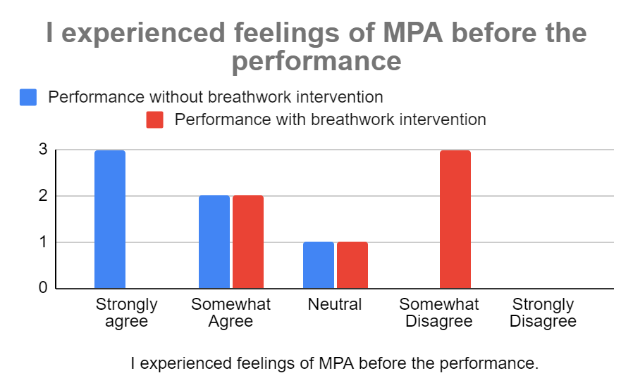
If we combine the ‘strongly agree’ and ‘somewhat agree’ categories to represent those participants experiencing MPA before the sessions, five participants experienced MPA prior to Session 1 compared with two in Session 2 with three participants stating they somewhat disagreed with the statement. This shows a reduction in MPA experiencing post breathwork intervention correlating with Taiwanese study (Su et al, 2010) and supporting the hypothesis. The mean shifted towards the ‘Disagree’ end of the scale from Session 1 to 2 suggesting that the breathwork intervention had a positive impact on reducing MPA symptoms prior to a performance. The Neutral response was selected by one participant for each performance. This is an anomaly as participant F rated MPA before the performance as Neutral for Session 1 and Somewhat Agree for Session 2 which goes against both the other data and hypothesis. Reasons for this may include differences in performance order, audience differences and could also be attributed to potential problems with the scaling system which will be investigated in full in the discussion. Participant B responded Somewhat Agree to experiencing MPA before Session 1 and Neutral for Session 2. It could be interpreted as a reduction in MPA, but I am aware of my bias as an insider researcher and the research is divided on the analysis of Neutral in Likert scales. The data is mixed for this question, and it does highlight the challenges in assessing a phenomenon that is experienced so differently by individuals.

MPA Symptoms during Performance
I experienced feelings of MPA during the performance. | Performance without breathwork intervention | Performance with breathwork intervention
Strongly agree | 3 | 0
Somewhat Agree | 3 | 2
Neutral | 0 | 2
Somewhat Disagree | 0 | 2
Strongly Disagree | 0 | 0
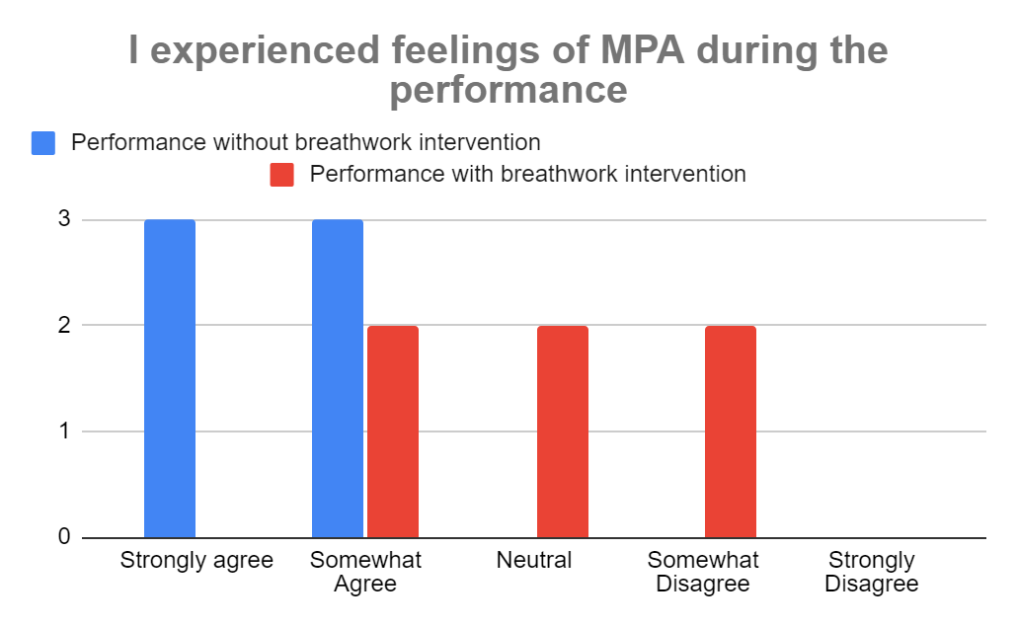
During a performance is often when symptoms become most difficult to manage (Kenney, 2005) and also where performers report most heightened MPA symptoms. When looking at the data for the effects of MPA during both performances all six participants experienced MPA during Session 1 compared to two in Session 2, with two participants stating neutral and somewhat disagree indicating a general move towards an overall reduction in symptoms during the performance. Both participants E and F responded Somewhat Agree to experiencing MPA during Session 1 and responded Neutral in Session 2. Similarly, to the previous question this could be interpreted as a reduction, but it is important not to make assumptions when dealing with the Neutral response. No participants rated Strongly Disagree which suggests that there were still some feelings of MPA present, although difficult to gauge the nuance or spaces-in between in this type of rating study (these challenges will be explored further in the discussion).
Did MPA affect performance achievement?
MPA affected my ability to perform to the best of my ability. | Performance without breathwork intervention | Performance with breathwork intervention
Strongly agree | 1 | 0
Somewhat Agree | 4 | 2
Neutral | 0 | 0
Somewhat Disagree | 1 | 2
Strongly Disagree | 0 | 2
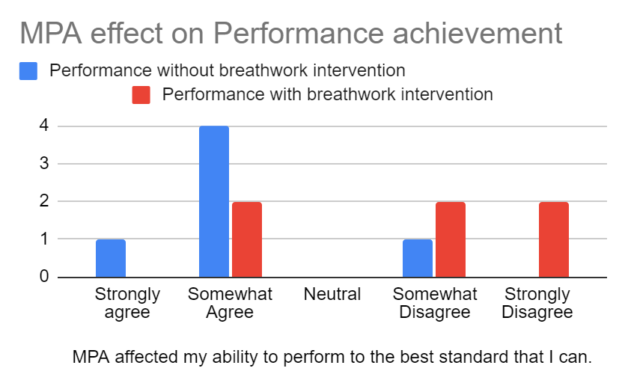
This question sought to assess each participants’ perception of how MPA may have affected their ability to deliver a good performance. This was reflected in the data from Session 1 where five out of the six participants strongly agreed that MPA affected their performance ability, with one somewhat disagreeing. In comparison two participants somewhat agreed with the statement in Session 2, with four strongly disagreeing suggesting that there was an improvement in their perception of their performance achievement.

Did MPA Affected performance enjoyment?

MPA affected my enjoyment of the performance. | Performance without breathwork intervention | Performance with breathwork intervention
Strongly agree | 1 | 0
Somewhat Agree | 2 | 0
Neutral | 1 | 2
Somewhat Disagree | 1 | 2
Strongly Disagree | 1 | 2
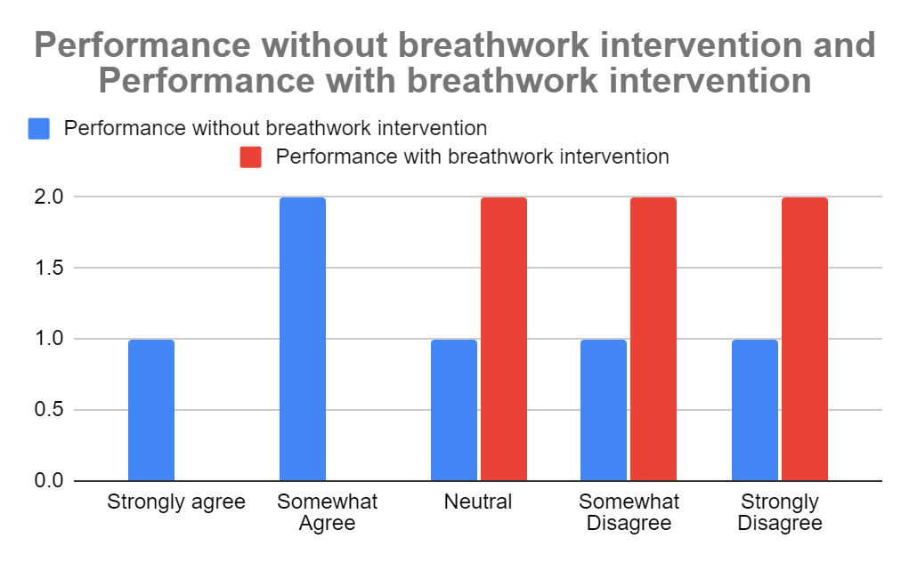
This question’s purpose was to evaluate how MPA impacted on the participants’ enjoyment of the performance. The question garnered some mixed results. In Session 1 the data was evenly spread over all categories ranging from Strongly Agree to Strongly Disagree (with Somewhat Agree receiving one more vote than the others suggesting a slight lean towards more participants feeling MPA affected performance enjoyment.) Session 2 again, saw an equal number of participants rating from Neutral to Strongly Disagree suggesting a shift away from MPA negatively affecting their performances.
Observation notes
I identified the following themes when coding my observation notes. These areas were the ones I wanted to explore and observe the changes. By using descriptive coding, I can cross reference some relevant themes when analysing the qualitative data from the Final Questionnaire to add greater insight and for triangulation purposes.
Nerves - represented physical manifestation of MPA symptoms such as trembling, breath control and intonation changes (overall reduction yet not elimination of).

Mistake making - attributed to the impact MPA symptoms can have on a performance (were there less mistakes made, did they remember their lyrics.)

Calm and relaxed - the optimal state for a performer to be in for performance achievement and enjoyment (Overall improvement of calm and relaxed state of all students manifesting in a confident well-rounded performance).

Confident - a positive state for a performer to be in (manifesting in musical communication and overall reduction of all features of MPA during the performance).
Qualitative data from Final MPA Questionnaire:
The Final MPA Questionnaire was made available online to the participants three days after Session 2 and I received responses from five out of the six participants. Descriptive and in vivo coding was used to extract themes and direct quotes that are pertinent to the research in order to analyse the data against the observation notes. Emotional coding could have been applied to the qualitative data but not the observation notes.
I will be cross referencing this data with the quantitative data form the previous methods and triangulation with my observations and existing literature on this research,

Enjoyment of using breathwork exercises | 5
Improved Confidence | 1
Easier to do at school in a group | 4
Easier to do at home on own | 1
Improved performance achievement | 1
Improved Performance enjoyment | 0
Calm and relaxed | 5
Reduced nerves | 4

The main insights from the qualitative data pertinent to this study was the frequency of which reduction of nerves and improvement of states of calm and relaxation came up as a theme when applying the breathwork exercises. All five participants that submitted responses found the exercises evoked calm and relaxation before the performance and four out of five said it reduced their performance nerves. This has been a common theme throughout the study as revealed in my observation notes and in the quantitative data, all students appeared much calmer and more relaxed in Session 2. However, it may be far too easy to singularly attribute this to the breathwork interventions. By Session 2 the participants had already experienced one performance and may have been feeling reduced nerves and heightened confidence for this reason. This poses more questions about research design and how this could be measured in future studies. The study sample is small which requires further investigation to corroborate this data, although emergent trends may be observed.
All participants said they enjoyed learning and applying the exercises which was also evidenced by my field notes; all participants engaged fully in the breathwork session and focused well. The design of this question may need further consideration as the prompts used may have been leading, to answer in this way. Despite their anonymity I fear the participants may have been influenced to answer this question in a way to please the researcher. (Social Desirability Bias will be explored fully in the next section.)
The location and context of where exercises were carried out was important to the participants according to the data. Four participants stated they preferred the exercises being conducted in school (as opposed to doing them at home alone) due to the fact it was guided by me, and they found this direction useful. One participant experienced more MPA before Session 2 which is an anomaly and supports the assertion that these exercises may be context-specific for many individuals. Some participants benefitted from the group, in-school breathwork session and others stated they would’ve preferred to conduct the exercises alone. This factor would need to be taken forward and offered as an option either way for future consideration. Participants stated that they preferred the in-school setting as the session was guided and that they benefitted from the directed exercises. This opens scope to think about how this could be provided by means of recording the sessions to access guided exercises from home.
In vivo coding allowed me to extract some direct quotations:
Many referenced the calming effect the breathwork exercises had:
“I definitely felt more relaxed than I normally do at performances”

“I found the exercises really helped my MPA and I felt a lot more calm before and during my performance. It helped to calm me down and reduce any nerves I had.”

Despite the somewhat mixed data on performance achievement and enjoyment participants found that in Session 2 they had improved confidence and improved performance achievement.

“I was a lot more confident in myself and wasn’t worrying about the performance before it happened”.
“I think that my performance was better than the first time.”

More than one participant cited context and proximity to performance as key factors when applying the exercises.
“Doing them (the exercises) straight before going on stage” (would improve efficacy).

“I think if I did it on my own I would feel more relaxed. “

Two participants suggested that exercise application proximity to performance is an important factor to improve their efficacy in reducing pre performance nerves. Another participant suggested that the exercises would be more effective when applied “them straight before going on stage”. In the performances there would have been some performers that had to wait longer for their turn to sing and this may have had an impact on the efficacy of the exercises. Especially with the quantitative data revealing that MPA is more problematic for them during the performance (make this more obvious earlier). This also supports the research in the importance of the proximity of exercises to performance and overall efficacy.
Data on performance outcomes were less clear. Despite my field notes noting a clear distinction between Session 1 and 2 in terms of performance achievement (with the participants performing more confidently and proficiently in the latter), only one participant felt the exercises improved their ability to do well in their performance. Surprisingly no participants commented on performance enjoyment despite the quantitative data revealing that with the intervention MPA affected their enjoyment less. This could be that clearer prompts are needed or that they didn't deem either achievement or enjoyment to be relevant. This again, may be in part attributed to question design for this age group requiring much more detailed prompts. Providing prompts without leading the question is a challenging balance and poorly constructed questions can skew the data (Dodgson, 2020).

Discussion and limitations
Although the data points towards a tentative correlation between box breathing and reduced MPA experiencing it is difficult to draw concrete conclusions from the research due to a number of factors concerning the research design.
Problems with Likert scales and self-reporting
Likert scales are used widely as a simple, reliable way to measure opinion and workable data in the social sciences and psychology research fields. It has also been used as a widespread tool in studies into children and adolescents with success due to its accessibility. This study sought ease of engagement and uncomplicated methods to gather data for the young participants. This pilot study of sorts also required a way to interpret the emerging data (by a novice researcher) and the simplicity was appealing although upon reflection the way the Likert scaling system was applied poses some challenges with the data and design. By design Likert scales involves ordinal 5-7 point scale and participants rate to which degree they agree with the statement posed (Sullivan, 2013). Although accessible, this method may not always reflect the nuanced experience and perspective of the participant due to the limited nature of scaling points. Central Tendency Bias is the tendency to avoid extremes of opinion when participating in a scaling questionnaire preferring to opt for a neutral response. This was a factor that was present in the data and proved difficult to interpret. The neutral responses to ascertain whether participants experienced MPA during the performance, did not provide us with clear data as it was not certain how they felt in that moment and the questionnaire design did not allow for further comment to aid interpretation.
Comparing the data that emerged from the quantitative data experiencing MPA before the performance we can deduce that the response trends moved towards MPA reduction after Session 2 although three participants chose the neutral response. It is difficult to make any assumptions about these responses. Research suggests people choose the neutral response due to ambivalence or if they are not motivated to engage cognitively in the process (Edwards, 2023) leading to miscalculation and problems in interpretation. The neutral response may be favoured by older children as they may feel the polarised scale may not represent their perspective and the avoidance of extremes (Mellor and Moore, 2014; Dawes, 2008) thus leading to difficulties with analysis. A possible solution would be to use a sliding scale measure where people can answer more accurately rather than having to commit to a singular point on the scale that may represent the participants’ views more closely. To look closer at the data, Participant F appeared to contrast with the rest of the set showing an increase in MPA before Session 2, with all others showing a reduction in MPA experiencing post breathwork intervention. As the questionnaires were completed anonymously it was not possible to corroborate this with the observation notes but by cross referencing this data with the qualitative responses from Participant F some interesting insights could be found. Despite stating that they found the breathing exercises useful and enjoyable they found the exercises difficult to do at school preferring to perform them alone not in a group setting at school. This could be attributed to many reasons why but inevitably leading to a potential inability to engage and be present in the breathwork session which could explain a lack of efficacy. Participant F also provided some further insight into the profundity of proximity in exercise application to performance. They stated that conducting the breathing exercises immediately before the performance would have had greater effect which again highlights the challenges in research design that some participants have to wait longer than others potentially affect the effectiveness of the exercises. Context and setting are clearly important factors when moving forward with this research.
The KPMAI (Kenny, 2009) scale are considered industry standard for self-reporting anxiety (Juncos, 2023). The KPMAI scale was going to be utilised in this study but upon reflection decided to go with the Likert for reasons of accessibility. The KPMAI scale provides much more detail and insight and may provide a more exhaustive measure for MPA experiencing. My initial concern was that the detail of the KPMAI may have been intimidating for the young participants, but I feel this underestimated their capacity to engage and process the information in conjunction with their experience. Self-reporting rating scales have been the most popular way to measure anxiety and although there is a place for this type of method design, other forms would be needed to corroborate and strengthen the data.
Self-reporting has its limitations when investigating a subject that has many components, some of which are psycho physiological. Rigour could be obtained by measuring the physiological symptoms experienced with the sympathetic nervous system arousal indicators, which may provide more robust data that could be easier to interpret. Skin conductance to quantify sweat changes is one of the most reliable measures of nervous system arousal (in relation to threat and anxiety), (Bach et al, 2010). Heart rate variability is another measure of nervous system arousal (Wascher, 2021) but these methods would require a level of clinical expertise to deliver and interpret, which despite overreaching the parameters of this study could broaden the scope for further investigation.

Social Desirability Bias

Social desirability (SD) bias can be a challenge with self-reporting research especially when investigating a subject, like MPA, that by its very essence is experienced so individually. When questionnaires are applied in a research design we rely on the authenticity and truthful answers from the participants to provide valid data to analyse (de Mortel, 2008). SD bias is where a participant feels they need to answer in a certain way to be deemed more socially acceptable or to please the researcher (Johnson and Fendrich, 2002). As researchers we presuppose that the participants will choose the rating point on the scale that aligns most with their perspective, but individuals may select the neutral scale point to avoid extremes (Douvan, 2008).
This bias usually more of a challenge when answering questions of a socially sensitive nature, it could be argued that this topic may illicit feelings of embarrassment and vulnerability. Anonymity was provided in this study but due to the small sample group the participants may feel exposed and vulnerable when answering and research suggests that both age and gender can be indicators of SD (Chung and Monroe, 2003).
Scales that measure a participants’ inclination for social approval (thus correlating their vulnerability to social desirability bias) can be built into the formative stages of the research design. The most popular method is the Marlowe-Crowne Social Desirability Scale (MCSDS) (Crowne and Marlowe, 1960) which provides an extra layer of scrutiny from the outset of the research design to improve quality of sampling.
More strategic screening and early measures of how participants experience MPA could be a way to improve sampling and produce more meaningful data. The screening process relied on participants self-reporting their experience of MPA with no way to establish the level to which they experience. This could be a way to move towards a more purposeful strategic sampling method rather than convenience.
Insider research
Insider researcher often has challenges with objectivity when investigating a subject that one is immersed in (Wilkinson and Kitzinger, 2014). Although my role as a practitioner researcher allows for advantageous positioning to obtain depth of insight and understanding, it is notwithstanding some methodological challenges and ethical concerns (Fleming, 2018). Having experienced MPA as a performer and being witness to many students and clients struggling with performance anxiety I was strongly connected to the research, and I had concerns that my determination to realise a solution may have had an impact on my process. A reflexive approach throughout the study was integral and helped to ensure my interpretation was not biased and my position was as neutral as possible. Further measures may involve a higher level of triangulation by involving another objective research partner in the process to help moderate the process and analysis.
The concept of both trust and trustworthiness in insider research is an interesting concept and is multifaceted. The existing trust between participants and researcher in practitioner research may lead to greater depth of understanding of the data and the best practices to design the research process, often proving essential to successful research (Barnard et al, 2018 – check this citation). Trustworthiness in the research is akin to validity and credibility (Lincoln and Guba, 1985). Participants demonstrated trust in the researcher and process by their willingness to fully engage in the process an openness in learning something new and applying this in a situation that took them outside of their comfort zone. The interpersonal relationship and rapport built between participants and researcher in this instance proved integral to participation and ongoing engagement (Guillemin et al, 2016). Despite the high level of trust between participants and researcher, there were areas for criticism in the process in terms of trustworthiness of the design and interpretation of the data. Questions of bias could be legitimately raised and further considerations regarding triangulation must be made to ensure the research stands up to higher scrutiny.
The study met its objectives in part and has provided some evidence for further investigation. The data mostly corroborated the literature and added some support to the hypothesis that box breathing can reduce symptoms of MPA. Although this study can be used as preliminary evidence to suggest this positive link, further investigations are necessary to improve the robustness of the data and to strengthen this claim.
References
Ashfaaq, & Devi, R. G., Priya, A. J. (2021). ‘Effect of Box Breathing Technique on Lung Function Test. Journal of Pharmaceutical Research International, 33(58A), 25-31. ISSN 2456-9119
Ahmed et al, (2021) ‘Theoretical investigations of Tamm plasmon resonance for monitoring of isoprene traces in the exhaled breath: Towards chronic liver fibrosis disease biomarkers’,
Physics Letters A, Vol 413.
Bach, D. R., Friston, K. J., & Dolan, R. J. (2010). ‘Analytic measures for quantification of arousal from spontaneous skin conductance fluctuations.’ International Journal of Psychophysiology, 76(1), 52-55. doi: 10.1016/j.ijpsycho.2010.01.011
Bentley et al, (2021). ‘The nature, timing, and symptom trajectories of dropout from transdiagnostic and single-diagnosis cognitive-behavioural therapy for anxiety disorders’.
Behaviour Therapy, doi:10.1016/j.beth.2021.03.007
Bishop, P. A., & Herron, R. L. (2015). ‘Use and misuse of Likert item responses and other ordinal measures.’ International Journal of Exercise Science, 8(3), 297-302. PMID: 27182418
Britsch, L. (2005). ‘Investigating Performance-related Problems of Young Musicians’. Medical Problems of Performing Artists, 20, 40-47.
Brown, R., & Gerbarg, P. (2005). ‘Sudarshan Kria Yogic Breathing in the Treatment of Stress, Anxiety, and Depression: Part II—Clinical Applications and Guidelines’. Journal of Alternative and Complementary Medicine, 11, 711-717.
Burin and Osorio (2017). ‘Music performance anxiety: ‘A Critical review of etiological aspects, perceived causes, coping strategies and treatment.’ Archives of Clinical Psychiatry. 44(5): 127-133.
Cazden, J. (2017). ‘Stalking the calm buzz: how the polyvagal theory links stage presence, mammal evolution, and the root of the vocal nerve’. Voice and Speech Review, 11, 132-153.
Cina, J. (2021). ‘Music Performance Anxiety and Cognitive-Behavioral Therapy: Some Pedagogical Insights’. Alumni Publications, 621. Retrieved from https://digitalcommons.cedarville.edu/alumni_publications/621
Chimi, C. J., & Russell, D. L. (2009). ‘The Likert Scale: A Proposal for Improvement Using Quasi-Continuous Variables’. In The Proceedings of the Information Systems Education Conference 2009, 26(3).
Chung, J., & Monroe, G. S. (2003). ‘Exploring Social Desirability Bias’. Journal of Business Ethics, 44(4), 291-302. doi: 10.2307/25075038
Costley, C., Elliott, G., & Gibbs, P. (2010). ‘Doing work based research: Approaches to enquiry for insider-researchers’. SAGE Publications Ltd. doi: 10.4135/9781446287880
Cornett, V., & Urhan, G. (2021). Performance anxiety experiences and coping techniques of Turkish music students and their teachers. International Journal of Music Education, 39(4), 504–519. https://doi.org/10.1177/02557614211005907
Creswell, J.W. (2013) Research Design: Qualitative, Quantitative, and Mixed Methods Approaches. 4th Edition, SAGE Publications, Inc., London. Crowne,
Creswell, J.W. and Plano Clark, V.L. (2011) Designing and Conducting Mixed Methods Research. 2nd Edition, Sage Publications, Los Angeles.
D. P., & Marlowe, D. (1960). ‘A new scale of social desirability independent of psychopathology’. Journal of Consulting Psychology, 24, 349-354.
Daubney, G., & Daubney, A. (2017). Performance Anxiety: A Practical Guide for Music Teachers. London: Incorporated Society of Musicians Trust.
Dawes, J. (2008). ‘Do data characteristics change according to the number of scale points used? An experiment using 5-point, 7 point and 10 point scales. International Journal of Market Research, 51(1).
Deen, D. R. (1999). ‘Awareness and breathing: Keys to the moderation of musical performance anxiety’. University of Kentucky.
Douven, I. (2018). ‘A Bayesian perspective on Likert scales and central tendency’. Psychonomic Bulletin & Review, 25, 1203-1211. doi: 10.3758/s13423-017-1344-2
Fehm L, Schmidt K. ‘Performance anxiety in gifted adolescent musicians’. Journal of Anxiety Disorders. 2006;20(1):98-109. doi: 10.1016/j.janxdis.2004.11.011.
Feilzer, M. (2010). ‘Doing Mixed Methods Research Pragmatically: Implications for the Rediscovery of Pragmatism as a Research Paradigm’. Journal of Mixed Methods Research, 4(1), 6–16. https://doi.org/10.1177/1558689809349691
Fleming, N. (2018). ‘Recognizing and resolving the challenges of being an insider researcher in work-integrated learning’. International Journal of Work-Integrated Learning, 19(3), 311-320.
Gerritsen, R. J. S., & Band, G. P. H. (2018). ‘Breath of Life: The Respiratory Vagal Stimulation Model of Contemplative Activity’. Frontiers in Human Neuroscience, 12. doi: 10.3389/fnhum.2018.000397
Guillemin, M., Gillam, L., Barnard, E., Stewart, P., Walker, H., & Rosenthal, D. (2016). ‘"Doing trust": How researchers conceptualize and enact trust in their research practice’. Journal of Empirical Research on Human Research Ethics, 11, 370-381.
Guillemin, M., Barnard, E., Allen, A., et al. (2018). ‘Do Research Participants Trust Researchers or Their Institution?’ Journal of Empirical Research on Human Research Ethics, 13(3), 285-294. doi: 10.1177/1556264618763253
Incite Blog. (2014, May 7). ‘The Effects of the Neutral Response Option on the Extremeness of Participant Responses’. Retrieved from https://blogs.longwood.edu/incite/2014/05/07/the-effects-of-the-neutral-response-option-on-the-extremeness-of-participant-responses/ Accessed ate: 20/06/23
Juncos, D. G., & de Paiva e Pona, E. (2018). ‘Acceptance and commitment therapy as a clinical anxiety treatment and performance enhancement program for musicians: Towards an evidence-based practice model within performance psychology’. Music & Science, 1. https://doi.org/10.1177/2059204317748807
Harris. (2020). The Dying Art of the Peripatetic Music Teacher. Retrieved from https://www.tes.com/magazine/archive/behold-dying-art-peripatetic-music-teacher. Accessed date: 18/06/23.
Haywood Rolling Jr. (2010) A Paradigm Analysis of Arts-Based Research and Implications for Education, Studies in Art Education, 51:2, 102-114, DOI: 10.1080/00393541.2010.11518795

Hodge, D. R., & Gillespie, D. (2003). ‘Phrase completions: An alternative to Likert scales.’ Social Work Research, 27(1), 45–55. https://doi.org/10.1093/swr/27.1.45

Jayawardena R, et. (2020) ‘Exploring the Therapeutic Benefits of Pranayama (Yogic Breathing): A Systematic Review’. International Journal of Yoga. Vol 13(2):99-110. doi: 10.4103/ijoy.IJOY_37_19.

Jebb, A. T., Tay, L., Wang, W. C., Huang, Q., Zhang, D. J., & Lee, J. J. (2021). ‘A Review of Key Likert Scale Development Advances: 1995-2019’. Frontiers in Psychology, 12. Retrieved from https://www.frontiersin.org/articles/10.3389/fpsyg.2021.637547. doi: 10.3389/fpsyg.2021.637547
Johnson, T., & Fendrich, M. (2002). ‘A validation of the Crowne-Marlowe Social Desirability Scale’. Retrieved from http://www.srl.uic.edu/publist/Conference/crownemarlowe.pdf. Date accessed: 01/07/23.
Kenny, D. T., & Osborne, M. S. (2006). ‘Music performance anxiety: New insights from young musicians’. Advances in Cognitive Therapy, 2(2-3), 1-112.
Kenny, Dianna. (2011). The Psychology of Music Performance Anxiety. 10.1093/acprof:oso/9780199586141.001.0001.
Kim, Y. (2005). ‘Combined Treatment of Improvisation and Desensitization to Alleviate Music Performance Anxiety in Female College Pianists: A Pilot Study’. Medical Problems of Performing Artists, 20, 17-24.
Kokotsaki and Davidson (2003) ‘Investigating Musical Performance Anxiety among Music College Singing Students: A Quantitative analysis. Music Education Research. DOI:10.1080/14613800307103
Kurth et al (2020) ‘Preparing for and Implementing Effective Inclusive Education With Participation plans’. Teaching Exceptional Children. DOI:10.1177/0040059920927433
LeBlanc, A., Jin, Y. C., Obert, M., & Siivola, C. (1997). ‘Effect of Audience on Music Performance Anxiety’. Journal of Research in Music Education, 45(3), 480–496. https://doi.org/10.2307/3345541
Linden, W. (2007). The autogenic training method of J. H. Schultz. In P. M. Lehrer, R. L. Woolfolk, & W. E. Sime (Eds.), Principles and practice of stress management (pp. 151–174). The Guilford Press.
MacAfee, L., & Comeau, G. (2023). ‘Teacher perspective on music performance anxiety: An exploration of coping strategies used by music teachers’. British Journal of Music Education, 40(1), 34-53. doi: 10.1017/S0265051722000146
Mazzone, L., Ducci, F., Scoto, M.C. et al. (2007) ‘The role of anxiety symptoms in school performance in a community sample of children and adolescents’. BMC Public Health 7, Vol 347, (2007). https://doi.org/10.1186/1471-2458-7-347
Mazzarolo, I, and Schubert, E (2022). “A Short Performance Anxiety Scale for Musicians.” Frontiers in psychology, vol. 12, 781262. 26 Jan. 2022, doi:10.3389/fpsyg.2021.781262
Mellor, D., & Moore, K. A. (2014). ‘Using Likert scales with children’. Journal of Pediatric Psychology. Vol 3 (23)
Mooventhan A, and Nivethitha L. (2017) ‘Evidence based effects of yoga practice on various health related problems of elderly people: A review’. Journal Bodywork and Movement Therapy. 2017 Oct;21(4):1028-1032. doi: 10.1016/j.jbmt.2017.01.004.
Morgan, D.L (2007). ‘Paradigms Lost and Pragmatism Regained: Methodological Implications of Combining Qualitative and Quantitative Methods.’ Journal of Mixed Methods Research. Vol 1(1).
Nagel, J.J. (2009). ‘How to Destroy Creativity in Music Students: The Need for Emotional and Psychological Support Services in Music Schools’. Medical Problems of Performing Artists, Vol 24 (1)
Norelli, S. K., et al. (2022). Relaxation Techniques. StatPearls Publishing. Retrieved from https://www.ncbi.nlm.nih.gov/books/NBK570516/. Accessed date: 01/07/23
O'Reilly, M., Svirydzenka, N., Adams, S., et al. (2018). ‘Review of mental health promotion interventions in schools’. Social Psychiatry and Psychiatric Epidemiology, 53, 647-662. doi: 10.1007/s00127-018-1530-1
Ortiz - Bruges, A (2019) Music Performance Anxiety: A Comprehensive Update of the Literature. Cambridge Scholars Publishing.
Orvik J, (1972), ‘Social desirability for individual, his group, and society’
Multivariate Behavioral Research, Vol. 7. pp. 3-32
Phillippi, J., & Lauderdale, J. (2018). ‘A Guide to Field Notes for Qualitative Research: Context and Conversation’. Qualitative Health Research, 28(3), 381-388. doi: 10.1177/1049732317697102
Porges, S.W. (2007) ‘The polyvagal perspective’. Biological Psychology. Vol 74(2), p116-43.
Robinson, J. D., & Persky, A. M. (2020). ‘Developing Self-Directed Learners’. American Journal of Pharmaceutical Education, 84(3), 847512. doi: 10.5688/ajpe847512
Ryan, C., & Andrews, N. (2009). ‘An Investigation Into the Choral Singer’s Experience of Music Performance Anxiety’. Journal of Research in Music Education, 57(2), 108–126. https://doi.org/10.1177/0022429409336132
Ryan, C. (2004). ‘Gender Differences in Children’s Experience of Musical performance Anxiety’. Psychology of Music, 32(1), 89–103.
Saunders, B., Kitzinger, J., & Kitzinger, C. (2015). ‘Anonymising interview data: challenges and compromise in practice’. Qualitative Research, 15(5), 616-632. doi: 10.1177/1468794114550439
Sengupta P. (2012) ‘Health Impacts of Yoga and Pranayama: A State-of-the-Art Review.’ International Journal of Preventive Medicine.Vol 3(7) p 444-58.
Schön, D. A. (1987). Educating the reflective practitioner: Toward a new design for teaching and learning in the professions. Jossey-Bass.
Shaw, T.A., Juncos, D.G, Winter, D (2020) ‘Piloting a New Model for Treating Music Performance Anxiety: Training a Singing Teacher to Use Acceptance and Commitment Coaching With a Student’, Frontiers in Psychology, Vol 11
Simply Psychology. (n.d.). Likert Scales. Retrieved from https://www.simplypsychology.org/likert-scale.html. Accessed date: 01/07/23
Spahn, C (2015) ‘Treatment and prevention of music performance anxiety.’ Progress in brain research Vol. 217, p129-40
Stanley, M., Brooker, R., & Gilbert, R. (2002). ‘Examiner perceptions of using criteria in music performance assessment’. Research Studies in Music Education, 18(1), 46-56. doi: 10.1177/1321103X020180010601
Steptoe A., Fiddler H. (1987). S’tage fright in orchestral musicians: A study of cognitive and behavioral strategies in performance anxiety’. British Journal of Psychology, 78, 241–249.
Stewart et al, (2015) ‘Transparency in Qualitative and Multi-Method Research: A Symposium.’ Qualitative and Multi-Method Research: Newsletter of the American Political Science Association's QMMR Section. vol.13 no.1: 2-64.

Sullivan, G. M., & Artino Jr, A. R. (2013). ‘Analyzing and interpreting data from Likert-type scales’. Journal of Graduate Medical Education, 5(4), 541-542. doi: 10.4300/JGME-5-4-18
Su, Y. H. et al. (2010) ‘Effects of using relaxation breathing training to reduce music performance anxiety in 3rd to 6th graders.’ Medical problems of performing artists, Vol. 25, issue 2, p 82-6.
Sweeney-Burton, C. (1998). ‘Effects of self-relaxation techniques on performance anxiety and on performance quality in a music performance condition’. Dissertation Abstracts International, 58(7-A), 2581.
Tomasi, Jessica et al. ‘Convergent parallel mixed-methods study to understand information exchange in paediatric critical care and inform the development of safety-enhancing interventions: a protocol study.’ BMJ open vol. 8,8 e023691. 1 Sep. 2018, doi:10.1136/bmjopen-2018-023691
Turner, D. (2016). In vivo coding and revealing life from the text. Retrieved from https://www.quirkos.com/blog/post/in-vivo-coding-and-revealing-life-from-the-text/. Accessed date: 23/06/23.
Urruzola, E. and Bernaras, E (2020). ‘Music performance anxiety in 8- to 12-Year-Old children’, Revista de Psicodidáctica (English ed.), Volume 25, Issue 1,
Pages 76-83,UK Statistics Authority. (n.d.). Ethical Considerations Associated with Qualitative Research Methods. Retrieved from https://uksa.statisticsauthority.gov.uk/publication/ethical-considerations-associated-with-qualitative-research-methods/pages/6/. Accessed date: 02/07/23.
Van de Mortel, T. F. (2008). ‘Faking it: social desirability response bias in self-report research’. Australian Journal of Advanced Nursing, 25(4), 40-48. Retrieved from https://researchportal.scu.edu.au/esploro/outputs/journalArticle/Faking-it-social-desirability-response-bias/991012821838002368. Accessed date: 01/07/23.
Wascher, C. A. F. (2021). ‘Heart rate as a measure of emotional arousal in evolutionary biology’. Philosophical Transactions of the Royal Society B: Biological Sciences, 376(1831), 20200479. doi: 10.1098/rstb.2020.0479
Wilkinson, S., & Kitzinger, C. (2014). ‘Representing Our Own Experience: Issues in "Insider" Research’. Psychology of Women Quarterly, 37(3), 251.
Willits, F. K., & et al. (2016). ‘Another Look at Likert Scales’. Journal of Rural Studies, 31(3). Retrieved from https://doi.org/10.1016/j.jrurstud.2013.07.006
Winter, D (2020). ‘Voicing a Practitioner Research Methodology: Further Framing the Conversation’. Voice and Speech Review, Vol 15 (1).
Woodley, H. & Mazzoli Smith, L. (2020). ‘Paradigmatic Shifts in Doctoral Research: Reflections Using Uncomfortable Reflexivity and Pragmatism’. International Journal of Qualitative Methods. Vol 19.
Wren, A. A., Neiman, N., Caruso, T. J., Rodriguez, S., Taylor, K., Madill, M., Rives, H., & Nguyen, L. (2021). ‘Mindfulness-Based Virtual Reality Intervention for Children and Young Adults with Inflammatory Bowel Disease: A Pilot Feasibility and Acceptability Study’. Children, 8, 368. doi: 10.3390/children8050368
Zaccaro et al (2018). ‘How Breath-Control Can Change Your Life: A Systematic Review on Psycho-Physiological Correlates of Slow Breathing’. Frontiers in Human Neuroscience, Vol 12.

Appendix A – MPA Performance Questionnaire (Session 1 – May)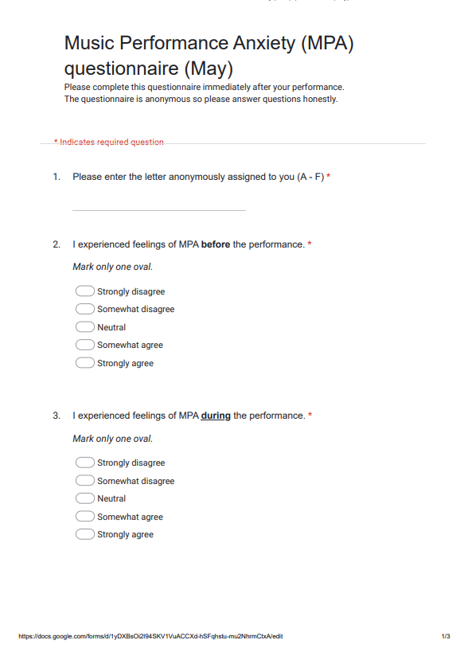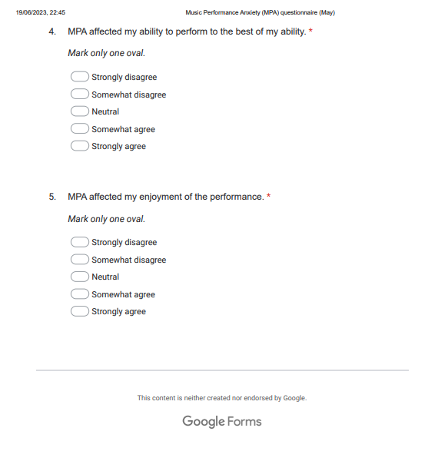

Appendix B: MPA Performance Questionnaire (Session 2 – June)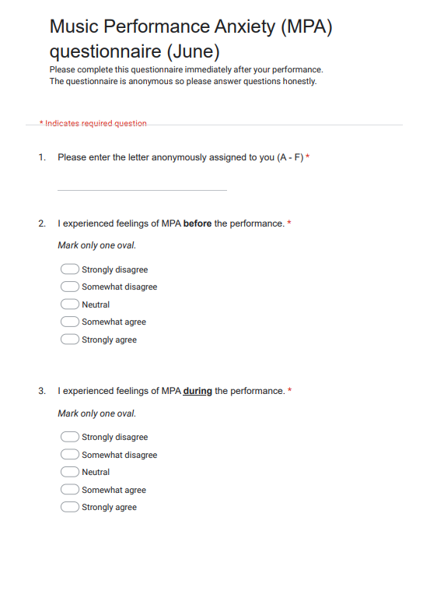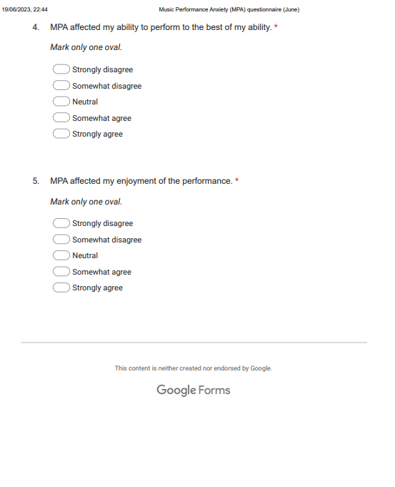

Appendix C: Final MPA Questionnaire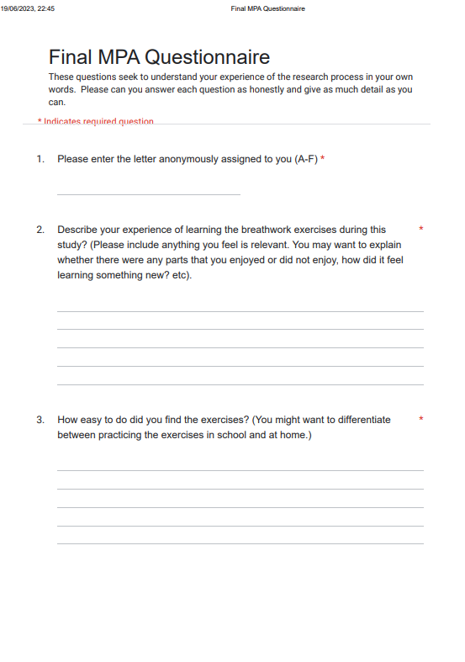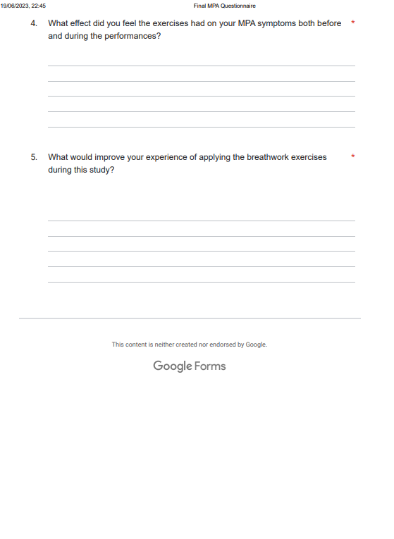

Appendix D – Observation notes

Session 1 Observation notes:

The Session 1 performance was held in the school's rehearsal room, a space familiar to the students that is used for performances. There is a large pa and various microphones, and the room was set up with 50 - 60 chairs for the audience. The audience capacity during this session was around 50, consisting of students and family members with two members of staff to support with the running of the session. The atmosphere was supportive, positive, and calm.

MW - performed first. Seemed a little nervous but she opened the session, so this was to be expected. She performed very well although nerves were evident in breath control and breath leakage. She seemed confident and focused. Aside from nerves having a small impact on vocal quality no mistakes were made.

RL - Performed well with some nerves at the start. She seemed to enjoy performing this song and no mistakes were made. Vocal quality was breathy but only a little more than usual.

PC - Seemed very nervous, some vocal shaking was detected despite this performed well and made only a couple of mistakes.

KF - No nerves were present, but she is an experienced performer so may be good at masking her nerves. Performed very well even with a technical problem occurring during her performance she remained focused.

CO - Performed confidently with no mistakes. No obvious nerves although some breath control seemed insecure towards the end.

JS - Nerves were palpable which caused some breathing and pitch placement insecurities. She kept looking my way for reassurance. Despite the strong nervous response, she carried on and finished the performance.

Session 2 observation notes

This session was set up to mimic the first session and was held in the same space and the audience was of a similar capacity and again made up of students, family members but this time there were more staff members present to watch (including the Head of Music which may have impacted the participants' experience.) The atmosphere was again calm, positive and supportive.

All participants appeared to have more confidence in this session. Projection, breath leakage and control seemed stronger, and no mistakes were evident. Two of the participants appeared much more confident than the first performance. One participant had a remarkably different experience and went from having a difficult time with her MPA in Session 1 appeared to have no obvious MPA symptoms and made no mistakes in Session 2.

PC - performed first this time and although seemed a little nervous her nerves did not appear as prevalent as in Session 1. She projected more and her overall performance seemed much more secure.

MW - Appeared more confident.

Breathwork warm up session

This session was held in a classroom that was marked to be private for the duration of the warm up by a sign on the door. Relaxing music was played throughout to help create a calm atmosphere. I structured all students to choose where they sat and to make themselves comfortable. I did get a hint that two of the participants may have felt a bit self conscious in the group environment, but they all engaged well and managed to stay focused throughout the whole session. The breathwork exercises latest for about 15 minutes with breaks in between to just stay relaxed in the moment. At the end of the warm up session, I gave the students the opportunity to continue with the exercises on their own in the space. By the end of the session the atmosphere was very relaxed and still.

Codes from observations:

Nerves - represented physical manifestation of MPA symptoms.

Mistake making - attributed to the impact MPA symptoms can have on a performance.

Calm and relaxed - the optimal state for a performer to be in for performance achievement and enjoyment.

Confident - a positive state for a performer to be in.

Appendix E – Ethics Form

APPLICATION FOR ETHICAL APPROVAL

In order for research to result in benefit and minimise risk of harm, it must be conducted ethically. A researcher may not be covered by the University’s insurance if ethical approval has not been obtained prior to commencement.

The University follows the OECD Frascati manual definition of research activity: “creative work undertaken on a systematic basis in order to increase the stock of knowledge, including knowledge of man, culture and society, and the use of this stock of knowledge to devise new applications”. As such this covers activities undertaken by members of staff, postgraduate research students, and both taught postgraduate and undergraduate students working on dissertations/projects.

The individual undertaking the research activity is known as the “principal researcher”.

Ethical approval is not required for routine audits, performance reviews, quality assurance studies, testing within normal educational requirements, and literary or artistic criticism.

Please read the notes for guidance before completing ALL sections of the form.

This form must be completed and approved prior to undertaking any research activity. Please see Checklist for details of process for different categories of application.

Delete the Guidance Notes at the end of the form BEFORE submitting your application

SECTION A: About You (Principal Researcher)
1 | Full Name: |  | Caroline Fitch
2 | Tick all boxes which apply: |  | Member of staff: | ☐ | Honorary research fellow: | ☐
3 | Undergraduate Student | ☐ | Taught Postgraduate Student | ☒ | Postgraduate Research Student | ☐

4 | Institute/Academic Discipline/Centre: | WAPPAR
5 | Campus: | Carmarthen
6 | E-mail address: | carolinefitch@gmail.com
7 | Contact Telephone Number: | 07816569729
 | For students:
8 | Student Number: | 2130215
9 | Programme of Study: | MA in Professional Practice (Voice Pedagogy)
10 | Director of Studies/Supervisor: | Nick Samuel

SECTION B: Approval for Research Activity
1 | Has the research activity received approval in principle?  (please check the Guidance Notes as to the appropriate approval process for different levels of research by different categories of individual) |  | YES | ☒ | NO | ☐
 |  |  |  |  | Date
2 | If Yes, please indicate source of approval (and date where known): Approval in principle must be obtained from the relevant source prior to seeking ethical approval | Research Degrees Committee |  | ☐
3 |  | Institute Research Committee |  | ☐
4 |  | Other (write in)  WAPPAR Ethics Board Representative |  | ☒

SECTION C: Internal and External Ethical Guidance Materials
 | Please list the core ethical guidance documents that have been referred to during the completion of this form (including any discipline-specific codes of research ethics, and also any specific ethical guidance relating to the proposed methodology). Please tick to confirm that your research proposal adheres to these codes and guidelines.
1 | UWTSD Research Ethics & Integrity Code of Practice | ☒
2 | UWTSD Research Data Management Policy | ☒
3 |  | ☐

SECTION D: External Collaborative Research Activity
1 | Does the research activity involve collaborators outside of the University? |  | YES | ☐ | NO | ☒
2 | If Yes, please provide the name of the external organisation and name and contact details for the main contact person and confirmation this person has consented to their personal data being shared.as part of this collaboration.
3 | Institution
4 | Contact person name
5 | Contact person e-mail address
6 | Has this individual consented to sharing their details on this form? |  | YES | ☐ | NO |  |  | ☐
7 | Are you in receipt of a KESS scholarship? |  | YES | ☐ | NO |  |  | ☐
8 | Is your research externally funded |  | YES | ☐ | NO |  |  | ☐
9 | Are you specifically employed to undertake this research in either a paid or voluntary capacity? | Voluntary | YES | ☐ | NO |  | ☐
10 |  | Employed | YES | ☐ | NO |  | ☐
11 | Is the research being undertaken within an existing UWTSD Athrofa Professional Learning Partnership (APLP) | If YES then the permission question below does not need to be answered. | YES | ☐ | NO |  |  | ☐
12 | Permission to undertake the research has been provided by the partner organisation | (If YES attach copy)  If NO the application cannot continue | YES | ☐ | NO |  |  | ☐

Where research activity is carried out in collaboration with an external organisation
13 | Does this organisation have its own ethics approval system? | YES | ☐ | NO | ☐
14 | If Yes, please attach a copy of any final approval (or interim approval) from the organisation

SECTION E: Details of Research Activity
1 | Indicative title: | To investigate if breathwork can reduce MPA in adolescent singing students in an evaluative performance context.
2 | Proposed start date: | 20/03/23 | Proposed end date: | 06/07/23
3 | Introduction to the Research (maximum 300 words)  Ensure that you write for a Non-Specialist Audience when outlining your response to the three points below:  - Purpose of Research Activity  - Proposed Research Question  - Aims of Research Activity  - Objectives of Research Activity  Demonstrate, briefly, how Existing Research has informed the proposed activity and explain  - What the research activity will add to the body of knowledge  - How it addresses an area of importance.
4 | Purpose of Research Activity  This research project has evolved from a previous study of nervous system dysregulation and music performance anxiety (MPA). This study aims to explore how breathwork can be used in a school setting to reduce symptoms of MPA, to improve performance outcomes and to regulate mood in a performative context.  Britsch’s (2005) study found that 75% of young musicians experience performance anxiety with a spike in onset during adolescence and this study aims find ways for teachers and students to manage their MPA using breathwork.  Research suggests there is a crucial connection between breath and the parasympathetic nervous system which is responsible for our ‘rest and digest’ response; the slowing of heart rate, breath and digestion eliciting feelings of safety and calm.  Evidence indicates MPA management strategies in education are overlooked and teacher-led techniques may be an effective way to support young singers with the symptoms of nervous system dysregulation.
5 | Research Question  Can breathwork that focuses on slow exhalations help to reduce MPA in adolescent female singers before a performance?
6 | Aims of Research Activity  To assess whether focused breathing techniques can minimise MPA in adolescent singers before an evaluative performance experience (e.g. audition or exam) to improve quality of performance and experience of the performer. Can the connection between breath and autonomic regulation help to support a teacher-led strategy that can be implemented in the classroom for young singers who struggle with MPA when performing?
7 | Objectives of Research Activity  - To develop research skills by undertaking a literature review which will examine existing research to establish this project’s relationship to the wider context.  - To broaden knowledge of breathwork, and understanding of autonomic nervous system function and vagal tone exercises.  - To explore teacher-led MPA management strategies to that can be beneficial to apply in my practice.  - There may be scope to share research with other vocal professionals to assist them in their practice when working with students that experience MPA.
8 | Proposed methods (maximum 600 words)  Provide a brief summary of all the methods that may be used in the research activity, making it clear what specific techniques may be used. If methods other than those listed in this section are deemed appropriate later, additional ethical approval for those methods will be needed.
9 | I will use a pragmatic paradigm to inform my methodology as it provides flexibility to use mixed research methods for the study and hermeneutics inquiry to support my analysis of data.  Sampling:  Ten invited participants will be the primary researcher’s (CF) secondary school singing students (aged 14-16) who have individual lessons and attend regular musical theatre singing performance workshops. These students are female, studying at Grade 3-6 level and are a convenience sample due to access, scheduling but also because they have been having lessons for an average of 3.8 years, so a good rapport has been built.  Students will register interest via an online screening assessment questionnaire to check their eligibility. If they indicate they experience MPA and are willing to engage they will be able to participate.  Screening questionnaire:  This will be mostly quantitative with closed questions, multiple choice and open-ended questions where the participants can elaborate on their MPA experiences should they wish. It will be delivered online in Google Form format which will be emailed directly to the students. Responses will be collected and stored on one encrypted spreadsheet.  Study design:  Participants will perform a solo song from memory according to their ability and grade curriculum that they are currently studying. The first performance will act as a baseline without any breathwork intervention and will be followed by a second performance with breathwork intervention four weeks later. In the four week period between performances the participants will be taught breathwork techniques in their weekly individual lessons. The literature review will help to ground the research and provide depth of understanding of the techniques that will be used. A breathwork warm up will be conducted by CF immediately before the second performance.  Performances will take place within the performance workshops all students in the study usually participate in so it will be a familiar space. The audience will be the peers and teaching staff who are usually in the performance sessions. This will remain consistent for both performances.  MPA Questionnaire:  I will be using components from the Kenny Music Performance Anxiety Inventory (K-MPAI) and scoring form and Mazzarolo’s Music Performance Anxiety Scale (M-PAS), (Mazzarolo and Schubert (2022) questionnaires to devise an age-appropriate quantitative questionnaire with a scoring system to measure participants’ experience of MPA. This will be conducted immediately after both performances and will measure how participants felt before, during and after the performance.  Observations and field notes:  These will be taken throughout the process and a performance report will be written up on each participant after each participants’ performance to measure and compare errors made, technical proficiency and evidence of MPA during the performance. There will be some set criteria of the report that will provide detail on the overall performance quality, including body language and mood of participant throughout. These notes will be kept in an encrypted spreadsheet in a password protected file on the school Google Drive.  Focus group and / or interviews:  I will use either a focus group (if the sample size is larger than 4) or interviews (4 or less participants) to produce more insight into the participants’ experience one week after the final performance. These will allow participants to elaborate on their experiences through the process and to give feedback either in a group or individual setting. These will be semi-structured in design and will utilise open questions to gain depth of feedback and gain more clarity on the efficacy of the project from the participants perspective. These will be filmed and transcribed, all audio/ visual data will be uploaded straight into the password protected folder on the school Google Drive. The focus group/ interviews will enable me to triangulate my research.  References  Mazzarolo and Schubert (2022) ‘A Short Performance Anxiety Scale for Musicians’, Frontiers in Psychology, Vol 12, DOI=10.3389/fpsyg.2021.781262  Kenny, Di. (2016). ‘Kenny Music Performance Anxiety Inventory (K-MPAI) and scoring form’.

10 | Location of research activity  Identify all locations where research activity will take place.
11 | Simon Balle All-Through School, Mangrove Road, Hertford, Herts, SG13 8AJ
12 | Research activity outside of the UK  If research activity will take place overseas, you are responsible for ensuring that local ethical considerations are complied with and that the relevant permissions are sought. Specify any local guidelines (e.g. from local professional associations/learned societies/universities) that exist and whether these involve any ethical stipulations beyond those usual in the UK (provide details of any licenses or permissions required). Also specify whether there are any specific ethical issues raised by the local context in which the research activity is taking place, for example, particular cultural and/or legal sensitivities or vulnerabilities of participants.
13 | N/A

14 | Use of documentation not in the public domain: Are any documents NOT publicly available? | NO | ☒
14 |  | YES | ☐
15 | If Yes, please provide details here of how you will gain access to specific documentation that is not in the public domain and that this is in accordance with prevailing data protection law of the country in question and England and Wales.

SECTION F: Scope of Research Activity
1 | Will the research activity include: | YES | NO
2 | Use of a questionnaire or similar research instrument? | ☒ | ☐
3 | Use of interviews? | ☒ | ☐
4 | Use of diaries? | ☐ | ☒
5 | Participant observation with their knowledge? | ☒ | ☐
6 | Participant observation without their knowledge? | ☐ | ☒
7 | Use of video or audio recording? | ☒ | ☐
8 | Access to personal or confidential information without the participants’ specific consent? | ☐ | ☒
9 | Administration of any questions, test stimuli, presentation that may be experienced as physically, mentally or emotionally harmful / offensive? | ☐ | ☒
10 | Performance of any acts which may cause embarrassment or affect self-esteem? | ☒ | ☐
11 | Investigation of participants involved in illegal activities? | ☐ | ☒
12 | Use of procedures that involve deception? | ☐ | ☒
13 | Administration of any substance, agent or placebo? | ☐ | ☒
14 | Working with live vertebrate animals? | ☐ | ☒
15 | Other primary data collection methods, please explain in this box  For example, ‘focus groups’. Please indicate the type of data collection method(s) in this box and tick the accompany box. | ☒ | ☐
16 | Details of any other primary data collection method:  Focus group | ☒ | ☐
If NO to every question, then the research activity is (ethically) low risk and may be exempt from some of the following sections (please refer to Guidance Notes).

If YES to any question, then no research activity should be undertaken until full ethical approval has been obtained.

SECTION G: Intended Participants
1 | Who are the intended participants: | YES | NO
2 | Students or staff at the University? | ☐ | ☒
3 | Adults (over the age of 18 and competent to give consent)? | ☐ | ☒
4 | Vulnerable adults? | ☐ | ☒
5 | Children and Young People under the age of 18? (Consent from Parent, Carer or Guardian will be required) | ☒ | ☐
6 | Prisoners? | ☐ | ☒
7 | Young offenders? | ☐ | ☒
8 | Those who could be considered to have a particularly dependent relationship with the investigator or a gatekeeper? | ☐ | ☒
9 | People engaged in illegal activities? | ☐ | ☒
10 | Others (please identify specifically any group who may be unable to give consent) please indicate here and tick the appropriate box. | ☐ | ☒
11 | Other – please indicate here: | ☐ | ☒

12 | Participant numbers and source  Provide an estimate of the expected number of participants. How will you identify participants and how will they be recruited?
13 | How many participants are expected? | 10
14 | Who will the participants be? | Singing students at Simon Balle All Through School that have lessons with CF
15 | How will you identify the participants? | The invited participants are singing students of CF and have been having lessons for an average of 3.8 years so a good rapport has been built. There is a convenience factor here as younger students may lack the emotional resilience to perform with MPA and older students will be engaged in exams during the timeline of this project.

16 | Information for participants: | YES | NO | N/A
17 | Will you describe the main research procedures to participants in advance, so that they are informed about what to expect? | ☒ | ☐ | ☐
18 | Will you tell participants that their participation is voluntary? | ☒ | ☐ | ☐
19 | Will you obtain written consent for participation? | ☒ | ☐ | ☐
20 | Will you explain to participants that refusal to participate in the research will not affect their treatment or education (if relevant)? | ☒ | ☐ | ☐
21 | If the research is observational, will you ask participants for their consent to being observed? | ☒ | ☐ | ☐
22 | Will you tell participants that they may withdraw from the research at any time and for any reason? | ☒ | ☐ | ☐
23 | With questionnaires, will you give participants the option of omitting questions they do not want to answer? | ☒ | ☐ | ☐
24 | Will you tell participants that their data will be treated with full confidentiality and that, if published, it will not be identifiable as theirs? | ☒ | ☐ | ☐
25 | Will you debrief participants at the end of their participation, in a way appropriate to the type of research undertaken? | ☒ | ☐ | ☐
26 | If NO to any of above questions, please give an explanation
27

28 | Information for participants: | YES | NO | N/A
29 | Will participants be paid? | ☐ | ☒ | ☐
30 | Is specialist electrical or other equipment to be used with participants? | ☒ | ☐ | ☐
31 | Are there any financial or other interests to the investigator or University arising from this study? | ☐ | ☒ | ☐
32 | Will the research activity involve deliberately misleading participants in any way, or the partial or full concealment of the specific study aims? | ☐ | ☒ | ☐
33 | If YES to any question, please provide full details
34 | Focus groups and interviews will be filmed on school equipment in order to transcribe and will be uploaded to the password protected folder immediately.

SECTION H: Anticipated Risks
1 | Outline any anticipated risks that may adversely affect any of the participants, the researchers and/or the University, and the steps that will be taken to address them.  If you have completed a full risk assessment (for example as required by a laboratory, or external research collaborator) you may append that to this form.
2 | Full risk assessment completed and appended? |  | Yes | ☐
2 |  |  | No | ☒
3 | Risks to participants  For example: emotional distress, financial disclosure, physical harm, transfer of personal data, sensitive organisational information
4 | Risk to Participant:  The subject matter is sensitive and the participants I will be selecting are those that have indicated they experience MPA. These students are potentially vulnerable to emotional distress and embarrassment as they will be asked to perform as part of the study.  Some students may be particularly vulnerable in this context with undisclosed mental health challenges. | How will you mitigate the Risk to Participant  I will be mitigating the risk of emotional discomfort and embarrassment by communicating boundaries and expectations clearly from the outset. There will be signposting to professional support that participants can access if they are affected by any challenges that arise connected to the project.  The screening questionnaire would make clear that the research is voluntary and that if emotional distress occurs the participant can opt out at any stage.
5 | If research activity may include sensitive, embarrassing or upsetting topics (e.g. sexual activity, drug use) or issues likely to disclose information requiring further action (e.g. criminal activity), give details of the procedures to deal with these issues, including any support/advice (e.g. helpline numbers) to be offered to participants. Note that where applicable, consent procedures should make it clear that if something potentially or actually illegal is discovered in the course of a project, it may need to be disclosed to the proper authorities
 | N/A
6 | Risks to investigator  For example: personal safety, physical harm, emotional distress, risk of accusation of harm/impropriety, conflict of interest
 | Risk to Investigator:  The study may produce conflicts of interest with the researcher being their teacher.  Due to MPA, participants may refuse to perform.  Breathwork can illicit emotional responses. If a participant became emotional this may be concerning as their teacher. | How will you mitigate the Risk to Investigator:  There must be clear communication of boundaries, project aims and objectives from the start. Consent must be granted by the participant who must be made aware that participation is voluntary and that they can opt out at any time.  The potential sample size of 10 mitigates against some potential drop outs.  The project aims and participant expectations will be outlined from the very beginning and it will be made clear that participation is voluntary.
7 | University/institutional risks  For example: adverse publicity, financial loss, data protection
 | Risk to University:  Reputational risks | How will you mitigate the Risk to University:  By creating a watertight ethics and research methodology, following GDPR compliance, gaining all relevant permissions and consents will ensure a solid framework.

8 | Disclosure and Barring Service
9 | If the research activity involves children or vulnerable adults, a Disclosure and Barring Service (DBS) certificate must be obtained before any contact with such participants. | YES | NO | N/A
10 | Does your research require you to hold a current DBS Certificate? | ☒ | ☐ | ☐

SECTION I: Feedback, Consent and Confidentiality
1 | Feedback  What de-briefing and feedback will be provided to participants, how will this be done and when?
 | I will not be providing specific feedback to the participants but I will offer my email address where they can contact me should they want to follow up with the results from the study.
2 | Informed consent  Describe the arrangements to inform potential participants, before providing consent, of what is involved in participating. Describe the arrangements for participants to provide full consent before data collection begins. If gaining consent in this way is inappropriate, explain how consent will be obtained and recorded in accordance with prevailing data protection legislation.
 | Clear and detailed project aims and objectives are to be communicated from the start and throughout the process, consent will be gained at the start from student and parents although it will be made clear throughout that the study is voluntary.
3 | Confidentiality / Anonymity  Set out how anonymity of participants and confidentiality will be ensured in any outputs. If anonymity is not being offered, explain why this is the case.
 | I will not be using the names of any participants, they will be given unique alphabetical identifiers to cross reference the data.

SECTION J: Data Protection and Storage
In completing this section refer to the University’s Research Data Management Policy and the extensive resources on the University’s Research Data Management web pages (http://uwtsd.ac.uk/library/research-data-management/).
1 | Does the research activity involve personal data (as defined by the General Data Protection Regulation 2016 “GDPR” and the Data Protection Act 2018 “DPA”)? | YES | NO
 | “Personal data” means any information relating to an identified or identifiable natural person (‘data subject’). An identifiable natural person is one who can be identified, directly or indirectly, in particular by reference to an identifier such as a name, an identification number, location data, an online identifier or to one or more factors specific to the physical, physiological, genetic, mental, economic, cultural or social identity of that natural person. | x | ☐
2 | If YES, provide a description of the data and explain why this data needs to be collected:
 | I will be collecting names, school email addresses and consent forms from the participants electronically. I need to be able to distinguish between participants and will be using initial questionnaires to focus the sample group and school email addresses to communicate with the students throughout the process.
3 | Does it involve special category data (as defined by the GDPR)? | YES | NO
 | “Special category data” means sensitive personal data consisting of information as to the data subjects’ –  (a) racial or ethnic origin,  (b) political opinions,  (c ) religious beliefs or other beliefs of a similar nature,  (d) membership of a trade union (within the meaning of the Trade Union and Labour Relations (Consolidation) Act 1992),  (e) physical or mental health or condition,  (f) sexual life,  (g) genetics,  (h) biometric data (as used for ID purposes), | ☐ | X
4 | If YES, provide a description of the special category data and explain why this data needs to be collected:
 | N/A

5 | Will the research activity involve storing personal data and/or special category data on one of the following: | YES | NO
6 | Manual files (i.e. in paper form)? | ☐ | ☒
7 | University computers? | ☐ | ☒
8 | Private company computers? | ☐ | ☒
9 | Home or other personal computers? | ☐ | ☒
10 | Laptop computers/ CDs/ Portable disk-drives/ memory sticks? | ☐ | ☒
11 | “Cloud” storage or websites? | ☒ | ☐
12 | Other – specify: | ☐ | ☒
13 | For all stored data, explain the measures in place to ensure the security of the data collected, data confidentiality, including details of password protection, encryption, anonymisation and pseudonymisation:
 | All data will be stored on a password protected folder on my (also password protected) profile on the school’s Google Drive which will be encrypted and not shared. Transcripts from the focus group and interviews will be only showed to relevant participants to ensure integrity of reporting. Participants will received a personal identifying that will only be shared with relevant participant and stored in the password protected folder.
14 | All Data Storage
15 | Will the research activity involve any of the following activities: | YES | NO
16 | Electronic transfer of data in any form? | ☒ | ☐
17 | Sharing of data with others at the University? | ☒ | ☐
18 | Sharing of data with other organisations? | ☒ | ☐
19 | Export of data outside the European Union or importing of data from outside the UK? | ☐ | ☒
20 | Use of personal addresses, postcodes, faxes, emails or telephone numbers? | ☐ | ☒
21 | Publication of data that might allow identification of individuals? | ☐ | ☒
22 | Use of data management system? | ☐ | ☒
23 | Data archiving? | ☐ | ☒
24 | If YES to any question, please provide full details, explaining how this will be conducted in accordance with the GDPR and DPA (and/or any international equivalent):
 | All data will be stored in a password protected folder on the school’s Google Drive. Any devices used to record the audio visual data will not be shared and data will be uploaded straight onto the encrypted folder then deleted from the devices. . In line with the DPA2018 all audio visual data will also be stored on the encrypted and password protected folder. Any data transfers will also be password protected and encrypted. Data will be stored until the project is completed and then deleted. Confidentiality will be achieved by allocating a unique indicator shared only with the individual participant and stored in the password protected folder. Participants have the right to request to see their data that is stored and can ask for it to be deleted and not used in the project.
25 | List all who will have access to the data generated by the research activity:
 | Caroline Fitch
26 | List who will have control of, and act as custodian(s) for, data generated by the research activity:
 | Caroline Fitch
27 | Give details of data storage arrangements, including security measures in place to protect the data, where data will be stored, how long for, and in what form. Will data be archived – if so how and if not why not.
 | In the unlikely event this project will be archived the data will be stored in an encrypted and password protected folder on the school’s Google Drive that will not be shared. All data will be deleted once the project upon completion.
28 | Please indicate if your data will be stored in the UWTSD Research Data Repository (see https://researchdata.uwtsd.ac.uk/ ). If so please explain. (Most relevant to academic staff)
 | (this box should expand as you type)
29 | Confirm that you have read the UWTSD guidance on data management (see https://www.uwtsd.ac.uk/library/research-data-management/) | YES | ☐
29 |  | NO | ☒
30 | Confirm that you are aware that you need to keep all data until after your research has completed or the end of your funding | YES | ☒
30 |  | NO | ☐

SECTION K: Declaration
31 | The information which I have provided is correct and complete to the best of my knowledge. I have attempted to identify any risks and issues related to the research activity and acknowledge my obligations and the rights of the participants.  In submitting this application I hereby confirm that I undertake to ensure that the above named research activity will meet the University’s Research Ethics and Integrity Code of Practice which is published on the website: https://www.uwtsd.ac.uk/research/research-ethics/
 | Signature of applicant: | Caroline Fitch | Date:  07/02/23

For STUDENT Submissions:
32 | Director of Studies/Supervisor: | Louise Emanuel | Date:  15-3-23
33 | Signature: | Louise Emanuel | Date:  15-3-23

For STAFF Submissions:
34 | Academic Director/ Assistant Dean: |  | Date:
35 | Signature: |  | Date:

Checklist: Please complete the checklist below to ensure that you have completed the form according to the guidelines and attached any required documentation:
☒ | I have read the guidance notes supplied before completing the form.
☒ | I have completed ALL RELEVANT sections of the form in full.
☒ | I confirm that the research activity has received approval in principle
☒ | I have attached a copy of final/interim approval from external organisation (where appropriate)
☒ | I have attached a full risk assessment (and have NOT completed Section H of this form) (where appropriate) ONLY TICK IF YOU HAVE ATTACHED A FULL RISK ASSESSMENT
☒ | I understand that it is my responsibility to ensure that the above named research activity will meet the University’s Research Ethics and Integrity Code of Practice.
☒ | I understand that before commencing data collection all documents aimed at respondents (including information sheets, consent forms, questionnaires, interview schedules etc.) must be confirmed by the DoS/Supervisor, module tutor or Academic Director.
☒ | I have deleted the guidance notes before submitting the PG2 for consideration

RESEARCH STUDENTS AND STAFF ONLY
All communications relating to this application during its processing must be in writing and emailed to pgresearch@uwtsd.ac.uk , with the title ‘Ethical Approval’ followed by your name.
You will be informed of the outcome of your claim by email; therefore it is important that you check your University and personal email accounts regularly.
STUDENTS ON UNDERGRADUATE OR TAUGHT MASTERS PROGRAMMES should submit this form (and receive the outcome) via systems explained to you by the supervisor/module leader.

This form is available electronically from the Academic Office web pages: https://www.uwtsd.ac.uk/academic-office/appendices-and-forms/

Application Process

All staff research projects and all research students must submit the Ethical Approval Form to the University Research Ethics Committee via the Academic Office (pgresearch@uwtsd.ac.uk). Staff research directly in relation to personal study for taught undergraduate or Masters programmes should be submitted via the Institute procedures explained below.

Taught masters and taught undergraduate research Ethical Approval Forms are considered within Institutes. Institutes will provide details of the specific processes for this. Where the Ethical issues within any single ethical application are of particular concern the Institute will refer these to the University Research Ethics Committee. Any student activity that involves the collection of primary data needs to undergo Ethical approval, this includes assignment work as well as dissertations.

Notes for guidance in completion of this form

Section A: About You
Please complete all relevant sections

Section B: Approval for research activity
Research proposals must be approved in principle before applying for Ethical Approval. The proposal approval only becomes final when the ethical approval is received.

The process for proposal approval varies according the individual and programme of study:
- Research students, by application on form PG1 to the Research Degrees Committee
- Taught students by review of research proposal within Institutes (Institutes provide specific details of these processes)
- Staff, by agreement by the Academic Director/Assistant Dean

Section C: External Ethical Guidance materials
Many discipline areas are required to operate with the discipline specific codes of research ethics (for example health, psychology, education etc.), any such codes must be listed and you must tick to confirm that you have consulted with these.

Section D: External Collaborative Research Activity
Provide details of the external collaborative partners, where appropriate you might want to submit a copy of the external collaboration agreement with the Ethical Approval Form. If the partner requires the research to be subject to its own internal Ethical approval process then please provide details of that process and a copy of any final (or interim) approvals received from the organisation.

Section E: Details of Research Activity
Remember that the individuals reviewing this Ethical Approval Form may not have seen your research proposal, and also may not be experts in the specific area of your research. The information provided should therefore be jargon free and clearly stated.

Indicative Title: please use the same title as used on the research proposal.

Purpose: the Ethical approval process will want to ensure that the methods you propose are adequate and appropriate to address the research aims and objectives. Excessive additional data collection can be seen as unethical.

Proposed Methods: the Ethical approval process seeks to ensure that you understand the methods that are intended, and that the implementation of those methods will be appropriate and without unnecessary impact on respondents. This section must explain how the methods described will lead to the collection of necessary and sufficient data, but not excessive data. Please be specific.

Location: this needs to mention geographical location and also local situation (for example, within Local Authority Offices in Cardiff, using a private room but close to other individuals). If you are collecting data within an organisational setting then you need to explain the permissions that you have obtained to do this.

Research Activity outside of the UK: please complete this section in detail, and note any guidance you have received. Also describe your own familiarity (or not) with the location that you will be utilising.

Section F: Scope of Research Activity
Please tick ALL of the research activities that might be undertaken. If any additional types of activity are intended then please add an extra box and describe these.

If you have answered no to all questions in F then sections G and I do not need to be completed. . Signatures are still required in section K.

Section G: Intended Participants
Please tick all categories that might apply.

Numbers & Source: if you are using a series of different methods or research activities please list numbers for each stage/phase. Be clear about how you will find respondents. Will you use intermediaries, and if so how? How will you ensure compliance with your sampling strategy?

Information for participants: all participants should be appropriately informed about the research, what is expected of them and what will happen to the information that they provide. The Ethical review process does not ask to see this documentation, but requires this to be reviewed and approved by the Director of Studies in the case of research students, the supervisor/module tutor in relation to students on taught programmes and the Academic Director/Assistant Dean in relation to staff research.

Section H: Anticipate Risks
All research carries some level of risk. The answers you provide to questions in this section will be reviewed to ensure that you have an appropriate understanding of the type of risks involved and how you can mitigate against these risks. If you have completed a full risk assessment, as required for example for laboratory work, field work, clinical tests, diving operations, or by a collaborative partner, you may append that to this form. In that case, please tick the box indicating this has been provided. You will not then be required to complete Section H.

Risk to participants Think very carefully about how your actions/questions/discussions might affect the people you are involving as participants. You might identify the risk as small but it would still be a risk. Many types of question have the potential to make respondents less content with their life / job; you need to recognise and try to ameliorate any such effects
If these are business owners, time with you may reduce profit.
In some locations physical risk is very real to both participants and yourself, please consider this.

Risk to you, the researcher Think about where you will meet people, if there are any dangers involved in the location. If you are meeting people as individuals think about using a public place. In general do not visit people in their own homes or remote locations. If you are talking to individuals about certain issues think about how their responses might affect you emotionally. What about the risk of collecting insufficient data?

Risk to the University When undertaking your research, you are acting as a member of the University (student or staff). Professionalism is important, so it is important to be well organised and well prepared. Punctuality, clarity etc. are all part of this. What will you do to ensure this? You must ensure you do not harm the good name of the University in any way and do nothing to undermine the reputation of the research it conducts and sponsors. Upholding high standards of conduct and integrity are vital in this regard. You must also conduct the research in such a way to minimise the potential for claims of negligence made against the University, its researchers and any collaborating individual or organisation. In this respect you should always comply with ethical, legal and professional frameworks, obligations and standards as required by statutory and regulatory authorities, as well as the university’s Research Integrity and Ethics Code of Practice. Research misconduct in this respect can take many forms, including:
- fabrication: making up results or other outputs (eg, artefacts) and presenting them as if they were real
- falsification: manipulating research processes or changing or omitting data without good cause
- plagiarism: using other people’s material without giving proper credit
- failure to meet ethical, legal and professional obligations: for example failure to declare competing interests; misrepresentation of involvement or authorship; misrepresentation of interests; breach of confidentiality; lack of informed consent; misuse of personal data; and abuse of research subjects or material
- improper dealing with allegations of misconduct: failing to address possible infringements such as attempts to cover up misconduct and reprisals against whistle-blowers

Adverse Outcomes. Think carefully about the possibilities, and cover here

Section I: Feedback, Consent and Confidentiality

Feedback to participants: outline your approach. Will interview transcripts be shared with respondents to check accuracy? Will summaries of questionnaire analysis be made available to respondents in some way? Will an overview report be provided? How and when?

Informed consent: Draft letter / e-mail / or heading (or footer) section of questionnaire must be approved by DoS/supervisor (if research student), supervisor/module tutor if taught student, or Academic Director / Assistant Dean if a member of staff.
Confidentiality/Anonymity. Explain clearly how you will ensure confidentiality and anonymity.

Section J: Data Protection and Storage
Before completing this section it is necessary to read the University’s Research Data Management information. The questions that follow are designed to ensure compliance with the Data Protection Act as well as established research protocols.

Many research activities will involve electronic transfer of data and use of data management systems in the summarisation and analysis of data. You will need to explain these in relation to compliance with the Data Protection Act.

Think carefully about who will have access to your data, this will include supervisors and examiners. Also that a thesis will be made available via the University library and the British Library system. If you are seeking an access bar for a period of time after completion then mention it here. If you will provide a copy of your findings, or intend to give a presentation, to a facilitating/ supporting/accessing organisation then explain that in this section. But also think about the general principle of data sharing, as explained in the Research Data Management information.

In terms of storage of data please ensure security, and also mitigate against loss of data.

Section K: Declaration
Ensure the appropriate countersignatures have been provided
Look carefully at the checklist and ensure that you comply with and tick all that are releva

