BMSW5106

ROLE AND EXTENT OF KNOWLEDGE & INFORMATION MANAGEMENT IN CONTEMPORARY ORGANISATIONS
COSTCO
Student Name: Costel Crap
Student ID: 2132995
Teacher: Nadeem Mirza
Executive Summary
The current report aims to explain the different approaches to organisational knowledge management systems. Implementation of an effective KM strategy can help business organisations to increase employee knowledge and efficiency. This, in turn, can improve the overall performance of the organisational business operations. However, in order to implement an effective KM system, the managers face lots of challenges due to lesser expertise and understanding and limited organisational resources. In that case, the managers need to pay attention to the strategic KM approaches and adoption of KM theories and models to better implement effective KM initiatives within the organisation. Moreover, in this digital era, the manager needs to ensure technical implications in the overall KM system to gain innovative business performance by the organisation.
Table of Contents
INTRODUCTION 4
TASK 1: INDIVIDUAL WRITTEN REPORT 6
1) An overview of your chosen organisation by briefly highlining the historical background of any KM-related activities 6
2) Who the participants are, both in the contribution and the collection of knowledge. 6
3) Evaluate the IM/KM approaches of your chosen org that have the potential to contribute to their overall success. 7
4) The incentives to participate in KM activities with an explanation why it is important for the company to invest in the Knowledge project. 12
5) The potential challenges and opportunities related to maximising the use of KM system 15
6) How will new sources of knowledge be identified and distributed to business partners, clients and other stakeholders 17
7) How the operating costs and legal requirements will be managed 18
8) Developing a plan to promote the KM system making all stakeholders beware of the system and helping them to make the best use of it. 20
d) How you may implement the chosen KM system without spending much of the organisation's resources 25
e) Describing ways how the knowledge accumulated could be commercialised 26
CONCLUSIONS 27
References 28
Appendix 31

INTRODUCTION
The main purpose of this report
The current report aims to identify the different approaches to knowledge management and sharing and therefore this will try to analyse the benefits of these approaches to improve the knowledge and expertise of the organisational employees. On the other hand, the paper will discuss on the different challenges involved with the KM system faced by the organisations and will try to identify systematic solutions against those challenges. Furthermore, the paper will try to develop insights into the cost and requirements to support the appropriate knowledge management system within the organisation.
Brief introduction of the company (COSTCO)
In order to analyse the different insights into organisational knowledge and information management, the current report has chosen Costco case study to make the discussion realistic. Costco is a well-known British multinational retail firm which has been running its business successfully since 1983 (costco, 2024). Currently, the firm has overall 29 stores in the UK and the firm holds a revenue of 711.81 USD. The firm has gained this successful business position in the market because of its effective knowledge management system which has supported the quality knowledge and expertise of its individuals (costco, 2024).
Which KM theories/models/principles will be used for this report
In this report, SECI and WIIG models of knowledge management will be used to analyse the strategic steps towards organisational knowledge and information management activities.

1) An overview of your chosen organisation by briefly highlining the historical background of any KM-related activities
Costco places a great focus on staff training and development programs. From onboarding to continual learning, workers have several possibilities to improve their abilities and advance within the organisation (costco, 2024). By investing in staff development, Costco guarantees that its personnel are informed and capable of providing high-quality service to consumers (costco, 2024). Costco empowers its staff by delegating autonomy and decision-making authority. Store managers are allowed to make their own judgments to fulfil consumer wants and handle local market demands. This empowerment installs a sense of ownership and accountability in employees, resulting in a more efficient and customer-focused organisation (linkedin, 2023).

2) Who the participants are, both in the contribution and the collection of knowledge.
In the organizational knowledge management system of Costco, the Chief Knowledge Officer is the main responsible person for both the collection and sharing of knowledge. However, in any organisation, no single person is responsible for the KM system. The entire organizational stakeholders are responsible for contribution and the collection of knowledge. For instance
- Chief Knowledge Officer -The knowledge managers are responsible for maintaining the overall system of knowledge management in the organisation through collecting and sharing the knowledge management system to support the Learning Organisational features in Costco (Ammirato et al, 2021).
- The HR managers -The HR managers are responsible for training the organizational employees to support effective knowledge sharing within the firm. This can enhance the overall learning and experience of the employees to perform their tasks with more accuracy.
- Employees - The employees should be very aware to become a great audience to learn new things through the knowledge management process such as training and seminars. The employees also must be careful with the overall knowledge sharing within the organisation to support a learning environment within the organisation (Appel-Meulenbroek and Danivska, 2022).
- The CEO- Ron Vachris is the CEO of Costco, who is responsible for establishing a learning business environment within Costco to support the quality Knowledge Management system for its stakeholders (costco, 2024).

3) Evaluate the IM/KM approaches of your chosen org that have the potential to contribute to their overall success.
Analyzing the KM approaches of Costco, this can be understood that, the Chief Knowledge Officer of the firm has employed the SECI model of knowledge management within the organisation. This model considers four different processes of knowledge creation within organizations which involves the interplay of tacit knowledge and explicit knowledge. SECI includes four knowledge-creation processes at the organizational level which are greatly employed by the Knowledge manager and HR managers of the firm (Demirbag et al, 2021). These are as follows
Socialization- This is the process of spreading tacit knowledge through the different individuals of the organisation. This occurs through the shared experience of Costco employees during meetings and seminars as well as in informal social meetings (Lam et al, 2021).
Examples of informal social meetings for Costco employees include having lunch together as well as time spending with colleagues (costco, 2024). This in turn supports the KM approaches of Costco to be more socialized for effective sharing of knowledge.
Externalization- This process involves articulating tacit knowledge into explicit knowledge (Tran, et al, 2022). Through this transformed process of knowledge management, the knowledge can be shared by other members of Costco employees. This in turn helps Costco individuals to learn new things through the effective flow of sharing organizational knowledge and information.
For instance, Costco employees are making improvements to the CRM process by effectively articulating the tacit knowledge base accumulated through their practical experience of handling customers (costco, 2024).
Combination- This process of knowledge management can be considered as the process of converting explicit knowledge into the complex as well as systematic sets of explicit knowledge (Uniyal et al, 2021). In this process of combining knowledge, the explicit knowledge is collected by individuals from inside or outside the organization. Then the knowledge is processed to form new information.
Internalization - This process includes effectively converting explicit knowledge into tacit knowledge.
For instance, in Costco training programs new employees can gain knowledge and information regarding their job roles and can incorporate these new ideas through reflecting these in their tacit knowledge base. Thus, they can perform better (costco, 2024).
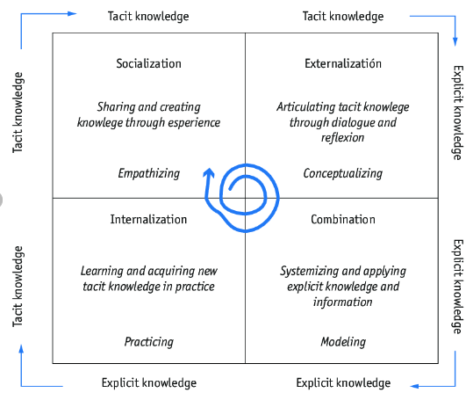
Figure 1: SECI model of knowledge management
(Source: Uniyal et al, 2021)
On the other hand, the knowledge management approaches of Costco have also implemented WIIG Model of knowledge management to manage the continuous learning activities within the organisation (Darmawan et al, 2021).
The WIIG Model is an effective model to support Knowledge management within an organisation as this model describes how organizational information is created and disseminated (Straccia et al, 2023). The WIIG Model consists of four different stages:
Building knowledge- This process supports the transformation of knowledge from external and internal sources that include both tacit and explicit knowledge.
Holding knowledge- This process supports Costco managers in effectively storing the organizational information in specific formats (De Bem Machado et al, 2022). Therefore, the managers can share their knowledge with the organisational people through training and developmental programs.
Pooling knowledge- This process ensures using the appropriate Knowledge Management systems to ensure knowledge sharing through cross-talk between organizational employees.
Applying knowledge- This step includes the practical application of the knowledge and experience gained by the individuals of Costco for making better performance in their job role (Ammirato et al, 2021).
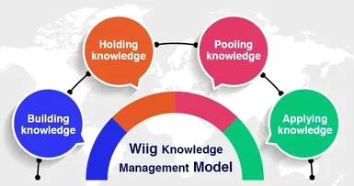
Figure 2: Wiig model of knowledge management
(Source: De Bem Machado et al, 2022)
According to Wiig's model of knowledge management, by successfully implementing this model, Costco can make use of quality knowledge to support better organizational performance (Pribadi et al, 2021). It also highlights the organizational need for effective organisational communication, employee collaboration, and organizational learning to leverage organizational knowledge with more accuracy.
Analysing the Costco Knowledge management approaches, this has been understood that the managers of Costco pay great attention to the effective sharing of knowledge and information to support the better learning initiatives for its employees. In this regard, Costco managers follow several ways (costco, 2024).
- Costco employees are provided with online training programs to support their understanding of handling the different software used in the operations.
- Costco employees are provided with the necessary training to handle the project management software to make successful project outcomes of its retail operations (costco, 2024).
- For effective knowledge sharing, Costco uses a shared digital white board, where each team member can easily collaborate with each other. This digital online whiteboard allows the team members of the firm to make notes to share, brainstorm maps and more (costco, 2024).
- There is also a chat platform available to Costco employees that supports the employees to chat with the team for sharing information. This in turn can support better collaboration among the employees for better organisational team performance (Demchig, 2020).
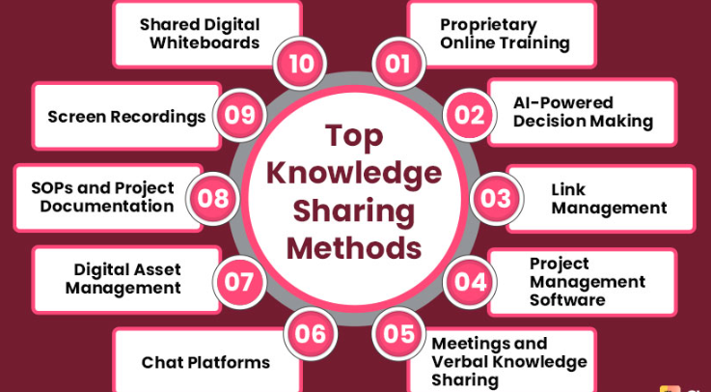
Figure 3: Knowledge sharing method within Costco
(Source: Demchig, 2020)

4) The incentives to participate in KM activities with an explanation of why it is important for the company to invest in the Knowledge project.
The practice of knowledge management and sharing has helped Costco to gain several benefits in its organisational performance. These are as follows
- The approach Knowledge Management system has enabled Costco to focus on the preservation of organisational knowledge (Appel-Meulenbroek and Danivska, 2022). This has been done through the appropriate and continuous transformation of knowledge and information among the employees. Therefore the firm became capable of preserving the previous knowledge and information exchange system within the organisation.
- The Knowledge Management system has also helped the firm Costco to effectively create a collaborative knowledge-sharing procedure (Demirbag, et al, 2021). In this regard, the organisational managers always motivate the employees to share their personal knowledge and experiences with the other and this has made the process easier to support the collaboration for sharing knowledge between the organisational individuals.
- The appropriate knowledge management increases the capability of the organisation to make the appropriate decision for any business situation (Demchig, 2020). Using the appropriate learning business environment, the Costco manager became capable of making effective decisions on product pricing.
For instance, Costco is 30% cheaper than Tesco, Asda, and Morrisons. (theguardian, 2022). At the same time, Costco is greatly recognised for its low rates and dedicated consumers who are ready to pay at least $60 per year in membership fees. The wholesaler offers some of the lowest rates anywhere, particularly on its Kirkland Signature store brand items (costco, 2024).
- For Costco, knowledge management has also helped the organisational managers to support better efficiency in business operations by gathering knowledge regarding business efficiency.
For instance, by continually providing customers with quality goods and services at the lowest possible prices, the firm has become very efficient in gaining customer loyalty (costco, 2024).
- The effective knowledge management system has enabled Costco to develop an appropriate strategy for competitive advantage (Pribadi et al, 2021). This is due to the high market analytical knowledge of its managers and this has helped the firm to make innovations in its product offering.
For instance, Costco's hidden weapon is its membership programme. With over 55 million members globally and a 90% renewal rate, Costco has mastered consumer loyalty. Unlike typical stores, Costco's revenues are mostly derived from membership fees rather than product sales (costco, 2024).
- The effective learning and knowledge management system has enabled Costco leaders to maintain quality CRM processes.
For instance, Costco offers a generous return policy and great customer service by keeping the products sold to products that are not liked by the customers (costco, 2024).
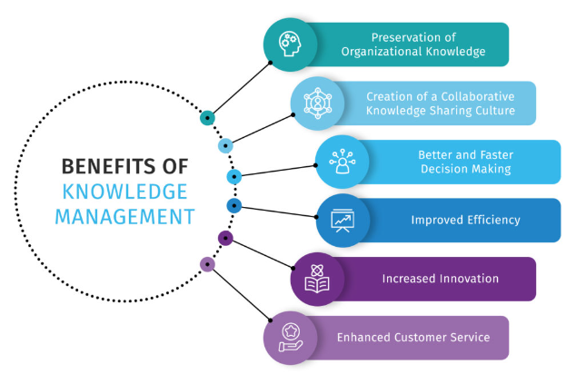
Figure 4: Benefits gained by Costco by effective knowledge management
(Source: Pribadi et al, 2021)
Furthermore,
- Effective knowledge management practices help the individuals of Costco to make better-informed decisions by effectively understanding the complex organizational concept (Straccia et al, 2023). This in turn helps the managers of the firm to solve the organizational problems with more accuracy.
- At the same time, the Organisational Knowledge approach offers Costco an opportunity to understand the knowledge requirements. This in turn ensures the organisation with a sound delivery of sustainable business development (Uniyal et al, 2021).
- Knowledge management, on the other hand, allows Costco managers to gain better innovation to have better access to best organizational practices.

5) The potential challenges and opportunities related to maximising the use of the KM system
There is a list of challenges and opportunities included with the implementation of the Knowledge management system. These are as follows
Challenge 1-Outdated technology
In most cases, the organisational fails to implement the updated knowledge management software that can support the effective sharing of knowledge and information among the organisational employees (Di Vaio et al, 2021). This in turn leads to poor sharing of knowledge within the organisational individuals.
Opportunity
In order to avoid the issue of outdated knowledge management technology the business may employ innovation to support better storing, processing and sharing knowledge between the organisational individual. In this regard, the firm may choose Knowmax, Google Workspace, Confluence and so on for a quick knowledge and information-sharing perspective.
Challenge 2: Lack of time
In some cases, the organisational managers and employees are provided with heavy work pressure and they are available with a lack of time to spend on knowledge and information management (Appel-Meulenbroek and Danivska, 2022). This in turn reduces the efficiency of the learning organisation and therefore the firm may face the issue of poor organisational performance.
Opportunity
The managers and the employees need to have an appropriate schedule for knowledge and information sharing which can deliver quality outcomes for the learning organisations.
Challenge 3-Resistance to organizational change
In most cases, employees of the organisations are comfortable with their own knowledge-sharing techniques and systems (De Bem Machado et al, 2022). In these cases, the employees feel hesitant to adopt new methods as there is resistance to organizational change.
Opportunity
The organisational leaders need to focus on flexibility within the knowledge management system which is very necessary to support the change management process and get suited to the changed organisational environment (Darmawan et al, 2021)
Challenge 4: Inaccessible information
In some cases, the knowledge and information might be available. However, employees have trouble accessing it. This kind of issue occurs because of a non-intuitive structure of knowledge sharing and transferring. Therefore, the employees become unable to properly access information they stop using Knowledge Management (Lam, et al, 2021). This in turn decreases the employee's ability to learn and knowledge sharing.
Opportunity
In this case, the organisational manager needs to be very careful regarding the effective access of the employees to the information base, otherwise, this is not possible to manage the flow of knowledge between the different organisational individuals (Tran et al, 2022). Therefore the organisational employees face the issue of poor performance due to poor knowledge and expertise.

6) How will new sources of knowledge be identified and distributed to business partners, clients and other stakeholders
In order to successfully identify and distribute new products and services offered by Costco to the clients, an effective marketing process is needed. Recently, Costco has added Coffee Machines & Accessories to its retail service (costco, 2024). In this regard, the organisational leaders can use their marketing knowledge to develop an innovative marketing strategy for promoting the product to the target clients. The marketing process involves
Social media marketing- Costco can use social media marketing to promote its new addition of Coffee Machines & Accessories to the target clients. This would be very cost-effective for the firm to make advertising the product (Demchig, 2022). On the other hand, in the current era use of social media can help the firm to improve its reach towards the target clients.
Email marketing- Cost can also use email marketing to promote its Coffee Machines & Accessories to the customer base. This kind of marketing is also effective for personalized offering and therefore the managers of the firm would be capable of attracting the client base to use its services therefore the firm would be profitable by selling more Coffee Machines & Accessories (Darmawan et al, 2021).
Promotional marketing- In this process, Costco can promote direct marketing of its Coffee Machines & Accessories through its employees in the physical store. This process is very effective for the firm to describe the innovative features of its product to the customers to positively impact on the buying decision-making process of the customers (De Bem Machado et al, 2022).

7) How the operating costs and legal requirements will be managed
In order to promote the marketing of the recent services offered by Costco- Coffee Machines & Accessories, a limited cost is required. As the firm has chosen social media and email marketing for its promotional activities, there are very low resources needed by the firm to promote the product (Straccia et al, 2023). However, the firm needs to allocate resources for employees to support the direct promotional activities of the Coffee Machines & Accessories in the physical stores.
Furthermore, the firm needs to pay attention to government permission and legal licenses while bringing new products to its services. In order to launch the new product, the Costco leaders need to follow the rules of New product development (NPD) (Tran et al, 2022). According to NPD, the new product must meet the necessary technical requirements and this need to ensure the quality and safety requirements to be legalized in the nation (The budget is referred to Appendix).

8) Developing a plan to promote the KM system making all stakeholders beware of the system and helping them to make the best use of it.
In order to improve the promotion of the Knowledge Management system, Costco can pay attention to several steps. These are as follows
Step 1: Establish Knowledge Management Program Objectives | In this step, the Costco managers need to set clear objectives to promote a betterment of the organisational KM system
Step 2: Prepare for Change | In this step, the organisational manager needs to inform the employees to be prepared for the changed organisational initiatives which include knowledge management and knowledge-sharing activities (Darmawan et al, 2021)
Step 3: Define a High-Level Process as a Foundation | In this step, the Costco managers need to focus on laying out a high-level knowledge management process. This is a very important part of the effective implementation of the KM system within the firm. Beginning with this high-level process of knowledge management can help the Costco manager to develop detailed procedures throughout the different steps of implementing the KM system (Ammirato et al, 2021).
Step 4: Determine and Prioritize Technology Needs | In this sage, Costco managers need to focus on successfully determining the technological implications and need to use the best technology (Knowmax, Google Workspace, Confluence)for quick and successful knowledge management perspectives for the organisation. This can support the effective sharing and transform of knowledge and information among the organisational individuals (Lam et al, 2021).
Step 5: Assess Current State | After establishing the knowledge management program objectives, the organizational manager needs to be prepared for cultural changes, so that the manager of the firm can assess the current state of knowledge management within Costco with more accuracy (Appel-Meulenbroek and Danivska, 2022).
Step 6: Build a Knowledge Management Implementation Roadmap | This step considers having an appropriate strategy for overcoming the shortcomings of knowledge management activities. This process is very important for in gaining leadership's support to find the best way to implement the necessary knowledge management process. This strategy must highlight specific gaps identified in the knowledge assessment and the effective solutions to handle those gaps (Pribadi et al, 2021).
Step 7: Implementation | This step involves the practical implementation of the KM system through holding meetings, group discussions or informal employee gatherings. In these steps, the managers of Costco need to ensure that there is an effective flow of knowledge sharing to support positive organisational performance (Darmawan et al, 2021).
Step 8: Measure and Improve the Knowledge Management Program | This process includes the monitoring phase. Here the managers of Costco need to ensure that, there is a well-established KM system within the organisation which can support the effective organisational knowledge sharing and experience of the employees. Through the monitoring process, the manager of the firm needs to pay attention to the areas for further improvement to make the employees more efficient with their knowledge and expertise (Appel-Meulenbroek and Danivska, 2022).

CONCLUSION
Analysing the above study this can be concluded that for successful performance management as well as effective business operations, business organisations need to pay attention to strategic KM approaches. In this regard, the business managers of Costco can focus on the strategic KM approaches along with better adoption of the SECI model and WIIG model to support the learning environment within the business organisation. However, there are always some challenges faced by the organisational managers to implement the Knowledge management system within the organisation. Therefore the manager can pay attention to the allocation of resources and use of software to conduct employee training and discussion programs to support better KM approaches within the organisation. This in turn can help the firm to enjoy better knowledge and expertise of the employee to ensure quality performance of the firm.

References
Report
Ammirato, S., Linzalone, R. and Felicetti, A.M., 2021. Knowledge management in pandemics. A critical literature review. Knowledge Management Research & Practice, 19(4), pp.415-426.
Appel-Meulenbroek, R. and Danivska, V., 2022. A handbook of management theories and models for office environments and services (p. 270). Taylor & Francis.
costco (2024). COMMERCE BUSINESS REPORT.Available at:https://costco-business-report-courtneyt.weebly.com/the-history-of-costco---a-timeline.html
Darmawan, A.K., Setyawan, M.B., Cobantoro, A.F., Masykur, F., Anwari, A. and Yulianto, T., 2021, August. Knowledge Management System Analysis of Smart Regency Mobile-Apps Service with Software Usability Measurement Inventory (SUMI) Approach. In 2021 International Conference on ICT for Smart Society (ICISS) (pp. 1-6). IEEE.
De Bem Machado, A., Secinaro, S., Calandra, D. and Lanzalonga, F., 2022. Knowledge management and digital transformation for Industry 4.0: a structured literature review. Knowledge Management Research & Practice, 20(2), pp.320-338.
Demchig, B., 2020, October. A holistic conceptual model of organizational knowledge management maturity. In International Conference on Intellectual Capital and Knowledge Management and Organisational Learning (pp. 142-150). Academic Conferences International Limited.
Demirbag, M., Apaydin, M. and Sahadev, S., 2021. Micro-foundational dimensions of firm internationalisation as determinants of knowledge management strategy: A case for global strategic partnerships. Technological Forecasting and Social Change, 165, p.120538.
Di Vaio, A., Palladino, R., Pezzi, A. and Kalisz, D.E., 2021. The role of digital innovation in knowledge management systems: A systematic literature review. Journal of business research, 123, pp.220-231.
Lam, L., Nguyen, P., Le, N. and Tran, K., 2021. The relation among organizational culture, knowledge management, and innovation capability: Its implication for open innovation. Journal of Open Innovation: Technology, Market, and Complexity, 7(1), p.66.
linkedin (2023). Emphasizing Employee Training and Development. Available at:https://www.linkedin.com/pulse/costco-approach-key-lessons-people-management-bendoraityte-
Pribadi, K.S., Abduh, M., Wirahadikusumah, R.D., Hanifa, N.R., Irsyam, M., Kusumaningrum, P. and Puri, E., 2021. Learning from past earthquake disasters: The need for knowledge management system to enhance infrastructure resilience in Indonesia. International Journal of Disaster Risk Reduction, 64, p.102424.
Straccia, L., Pollo-Cattaneo, M.F. and Maulini, A., 2023, June. Knowledge management model: A process view. In International Conference on Computational Science and Its Applications (pp. 599-616). Cham: Springer Nature Switzerland.
theguardian (2022). Cash and carry stores: can buying in bulk cut your shopping bills?. Available at:https://www.theguardian.com/money/2022/oct/08/cash-and-carry-stores-buying-in-bulk-shopping-bills-costco-booker-deals#:~:text=Conclusion%20Costco%20is%2030%25%20cheaper,everyday%20groceries%20and%20household%20goods.&text=Costco%20%C2%A36.49%20(minimum%20purchase,Asda%20%C2%A36.
Tran, H.T., Santarelli, E. and Wei, W.X., 2022. Open innovation knowledge management in transition to market economy: Integrating dynamic capability and institutional theory. Economics of Innovation and New Technology, 31(7), pp.575-603.
Uniyal, S., Mangla, S.K., Sarma, P.R., Tseng, M.L. and Patil, P., 2021. ICT as “Knowledge management” for assessing sustainable consumption and production in supply chains. Journal of Global Information Management (JGIM), 29(1), pp.164-198.

Appendix
Operating cost estimation for implementing technology-based KM approach by Costco
Particulars | Monthly Costs (£) | Annual Costs (£)
Fixed Costs | - | -
- Cost of Premises (Quarterly) | £5,000 | £60,000
- Insurance | £500 | £6,000
- License and Permits | £750 | £9,000
- Technology | £500 | £6,000
- Contingency Cost | £750 | £9,000
Total Fixed Cost (A) | £7,500 | £90,000
Running Costs | - | -
- Equipment | £1,500 | £18,000
- Communication channel | £750 | £9,000
- Utility and Setup | £1250 | £15,000
Total Running Cost (B) | £3,500 | £42,000
Total Fixed and Running Costs (A+B) | £11,000 | £1,32,000

