
April 26, 2026
henry chilaka
Lecturer: Rebecca Francia-Davis

programme: MA leadership
Module: Developing People in Organisation-



Contents
Executive Summary 1
1. Introduction and Scope 2
2. Analysis 3
2.1. Strategic Workforce Challenges in AI Adoption 3
2.2. Leadership and Change Management in AI transformation 4
2.3. Learning, Development and Organisational Culture 5
2.4. Ethical, Governance and Workforce Implications 7
3. Recommendations 7
4. Conclusion 8
References 9

Executive Summary
The report assesses the potential of cancer Research UK (CRUK) to adopt a strategic workforce plan to emerge as an AI-powered organisation, as per the ambition of the UK to be a leader in the field of AI. The report finds that the main workforce issues are the absence of digital skills, job redesign, ethical issues, and change resistance. Relying on theoretical frameworks including the Resource-Based View (VRB), the Human Capital Theory, and Lewin’s Change Model, the report demonstrates the leadership potential and people development should be the focus of the successful introduction of the AI instead of the technology. Indeed, these findings have highlighted the importance of specific reskilling, strategic talent acquisition, and the creation of an inclusive and learning-based organisational culture. Moreover, accountable AI utilization and ethical administration are essential in ensuring the confidence of the stakeholders in a healthcare scenario. Based on the analysis, the report suggests four strategic recommendations to make CRUK develop sustainable organisational capability and provide better research and societal outcomes; that is, the development of skills, relent management, governance, and change leadership.

1. Introduction and Scope
Cancer Research UK (URUK) is among the largest independent cancer charities globally, and it funds cancer research, affects policy and offers public health awareness across the UK (Cancer Research UK, 2024). CRUK has its operations in a knowledge and mission-driven environment with more than 400 million invested every year on research and a workforce that includes scientists, clinicians, fundraisers, retail and data professionals (Cancer Research UK, 2025). Artificial intelligence (AI) has a strategic value at the organisation as it is becoming increasingly digital and is driven by its 2033 data strategy to have greater focus on genomics, clinical trials, and data analytics (CRUK, 2025). The changing environments that dictate the workforce strategy of CRUK indicate swift changes in the technology environment, regulations, and society. The plans to develop the UK into an AI superpower (Macaskill and Sandle, 2025) by the UK government and investments of the NHS in AI-based diagnostics (e.g., early cancer detection tools) indicate increased expectations that charities are supposed to utilise the newest technologies. Furthermore, PwC (2024) reports that already 57% of UK employees consider genitive AI as an opportunity, which increases the competition for digital and AI talent. Legally and ethically, GDPR compliance, patient data governance, and algorithmic bias are essential issues in healthcare,
Table 1: PESTELE. Cancer Research UK
Factor | Key Position
Political | - Uk governance AI strategy (2025) promotes AI adoption in healthcare (Macaskill and Sandle, 2025)  - NHS support for AI-driven diagnostic increases expectations on charities like CRUK (DHSC, 2026)
Economy | - Raising competition for AI talent in the UK labour market increases recruitment costs (PwC, 2024)  - Funding pressure on charities requires cost-efficient digital transformation
Social | - Growing public trust concerns around AIU in the public sector, including healthcare (Nesta, 2025)  - Increasing in demand for improved cancer outcomes and personlised treatments (DHSC, 2026)
Technology | - Rapid advancement in AI (e.g., machine learning in cancer detection, genomics) (Fountzilas et al., 2025)  - Need for continuous workforce upskilling and digital capacity development.
Legal | - Compliance with UK GDRP, data protection laws, and ethical use of patient data  - Accountability for algorithmic decisions
Environmental | - Alignment with CRUK’ broader social responsibility goals

Internally, CRUK experiences gaps in capability related to AI literacy, interdisciplinary teams integration and limitations under the 2023 guidance for the use of generative AI in research (Cancer Research Uk, 2023). From the perspective of the resource-based view (RB) by Barney (1991), human capital, specifically data scientists, clinicians, and digital skilled employees, is one of the most important assets of the long-term competitive advantage. Therefore, this report is concerned with the ability of strategic leadership to build the workforce capacity, culture, and organisational system to facilitate the switching to an AI-driven organisation and be ethically upright and trusted by the populace.

2. Analysis

2.1. Strategic Workforce Challenges in AI Adoption
The reorganization into an AI-driven organisation poses a complicated workforce issue to CRUK, which includes skills gaps, workforce planning, and job redesign issues. PwC (2025) asserts that when organisations implement AI, jobs and necessary skills must be re-evaluated, automation and augmentation transform the structure of the tasks. The research groups of CRUK, including the Breton and Markowetz Group, are actively Group, and are actively applying AI to cancer imaging, drug discovery for cancer, and predictive analytics (CRUK, 2024). Nevertheless, a lot of existing positions, especially the ones related to fundraising and retail operations, as well as administration, are not yet customised to the workforces involving AI.
According to the human capital theory lens, organisational productivity depends on the investment in the skills of employees (Mekuri-Ndimele, 2022). CRUK stands in a twofold bind of not only recruiting high-priced AI experts into the market but also shifting the skill base of current employees. The AI labour Market Survey 2025 report showed that the UK AI market is typified by major skills shortages where there is more demand for data scientists and AI engineers that there are available, with private tech companies attracting most talent (DSIT, 2026). Workforce segmentation also adds to this difficulty. The HR architecture model by Lepak and Snell (1999) proposes that organisations should take differentiated HR approaches, depending on how employees are valued and unique (Figure 1). In the case of CRUK, core knowledge workers (e.g., researchers and data scientists) need long-term investment and relation approaches, whereas peripheral jobs can need reskilling so that they can be viable in an AI-enabled world. Failure to do this segmentation may give rise to imbalances in capabilities and poor organisational performance.
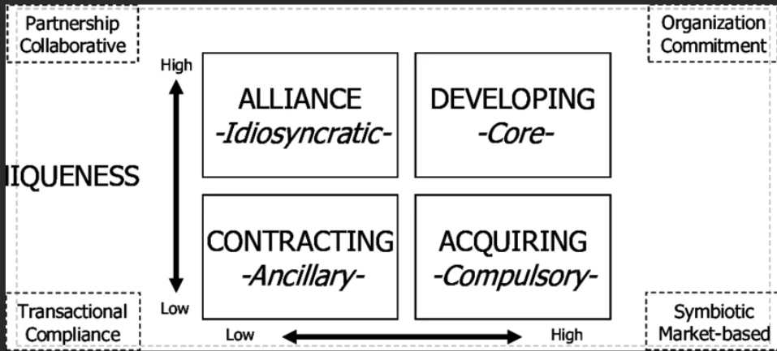
Figure 1: HR architecture model
Source: Cornachione Jr (2010)- adapted from Lepak & Snell (1999)
Moreover, job redesign is necessary. Using the lens of the Hackman-Oldham job Characteristics Model (Siruri and Cheche, 2021), there is a potential that AI integration will increase task variety and autonomy but decrease task identity in some jobs, which can lead to employee motivation. For example, automated data processing in research can decrease manual processing, but demands a higher level of analysis (Adrita et al., 2021), which requires redesigning the roles to ensure engagement and purpose.

2.2. Leadership and Change Management in AI transformation
Implementation of AI at CRUK has been and will be more of a leadership problem than a technical one. The Three-step change Model created by Lewin (1951) can be used to comprehend the transformation process (Figure 2). Before CRUK leadership can create and realise new mindsets, it will have to unfreeze the current mindsets by associating the use of AI with better cancer outcomes and operational efficiency. This is especially relevant where an organisation is driven by purpose and does not focus on profit but on employees with a mission to accomplish.
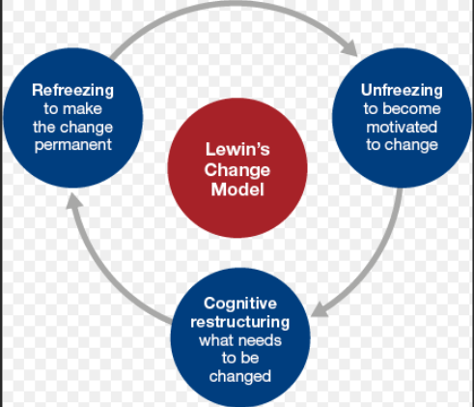
Figure 2: Lewin’s Three-Step Change Model
Image source: Leadership Centre (2023)
In this regard, transformational leadership (TL) style comes particularly in handy. As per Khirfan et al. (2024), under TL style, the leaders must create a common vision of how AI can contribute to the research impact and patient outcomes, as well as overcome concerns about job loss. Usman (2020) argued that leaders should be visionary, supportive, and considerate of individuals to motivate employees to accept change. Nevertheless, change resistance is still a major challenge. In CRUK, opposition can be based on ethical issues, digital confidence, and perceptions of endangered professional identity, especially in the face of clinicians and researchers having doubts about algorithmic decision-making. Further, distributed leadership plays a vital role in an orgainsation such as CRUK, which is complex. According to Berraies, Hamza and Chtioui (2021), such leaders will insist on sharing decisions within the team so that they can collaborate and innovate. The implementation of AI involves a cross-functional team comprising the data scientists, clinicians, and operational personnel. Also, issues of ethics need to be considered by the leadership. The CIPD (2023) prioritises responsible AI usage, such as transparency, fairness, and accountability. Ethical leadership plays a critical role in ensuring that the population enjoys trust in a healthcare setting. This conforms to the stakeholder theory that focuses that organisations juggle the interests of various parties, including the patient, doners, the employees and the regulating bodies (Jose and Venkitachalam, 2019)

2.3. Learning, Development and Organisational Culture
Creating an AI-enable workforce requires a methodical decision of learning and development (L &D). It is especially pertinent to the learning organisation notion with its insistence on never-ending learning, sharing of knowledge, and flexibility (Rupcic, 2020). In the case of CRUK, a culture of lifelong learning should be promoted, because this group of employees should be operating under the current technological conditions. The training of digital skills should not be limited to technical skills should cover data literacy, critical thinking, and Technological Literacy as some of the most needed skills globally (Masterson, 2023) (Figure 3). CRUK should, therefore, adopt focused training programmes applicable to various groups of employees, which will include rudimentary training on digital awareness among the retailing staff to advanced training on AI among the researchers.

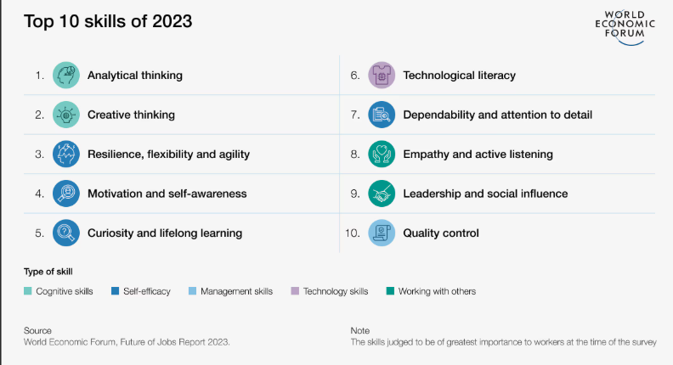
Figure 3: Key skills as of 2023
Image source: Masterson (2023)
According to experimental Learning Theory, learning can be best achieved with practical experience (Morris, 2020). CRUK can leverage this theory by introducing pilot projects involving AI that would enable employees to gain knowledge through experience. This, too, can be compared to the principle of learning through doing, which does not work very well in non-technical environments due to their complex nature. Moreover, the organisational culture is also an important part of the underlying assumptions and values. CRUK needs to promote an organisational culture of innovation without compromising ethics. The role of psychological safety (Edmondson and Bransby, 2023) is especially essential, as the staff should be ready to feel safe to explore new technology without being afraid of failure.
Nevertheless, it poses a chance of digital disparity among the workforce. Less skilled employees in digital skills will experience exclusion or fear over the use of AI. This is congruent with CIPD (2023b) fears on making sure that ‘no one is left behind’. Individual training and mentoring are some of the inclusive learning strategies that are imperative.

2.4. Ethical, Governance and Workforce Implications
The application of AI in CRUK presents important ethical and governance issues, especially concerning the privacy of data, bias, and accountability. Application of patient information in AI solutions should adhere to UK GDPR and NHS Data Governance regulations (Olawade et al., 2025). Any failure to maintain data security would lead to loss of image and credibility. Another important issue is algorithmic bias. Ferrara (2024) found that AI systems can reinforce the current unjustness when trained with one-sided data through what is known as the ‘butterfly effect’. Under a health care setting, this can result in skewed treatment outcomes, which are very much an ethical concern. CRUK should hence adopt sound governance systems to bring about fairness and transparency. Moreover, potentially, AI will cause job displacement in some jobs and create job opportunities in others (Kumar, 2025). This conforms with the nation of creative destruction (Robra et al., 2023). Strategic workforce planning needs their aim at redeployment and reskilling, and not redundancy. The AMO model (Ability, Motivation Opportunity) by Appelbaum et al. (2000) offers a practical prism through which it is possible to view the performance of the workforce in the context of AI. CRUK needs to ensure that employees possess the required skill (ability), are encouraged to implement AI (motivation), and given a chance to utilise novel skills (opportunity). Any of these dimensions might be compromised by failure to address them, and as a result, negatively affect the effectiveness of adoption AI adoption.

3. Recommendations
The following strategic workforce interventions are suggested to allow CRUK to become an organisation powered by AI. First, CRUK needs a CRM based on an AI skills development programme for workforce segmentation. Foundational AI literacy should be incorporated for every employee, whereas intermediate data skills will fit the operational employee categories, and advanced AI training will be applied to research and technical workers. This conforms with the Human Capital Theory and ensures development in capability bin the long-term (Obiekwe, 2018. Collaboration with the UK institutions (e.g., NHS AI Lab, universities) would allow us to increase the quality of the training and minimise expenses. Second, CRUK should take a strategic approach to recruiting and retaining AI specialists. With the shortage of labour in the market, CRUK should consider focusing on its mission-centred value proposition to draw in talent, which offers flexible work, autonomous research and purpose-driven careers. This depicts the Resource-Based View (RBV) (Barney, 1991), and places human capital as a strategic resource. Third, CRUK needs to create a sustainable AI governance model that entails ethics, data security policies, and responsibility models. This will entail cross-functional ethics committees and frequent audits of the AI systems to make sure they comply with the regulations and agency expectations. The recommendations relates to the stakeholder theory and the focus CIPD on ethical AI (CIPD, 2024). Fourthly CRUK should adopt change leadership and a cultural transformation programnme, align with TL style as Gyanamurthy and Radhanath (2023) assert. This must involve leadership training, communication strategy, and employee engagement programme to minimise resistance and create a culture of innovation. By incorporating psychological safety and cases of inclusion, workforce alignment will be guaranteed to organisational objective.
Table 2: Estimated cost for the suggested recommendations
Recommendation | Key Activities | Approx. annual cost (£)
AI skills Development Programme | Training modules, partnerships, digital Platforms | £1.2 million
Talent Acquisition Strategy | Recruiting campaigns, employer branding, incentives | £800,000
AI Governance Framework | Compliance systems audit, ethics committees | £500,00
Change Leadership Programme | Leadership training, workshops, and communication tools | 400,000
Total Estimated Cost |  | £2.9 million

4. Conclusion
This report shows that good workforce planning should not only entail solving the skills gaps, but also tackle the organisational culture, ethical issues and leadership potential. The implementation of AI in the operations of CRUK must take a holistic perspective that connects the development of the workforce with orginsational purpose and expectations of the stakeholders. The implementation of ideas like the RBV and the Human Capital Theory ensures that there is a need to invest in individuals as a means of achieving sustained competitive advantage. Similarly, change management model, specifically the one offered by Kotter, also highlights that leadership is a key factor that drives the change and the elimination of resistance. In the absence of good leadership and a strategic vision, AI projects are bound to fail to produce a meaningful impact. Finally, the capacity to utilise AI successfully in CRUK will be based on its capability of developing an all-inclusive, learning-based, and ethical organisational culture. Focused workforce planning solution and the culture of innovation and collaboration will help CRUK increase its research opportunities, operational efficiency, and preserve the results in terms of saving lives in an ever-more digitalized healthcare setting.

References
Adrita, M.M., Brem, A., O’Sullivan, D., Allen, E. and Bruton, K. (2021) ‘Methodology for data-informed process improvement to enable automated manufacturing in current manual processes’, Applied Sciences, 11(9), p. 3889.
Appelbaum, E., Bailey, T., Berg, P. and Kalleberg, A.L. (2000) Manufacturing advantage:, NY: Cornell University Why high-performance work systems pay off. Ithaca Press.
Barney, J. (1991) ‘Firm resources and sustained competitive advantage’, Journal of Management, 17(1), pp. 99–120.
Berraies, S., Hamza, K.A. and Chtioui, R. (2021) ‘Distributed leadership and exploratory and exploitative innovations: Mediating roles of tacit and explicit knowledge sharing and organizational trust’, Journal of Knowledge Management, 25(5), pp. 1287–1318.
Cancer Research UK (2023) Research with integrity – What you need to know about generative AI. Available at: https://news.cancerresearchuk.org/2023/11/07/research-with-integrity-what-you-need-to-know-about-generative-ai/ (Accessed: 10 April 2026)
Cancer Research UK (2024) Cancer Research UK | The world’s leading cancer charity. Available at: https://www.cancerresearchuk.org/ (Accessed: 10 April 2026).
Cancer Research UK (2025) Our role in beating cancer globally. Available at: https://www.cancerresearchuk.org/about-us/global-role (Accessed: 10 April 2026).
CIPD (2023a) HR should lean into AI and drive principles about ethical and responsible use to ensure a just and fair transition. Available at: https://www.cipd.org/en/about/press-releases/ai-use-hr-teams-responsible-ethical/ (Accessed: 10 April 2026).
CIPD (2023b) Devolution and evolution in UK skills policy. Available at: https://www.cipd.org/globalassets/media/knowledge/knowledge-hub/reports/2023-pdfs/2023-devolution-evolution-skills-report-8483.pdf (Accessed: 10 April 2026).
CIPD (2024) CIPD to develop principles and guidance for safe and ethical use of AI in the workplace. Available at: https://www.cipd.org/en/about/news/cipd-guidance-ai-in-workplace/ (Accessed: 10 April 2026)
Cornachione Jr, E.B. (2010) ‘Investing in human capital: Integrating intellectual capital architecture and utility theory’, Journal of Human Resource and Adult Learning, 6(1), p. 29.
CRUK (2024) Artificial intelligence – Cancer Research UK Cambridge Institute. Available at: https://www.cruk.cam.ac.uk/research-themes/artificial-intelligence/ (Accessed: 10 April 2026).
CRUK (2025) Big data and cancer – Our greatest obstacles present a real opportunity. Available at: https://news.cancerresearchuk.org/2025/04/23/big-data-and-cancer-our-greatest-obstacles-present-a-real-opportunity/ (Accessed: 10 April 2026).
DHSC (2026) Three in four cancer patients to survive long term under new plan. Available at: https://www.gov.uk/government/news/three-in-four-cancer-patients-to-survive-long-term-under-new-plan (Accessed:10 April 2026).
DSIT (2026) AI Labour Market Survey 2025 report: Executive summary. Available at: https://www.gov.uk/government/publications/ai-labour-market-survey-2025-report/ai-labour-market-survey-2025-report-executive-summary (Accessed: 10 April 2026).
Edmondson, A.C. and Bransby, D.P. (2023) ‘Psychological safety comes of age: Observed themes in an established literature’, Annual Review of Organizational Psychology and Organizational Behavior, 10(1), pp. 55–78.
Ferrara, E. (2024) ‘The butterfly effect in artificial intelligence systems: Implications for AI bias and fairness’, Machine Learning with Applications, 15, p. 100525.
Fountzilas, E., Pearce, T., Baysal, M.A., Chakraborty, A. and Tsimberidou, A.M. (2025) ‘Convergence of evolving artificial intelligence and machine learning techniques in precision oncology’, npj Digital Medicine, 8(1), pp. 1-10.
Gyanamurthy, V. and Radhanath, S. (2023) ‘Leading change in the AI era: Strategies for transformational leadership’, International Journal of Advanced Engineering Technologies and Innovations, 1(4), pp. 164–184.
IEA (2025) Energy demand from AI. Available at: https://www.iea.org/reports/energy-and-ai/energy-demand-from-ai (Accessed: 18 March 2026).
Jose, S. and Venkitachalam, K. (2019) ‘A matrix model towards CSR – moving from one size fit approach’, Journal of Strategy and Management, 12(2), pp. 243–255.
Khirfan, R., Kotb, H., Atiyeh, H., Khalifah, A., Al Hasan, N. and Abdelalla, S. (2024) ‘Exploring the influence of transformational leadership on nurses’ intentions towards artificial intelligence utilization in non-AI implemented hospitals’, Research Journal of Pharmacy and Technology, 17(11), pp. 5469–5479.
Kumar, A. (2025) Why AI is replacing some jobs faster than others. Available at: https://www.weforum.org/stories/2025/08/ai-jobs-replacement-data-careers/ (Accessed:10 April 2026).
Leadership Centre (2023) Lewin’s model of change. Available at: https://www.leadershipcentre.org.uk/artofchangemaking/theory/lewins-model-of-change/ (Accessed: 10 April 2026).
Lepak, D.P. and Snell, S.A. (1999) ‘The human resource architecture: Toward a theory of human capital allocation and development’, Academy of Management Review, 24(1), pp. 31–48.
Lewin, K. (1951) Field theory in social science: Selected theoretical papers. New York: Harper & Row.
Macaskill, A. and Sandle, P. (2025) ‘Prime Minister Starmer plans to make Britain AI “superpower”’, Reuters, 13 January. Available at: https://www.reuters.com/world/uk/uk
pm-starmer-outline-plan-make-britain-world-leader-ai-2025-01-12/ (Accessed: 10 April 2026).
Masterson, V. (2023) Future of jobs: These are the most in-demand core skills in 2023. Available at: https://www.weforum.org/stories/2023/05/future-of-jobs-2023-skills/ (Accessed: 10 April 2026).
Mekuri-Ndimele, J.A. (2022) ‘Assessing human capital development and employee performance in organisations’, BW Academic Journal, pp. 7–7.
Morris, T.H. (2020) ‘Experiential learning – A systematic review and revision of Kolb’s model’, Interactive Learning Environments, 28(8), pp. 1064–1077.
Nesta (2025) Less than half of the UK public trust the public sector to use AI responsibly. Available at: https://www.nesta.org.uk/press-release/less-than-half-of-the-uk-public-trust-the-public-sector-to-use-ai-responsibly-survey-finds/ (Accessed: 10April 2026).
Obiekwe, O. (2018) ‘Human capital development and organizational survival: A theoretical review’, International Journal of Management and Sustainability, 7(4), pp. 194–203.
Olawade, D.B., Weerasinghe, K., Teke, J., Msiska, M., Boussios, S. and Hatzidimitriadou, E. (2025) ‘Evaluating AI adoption in healthcare: Insights from information governance professionals in the United Kingdom’, International Journal of Medical Informatics, 199, p. 105909.
PwC (2024) UK workers look more favourably on AI as workloads increase. Available at: https://www.pwc.co.uk/press-room/press-releases/research-commentary/2024/uk-workers-look-more-favourably-on-ai-as-workloads-increase.html (Accessed:10 April 2026).
PwC (2025) Reinventing work, roles, and leadership. Available at: https://www.pwc.com/gx/en/issues/technology/beyond-automation.html (Accessed: 13 April 2026)
Robra, B., Pazaitis, A., Giotitsas, C. and Pansera, M. (2023) ‘From creative destruction to convivial innovation: A post-growth perspective’, Technovation, 125, pp. 102760.
Rupčić, N. (2020) ‘Learning organisation as technology for the socio-economic paradigm implementation’, International Journal of Agile Systems and Management, 13(2), pp. 182–212.
Schein, E.H. (2010) Organizational culture and leadership. Hoboken, NJ: John Wiley & Sons.
Siruri, M.M. and Cheche, S. (2021) ‘Revisiting the Hackman and Oldham job characteristics model and Herzberg’s two-factor theory’, European Journal of Business and Management Research, 6(2), pp. 162–167.
Usman, M. (2020) ‘Transformational leadership and organizational change: In the context of today’s leader’, International Business Education Journal, 13(1), pp. 95–107.

