Tamzyn briggs 1803883

surface pattern design

Word count: 1355

Tutor: Julia Lockhart

Abstract
[Draw your reader in with an engaging abstract. It is typically a short summary of the document.
When you’re ready to add your content, just click here and start typing.]
October 2018 was when my world got turned upside down. I lost my grandfather , and the man who raised me from the age of 3. Since then my life has changed completely , his stuff remains in the house untouched.

My exhibition will be in a bird garden,with birds chirping in the background. In the exhibition there will be specific things he used every day and that hold a lot of memories now.
Every day he spoke about birds , he knew every bird by the sound of their chirping. We used to sit in the garden with binoculars and look at the forest next to our house watching all the birds.
He had an old blue flat cap that he never used to take off, the ugliest hat I’ve ever seen , so old and faded but he refused to buy a new one.
He would sit in the house in his arm chair , smoking his pipe watching animal documentaries.
I can remember from when I was young he used to wear a dark blue fleece that had a Dunlop logo embroidered into it, he used to make me spell “Dunlop “ for him, he would wear that in the house every day and when he used to go to the shed. I can remember him going somewhere nice and always polishing his black shoes before going, he was a smart man who always liked to dress smart out in public.

Frida kahalo was an artist that I took inspiration from as she turned her heartbreak into art. I would have some of her artwork in the exhibition
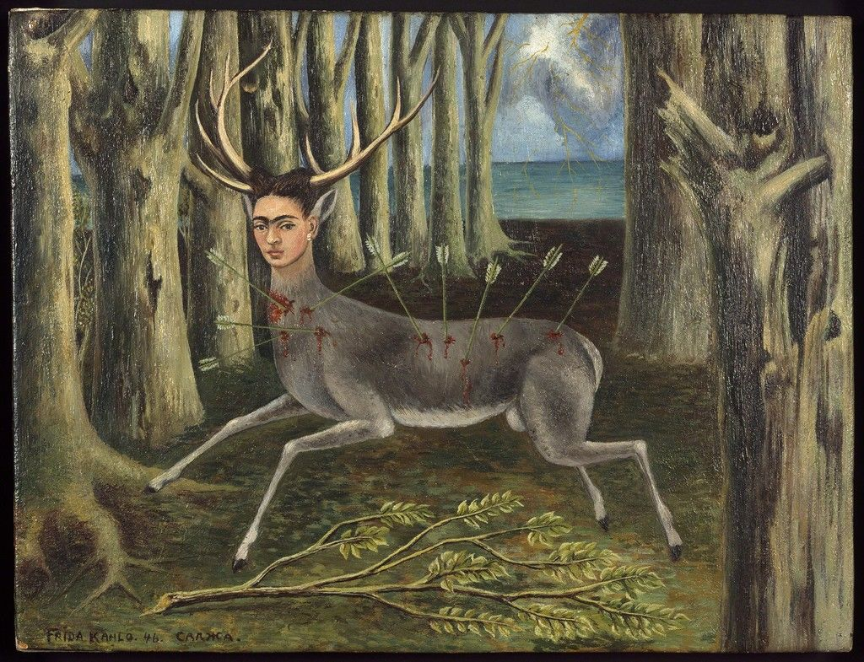
“I suffered two grave accidents in my life: one in which a streetcar knocked me down.…The other accident is Diego,” she is referring to her husband , Diego , as an accident because of their extremely volatile relationship. She was effected deeply by both the streetcar accident and her husband but she portrayed her pain through her painting and artwork.

Another artist that I took influence from is Felix Gonzalez-Torres.

He mounted the potent image on 24 billboards across New York city. The image shows and empty ,rumpled bed where it looks like 2 bodies had been laying. He made the work the same year as his partner , Ross Laycock, died from an aids related illness. The piece shows the grief of Gonzales-Torres , intimacy and loneliness. i feel like this relates a lot to me because the first night that I lost my grandfather I could hear my grandmother crying in bed alone, and knowing there was nothing I could do to fill that empty space that she is going to deal with for the rest of her life.
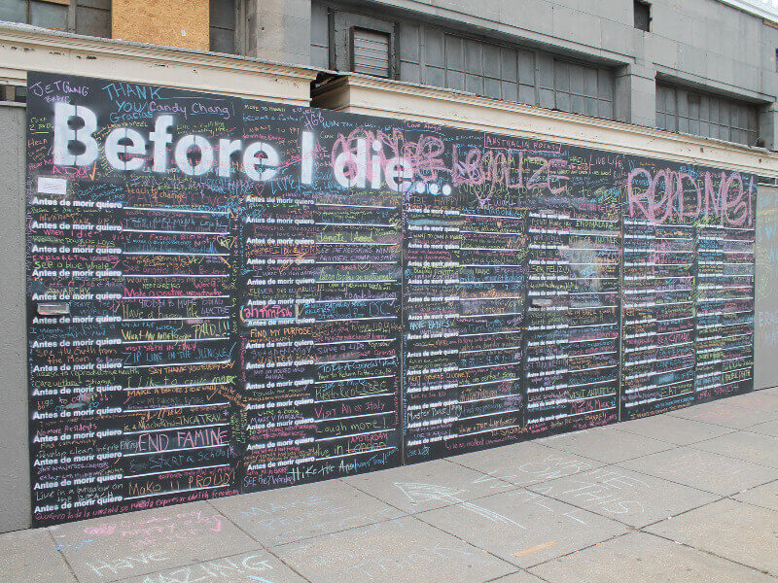

Another piece of art that will be in my exhibition is ‘before I die’ by Candy Chang. This is an ongoing participatory art piece where members of the public write their goals that they have before they die. She built the first ‘before I die’ wall in New Orleans after “the death of a loved one got her thinking about what matters in life”.
Since this wall there have been
over 2,000 walls in over 70 countries , created by the local community , where there’s a chance for passers by to share their life goals. I can relate to this a lot , after the death of my grandfather it got me thinking about what matters , I deeply regretted not spending enough time with him, or maybe I did but I felt like everything happened so fast. It made me realise that I need to cherish every moment I have with someone as one minute you’re laughing and talking to them but the next they might not be here.
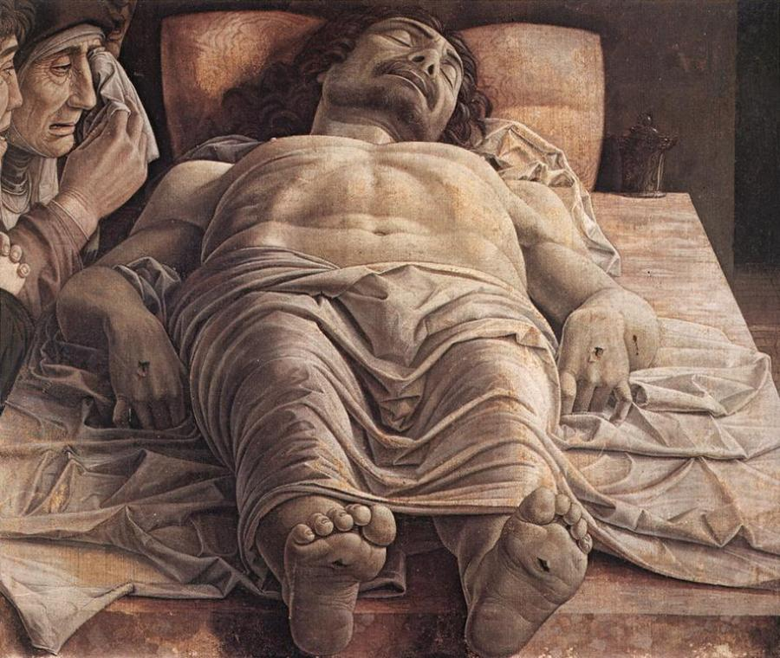
“lamentation of Christ” by Andrea Mantegna , is another piece of work that will be in my exhibition. This painting portrays the body of Christ laid out , lifeless, as Virgin Mary and Saint John watch over. I can relate to this deeply because a couple of days after my grandfathers death I got as chance to see him in the chapel of rest, It was a really hard decision to make , did I want to go and see my grandfather lay in a coffin lifeless?, ,my grandmother said I didn’t have to go but I knew I would regret that very much so I decided to go , and I will never get the image of him laying in the coffin out of my head, he looked so peaceful, very much at rest.
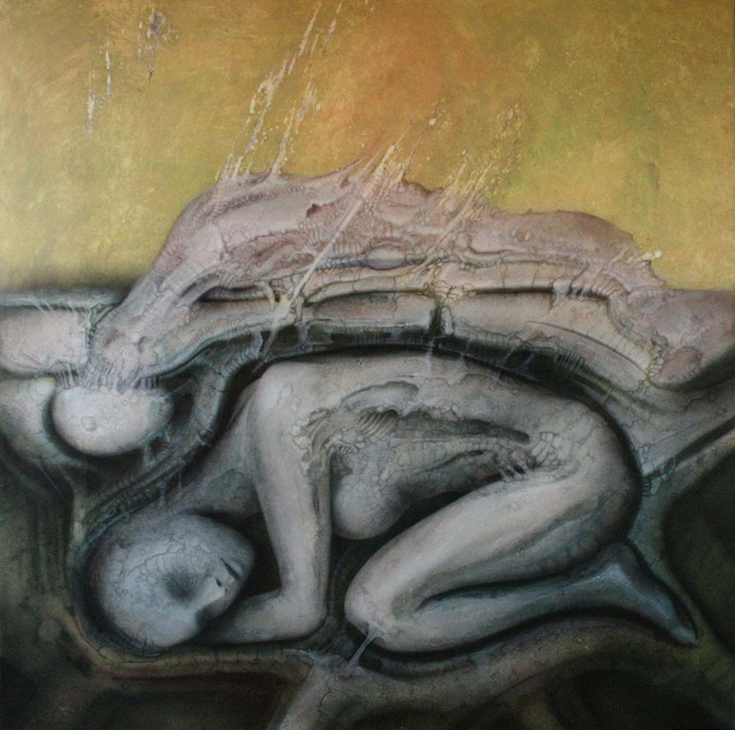
‘the grieving process’ by Ed Schaap
Would also go into my exhibition. I feel like understanding what grief actually is was really hard for me.
Grieving takes a long time and it doesn’t just come and go , it comes in different stages. People react differently to loss. Including the feeling of anger towards someone who has passed for “leaving you behind”. I felt like this for a long time , I asked myself why would he do this to me?, why would he want me to suffer like this? But you start to understand that now they’re out of pain and it was probably the best thing.


A main piece I would put in my exhibition is an installation of 300 speakers by John Wynne. “ It uses sound and sculptural assemblage to explore and define architectural space and to investigate the borders between sound and music.”

I would have different sounding bird noises playing and echoing throughout the garden. One thing about my grandfather was his love for birds, and I think this would be a really meaningful piece to add.

Design layout of the garden.

Frida painting
Grandfathers
Belongings Gonzalez-Torres
Painting

Andrea
mantegna
ed schaap Speakers playing bird sounds

Candy chang before I die wall
To conclude my reasoning behind wanting to do this exhibition about my grandfather and his belongings is because they are the only things that I have left that really make me remember him and the good times that we had. he enjoyed everything he did, and after his death i started to appreciate all the amazing memories he gave me, and everything he did did for me . But also in this exhibition , adding paintings that have deep meaning and reason behind them, that portray feelings that I felt and still feel after the death of my grandfather. I feel like having an exhibition with so much meaning will be good for the audience to be able to relate to the feeling that the artists want you to feel from the artwork, I want the audience to walk around my exhibition and if they’ve got any loved ones that they have lost , I want them to remember all the amazing memories that they have to cherish. I also want them to remember the hard time they had when they lost their loved ones to remember how strong they are for going through something so hard but coming out on the other side still pushing .I look back at the first days and realise that I am a strong person , and that I could get though a situation that I didn’t even think I would ever go through. But mainly remembering our short time that we have with the people that we love , and not to take it for granted because one moment in life were having the best time with the best people around us , but in the next moment, anything could happen and there’s nothing we can do other than remember these people , for doing everything that they’ve done. We have to remember that our loved ones didn’t leave us, but it was their time to rest and be at peace, and I definitely know that my grandfather is at rest , and he is in a better place now.

Bibliography

Pricilla frank, 19/03/2015 updated 06/12/2017. https://www.huffingtonpost.co.uk/2015/03/19/death-in-art-_n_6849376.html?guccounter=1&guce_referrer=aHR0cHM6Ly93d3cuZ29vZ2xlLmNvbS8&guce_referrer_sig=AQAAAC_wHD-ZvJGsRMdgXE4k8HSB_RY3ZDMl64NXZ37D6bGXZi4Gha1WQJY3VqILri5aV7jSxPGx5JVRtWRBnSqQzGNBzTFTiBNnjjwzBfxMGamq8Zzqma1ixoQ2Be_Yw4fkh2llP58c0OjIm341CqwgZ_yY0jveCTjlfTGHN3Y3bdGm

John wynne
http://sensitivebrigade.com/wynne.htm

16/08/2017.
https://www.funeralzone.co.uk/blog/death-art

http://macabregallery.com/en/ed-schaap-the-grieving-process/

