
Applied Industrial Placement (SPORT)
M5X02295
Placement Portfolio Template

Student Name
Name – Jonathan Booth
P Number – P148104
Report
Title – Applied Placement
Word Count – 4897
References (Total) – 10
Job Title – Operations Support
Organisation
Name – Glamorgan Cricket
Address– The SSE Swalec
Cardiff
CF11 9XR
Email – info@glamorgancricket.co.uk
Telephone Number – 02920 409380
Line Manager
Name – Dan Cherry
Position – Operations Manager
Email – dan@glamorgancricket.co.uk
Telephone Number – 02920 409380

TASK A – (Reflective Learning Log 1 - 500 words – First Experience of Placement)
Recommend to link the reflective experience to two different key themes.
Event Management
Event management can be described as ‘a non-routine occasion which has leisure, cultural, personal or organisational objectives set apart from the normal activity of a person’s daily life’ (Shone, 2001).
The management of the SSE Swalec in Cardiff, solely rests on the shoulders of the Operations Team/ Stadium Maintenance Staff. The amount of time and effort that goes into maintaining the stadium and its day to day operations, is quite an eye opener. In future when attending any sporting event, I shall be taking into consideration the amount of work that people have gone through just to make the event a spectacle and an enjoyable experience for the customers and fans attending.
Furthermore, the management of volunteers and casual event staff on a match day is extremely surprising and challenging. I was quite alarmed by how many staff were not on hand to be able to address the casual staff, and give them support and direction that they needed on a match day. From my own personal point of view and with the recent security issues around the world, I would have thought that there would be a lot more staff in and around the stadium to deal with any potential issues that may arise. If in future I was to be in control of an event or match day, I would certainly make sure that there would be enough staff on duty to cater for all guests, and they were fully trained with the correct knowledge to give them the best experience possible.
Event Planning
Event planning ‘consists of establishing where the organisation is currently at, what it’s future goals are and what is required to make it a success’ (Bowdin, 2006). In terms of the SSE Swalec, it is already an established venue which has hosted international cricket. Therefore, one of its future goals would be to increase footfall and income, as well as boosting the popularity of the stadium and Glamorgan County Cricket Club on the world stage.
On one of my first days at the SSE Swalec, I was quite taken aback by the sheer amount of work and planning that goes into the staging of a single event. Even in doing my own Operational Planning Document in Year 1 of study, being given an in-depth insight into how a professional sporting organisation conducts a plan is extremely beneficial for myself. In a possible future job role or career, if I’m to be required to do another planning document I will have a lot more knowledge in what it must entail. In doing so, I was invited to attend a meeting with several individuals from different departments in and around the stadium. This meeting was primarily to discuss the ongoing progress, and further developments in the staging of the ICC Champions Trophy 2017 and an International T20 match to be staged later on in the summer. In all, there were individuals there from the following departments catering, ticketing, operations, commercial, financial, Welsh Government and Cardiff Council.
Something which I did not realise that took so long to do and keep updated, was a delivery schedule. With increased security and the stadium on lock down during the Champions Trophy, all incoming deliveries had to be pre-planned. Once this was done, the stewards and reception staff were then made aware of what was due to be delivered daily, and whether they would be able to be granted entry into the stadium grounds.

TASK A – (Reflective Learning Log 2 - 500 words – Mid Point Experience)
Recommend to link the reflective experience to two different key themes.
Facility Management
“Facilities management is the process by which an organization delivers and sustains support services in a quality environment to meet strategic needs.” (Alexander, 2005, Page 1).
The management of the facility is a key aspect, and maintaining the high-quality standards which have been set at the SSE Swalec will hopefully attract more international cricket to the stadium in future. The Operations Team are responsible for overseeing the whole stadium, who will then in turn pass on any required work to the maintenance staff. The amount of time and effort that goes into maintaining the stadium, and keeping it up to international standard is quite surprising. In week four of my placement at the SSE Swalec, the ICC Champions Trophy match between England and New Zealand was fast approaching, and the amount of work that was needed to be carried out was extraordinary. Due to the nature of the competition and the specific amount of sponsorship deals that come with hosting the tournament, I was required to help the maintenance team get the stadium ready. After learning about the amount of rebranding that had to take place in and around the stadium, I was advised to remove any signage that was not an official partner of the ICC Champions Trophy. This included things such as name plaques in the car park and sponsorship signs that were in the stands. Even with the importance of keeping the ICC and the sponsors of the tournament happy, it is of paramount importance to keep the customers and fans happy. With this is mind, I was assigned the role of checking all 15,643 seats at the stadium for any damage or hazards around the stadium that may cause supporters discomfort or potential injury. Whilst this was being done, I would be noting down any maintenance work that needed to be done around the ground and this would be carried out before the start of the tournament.
Security, Policing and Match Fixing
With the everyday threat that we now have with regards to security around sporting events, I was given the opportunity to spend some time with the security team at the SSE Swalec. On this match day (New Zealand vs Bangladesh), I was given an in depth look as to what needed to be looked out for to keep all customers safe, and to make sure the game went ahead without any problems.
Something that I would not have taken into account before my placement at the stadium, would be the importance and intelligence that the security team has on any potential match fixers that are attending the game. Match fixing can be defined as ‘irregularly influencing the course or result of a sports event in order to obtain advantage’ (AusSport.gov.au). In recent years, match fixing at big cricket events has been on the increase and the police must be aware of exactly who is in the stadium and around the ground. The staff in the security box, must therefore be made aware of who is likely to be attending a particular game and if they have any previous offences or banning orders for the particular offence in question. This would be a major security aspect for the ICC Champions Trophy games at the SSE Swalec, as there were several Asian teams playing and that is who the match fixers target. Primarily, they would target these games due to the games being broadcast across to the other side of the world and in turn they could let other people know the outcome of the action that was going on.

Security, Policing and Match Fixing continued
If in the future I was to look into the possibility of a career in security in the sporting sector, this would definitely be something that I would look out for in all sporting arenas. It seems to be something that is happening in all sports, and needs to be clamped down on.

TASK A – (Reflective Learning Log 3 - 500 words – Mid Point Experience)
Recommend to link the reflective experience to two different key themes.
Hospitality

Hospitality can be defined as “a relationship between individuals who take the roles of host and guest” (Mullins and Dossor, 2013, Page 4).

It was not until a few weeks into my placement journey, that I was to realise the extent that the club goes to in making the match day an all-round experience for the customer. Once again relating back to the hosting of the ICC Champions Trophy, I was able to see the top-class hospitality and customer service relationship that the staff have with its fans. One of the things that stood out to me, was the transport that was on offer to fans outside of the stadium (see image 6.) The club had provided some staff with golf buggy’s, in which they were able to drive around and transport the fans to and from the stadium. Luckily, I was given the opportunity to help out with this facet of a match day, and the reaction from the fans was extremely appreciative. Once transporting some fans, it came up in conversation that they had never received such customer service and hospitality at any cricket ground they had visited and offered me money for the service.

Besides hosting the ICC Champions Trophy, I have been able to see first-hand how popular the stadium seems to be with other business. On a daily basis, the stadium is in use for other meetings and conferences which are hosted by business and sponsors.

Marketing

Defining marketing can be as simple as being “the process by which companies create value for customers and build strong customer relationships in order to capture value from customers in return” (Kotler and Armstrong, 2012 Page, 27).

Due to the time of the year that I was on placement, it was extremely difficult for the club to market any matches and events. This in part, was down to the city of Cardiff hosting the UEFA Champions League Final. With minimal opportunity to market the games and events going on at the stadium, I had to go out with another member of staff and post 2,500 flyers to the residents of the surrounding area. By doing this, it was not only a source of marketing from the stadium but also making residents aware that there could be parking issues for the games. In the instance of this happening, the club was going out of their way to carry out this procedure and also building good relations with the residents of the surrounding area who in turn could be loyal customers and fans of the cricket club in the future.

One of the ways that they were able to promote the ICC Champions Trophy, was by doing a tour around the Cardiff area with fans able to have photographs with the trophy. In partnership with the ICC and Cricket Wales, tickets were then issued to local school children for some of them to attend the games which were to be hosted at the SSE Swalec. It was not until the UEFA Champions League Final had been hosted, that the ICC Champions Trophy could properly be advertised around the stadium and on flags around the city centre.

TASK A – (Reflective Learning Log 4 - 500 words – Near end of Experience)
Recommend to link the reflective experience to two different key themes.
Operational Management
Operational management is the ‘the activity of managing the possessions, decisions and tasks that help with the smooth delivery of vital products and services to consumers’ (Slack, Chambers, and Johnston, 2009).

The operational management aspect of the club, runs side by side with the management of the facility. Even from the first day I started my placement, the operations team have slightly changed the way that they approach their decision making and issue out the daily tasks. On a daily basis, the operations team will meet with the maintenance staff and issue them a checklist of jobs which need to be done in the shift ahead if possible. There also several meetings arranged across all the departments, to bring up any queries or problems which may have arisen in the previous week since the last meeting took place.

From my own personal point view, I am of the belief that this is the correct system for the business to use. By doing this, every department gets to put across their opinions and queries and in turn they may then be able to help any other areas of the business. Also in doing so, it will enhance stronger bonds between departments and encourage more teamwork and communication to take place. In a stadium where there are multiple events taking place, it is imperative that the team works hand in hand. If this is not to be the case there is a good chance that the event will fail, and in turn any future revenue from these events will then be put in severe jeopardy.

Sponsorship and Branding
Sponsorship in the sporting context can be seen as “a business relationship in which a cash fee is paid to an organisation or event in return for access to exploitable commercial potential associated with that organisation or event” (Crompton, 2014, Page 1).
In the instance of sponsorship and branding, I could not have chosen a better time to be on placement at the SSE Swalec. The importance of sponsorship and branding, was highlighted to me during the preparation for all of the ICC Champions Trophy matches that were held at the stadium. It was not just signage and posters that had to be amended at the stadium, but also advertising hoardings around the perimeter of the pitch and also the stadium name. Due to the stadium being named the ‘SSE Swalec’ and those sponsors not being official sponsors of the tournament, the stadium had to be renamed the Cardiff Wales stadium for the duration of the competition. The same had to happen with certain stands around the ground, as if they were branded with anything other than official tournaments sponsors they had to be revamped and renamed.
Branding and official trademarks, have become a huge part of sport in recent times. “Strong brands command customer loyalty and premium prices, they are central to many sports business transactions ‘(WIPI.int).From my time spent at the stadium, I was told that the club find it quite difficult to sell all the advertising hoardings to outside businesses. This is mainly caused, as not many of the club’s games are broadcast live of Sky Sports and in turn this gives the businesses minimal exposure. Ideally the club are always looking to get sponsorship from local businesses, who then in turn will hold conferences and events

Sponsorship and Branding continued
at the stadium. The return in custom, goes a long way in helping the club and stadium operate out of season.

TASK A – (Add 250 words on link to future Continued Professional Development and Reference list based on total referenced material in Task A)
Continued Professional Development post placement (250 words - Link to pre placement module)
“Continued Professional Development is the systematic maintenance and improvement, of knowledge, skills and competence and the enhancement of learning undertaken by an individual throughout their working life “(CPDinstitute.org). With this being in mind, it was extremely important for me to gain the correct knowledge and skills whilst on placement this summer. I can now go away and into my final year of study, knowing what is required to achieve my end goal and ultimately my goal of getting a career in the sporting sector.
In regards to my placement selection at the SSE Swalec, I am of the belief that it was the correct placement for myself to gain valuable experience at an international multi-purpose sport’s venue. It would have been my preference to spend more time with operations team on a match day, but due to the circumstances and the busy schedule I was unable to. If in the future I decide to venture into this sector of sport, I will have experienced the workplace which I will be stepping in to. It was also valuable for me to see that the club are trying to develop their own home – grown cricketers through the academy and the National Cricket Centre that is it at the stadium. From my own point of view, it is extremely important to develop young players, who in turn in the future could become modern professionals for the county.

References from TASK A (10+ references)
Alexander, K. (2005). (Page 1) Facilities Management. London [u.a.]: Taylor & Francis
Ausport.gov.au. (2017). Match Fixing: Supporting Sport: Australian Sports Commission. [Online] Available at: http://www.ausport.gov.au/supporting/integrity_in_sport/match_fixing [Accessed 25 July. 2017].

Bowdin, G, 2006. Events Management. 2nd Revised edition. A Butterworth-Heinemann Title
CPD & The Institute. [ONLINE] Available at:https://cpdinstitute.org/cpd_and_the_institute?locale=en. [Accessed 26 July 2017].

Crompton, J. (2014). (Page 1) Sponsorship for sport managers. Morgantown, WV: Fitness Information Technology.

Kotler, P. and Armstrong, G. (2012). (Page 27) Principles of Marketing. Harlow: Pearson

Mullins, L. and Dossor, P. (2013) (Page 4). Hospitality Management and Organisational Behaviour. Harlow: Pearson.

Shone, A, 2001. Successful Event Management: A Practical Handbook. 1. Continuum.

Slack, N., Chambers, S. and Johnston, R. (2009) Operations management. 6th edition, Harlow, England: Financial Times Prentice Hall.

Wipo.int. (N/A). [Online] Available at: http://www.wipo.int/ip-sport/en/branding.html [Accessed 25 July. 2017].

.

.

TASK B – (YouTube Video – 10 x 1 min integrated video) (Experience, Roles, Improvements)
NOTE – Make sure the link works correctly
Website Link –

Link Password –

Video Duration –

Device used to create video –

Software used to create video –

Production contributors
Name | Position | Organisation

TASK B – (Picture Board – 5 pics (40MB upload limit to Turnitin) (Experience, Roles, Improvements)
Picture | Text (Paragraph)
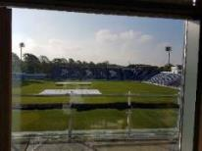 | Image 1 - From the image on the left you can see the view, from my office on day one at the stadium. In the coming weeks, I was able to see the transformation of the stadium in the build up to the ICC Champions Trophy. Whilst being located in this office space, I was able to see first-hand the interaction that the players and coaching staff have with the operations team on a daily basis. My role at this point, was to assist the operations team with anything that needed doing within the office.
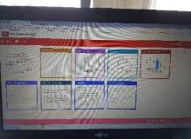 | Image 2 - In the image, you are able to see a health and safety program that is in use. In the opening days of my placement, I was given the responsibility of transferring all paper documents onto this online program. The main benefit of this, is that the documents are then easier to find when needed and can be accessed by other members of staff all around the stadium on a shared drive. In this role, I was still assisting with office duties and helping out wherever I could.
 | Image 3 - In the image, it shows a Stewards Briefing which must be handed out and explained to each steward before every home game at the SSE Swalec or any other home ground that Glamorgan use. I was pleased to be given the opportunity to compile one of these documents for the operations team. In doing so, I was able to meet up and chat with the head of security at the stadium, and be briefed about was to be required in the document. When carrying out this role, it gave me the opportunity to interact with people from the other departments of the stadium.
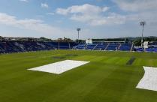  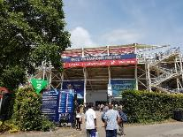 | Image 4 - The image on the left, shows my view of the stadium being prepared on a match day for the ICC Champions Trophy. It was at this time, I was required to check all the seats in the stadium and make sure that the stadium was in tip top condition for the game ahead. It is no doubt a huge thing for the stadium to be in immaculate for any guests or visits that are coming to the stadium. This was the during the mid- point of my placement experience, and when I was required to work outdoors with the maintenance team.  Image 5 - As can be seen from the image, the sponsorship and branding of the tournament is extremely important. The front of the stadium is decorated with all the required ICC Champions Trophy branding, and the inside is no different. For the duration of the tournament, all this branding must be kept in place.  At this time, my role was out working with the matchday staff around the ground. If required, I would then be able to help with the security and stewarding aspect of a matchday.
 | Image 6 - The image on the left is the view I had from my golf buggy for the England vs Pakistan, ICC Champions Trophy semi-final. It was my job role to escort any supporters around the stadium in this vehicle, and in turn make sure they got to the game in time as well as enhancing their experience at the stadium. This type of customer service role was not something that I had experienced previously but it certainly turned out to be an enjoyable one.

TASK B – (Picture Board Cont.–5 pics (40MB upload limit to Turnitin) (Experience, Roles, Improvements)
Picture | Text (Paragraph)
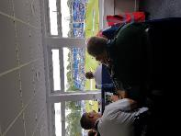 | Image 7 - The image shows the view from the security room at the SSE Swalec. It was during this time, that I was shown what planning and preparation went into the security operation on a match day. In this situation, I was also given the information with the regards to the possibility of match fixing and how they intend to combat it.  In more recent times it has become a problem in the game of cricket, with both players and fans being charged with match fixing. With the amount of technology available, the staff and police are doing a good job of policing this. The enhancement in technology and with more cameras available around the stadium, the police and security are now able to monitor this more closely.
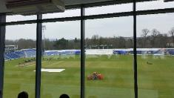 | Image 8 - The view in this image, is from when I had the opportunity to spend some time in the media centre at the stadium. In this role, I was able to oversee the stadium from a different viewpoint, and was shown how it would be managed differently on an international matchday to a county cricket matchday. As for improvements, this is a one of the newer parts of stadium and is already up to superb international standard.
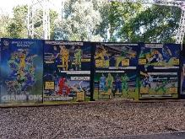 | Image 9 - The image shows a cartoon montage of the ICC Champions Trophy tournament, in which a few of the games were held at the stadium. I was quite surprised, as this montage was not put up at the stadium until after the tournament had finished. Whilst helping the maintenance staff to put it up, I did ask why only now it had been put on display but they were as lost for ideas as myself.  Possibly the reasoning behind this was due to the stadium wanting to show off what they had already hosted, and also the success of the tournament at the stadium.
 | Image 10 - The image on the left shows a number of different passes, which I was required to number up and hand out for the international T20 between England and South Africa. This in turn, gave me an insight in to how much attention to detail goes into a single matchday.  There are several different passes for event staff, and separate media guests who need to enter certain areas of the stadium. In the main these passes are issued separately in the build up to an international match only.

TASK C Evidence – Employer Report (Signed),
NOTE – This will be compared against the report sent to the University.
NOTE – You will need to complete additional copies if you have more than one provider.
Jonathan has worked hard during his placement with Glamorgan Cricket and made himself into a helpful colleague during a very busy period at the Stadium which included a major International tournament, and England International match and the start of our domestic t20 season.
Jonathan was always punctual and keen to assist wherever possible. He is quiet and unassuming but has a determination to complete all of the tasks given to him in a timely and efficient fashion. He worked well as part of a team and also contributed to various tasks that he was given to achieve on his own.
He has hopefully learnt that there are many facets to working in the events industry and we have tried to balance his experience so that he has seen the full spectrum of working in the Operations Department. This has included working in the office environment completing paperwork tasks, being involved in planning meetings and also assisting the maintenance and grounds teams as they prepare the Stadium for each event.
During the period with us Jonathan has proved to be helpful, friendly and hard -working and I am sure that he will be able to progress with a future in the events industry if he chooses to do so.
Dan Cherry
Head of Operations – Glamorgan Cricket
July 2017
TASK C Continued Evidence – Employer Report (Signed),
NOTE – This will be compared against the report sent to the University.

TASK C Evidence – Ethics Form – Signed by Organisation and Lecturer
NOTE – You will need to complete additional copies if you have more than one provider.
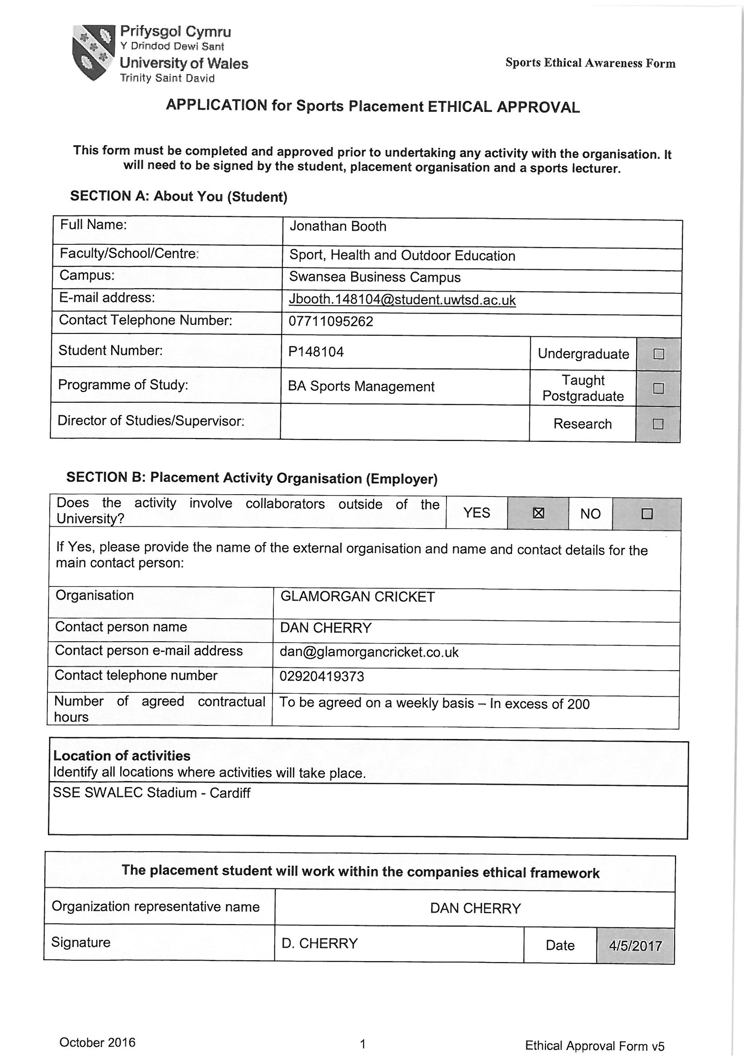

TASK C Evidence – Ethics Form Continued
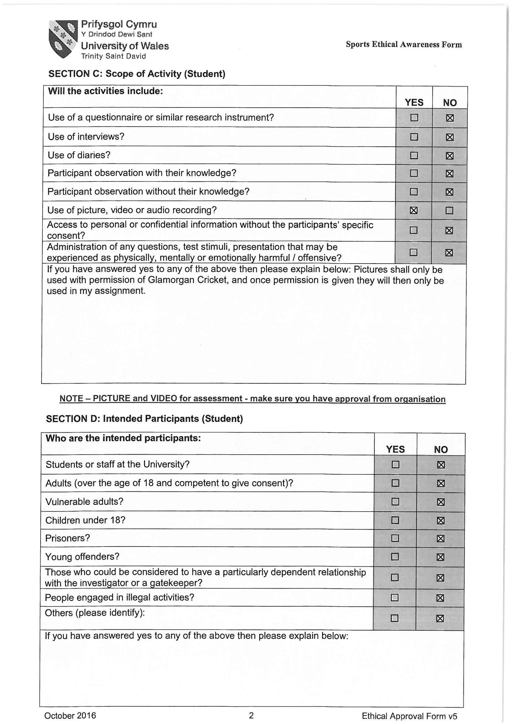

TASK C Evidence – Ethics Form Continued
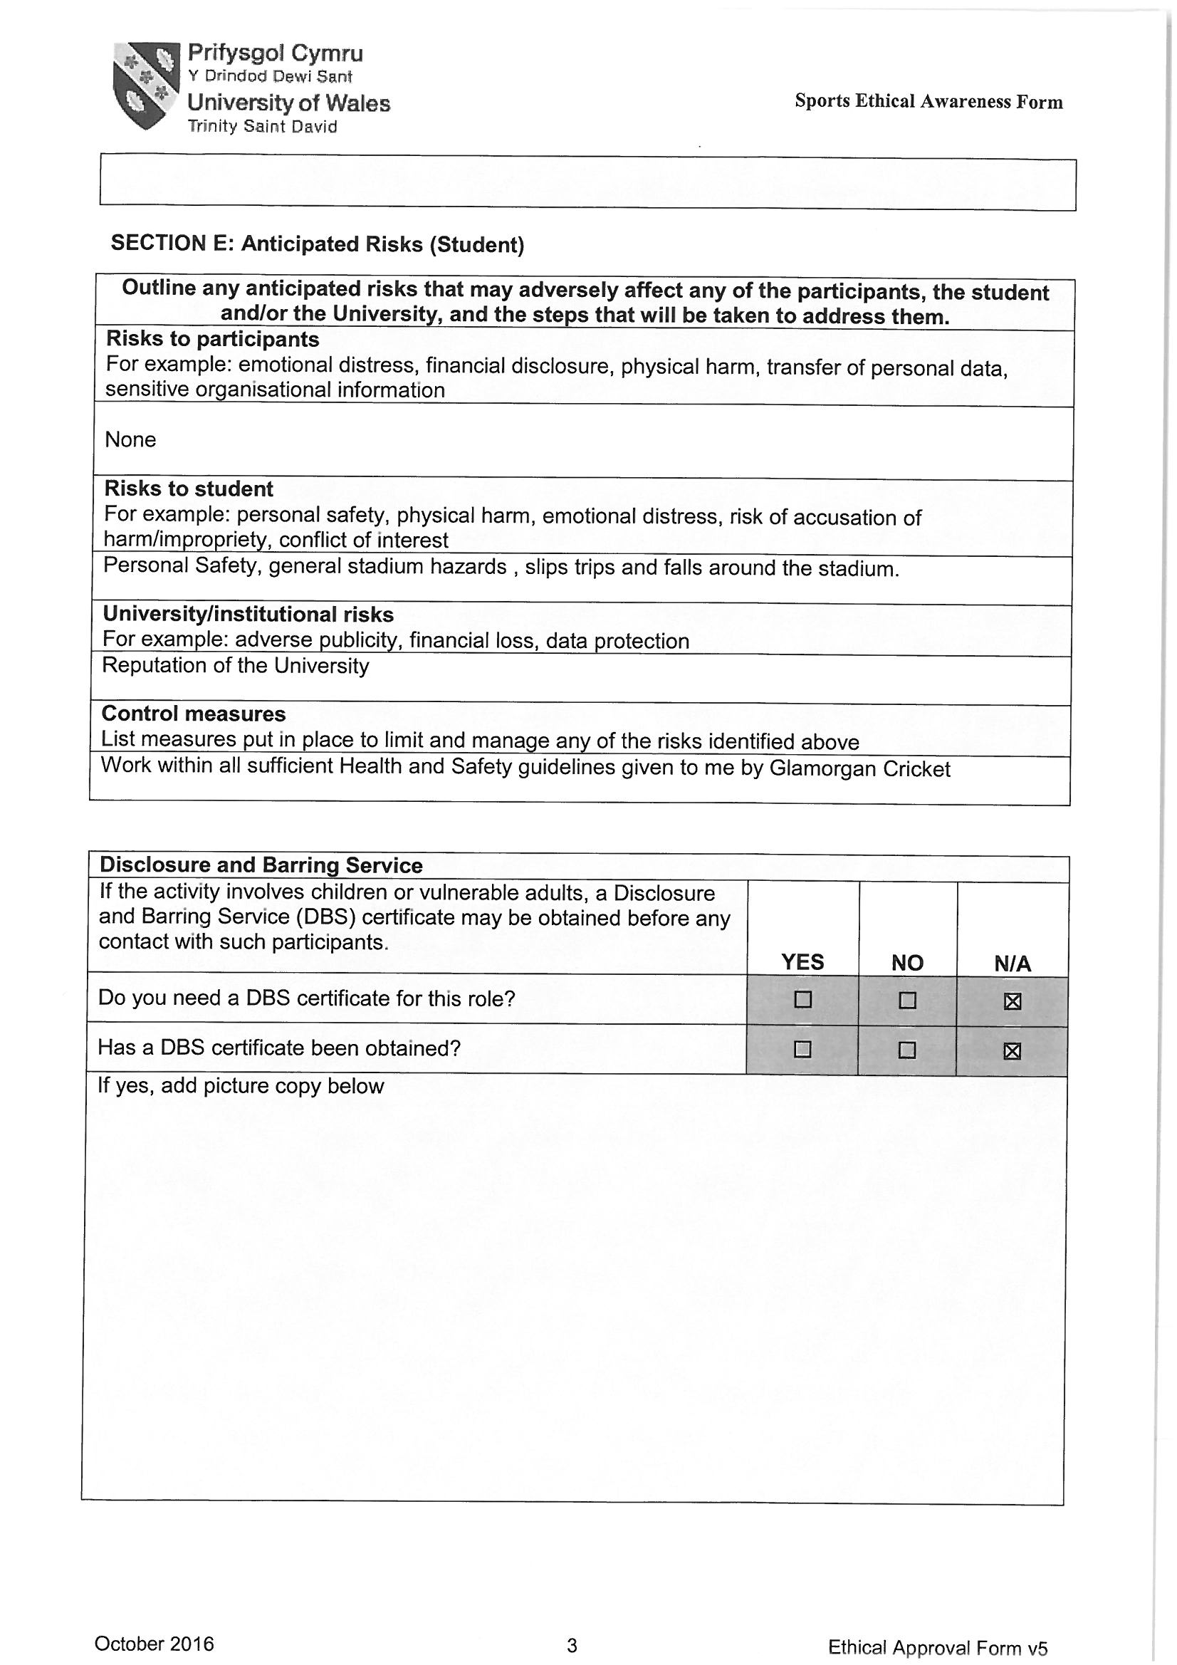

TASK C Evidence – Ethics Form Continued
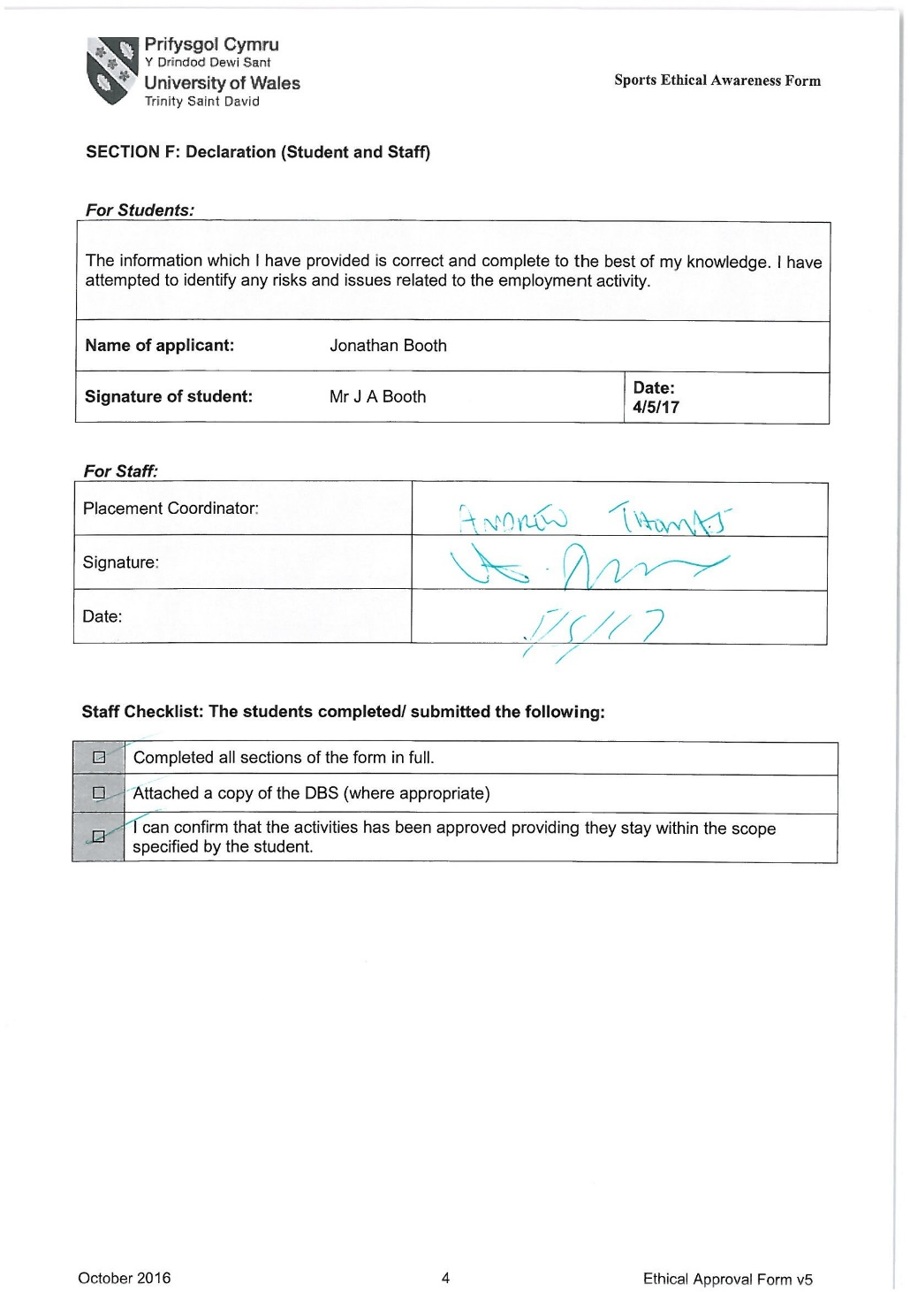

TASK C Evidence – Post Placement Review and Feedback
Dear Participant

Many thanks for your involvement in the work placement. I hope that you had a positive experience. The University of Wales Trinity Saint David reviews the provision annually for enhancement purposes and so we would be pleased to hear your feedback on any aspect of the placement.

Yours sincerely

Andrew Thomas, Placement Coordinator Sports Management Portfolio

Name of provider’s organisation: |  | Glamorgan Cricket
Name of student: |  | Jonathan Booth
What were the positive aspects?
In the early weeks of my placement, I was given a good insight into how the organisation is run and was able to attend several meetings with other departments. I was also glad that that I was given the opportunity to work on an international match day at the stadium.

Were there any problems?
During the last few weeks at the placement, it felt as if I was just a spare pair of hands to the maintenance team and learnt nothing at all about management or operations. After being in contact with the stadium after my placement, this was spoken about and now I can see the reasons behind that decision.

Do you have any recommendations for enhancement for the future?
For my own future enhancement, and if I was to have the opportunity to go on a placement again I would try go to more than one. So perhaps I would choose to do one at a stadium in the UK and possibly one abroad, just to see the difference in organisation and how they would operate.

Signed: | J A Booth
Name in block capitals: | Jonathan Booth
Position (please tick one): | ☐ Placement Provider  ☒ Student  ☐ Placement Tutor |  | Date: | 19/7/17

TASK C Evidence – Student Placement Induction Checklist
Student Name: | Jonathan Booth
Name of Placement Provider organisation: | Dan Cherry (Glamorgan Cricket)
Placement Site Address: | SSE Swalec, Cardiff

Health & Safety Issues | No | Yes | Date
- Introduction to key staff members and their roles explained |  | Yes | 1/5/17
- Location of welfare facilities (e.g. toilets, kitchen, rest room, showers, etc.) |  | Yes | 1/5/17
- Emergency procedures |  | Yes | 1/5/17
- Copy of safety policy received or location known |  | Yes | 1/5/17
- Location of first aid facilities and contact for first aiders |  | Yes | 1/5/17
- Fire procedures and location of fire-fighting equipment |  | Yes | 1/5/17
- Accident/incident reporting and location of accident book |  | Yes | 1/5/17
- Use/control measures for hazardous substances in the workplace (e.g. COSHH) – if applicable |  | N/A
- Display Screen Equipment Regulations and associated procedures – if applicable |  | Yes | 1/5/17
- Manual handling procedures – if applicable |  | Yes | 1/5/17
- Protective clothing/equipment arrangements – if applicable |  | Yes | 1/5/17
- Instruction on equipment you will be using (list equipment) |  | Yes | 1/5/17
- Specific training for tasks to be undertaken |  | Yes | 1/5/17
- Specific information relating to risk assessments covering tasks to be undertaken |  | Yes | 1/5/17
- Location of health and safety information and advice |  | Yes | 1/5/17
- Specific disability related induction issues |  | Yes | 1/5/17
- Other issues covered/to be covered please state:

As a minimum, the topics listed above should be included within the induction that you provide for the student on placement, preferably on their first day. Please check off the subjects as they are covered.

PLACEMENT PROVIDER CONFIRMATION

I confirm that the student has been provided with the induction specified above:
Signed: | Dan Cherry
Print Name: | Mr. Dan Cherry
Position: | Head of Operations | Date: | 1/5/17

STUDENT CONFIRMATION

I confirm that I have been provided with an appropriate induction as specified above:
Signed: | Jonathan Booth
Print Name: | Mr. J A Booth
Position: | Operations Support | Date: | 1/5/17

NOTE – If this is not completed please ask your supervisor on the placement to complete ASAP. However, please inform the placement coordinator at the earliest possible opportunity if this procedure does not take place.


UWTSD SPORT
Placement

