Digital Technologies
Student Name - Adrian Dulgheru
Student Id - 2231314

Table of Contents
Introduction 3
Examples of Digital Resources and their Uses By Professionals 3
Internet of Things (IoT) 3
Robotics 3
Big Data and Real-time Analytics 4
Application Programming Interface (API)-related integrating software 4
Professional Prospects within the Digital Industry 5
Conclusion 6
Description and Justification of the Poster Presentation 7
Justification for the Text and Imagerial Representation 7
Justification for the Utilised References in the Poster 7
References 9

Poster
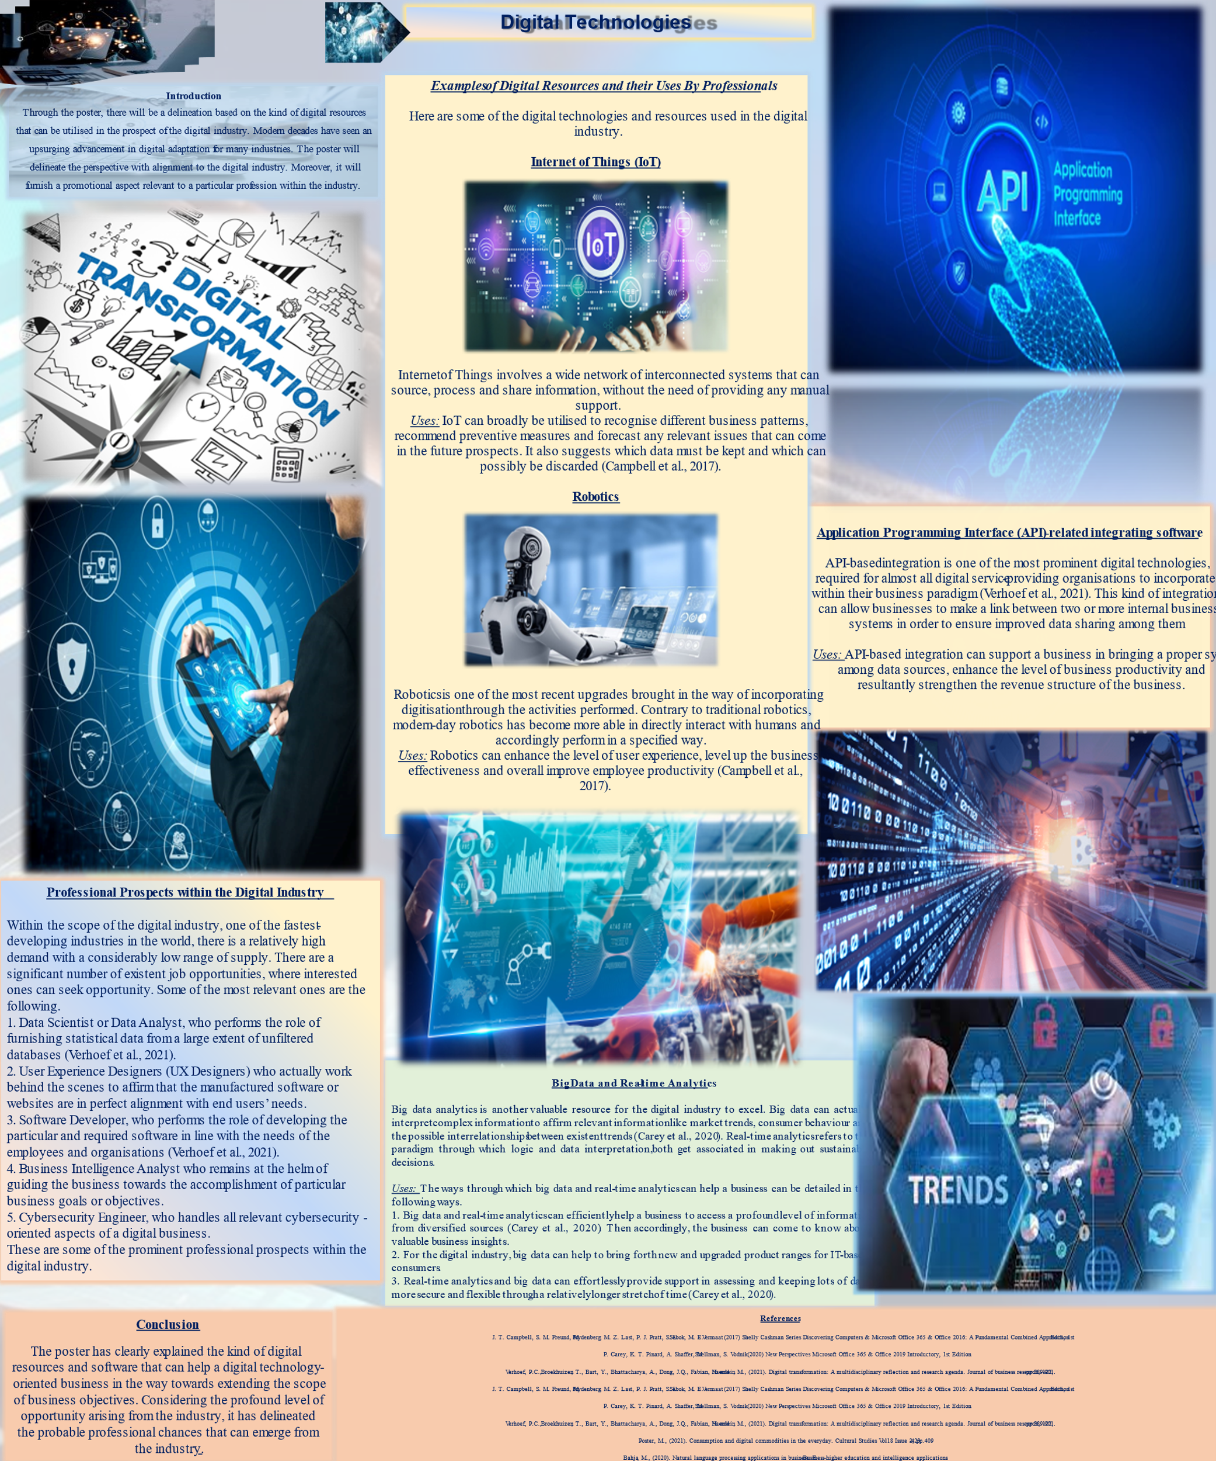

Introduction
Through the poster, there will be a delineation based on the kind of digital resources that can be utilised in the prospect of the digital industry. Modern decades have seen an upsurging advancement in digital adaptation for many industries. The poster will delineate the perspective with alignment to the digital industry. Moreover, it will furnish a promotional aspect relevant to a particular profession within the industry.

Examples of Digital Resources and their Uses By Professionals
Here are some of the digital technologies and resources used in the digital industry.

Internet of Things (IoT)
Internet of Things involves a wide network of interconnected systems that can source, process and share information, without the need of providing any manual support.
Uses: IoT can broadly be utilised to recognise different business patterns, recommend preventive measures and forecast any relevant issues that can come in the future prospects. It also suggests which data must be kept and which can possibly be discarded (Campbell et al., 2017).

Robotics
Robotics is one of the most recent upgrades brought in the way of incorporating digitisation through the activities performed. Contrary to traditional robotics, modern-day robotics has become more able to directly interact with humans and accordingly perform in a specified way.
Uses: Robotics can enhance the level of user experience, level up the business effectiveness and overall improve employee productivity (Campbell et al., 2017).

Big Data and Real-time Analytics
Big data analytics is another valuable resource for the digital industry to excel. Big data can actually interpret complex information to affirm relevant information like market trends, consumer behaviour and the possible interrelationships between existent trends (Carey et al., 2020). Real-time analytics refers to the paradigm through which logic and data interpretation both get associated in making sustainable decisions.
Uses: The ways through which big data and real-time analytics can help a business can be detailed in the following ways.
1. Big data and real-time analytics can efficiently help a business to access a profound level of information from diversified sources (Carey et al., 2020). Then accordingly, the business can come to know about valuable business insights.
2. For the digital industry, big data can help to bring forth new and upgraded product ranges for IT-based consumers.
3. Real-time analytics and big data can effortlessly provide support in assessing and keeping lots of data more secure and flexible through a relatively longer stretch of time (Carey et al., 2020).

Application Programming Interface (API)-related integrating software
API-based integration is one of the most prominent digital technologies, required for almost all digital service-providing organisations to incorporate within their business paradigm (Verhoef et al., 2021). This kind of integration can allow businesses to make a link between two or more internal business systems in order to ensure improved data sharing among them.
Uses: API-based integration can support a business in bringing a proper sync among data sources, enhance the level of business productivity and resultantly strengthen the revenue structure of the business.

Professional Prospects within the Digital Industry
Within the scope of the digital industry, one of the fastest-developing industries in the world, there is a relatively high demand with a considerably low range of supply. There are a significant number of existent job opportunities, where interested ones can seek opportunity. Some of the most relevant ones are the following.
1. Data Scientist or Data Analyst, who performs the role of furnishing statistical data from a large extent of unfiltered databases (Verhoef et al., 2021).
2. User Experience Designers (UX Designers) who actually work behind the scenes to affirm that the manufactured software or websites are in perfect alignment with end users’ needs.
3. Software Developer, who performs the role of developing the particular and required software in line with the needs of the employees and organisations (Verhoef et al., 2021).
4. Business Intelligence Analyst who remains at the helm of guiding the business towards the accomplishment of particular business goals or objectives (Poster, 2021).
5. Cybersecurity Engineer, who handles all relevant cybersecurity-oriented aspects of a digital business.
These are some of the prominent professional prospects within the digital industry.

Conclusion
The poster has clearly explained the kind of digital resources and software that can help a digital technology-oriented business in the way towards extending the scope of business objectives. Considering the profound level of opportunity arising from the industry, it has delineated the probable professional chances that can emerge from the industry.

Description and Justification of the Poster Presentation

Justification for the Text and Imagerial Representation
The poster has been constructed in a definite and sequential way. It has been structured around the points of introduction, Examples of Useful Digital Resources in the way of the digital business, Emerging prospective job opportunities and a Conclusive Statement. Throughout the poster, these distinct parts have been presented through a definite level of arranged sections through subheadings. In order to break the monotony in the presentation, various relevant images of digital resources or technologies have been incorporated into the poster. Along with that, the poster has added relevant images of different emerging professions within the digital industry.

Justification for the Utilised References in the Poster
Two Academic books and Three articles have been chosen to be incorporated into the poster. This will be assessed through the CRAAP method in this section.
Discovering Computers & Microsoft Office 365 & Office 2016: A Fundamental Combined Approach, 1st Edition
The above-mentioned book was published in the year 2017, and aimed towards elucidating various computer-based contexts with a proper mention of instructions related to Microsoft Office365 and Office 2016. This is one of the most trustworthy resources, aligned with the Shelly Cashman Series that allows prospective learners to learn about the required and significant levels of computer skills.
New Perspectives Microsoft Office 365 & Office 2019 Introductory, 1st Edition
The book has been published in the year 2020. The book is about an upgraded form of Office 365 and Office 2019, prevalent in that particular time frame. The book has provided information regarding the ways through which learners can be encouraged towards advancing their skill-base, beyond the scope of problem-solving and critical thinking.
Verhoef, P.C., Broekhuizen, T., Bart, Y., Bhattacharya, A., Dong, J.Q., Fabian, N. and Haenlein, M., 2021. Digital transformation: A multidisciplinary reflection and research agenda. Journal of business research, 122, pp.889-901.
This research journal article was published in 2021. The journal article was published on the online research database of ScienceDirect. The research article has detailed some of the most important prospects around the way digital transformation can get aligned with the consumer’s level of interest and attitudes. This particular journal has provided a strong framework, by delineating the kind of digital resources, indispensable for smooth functioning within the digital industry.
Poster, M., (2021). Consumption and digital commodities in the everyday. Cultural Studies Vol18 Issue 2, pp.409-423.
This journal article was published in the year 2021. The journal article is aimed towards assessing and delineating the prospects around daily life with an alignment to digitalised culture.
Bahja, M., (2020). Natural language processing applications in business. E-Business-higher education and intelligence applications.
The peer-reviewed journal article was published in the year 2020. The open-accessible paper has pointed towards the context of an increased level of dependency of individuals on digitised systems and computer-aided processes. Thus, the paper has tried to focus on the way the human level of interaction has been suppressed through a relatively larger scope of digital adaptations.

References
Bahja, M., (2020). Natural language processing applications in business. E-Business-higher education and intelligence applications.
J. T. Campbell, S. M. Freund, M. Frydenberg, M. Z. Last, P. J. Pratt, S. L. Sebok, M. E. Vermaat (2017) Shelly Cashman Series Discovering Computers & Microsoft Office 365 & Office 2016: A Fundamental Combined Approach, 1st Edition
P. Carey, K. T. Pinard, A. Shaffer, M. Shellman, S. Vodnik (2020) New Perspectives Microsoft Office 365 & Office 2019 Introductory, 1st Edition
Poster, M., (2021). Consumption and digital commodities in the everyday. Cultural Studies Vol18 Issue 2, pp.409-423.
Verhoef, P.C., Broekhuizen, T., Bart, Y., Bhattacharya, A., Dong, J.Q., Fabian, N. and Haenlein, M., (2021). Digital transformation: A multidisciplinary reflection and research agenda. Journal of business research, 122, pp.889-901.

