Selection in Python (1) – if/else statements

Work through the following exercises, deciding whether you need if/else or if/elif/else etc.

Don't forget that input in Python is inferred as a string by default, so cast your inputs to ints or floats where appropriate.

1. Write a program to allow the user to enter a number between 1 and 20. The program should tell the user whether the number they entered was 10 or more, or less than 10.

Sample output:

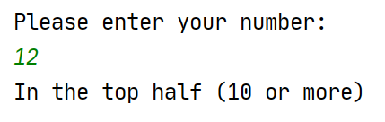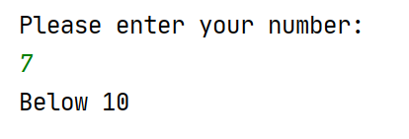

2. Write a program which tells you whether a number entered by the user is negative, positive or zero.

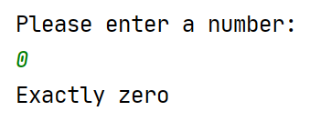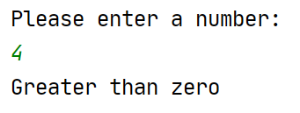

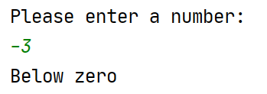

3. Write a program to allow the user to enter 2 numbers. The program should tell the user
which is the larger number.

Sample output:

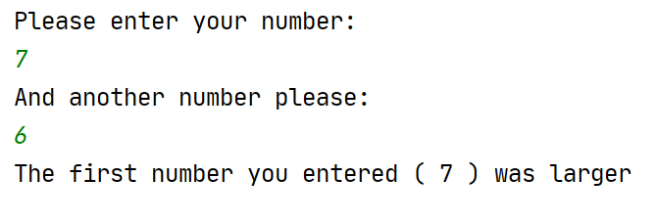

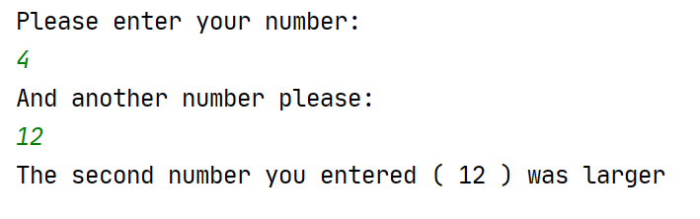

4. Ask the user to enter their favourite pizza topping. Pass comment on their choice (good and bad – note: lighthearted, have a fun with it! ) You should comment on at least 3 pizza toppings.

Sample output:

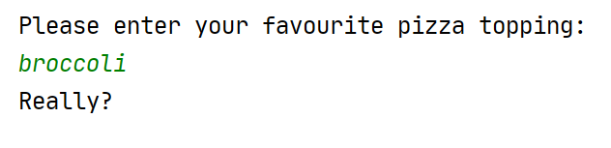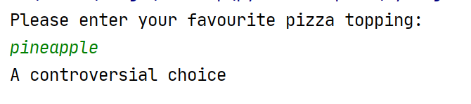

5. Write a program to allow the user to enter their PIN on a bank ATM machine. Compare this PIN number with the actual correct PIN number and print a message on the screen to inform the user if the PIN they entered was correct.

Sample output:

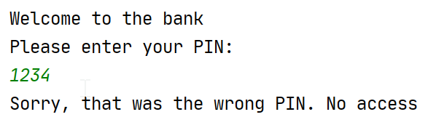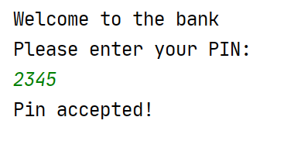

6. Enter a student's overall degree mark and tell them their classification as follows:

Mark of 70 or more – "First"
Mark between 60 and 70 – "2:1"
Mark between 50 and 60 – "2:2"
Mark between 40 and 50 – "3"
All other scores get "Resit"

Sample output:

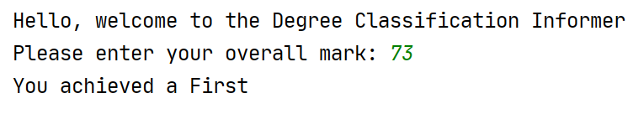

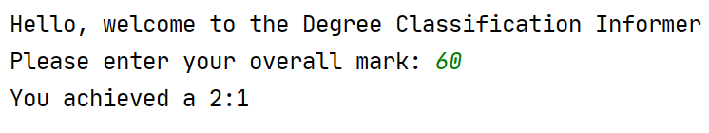

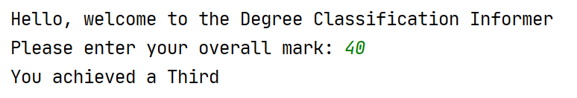

7. Write a program to check whether a number entered by the user is even or odd. (hint: % mod is helpful)

Sample output:

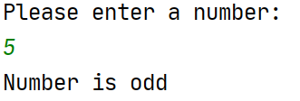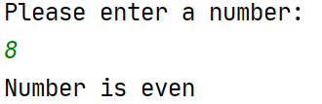

8. Write a C program to check whether a year is leap year or not. (hint: % mod is helpful)

Sample output:



