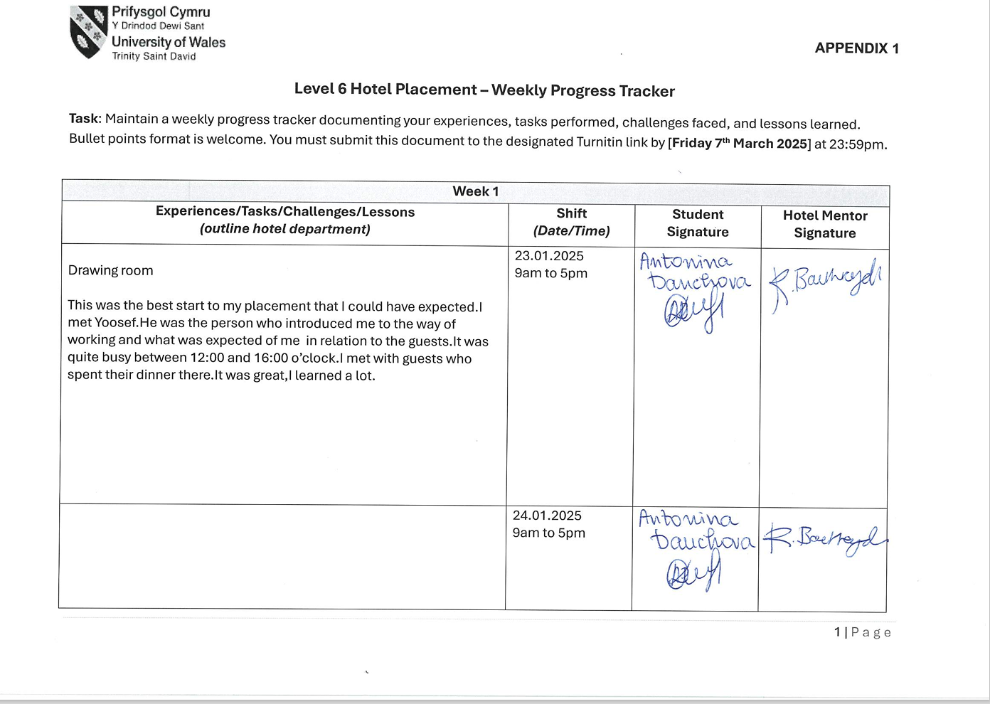
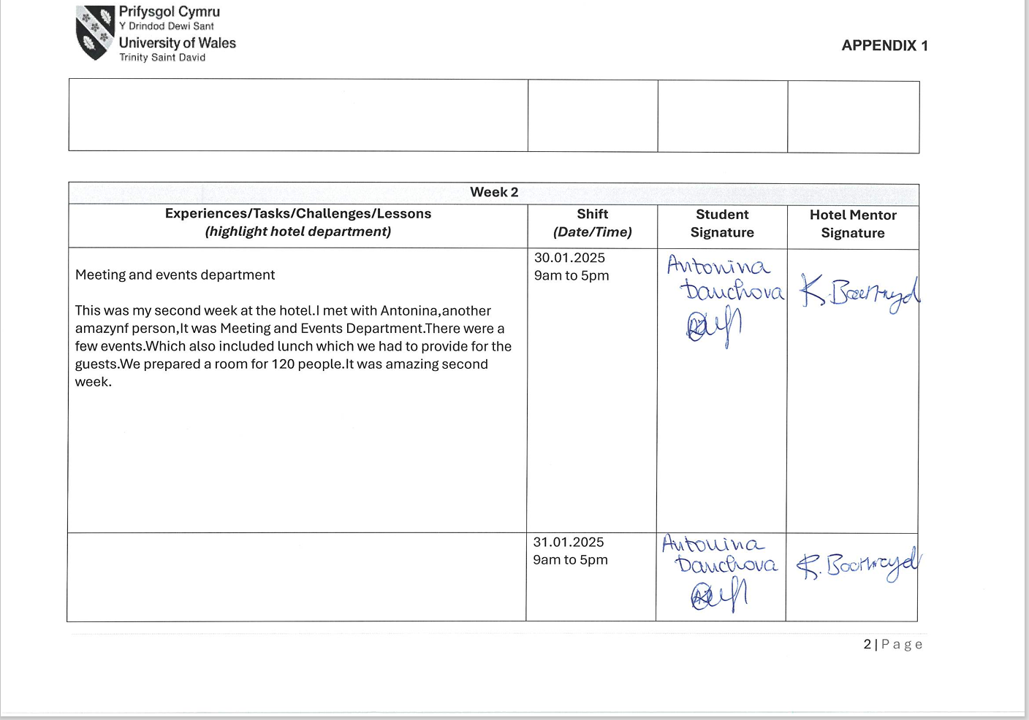
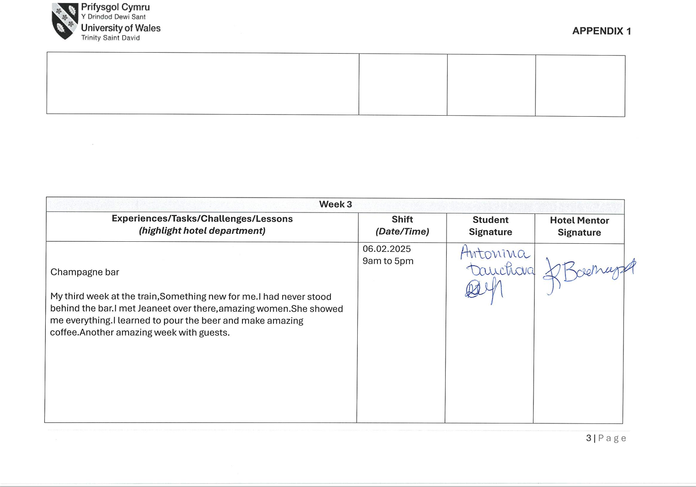
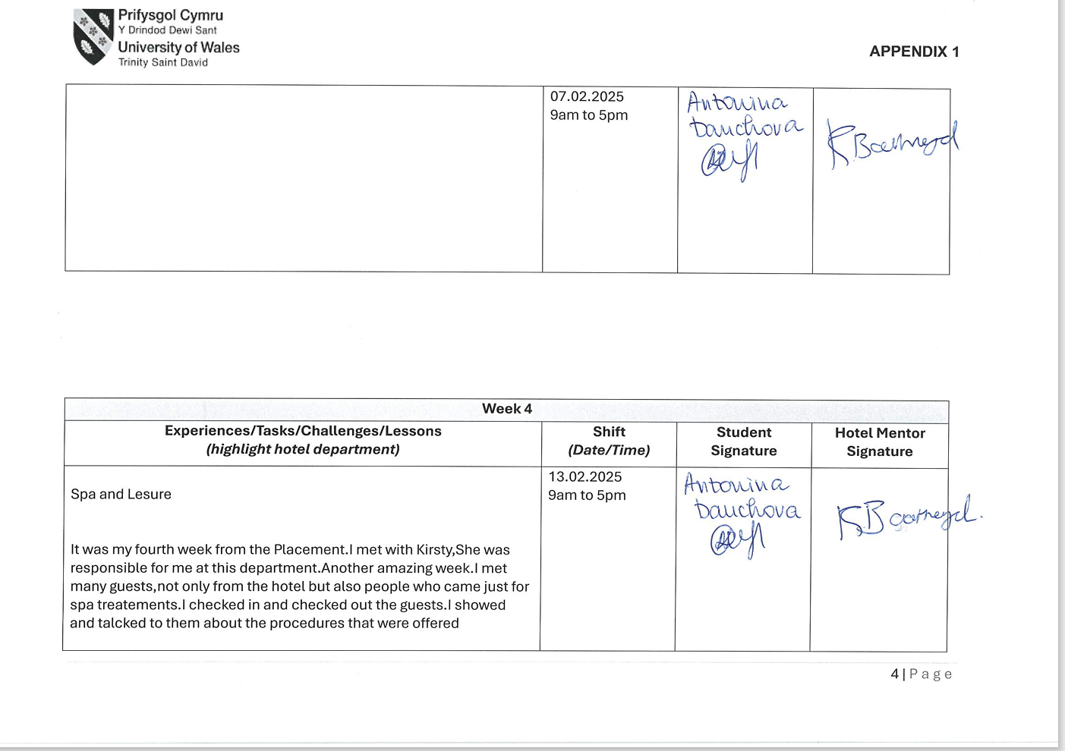
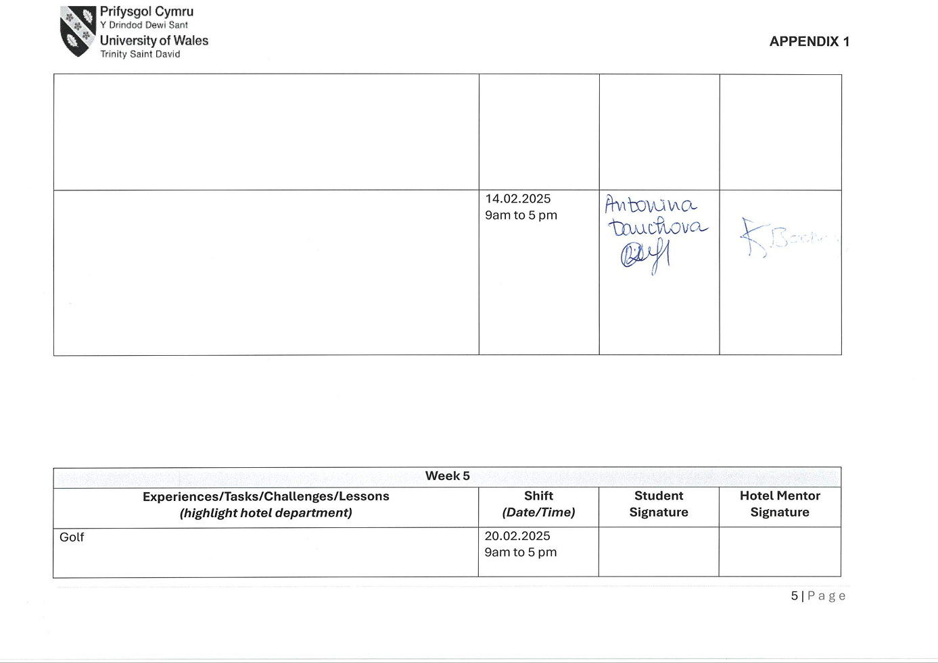
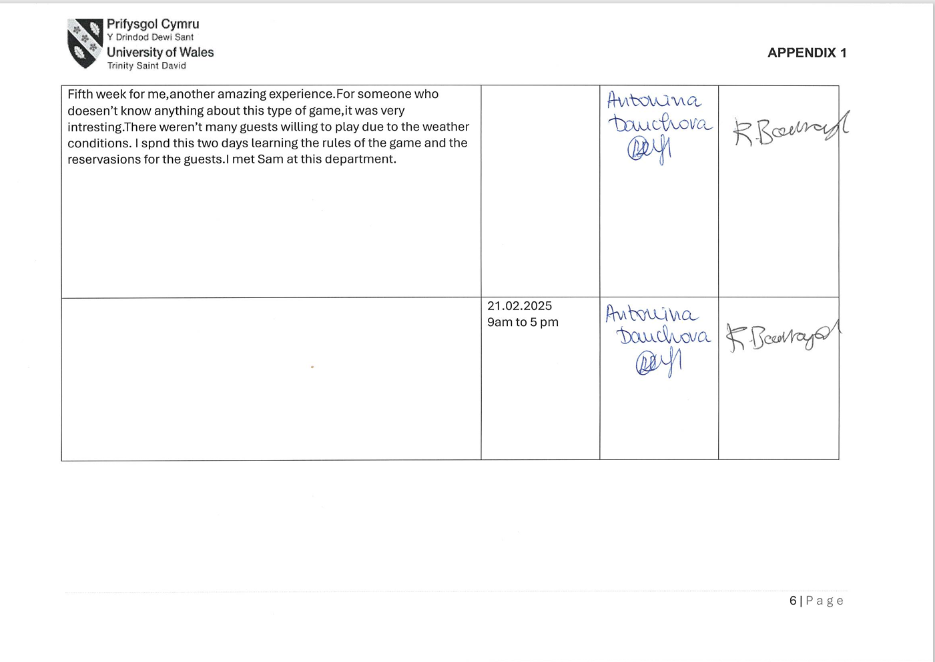
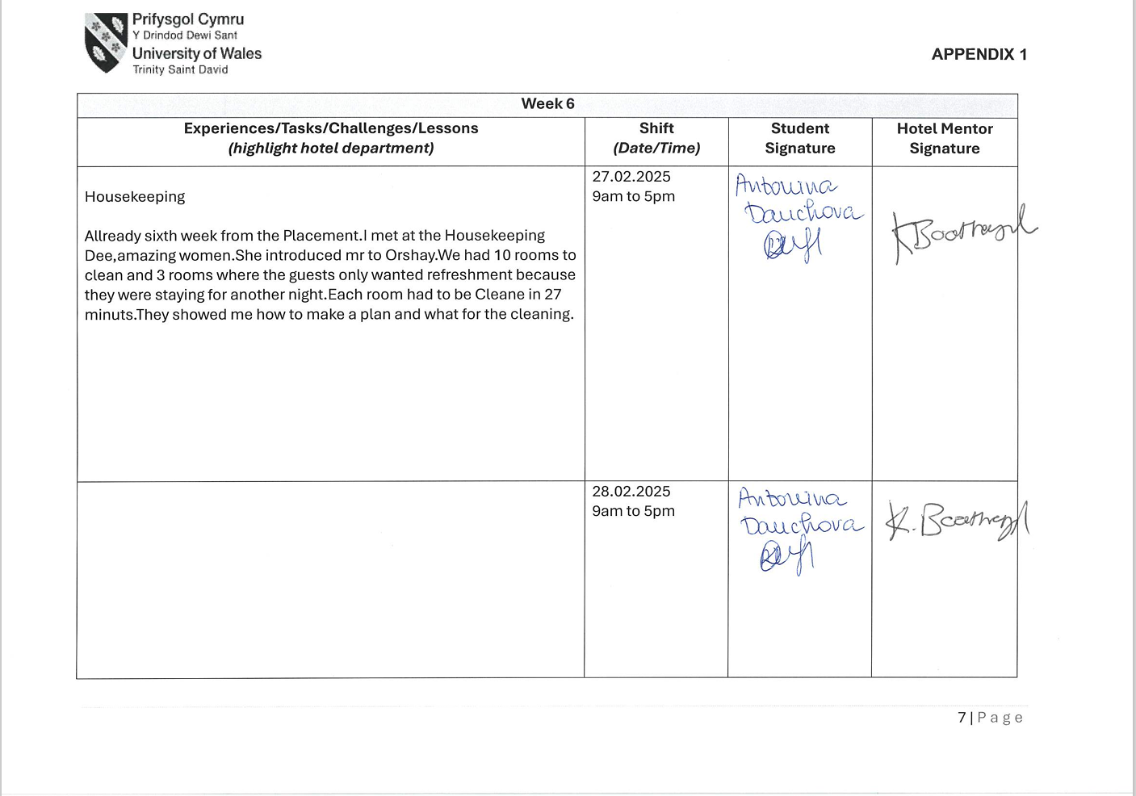



Assignment title: Student Learning Log
Module title:Managing guest Service Operations
Module code:BMIH6003
Student name:Antonina Vasileva Danchova
Student ID:2211877
Lecture name:Kathryn Roberts

Table of Contents
Part 2: Reflective Learning Log 2
References 6

Part 2: Reflective Learning Log
According to the University of Edinburgh (2024), Gibbs's Model of Reflection has been identified as a structured way of reflecting on the experiences that shaped my development in various aspects. The main stages in support of which the experiences of shadowing a supervisory position within departments such as housekeeping, maintenance, and leisure club will be analysed are Description, Feelings, Evaluation, Analysis, Conclusion, and Action Plan.
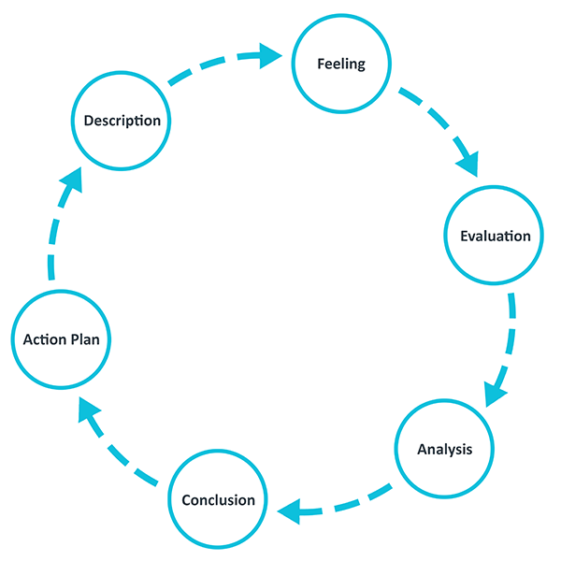
Figure 1: Gibbs Model of Reflection
(Source: University of Edinburgh, 2024)
Description
I underwent an orientation program on the first day at the hotel and this orientation program was inclusive of meeting the team, which made me comfortable within the hotel environment. I would describe that such meeting with the team on the first date made me well acquainted with my peers and influenced my confidence, which was much needed during performing skills and abilities. In the initial stage, I was further briefed on the prevailing health and safety policies of the hotel. In relevance to such briefing about the health and safety policies, I would describe that this was a very beneficial knowledge exchange session because through a briefing of the health and safety policies I was made aware of situations through which I could minimise commitment of risky events. It is understood that abiding and complying with the health and safety policies while functioning within the operational sphere of the hotel would abolish loss generation (Chan, Gao, and McGinley, 2021). It has been evaluated that COVID-19 has been the key factor that influenced the change in operations in light of service standards to ensure health and safety standards in the hotel. In other words, the key objective lying underneath the briefing of health and safety policies existing in the hotel was reducing risks and diminishing the possibility of accidents to a major level. After a briefing on the policies, I met the peers who were functioning responsibilities within the meetings and events department at the hotel.
Feelings
During my meeting with the Meetings and Events department, I felt that working in a hotel is also about effective communication and the use of interpersonal skills to ensure appropriate functioning within the limits of the allocated job responsibilities. I had mixed feelings inclusive of tension and confidence when I was allocated job responsibilities in the Champagne bar. The main reason for my feeling in the champagne bar was due to the continuous meeting with the customers and functioning simultaneously. I felt slightly nervous due to the continuous change of command according to the needs of the guests. I also felt that in this pressure situation working actively via the following command is the key to enhancing performance without committing mistakes. Later, I was assigned to perform responsibility in Spa, which was within the leisure facilities of the hotel and this needed much attention to the fulfillment of the needs of visitors. Hence, I felt that acknowledging the customer’s requirements with the quick turnaround system could be an effective way of stimulating my functioning skills. My feelings after my work experience at the Champagne Bar and Leisure services were positive because, throughout my functioning, I was guided by a superior, who was well experienced at dealing with new employees. Hence, I felt that having a cooperative superior could make a huge difference regarding experience accumulation while performing skills and responsibilities.

Evaluation
The great experience I undergone was my acceptance by my peers in various departments. In other words, I have experienced a warm welcome from the already existing professionals who were already a part of the hotel. This boosted my confidence in functioning with them and subsequently, my experience of working went well. I have evaluated during functioning at the Housekeeping department that cleaning rooms, refilling amenities and maintaining safety were the essential services that I steer the experience of guests to a high level. Hence, in light of the evaluation, it can be put forth that the commitment of the hotel towards sustainable housekeeping practices and overall guest satisfaction comes hand in hand. Additionally, evaluation of the experience in reference to the present housekeeping standards of the hotel can be put forth instead of traditional housekeeping practices. This included excessive water and energy consumption, as the hotel shall focus on sustainable housekeeping practices to enhance the position of the hotel as a responsible steward of the environment (Sharma, Bideshi and Bajpai, 2023).
I have also evaluated my experience at the reception of the hotel and it was deduced that attending and greeting visitors is easier than performing skills at the housekeeping department of the hotel. In reception, while I was functioning I found that assisting visitors with their specific needs and approaching the visitors with honour makes a huge difference. It has been evaluated that reception is the first point of contact for the guests and is a significant part of their overall experience (Müller, 2024). I evaluated my experiences at the reception and it was positive because making books, dealing with special requests and managing complaints were done in a hassle-free manner, which led me towards praise from my superior and this boosted my confidence to an enhanced standard. I also loved answering questions from the visitors, which subsequently influenced the brand equity of the hotel as well via leveraging the satisfaction rate of visitors during my duty hours.
Analysis
It has been analysed that my overall experience in the hotel was valuable towards the development of my skills and abilities. I have further analysed that my professional skills were enhanced due to the diversified functioning of the various departments of the hotel. It can be further analysed that from the functioning of the various departments of the hotel, I became capable of understanding the need to be cordial with the guests. In other words, it can be analysed that hotel reception is the central interface between the guests and the departments of the hotel. My experience in the restaurant of the hotel and leisure area was common because both are customer satisfaction centric. Hence, I have analysed that during functioning in the hotel, it is essential to understand the needs of the customer or the guest before serving or providing information.
Conclusion
The conclusion can be drawn from the reflection that cooperative superior and orientation program on the initial days of joining plays a crucial role in the functioning of the person in the subsequent period. Relatively, it can be concluded that my experiences of shadowing a supervisory position in various departments influenced my professional abilities within me, which will be beneficial at gaining opportunities in future. Further, it can be concluded that work-based skills and technical knowledge advancement were crucial developments that were identified after the successful completion of the functioning at the hotel.
Action Plan
In future in case I have to do similar operations and functions within a hotel environment, I would use the experience and understanding gained from this program. I would also focus on not repeating similar mistakes that I have committed during functioning skills at the various departments. Precisely, in the initiation period of working in the restaurant, without asking about the preferences of the customers or guests I used to suggest options from the menu, which I should not repeat. Hence, I have understood that I have to improve my interpersonal skills to ensure valuable customer dealing only after successfully considering their needs. I have to also develop my communication with peers, which could be a key to steering collaborative functioning in the pressure environment and this action must be coupled with a stringent deadline of 6 months only to ensure faster skill development in me with a specific vision.

References
Chan, J., Gao, Y. and McGinley, S., (2021). Updates in service standards in hotels: how COVID-19 changed operations. International Journal of Contemporary Hospitality Management, 33(5), pp.1668-1687. DOI: 10.1108/IJCHM-09-2020-1013
Müller, T. (2024) The hotel reception in transformation, straiv. Available at: https://straiv.io/en/blog/the-hotel-reception-in-transformation/ (Accessed: 28 January 2025).
Sharma, V., Bideshi, R.K. and Bajpai, S., (2023). " Impact of Sustainable Housekeeping Practices on Environmental Stewardship and Operational Efficiency in the Hotel Industry. DOI: 03.2021-11278686
The University of Edinburgh (2024) Gibbs’ Reflective Cycle, The University of Edinburgh. Available at: https://reflection.ed.ac.uk/reflectors-toolkit/reflecting-on-experience/gibbs-reflective-cycle (Accessed: 28 January 2025).

